4-Day Training Programme

on

Laboratory Quality Management System and Internal Audit

as per IS/ISO/IEC 17025:2017

General Requirements for the Competence of Testing and Calibration Laboratories

19-22 January 2027
at NITS, Noida

\

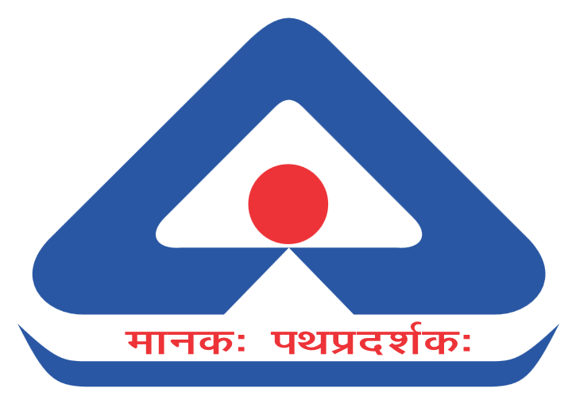

NATIONAL INSTITUTE OF TRAINING FOR STANDARDIZATION
BUREAU OF INDIAN STANDARDS
Ministry of Consumer Affairs, Food & Public Distribution
Government of India

About BIS

Bureau of Indian Standards (BIS) being the National Standards Body of the country discharges multitude of functions and services for enhancing the quality ecosystem in the country. The activities of BIS include standards formulation at national and international level, conformity assessment (Product Certification, Systems Certification, Registration and Hallmarking), testing, training and promotion of standards. All these activities are carried out through their network of offices at its headquarters, regional and branch offices and labs spread throughout the country.

About NITS

National Institute of Training for Standardization (NITS), the training arm of BIS, was set up under the aegis of BIS in 1995 to meet the growing needs and expectations of the industry for quality training in the fields of standardization, quality assurance, management systems, certification, laboratory testing, etc.

Since then, NITS has been organizing various types of training programmes for govt., academia, industry as well as for consumer bodies and common man. NITS has also been organizing various International Training Programmes for Developing Countries of Asia, Africa, Europe and Latin & South America. The programmes are conducted by a team of well-experienced, qualified and trained faculty.

The annual Training Calendar for FY 2026-27 can be accessed via the following link: -
https://www.bis.gov.in/training-2/annual-training-calendar/

On many occasions, client organizations of NITS require training courses customised for their officers/staff and conducted at their premises/online. NITS caters to these requirements by imparting the training at the premises of the clients on request. Such customized programmes conducted on specific request of client organizations at their premises/online are called as ‘Off-Campus Programmes’.

Over the years, NITS has acquired the reputation of being the leading institute in the country offering trainings in the field of standardization, conformity assessment and quality.

About the Course

- In the global landscape of Conformity Assessment, Accreditation plays a crucial role in enhancing both international and domestic trade and commerce. It ensures the quality, safety, and reliability of products and services by recognizing the competence of testing and calibration bodies through a globally accepted framework. Accreditation helps bridge gaps in testing capacities across countries and promotes mutual trust in results, reducing the need for duplicate testing. This removes technical barriers, lowers costs, and facilitates smoother trade.
- Beyond trade, accreditation supports national economies and safeguards public health, safety, and consumer interests by ensuring that various products and services meet stringent standards. Countries require accredited laboratories to deliver reliable and internationally comparable results, assessed under IS/ISO/IEC 17025.
- The principle of “Tested once, accepted everywhere” reflects the international goal of mutual recognition, reduced redundancy, and a more efficient and trustworthy global system.
- The standard, ISO/ISO/IEC 17025 specifies the general requirements for the competence, impartiality and consistent operation of laboratories, and is applicable to all organizations performing laboratory activities, regardless of the number of personnel.
Learning Objectives

- To appreciate the purpose and benefits of a Laboratory Quality Management System (LQMS)
- To understand the requirements of IS/ISO/IEC 17025:2017 in the context of an audit
- Audit definition and Auditing principles
- Planning, preparation, tools, and techniques of audit
- To learn the role of an Auditor to plan, conduct, report, and follow up on Laboratory Quality Management System audit
- To assess the overall conformity (or otherwise) of the Laboratory Quality Management System to the audit criteria
- Post audit activities including corrective actions
- Exercises/Workshops
Training Methodology

- Classroom based with combination of lectures, presentations and case studies, etc.
- Interactive Sessions with expert trainers
- Soft copy of all training material provided
Who should attend?

- Top Management
- Quality Managers/ Technical Managers
- Laboratory Personnel
- Professionals wanting to gain comprehensive knowledge about LQMS
- Expert advisors/Consultants for LQMS
- Auditors/Internal auditors
Career Benefits

- Understand the roles and responsibilities of an internal auditor
- Learn how to plan, conduct and report an audit
- Discover risks that affect LQMS compliance and learn to mitigate them
- Become well-versed with the structure of IS/ISO/IEC 17025
- Developing and understanding on QMS documentation for testing & calibration Laboratories.
- Develop proficiency for conducting internal audit and management review

Fee and Discount

- The course fee is Rs. 13,000/- + 18% GST per participant (Inclusive of Tea/Snacks & Lunch)
- Discount of 10% for 2-5 persons and 15% for more than 5 persons from the same organization is applicable on the course fee
- Limited seats are available and shall be offered on first come first served basis
- (100% Payment of Training fee shall be made in advance before Training start date).
Date & Venue

- The course will be run by NITS, Noida during 19-22 January 2027 at its campus at:
National Institute of Training for Standardization
A-20&21, Institutional Area, Sector 62, Noida – 201301, Uttar Pradesh
How to Apply?

Application has to be made through BIS “Training Portal” by following the steps mentioned below:
https://www.services.bis.gov.in/php/BIS_2.0/trainings/index.php/HomeUser/annual_action_calendar_by_category/3

- VISIT the e-BIS Website: www.manakonline.in
- CLICK on the "Training" Head
- LOGIN by clicking on the blue "LOGIN" button on the top right corner
- SIGNUP by clicking on "SIGNUP" on the Member Login Page if you are not a member otherwise "SIGN IN" using your credentials
- FILL OUT all the fields and click on "REGISTER" and complete the registration process
- CHOOSE the course you want to apply for, fill in the required information and "PAY" the requisite fee.

Why choose NITS as your Training Partner?

- Advantage of getting trained by the Bureau of Indian Standards (BIS), the National Standards Body of India
- Rich pool of Trainers with decades of auditing experience across disciplines
- Course contents developed by subject matter experts
- Expertise of BIS in conducting trainings
- Focus on the provision of practical training using real life scenarios
- Availability of customized training solutions
- Competitive pricing and corporate discounts
Contact

For any further queries, you may contact:
Shri Tony Jacob
Management Executive & Course Coordinator,
Email – nits@bis.gov.in
Mobile – 9809800296

