



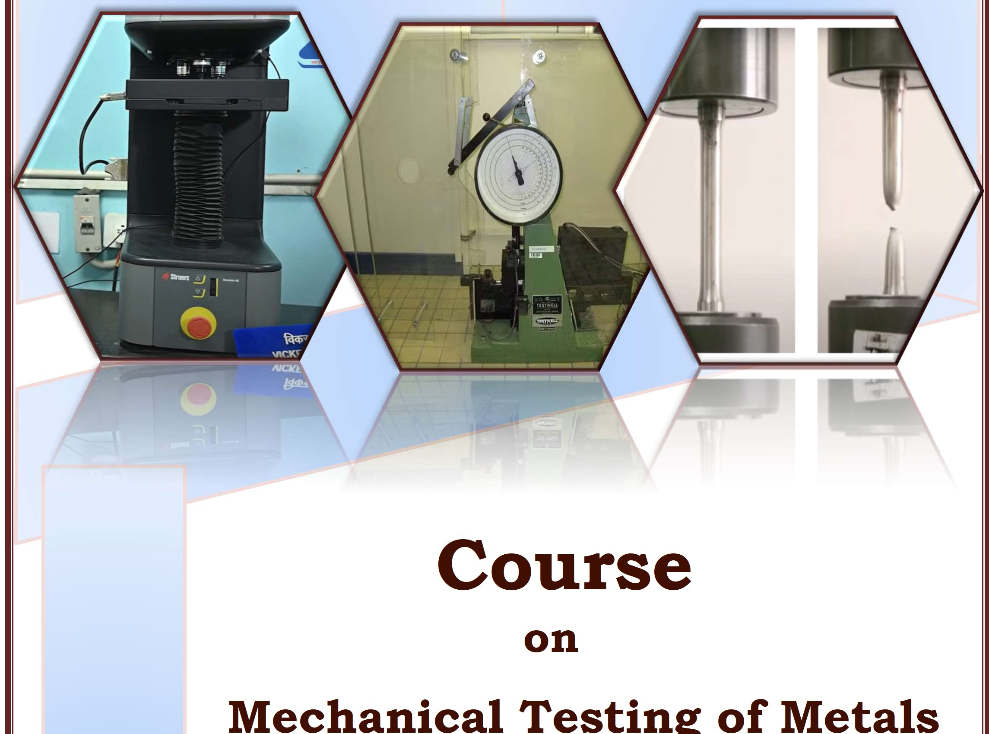


Course
on
Mechanical Testing of Metals
6 September 2025
at Central Laboratory, BIS

BUREAU OF INDIAN STANDARDS
National Institute of Training for Standardization (NITS), A 20 &21, Institutional Area,
Sector 62, NOIDA - 201309

Bureau of Indian Standards (BIS) being the National Standards Body of the country discharges multitude of functions and services for enhancing the quality ecosystem in the Country. The activities of BIS include standards formulation at national and international level, conformity assessment schemes (Product Certification, Systems Certification, Registration and Hallmarking) testing and training. All these activities are carried out through their network of offices at its headquarters, regional and branch office and labs spread throughout the country.

BIS has formulated National Standards for almost every field including Products, Systems, Processes, Vocabulary and test Methods. These standards provide uniform set of specifications, methods and guidelines to ensure quality and safety, interchangeability, interoperability of products and implementation of best practices and methods for the intended scope of application.
Manufacturing is a complex and intricate process that requires precision, accuracy, and attention to detail. It is imperative that a material used for a particular product shall be suitable for its usage in terms of strength, hardness, resilience, toughness, resistance to impact and elasticity. Mechanical tests are performed on the material to determine the performance characteristic of the product/material when it is subjected to various kinds of loads.
This Course on Mechanical Testing of Metals is designed to enable participants to be aware of the provisions in relevant Indian Standard and equip them in carrying out various types of mechanical tests, namely, Tensile and Elongation test, Hardness test and Impact tests under different conditions.
Participants will be given an insight into the principles, sample preparation and the methods for tensile testing of various metallic materials which defines the mechanical properties like yield strength, tensile strength, elongation etc. Participants shall also be given an exposure to the various Hardness tests like Rockwell’s, Brinell’s and Vicker’s. Participants will also gain an overview of Impact tests like Izod and Charpy tests.
BIS has published several standards related to Mechanical testing of metals. In this training the participants will be apprised about the various provisions in the following standards and implementation of the same

IS 1608 (Part 1) : 2022 Metallic Materials – Tensile Test
IS 1500 (Part 1) : 2019 Metallic Materials – Brinell Hardness Test IS 1501 (Part 1) : 2020 Metallic Materials – Vickers Hardness Test IS 1586 (Part 1) : 2018 Metallic Materials – Rockwell Hardness Test IS 1757 (Part 1) : 2020 Metallic Materials – Charpy Impact Test
IS 1598 : 1977 Method for Izod Impact Test of Metals

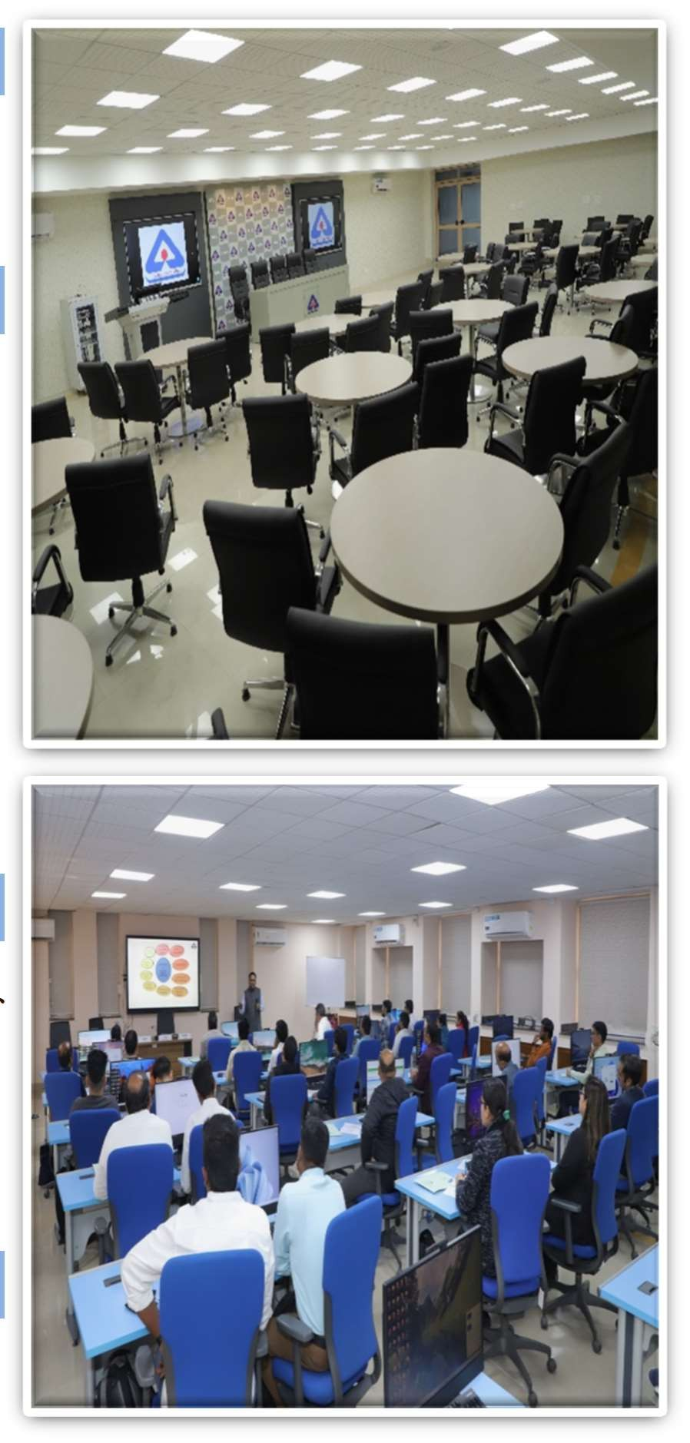

Learning Objectives
- Exposure to various mechanical tests and the underlying principles
- To understand the requirements of standards and test methods
- Sample preparation for various types of tests
- Carrying out various types of mechanical tests like yield strength, tensile strength, elongation, Rockwell’s, Brinell’s and Vicker’s Hardness test, Izod and Charpy tests
- Expression of results
Training Methodology
- Classroom based along with lectures, presentation and demonstration in laboratory.
Fee
- The course fee is Rs. 1000/- + 18% GST per participant.
- Participants have to arrange transport and accommodation on their own.
- Accommodation and transportation charges have to be borne by the participants.
- No training fee for Government Officials (Central/States/UTs) officially nominated by their department’s heads.
Who should attend?
- Personnel involved in Mechanical Testing
- Industries involved in Mechanical Testing
- Labs conducting Mechanical Testing
- Students from Mechanical/ Production/ Metallurgy/ Engineering/ Diploma/ ITI
- Professors and Lecturers from Academia
Criteria for Selection
- Selection on First come First serve basis

Certification
- Certificate will be awarded to all participants upon completion of course

Venue
  - The course will be held at BIS Central Laboratory, Sahibabad
  - Address: Plot No. 20/9, Site IV, Sahibabad Industrial Area, Sahibabad 201010, U.P.

Training Module

One-Day Course on Mechanical Testing of Metals
6 September 2025 at BIS Central Laboratory, Sahibabad
Time | Session | Faculties/Speakers
09:30 h - 10:00 h | Registration | -
10:00 h - 11:00 h | - Opening Address  - Inaugural Address  - Introduction to Metal Testing at Central Laboratory | Smt. Ankita Neogi Bag, Sc- C, NITS  Head CL  Smt. Shalu Varshney, Scientist E, CL
11:00 h - 11:30 h | Tea Break | -
11:30 h - 13:00 h | Tensile Testing  - Principles of Tensile Testing  - Sample Preparation  - Demonstration of Tensile Testing  - Wires  - Tubes/Pipes  - Flats/Strips | Sh Manish Raj, Sc C (Mech), CL/  Sh Amit Kumar (Lab officer), CL &  Sh Kundu (Lab officer), CL
13:00 h - 14:00 h | Lunch Break | -
14:00 h - 15:30 h | Hardness Testing  - Principles of Hardness Tests  - Types of Hardness Tests  - Sample Preparation  - Demonstration of Tests  - Rockwell’s  - Brinell’s  - Vicker’s | Sh Manish Raj, Sc C (Mech), CL/  Sh Amit Kumar (Lab officer), CL &  Sh Kundu (Lab officer), CL
15:30 h - 16:00 h | Tea Break | -
16:00 h - 17:30 h | Impact Testing  - Principles of Impact Testing  - Types of Impact tests  - Sample Preparation  - Demonstration of Tests  - Izod  - Charpy | Sh Manish Raj, Sc C (Mech), CL/  Sh Amit Kumar (Lab officer), CL &  Sh Kundu (Lab officer), CL

How to Apply?
Application has to be made through BIS Training Portal by following the steps mentioned below:

- VISIT the e-BIS Website: www.manakonline.in
- CLICK on the "Training" Head
- LOGIN by clicking on the blue "LOGIN" button on the top right corner
- SIGNUP by clicking on "SIGNUP" on the Member Login Page if you are not a member otherwise "SIGN IN" using your credentials
- FILL OUT all the fields and click on "REGISTER" and complete the registration process
- CHOOSE the course you want to apply for, fill in the required information and "PAY" the requisite fee.
In case you are unable to submit your nomination on the BIS Training Portal, the same may be done by emailing filled up nomination form (given on next page) to nits@bis.gov.in. In that case, payment of the requisite fee may be made via NEFT/UPI to the Bureau of Indian Standards Bank Account, details of which are mentioned in the nomination form.

Contact
For any further queries, you may contact:

Smt Ankita Neogi Bag
Sc.-C and Course Coordinator, NITS
Mobile – 8777529355

Email: nits@bis.gov.in

