REFERENCE MATERIAL FOR
TWO-DAY CAPACITY BUILDING PROGRAMME FOR
SENIOR OFFICERS OF
MUNICIPAL CORPORATIONS AND
URBAN DEVELOPMENT DEPARTMENTS OF STATES

TABLE OF CONTENTS

Sl. No. | Chapter No. | Content | Page No
1 | Chapter 1 | Building Regulatory System: Administration and Permits as per SP 73: 2023 ‘Standardized Development and Building Regulations 2023’ | 3 to 14
2 | Chapter 2 | Land Development and Development and Building Controls | 15 to 27
3 | Chapter 3 | Geospatial Planning for Resource Management | 28 to 40
4 | Chapter 4 | General Building Requirements | 41 to 48
5 | Chapter 5 | Requirements for Special Developments and Buildings | 49 to 66
6 | Chapter 6 | Piped Drinking Water Management System as per IS 17482 | 67 to 77
7 | Chapter 7 | Solid Waste Management | 78 to 90
8 | Chapter 8 | Recycling of Plastic Waste | 91 to 98
9 | Chapter 9 | Non-sewered Sanitation System (Packaged STPs, Biodigestors and Rotational Moulded Polyethylene Septic Tanks) | 99 to 123
10 | Chapter 10 | Requirements for Street Food Vendors as per IS 16066 | 124 to 136

CHAPTER 1

Building Regulatory System: Administration and Permits as per SP 73: 2023 ‘Standardized Development and Building Regulations 2023’
About
This chapter outlines the administrative set up required for regulating land development or redevelopment, building construction or reconstruction, alteration and demolition activities by an Urban Local Body (ULB)/ Authority which is conferred with relevant powers through legal statute. The chapter is divided into three key sections as depicted below. Each section provides powers and duties of BO, Applicant and the RBP.
Key Highlights – clear documentation of roles, exhaustive listing and identification of RBPs (10 in total) involved in development and/ or construction work along with their qualification and competence criteria, guidelines for manual process of permits
2.1 Building Official (BO)
Any land development or redevelopment, building construction or reconstruction, alteration and demolition activity shall be carried out only after obtaining permission from the Authority where a Competent Official (CO) or a delegated official of the Authority may act as the BO.
Key responsibilities of a BO include –
- Receive applications
- Undertake scrutiny, inspections, etc
- Issue notices
- Sanction any compoundable development in accordance with these or any prevalent regulations,
- Ensure compliance for allotment of land and relevant acts such as RERA
- Issue permits for land development or redevelopment, building construction or reconstruction, alteration and demolition activity,
- Issue occupancy permit and maintain records of all applications
- Stall work on site for non-permissible development and/or construction

2.2 Applicant
Applicant is fully responsible for compliance with these regulations, master plan/development plan/zonal plan and other relevant acts/regulations applicable on the development/ construction/ demolition/ alteration activity being undertaken by them.
Key responsibilities of an Applicant include –
- Obtain necessary permit(s), NOCs and approvals,
- Undertake development/ construction in accordance with sanctioned plans,
- Engage RBPs, comply with BO in inspection and scrutiny,
- Notify BO at various stages of development and construction,
- Ensure no development/ construction is undertaken during lapsed or revoked permit,
- Ensure safety on site, safeguards for environment protection and maintain the building in accordance with Part 12, ‘Asset and Facility Management’ of NBC 2016,
- Maintain permit records for at least 1 year after completion of construction.

2.3 Registered Building Professional (RBP)
All plans for development or redevelopment, building construction or reconstruction and alteration and demolition shall be prepared and signed by a qualified RBP.
- 10 types of RBP, to be engaged by Applicant - Architect, Civil engineer, Structural engineer, Geotechnical engineer, Town Planner, Supervisor, Landscape architect, Urban designer, Engineer for utility services and Building constructor
- Engagement of RBP basis type of development/ construction activity, minimum qualification competence criteria of each RBP is in Annex A
Key responsibilities of an RBP include –
- Study and be conversant with state and local rules, regulations, orders and other instructions,
- Prepare all plans in accordance with regulations,
- Upload the documents on Authority’s portal, ensure submission of correct details intimate applicant the corrections/ changes suggested by BO,
- Carry out work on site, ensure accessibility requirements as per these regulations and Rights of Persons with Disabilities Act, 2016, as amended from time to time
- Inform BO of their employment/ assignment/ resignation for any work
Note: Guidelines for manual process for Permit
The regulations do not encourage manual process of permit. However, in case the authority is still adapting to the online permit process, additional responsibilities and duties for obtaining permits (through a manual process) shall be as follows:
- BO - Ensure availability of all the required forms, inform the applicant and RBP about any modifications/objections/grant or refusal, accept scanned copies of updated plans, documents and application
- Applicant - Ensure signature of documents/ plans before submission, provide correct details of communication to BO, inform BO about revisions in plan submission
- RBP – Prepare plans in required legible formats, sign the plans as per their competence along with their full name, registration no, contact no and address
Permits
About
This chapter details out the process for obtaining Development Permit, Building Permit, Occupancy Permit and Demolition Permit across nine sections as depicted below
Key highlights –process documentation aligned to sequential flow of development, flowchart representation for processes, tabular representation for list of documents, standard templates for all forms/ approvals/ permits/ orders, functions for single window approval system - all of which can be readily embedded into an online plan approval system
3.1 Applicability
- Any development or redevelopment of land, construction or reconstruction, alteration and demolition activity and occupation of any building or its part shall be carried out only after obtaining permission from the BO of the Authority.
- Exemptions for certain activities such as alterations (plastering, flooring, internal partitioning, gardening, public art, etc.), operational construction/ installations of government services from taking permit, provided they conform to all clauses of these regulations
3.2 Development Permit and/or Building Permit Issued Prior to These Regulations
- Development and/or building permit has been issued before the notification of these regulations. Following cases are included –
  - where the sanctioned activity is not completed within the validity period of permit
  - where the validity of permit has expired, and the work has not commenced
  - a plot or a building is allotted/leased by any government department or Authority with specific provisions
  - where the validity of permit has not expired and the sanctioned activity is in progress
3.3 Permit process
- Permit process to be followed for any land development or redevelopment, building construction or reconstruction, alteration and demolition activity (including occupancy and part occupancy permit) through following steps.
  - Submission of application
  - Scrutiny of application
  - Sanction or Refusal of Development Permit and/or Building
  - Deemed Approval in Case of Development and/or Building Permit
  - Addition and/or Change in Sanctioned Development and/or Building or Sanctioned Demolition Plan
  - Withdrawal of Application
  - Procedure During Development and/or Construction
  - Validity and Extension of Time
  - Notice of Completion
  - Inspection for Occupancy Permit
  - Grant or Refusal of Occupancy Permit
- Each process step details timelines, documents, responsibilities, flow of information, output, etc. represented through an individual flowchart.

List of Documents to be Provided along with the Application of Permit (except for Demolition Permit)
Documents | Development permit | Building permit
Engagement of RBP (ANNEX B) | Y | Y
Application for obtaining development permit/building permit (ANNEX C) | Y | Y
Subdivision/layout plan | Y | NA
Key plan | Y | Y
Site plan | Y | Y
Building plan | NA | Y
Services plans | Y | Y
Specifications | Y | Y
Applicant/ownership documents | Y | Y
Certificate of structural design sufficiency (ANNEX D) | NA | Y
NOCs (as per requirement); (ANNEX E) | Y | Y
Indemnity Bonds (ANNEX F and ANNEX G) | Y | Y
Valid time extension (wherever applicable) | Y | Y
Photographs of the site with date-time stamp | Y | Y
Receipts of all applicable fees and charges including labour cess (ANNEX H) | Y | Y
Energy Efficiency Compliance Report from BEE certified professional, wherever applicable as per ECBC Rules | NA | Y

List of Documents to be Provided along with Application for Demolition Permit
Documents
Engagement of RBP (ANNEX B)
Application for obtaining demolition permit (ANNEX J)
An engineering survey of the structures/buildings prepared by RBP.
Demolition plan as described in 3.7.5 of these regulations
NOC from all essential utility services (supply of gas, water, sewerage, telecommunications, electricity). (ANNEX E)
Receipts of all applicable fees and charges (ANNEX H)

Process flow for obtaining Development Permit and/or Building Permit (illustrative)
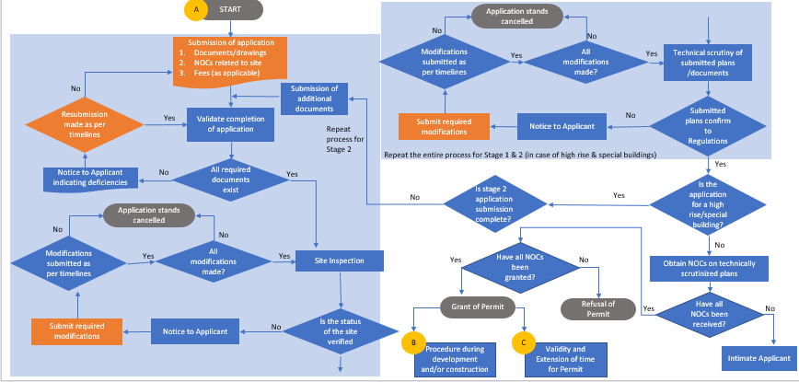
Flow chart for deemed approval (illustrative)
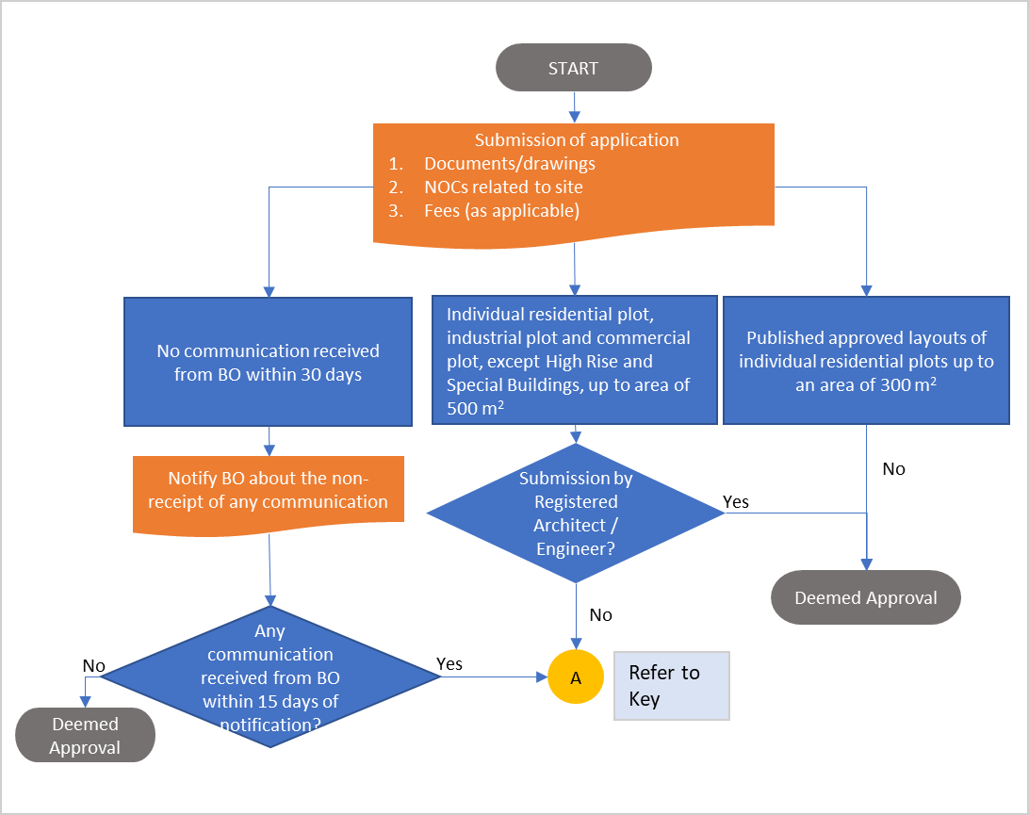
Indicative list of NOCs/ approvals required
Agencies from whom NOCs/Clearances may be required (wherever applicable)
Airport Authority of India (AAI)
National Monuments Authority of India
Ministry of Environment, Forest and Climate Change (MoEFCC)
Fire Service Department
Designated authorities under factories act
Designated authorities under cinema regulation act
Urban Art Commission
Heritage Committee
Pollution Control Board
Designated Coastal Regulation Zone Authority
Clearance from Metro Rail Corporation (MRC)
Lessor in case of leased sites
Chief Controller of Explosives
Service departments
Town planning department
Clearance from defence, border roads
Public Works Department (PWD)
National Highway Authority of India (NHAI)
Departments/Agencies responsible for the maintenance of the public utilities (If the allotted site falls in the proximity of their establishment or has any departmental utilities or conveniences or infrastructure, etc. within, below or above the ground or on the periphery of the site which has the possibility of being affected while undertaking the construction.)
Railways
Police (For construction of religious structures)
District Magistrate
Inspectorate of boilers and smoke nuisance
Atomic Energy Regulatory Board

Procedure During Development/Construction (illustrative)
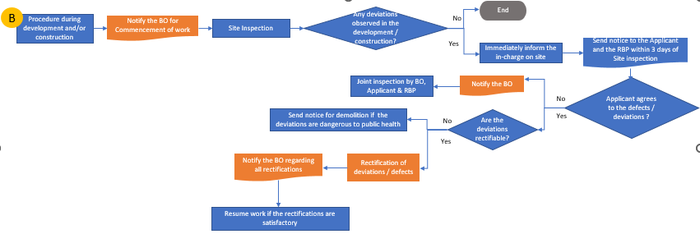
Validity and Extension of Time (illustrative)
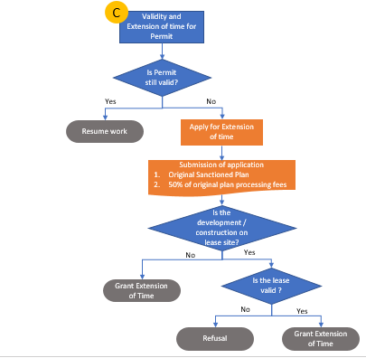

Process for Occupancy Permit (illustrative)
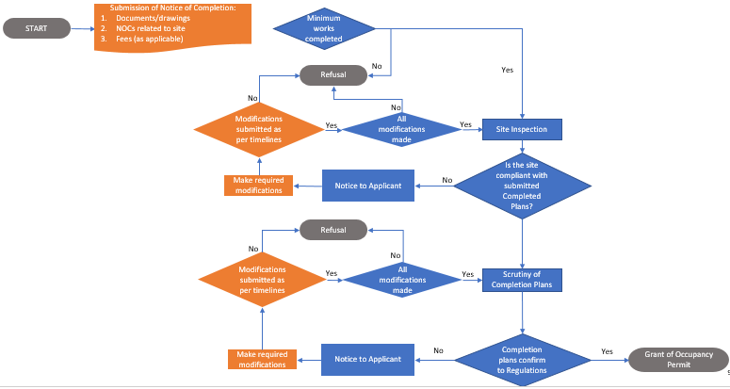
Timelines for the Permit Process for Development and/or Building Permit(other than 2-stage process)
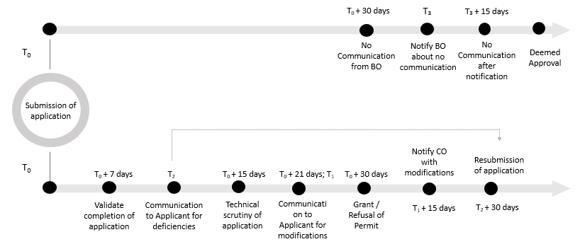
3.4 Penalties and Violations
- BO is empowered to undertake following actions against person who contravenes any of the provisions of these regulations -
  - Levy penalty
  - Seal and demolish or bring within limits
  - Cancel registration of the concerned RBP or make such recommendation to the statutory body governing such profession
  - Any other appropriate actions as provided in law
- All expenses shall be borne by the applicant and if not paid on demand, the BO shall recover the same as revenue arrears
3.5 Unsafe buildings
Unsafe buildings shall be dealt in the following manner, after their examination –
- Serving a legal notice to the applicant or occupier of any unsafe building stating time period to vacate the building or complete specified repairs/improvements or demolish and remove the building or portion thereof.
- BO vacating the building to remove the danger by repair or demolition of the building or portion thereof. All expenses shall be borne by the owner/occupier and if not paid on demand, BO shall recover as revenue arrears.
3.6 Third Party Audit
Appointment of third-party technical audit agency (TPTAA) and/or third-party quality assurance (TPQA) by BO for highrise and special buildings. Following in context of these agencies is detailed-
- Selection criteria of TPTAA to be based on experience of similar works, conflict of interest, etc.
- Objectives of TPTAA include review of project implementation and procurement process, statutory clearances, quality monitoring plan; examination of documentation with respect to sanctioned covenants; preparation of detailed reports and their follow up, etc.
- Process flow for appointment of TPTAA by the applicant and their audit at various stages of development and/ or construction works
3.7 Demolition of a building
Provisions for demolition of a building include -
- Applicability and procedure for seeking demolition permit
- Safety provisions during demolition as per Chapter 7 of these regulations, Part 4 and Part 7 of NBC 2016 and waste disposal provisions during demolition as per Chapter 12 of these regulations
- Notification to concerned departments/agencies related to utilities having service connections within the building, such as water, electricity, gas, sewer and other connections and obtain an NOC related to their disconnection;
- Plan of procedure for the demolition work to be prepared by RBP ensuring structural integrity of the adjacent / adjoining building, safe methods, lifting, handling, storing arrangements, safe access and working area, disposal of waste, risk assessment plan, etc.
3.8 Permit for signage
Applicant shall erect, alter or maintain a sign after obtaining a permit. Provisions in terms of the following are detailed -
- Process for application including steps, documents, validity, approval, deemed approval and cancellation/ revoke of permit
- Placement of signages (including accessible signages for public buildings)
- Content and display of signages (conforming to Part 10 , Section 2 of NBC 2016)
- Structural safety (conforming to Part 6 of NBC 2016
- Existing advertising signages
- Exemptions
- Unsafe and Unlawful signages
3.9 Online building permits
- Functions for permits that may be performed through an online approval system with the use of electronic forms such as -
  - Receipt or acknowledgement of applications (see Note 1) and payments;
  - issue of notices, permits, orders or directions;
  - scrutiny, enquiry or correspondence for grant of sanction/refusal of permits,
  - filing of documents;
  - calculation and payment of fees and any charges;
  - maintenance of registers and records;
  - any other function that the Authority may deem fit in public interest; and
  - communication with the applicant .
- Additional requirements for an online single window approval system are in terms of–
  - unique identification number for each application
  - status of the approval, stage of development, observations, etc to be posted on the website and made available through SMS
  - In cases where an online system is still in the process of being adopted, application status to be constantly updated to the Applicant, forms to be signed and accepted in triplicate, multiple payment options for online transaction/ Demand Draft/ Cheque and cash.

CHAPTER 2

Land Development and Development and Building Controls
Standardized Building Regulations
About
This chapter addresses various aspects related to land development or redevelopment in an area. It has been divided into three key sections- Land Use; Layout Plans; and Density.
Key highlights
Aspects related to Compensatory FAR (CFAR), Transferrable Development Rights (TDR) and Purchasable FAR ; buffer zones applicable for all Master Plans for different development types along with reference to relevant Guideline/Manual/ Notification.
4.1 Land Use
- This clausae empowers the Authority to regulate land development through a set of land use zones, sub zones and associated core and support activities defined in the master plan and subsequently detailed in the zonal and layout plans.
- A list of land use classification is provided as illustrated below:
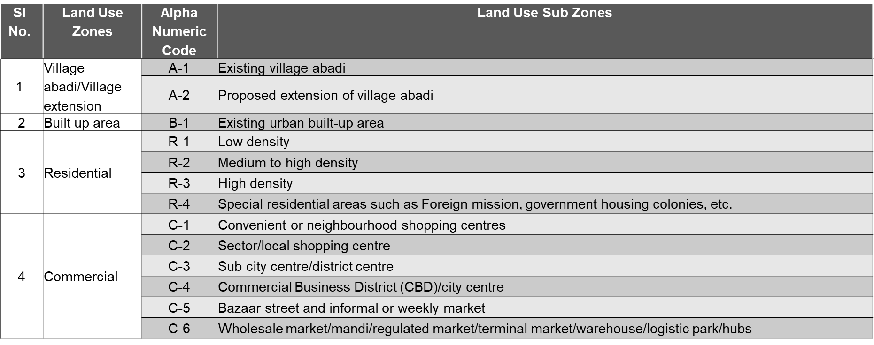
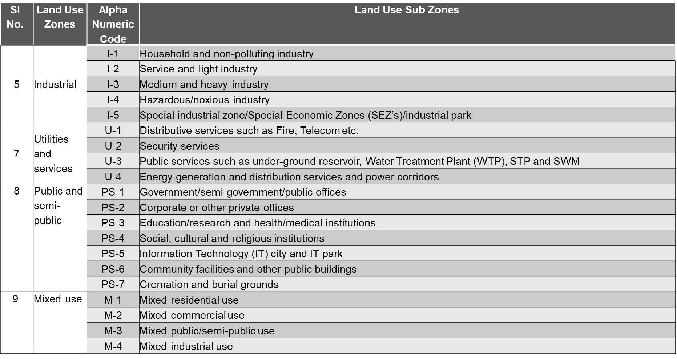
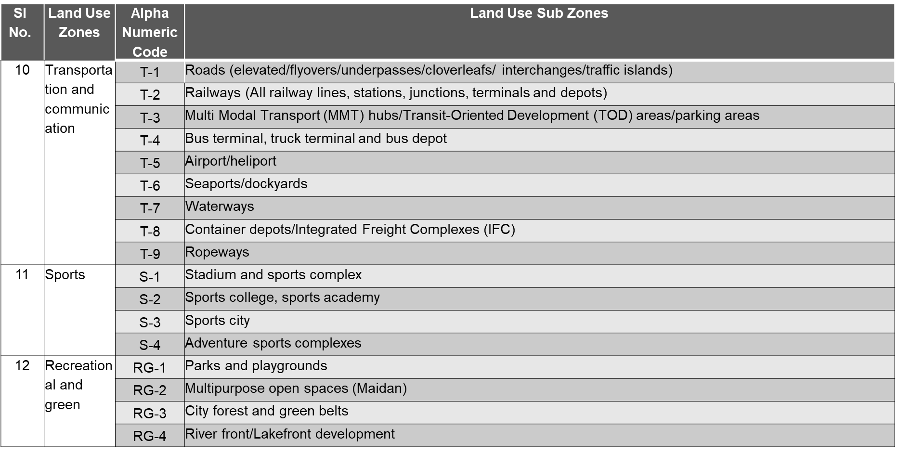
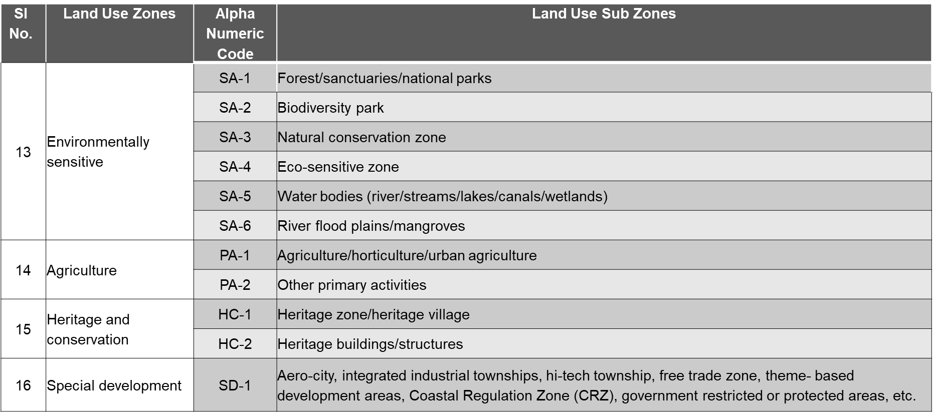
4.1 Land Use (Continued)
- Any redevelopment activity to be in consonance with the Master Plan which should also demarcate distinct fire zones as per 7.3 of these regulations
- Any kind of development following areas shall only be proposed after due considerations as suggested in these regulations.
  - Areas with sharp and deep slopes, cliffs, major drainage, water channels, river flood plains, mangroves, wetlands, high tides, mining activities, and adjacent to active fault lines, which are prone to erosion, landslides, avalanches, floods, waterlogging, and other environment hazards
- Other considerations included for –
  - Environmentally sensitive areas, heritage and conservation areas
  - Ensuring compact development
  - utilizing land resource mobilization tools
  - integrating urban and rural realms to achieve efficient management of growth and land development
  - use of urban agriculture like green roofs, neighbourhood and community farms, vertical/stack farming or large farm operations, within the greenbelts of planned urban areas.
4.1 Land Use (Continued)
- Buffer zones applicable for all master plans have been provided for different development types as illustrated below:
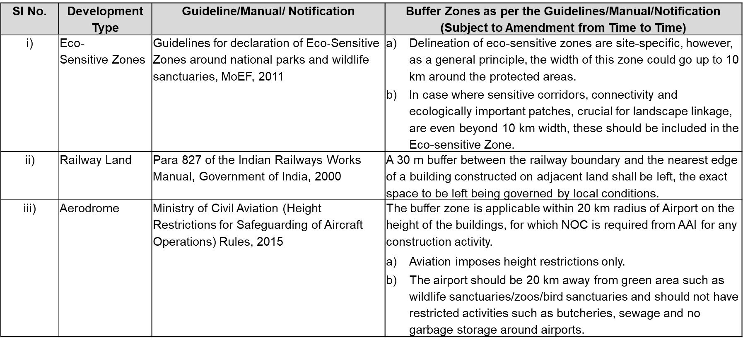
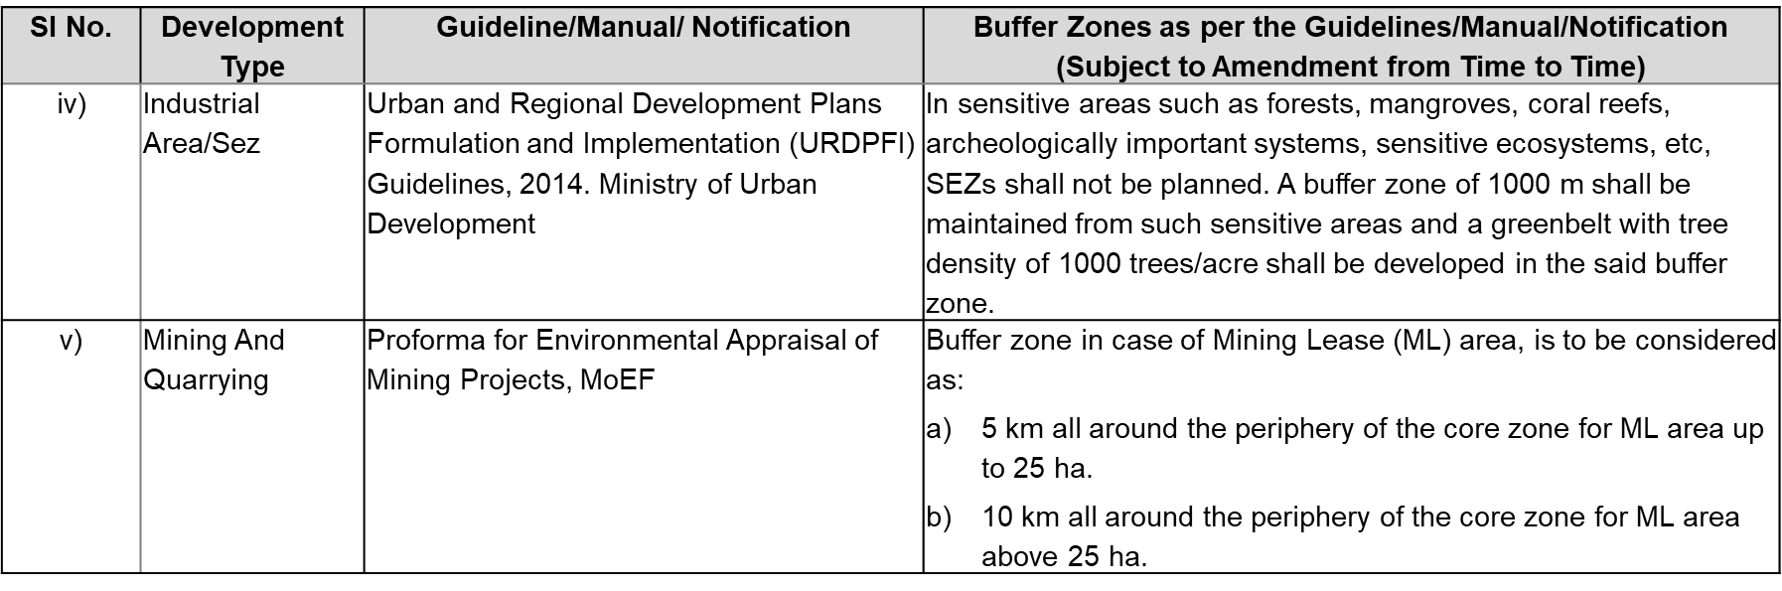
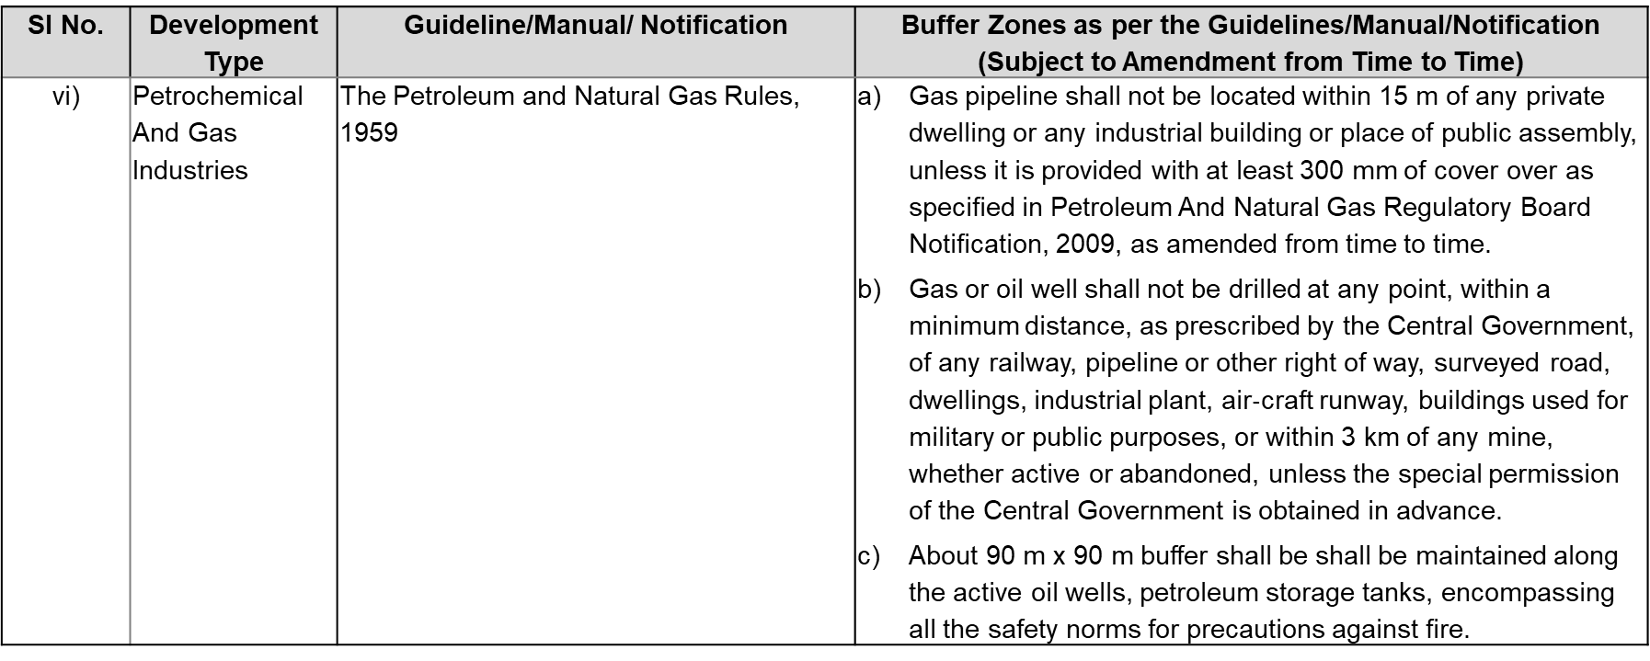
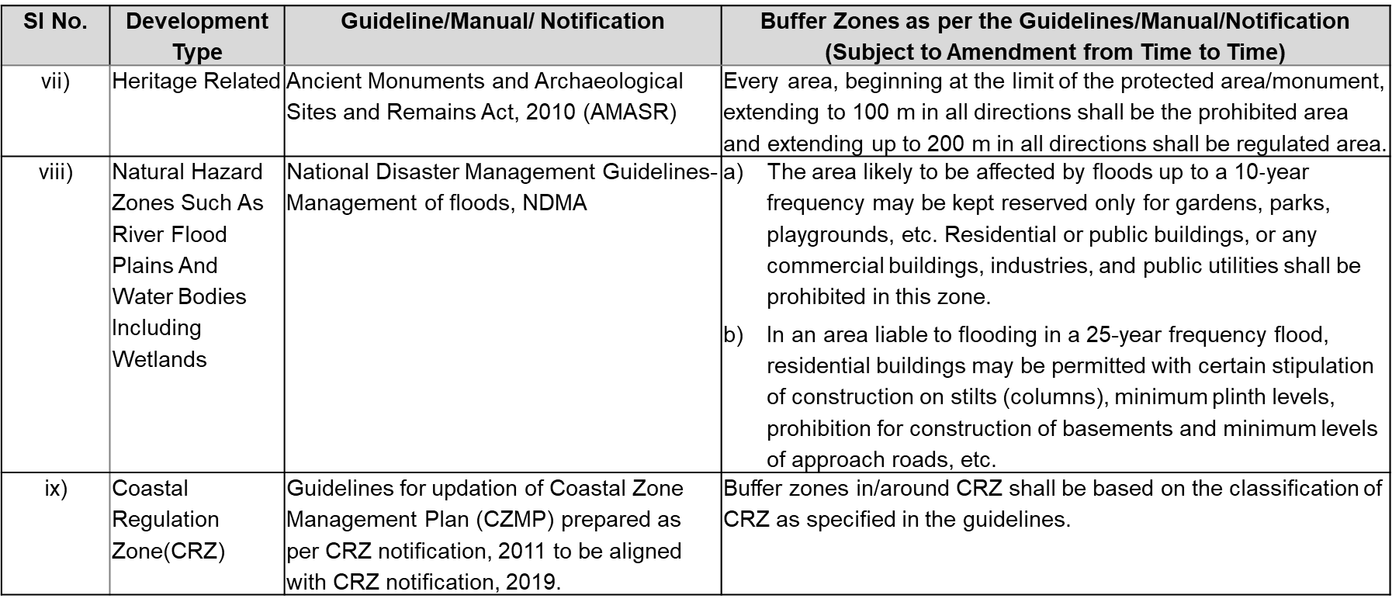
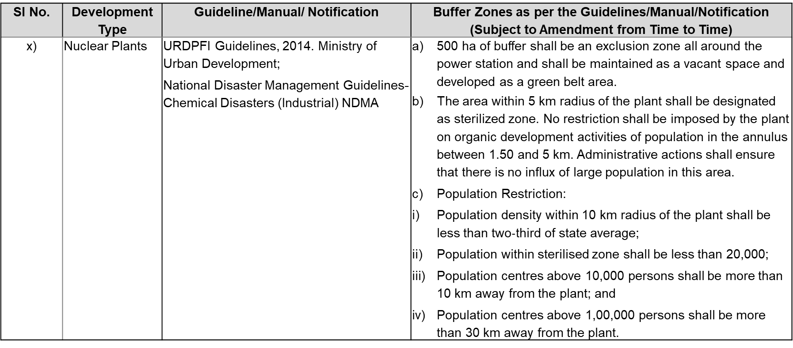
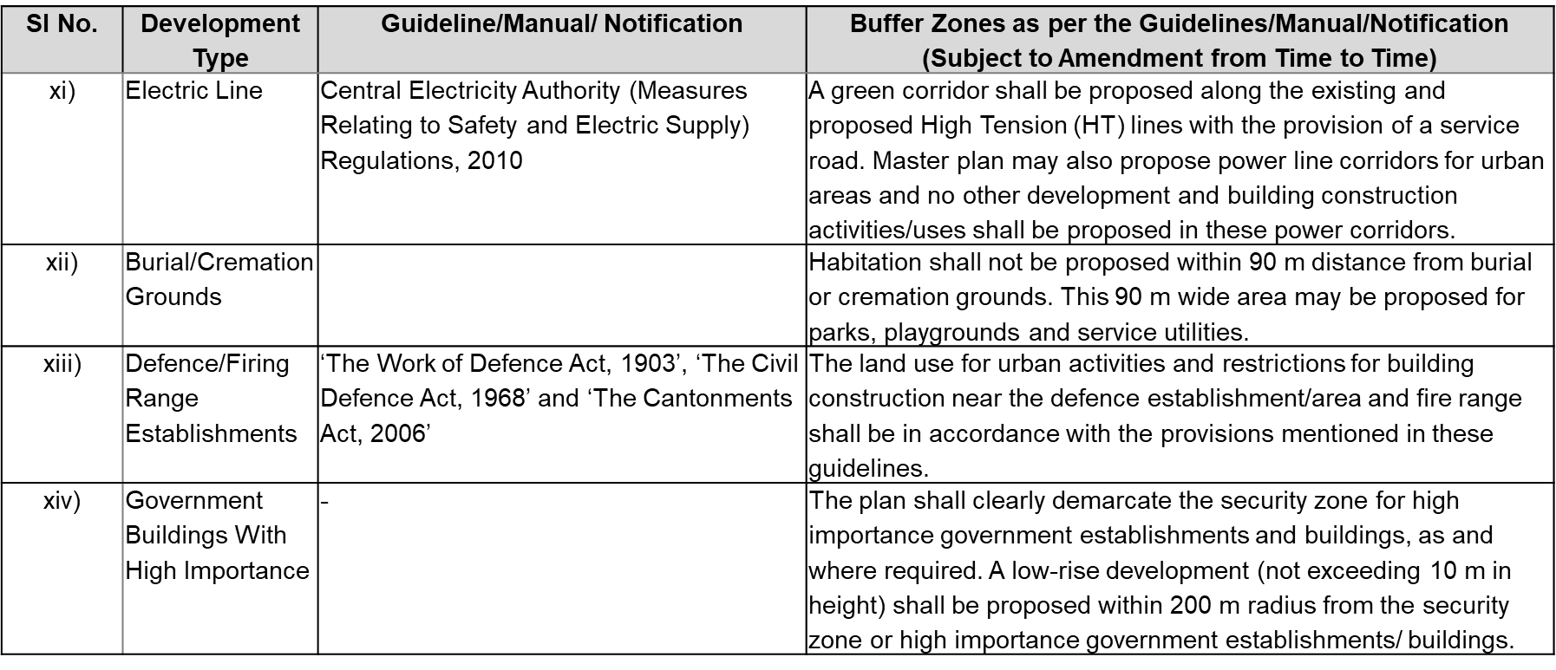
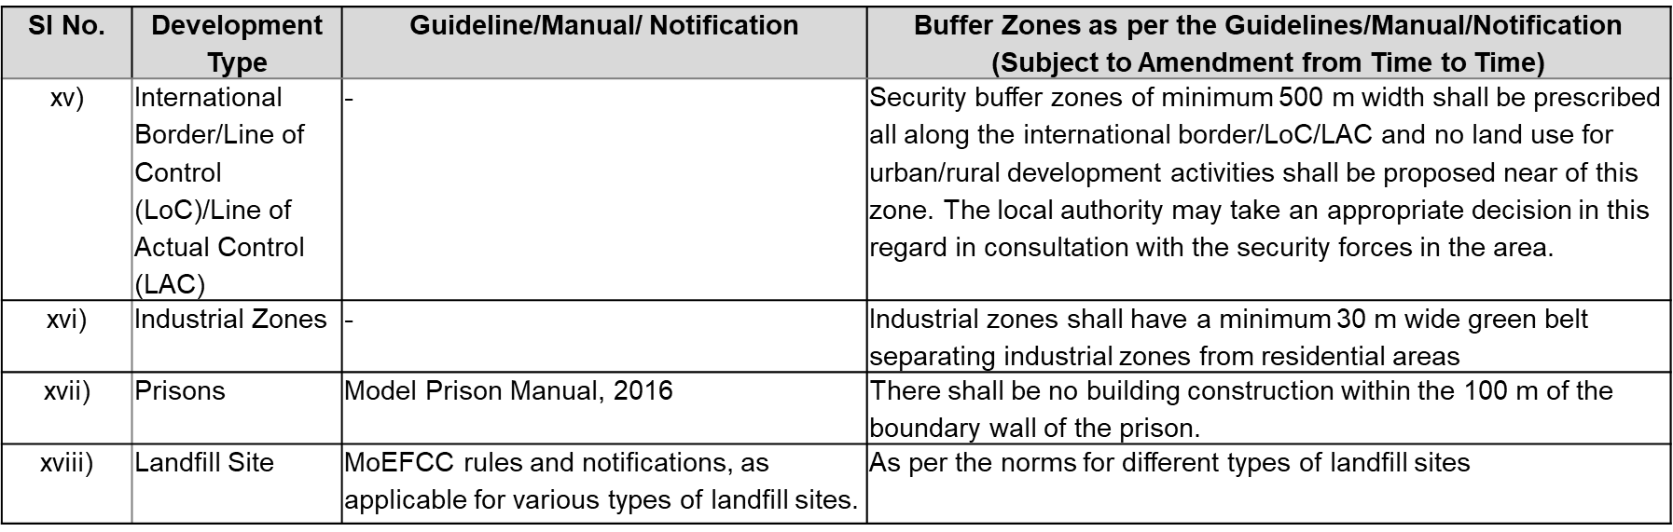
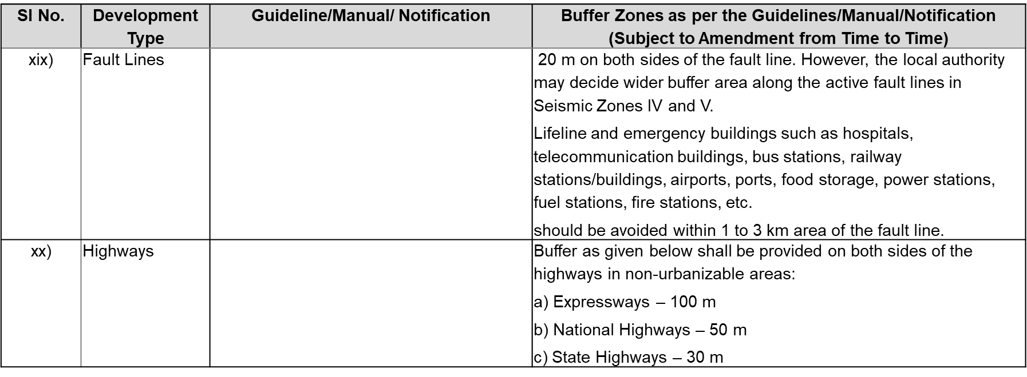
4.2 Layout Plans
- This clause addresses the requirements for layout plans.
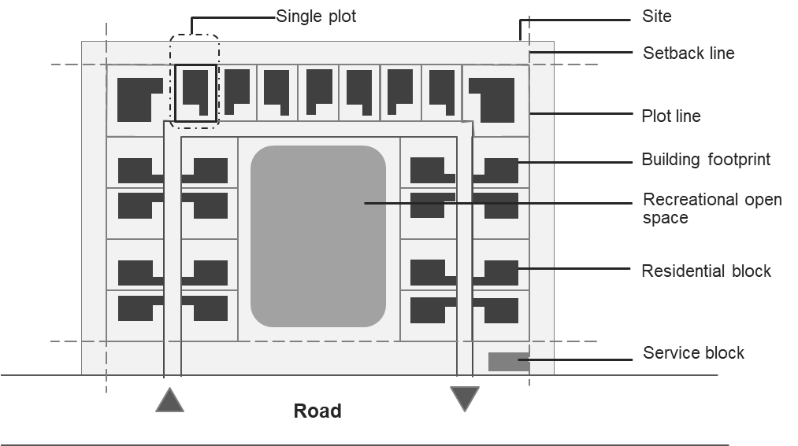
Typical Layout for Plots with Area More than 3000 m²

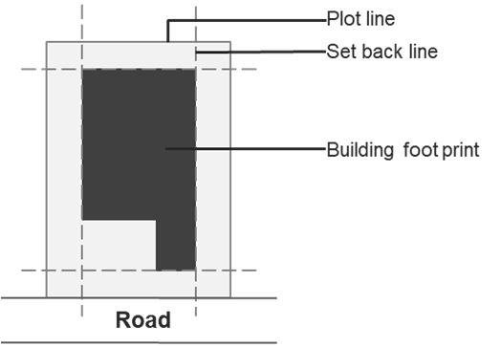
Typical Layout for a Single Plot
4.3 Density
- Population densities for different settlement types in tabular format

ANNEX W
- This annexure covers resource mobilization for land development. It states the requirements for the following:
  - Compensatory Floor Area Ratio (CFAR)
  - Transferrable Development Rights (TDR)
  - Purchasable Floor Area Ratio
Compensatory Floor Area Ratio
- This section of the Annexure specifies the public purposes for which CFAR may be provided by the Authority to the landowner in lieu of land parcel, which is to be acquired partly or fully.
- It also specifies the conditions that shall apply if CFAR is provided on the remaining part of the same plot.
- Additionally, it specifies the conditions that shall apply if CFAR is provided on other receiving plot(s).
Transferrable Development Rights (TDR)
- Conditions under which TDR can be issued.
- Circumstances under which TDR shall not be permissible
- Mechanisms for TDR
- Stages of TDR
- TDR utilization
Purchasable FAR
- Cases in which Purchasable FAR shall be permitted
- Conditions with which Purchasable FAR shall be permitted
- Cases in which Purchasable FAR shall not be permitted
- Calculation Method for the Rate of Charges of Purchasable FAR

Development and Building Controls
Standardized Building Regulations
About
The chapter details out the development and building controls and is structured in eight key sections– means of access, approach to a building, setbacks, open spaces, FAR and ground coverage, subdivision and amalgamation of plots, off-street parking, and urban design features.
Key highlights –inclusion of universal accessibility features as part of the regulations; recommendatory provisions, which can be modified by the states/UTs, regarding setbacks, ground coverage and FAR; Urban Design features including Public Art, Street Furniture, and Greenbelts and Landscaping.
5.1 Means of Access
- Minimum Right of Way (RoW) requirements for means of access of plots, as illustrated below:
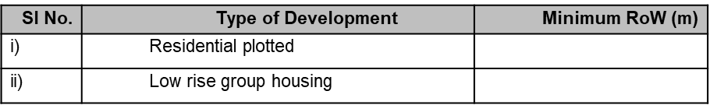
- Further, plots which do not abut on a street/road shall abut/front on a means of access, the width and other requirements of which shall be as given below:
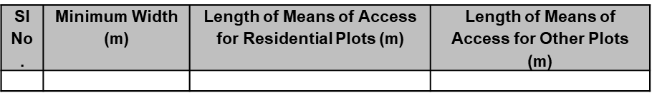
- Facilities and amenities for which direct access from highways or roads greater than 52 m in width shall be permitted
- Provisions on means of access for high rise buildings and special buildings
- Road intersections and junctions shall provide clear sight distance and shall be universally accessible.
- Requirements for cul-de-sacs to ensure easy turning of vehicles.
- Requirements for footpaths
5.2 Approach to a Building/Amenity
- Approach to the buildings from road/street/internal means of access shall be through paved pathways.
- Approach to the public buildings/ amenities and group housing.
5.3 Setbacks
- Minimum front, rear and sides setback requirements for different building types with height up to 15 m as illustrated below:
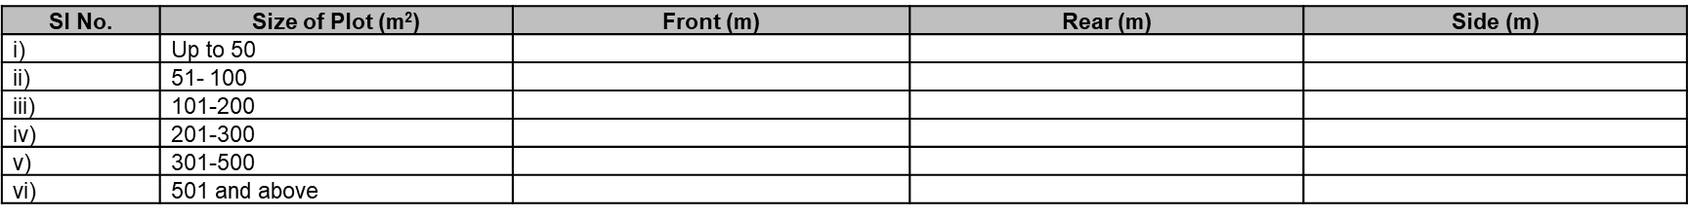
- Minimum front, rear and sides setback requirements for different building types with height 15 m and above
- Exemptions to erections prohibited from the setback area.
5.4 Floor Area Ratio (FAR), Ground Coverage and Building Height
- Regulations for different land uses/activities as illustrated in the table below:
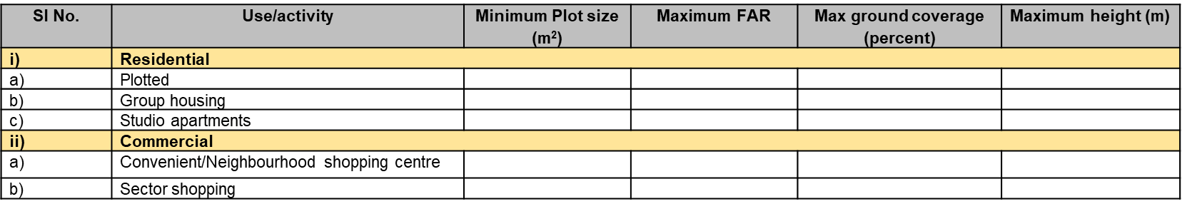
- Exemptions from covered area calculations in accordance with NBC 2016.
- Features and structures that shall be excluded from the FAR calculations and shall not exceed 20 percent of the permissible FAR of the building. Additionally, basement and podium used exclusively for parking, ramps used for multi-level car parking, and staircases which are fire exits shall be completely exempted from FAR calculation.
- The FAR applicable in an area may be increased by the Authority based on the growth of the city subject to the conditions specified.
- The exemptions to roof structures that shall not be included in the height of the building.
5.5 Subdivision and Amalgamation of Plots
- Conditions binding the subdivision and amalgamation of Plots.
- The minimum size of the subdivided plot, setbacks of the subdivided plots, land use of subdivided plot, subdivision charges, amalgamation of two or more plots etc.
5.6 Open Spaces
- Open spaces at four levels: master plan; zonal; layout Plan; and plot/building level.
- Open space requirements in a plot for the following:
  - a single high rise/special building proposed on a plot;
  - multiple high rise/special buildings proposed on a single plot including
    - When two or more independent buildings (not part of a block of buildings) are planned and
    - If multiple high rise buildings in the form of block of buildings are proposed on a plot; and
  - when a low-rise building is proposed
    - between two high rise buildings (independent or blocks) or
    - next to a high rise building or
    - next to a low rise special building.
- Exemptions to Open Spaces.
5.7 Off-street Parking Facilities
- Parking requirements for off-street parking facilities.
- Minimum area required for parking different types of vehicles as shown below:
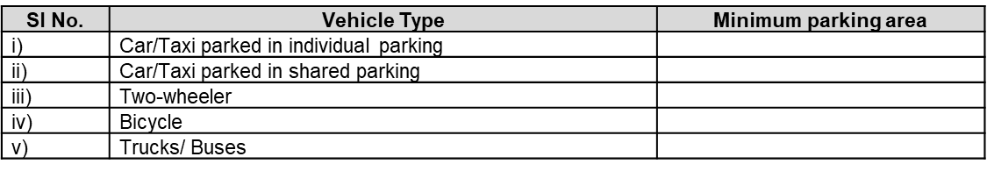
- Minimum parking area to be provided based on building use/activity in terms of Equivalent Car Space (ECS), part of which has been illustrated below:
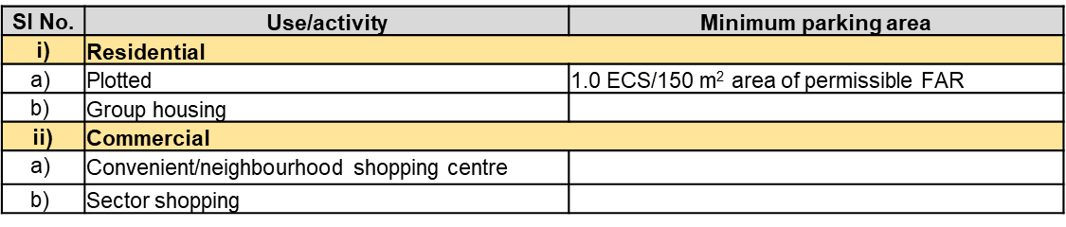
- Requirements for accessible parking.
- Other parking requirements such as access to the parking, planning of basement parking and surface parking, etc.
5.8 Urban Design Features
- Provisions on public art, public spaces, greenbelts and landscaping, uses permissible under flyovers, signages and outdoor display structures and architectural control in terms of -
- provisions related to public art and empowers the Authority to issue guidelines on public art from time to time.
- design and utility of public spaces.
- unhindered access and pedestrian movement.
- provisions related to greenbelts and landscaping.
- uses permissible below flyovers.
- provisions on architectural control that may be imposed/adopted by the Authority.
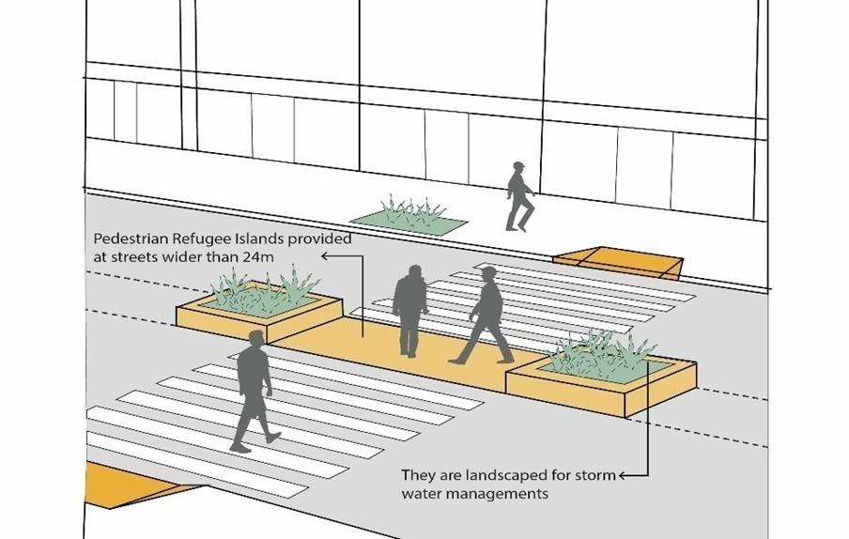

.

CHAPTER 3

ROLE OF GEOSPATIAL TECHNOLOGIES IN INFRASTRUCTURE PLANNING

- INTRODUCTION TO GEOSPATIAL TECHNOLOGIES AND TOOLS
This session aims to provide participants with an introduction to the fundamental concepts of geospatial technologies. It covers the broad spectrum of tools and techniques that enable the collection, visualization, and analysis of spatial data. The focus will be on understanding how these technologies contribute to informed decision-making in infrastructure planning, urban development, and resource management.
1.1 Overview of Geographic Information Systems (GIS) for mapping and analysis.
A Geographic Information System (GIS) is a computer system that stores, analyzes, and displays data that is linked to a specific location. GIS integrates location data with other types of information to create maps and 3D scenes that help users understand patterns, relationships, and geographic context. GIS software can store information as points, lines, areas, or raster images. For example, city data can be stored as points, road data as lines, and postal code boundaries as areas.
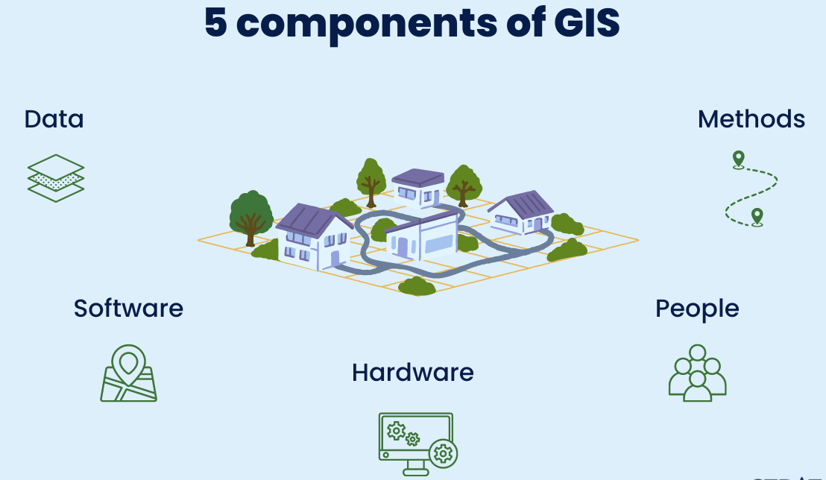
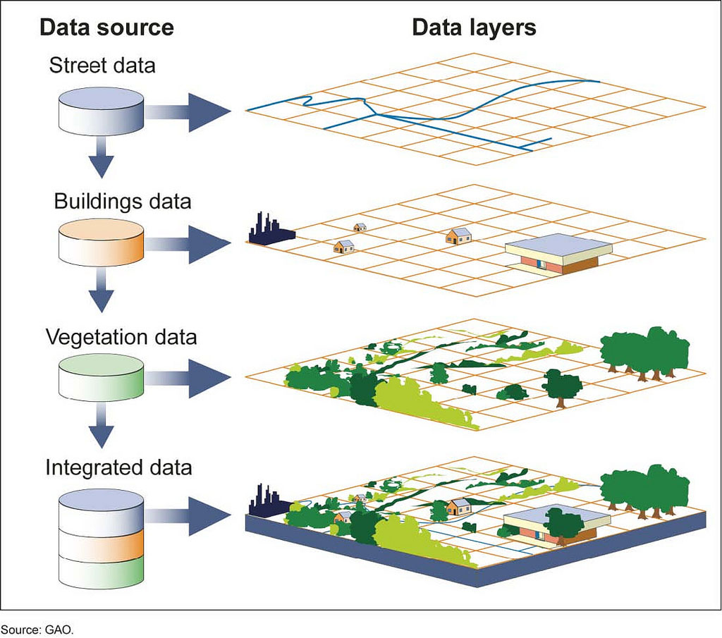
Geospatial Analysis Tools encompass a wide range of software applications, libraries, and platforms used for processing, analyzing, and visualizing geographic data. Some commonly used tools are ArcGIS, QGIS, Python Geospatial Libraries, R Spatial Packages, Google Earth Engine, Network Analysis Tools.
1.2 Role of Remote Sensing in monitoring and planning.
Remote sensing is the process of detecting and monitoring the physical characteristics of an area by measuring its reflected and emitted radiation at a distance (typically from satellite or aircraft).
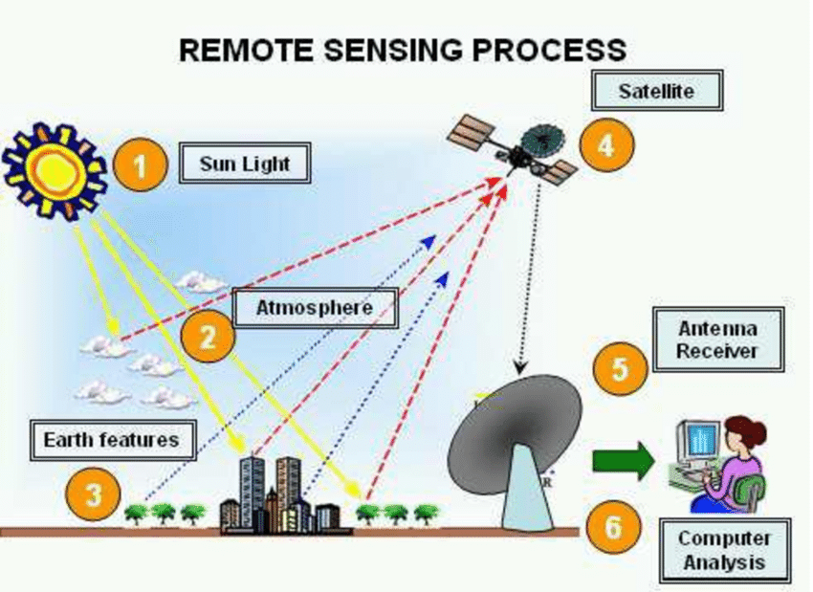
Some specific uses of remotely sensed images of the Earth include:
- Large forest fires can be mapped from space, allowing rangers to see a much larger area than from the ground.
- Tracking clouds to help predict the weather or watching erupting volcanoes, and help watching for dust storms.
- Tracking the growth of a city and changes in farmland or forests over several years or decades.
- Discovery and mapping of the rugged topography of the ocean floor (e.g., huge mountain ranges, deep canyons, and the “magnetic striping” on the ocean floor).
1.3 Basics of Global Positioning Systems (GPS).
The Global Positioning System (GPS) is a space-based radio-navigation system consisting of a constellation of satellites broadcasting navigation signals and a network of ground stations and satellite control stations used for monitoring and control.
There are five main uses of GPS:
Location — Determining a position.
Navigation — Getting from one location to another.
Tracking — Monitoring object or personal movement.
Mapping — Creating maps of the world.
Timing — Making it possible to take precise time measurements.

- APPLICATION OF GEOSPATIAL PLANNING IN RESOURCE MANAGEMENT
2.1 PM GatiShakti Mission
The PM GatiShakti Mission is a prime example of application of Geospatial technologies in Infrastructure planning. Started by the Indian government with the goal of integrating and optimizing infrastructure development across many sectors in order to minimize delays, cut expenses, and foster economic growth.
Planning and Execution: PM GatiShakti operates on a comprehensive digital platform powered by GIS-based systems that integrate geospatial data from various sectors. This facilitates precise planning by identifying optimal routes, assessing terrain, and analyzing connectivity between key industrial, logistic, and economic hubs.
Stakeholder Collaboration: The mission emphasizes coordination among multiple stakeholders, including central and state government departments, private contractors, and local authorities.
Risk Management: The mission employs satellite imagery to monitor project progress and anticipate potential bottlenecks, allowing for timely interventions. Environmental sensitivity maps ensure compliance with regulations and minimize ecological impact.
The PM GatiShakti Mission represents a paradigm shift in infrastructure planning, leveraging geospatial technologies to create a cohesive, efficient, and sustainable infrastructure network that drives economic growth and improves the quality of life for millions.
2.2 Case studies on land use planning, water resource management, and disaster management.
Case Study: Designing an Industrial Corridor from Delhi to Alwar Using PM GatiShakti Mission
Objective
The case study highlights the role of geospatial technologies in planning, designing, and implementing an industrial corridor. It emphasizes using GIS to optimize land use, connectivity, and resource allocation while aligning with the vision of PM GatiShakti.
Geospatial Parameters for Designing the Corridor
- Land Use and Land Cover Analysis (LULC): To identify suitable areas for industrial zones, avoiding ecologically sensitive zones or agricultural lands.
- Connectivity Mapping: To map existing transportation networks (roads, railways, and airways) ensures seamless integration and improved multi-modal connectivity.
- Environmental Impact Assessment (EIA): It identifies eco-sensitive areas, such as wetlands and forests, to minimize environmental disruption.
- Demographic and Socioeconomic Analysis: Analyzes population density, workforce availability, and proximity to markets, ensuring the corridor supports economic development.
- Risk and Hazard Mapping: Geospatial tools identify natural hazard-prone areas, such as flood zones, to design resilient infrastructure.
- Terrain Analysis: Using digital elevation models (DEMs) and contour mapping to optimize the alignment of the corridor, avoiding steep terrains and reducing construction costs.
Agencies such as the National Industrial Corridor Development and Implementation Trust (NICDIT), Delhi-Mumbai Industrial Corridor Development Corporation (DMICDC), and various central (MoRTH, Ministry of Railways, MoEFCC) and state government bodies (Urban Development Authorities) play a critical role in approvals and oversight
Surveyors play a pivotal role in designing the corridor by conducting field surveys for accurate geospatial data on terrain, land boundaries, and existing infrastructure, verifying satellite imagery and GIS data against on-ground realities, liaising with landowners, local officials, and community members to gather inputs and address concerns, and using drones and GNSS systems to monitor project progress and ensure adherence to designs.
2.1.3 Case Study 2: Geospatial Framework for Affordable Housing Projects
Objective: Support urban development officers in identifying suitable locations for affordable housing projects using geospatial technologies.
Planning and Execution:
GIS and remote sensing can be used to analyze factors such as land availability, proximity to public amenities, and environmental constraints. Layers of data including demographics, land use, and infrastructure are integrated to create suitability maps for housing development.
Stakeholder Collaboration:
Urban development authorities partnered with local governments, housing developers, and financial institutions. Community feedback sessions ensure the inclusion of public needs in the planning process.
Risk Management:
Challenges like data inaccuracies and conflicting land claims can be mitigated through ground surveys and legal vetting of land ownership records.
Quality and Safety:
Compliance with building codes and environmental regulations can be ensured through GIS-based impact assessments. Periodic reviews and inspections maintain high-quality construction standards.
Sustainability:
The geospatial framework can minimize urban sprawl by identifying infill development opportunities and integrating green spaces into housing projects, ensuring long-term liveability.
2.2 Importance of geospatial technologies in sustainable resource management.
Geospatial technologies have become indispensable tools in achieving sustainable resource management by enabling precise monitoring, analysis, and decision-making. Here's why they are critical:
- Enhanced Resource Efficiency: Geospatial tools like GIS and remote sensing help optimize the use of resources such as land, water, and energy.
- Real-Time Monitoring and Management: Remote sensing provides up-to-date information on changes in land cover, vegetation health, and water availability.
- Data-Driven Decision-Making: By integrating spatial data with analytical models, geospatial technologies support evidence-based decisions.
- Sustainability in Infrastructure Development: Infrastructure planners can use geospatial data to assess environmental impacts, minimize disruptions, and ensure projects align with sustainability goals.
- Climate Change Mitigation and Adaptation: Geospatial technologies support initiatives like carbon mapping, renewable energy site selection, and climate-resilient agricultural practices.
- Stakeholder Collaboration and Transparency: With standardized geospatial data, stakeholders, including government agencies, NGOs, and private entities, can collaborate effectively.
- Regulatory Compliance and Standards: Adhering to geospatial data standards ensures data quality and interoperability. Compliance with frameworks like the National Geospatial Policy helps maintain consistency and supports large-scale resource management projects.
- Disaster Preparedness and Risk Reduction: Geospatial technologies enable risk assessments and disaster preparedness plans, minimizing the loss of resources during natural calamities.

- STANDARDS OF GEOSPATIAL INFORMATION
3.1 Overview of National Geospatial Policy
The National Geospatial Policy, 2022 (the Policy) is a citizen-centric policy that seeks to strengthen the Geospatial sector to support national development, economic prosperity and a thriving information economy. The Policy builds on conducive environment generated by the “Guidelines for acquiring and producing Geospatial Data and Geospatial Data Services including Maps” dated 15.02.2021 (the Guidelines), issued by Department of Science and Technology (DST), Government of India (GoI).
Sl. | National Fundamental Geospatial Data Themes: | Nodal Ministry/Dept | Convener | Draft Standard (UC)
1. | Geodetic Reference Frame | SOI | Dr U N Mishra | Geodetic Reference Frame - Specs
2. | Orthoimagery | SOI | Shri Sandeep Shrivastava | Orthoimage - Specifications
3. | Functional Areas (Administrative  Boundaries) | SOI | Sh S V Singh | Administrative Boundaries (P Draft)
4. | Geographical Names (Toponymy) | SOI | Sh Mahesh Ravindranathan
5. | Elevation and Depth | SOI | Ms Bindu Manghat (Elevation) | Elevation - Specifications
6. | Water | DoWR
7. | Transport Networks | MorTH, MoR, MoCA
8. | Buildings and Settlements | MoHUA, MoPR
9. | Land Cover and Land Use | NRSC, FSI
10. | Physical Infrastructure | MoHUA and MoPR
11. | Land Parcels | DOLR | Sh Kunal Satyarthi (DoLR) | LADM (IS 18594)
12. | Addresses | Dept of Posts | Sh Dushyant Mudgal (Posts) | DIGIPIN
13. | Geology and Soils | GSI and NBSSLUP |  | DCS – Soils, Geology and Forestry
14. | Population Distribution | ORGI

3.2 Key standards of Geospatial Information
SI. No. | IS No. | Title
1. | IS 13393 : 2017  ISO 6709 | Standard representation of geographic point location by coordinates (First Revision)
2. | IS 16439 : 2016 | Metadata standard for geospatial information
3. | IS 16554 : 2017 | Data exchange standard for geospatial information
4. | IS 16626 : 2017  ISO 19136 : 2007 | Geographic information - Geography markup language (GML)
5. | IS 16626 (Part 2) : 2018  ISO 19136-2 : 2015 | Geographic information - Geography markup language (GML): Part 2 extended schemas and encoding rules
6. | IS 16699 : 2018  ISO 19128 : 2005 | Geographic information - Web map server interface
7. | IS 16701 : 2021  ISO 19142: 2010 | Geographic information — Web Feature Service
8. | IS 16966 : 2018  ISO 19132 : 2007 | Geographic Information — Location-Based Services — Reference Model
9. | IS 16967 : 2018  ISO 19133 : 2005 | Geographic information - Location - Based services - Tracking and navigation
10. | IS 16968 : 2018  ISO 19134 : 2007 | Geographic information - Location - Based services - Multimodal routing and navigation
11. | IS 16970 : 2018  ISO 19109 : 2015 | Geographic information - Rules for applications schema
12. | IS 17007 : 2018  ISO 19103 : 2015 | Geographic information - Conceptual schema language
13. | IS 18565 (Part 1) : 2024  ISO 19157-1 :2023 | Geographic information ï¿½ Data quality Part 1 General requirements
14. | IS 18565 (Part 2) : 2024  ISO/TS 19157-2 | Geographic Information Data Quality Part 2: XML Schema Implementation
15. | IS 18594 : 2024  ISO 19152:2012 | Geographic information ï¿½ Land Administration Domain Model (LADM)
16. | IS 18620 (Part 1) : 2024  ISO 19168-1:2020 | Geographic information ï¿½ Geospatial API for features ï¿½ Part 1: Core

3.3 Importance of data accuracy, interoperability, and metadata in geospatial systems.
Geospatial systems depend on high-quality data and seamless integration of technologies to provide actionable insights for various applications, including urban planning, infrastructure development, and disaster management. To achieve this, data accuracy, interoperability, and metadata are fundamental requirements. Here’s why they are essential:
Data accuracy is critical for geospatial systems because it directly impacts the reliability of analysis and decisions. It ensures the information used for planning and analysis reflects real-world conditions, minimizing errors. Projects like road construction or utility network planning require precise spatial data to avoid costly errors and delays. Accurate data helps allocate resources efficiently, such as identifying water-scarce areas for irrigation planning. Many geospatial projects need to adhere to specific accuracy standards set by government or international bodies to ensure uniformity and reliability.
Interoperability ensures that diverse geospatial systems, datasets, and software can work together seamlessly, which is essential in complex projects involving multiple stakeholders. Geospatial systems often require combining data from various sources like satellites, GPS, and GIS platforms. Interoperability ensures these datasets integrate seamlessly. It reduces the need for redundant data collection and speeds up project timelines.
Metadata is the descriptive information about geospatial data that ensures its usability, reliability, and transparency. It enables users to locate relevant datasets quickly by providing information about what the data represents and how it was collected. By describing data formats and structures, metadata ensures compatibility between datasets from different sources.
- Challenges and Best Practices
4.1 Key challenges in geospatial planning implementation.
4.1.1 Case study: Mapping Sewer Lines for Sustainable Urban Sanitation
Problem: India faces a critical challenge in managing its sewer systems due to rapid urbanization and outdated infrastructure. Many urban areas lack proper maps of existing sewer lines, resulting in inefficient planning, frequent blockages, and environmental contamination. These problems are exacerbated in expanding urban areas where laying new sewer lines is essential but fraught with challenges like uncoordinated construction, repeated excavation of roads, credibility of data, data reliability and accuracy, and mismanagement of resources.
Previously, infrastructure planning in India has relied heavily on surveyors conducting manual ground-level surveys. This traditional approach, while valuable, is often time-consuming, error-prone, and lacks the ability to integrate multiple layers of data. Decisions are sometimes based on fragmented or inaccurate information, leading to inefficiencies and higher project costs. The absence of advanced geospatial tools like GIS has contributed to disorganized urban development and inadequate sewer networks. Without accurate data, laying new sewer lines in expanding urban areas becomes a logistical nightmare.
Solution: GIS offers a transformative approach to address this problem. By integrating spatial data with existing sewer infrastructure, GIS can create accurate and interactive sewer line maps. Integrating Artificial Intelligence (AI) into GIS-based solutions can amplify efficiency and accuracy in addressing India’s sewer line challenges.
- Surveying Existing Infrastructure:
A survey of current sewer systems using GPS-enabled tools and drones can provide accurate geospatial data through which detailed maps that include pipe dimensions, connections, and flow directions can be developed. Machine learning models can process the data rapidly, identifying defects and anomalies that require immediate attention.
- Planning New Sewer Lines:
AI algorithms can analyze GIS layers to predict future demand for sewer infrastructure. This ensures new sewer lines are proactively planned in areas likely to experience high stress.
- Optimizing Routes and Resources:
Combining AI with GIS, advanced algorithms can calculate the most efficient routes for new sewer lines, factoring in cost, environmental impact, and construction feasibility.
- Real-Time Monitoring and Maintenance:
Post-implementation, GIS can be used to monitor sewer performance in real-time.
Artificial Intelligence (AI) is revolutionizing infrastructure planning by enabling smarter, faster, and more data-driven decisions. By leveraging AI-powered tools like machine learning, predictive analytics, and computer vision, planners can analyze vast datasets to optimize project design and execution.

CHAPTER 4

General Building Requirements
About
This chapter includes general building requirement, including those of various parts of the building. It covers distinct building parts along with all relevant spatial requirements. These building parts consist of both mandatory as well as recommendatory regulations.
Key highlights are –provisions on all parts of building, including swimming pools, helipads, meter rooms, office cabins, etc.; accessibility provisions that individual owners are encouraged to adopt; requirements for building services such as substations, switch rooms, pipe shafts, air ducts etc.
6.1 Requirements for Parts of a Building
- Clauses on the requirements of various parts of a building including plinth, rooms, roof, balcony, terrace etc.
- Plinth or any part of a building shall be so located with respect to the surrounding ground level that adequate drainage of the site is assured.
6.1.1 Plinth
- Plinth for all parts of the building (except those given at 6.1.1.3 of these regulations) with adequate drainage provisions shall meet the requirements given below.
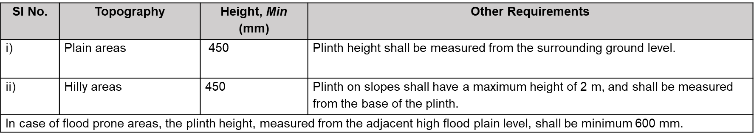
- Plinth shall not interfere with the natural flow of the water streams.
- Inner courtyard, as well as covered parking at ground level and stilt floor, shall have a minimum plinth height of 150 mm above the determining ground level.
6.1.2 Rooms
- Minimum requirements including floor area, width and room height of habitable rooms as shown in the illustrative table below and some additional minimum requirements.
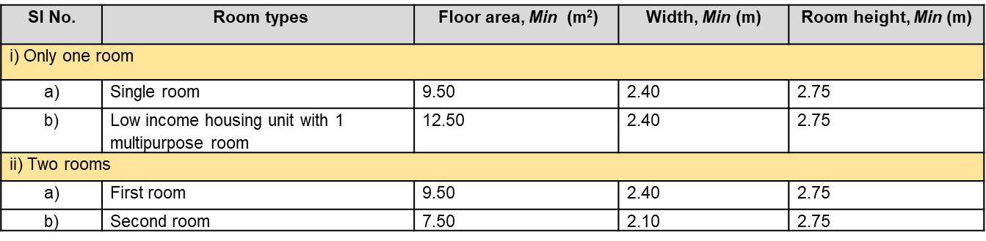
- Minimum requirements including floor area, width and room height of kitchen as shown able below as well as some additional minimum requirements.
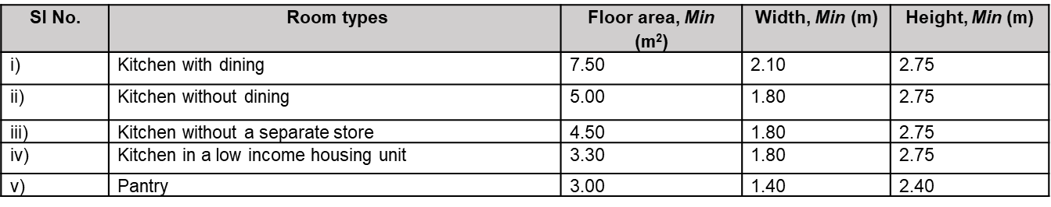
6.1.2 Rooms (Continued)
- Minimum requirements of other rooms such as shops, storeroom, prayer room, hospital wards, etc for different uses as shown in the illustrative table below and some additional minimum requirements.
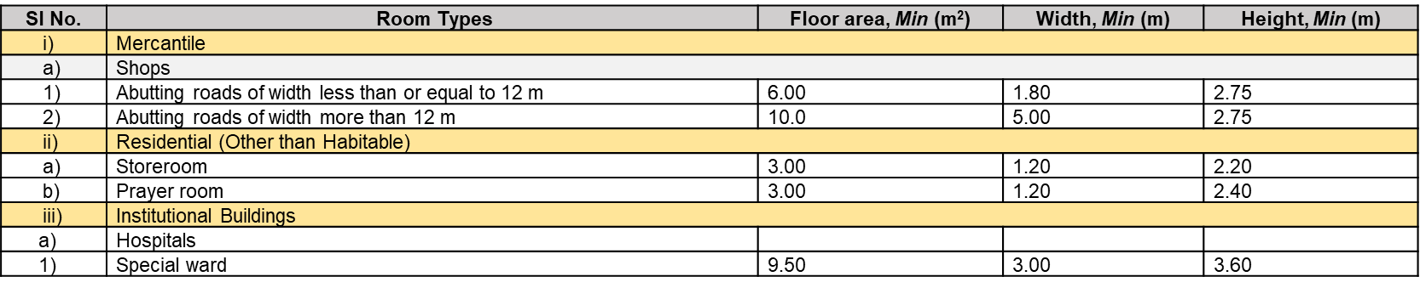
- Light and ventilation requirements for rooms including the requirements for openings in a room.
6.1.3 Bathroom and Water-closets
- Minimum Requirements for Bathroom and Water-closets including floor area, height and width, and some other requirements as shown below:
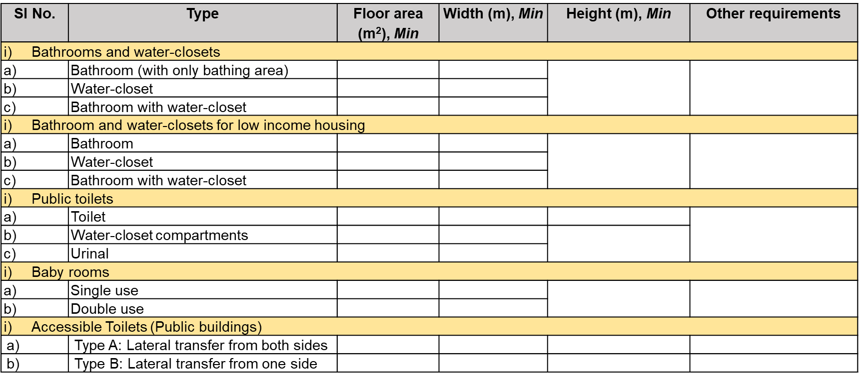
6.1.3 Bathroom and Water-closets (Continued)
- Water proofing for bathrooms and water-closets.
6.1.4. Interior Open Spaces
- Requirements for inner courtyard, outer courtyard, ventilation shaft and sunken courtyard.
- Minimum size of ventilation shaft as shown below:
6.1.5 Ledge/Loft/Tand
- Permits the provision of Ledge/Loft/Tand over the kitchen, habitable rooms, bathrooms, water-closets, and corridors within the buildings.
- Provides the minimum requirements for ledge/loft/tand.
- The maximum coverage area for Ledge/loft/Tand have been given as illustrated below:
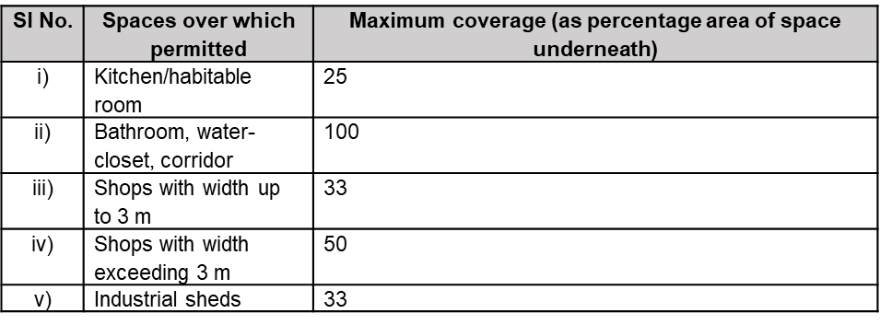
6.1.6 Mezzanine Floor
- Requirements for Mezzanine floor including the minimum area and minimum height requirements.
6.1.7 Parapet
- Requirements for Parapet wall.
6.1.8 Roof
- Requirements for roofs including the sloping gradient.
6.1.9 Terraces
- Requirements for terraces including the permissible uses.
6.1.10 Balcony
- The width of an unenclosed balcony shall be between 0.90 m to 1.50 m.
6.1.11 Porch/Portico
- Requirements for porch/portico including the minimum width.
6.1.12 Verandah
- Minimum requirements for Verandah including the minimum width
6.1.13 Chimney
- Requirements for chimneys provided atop roofs.
6.1.14 Stilt
- Requirements for stilts including minimum and maximum clear height.
6.1.15 Garage
- Requirements for garage including the location, maximum size and minimum height.
6.1.16 Basement
- Lists the uses for basements provided in buildings.
- Minimum and maximum internal height for basements and their ceiling height with respect to the surrounding ground level.
- Requirements for basements permitted beyond the building lines.
- Damp proofing, ventilation, surface drainage and the accessibility of basements.
6.1.17 Canopy
- Minimum requirements for canopy.
6.1.18 Corridors and Passageways
- Requirements for accessible corridors and passageways including the dimensions, clear height and other requirements.
6.1.19 Staircase
- Minimum clear width of staircase for different occupancies.
- General requirements for staircase.
6.1.20 Ramps for People’s Movement
- Requirements for ramps designed for the movement of people.
- Required dimensions and components of ramps as per the level difference as illustrated below:
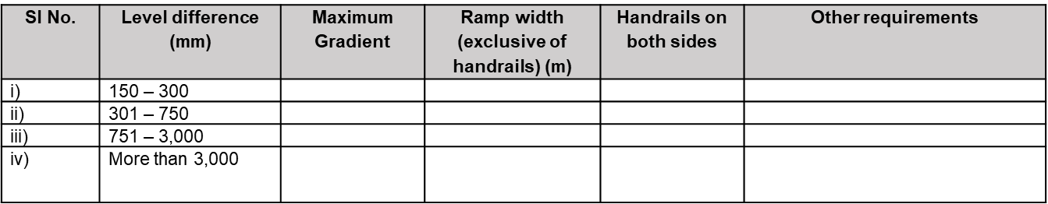
- Discourages provision of internal ramps; however, it specifies the requirements that should be complied with if they really have to be provided.
6.1.21 Lifts
- Requirements for lifts including the type of lift and its usage as illustrated below:
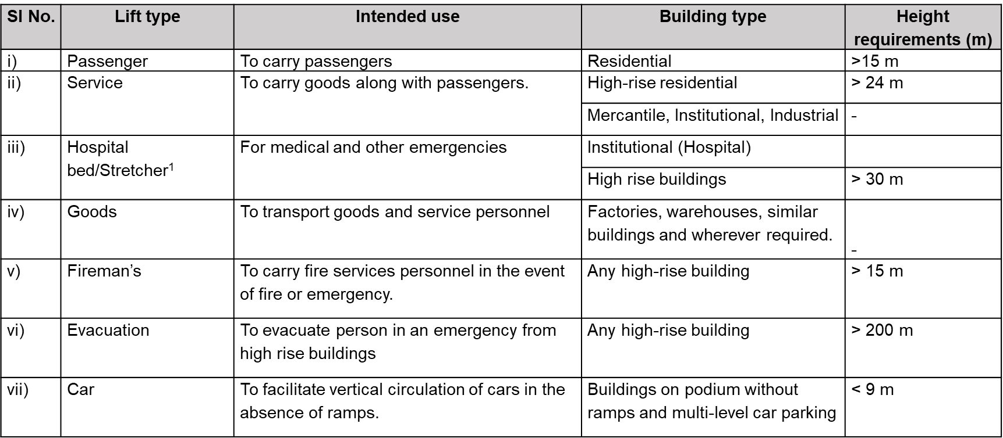
- Requirements for accessible lifts and other relevant requirements.
6.1.22 Escalators and Moving Walks
- Minimum requirements for escalators and moving walks including the dimensions, clear head room and other requirements.
6.1.23 Vertical and Inclined Lifting Platforms
- Minimum requirements for Vertical and Inclined Lifting Platforms when provided to enhance accessibility for PwD in an existing building.
6.1.24 Service Floors
- Minimum requirements for service floors in a building.
6.1.25 Office Cabins
- Minimum requirements for office cabins.
6.1.26 Boundary Walls
- Requirements for boundary walls including maximum height requirements.
6.1.27 Open Wells
- Requirements for open wells.
6.1.28 Sceptic Tanks
- Minimum requirements for sceptic tanks including the dimensions, distance from drinking water source and nearest building, and ventilation requirements.
- Specifies the seepage pit requirements for sceptic tanks.
- Dispersion trench requirements for sceptic tanks.
6.1.29 Refuse Chutes
- Minimum requirements for refuse chutes including the following:
  - Dimensions
  - Requirements for refuse collection chamber
  - Location from fire exit
  - Other requirements including color and texture to allow easy identification.
6.1.30 Office cum Letter Box Room
- Minimum requirements for office cum letter box room.
- An office cum letter box room shall be provided for all multi-storeyed apartments. This room may be used as office space for housing societies.
6.1.31 Meter Rooms
- Minimum requirements for meter rooms.
6.1.32 Water Tanks
- Minimum requirements for water tanks.
6.1.33 Swimming Pools
- Minimum requirements for swimming pools including the following:
  - Swimming pool user load
  - Design
  - Dimensions
  - Floor slopes
  - Transition point
  - Pool walls
  - Water depth
  - Walkways and deck areas
  - Starting platforms
6.1.34 Helipad
- Minimum requirements for helipads.
6.1.35 Substation and Switch Rooms
- Minimum requirements for Substation and Switch Rooms including the requirements for location of substation, oil-filled installation, dry-type installation, height of substation rooms, etc.
6.1.36 Switch Rooms other than in Sub Stations
- Minimum requirements for Switch Rooms other than in Sub Stations.
6.1.37 Emergency Power Backup System (Standby Supply)
- Minimum requirements for Emergency Power Backup System (Standby Supply).
6.1.39 Equipment Room for Central Air Conditioning Plant
- Minimum requirements for Equipment Room for Central Air Conditioning Plant including
  - Location,
  - Dimensions, and
  - Requirements for mechanical ventilation.
6.1.40 Equipment Room for Air Handling Units (AHU) and Package Units
- Minimum requirements for Equipment Room for Air Handling Units (AHU) and Package Units.
6.1.41 Pipe Shafts
- Minimum requirements for pipe shafts including location and other requirements.
6.1.42 Supply and Return Air Ducts
- Requirements for supply and return air ducts.
6.1.44 Telecommunication spaces
- The general requirements as per Part 8 ‘Building Services’ Section 6 ‘Information and Communication Enabled Installations’ of NBC 2016, as amended from time to time.
6.1.46 NBC 2016 to be followed for operation and maintenance of hard and soft services including security services.

CHAPTER 5

Requirements for Special Developments and Buildings
About
This chapter includes requirements for special development and buildings like heritage conservation, group housing, hostels, underground buildings, etc. It provides an overview of development control regulations and other special considerations for these developments in 22 key sections.
Key highlights - The development control regulations for different land uses in special areas have been included in this chapter. The state/local governments have the flexibility to modify the regulations as per local needs such as population densities, parking, traffic load, services etc
10.1 Heritage conservation
Heritage sites/buildings shall be identified in the Master plan demarcating the prohibited and regulated zones for all heritage sites/buildings These regulations shall be applicable in addition to any other regulations notified by the Heritage Committee and national legislation on heritage conservation, as amended from time to time.
- The heritage buildings/site include buildings, artifacts, structures, streets, areas and precincts that have a historic, architectural, aesthetic, cultural or environmental values, sacred groves, hillocks, water bodies, etc
- Prohibition against land use changes or sub-division into smaller plots of these sites/ buildings
- Heritage site/buildings that fall within the non commercial land uses zones could be permitted for commercial uses subject to special conditions provided the owner(s) agree to repair and maintain the building as stipulated by the Authority, preserving its heritage state
- The repair and maintenance shall be the owner’s responsibility, consistent with heritage site and street facades, as per guidelines laid out by the heritage conservation committee
- High rise buildings shall not be approved for construction within the heritage site zone
- Visitor facilities like car parking shall be provided within the site or in nearby facilities if the heritage site/buildings are being used for tourism purposes.
- The heritage sites/buildings shall be universally accessible.
- Consistency of building materials and colour shall be maintained in the heritage site and street facades.
10.2 Group Housing
Development control regulations, forms of group housing, number of permitted DU’s per hectare, minimum plot area, and FAR consumption/calculations etc for group housing as follows
- Group housing may be in form of low rise housing clusters and/or high-rise multi-storeyed apartments.
- Development control regulations stated in terms of –
- Minimum plot size, no of dwelling units (DU), clustering of DUs, specifications for group toilets, etc.
- 20 percent of dwelling units of the total proposed/permissible DUs in a group housing scheme shall be reserved for LIG housing. In case the developer does not want to build EWS and LIG housing units, they shall pay shelter fees to the Authority
- Prohibition against mortgaging LIG housing plots to the Authority or any financial institutions. Exemption from constructing LIG Housing units can be adhered by paying for shelter fees to the Authority.
- Development control regulations for EWS stated in terms of –
- Minimum plot size, number of DUs FAR and ground coverage permitted
- Regulations for EWS cluster on larger plots beyond 25 sqm shall be according to the goods practice IS 8888 ‘Guide for requirements of low income housing: Part 1 Urban area’.
10.3 Low Income Housing and Cluster Planning for Economically Weaker Sections (EWS) Housing
Development control regulations for LIG and EWS housing are as follows –
- In case of an exclusive project or scheme for Low Income Group housing, the provisions in accordance with good practice IS 8888 ‘Requirements of low income housing for urban areas ― Guide’, as amended from time to time, may be followed.
- In case of an exclusive project or scheme for EWS in cluster housing pattern, the provisions in accordance with good practice IS 13727 : 2020 ‘Requirements of cluster planning for housing — Guide’, as amended from time to time, may be followed.
- The minimum permissible plot size of EWS cluster pattern shall be 15 m2. 100 percent ground coverage and FAR of 2 shall be applicable up to plot size of 25 m2.
- In ground and one storeyed structures, not more than 20 houses shall be grouped in a cluster.
- DUs with plinth areas up to 20 m2 shall have scope for adding a habitable room.
- Cluster housing may have group toilets with one water-closet, one bath and a washing place, shared between three families. These shall not be community toilets.
10.4 Development control for coastal regions
Regulations to control the development within Coastal regions. Activities permitted within Coastal regulation zones as demarcated in the Master Plan/ Coastal Zone Management Plan (CZMP), shall be as per the ‘Coastal Regulation Zone (CRZ) Notification 2019’ issued by Ministry of Environment, Forest and Climate Change (MoEFCC), as amended from time to time.
- The prohibited activities in the Coastal Regulation Zone are:
  - Setting up of new industries and expansion of existing industries
  - Storage, disposal, manufacture or handling of oil and hazardous substances.
  - Setting up new fish processing units
  - Land reclamation, bunding or disturbing the natural course of seawater
  - Discharge of untreated waste and effluents from industries or settlements.
  - Dumping of Solid wastes for land filling
  - High eroded stretches due to port or harbour projects
  - Mining
  - Dressing or altering of active sand dunes; disposal of plastic into the coastal waters; and withdrawal of ground water.
- Transfer of TDR shall not be permitted in CRZ.
- Measures to be undertaken to safeguard aquatic and marine life from disposal of plastic materials.
10.6 Development control for hilly regions
- Regulations for any land area above 600 m in height from mean sea level, or any land area with average slope of 30°, considering the sensitive and fragile ecosystem. Divided into 3 parts: Land use, Development and Building Controls, Safety requirements and preservation of local heritage and hilly areas.
10.5.1 Land use – Conformity with the proposed land use distribution for hill area planning. Percentage of land use distribution in the hilly areas shall be as specified in Table 65.
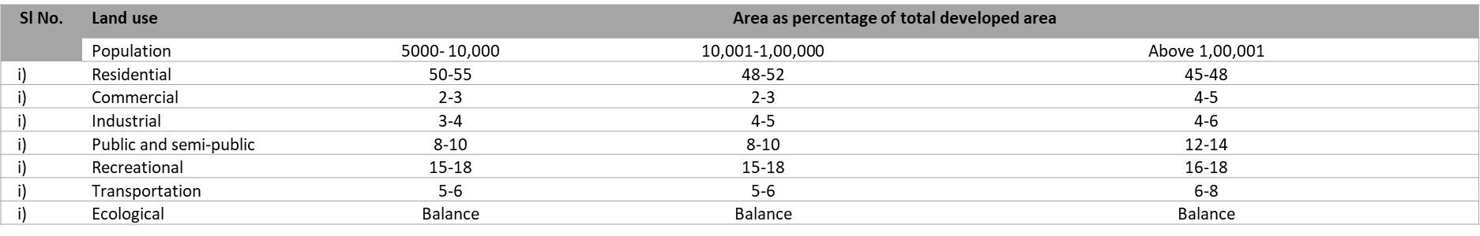
10.4.2 Development and Building Controls – Regulations for means of access, setbacks, FAR and ground coverage, building heights, parking facilities, safety requirements.
10.4.2.1 Means of Access - shall be defined as per the minimum ROW required for various types of developments. The minimum ROW requirements have been specified in Table 66
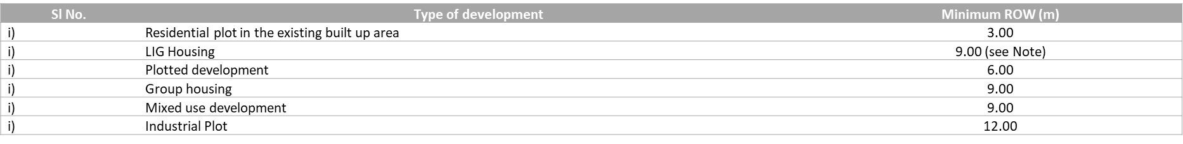
10.5.2.2 Setbacks – Conformity with minimum setbacks for residential and other plots in the hilly areas as specified in Table 67 and 68
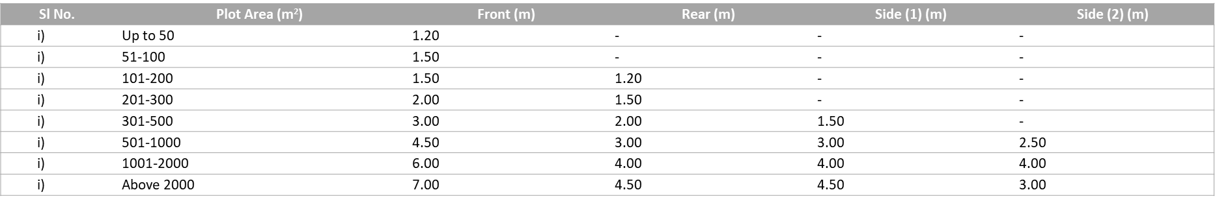
The regulations on setbacks highlight the detailed criteria's for laying of the setbacks depending on the type and location of the land parcels.
10.5.2.3 FAR and Ground Coverage –Regulations highlighting FAR and ground coverage for different land uses have been specified in the Table 69.
- Applicability, relaxations and exemptions of FAR and Ground coverage have also been included in terms of steep slope, hill cut, clearance between boundary and building wall, etc.
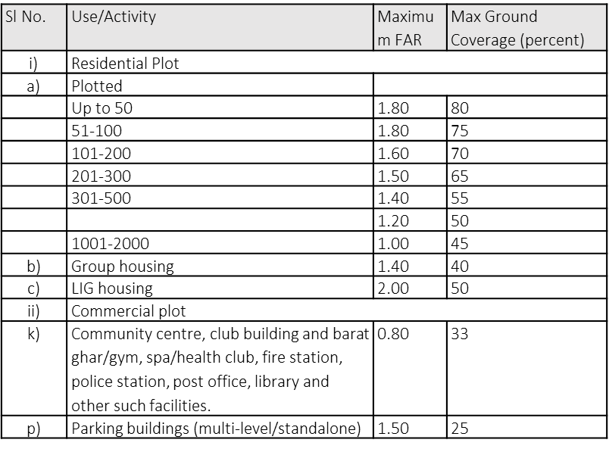
10.5.3.4 Building Height –maximum building heights in the hilly areas have been specified in Table 70
- Regulations are subject to conformity with the view obstructions to sites like lakes, snow bound hills, etc., sloping roofs, development around national highways and state highways roads etc.
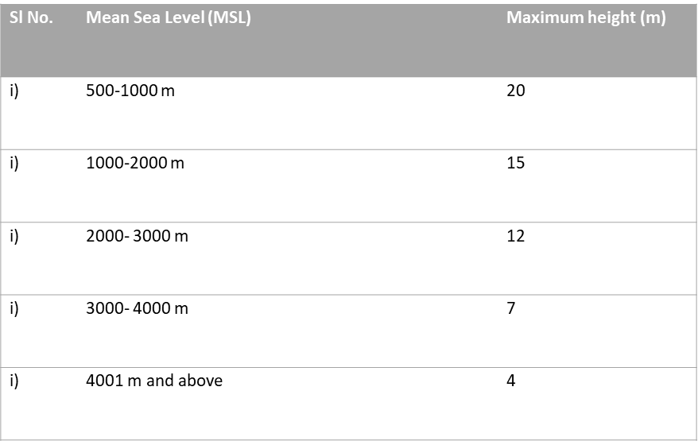
10.5.5 Community Facilities – Regulations discussing the size, requirements, min plot area and detailed norms for setting up community facilities and services like type – educational, health and other facilities and services in Table 71.
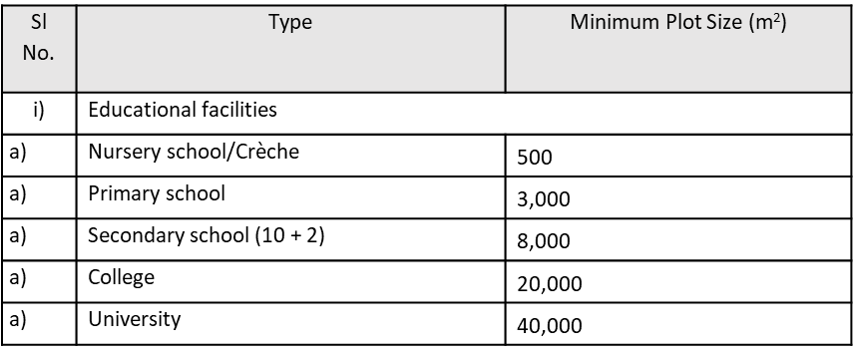
10.5.3.6 Parking Facilities – The minimum parking spaces for building use like residential, commercial, industrial, and all other activities have been specified in Table 72.
Parking requirements for multi-storey or public parking spaces in hilly tourist urban areas have also been included in the regulations under parking facilities.
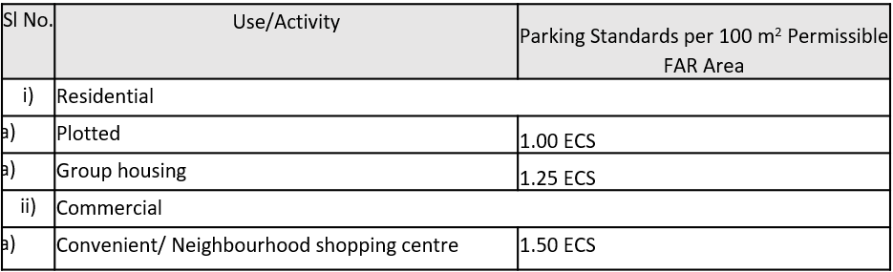
10.5.4 Safety Requirements – Conformity with detailed scheme and design for development of individual plot including earth work calculation (cutting and filling) and slope stability analysis calculation, remedial measures for slope protection, etc by the committee shall be required.
10.5.5 Conformity with local heritage and hill architecture in hilly areas shall be necessary for the preservation and must be included in the designs of facades, sloping roof, windows, doors.
10.6 Integrated township projects
- Area for integrated township projects shall be earmarked in the master and/or zonal plans
- Minimum size of any integrated township project shall be 10 ha, minimum 24 m wide RoW for approach road
- Proposed land use distribution in the township projects shall be as specified in Table 73.
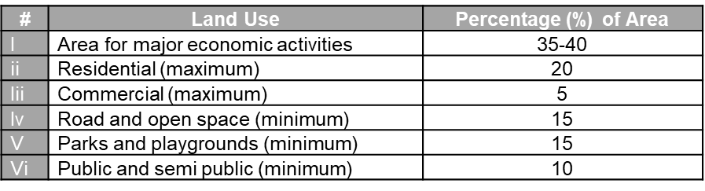
- Other requirements are specified in terms of –
  - Development of public facilities by Authority such as police station, post office, etc. within township limit
  - Provisions for Accessibility as per Part 3 ‘Development Control Rules and General Building Requirements’ of NBC, 2016.
  - Conformity to provisions as suggested in Chapter 11 ‘SWM’ and Chapter 12 ‘Sustainability’. STP to be provided inside the integrated township.
  - Conformity to provisions of Chapter 5 “Development and Building Controls” for ground coverage, FAR, setbacks, open spaces and parking requirements.
10.7 Multiplex and cinemas
- Development controls as per Table 74 –
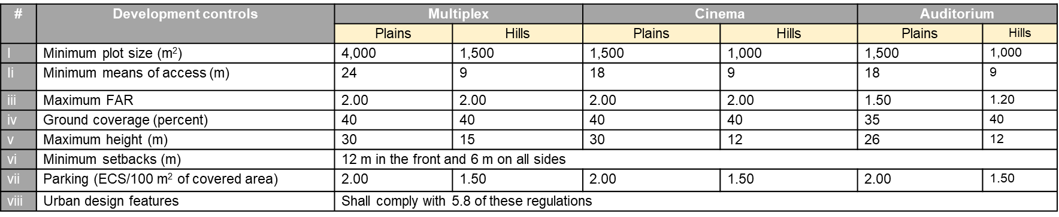
- Other requirements in terms of -
  - Permissible uses and bundling of activities, location criteria, Entry/ exit gates
  - Toilets, baby feeding rooms and accessible toilets
  - Seating capacities and number of auditoriums
  - Accessibility features in compliance with the provisions of Part 3 ‘Development Control Rules and General Building Requirements’ of NBC 2016.
  - Conformity to chapter 12 ‘Sustainability’ and chapter 6 ‘General Building Requirements’ of these regulations, IS 4878, IS 2526 and concerned Cinematographic Acts/rules.
- Conversion of existing cinema hall to multiplex shall be allowed as per the provisions of concerned state policies and these regulations
10.8 Amusement park
Regulations required to develop an Amusement Park along with details of primary and ancillary facilities, landscaping details, parking facilities and universal accessibility provisions.
- The primary and ancillary facilities included in a amusement park are giant wheel, roller coaster, merry-go-round or similar rides both indoor and outdoor, oceanic-park, swimming pool, administrative offices, exhibition halls, open air theatre etc
- Development controls as per Table 75 –
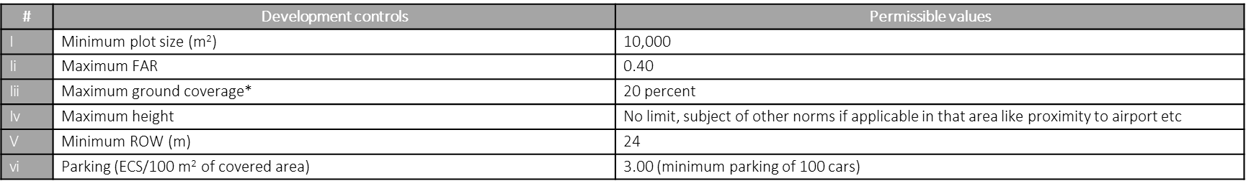
- Other requirements are specified in terms of –
  - Conformity with Chapter 6 “General Building Requirements” for sanitary facilities and compliance with Part 3 ‘Development Control Rules and General Building Requirements’ of NBC 2016 for drinking water requirements, reception counters, ancillary facility provision, and physical infrastructure like plumbing and waste water services
  - Parking facilities provision
  - Power back up systems
  - Universal accessibility provisions
10.9 Healthcare facilities
- Regulations functional requirements and distribution of areas for different type of healthcare facilities as per Table 76 and 77 .
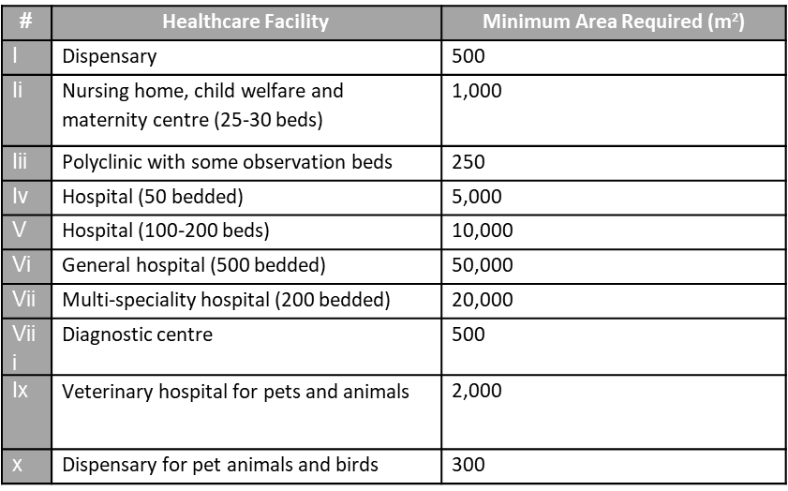
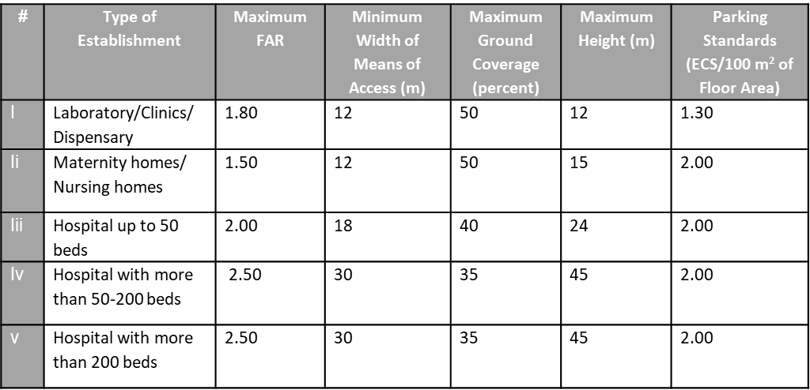
- Functional requirements and locations to adhere to the regulations proposed in the Chapter 6 – General Building Requirements.
- Conformity to Sustainability measures as per Chapter 12 for installation of rainwater harvesting, ground water recharge, energy conservation etc and ‘Solid Waste Management’ and ‘Bio Medical Waste Regulations 2016 as outlined in Chapter 11.
- Specifications for building healthcare facilities as per Compendium of Norms for designing of Hospitals and Medical Institutions, Central Public Works Department (CPWD), MoHUA.
10.10 Educational facilities
- Land requirements, permissible FAR, required ancillary facilities and detailed development control regulations for educational institutions as per Table 78 –
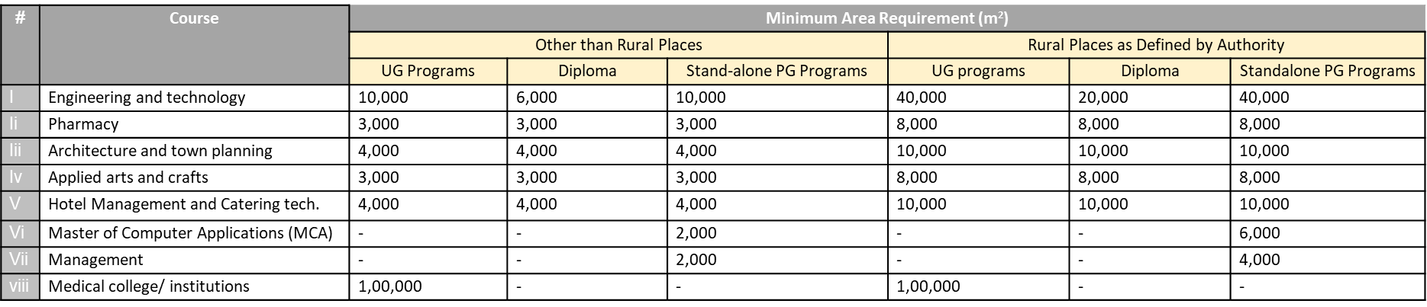
- 25% of the allowable FAR shall be utilized for hostel/staff residential facilities in all educational/training institutes.
- Land requirements for all the ancillary facilities like administrative area, amenities area, circulation area etc shall be as per AICTE guidelines.
- Clause 10.9.5 states the minimum plot size required for higher secondary schools in plain areas, hilly areas and preschools.
- Clause 10.9.6 states capacities required to establish a coaching centre, minimum plot area required, space per student, means of access and the permitted land use zones.
10.11 Liquified petroleum gas godown
This section states the land requirements, permissibility for development and ancillary spaces requirements around LPG Filling Stations
- Development controls for Technical Institutions as per Table 79 –
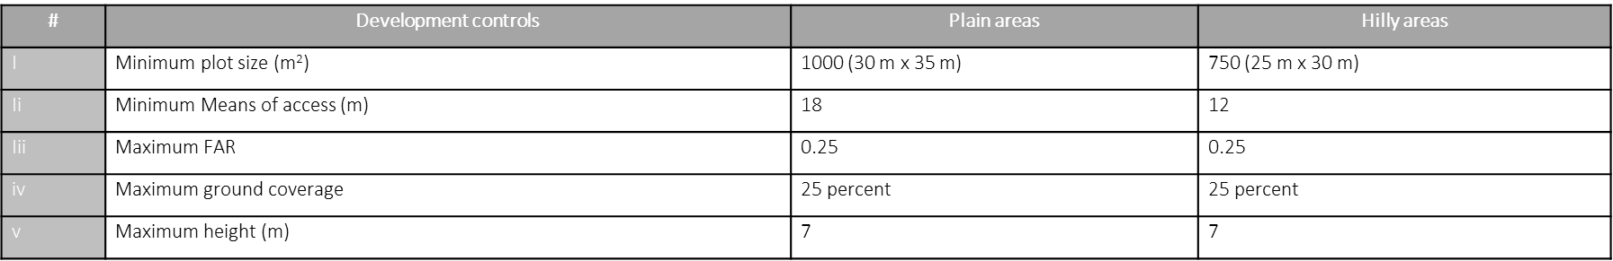
- Prohibition from setting up LPG Godowns in a residential area; permissibility as per Master Plan.
- Chapter 4 ‘Land Development’ shall be considered for site specifications regarding setting up of the Godowns.
- Single storey structure for godowns to be considered.
- Clause 10.7.7 states the detailed building and material requirements to be considered for the construction of the LPG Godowns.
- Other provisions as per the requirement mentioned in the Gas cylinder rules and the Explosives Act, as amended from time to time.
10.12 Petrol/diesel/CNG filling stations
- Development controls, land requirements, means of access and required ancillary services around Petrol/Diesel/CNG Filling stations.
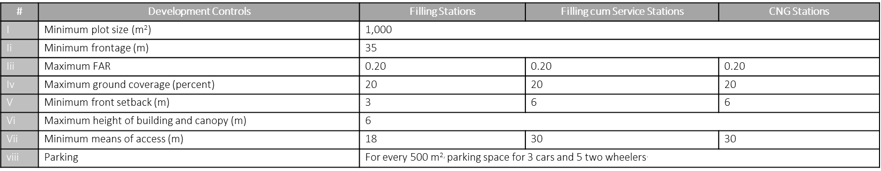
- Prohibition to set up a filling station in 12m proximity from schools, hospital and assembly building.
- Clause 10.11.1 states the minimum distance required as a means of access for the road intersections at the filling station
- Provision for ancillary facilities like storage, office, public conveniences, kiosks, drinking water, public toilets with water-closet (WC) separately for men and women etc.
- Conformity with provisions of Chapter 6 ‘General Building Requirements’ of these regulations and relevant sections of Part 9 ‘Plumbing Services’ of NBC 2016.
- Conformity with ‘Petroleum Rules 1976’ under the ‘Petroleum Act 1934’ and the norms as prescribed in IRC 012 ‘Guidelines for Access, Location and Layout of Roadside Fuel Stations and Service Stations’ to be adhered during the setting up of a Petrol/Diesel/CNG Filling Stations
10.13 Retirement homes
Regulations, specification for the site, various residential options and other facilities for the development of Retirement homes.
- Detail specification of the site requirement like land chosen not to be in a crowded/congested locality or in a secluded/isolated area, well connected to public transport, good accessibility to local facilities, health services, markets, shops etc.
- Development control regulations and community facilities for retirement homes as per table 81 and table 82-
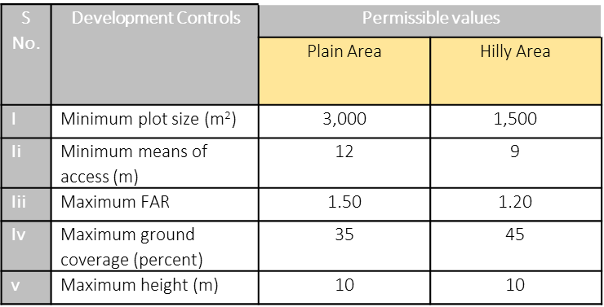
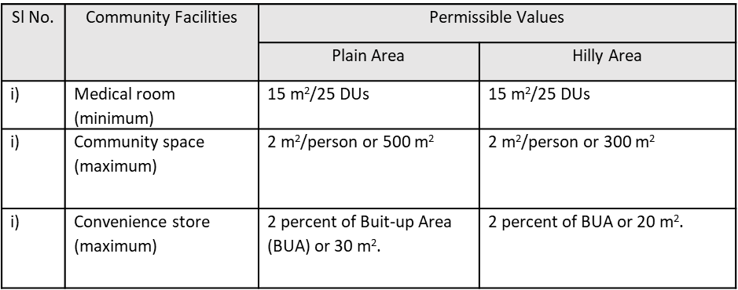
- Other requirements such as attendants/staff, lifts in more than one storey building and assistance for the people using wheelchairs, accessibility features, lighting, ventilations in accordance with specific provisions for Persons with Disability (PwDs) as per Part 3 ‘Development Control Rules And General Building Requirements’ of NBC 2016 and MoHUA guidelines for development and regulation of retirement homes, as amended from time to time.
- Specific requirements for dormitories in terms of;
  - maximum number of residents to be admitted,
  - minimum bedroom space and living space including bedroom space and ancillary areas like kitchen, dining hall, recreation room, medical room etc.
  - provision of windows according to better light and free flow of air
  - Provision of emergency light, alarm bells at the bedside
  - requirement and location of toilet in the dormitory
  - Isolation ward etc.
10.14 Hostels
- Detail development control regulations for hostel as per table 83.
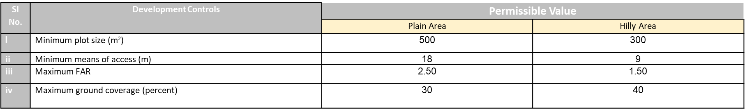
- Minimum area requirements for different rooms in a hostel as per table 84
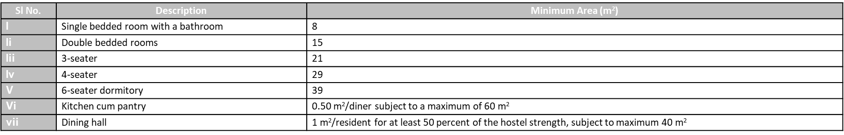
Note — For a 100 bedded hostel, provision of 30 children may be made in day care centre.
10.15: Night shelters
- Various aspects and requirements permitted for the development of night shelters in any plot.
- Development control regulations as per table 85
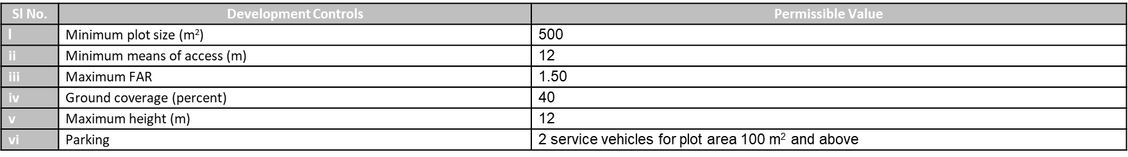
- Permissibility of night shelters in the following areas
  - Integrated freight complex or wholesale markets
  - Industrial zones and
  - Railway terminal or integrated bus terminals
- Requirement of adequate community toilets & arrangement of disposal of waste in accordance with provisions of Chapter 11 ‘Solid Waste Management’ of these regulations
- Requirement of fire safety to be complied with provision of chapter 7 ‘Fire and Life safety’ of these regulations and Part 4 ‘Fire and Life Safety’ of NBC 2016
- Minimum living space available to each person shall be 4 m2 excluding kitchen, toilet and other common spaces. Provision of common facilities such as common recreation space, cooking space with gas connection, child care facilities etc.
10.16 Prison
- Regulations, specification and requirements for the development of prisons as per table 86, Minimum requirements for a prison cell to be specified as per table 87.
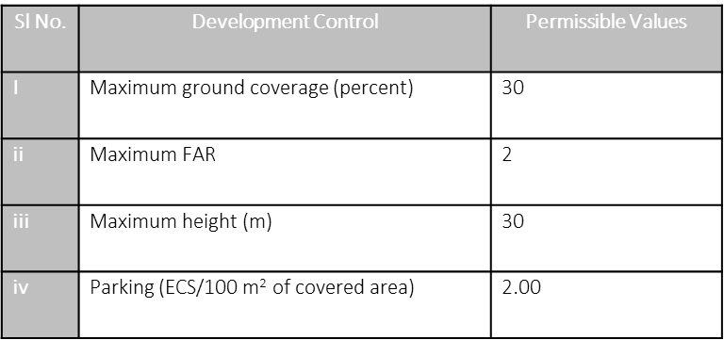
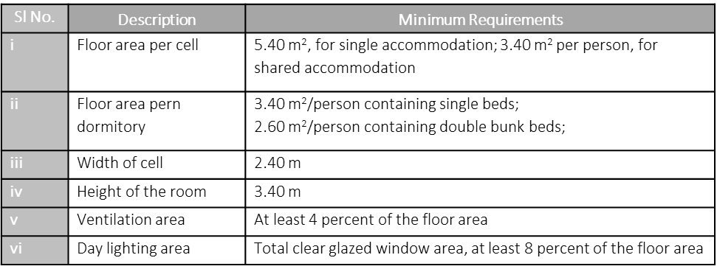
- General requirement which includes maximum FAR to be utilized, area, separate provisions for women prisoners entry and exit points of the prisons etc.
- Other controls to be followed for a prison as follows;
  - Facilitate gate operations
  - Accommodation specification for prisoners
  - Design control specification for dormitories including ratio of WCs in the prison complex
  - Standardization for toilet, washing places, kitchen etc.
  - Provision of dinning space, hospital facility, recreational facilities.
  - Arrangement for disposal of waste; Adequate measure for installation of rainwater harvesting, ground water recharge, zero discharge etc.
  - Compliance of structure with provision of Part 4 ‘Fire and Life Safety’ of NBC 2016
  - Compliance of other building requirement with Prison Manual, 2016, MoHUA as amended from time to time.

10.17 Bus terminals
Regulations, primary and structural infrastructural requirement for the bus terminals as per table 88.
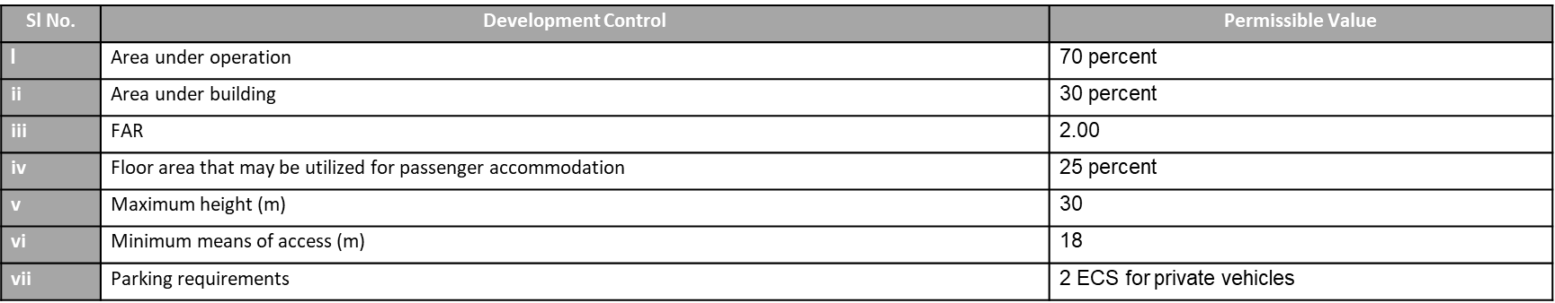
- Requirements for primary infrastructural elements categorised intro three areas, as follows
  - Passenger Areas
  - Areas for terminal staff
  - Areas for bus staff
The detail under all the categories as per table 89.
- Specifications on supporting infrastructure as per table 90 listed as various components such as, feeder infrastructure, seating, hardscape and landscaping etc.
- Fire prevention and fire safety measures to be complied as per Fire Service Act and Part 4 ‘Fire and Life Safety’ of NBC 2016
- Other requirements for bus terminal as follows;
  - Location to be in core city areas
  - Ingress and egress points
  - Provision of integration of cycle/auto rickshaws, buses, private vehicles in the facility design
  - Provision of signage
  - Universal accessibility for PwDs
  - Arrangement for disposal of waste
  - Fire requirement to be complies with provisions of Part 4 ‘Fire and Life Safety’ of NBC 2016
  - Sustainable measures such as installation of rainwater harvesting, ground water recharge, zero discharge of sewerage etc. to be in accordance with provision of Chapter 12 ‘Sustainability’ of these guidelines.
10.18 Farm house
- Regulations for the farm house corresponding to zoning, minimum plot size, permissible ground coverage, maximum height, setbacks, permissible activities, etc.
10.19 Metro station buildings and trainways
- Requirements for fire and life safety that shall be in accordance with Part 4 ‘Fire and Life Safety’ of NBC 2016.
- Provision of adequate ventilation system for underground metro stations in accordance with Part 8/Section 3 ‘Building Services, Air Conditioning, Heating and Mechanical Ventilation’ of NBC 2016.
10.20 Electric vehicle (EV) charging stations
- Provision of adequate charging infrastructure in parking spaces of various types of complexes and buildings.
- Minimum requirements for Public charging stations (PCS) in accordance to ‘Charging Infrastructure for Electric Vehicles (EV)-the Revised Consolidated Guidelines and Standards, 2022’ by Ministry of power (MoP).
- Specification for charging stations in various types of buildings
- Provision and specification of installation of charging points
- Specification of a parking space considering the proximity of the vehicle to the connection point
- Requirement of captive charging stations for internal use of an organisation/company’s own fleet
NOTE: The norms for performance and safety requirements for EV charging infrastructure as specified in ‘Charging Infrastructure for Electric Vehicles (EV) – the Revised Consolidated Guidelines and Standards, 2022, Ministry of Power’, ‘The Central Electricity Authority (Technical Standards for the Connectivity of Distributed Generation Resources) (Amendment) Regulations, 2019’ and ‘The Central Electricity Authority (Measures relating to Safety and Electric Supply) (Amendment) Regulations, 2019’ shall be complied with, as amended from time to time.
10.21 Wind electricity generator
The permit and development of WEG shall be regulated as per the State specific policies for wind energy generation
10.22 Telecommunication towers
Permissible location, type of structure on which the installation of telecommunication towers are permitted.
- Building requirements on which the telecommunication tower is to be installed followed with control regulations for the same.
- Restricted building types and the required documents to be submitted while applying for the request of installing the telecommunication towers.
- Type of structures for the installation of telecommunication towers.
10.23 Transit Oriented Development (TOD)
- Design principles and specific regulations to create TOD. Implementation and regulation of TOD as per Annex Z
Annex Z
- Areas to be avoided for the development of TOD
- Preparation of Influence Zone Plans (IZP) according to the site characteristics and context of each transit station
- Development controls to be followed in the influence zones.
- Requirement to be followed for the development Transit Stations
- Provision of parking spaces depending upon the nature and requirement of different types of vehicles as per table 91
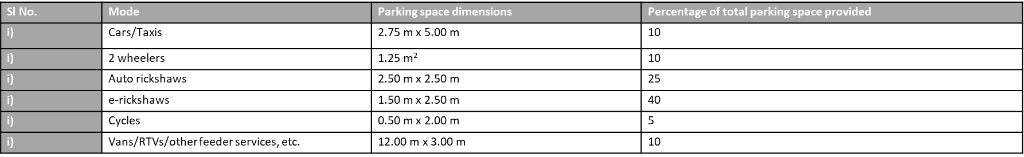
A section on TOD has been included in the chapter which can be adopted by the Authorities that either have or proposed MRTS/metro-rail/Bus Rapid Transit System (BRTS) corridors in their development plans. TOD may be suitable for all newly planned cities. However, it can also be provided in existing cities where new expansion/development are taken up backed up with effective mass rapid transport system and new nodes.
10.24 Slaughter Houses
- 10.24.1 These shall comply with the Prevention of Cruelty to Animals (Slaughter House) Rules, 2001 as amended from time to time.
10.25 Emergency Shelters
Cyclone shelters shall be designed and constructed in accordance with IS 17164 ‘Design and construction of cyclone shelters — Guidelines’. The same guidelines may also be used suitably for other emergency shelters.
10.26 Data/Incubation Centres
For planning, design and construction of Data/Incubation Centre, the ‘Guidelines for Setting Up of Atal Incubation Centres (AICs)’ issued by Government of India may be referred.

CHAPTER 6

Piped Drinking Water Management System
as per IS 17482
INTRODUCTION
This chapter focuses on understanding the broad framework of the management system of a Piped Drinking Water Utility Service.
STANDARDS REFERRED
IS 17482 : 2020 Requirements for Piped Drinking Water Supply Services
Water Facts and Figures
To start with, a global context is important to be understood. Globally, only 2.5% of water is freshwater, and a mere 0.3% is accessible in rivers and lakes. The rest is locked in ice or underground aquifers. These statistics, from the UNEP, highlight the critical need for effective management of drinking water.
India is a water-stressed country. Despite receiving 4000 BCM of precipitation annually, only 1869 BCM is available for use, and even less is utilizable. Per capita water availability has declined drastically—from 5178 m³ in 1951 to a projected 1228 m³ by 2051, which is below water scarcity thresholds.
Unfortunately, India is ranking 120th of 122 countries in the Water Quality Index. However, initiatives like the Jal Jeevan Mission are driving change.
Challenges for Water Utilities Management
Drinking water management in India faces several critical challenges. 2 most important being, lack of incentives to promote competitiveness and cooperation between utilities and poor service quality, such as low metering coverage, high non-revenue water (i.e. water that is produced and supplied but is lost or unaccounted for before it reaches the customer), and the absence of a Management Information System (MIS).
Why there is a requirement of Standards?
The lack of comprehensive standards has created operational and managerial gaps. There were no uniform guidelines for procurement processes of raw water, water treatment methods, or distribution practices, and water quality requirements remain inconsistent. To address these challenges, it is essential to establish a standardized framework that defines the roles and responsibilities of drinking water supply managers, minimizes costs, enhances reliability, and ensures consistent water quality. A standardized approach is critical to bridging these gaps and achieving efficient and sustainable drinking water management.
Brief About Standards on Drinking Water Utility
BIS has developed two key standards:
- IS 17482:2020 – Drinking Water Supply Management System — Requirements for Piped Drinking Water Supply Service
It sets out the requirements for water utilities service providers. The standard includes the expectations from the organization involved in raw water procurement, treatment, and distribution, to maintaining the quality of the water and ensuring that management takes responsibility for meeting these standards.
The standard emphasizes that the utilities should cater to the needs of individuals, communities, or organizations as per the specifications laid out by responsible authorities, working together with other stakeholders. It applies to any organization that provides water services be it government, private entities or any other non-governmental organizations.
- IS 18182:2023 – Management of Assets of Drinking Water Supply System — Guidelines
This standard ‘Management of Assets of Drinking Water Supply System — Guidelines’ is part of the larger concept of asset management and it focuses specifically on managing the physical assets of a drinking water supply system. When we say "physical assets," we’re talking about everything from the infrastructure used for collecting and treating water to the systems for pumping, storing, and distributing it.
This includes creating a detailed inventory, understanding historical failures, and keeping track of how these systems have been operating over time. Why is this important? For example, if a pipeline has had multiple issues, we can use the data to determine why it’s failing and decide whether it needs repair or replacement. By understanding the risks associated with each asset, we can prioritize which ones need immediate attention—whether it’s maintenance, rehabilitation, or even upgrading.
Moving ahead with IS – 17482:2020 - Drinking Water Supply Management System — Requirements for Piped Drinking Water Supply Service. IS 17428 is intended to facilitate dialogue between the stakeholders enabling them to develop a mutual understanding of the functions and takes that fall within the scope of water utilities.
This standard is applicable to and can be implemented by all such organizations which are either directly providing services to the society at large and to those organizations which indirectly offers the services to be/ being provided by these services. The main objectives of piped drinking water supply systems are:-
          - Minimizing cost of supplying water.
          - Maximization of reliability in the supply of water.
Scope of IS 17482 says:
This standard specifies the requirements for management system of drinking water supplier/utility and for the assessment of piped drinking water supply services where the water supplier/utility,
(a) needs to demonstrate its ability and performance to consistently provide drinking water and related utility services while ensuring compliance to applicable statutory and regulatory guidelines.
b) aims to ensure continuous supply of piped drinking water conforming to the acceptable limit of IS 10500.

First, the standard ensures that the water supplier or utility can consistently demonstrate its ability and performance to provide drinking water services. This includes adherence to all applicable statutory and regulatory guidelines, ensuring compliance with legal and safety requirements. Second, it emphasizes the need for a continuous supply of piped drinking water that meets the acceptable limits specified in IS 10500, which is the Indian Standard for drinking water quality. This means the water must be safe, reliable, and of a quality suitable for human consumption.

The term Water Utility refers to the entire system or organization involved in managing water services. This includes all the processes, activities, means, and resources necessary for key functions such as abstracting water from natural sources, transporting and treating it, and distributing it to consumers. It also covers associated services, such as risk management and disaster preparedness to ensure resilience and reliability in water supply operations.

Assistance from the following references has been derived for the developments of this standard.

- IS/ISO 9000:2015 Quality management systems — Fundamentals and vocabulary (Fourth revision)
- IS 10500:2012 Drinking Water – Specifications
- IS 16633 : 2017/ISO 24512 : 2007 Activities relating to drinking water and wastewater services— Guidelines for the management of drinking water utilities and for the assessment of drinking water services

This standard is organized into different clauses given in this slide including the following essential aspects and requirements related to Drinking Water Supply Management System:

- Understanding the Water Utility/Supplier and its Context
- Understanding the Needs and Expectations of Interested Parties
- Determining the Scope of the Piped Drinking Water Supply Service Management System;
- Addressing the risks and opportunities;
- Defining their Policy;
- Roles Responsibilities and Authorities of organization;
- Planning;
- Setting out the objectives;
- Support including Resources, People Infrastructure, Maintenance, and Environment
- Provision for MIS
- Production and Service Requirements
- Leadership and Commitment
- Customer feedback and satisfaction
- Internal Audit
- Water audit
- Performance review and
- Management review
For a more detailed understanding, consider the following hypothetical case study:
City X, a rapidly growing IT hub in India, was grappling with a severe water crisis. Despite having access to adequate raw water resources, the city struggled with poor service delivery, low water pressure, inconsistent water quality, and frequent disruptions. Complaints of unsafe drinking water, particularly during peak summer months, highlighted the urgent need for a structured approach to improve water supply services.

Key Issues Identified were
- Low Water Quality: Water samples collected from consumer points revealed non-compliance with IS 10500 standards, with high levels of contaminants and turbidity.
- Frequent Breakdowns: Aging pipelines and pumps resulted in frequent service interruptions, affecting supply reliability.
- Inefficient Management: Lack of documentation, monitoring, and a robust quality management system hampered effective operation and maintenance.
- Customer Grievances: Ineffective grievance redressal mechanisms led to public dissatisfaction and mistrust.
City X- Water Supply and Sewerage Board decided to adopt IS 17482:2020 to systematically address its challenges. The basic requirements of the standard are stated below. A detailed assessment was conducted to understand the city's water demand, the condition of the existing infrastructure, and the socio-economic characteristics of different areas.
This standard specifies that needs and expectations of various stakeholders, including residents, industries, and environmental groups, shall be carefully considered.
Determining the Scope: The scope of the drinking water supply service system shall be defined, focusing on improving water supply reliability, reducing water loss, promoting rainwater harvesting, and enhancing water quality.
The next few slides talk about General requirements of the drinking water supply system. First step being:
1. Intake of water from the source
2. Transportation till the treatment plant
3. Water treatment
4. Safe disposal of residues, and
5. Water distribution
A brief outline of the processes involved in the treatment of piped drinking water is provided in the flow chart-
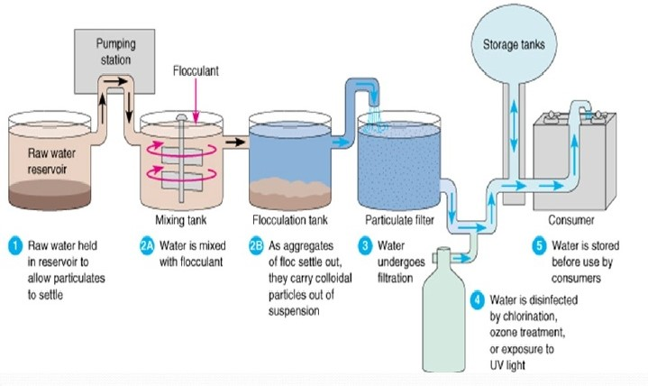
Different water sources from where the water can be procured shall be identified. Sometimes rainwater or seawater may also used as a source. So, identification of source of water is important. Service provider shall ensure functional water intake works and its transportation through pumping works. Now let’s focus on water intake and its transportation to the treatment facilities. Ensuring functional intake structures is a critical step in the water supply process. The service provider must guarantee the pumping system are properly designed and maintained to extract water from ground, or surface. The service provider shall ensure that the water shall be treated so that the final product confirms to IS 10500 ‘Drinking Water – Specifications’. Moreover, treated water must be stored and distributed at a specified pressure to maintain consistent flow and quality.
The management shall ensure that a Management Information System (MIS) is established. It shall determine the resources needed for all the above processes and ensure their availability, assign the responsibilities to the concerned for these processes and address the risks and opportunities.
Conforming to these items, City X – Established a robust management system, clearly defining roles and responsibilities for staff. An organizational hierarchy was created, ensuring accountability at every level of operation.
The standard also ensures that water supplier shall maintain and retain records to support operations, ensure processes follow planned schedules, document workforce requirements, and establish traceability for non-conformities.
Involvement of Leadership
The next is Leadership and commitment in which the top management shall be responsible for:
- Deviation from intended action of the organization.
- Suitable quality policy formulation
- Resource management as well as
- Ensuring that all is achieved.
Leadership and commitment shall also ensure customer satisfaction through identification of the same.Top management shall establish, implement and maintain a quality policy understanding its scope, objectives and commitment. This policy should be appropriate to the organization’s purpose, provide a framework for setting objectives, include a commitment to satisfy applicable requirements, and ensure continual improvement of the management system. The policy that the services manage should be documented, well-maintained, and effectively communicated to stakeholders. To ensure it remains relevant and effective, the policy should be periodically reviewed and updated as necessary.
Top management shall assign the responsibility and authority for ensuring that the management system conforms to the requirements of the standard. This includes reporting on the performance of the management system and opportunities for its improvement to top management, and ensuring the promotion of customer focus throughout the organization.
Planning for execution
Top management is responsible to plan actions to address risks and opportunities in a manner that ensures the management system can achieve its intended outcomes. These actions should help prevent or reduce undesired effects and promote continual improvement. Additionally, disaster management plans should be developed, implemented, and periodically evaluated. The standard elaborates it in its Annexure.
This chart outlines the essential factors to consider when planning and establishing quality objectives. The current status of the system and desired goal are to be determined and define clear and actionable objectives. These objectives must align with the organization’s quality policy and be measurable, achievable, and relevant. Additionally, the objectives should include a defined timeline and should be periodically reviewed to ensure progress and continued suitability.
When the water supplier/utility determines the need for changes to the management system, the changes shall be carried out in a planned manner considering the need and purpose of the changes, their potential consequences, the availability of required resources, and other relevant factors stated in the standard.
Support required to execute the task
Top management shall determine the resources required for the effective operation of the management system. This includes manpower, infrastructure, and the organizational environment necessary to establish, implement, maintain, and continually improve the system. Support requires competence to ensure effectiveness and thus training is important aspect of this clause. The workforce should be aware of the quality policy, objectives and implications of non conformance with the requirements of drinking water management system.
A robust Management Information System (MIS) shall be implemented to track water usage, monitor water quality, and identify areas for improvement.
Operation and Execution
The water supplier/utility is responsible for planning, operations (including extraction, treatment, and distribution), maintaining operational efficiency, conducting maintenance (inspection, repair, leak management), monitoring water quality and quantity, troubleshooting, preventive maintenance, safe residue disposal, reducing water pilferage to below 20%, and ensuring an alternative water supply in case of disruption beyond 36 hours.
Operation includes water sources, treatment, operation of distribution system, metering and release after sampling.
Customer communication: Regular surveys and feedback mechanisms shall be established to gather input from residents and industries on their water service experiences. The supplier/utility shall conduct review before committing to supply drinking water services to a customer. This review shall identify the needs to be fulfilled by the service provider.
In determining the stages and controls for design and development, the utility/supplier shall consider the nature, duration and complexity of the infrastructure. The organisation shall ensure to cater to each process, resource, responsibility and control points.
Operation also involves in preparation of risk mitigation plan, SOPs at all levels, maintenance of the stock and process checklists.
The water supplier/utility shall have record system, wherever required, to ensure the required maintenance of the equipment. The record shall contain all kinds of data relevant to the equipment.
In case of emergencies that may arise due to power failure, breakdown of water supply system units, vandalism, strikes by workforce, etc., a plan shall be prepared well in advance to meet such exigencies and shall be periodically rehearsed.
Records of mock drills shall also be kept in record.
A water audit is a calculation comparing the amount of water distributed with the amount consumed. It is recommended to be conducted quarterly and documented. The water agency aims to reduce water loss to 15% of total supply. Guidelines for conducting the audit are provided in Annex B of the IS 17482.
The water utility/services shall implement control and monitoring systems, at appropriate stages, to verify that the drinking water requirements have been met. The water quality shall conform to IS 10500 at consumer point of distribution.
Performance
The approach to move ahead for performance evaluation is given, the details of which is to be determined by the service provider. The customer satisfaction and effectiveness of the supply system shall be obtained through surveys and other feedback mechanism. All results shall be assessed for effective implementation and planning.
Internal Audits and Performance Reviews: Regular internal audits and performance reviews shall be conducted to assess the effectiveness of the water management plan and identify areas for improvement.
Assessment and Improvement
It highlights a framework for enhancing customer satisfaction and improving service quality. To enhance customer satisfaction, organizations focus on improving services to meet user requirements, anticipating future needs, and implementing risk assessment measures. Additionally, the framework emphasizes addressing non-conformities through corrective action and efficient complaint resolution mechanisms. Complaints can be made available to be registered through multiple digital channels.
Conclusion:
So, IS 17482:2020 provides a solid framework for managing piped drinking water services effectively. By following this standard, utilities can ensure quality, continuous supply and compliance with regulations. All of this leads to higher customer satisfaction and more efficient operations.
Coming to the issues of City X- Water Supply and Sewerage Board and how they managed to resolve their problems by adopting this standard:
- Problem 1 : Low Water Quality
Solution:
Clause 4.4(d): Ensures treated water conforms to IS 10500 standards.
Action to perform: Implement rigorous monitoring at the treatment plant and consumer points. Adjust treatment processes such as filtration and disinfection.
Clause 8.5.5: Details water treatment requirements.
Action to perform: Document treatment procedures, use advanced treatment technologies, and retain records of water quality tests.
Clause 8.6.1-8.6.2: Monitoring and sampling to ensure compliance with IS 10500 at all stages.
Action to perform: Establish a frequent water quality testing schedule and random sampling at critical points.
- Problem 2 - Frequent Breakdowns
Solution:

Clause 7.1.3.1: Addresses infrastructure maintenance and management.
Action to perform: Develop a preventive maintenance schedule for pipelines, pumps, and other infrastructure.
Clause 7.1.3.2: Provides guidance on risk assessment and mitigation plans for maintaining optimal working conditions.
Action to perform: Conduct risk assessments to identify potential failure points and create an inventory of spare parts.
Clause 8.5.3: Stresses maintaining the distribution system's integrity.
Action to perform: Use leak detection technologies, repair damaged sections promptly, and upgrade pipelines in high-risk areas.
- Problem 3 - Inefficient Management:
Solution:
Clause 4.5: Emphasizes maintaining documented information to support operational processes.
Action to perform: Implement a Management Information System (MIS) to centralize data on operations, maintenance, and performance.
Clause 5.1.1: Highlights leadership accountability and resource availability.
Action to perform: Assign roles and responsibilities for key processes and ensure resources are allocated effectively.
Clause 6.1.2: Planning actions to address risks and opportunities.
Action to perform: Identify risks in operational workflows and create contingency plans for disruptions.
- Problem 4 - Customer Grievances
Solution:
Clause 8.2.1: Focuses on customer communication, complaint handling, and feedback mechanisms.
Action to perform: Establish multiple complaint channels (e.g., helplines, apps, and social media) and ensure timely resolution of complaints.
Clause 9.1.2: Monitoring customer satisfaction through surveys and feedback.
Action to perform: Conduct regular satisfaction surveys and act on feedback to improve services.
Clause 5.1.2: Leadership focus on customer satisfaction.
Action to perform: Integrate customer satisfaction as a key performance indicator and make improvements based on grievances received.

CHAPTER 7

Solid Waste Management
INTRODUCTION
This document focuses on understanding the challenges of solid waste management in urban areas and how Indian Standards can help in addressing these challenges.
STANDARDS REFERRED
- IS 16657 : 2016 - Solid Waste Management- Segregation, Collection and utilization at household/Community Level- Guidelines
- IS 18520 : 2024 - Solid Waste Management- Segregation, Collection and utilization at Commercial Facilities (Shops, markets and malls)- Guidelines
- IS 12647:2021 - Solid Waste Management Collection Equipment – Requirements and Guidelines (First Revision)
- IS 12262 PART 1 : 2021 - Guidelines for Use of Vehicles for Collection and Transportation of Solid Wastes Part 1 Selection of Vehicles
- IS 12262 PART 2 : 2002 - Vehicles for Collection of Municipal Solid Wastes: Part 2 Guidelines for Maintenance

Solid Waste Facts and Figures
As cities grow and expand due to rapid urbanisation and economic development, the sheer volume of waste generated places a burden on the existing waste management infrastructure and resources. As a result, handling and disposing of this mounting waste in an efficient manner becomes a crucial task to prevent environmental degradation and associated health hazards. According to the CPCB (Central Pollution Control Board) report 2020-21, the overall quantity of solid waste generated stands at 160,038.9 tons per day (TPD) in the country. Out of which 152,749.5 TPD of waste is collected in an efficient manner. Out of the total collected waste, 79,956.3 TPD, constituting 50 per cent, undergoes some form of treatment, while 29,427.2 TPD, i.e., 18.4 per cent, is directed to landfills and 50,655.4 TPD, representing 31.7 per cent of the total waste generated remains unaccounted3. Meena et al., (2023) highlight that the consistent and indiscriminate disposal of Municipal Solid Waste (MSW) is intricately connected to unscientific practices, urbanisation, population growth, lifestyle ethics, and a lack of ecological awareness. For example, open dumping of MSW has detrimental effects on both the environment and human health. Solid waste management includes a spectrum of activities spanning the generation, storage, collection, transfer, transport, processing, and disposal of solid wastes (Meena et al, 2023). The mismanagement of these stages not only leads to environmental degradation but also poses a serious threat to the well-being of the residents in these densely populated urban areas.
Challenges of solid waste management in urban areas

i) Rapid Urbanization and Economic Growth
Urbanization and economic growth have significantly contributed to the increase in waste generation. The higher consumption rates, coupled with increasing population densities, create an enormous strain on existing waste management systems. Cities are growing rapidly, often outpacing the development of infrastructure and services required to handle the waste effectively. This mismatch leads to issues such as uncollected waste, illegal dumping, and the overburdening of existing disposal facilities. For example, cities like Delhi generate over 11,000 tonnes of waste daily, but only a fraction is processed scientifically. Moreover, economic growth often results in lifestyle changes, which include higher use of disposable goods and packaging materials, further aggravating the problem. Addressing these issues requires a coordinated effort that includes planning for future growth, enhancing resource efficiency, and integrating advanced technologies into waste management processes. Municipal authorities must also engage with communities to promote waste reduction and recycling practices at the local level.
ii) Inadequate Segregation at Source
A major barrier to effective waste management is the lack of segregation at the source. Many households and establishments dispose of mixed waste, often inappropriately, such as in open drains or water bodies. It is known fact that segregation improves recycling efficiency and reduces the cost of waste treatment. However, in India, the implementation of waste segregation remains limited, with only a few areas achieving 100% source segregation. The absence of standardized segregation practices leads to an increased burden on downstream recycling and disposal systems​

iii) Insufficient Infrastructure
One of the major challenges faced is a glaring lack of infrastructure for waste collection, transportation, and treatment. Many municipal bodies operate with inadequate resources, resulting in irregular waste collection and reliance on outdated technologies. Centralized systems dominate, often leading to overflowing landfills and open dumping practices. This scarcity of facilities exacerbates environmental pollution and highlights the need for decentralized waste processing units and investments in advanced technologies

iv) Low Public Awareness and Participation
The document points out that low public awareness and participation are significant hurdles in promoting sustainable waste management. Despite regulations, many citizens remain uninformed about proper waste disposal practices. Awareness campaigns and community engagement initiatives are essential to foster responsible waste behaviour. Successful examples from countries like Japan and Indonesia demonstrate that citizen participation in waste segregation and recycling is critical to the system's success​.
Each of these challenges demands tailored solutions that take India’s unique socio-economic and geographic context into account.
Addressing Challenges with Indian Standards

BIS has developed the following standards to address the issues related to solid waste management

S.No | IS Number | Title
1 | IS 16557:2016 | Solid Waste Management- Segregation, Collection and utilization at household/Community Level- Guidelines
 | IS 18520 : 2024 | Solid Waste Management- Segregation, Collection and utilization at Commercial Facilities - Guidelines
2 | IS 12647:2021 | Solid Waste Management Collection Equipment – Requirements and Guidelines (First Revision)
3 | IS 12262 PART 1 : 2021 | Guidelines for Use of Vehicles for Collection and Transportation of Solid Wastes Part 1 Selection of Vehicles
4 | IS 12262 PART 2 : 2002 | Vehicles for Collection of Municipal Solid Wastes: Part 2 Guidelines for Maintenance

Let’s address the challenges through the provisions of these Indian Standards

A. Rapid Urbanization and Economic Growth

Indian Standards provide a robust framework to address the challenges posed by urbanization. These standards focus on ensuring that waste management systems are scalable and adaptable to the rapid pace of urban expansion. They include guidelines for optimizing waste collection routes, establishing waste transfer stations, and ensuring proper disposal methods. Additionally, they recommend integrating modern technologies like GPS-enabled vehicles and automated segregation systems to enhance efficiency. The standards also emphasize the importance of creating public-private partnerships to fund and implement advanced infrastructure. By adopting these provisions, municipalities can ensure that their waste management systems are not only efficient but also sustainable in the long term, capable of meeting the demands of growing urban populations.

IS 16557 :2016 - Solid Waste Management- Segregation, Collection and utilization at household/Community Level- Guidelines

This standard prescribes guidelines for segregation, collection and utilization of solid waste (SW) generated at household and/or community levels. Elements namely, ‘Transportation from primary vehicles to processing and recycling facilities’ and ‘Final disposal of reject material’ are excluded from this standard.

The following provisions in IS 16557 helps in addressing the challenge rapid urbanization and economic growth

- Segregation at Source:
  - Solid waste generated at household/community level shall be segregated and stored in the bins/bags specified. No solid waste shall be thrown on the streets, footpaths, open spaces, drains, or water bodies.
  - Segregation should occur in three categories:
    - Green: For biodegradable waste (e.g., food scraps and yard waste).
    - White/Blue: For dry/recyclable waste (e.g., plastics, metals, paper, and glass).
    - Red: For biomedical and hazardous waste (e.g., batteries, used syringes, and sanitary waste)​.
  - This system ensures the systematic handling of various waste streams and prevents contamination.
- Decentralized Waste Management:
  - "Households shall be motivated to process bio-degradable waste within their premises or communities to the extent it is feasible to do so.
  - Encourage the use of:
    - Home composting and vermicomposting for biodegradable waste.
    - Bio-methanation systems to convert organic waste into biogas, reducing reliance on centralized treatment plants​.
  - Community composting setups allow local residents to manage biodegradable waste collectively​.
- Behavioral Awareness:
  - "Training, awareness-raising campaigns, extension activities, school and college educational programs, and environmental education are key elements of effective segregation.

IS 18520 : 2024 Solid Waste Management- Segregation, Collection and utilization at Commercial Facilities – Guidelines

This standard prescribes guidelines for segregation, collection and processing of solid waste (SW) generated at commercial facilities including shops, markets, malls etc. Elements namely, collection from the facility, transportation by primary vehicles to transfer station and further transport by secondary vehicles to transport for processing and recycling and final scientific disposal of reject material’ are excluded from this standard.

The following provisions in IS 18520 helps in addressing the challenge rapid urbanization and economic growth

- Biodegradable Waste Management:
  - Biodegradable waste generated by large commercial facilities (e.g., malls, markets, and restaurants) shall be stored in air-conditioned storage facilities prior to being transferred to processing plants.
  - Bulk waste generators producing more than 100 kg/day must establish composting or bio-methanation facilities on-site​.
  - This measure prevents odour and minimizes decay-related issues.
- Regular Collection and Treatment:
  - Biodegradable waste shall be collected from storage points at least once every 24 hours to prevent putrefaction and air quality deterioration. Dry waste may be collected at longer intervals based on volume and type.
- E-waste and Hazardous Waste:
  - Non-industrial e-waste and hazardous waste shall be stored separately to prevent contamination of other waste streams and shall be collected periodically.
  - Items such as batteries, CFL bulbs, and expired chemicals must be stored in puncture-proof containers​.

B. Inadequate Segregation at Source

One of the most persistent challenges in solid waste management is the inadequate segregation of waste at its source. When waste is not properly separated into biodegradable, recyclable, and non-recyclable categories, it complicates subsequent processing stages. Mixed waste streams make recycling inefficient and often result in the contamination of recyclable materials, rendering them unusable. This problem is further exacerbated by a lack of awareness among the general public about the importance of segregation and its benefits for the environment. Additionally, inadequate infrastructure, such as the absence of separate bins or collection systems for different types of waste, discourages people from practicing segregation. To tackle this challenge, it is essential to implement widespread education campaigns, establish clear policies mandating segregation, and provide the necessary infrastructure at the community level. Encouraging segregation can significantly improve recycling rates, reduce the volume of waste sent to landfills, and contribute to more efficient waste management overall.

As mentioned previously provisions of IS 16657 : 2016 and IS 18520 : 2024 elaborates the specific types of waste that need to be segregated, such as biodegradable waste, plastics, metals, glass, and hazardous materials. They also provide recommendations for implementing color-coded bins and labels to simplify the segregation process for households and businesses. Community-level initiatives, supported by these standards, can include workshops, campaigns, and pilot projects to demonstrate the benefits of proper segregation. By adopting these measures, municipalities can foster a culture of responsibility and sustainability, ensuring that segregation becomes an integral part of daily life.

C. Insufficient Infrastructure

The lack of adequate infrastructure is a significant hurdle in achieving effective waste management. Many urban areas suffer from an acute shortage of waste collection vehicles, processing facilities, and sanitary landfills. This leads to inefficient waste collection, with large amounts of waste left uncollected and dumped in open spaces, causing environmental and health hazards. Additionally, the absence of advanced processing facilities, such as composting plants and recycling units, limits the ability to recover resources from waste, leading to increased landfill dependency. Another issue is the poor maintenance of existing infrastructure, which reduces its efficiency and lifespan. Addressing these infrastructure gaps requires substantial investment, strategic planning, and the adoption of innovative solutions. Municipalities need to focus on creating a comprehensive waste management network that includes collection, transportation, processing, and disposal facilities designed to handle the increasing volumes of waste effectively.

Indian Standards provide comprehensive guidelines to overcome infrastructure challenges in waste management. These standards include specifications for designing waste collection vehicles, establishing recycling plants, and constructing sanitary landfills that meet environmental safety requirements. For example, they recommend the use of compactors and shredders to reduce the volume of waste before transportation, making the process more efficient. The standards also emphasize the importance of regular maintenance and monitoring of waste management infrastructure to ensure its optimal performance. Moreover, they encourage the adoption of modern technologies, such as waste-to-energy plants, to maximize resource recovery and minimize landfill usage.

IS 12662 (Part 1) : 2021 Guidelines for Use of Vehicles for Collection and Transportation of Solid Wastes Part 1 Selection of Vehicles

This standard (Part 1) prescribes the guidelines for selection of vehicles for collection and transportation of solid wastes to processing or disposal site.

The following provisions in IS 12662 Part 1 helps in addressing the challenge inadequate infrastructure

Different types of collection and transportation vehicles include:

- Hand Cart
- Padal Tricycle
- Short Range Small Capacity Vehicle
- Tractor Trailor System
- Container Carrier System
- Conventional Trucks System
- Special Municipal Vehicles
- Compactor Vehicles
- Refuse Collector

Criteria for Vehicle Selection
A wide variety of vehicles are available in the country each suitable for specific situation. Hence, selection of a vehicle should be made after carefully evaluating all possible alternatives. For evaluating the comparative cost, it is desirable to find out cost/tonne/km.

This can be calculated in the following manner.

a) Annualized cost over 7 years.
b) Waste transported/year = Weight per trip × no. of trips/day × average no. of working days/year.
c) Manpower cost = No. of persons/vehicle × annual salaries of these persons
d) Fuel cost/year = litres consumed/year × cost/litre.
e) Maintenance cost @ 10 percent per year of capital cost.
f) Supervisory cost @ 10 percent of labour cost.
g) Cost/tonne/km = (a + c + d + e + f)/b

IS 12662 (Part 2) : 2002 Vehicles for Collection of Municipal Solid Wastes: Part 2 Guidelines for Maintenance

This standard prescribes the guidelines for maintenance of vehicles for collection and transportation of urban solid wastes for processing at disposal site.

The following provisions in IS 12662 Part 2 helps in addressing the challenge inadequate infrastructure

- Preventive and Breakdown Maintenance:
  - "Preventive maintenance systems should include daily, periodical, and monsoon-specific attention to vehicles. Repairs must be prioritized based on cost-effectiveness, and vehicles beyond repair should be replaced promptly.
  - Breakdown maintenance should ensure that critical vehicles are repaired on a priority basis to minimize disruption of waste collection services.
- Systematic Workshop Layouts:
  - For systematic maintenance of vehicles, it is essential to have proper workshop layouts including:
    - Repair sheds and parking zones.
    - Service pits for easier vehicle servicing.
    - Dedicated areas for painting, welding, and battery storage.
  - A well-equipped transport workshop enhances fleet reliability and longevity.

D. Solid Waste Collection and Equipment Design

Effective waste collection is the backbone of any waste management system, and having well-designed equipment is critical to its success. Indian Standards provide detailed guidelines for the selection, design, and maintenance of waste collection equipment. These guidelines cover a wide range of equipment, from small household bins to large compactor trucks, ensuring that each component is suited to the specific type and volume of waste it is meant to handle. For instance, the standards recommend the use of lightweight, durable materials for bins to ensure ease of use and longevity. Similarly, vehicles used for waste collection are required to have features like sealed compartments to prevent spillage and odour, as well as GPS tracking systems to optimize collection routes. By adhering to these standards, municipalities can enhance the efficiency and reliability of their waste collection systems, ensuring that waste is managed effectively from the point of generation to disposal.

Challenges | Provisions of IS 12647 addressing the challenge
Inefficiencies in Manual Waste Collection:  The reliance on manual methods, such as brooms and handcarts, often results in slower collection rates and higher physical strain on workers. | Specifications for long-handled brooms, spades, and wheelbarrows to reduce physical strain on workers and improve efficiency. Recommendations for galvanized steel pans and bamboo baskets to ensure durability and ease of handling.
Inadequate Equipment Design:  Poorly designed collection equipment, including dustbins, receptacles, and handcarts, leads to inefficiencies in waste collection, storage, and transportation. | Design specifications for collection equipment, including proper dimensions and materials for dustbins, receptacles, and handcarts, ensuring durability and usability.
Limited Accessibility of Community Dustbins: Improper placement and insufficient spacing of dustbins create challenges in waste disposal by residents, often leading to illegal dumping and open waste piles. | Recommendations for suitable placement and spacing of community dustbins to minimize distance travelled by residents and workers. Spacing should consider population density and refuse generation rates.
Strain on Workers: Traditional tools such as baskets and pans require workers to carry waste overhead or make multiple trips, increasing physical strain and reducing productivity. | Encouragement of handcart use with removable containers to reduce trips and physical burden. Recommendations for ergonomic designs to improve worker productivity.
Inconsistent Waste Storage Solutions: Lack of standardized designs and capacity for storage bins at both household and community levels creates inefficiencies in waste collection and transfer. | Guidelines for standardized sizes and designs of household (10-15 liters) and community bins to optimize waste collection and transfer processes.

CHAPTER 8

Recycling of Plastic Waste

Slide 1: Title Slide
- Title: Capacity Building Programme for Urban Development Department and Municipal Corporation Department.
- Topic: Plastics Recycling.
- Focus: Discusses the integration of recycling practices into urban planning and waste management systems.
- Purpose: Set the stage for understanding plastic recycling within the context of urban and municipal development, with a focus on capacity building.

Slide 2: Introduction to Polymers
Definition of Polymer: Polymers are large molecules formed by the repetitive bonding of monomers (smaller molecules). Greek origins: "Poly" (many) + "Mer" (parts/units).
Polymers are large molecules composed of repeating structural units known as monomers, bonded together through chemical processes.
Historically, natural polymers like rubber and cellulose have been utilized for centuries. The development of synthetic polymers began in the early 20th century, revolutionizing various industries by providing materials with tailored properties for specific applications.
The versatility of polymers offers numerous benefits across different sectors. In the medical field, polymers are used in applications such as wound dressings and drug delivery systems due to their biocompatibility and ability to be engineered for specific functions.
Industrially, polymers are favoured for their cost-effectiveness, chemical resistance, and design flexibility, making them suitable replacements for metals in various components. Additionally, polymers play a crucial role in daily life, forming the basis of products like plastic bottles, packaging materials, and shopping bags, which are predominantly made from polyethylene.

Their adaptability and wide range of properties continue to make polymers indispensable in modern society.

Slide 3: Major Polymers
Highlights the common types of plastics for recycling.
List of Key Polymers and Their Uses:
  - PET: Beverage bottles, food containers.
  - HDPE: Milk jugs, detergent bottles.
  - PVC: Pipes, window frames, flooring.
  - LDPE: Shopping bags, squeeze bottles.
  - PP: Food containers, automotive parts.
  - PS: Disposable utensils, packaging foam.
  - PC: Optical discs, safety helmets.
Recycling Potential: Discusses durability, usage, and challenges in recycling these polymers.

Slide 4: Plastic Pollution Statistics
Source: UNEP on plastics pollution.
Insight: Statistics provide an understanding of the scale and urgency of addressing plastic pollution.
  - Annual production exceeds millions of tons.
  - Percentage of plastic waste recycled globally remains low.
  - Impact on ecosystems: Microplastics in oceans, soil contamination.

Slide 5: Environmental Impact of Plastic Waste
Environmental consequences of unmanaged plastic waste.
Explains the importance of recycling to mitigate these impacts.
Key Issues:
  - Wildlife Impact: Ingestion and entanglement.
  - Human Health: Toxicity from leaching chemicals.
  - Pollution: Landfill overflow, ocean debris.
Global Perspective: The long lifecycle of plastics exacerbates environmental harm.

Slide 6: Materials Suitable for Recycling
Overview of materials that can be recycled effectively. Provides clarity on the recyclability of different types of plastics.
Focuses on common plastics and criteria for recyclability:
  - Thermoplastics (easily remolded): PET, HDPE, LDPE, PP.
  - Exclusions: Thermosets (e.g., bakelite), heavily contaminated plastics.

Slide 7: Benefits of Recycling Plastics
Environmental:
  - Reduces landfill waste.
  - Lowers greenhouse gas emissions.
Economic:
  - Creates job opportunities in waste management.
  - Reduces production costs by reusing materials.
Energy Conservation: Saves energy compared to producing virgin plastic.

Slide 8: Overview of IS 14534:2023
Standard Title: Plastics — Recovery and Recycling of Plastics Waste — Guidelines.
Key Points:
  - Establishes guidelines for plastic recovery and recycling.
  - Encourages standardization in collection, sorting, and reprocessing.
Impact:
  - Promotes sustainable practices.
  - Aligns with global standards for recycling.

Slide 9: Source of Plastic Materials for Recycling
Primary Sources:
  - Post-consumer waste (household, commercial).
  - Industrial waste (production scrap).
Segregation Needs:
  - Differentiating clean versus contaminated plastics.

Slide 10: Recovery Options
Mechanical Recycling:
  - Steps: Collection → Identification → Sorting → Grinding → Washing → Agglomerating → Extruding → Pelletizing.
  - Outcome: Produces usable raw materials.
Mechanical recycling is a process that converts plastic waste into reusable raw materials without significantly altering their chemical structure. This method is essential for reducing environmental impact and promoting sustainability. The mechanical recycling process comprises several key steps:
1. Collection
The process begins with the collection of plastic waste from various sources, including households, businesses, and industrial facilities. Efficient collection systems are crucial to gather sufficient quantities of recyclable materials.
2. Sorting
Once collected, the plastic waste is transported to a Materials Recovery Facility (MRF) where it is sorted by type and colour. Proper sorting is vital due to different plastics having unique physical properties and melting points.
3. Washing
After sorting, the plastic materials undergo a washing process to remove impurities such as dust, dirt, adhesives, and food residues. This step ensures that the plastics are clean before proceeding to the next stage, enhancing the quality of the recycled product.
4. Shredding (Grinding)
The cleaned plastics are then shredded into smaller pieces or flakes. Shredding facilitates easier handling and further processing of the materials.
5. Agglomerating
In some recycling processes, the shredded plastic fragments undergo agglomeration to eliminate impurities like paper labels. This material is melted and often extruded into the form of pellets, which are then used to manufacture other products.
6. Extruding
The purified plastic flakes are melted and extruded to form continuous strands. This process helps in homogenizing the material and preparing it for final shaping.
7. Pelletizing
Finally, the extruded plastic strands are cooled and cut into uniform pellets. These pellets serve as raw materials for manufacturing new plastic products, effectively closing the recycling loop.
Each of these steps is integral to the mechanical recycling process, ensuring that plastic waste is efficiently converted into reusable materials, thereby contributing to a more sustainable environment.
Chemical Recycling:
  - Process: Depolymerization via pyrolysis or equivalent methods.
  - Products: Monomers, hydrocarbons, or chemicals.
  - Suitability: For mixed or complex plastics.
Biological Recycling:
  - Process: Aerobic or anaerobic biodegradation.
  - Use: For specific biodegradable plastics.

Slide 11 Mechanical Recycling:
  - Process steps: Sorting, grinding, washing, drying, and pelletizing.
  - Output: Recycled plastic granules for reuse.
  - Limitation: Effective for clean, single-polymer plastics.
Slide 12 Chemical Recycling:
  - Converts plastics back to monomers or hydrocarbons via pyrolysis or similar processes.
  - Suitable for complex or mixed plastics.
  - High energy input but produces pure feedstock.
Chemical recycling refers to processes that break down plastic waste into its fundamental chemical components, enabling the production of new plastics or other valuable materials. Unlike mechanical recycling, which physically processes plastics without altering their chemical structure, chemical recycling can handle a broader range of plastic types, including those that are contaminated or difficult to recycle mechanically. This versatility makes it a promising solution for managing complex plastic waste streams.
One of the primary benefits of chemical recycling is its ability to reduce landfill waste by converting plastics into reusable materials, thereby conserving natural resources. Additionally, it supports a circular economy by enabling the continuous reuse of materials without significant degradation in quality. For instance, chemical recycling can produce high-quality feedstock suitable for various applications, ensuring that recycled products meet stringent quality standards.
However, chemical recycling also presents several challenges. The processes involved can be technically complex and capital-intensive, requiring specialized equipment and expertise, which may hinder large-scale implementation, especially in regions with limited resources. Moreover, some chemical recycling methods may emit greenhouse gases or produce hazardous by-products, necessitating careful monitoring and mitigation measures to minimize environmental impact. Additionally, contaminants present in plastic waste streams, such as additives or dyes, can complicate recycling processes and affect the quality of the recycled products, highlighting the need for effective sorting and pre-treatment methods.
Slide 13 Biological Recycling:
  - Aerobic/anaerobic breakdown of biodegradable plastics.
  - Used for polylactic acid (PLA) and other bioplastics.

Slide 14: Identification Marking
Purpose: Facilitates/streamlines sorting during recycling.
Examples:
  - PET (1), HDPE (2), PVC (3), LDPE (4), PP (5), PS (6).
  - "Other" category includes ABS, PC, etc., for mixed materials.
Visual Aid: Standard recycling symbols used globally.

Slide 15: Recent Developments
Content: Advances in recycling technologies and practices.
Technological Advances:
  - AI-assisted sorting technologies.
  - Enhanced chemical recycling methods.
  - Biodegradable plastic innovations.
Industry Trends:
  - Shift toward circular economies.
  - Increased use of recycled content in manufacturing.

Slide 16: Challenges in Plastic Recycling
Key Issues:
  - Mixed waste contamination.
  - Lack of infrastructure.
  - Economic and logistical hurdles.
Technical:
  - Contamination of waste streams.
  - Difficulty in processing multi-layered or composite plastics.
Economic:
  - High cost of advanced recycling technologies.
  - Fluctuating market demand for recycled materials.

Slide 17: Regulatory Framework - Plastic Waste Management Rules, 2016
Aim: Minimize plastic waste, encourage segregation, recycling, and adopt polluter-pays principles.
Applicability: Waste generators, local bodies, manufacturers, importers, and producers.

Slide 18: Regulatory Framework - Plastic Waste Management Rules, 2016
Objectives:
  - Source segregation and recycling.
  - Involvement of informal sectors (waste pickers).
  - Encouraging producers to take responsibility for waste.
Key Principles:
  - Polluter-pays principle.
  - Extended Producer Responsibility (EPR).

Slide 19/20: Extended Producer Responsibility (EPR)
Assigns roles to stakeholders like producers, importers, and recyclers.
Categories:
  - Category I: Rigid packaging.
  - Category II: Flexible packaging (e.g., sachets, multilayer plastics).
  - Category III: Multi-layered and composite plastics.
  - Category IV: Compostable plastics.
Benefits:
  - Ensures accountability.
  - Reduces environmental footprint.

Slide 21: Key Takeaways
Summary Points:
  - Importance of recycling for environmental sustainability.
  - Overview of frameworks and recovery options.
  - Challenges and opportunities in the field.
Action Items:
  - Promote awareness.
  - Advocate for policy implementation.
  - Encourage industry innovation.

Slide 22: Q&A Session
- Invitation to Participate: Engage with questions for clarity or further discussion.

CHAPTER 9

Non-sewered Sanitation System (Packaged STPs, Biodigestors and Rotational Moulded Polyethylene
Septic Tanks)

- INTRODUCTION TO NON-SEWERED SANITATION SYSTEMS

Sanitation refers to the systems, practices, and infrastructure used to manage human excreta, wastewater, and solid waste in a safe and hygienic manner. Its primary goal is to protect human health, prevent environmental contamination, and ensure dignity. Sanitation is more than infrastructure; it is about dignity, health, and a commitment to building a safer, cleaner world for all.

Owing to the limited access of a high share of urban and rural population to sewerage systems in India, strengthening the ecosystem for non-networked sanitation becomes imperative.

Non-sewered sanitation systems (NSS) are on-site sanitation solutions that operate without the need for a connection to a centralized sewer system. They are designed to safely manage human waste and provide hygienic services in areas lacking conventional sewer infrastructure and operate independently of piped sewer networks. They Include containment, emptying, transport, treatment, and disposal/reuse of waste and are adaptable to various environmental and socio-economic contexts. Additionally, they can also be used in integration with centralized sewer systems leading to reducing load on sewage treatment plants (STPs).

Non-sewered sanitation systems are critical to addressing global sanitation challenges, particularly in under-served communities, while contributing to health, dignity, and environmental preservation. They are most appropriate for urban slums and remote or rural regions with limited infrastructure. Bio toilets have also been installed in Indian railway coaches to manage onboard human waste.

To facilitate the achievement of the desired public health and environmental outcomes through non-networked sanitation, it is crucial to safeguard the quality of existing on-site sanitation systems. Furthermore, the varying characteristics of settlements, hydrogeology, and environmental sensitivity necessitate innovations in product design to respond to the needs of these diverse contexts.

Biodigesters are systems that break down organic waste, such as human excreta, through anaerobic digestion (a process carried out by microorganisms in the absence of oxygen). This process and transforms organic waste into simpler organic molecule, effluent water and biogas.

- OVERVIEW OF IS 18150 AND BIODIGESTERS
- Key Components of a Biodigester
Inlet Chamber: Allows for the introduction of organic waste, such as food scraps, animal manure, or human waste, into the biodigester.
Digestion Tank/Chamber: The sealed, oxygen-free environment where anaerobic digestion occurs. It houses microorganisms that break down organic matter.
Gas Storage Chamber: A section of the biodigester designed to collect and store biogas produced during the digestion process.
Outlet for Bio-Slurry (simple organic molecules and effluent water): A system for discharging the nutrient-rich slurry, which can be used as organic fertilizer.
Piping and Valves: Facilitates the flow of biogas to appliances or storage and regulates pressure within the system.
- Design requirements as per IS 18150
1. Tank Design
- Multi-Chamber Structure: A biodigester tank must have at least two partition (baffle) walls, resulting in three chambers with a volumetric ratio of 4:3:3. This design increases the waste's path length, contact time, sedimentation, and degradation.
- Inlet and Outlet Provisions:
  - The inlet chamber should occupy approximately 40% of the total tank volume.
  - Outlets for treated effluent and biogas must be incorporated for efficient waste management and gas collection.
- Immobilization Matrix: Polyvinyl chloride (PVC) immobilization matrix should be provided on both sides of the partition walls and as hanging structures to enhance bacterial activity.
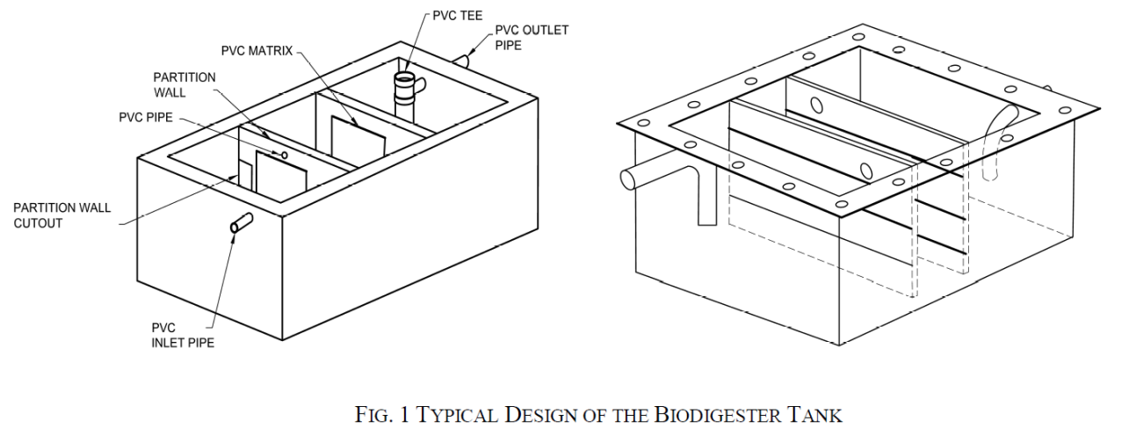
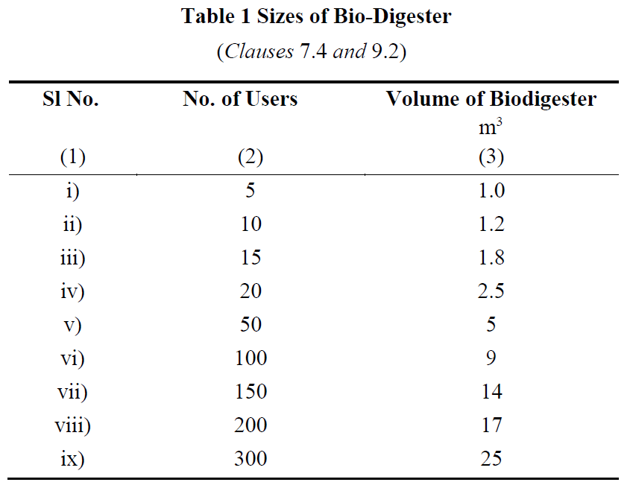
2. Material Specifications
- Fabrication Materials:
  - Fiber Reinforced Plastic (FRP), stainless steel (SS), or reinforced cement concrete (RCC) may be used, depending on the scale and application.
  - For larger volumes, on-site construction using RCC/PCC is recommended to reduce transportation and installation issues.
- FRP Specifications:
  - Resin properties, such as viscosity, acid value, gel time, and tensile strength, are defined to ensure durability and functionality.
  - Cured cast resin must be hard, tough, and have a specified impact resistance and density.
3. Capacity and Sizing
- The tank's size depends on the number of users:
  - A tank for 5 users requires 1 m³ volume.
  - Larger setups can be designed, with capacities ranging from 1.2 m³ for 10 users to 25 m³ for 300 users.
4. Key Design Considerations
- Chamber Configuration: Dimensions should cater to the required Hydraulic Retention Time (HRT) for effective digestion.
- Temperature Adaptation: Provisions for insulation, such as PUF panels, may be added for cold regions to maintain microbial efficiency.
- Anaerobic Microbial Inoculum (AMI) - Microbial consortium is a mixture of different types of bacteria (hydrolytic, acidogenic, acetogenic and methanogenic groups) responsible for breakdown of complex polymers into simple sugars which are further broken down into low chain fatty acids and finally into biogas.
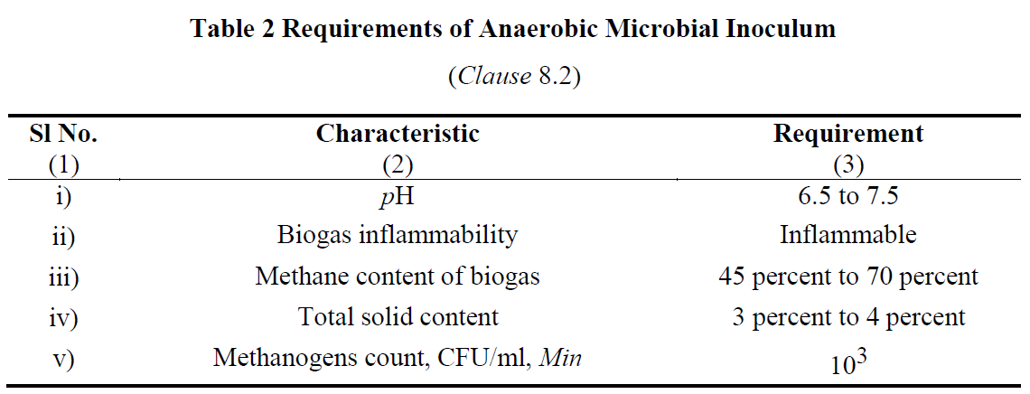
5. Effluent and Biogas Management
- The effluent must meet environmental standards, and biogas should be safely stored or utilized.
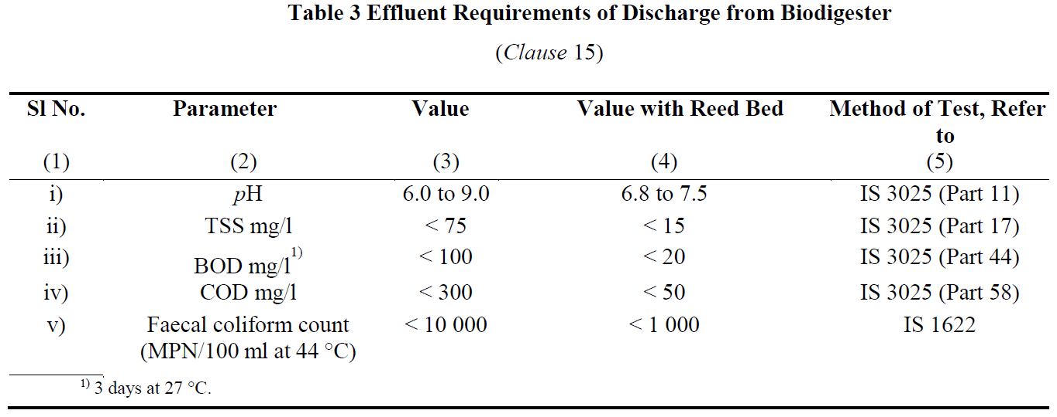
These specifications ensure the biodigester operates efficiently, minimizing health risks while promoting environmental sustainability.
- SITE SELECTION AND INSTALLATION OF BIODIGESTERS
Location of Biodigester Tank and Reed Bed
- Preferred Location:
  - The biodigester tank should ideally be installed underground, close to the toilet superstructure.
  - The reed bed can be placed above ground, either separately or on top of the tank.
- Placement Considerations:
  - The positioning of the tank and reed bed must account for the plinth height of the toilet and the site's ground level.
  - This ensures proper and effortless discharge of treated water into soak pits, open drains, or other designated areas.
Layout and Installation of FRP or SS Biodigesters
- Layout Guidelines:
  - The layout should be simple and direct to facilitate the smooth flow of waste from the toilet to the biodigester tank without blockages.
- Piping Arrangement:
  - Pipes should be configured to avoid hindrances or choking.
  - Cleaning eyes should be provided wherever pipe bends are necessary.
- Installation Considerations:
  - Selection of Location: Choose an area that is accessible and suitable for the biodigester.
  - Determination of Tank Size: The size must correspond to the number of users.
  - Pit Preparation:
    - The pit should be smooth and free from protruding stones or roots.
    - Excavated soil should be completely cleared from the pit edges to prevent collapse.
  - Base Construction:
    - A plain cement concrete (PCC) base layer is required at the bottom of the pit.
    - Concrete blocks may be added for additional support.
  - Connections:
    - Proper sealing of pipes and partitions is essential to prevent leaks.
    - Gas outlet placement must ensure safe gas release.
    - Effluent outlet pipes should lead to a soak pit or other designated area.
- Inoculum Addition:
  - Anaerobic microbial inoculum (30% of the tank volume) is added during installation or through the toilet itself.
On-Site Construction of RCC/PCC Biodigester Tanks
- Material Requirements:
  - Materials include bricks, cement, sand, stone chips, reinforcement for RCC, PVC pipes, and bacterial immobilization matrices.
- Construction Guidelines:
  - The tank is a rectangular structure with three chambers in a 4:3:3 volumetric ratio.
  - Partition walls should be 80% of the tank's length, allowing water flow through chambers.
- Tank Features:
  - Inlet Pipe: Positioned to allow 70% downward flow into the tank.
  - Outlet Pipe: Configured for proper effluent discharge, leading to a reed bed or soak pit.
- Bacterial Matrix Installation:
  - PVC matrices are hung inside the tank at specific intervals to enhance bacterial activity.
- Effluent Management:
  - Treated water exiting the reed bed can be safely released into the environment or reused for irrigation or other purposes.
- OPERATION AND MAINTENANCE
Operation and Maintenance Guidelines
- Start-Up of Biodigesters:
  - Once the biodigester is fabricated or constructed, anaerobic microbial inoculum (AMI) is added through the toilet or inlet pipe.
  - Care must be taken to minimize oxygen exposure during this process.
  - A properly functioning biodigester will produce colourless and odourless water at the outlet and maintain a clean, odour-free ambiance.
- Use of Detergents and Disinfectants:
  - Excessive use of detergents or disinfectants can harm the bacterial population and disrupt the anaerobic digestion process.
  - Adhere to the recommended dosage provided by the manufacturer to maintain system efficiency.
- Effluent Testing:
  - The biodigester's effluent must meet specific parameters (e.g., pH, BOD, COD, TSS, and fecal coliform counts).
  - Effluent testing should be conducted after one month of operation or after initial discharge to ensure compliance.
  - Testing is recommended to be carried out in DRDO-approved laboratories.
- General Maintenance Practices:
  - Regularly inspect connections, inlet and outlet pipes, and gas release mechanisms for leaks or blockages.
  - Clean the reed bed periodically to maintain its effectiveness in effluent quality improvement.
  - Monitor gas pressure and ensure safe storage or use of biogas.
- Instructions for Users:
  - Manufacturers must provide clear usage and maintenance instructions to the purchaser or operator.
  - Proper handling of biogas and bio-slurry byproducts is crucial for safety and resource recovery.
By following these guidelines, biodigesters can operate effectively, ensuring hygienic waste treatment, biogas production, and environmental protection.
- BENEFITS AND CHALLENGES
Benefits:
- Passive system for eco-friendly degradation of organic matter.
- Customizable sizes and pre-fabricated options available commercially.
- Promotes water recovery and recycling.
- Zero running cost and zero maintenance cost for primary treatment and negligible maintenance cost for periodic evaluation of secondary treatment.
- Does not require periodic replenishment of bacterial cultures and rigorous monitoring of performance.
- Does not have intermittent de-sludging requirement
- Does not restrict use of toilet cleaners
- Can be deployed even in extreme climatic conditions and areas with high water table or risk of flooding.
Risk & Limitations of Biodigester:
- Higher one time capital investment as compared to Leach Pits.
- Removal of nitrogen and phosphorous requires reed bed.
- Space constraints in urban areas could limit implementation of reed bed.

- CONCLUSION AND Q&A
Biodigesters represent a transformative solution in non-sewered sanitation systems, addressing critical challenges in waste management and environmental sustainability. By utilizing anaerobic digestion, biodigesters efficiently decompose organic waste into biogas and nutrient-rich effluent, offering multiple benefits such as renewable energy generation, reduced pathogen transmission, and resource recovery.
The design, installation, and maintenance of biodigesters, as outlined in the Indian Standard emphasize the importance of proper materials, site selection, and adherence to operational protocols for optimal performance. Integrating reed beds further enhances effluent treatment, ensuring safe discharge or reuse.
As a sustainable technology, biodigesters provide scalable solutions for households, communities, and institutions, particularly in areas lacking centralized sewer systems. Their role in reducing environmental pollution, conserving resources, and improving public health underscores their alignment with global sanitation and sustainability goals.
With proper implementation and regular maintenance, biodigesters can pave the way for a cleaner, greener, and healthier future, making them a vital component of modern waste management systems.

Advanced Sanitation Solutions: Packaged Sewage Treatment Plants as per IS 18797

- Introduction to Packaged Sewage Treatment Plants
Overview - This session provides a comprehensive understanding of Packaged Sewage Treatment Plants (PSTPs), focusing on their concept, design, operation, and real-world applications. It begins with an introduction to PSTPs, their significance, and applications in areas without centralized sewage systems, followed by an overview of the IS 18797 standards governing their design and construction. Participants will explore the design and installation guidelines, operational best practices, and maintenance protocols necessary for optimal performance. The session also examines the benefits, challenges, and practical applications, culminating in a summary and an interactive Q&A segment to clarify doubts and solidify learning.

Introduction - Sanitation refers to the systems, practices, and infrastructure used to manage human excreta, wastewater, and solid waste in a safe and hygienic manner. Its primary goal is to protect human health, prevent environmental contamination, and ensure dignity. Sanitation is more than infrastructure; it is about dignity, health, and a commitment to building a safer, cleaner world for all.
Owing to the limited access of a high share of urban and rural population to sewerage systems in India, strengthening the ecosystem for non-networked sanitation becomes imperative.
Non-sewered sanitation systems (NSS) are on-site sanitation solutions that operate without the need for a connection to a centralized sewer system. They are designed to safely manage human waste and provide hygienic services in areas lacking conventional sewer infrastructure and operate independently of piped sewer networks. They Include containment, emptying, transport, treatment, and disposal/reuse of waste and are adaptable to various environmental and socio-economic contexts. Additionally, they can also be used in integration with centralized sewer systems leading to reducing load on sewage treatment plants (STPs).
Non-sewered sanitation systems are critical to addressing global sanitation challenges, particularly in under-served communities, while contributing to health, dignity, and environmental preservation.
To facilitate the achievement of the desired public health and environmental outcomes through non-networked sanitation, it is crucial to safeguard the quality of existing on-site sanitation systems. Furthermore, the varying characteristics of settlements, hydrogeology, and environmental sensitivity necessitate innovations in product design to respond to the needs of these diverse contexts.
Packaged sewage treatment systems are compact, self-contained units designed to treat wastewater from small-scale applications such as homes, businesses, or remote locations. These systems use a combination of physical, biological, and chemical processes to remove contaminants, producing treated water suitable for discharge or reuse. Typically pre-engineered and modular, they are easy to install, require minimal space, and offer efficient wastewater treatment solutions. They are especially useful in areas without access to centralized sewage networks, providing a sustainable and cost-effective alternative for wastewater management.
- Overview of IS 18797 and PSTP Components (15 minutes)
The IS 18797:2024 standard ensures PSTPs are designed and built for reliable, sustainable, and efficient sewage treatment while meeting stringent safety and environmental criteria.
Key Components of Packaged Sewage Treatment Plants (PSTPs) are:
- Primary Treatment:
- Purpose: Removal of large solids, grit, and scum from raw sewage.
- Features:
  - Bar screens, grit chambers, and oil/grease traps.
  - Settling chambers for sedimentation of suspended solids.
  - Design to minimize disturbance to sludge or scum during inflow.
- Secondary Treatment:
- Purpose: Biological treatment for organic matter removal.
- Features:
  - Aerobic processes using blowers and diffusers for oxygenation.
  - Compartmentalized design for optimized microbial activity.
  - Ensures compliance with effluent Biological Oxygen Demand (BOD) and Total Suspended Solids (TSS) limits.
- Tertiary Treatment:
- Purpose: Advanced treatment for polishing and disinfection.
- Features:
  - Disinfection methods: Chlorination, ozonation, or UV treatment.
  - Nutrient removal (Nitrogen and Phosphorous) as per environmental standards.
  - Final effluent quality: pH 5.5–9.0, BOD ≤ 30 mg/L, and TSS ≤ 100 mg/L.
- Sludge Management:
- Purpose: Safe and efficient handling of settled solids.
- Features:
  - Adequate storage capacity for 6 months' sludge production.
  - Desludging access with a minimum opening diameter of 400 mm.
  - Durable filter media and structural integrity for long-term use.
Standards for Design, Materials, and Construction of PSTPs
- Design Principles:
- PSTPs must provide complete treatment and disinfection of incoming wastewater, ensuring no untreated or partially treated effluent is discharged into the environment.
- Systems must have two or more compartments, maintain a minimum Hydraulic Retention Time (HRT) of 16.5 hours at 25°C or higher, and accommodate variations in colder climates.
- The inlet and outlet designs must prevent sludge disturbances and ensure efficient scum management.
- Material Standards:
- Constructed from durable materials like Glass Fibre Reinforced Plastic (GFRP), Polyethylene (PE), Polypropylene (PP), or Dicyclopentadiene (DCPD).
- All components, including internal partitions and ancillary parts, must resist corrosive wastewater environments and support a minimum service life of 15 years.
- Structural Strength:
- Systems must withstand hydrostatic, pedestrian, and backfill loads without failure.
- Tanks must pass stringent watertightness, pneumatic pressure, and leakage tests.
- Efficiency & Safety:
- Effluent discharge must meet standards set by the Ministry of Environment, Forest, and Climate Change (MoEFCC):
  - BOD: ≤ 30 mg/L
  - COD: ≤ 250 mg/L
  - TSS: ≤ 100 mg/L
- Systems must be safe, energy-efficient, and operate within acceptable noise levels.
- Maintenance & Durability:
- Access openings for maintenance must have a locking mechanism and corrosion-resistant components.
- Desludging capacity of six months or more is mandatory under normal operating conditions.
Importance of Compliance with IS 18797
Adhering to IS 18797 is vital for ensuring the efficiency, safety, and sustainability of Packaged Sewage Treatment Plants, while also protecting public health and the environment.
- Enhanced System Efficiency:
- Design Optimization: Ensures systems are tailored for effective sewage treatment, meeting discharge standards for BOD, TSS, and nutrient removal.
- Hydraulic Retention Time (HRT): Minimum of 16.5 hours to optimize treatment processes, reducing the risk of untreated discharges.
- Testing and Quality Assurance: Regular type and acceptance tests validate system performance under diverse conditions.
- Safety and Reliability:
- Structural Integrity: Design standards ensure resistance to hydrostatic and backfill loads, preventing failures during operation.
- Watertight Construction: Prevents leakage and contamination of surrounding areas.
- Ventilation and Access: Adequate ventilation and secure access openings protect operators during maintenance.
- Environmental Protection:
- Effluent Standards Compliance: Discharge aligned with Ministry of Environment, Forest, and Climate Change (MoEFCC) norms to safeguard water bodies.
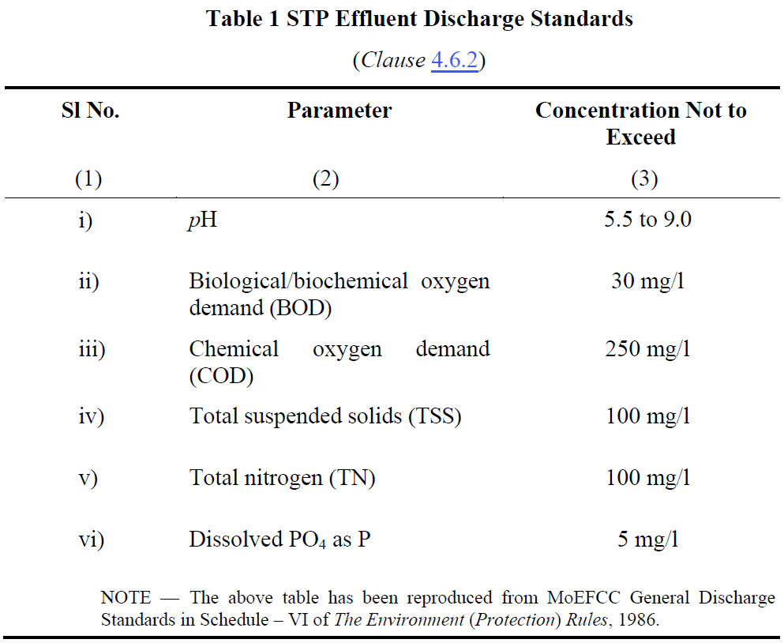
- Nutrient Removal: Controls nitrogen and phosphorus levels, mitigating risks of eutrophication.
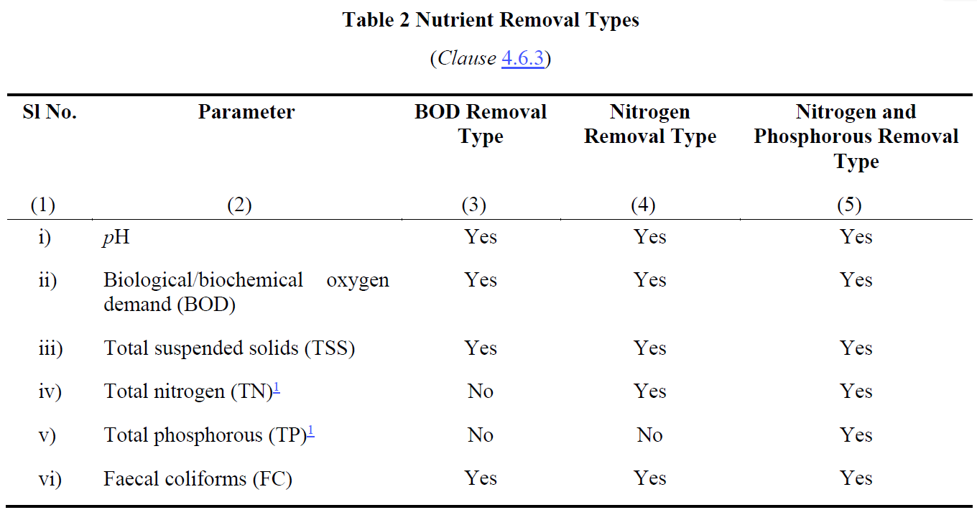
- Longevity and Sustainability:
- Durable Materials: Use of GFRP, PE, PP, and DCPD ensures systems endure harsh environments for 15+ years.
- Energy Efficiency: Declared power consumption promotes sustainable operations.
- Regulatory and Operational Confidence:
- BIS Certification: Builds trust among stakeholders, from manufacturers to users.
- Periodic Assessments: Ongoing monitoring of effluent quality ensures continued compliance and reliability.
- Design and Installation Guidelines
Design considerations for PSTPs
PSTP design prioritizes appropriate capacity, the ability to handle diverse inflow characteristics, and the production of high-quality effluent that meets stringent environmental standards.
- Capacity:
- Designed to serve a population equivalent to at least 5 individuals.
- Adequate sizing to store at least 6 months' sludge production without compromising performance.
- Flexibility to meet varying wastewater generation rates as per local authority regulations (e.g., 108 LPCD for residential areas).
- Inflow Characteristics:
- Handles raw sewage with standard characteristics:
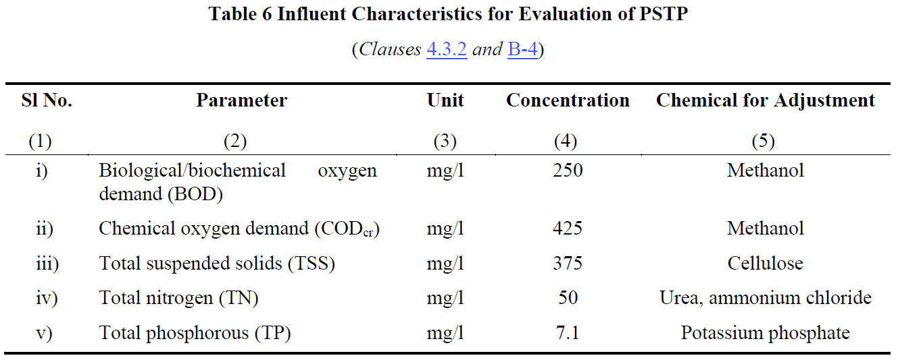
- Equipped to manage flow variations:
  - Normal flow (Q), low flow (0.5Q), and high flow (1.25Q) conditions during a 48-week evaluation period.
- Effluent Quality:
- Meets Ministry of Environment, Forest, and Climate Change (MoEFCC) General Discharge Standards:
- Final effluent ensures environmental protection and compliance with regulatory norms.
Installation
Proper installation and adherence to best practices ensure the long-term efficiency, safety, and reliability of PSTPs while minimizing operational challenges.
The manufacturer must provide installation instructions covering the following aspects:
- System installation, including other tanks for large capacities.
- Pipe and valve connections.
- Commissioning and start-up procedures.
- Properties of backfill material.
- Maximum backfill height.
- Suitability for dry/wet sites.
- Top load limitations.
- Maximum depth of extension shaft.
- Treatment efficiency.
- Anchoring arrangement.
- Foundation preparation.

- Operation, Maintenance, and Performance Monitoring
Regular operation, maintenance, and performance monitoring are critical for the efficiency, compliance, and longevity of PSTPs, ensuring they meet environmental and safety standards.
- Routine Operation:
- Ensure regular functioning of:
  - Pretreatment units (bar screens, grit chambers, oil/grease traps).
  - Pumps, blowers, and aeration systems.
  - Disinfection systems like UV, ozonation, or chlorination.
- Maintenance Schedule:
- Weekly:
  - Inspect pretreatment units for blockages or wear.
  - Check the operation of mechanical components (e.g., blowers, pumps).
- Monthly:
  - Clean air filters and inspect pipes for leaks or clogs.
  - Check filter media condition.
- Biannually:
  - Desludge the tank and inspect sludge levels.
  - Replace air filters and clean all chambers.
  - Inspect scum levels and remove any accumulation.
- Performance Monitoring:
- Conduct regular assessments of influent and effluent quality:
  - Key Parameters: pH, BOD, COD, TSS, Total Nitrogen, and Phosphorous.
  - Frequency: Weekly for critical parameters like BOD and COD.
- Monitor and maintain a record of sludge levels and scum accumulation.
- Regular assessments conducted in accordance with Indian Standards for accurate measurement of water quality.
- Documentation and Reporting:
- Maintain detailed records of maintenance activities, performance tests, and operational data.
- Ensure records are stored for a minimum of 5 years for compliance and troubleshooting.
- Best Practices:
- Use only trained personnel for maintenance tasks.
- Ensure adequate ventilation during maintenance.
- Follow safety protocols to prevent exposure to hazardous materials.
- Benefits and Challenges
Benefits:
- Cost-Effective Solution:
  - Reduces the need for extensive sewer networks.
  - Ideal for decentralized wastewater management.
- Environmental Protection:
  - Treats sewage to meet discharge standards, minimizing pollution.
  - Supports nutrient removal, reducing risks of water body eutrophication.
- Adaptability and Scalability:
  - Suitable for individual households, small communities, or specific industries.
  - Modular designs allow easy scaling based on population needs.
- Ease of Installation and Maintenance:
  - Prefabricated units simplify setup and reduce installation time.
  - Low-maintenance systems with long-lasting materials (e.g., GFRP, PE).
- Regulatory Compliance:
  - Ensures adherence to IS 18797 and environmental guidelines for effluent quality.
Challenges:
- Initial Investment:
  - Higher upfront costs compared to traditional septic tanks.
- Maintenance Requirements:
  - Regular desludging, inspections, and component checks needed to maintain efficiency.
  - Dependence on skilled operators for complex systems.
- Site-Specific Limitations:
  - Performance can be impacted by extreme environmental conditions, such as low temperatures or high water tables.
- Effluent Standards Monitoring:
  - Consistent monitoring of effluent quality is critical to avoid non-compliance.
- Energy Dependency:
  - Systems with aeration or disinfection units rely on stable energy supplies, increasing operational costs in energy-scarce areas.
- Conclusion and Q&A
Key Takeaway: PSTPs are essential for achieving sustainable and efficient wastewater management, with proper adherence to design, installation, and operational practices ensuring long-term success.
- PSTPs provide efficient on-site sewage treatment for decentralized systems.
- Compliance with IS 18797:2024 ensures safety, performance, and environmental protection.
- Primary Treatment, Secondary Treatment, Tertiary Treatment, Sludge Management.
- Capacity, inflow characteristics, and effluent quality tailored to local requirements.
- Best practices in installation ensure long-term system stability and efficiency.
- Routine checks for mechanical components, filter media, and sludge levels.
- Performance monitoring for compliance with discharge standards.
- Benefits and Challenges.

Sanitation Solutions: Rotationally Moulded Polyethylene Septic Tanks and IS 18666
- Introduction to Polyethylene Septic Tanks
Overview - This session equips participants with a comprehensive understanding of polyethylene septic tanks, IS 18666 standards, and their application for sustainable wastewater management.
- Introduction to Polyethylene Septic Tanks – Definition and advantages,
- Overview of IS 18666 Standards – Scope, material specifications, design requirements, Design and Manufacturing Process – design principles, load requirements, compliance significance,
- environmental impact; rotational moulding steps,
- Installation and Maintenance Guidelines, cost-effectiveness, long-term benefits.
Introduction - Sanitation refers to the systems, practices, and infrastructure used to manage human excreta, wastewater, and solid waste in a safe and hygienic manner. Its primary goal is to protect human health, prevent environmental contamination, and ensure dignity. Sanitation is more than infrastructure; it is about dignity, health, and a commitment to building a safer, cleaner world for all.
Owing to the limited access of a high share of urban and rural population to sewerage systems in India, strengthening the ecosystem for non-networked sanitation becomes imperative.
Non-sewered sanitation systems (NSS) are on-site sanitation solutions that operate without the need for a connection to a centralized sewer system. They are designed to safely manage human waste and provide hygienic services in areas lacking conventional sewer infrastructure and operate independently of piped sewer networks. They Include containment, emptying, transport, treatment, and disposal/reuse of waste and are adaptable to various environmental and socio-economic contexts. Additionally, they can also be used in integration with centralized sewer systems leading to reducing load on sewage treatment plants (STPs).
Non-sewered sanitation systems are critical to addressing global sanitation challenges, particularly in under-served communities, while contributing to health, dignity, and environmental preservation.
To facilitate the achievement of the desired public health and environmental outcomes through non-networked sanitation, it is crucial to safeguard the quality of existing on-site sanitation systems. Furthermore, the varying characteristics of settlements, hydrogeology, and environmental sensitivity necessitate innovations in product design to respond to the needs of these diverse contexts.
A septic tank is an underground system designed to treat wastewater from homes or businesses, especially in areas without municipal sewage systems. It consists of three main components: Inlet Pipe, Septic Tank Chamber, and Outlet Pipe.
Basic Functioning of a septic tank is as below:
- Separation: Solid waste is separated from liquid waste.
- Treatment: Biological bacteria break down solids inside the tank.
- Filtration: Effluent is further treated and filtered through soil in the drain field.
Proper maintenance is essential to prevent issues such as backups, clogs, and contamination, ensuring both environmental protection and public health.
Polyethylene tanks are a popular choice for septic systems due to their numerous advantages:
- Durability:
  - Polyethylene is highly resistant to cracking, corrosion, and impact, making these tanks long-lasting and reliable in harsh environmental conditions.
  - They can withstand extreme temperatures and chemical exposure, providing years of service without degradation.
- Cost-Effectiveness:
  - Polyethylene tanks are generally more affordable than tanks made from materials like concrete or fiberglass, offering a cost-effective solution for homeowners and businesses.
  - Their long lifespan and minimal maintenance needs help reduce long-term costs.
- Ease of Installation:
  - Lightweight and easy to transport, polyethylene tanks are quicker and easier to install than heavier alternatives.
  - Their flexibility and resistance to damage during installation reduce the likelihood of costly repairs.
- Overview of IS 18666 Standards
Scope and Applicability of IS 18666:2024, “Rotationally moulded polyethylene septic tanks"
Introduction to IS 18666:2024:
"This standard has been developed by the Bureau of Indian Standards to address the growing reliance on on-site sanitation systems, both in urban and rural areas. It ensures the quality and performance of polyethylene septic tanks, which are widely adopted for decentralized wastewater treatment."
Scope:
- Design & Installation: Specifies requirements for design, materials, sizing, performance, and testing of septic tanks for underground use.
- Exclusions: Does not cover effluent disposal mechanisms, which require further treatment as per IS 2470 (Part 2).
Applicability:
- Supports on-site sanitation systems in urban and rural areas, especially where centralized sewerage is unavailable.
- Ensures environmental and public health protection by standardizing tank quality and performance.
Key standards for the design, material specifications, and construction requirements in IS 18666
Design Standards:
General Design: "The tanks are intended for underground installation and must ensure durability, watertightness, and effective wastewater treatment. Hydraulic retention time must be at least 24 hours, with a minimum sludge storage period of two years."
Inlets and Outlets: "Inlets and outlets should minimize disturbance of settled solids and prevent scum escape, with minimum pipe diameters of 110 mm for tanks up to 6,000 liters and 150 mm for larger tanks."
Ventilation and Access: "Adequate ventilation must be provided, and tanks must feature accessible openings for maintenance and inspection."
Material Specifications:
Primary Raw Materials: "The tanks must be made of polyethylene with a density of at least 0.935 g/cm³ and comply with environmental stress cracking resistance and UV stability requirements."
Additives: "UV stabilizers, antioxidants, and pigments must ensure durability, with carbon black content at 2.5% ± 0.5% for UV protection."
Construction Requirements:
Structural Strength: "The design must account for soil pressure, hydrostatic groundwater pressure, and thermal loads. A minimum wall thickness of 8 mm is required, with safety factors ranging from 3 to 5."
Shape and Dimensions: "Cylindrical tanks are preferred for durability, with a length-to-width ratio of at least 2:1 for rectangular tanks. All tanks must include a freeboard of at least 300 mm."
Compartmentation: "Tanks over 2,000 litres must have at least two chambers, with partitions designed to withstand mechanical desludging."
In summary, the standards ensure that septic tanks are robust, efficient, and safe for long-term wastewater management. By adhering to these guidelines, manufacturers and installers contribute to better public health and environmental sustainability.
- Design and Manufacturing Process
Let’s delve into the critical design considerations focusing on capacity, load-bearing requirements, and environmental impact.
Capacity:
Hydraulic Retention Time: "The tanks must provide a minimum retention time of 24 hours to settle solids and support anaerobic digestion."
Population and Usage: "Capacity should align with user requirements, with a minimum effective volume of 1,000 liters. For residential use, the recommended size increases with the number of users, ensuring proper sludge storage for at least two years."
Design Flexibility: "Designs must accommodate both blackwater and combined wastewater scenarios, as detailed in the standard."

Load-Bearing Requirements:
Structural Strength: "Septic tanks must withstand vertical and lateral soil pressure, hydrostatic groundwater pressure, and any surcharge loads. The minimum design must accommodate 18 kPa of soil loading per meter of depth."
Wall Thickness: "A minimum wall thickness of 8 mm is required, with a safety factor of 3 to 5 to ensure durability under varied stress conditions."
Testing: "Load-bearing tests, including wet and dry conditions, ensure no structural failures occur under operational loads."

Environmental Impact:
Leakage Prevention: "The tanks must be watertight to prevent contamination of surrounding soil and groundwater, meeting stringent pneumatic and water-tightness testing requirements."
Material Selection: "Materials must be non-toxic, durable, and resistant to UV degradation to ensure long service life and minimal environmental impact."
Effluent Treatment: "Septic tanks are designed for primary treatment, but effluent must undergo secondary treatment before disposal to comply with environmental standards and reduce pollution risks."

Steps Involved in the Rotational Moulding Process
- Preparation of the Mould and Material: "Finely divided plastic powder is prepared and measured. The mould is cleaned and assembled, ensuring proper alignment."
- Loading: "The required amount of plastic powder is loaded into the mould. This powder must meet specific particle size and flow characteristics for even distribution."
- Heating and Rotation: "The mould is placed in a rotational moulding machine and simultaneously rotated on two axes while being heated. This ensures the plastic powder melts and coats the interior surface of the mould uniformly."
- Cooling: "After achieving the desired wall thickness, the mould is cooled while still rotating to solidify the plastic and prevent warping."
- Demoulding: "Once cooled, the mould is opened, and the finished product is carefully removed, ensuring no damage occurs during handling."

Quality Control Measures
- Material Specifications: "The base resin must meet density, melt flow index, and environmental stress cracking resistance requirements as specified in Indian Standard."
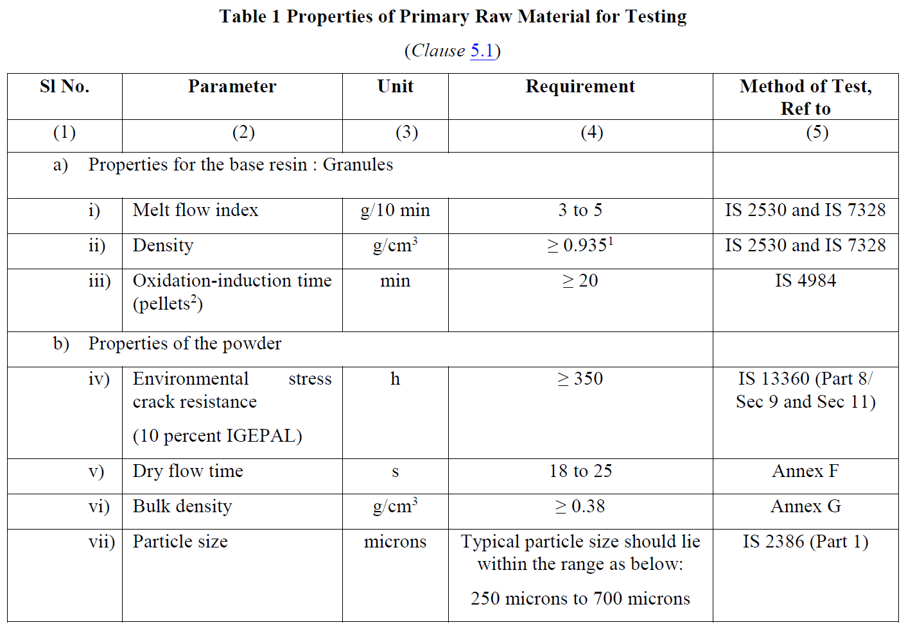
- Additives: "UV stabilizers, antioxidants, and pigments must be evenly distributed to ensure durability and performance."
- Dimensional Accuracy: "Regular checks ensure adherence to design specifications, including wall thickness, shape, and size tolerances of ±3%."
- Visual Inspection: "The surface of the tank is checked for defects such as air bubbles, cracks, or uneven coloration that could compromise performance."

Testing Procedures
- Water Tightness Tests: "Tanks are subjected to water and pneumatic pressure tests to ensure no leakage occurs under operating conditions."
- Load-Bearing Tests: "Vertical and lateral load tests verify the tank's structural integrity under soil and groundwater pressure."
- Hydraulic Efficiency: "Tests using simulated sludge confirm the tank’s ability to achieve efficient wastewater treatment."
- Material Properties Testing: "Tests for tensile strength, elongation, flexural modulus, and UV resistance ensure the tank can withstand environmental and operational stresses."
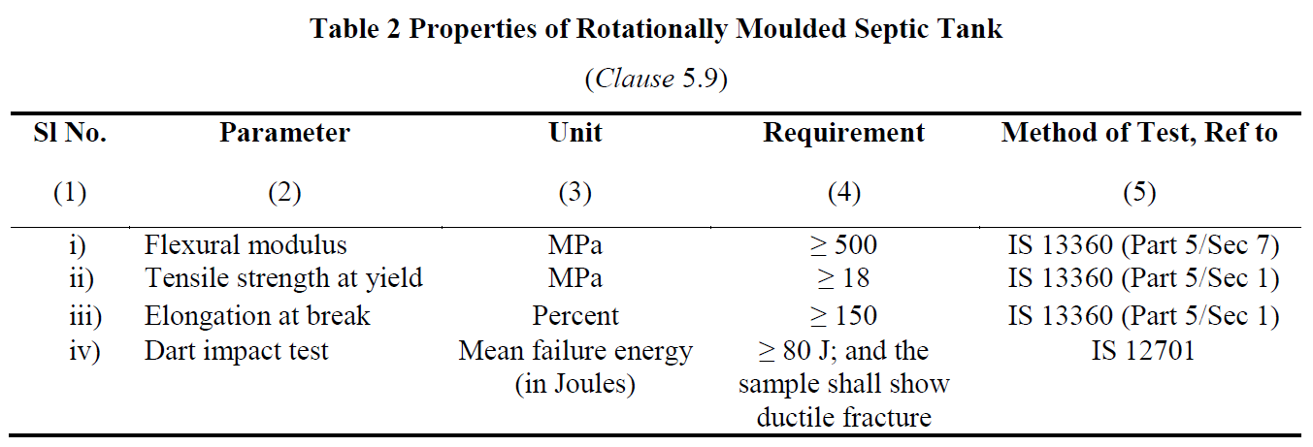
The rotational moulding process is a precise and controlled method, ensuring septic tanks meet the highest standards of quality and performance. Combined with rigorous testing, this process guarantees reliability and durability.
Advantages of rotational moulding include:
- Seamless Construction
- Material Efficiency
- Design Flexibility
- Cost-Effectiveness
- Structural Integrity

- Installation and Maintenance Guidelines
The manufacturer shall provide installation instructions with each septic tank, covering the following:
a) Installation, including duplicating tanks for larger capacities;
b) Pipe connections;
c) Commissioning and start-up;
d) Backfill material properties (Φ and ρ);
e) Designed water table level;
f) Maximum service temperature;
g) Tank depth;
h) Top load limits and maximum cover depth;
i) Hydraulic efficiency.

Maintenance and Troubleshooting
Routine maintenance and timely troubleshooting are key to ensuring the long-term performance and safety of septic tanks. By following the best practices, we can prevent costly repairs and safeguard public health.

Routine Maintenance Tasks
- Sludge Removal: "Periodic desludging is crucial to maintain the tank’s efficiency. Ideally, sludge should be removed every 2–3 years, depending on the tank’s usage and capacity. This prevents clogging and ensures the system operates effectively."
- Component Checks:
  - Inlets and Outlets: "Inspect inlets and outlets to ensure they’re clear and functioning properly, minimizing disturbance to sludge and scum layers."
  - Ventilation Systems: "Check vent pipes for blockages to avoid the buildup of harmful gases."
  - Access Covers and Seals: "Ensure covers are intact and sealed to prevent unauthorized access and water intrusion."
- System Cleaning:
  - Effluent Filters: "Clean effluent filters regularly to prevent the accumulation of solids in the disposal system."
  - Dispersion Trenches or Soak Pits: "Inspect and clean to maintain proper drainage of effluent into the surrounding soil."

Troubleshooting Common Issues
- Slow Draining or Backup:
  - Cause: Blockages in pipes or excessive sludge accumulation.
  - Solution: Check for blockages and schedule desludging if the sludge layer is too high.
- Foul Odors:
  - Cause: Poor ventilation or excessive buildup of scum and sludge.
  - Solution: Inspect and clean the vent pipe, and schedule routine maintenance.
- Surface Water Pooling:
  - Cause: System overload, poor soil absorption, or damage to the dispersion trench.
  - Solution: Reduce water usage, inspect the trench, and repair or extend it as needed.
- Structural Damage:
  - Cause: Soil pressure, improper installation, or physical impact.
  - Solution: Conduct a structural integrity assessment and repair or replace the tank if necessary.
- Frequent Clogging of Effluent Filters:
  - Cause: High solid content or improper cleaning.
  - Solution: Increase cleaning frequency and ensure filters are properly maintained.

Environmental Benefits
- Reduction in Pollution: "Septic tanks effectively treat wastewater on-site, preventing untreated effluent from contaminating groundwater or surface water."
- Support for Decentralized Sanitation: "By eliminating the need for large-scale sewer infrastructure, septic tanks reduce the ecological footprint of sanitation systems."
- Recyclable Materials: "Rotationally moulded polyethylene tanks are made from recyclable materials, minimizing environmental impact at the end of their lifecycle."
- Water Conservation: "The treated effluent can be safely reused for irrigation or groundwater recharge when paired with secondary treatment systems."

Cost Savings
- Lower Installation Costs: "Septic tanks are more affordable than centralized sewage systems, especially in rural or remote areas."
- Minimal Operating Costs: "They require no continuous energy supply, making them cost-efficient to operate and maintain."
- Reduced Infrastructure Dependency: "By treating wastewater on-site, households and communities save on utility bills and avoid infrastructure-related costs."
- Durability and Low Maintenance: "With proper maintenance, these tanks have a long service life, reducing the need for frequent replacements or repairs."

Long-Term Benefits
- Sustainability: "Septic tanks contribute to sustainable wastewater management by offering a decentralized solution that works efficiently for decades."
- Health and Hygiene: "Properly functioning septic systems prevent exposure to untreated waste, safeguarding public health in the long run."
- Property Value Enhancement: "A well-maintained septic system is an asset that adds value to properties, particularly in areas without access to centralized sewage systems."
- Flexibility in Expansions: "Septic systems can be adapted or upgraded as needs change, providing scalability for growing households or communities."

- Conclusion and Q&A (5 minutes)
We discussed the scope and applicability of IS 18666:2024, focusing on its standards for septic tank design, material specifications, and environmental impact. Key points included design considerations like capacity, load-bearing requirements, and maintenance practices. We also highlighted the benefits of rotational moulding, routine maintenance tasks, troubleshooting common issues, and the long-term environmental and cost-saving advantages of septic tanks.

Why follow Indian Standards

- Optimal Performance: Clear guidelines ensure efficient wastewater treatment.
- Durability: Tanks withstand environmental stresses, preventing failures.
- Public Health: Reduces contamination risks, safeguarding hygiene.
- Environmental Protection: Promotes sustainable and eco-friendly practices.
- Cost Savings: Minimizes maintenance and repair expenses.
- Regulatory Compliance: Aligns with policies, avoiding penalties.

CHAPTER 10

Requirements for Street Food Vendors as per IS 16066

INTRODUCTION

To make any city most safe and liveable, the primary need is to ensure that the city is clean, hygienic, and safe from all angles. While safety from crime is a well-known fact, safety from diseases is also equally if not much more important as it affects a much larger number of people.

To ensure safety from diseases and good health the most crucial needs are “safe water” and “safe food”.

In this regards the “Street foods” are of most priority concern. The reasons are well known:
- Street foods are sold in the open environment so can get easily contaminated.
- Street foods are the cheapest food source, so quality is often compromised.
- Street food vendors do not need any training or awareness generation to open a stall.
- Street food vendors have very limited access to safe water in adequate amounts
- Street food stalls commonly lack hygiene and cleanliness and are often placed in unclean areas
- Street food customers being poorly informed do not look for safety and hygiene parameters
- Street food customers are often from the neediest communities so any diseases or infection damage their already existing poor health status.

However, most unfortunately, till recently the monitoring parameters as approved, were complex and needed laboratory investigations along with proper sampling procedures. This was exceedingly difficult and nearly impossible due to lack of adequate number of trained man power to collect samples, conduct laboratory analysis etc. which was a most lengthy and complicated procedures.

Street food business which serves as a mean of livelihood for millions of people in the country also plays an important role by serving food at affordable price to the lower and middle income group. It also serves as the only source food to millions of migrant workers in metropolitan cities. It has been often observed that these hawkers do not maintain proper hygienic conditions which leads to food poisoning to common consumers.

Unless proper hygienic norms are adopted, the consumption of such foodstuffs from these hawkers may be a potential health hazard to the consumers. Frequent heating and reheating of the food products by the food vendors also leads to food contamination. Lack of education/awareness also adds to this problem. There is a considerable scope for improving the hygienic conditions for such food vendors.

Challenges Faced by Street Food Vendors
Street food vendors face several challenges that compromise safety and hygiene:
- Hygiene and Food Handling Issues: Many vendors lack adequate knowledge or facilities for safe food preparation and handling, increasing the risk of foodborne illnesses.
- Inadequate Infrastructure: Vendors often operate without access to clean water, proper sanitation facilities, or suitable storage for food and equipment.
- Poor Waste Management: Improper disposal of food waste leads to environmental pollution and health hazards.
- Health Risks for Consumers: Contaminated food, unsafe cooking practices, and exposure to unclean environments pose significant public health risks.
- Inconsistent Quality: The absence of standardized practices results in varying levels of quality, which erodes consumer trust in street food.

The Role of IS 16066:2017
The Indian Standard IS 16066:2017 was developed to address these challenges and create a structured approach for improving the safety and quality of street food vending. It provides:
- Hygiene and Food Safety Requirements: Guidelines for safe food handling, preparation, and storage to reduce health risks.
- Infrastructure Standards: Recommendations for clean water access, sanitation facilities, and appropriate equipment.
- Waste Management Practices: Directions for proper disposal of food waste to minimize environmental and health impacts.
- Grading and Ranking Systems: A system to evaluate and rank vendors based on their adherence to safety and hygiene standards, serving as an incentive for improvement.
- Municipal Oversight: Clear roles and responsibilities for municipal authorities to monitor compliance and provide support to vendors.

Benefits of Standardized Practices
Implementing IS 16066 has far-reaching benefits for the urban food ecosystem:
- Public Health Improvements: Better food handling practices reduce the incidence of foodborne diseases.
- Consumer Confidence: Transparent and reliable grading systems enhance trust in the safety and quality of street food.
- Support for Vendors: Clear guidelines help vendors improve their operations, increase customer satisfaction, and boost their economic prospects.
- Environmental Sustainability: Effective waste management practices contribute to cleaner urban environments.
- Urban Food System Transformation: Standardized practices promote a safer, more hygienic, and reliable street food ecosystem
BACKGROUND OF IS 16066
This Standard was first published in 2012. IS 16066 follows the food chain approach from primary production to final consumption. It highlights the key hygiene controls at each stage to ensure safe food to consumer.
The standard IS 16066 ‘Street Food Vendors — Food Safety Requirements’ was first published in 2012 to fulfil this long felt need and follows the food chain from primary production through to final consumption, highlighting the key hygiene controls at each stage. Considerable assistance has been derived from CII publication namely ‘CII-14 Points check on food safety for street vended food, Version 1.0 while framing this standard’

The standard was revised in 2017 to incorporate grading of Street Food Vendors based on the checklist on the basis of compliance to the requirements of the standard so as to make it an auditable and implementable standard. It is expected that this standard, will be of considerable assistance to local health authorities in enforcing proper hygienic conditions in the interest of public health.

The revised Indian Standard IS 16066: 2017 Street Food Vendors – Food Safety Requirements published by BIS for the first time provides with an easy to assess method (mostly visual) at Level – 1 evaluation, which is fast, easily understood and simplest. This can be conducted in a few minutes by even the vendor or customer himself if a simple training is provided. Based on this ‘Star ratings’ have also been suggested for the vendors, so that there is a healthy competition among them to motivate them to improve and sell clean and safe food and beverage. Hence, this is a most convenient, effective and easy to implement procedure which is expected to help the common man significantly.

IS 16066: 2017

Scope
The scope of the IS 16066 standard includes critical checkpoints and criteria to ensure the safety and hygiene of street food vendors. It applies to both mobile and fixed vendors serving prepared or raw food for human consumption.
Control Check Points and Minimum Requirements:
- Establishes control points with minimum requirements to ensure food safety.
- Provides a checklist with grading criteria for vendors to ensure safe food practices.
- Covers all mobile and fixed food vendors, ensuring uniformity in safety practices.
Potentially Hazardous Food:
- Includes foods capable of supporting the rapid growth of pathogenic and toxic microorganisms.
- Requires temperature control to prevent contamination.
- Examples: Milk, meat, fish, eggs, and cut fruits.

II. Control Check Points
The standard identifies key areas for monitoring and control to ensure safety and hygiene:
- Quality of inputs and ingredients
- Transport, reception, and storage of inputs
- Vending location
- Vending cart
- Utensils and cutting tools (material, cleaning, and storage)
- Hygienic practices
- Personal hygiene and habits
- Food preparation, cooking, and handling
- Transport of prepared food
- Protection and serving of food
- Handling and disposal of waste
- Pest control
- Training for food handlers

III. Detailed Checkpoints and Guidelines

Quality of Inputs and Ingredients
- Use high-quality ingredients with good sensory properties (taste, smell, color, texture).
- Prefer seasonal and local ingredients for freshness and sustainability.
- Ensure packaged food items are within their expiry or “best before” date and are intact.
- Verify the presence of quality marks such as ISI or Agmark for packaged goods.

Transport, Reception, and Storage of Inputs
- Maintain proper time and temperature standards during transport and storage of perishable items.
- Store inputs in clean, covered containers and avoid cross-contamination.
- Separate storage for soaps, chemicals, and sanitizers from food items.
- Ensure perishable items are consumed within their appropriate shelf life.
- Label ingredients that look similar to avoid misuse.
- Store raw, semi-cooked, and cooked food separately to prevent contamination.
- Dispose of unfit or rejected materials hygienically.

Vending Location
- Locate vending units away from polluted areas, open drains, and animals.
- Avoid flood-prone areas or those with improper waste removal.
- Operate only in authorized locations approved by local authorities.
- Ensure surroundings are clean, litter-free, and well-lit for hygienic operation.
- Provide waste disposal facilities and covered rubbish bins at sale points.

Vending Cart
- Ensure the cart is built from rust-resistant, easy-to-clean materials.
- Maintain working surfaces that are hygienic and impermeable, at least 60-70 cm above ground.
- Protect carts from sun, wind, and dust, and store them in clean, safe locations when not in use.
- Equip carts with clean water in protected containers for cooking and cleaning.
- Ensure mobile van driving compartments are separated from the food area.

Utensils and Cutting Tools
- Use heat-tolerant, corrosion-resistant cooking utensils that are easy to clean.
- Avoid utensils made from copper, cadmium, or other toxic materials.
- Ensure utensils are cleaned with detergent and running water after each use.
- Air dry utensils and store them in a protected place.
- Prohibit wiping utensils with unclean cloths, aprons, or hands.

Hygienic Practices
- Ensure food handlers wash hands with soap and water before handling food.
- Provide separate containers for handwashing.
- Use potable water for cleaning and preparing food.
- Handle ready-to-eat food with utensils such as scoops, tongs, or disposable gloves.
- Replace soiled or damaged gloves immediately.

Personal Hygiene and Habits
- Food handlers must be free from infectious diseases and practice good hygiene.
- Maintain short, clean fingernails and wear clean clothing.
- Avoid wearing jewelry or loose items that could fall into food.
- Prohibit smoking, eating, or chewing in food preparation areas.

Food Preparation, Cooking, and Handling
- Cook food thoroughly and serve at safe temperatures.
- Avoid reheating food multiple times or using reheated oil.
- Protect food from dust and contamination during preparation and serving.
- Wash vegetables, pulses, and meats with potable water before cooking.
- Prepare food in quantities sufficient for the day to avoid leftovers.

Transport of Prepared Food
- Use protected containers for food transport.
- For long distances, maintain hot food in thermal boxes and cold food in refrigerated containers.

Protection and Serving of Food
- Protect food with acrylic or glass covers to prevent contamination.
- Use food-grade containers for storage.
- Serve food using clean utensils and disposable materials where necessary.
- Store leftover food at appropriate temperatures and avoid re-serving it.

Handling and Disposal of Waste
- Use covered bins with foot-operated lids for waste disposal.
- Segregate solid and liquid waste and dispose of it at designated points.
- Use color-coded bins for biodegradable and non-biodegradable waste.

Pest Control
- Keep vending areas clean and free from rodents, birds, and pests.
- Use traps or preventive measures to avoid contamination.
- Periodically fumigate food vending areas with approved chemicals.

Training
- All food handlers must undergo basic training in food safety and hygiene before beginning operations.
- Regular refresher training sessions should be conducted to maintain standards.
GRADING AND RATING OF STREET FOOD VENDORS
- Categorization of Street Foods
For the purpose of grading of street food vendors, street foods can be categorized as under:
- Category I - Foods prepared in small scale or cottage industry and brought to the street food stalls by different vendors for sale (eg. Sandesh, Bhelpuri, chaat-papdi etc).
- Category II - Foods prepared at the home of vendor and brought to street food stall for sale (eg. Curries , biryani etc).
- Category III - Foods prepared and sold at the street food stall itself (eg. Parantha roll, Dosa, chowmein, jalebis etc).

- Grading/Rating of street foods
Level 1- Preliminary Basic Safety Rating System
The rating is conducted based on selected indicators provided in the standard checklist.
S.No. | Indicators | No. of Sub-indicator
1. | Raw Material Quality | 3
2. | Cleaning & Storage of Raw Material (done through interview for Category I & II) | 3
3. | Food Processing & Cooking (done through interview for Category I & II) | 3
4. | Transport to street food stall/kiosk (NA for Category III) | 3
5. | Display and serving of food | 6
6. | Water & Ice | 4
7. | Hygiene and Health of Food Handlers | 7
8. | Kiosk location & cleanliness | 3
9. | Garbage handling and disposal | 4
10. | Improving nutrition value of street foods | 4
 | TOTAL | 40

Category wise checklist with total indicators for street foods is as under:
Numbers | Category I | Category II | Category III
Overall Indicators | 10 | 10 | 9
Sub-Indicators | 40 | 40 | 37

Based on level of implementation and compliance to categorized indicators, street food vending establishments are rated as follows
Ratings
Excellent | All overall Indicators complied with Plus 90%-100% complia nce of sub-indicators
Very Good | All overall Indicators complied with Plus over 80% - Below 90% compliance of sub-indicators
Good | All overall Indicators complied with Plus over 60% to Below 80% compliance of sub-indicators
Fair | All overall Indicators not covered or sub-indicators complied below 60%

Detailed of Grading of Street Foods
Grades | Overall Indicators |  |  | Sub- Indicators
Grades | Categories |  |  | Categories
Grades | I (10) | II (10) | III (9) | I (40) | II (40) | III (37)
Excellent | 10 | 10 | 9 | 36-40 | 36-40 | 33-37
Very good | 10 | 10 | 9 | 32-35 | 32-35 | 30-32
Good | 10 | 10 | 9 | 24-31 | 24-31 | 22-29
Fair | <10 | <10 | <9 | <24 | <24 | <22

Level 1- Preliminary Basic Safety Rating
Street Food management needs active involvement of following stakeholders: | Food Safety Officer
 | Municipality/Corporation/Local Urban Body Personnel
 | Police
 | Vendors
 | Community (Customers)
 | NGOs and Voluntary Bodies
 | Experts

Check Points for Different Stakeholders for Grading
Sl No. | Checkpoints | Vendors | Food Safety/ Municipal Officers | Police | Customers | Experts/Others
i | Raw Material | ✔ | ✔ | x | ✔ | ✔
ii | Storage of raw material | ✔ | ✔ | x | ✔ | ✔
iii | Processing and cooking | ✔ | ✔ | x | ✔ | ✔
iv | Transportation to street food stall/Kiosk | ✔ | ✔ | x | x | ✔
v | Display/ Sale of food | ✔ | ✔ | x | ✔ | ✔
vi | Use of left overs | ✔ | ✔ | × | × | ✔
vii | Personal hygiene and health | ✔ | ✔ | × | ✔ | ✔
viii | Overall cleanliness | ✔ | ✔ | ✔ | ✔ | ✔
ix | Water and ice | ✔ | ✔ | ✔ | ✔ | ✔
x | Nutrition | ✔ | ✔ | × | ✔ | ✔

Level 2 - Advance Safety Rating System
For doing a confirmed Grading, specially for either high risk foods or foods sold in vulnerable areas like near school, hospitals etc, using supportive laboratory supported assessment.
This involves detailed assessments for high-risk foods or food sold in vulnerable areas. After initial grading under Level 1, further confirmation is done through sample surveys and analysis covering physical, chemical, and microbiological aspects. This process certifies food safety.
Elaborate assessment needs for either high risk foods or food sold in vulnerable areas.
- After grading/categorization as under Level 1, confirmation done through a sample survey and analysis following the physical, chemical and microbiological
- Helpful to certify that the food is safe.
Physical Contaminants
Indicators | Clinical Significance
- Filth | - Since street foods are sold in open, physical contaminants may cause stomach irritation  - Smell and appearance indicate whether food is acceptable  - Taste/eatability indicate whether the food is of good quality or not.
- Dust
- Dirt
- Appearance
- Smell
- Taste
- Eatability

Chemical Contaminants
Indicators | Clinical Significance
Ash | Discerned by consumers, deterrent for sale
Argemone Oil | Toxic adulterant in edible oils
Lathyrus Sativus | Lathvrism
Metanil Yellow | Toxic colour- carcinogenic
Saccahrin | Co-carcinogenic agent – chronic consumption might be injurious to  Health
Heavy metal | Pigmentation, vomiting, irritation
Aflatoxin | Toxin from fungal infection

Microbiological Contaminants
 | Indicators | Clinical Significance
Food | 1. E.coli | Indicate faecal coliform contamination
Food | 2. Salmonella | Cause food poisoning related typhoid
Food | 3. Shigella | Cause dysentery
Food | 4. Streptococcus | Cause food poisoning
Food | 5. Fungus | Bad odour, bad taste and toxic symptom
Food | 6. Proteus | Invasive and toxigenic causes diarrhoea
Food | 7. Streptococcus | Exotoxin in food causes vomiting and diarrhoea. Generally fever is absent
Food | 8. Enterococcus | Causes diarrhoea
Food | 9. Bacillus | Toxin in food causes vomiting and diarrhoea
Water | 1. Coliform | Imparts bad odour and taste  Indicates presence of faecal coliform
Water | 2. E.Coli

IMPLEMENTATION IS 16066: 2017
The implementation of IS 16066: 2017 focuses on ensuring food safety and hygiene standards for street food vendors. The process is outlined through the following detailed steps:

I. Identify Locations with Significant Street Vendor Presence
- Conduct surveys and mappings to locate areas with a high density of street food vendors.
- Focus on busy markets, transportation hubs, and areas with high pedestrian traffic.

II. Recognize Vulnerable Areas
- Pay special attention to sensitive zones where food safety is critical, such as:
  - Schools: To protect children from foodborne illnesses.
  - Hospitals: To avoid compromising the health of patients and visitors.
  - Temples and Religious Areas: To ensure food offered or consumed in large gatherings is safe.

III. Sensitize Municipalities and Local Urban Bodies
- Educate local governing bodies about the standard's requirements.
- Highlight the importance of adopting food safety practices to reduce health risks and enhance public confidence in street food quality.

IV. Conduct Training and Awareness Programs
- Organize workshops and training sessions for:
  - Vendors: To teach safe food handling, hygiene, and waste disposal practices.
  - Consumers: To raise awareness about identifying safe food options.
  - NGOs and Other Stakeholders: To encourage active participation in monitoring and supporting vendors.

V. Perform Surveys to Assess Training Effectiveness
- Measure the impact of the training programs through:
  - Feedback from vendors and participants.
  - Observations of changes in vendor practices.
  - Data on the reduction of foodborne illnesses in the community.

VI. Contact BIS Offices for Implementation Support
- Municipalities and local urban bodies are encouraged to seek guidance and resources from Bureau of Indian Standards (BIS) offices.
- BIS can provide:
  - Detailed documentation on standards.
  - Support for training and awareness initiatives.
  - Certification services to verify compliance with IS 16066: 2017.

