Micro Irrigation Systems

INTRODUCTION

Today, I’ll be discussing about the Indian Standards on Micro-Irrigation Systems developed by the Bureau of Indian Standards, with a focus on drip and sprinkler irrigation system. Let’s dive in and explore the standards that guide the design, manufacturing, and functionality of these systems, ensuring efficiency and sustainability in agricultural practices.

CONTENTS

Our Ist session of today will cover the following topics:

- About Irrigation, the concept, types of irrigation methods and factors affecting irrigation.

- Indian Standards in the field of irrigation.

- What these standards cover for drip and sprinkler irrigation systems.

- A breakdown of specific standards, including their technical specifications and test requirements.

Our 2nd Session will then cover details of

- Indian Standards on different types of Filters, Fertigation Systems,

- Design, Installation and Operation of Sprinkler Irrigation,

- Preventive Maintenance of Drip Irrigation Systems

Let’s begin with the basics.

IRRIGATION OVERVIEW

Irrigation refers to the artificial application of water to crops. It is a critical agricultural practice, especially in areas with irregular rainfall or arid climates. The main goal of irrigation is to ensure optimal water availability for crops, maximizing yield and productivity.

As per report of Bureau of Water Use Efficiency, agriculture is the largest consumer of water in India, which accounts up to 80% of the total freshwater withdrawals out which irrigation consumes the most. There are various types of irrigation methods (see Slides), which may be used by the farmer based on various factors (see slides). But out all, Micro Irrigation is the most water efficient methods of irrigation. You all are aware, efficient water use in irrigation is not just a best practice—it is a necessity. MIS ensures that water is delivered exactly where it’s needed, in the right amounts, and at the right time, preventing wastage and promoting sustainability

Therefore, objective of this session will be to discuss the standards developed by the BIS on micro-irrigation systems (Drip and Sprinkler Irrigation System), which ensures their performance and reliability.

INDIAN STANDARDS IN IRRIGATION

BIS has developed standards on:

- Pipes, Filters, Valves used in Drip and Sprinkler Irrigations Systems
- Standards for fertigation unit
- Code of practices for design, installation, operation, maintenance of sprinkler and drip irrigation
- Quality of Irrigation Water

Adhering to these standards is essential for achieving long-term durability, efficiency, and compatibility of irrigation equipment.

Now, let’s delve into the specific standards for drip and sprinkler irrigation systems.


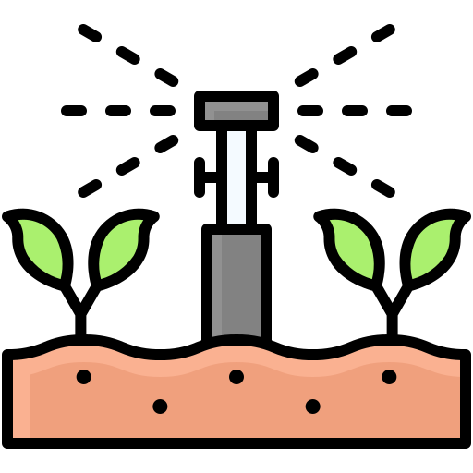

DRIP IRRIGATION STANDARDS

Drip irrigation is a method where water is delivered directly to the root zone of plants in small, controlled quantities. This system is highly efficient as it minimizes water loss due to evaporation or runoff.

You may see the representation of a Drip Irrigation System in the below Picture:

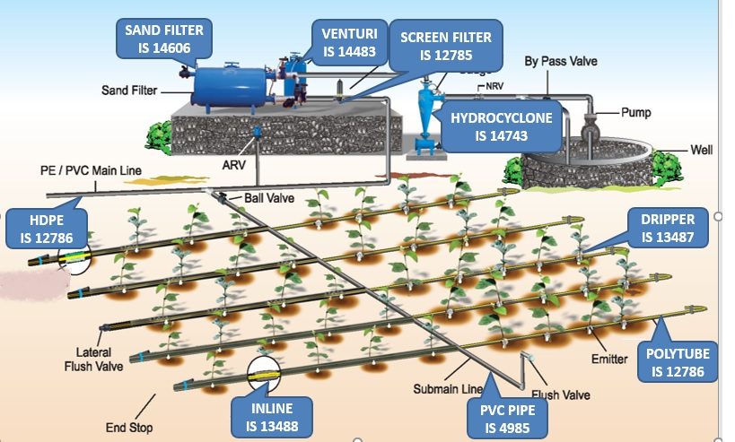

The key standards on drip irrigation include:
1. IS 12786 : 2024
2. IS 13488 : 2008
3. IS 13487 : 2025
4. IS 14971 : 2024

About IS 12786 : 2024 IRRIGATION EQUIPMENT — POLYETHYLENE PIPES FOR IRRIGATION LATERALS — SPECIFICATION (first revision)

This standard lays down requirements for pipes of outside diameter from 12 mm up to 32 mm to be used for irrigation laterals that is branch supply lines on which sprayers or drippers or emitters are mounted directly or by means of a fitting or formed in the pipe during production.

The pipes must be able to withstand up to 800 working hours annually, at a maximum water temperature of 35°C. Under these conditions, the expected lifespan of the pipes is 10 years.

Classification of Lateral Pipe based on Working Pressure

Class of Pipe | Working Pressure | Colour
Class 1 | 0.20 MPa | Red
Class 2 | 0.25 MPa | Yellow
Class 3 | 0.40 MPa | Green

SPECIFICATION  REQUIRMENTS  TEST | SIGNIFICANCE
Material | To ensure right quality material with right amount of ingredients to achieve resistance against UV and to withstand environmental conditions.
Dimensions | All the manufacturer follows common dimensions. Makes it easy for the user to select proper tubing according to his requirements.
Hydraulic Characteristic | Pressure withstanding capacity of the tubing for ambient and elevated temperature.
Reversion Test | Checks effect of air temperature on laying length of the lateral.
Tensile Test | Tube shall withstand pulling force while laying and retrieval
Environmental Stress Crack Resistance | Ensure that tube shall not crack due to environmental stresses

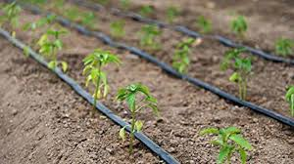
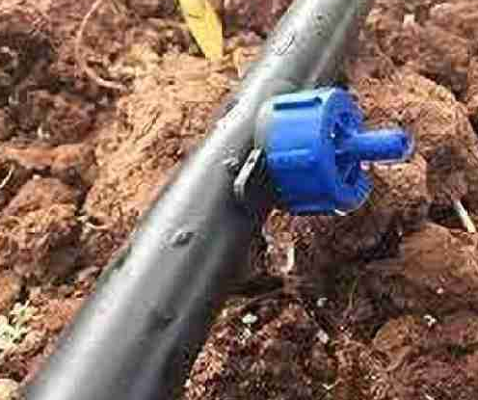
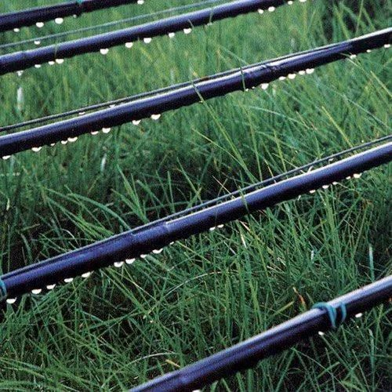
Dimensions of Polyethylene Pipes for Irrigation Laterals

Outside  Diameter | Tolerance on outside  Diameter | Class 1  (0.20 MPa) |  | Class 2  (0.25 MPa) |  | Class 3  (0.40 MPa)
 |  | Min | Max | Min | Max | Min | Max
12 | + 0.2 | 0.6 | 0.8 | 0.9 | 1.1 | 1.2 | 1.4
16 | + 0.2 | 0.8 | 1.0 | 1.1 | 1.3 | 1.4 | 1.6
20 | + 0.2 | 0.9 | 1.1 | 1.2 | 1.4 | 1.5 | 1.7
25 | + 0.3 | 1.2 | 1.6 | 1.7 | 2.0 | 2.1 | 2.4
32 | + 0.3 | 1.5 | 1.9 | 2.0 | 2.4 | 2.5 | 2.9
NOTE — Wall thickness of pipes are based on a safe working stress of 2.5 MPa at 20 °C. Occasional rise ii temperature has no deleterious effects on the life and working pressure of the pipes.

About IS 13488 : 2008 IRRIGATION EQUIPMENT — EMITTING PIPE SYSTEMS — SPECIFICATION (first revision)

IS 13488 specifies the mechanical and functional requirements of the emitting pipes and their fittings, test methods and the data to be supplied by the manufacturer to facilitate correct installation and operation in the field.

This standard applies to emitting and trickling pipes, hoses and tubings intended for irrigation. in which the emitting units form an integral part. This standard also applies to the fittings used for connecting these pipes, hoses and tubings. This standard does not apply to continuously porous pipe (porous along its entire length and circumference).

It classifies Emitting Pipes into different Categories:
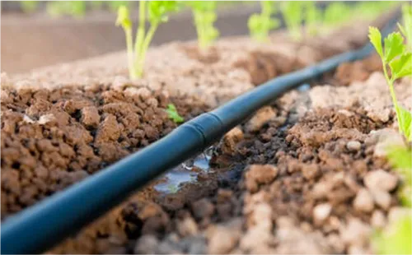
Based on Pressure Regulation

Unregulated Emitting Pipes
Regulated Emitting Pipes

Based on Uniformity

Uniformity Category A
Uniformity Category B

Based on Working Pressure

Class of Pipe | Working Pressure
Class 1 | 0.100 MPa
Class 2 | 0.125 MPa
Class 3 | 0.250 MPa
Class 3 | 0.400 MPa

Material Requirement of Emitting Pipes:

- The material used in the manufacture of emitting pipes and their fittings shall be resistant to fertilizers and chemicals commonly employed in irrigation and shall be suitable for use with water at temperatures up to 60°C and at pressures designed for the emitting pipe.

- The materials shall, as far as possible. not support the growth of algae and bacteria. The parts of the emitting pipe that are exposed to sunlight. shall be opaque and protected against UV degradation.

Dimensions of Polyethylene Emitting Pipes ((All dimensions in millimeters)

Sl. No. | Nominal  Diameter | Inside  Diameter | Tolerance on I.D. | Wall Thickness
 |  |  |  | Class 1  0.100 MPa | Class 2  0.125 MPa | Class 3  0.250 MPa | Class 4  0.400 MPa
 | 12 | 10.50 | + 0.20  - 0.00 | 0.4-0.5 | 0.6-0.7 | 0.8-1.0 | 1.1-1.3
 | 16 | 14.20 | + 0.20  - 0.00 | 0.5-0.6 | 0.7-0.9 | 1.0-1.2 | 1.3-1.5
 | 20 | 18.00 | + 0.20  - 0.00 | 0.7-0.8 | 0.9-1.1 | 1.2-1.4 | 1.5-1.7
 | 25 | 22.60 | + 0.20  - 0.00 | 0.9-1.1 | 1.2-1.4 | 1.5-1.7 | 1.8-2.2
NOTE — The wall thicknesses of pipes are based on safe working stress of 2.5 MPa at 20°C. Occasional rise in temperature has no deleterious effect on the life and working pressure of the pipe. Clamping, such as bands and screws, shall be of non-corrosive materials or of materials protected against corrosion.

SPECIFICATION  REQUIRMENTS  TEST | Significance
Material | To ensure right quality material with right amount of ingredients to achieve resistance against UV and to withstand environmental conditions.
Dimensions | All the manufacturer follows common dimensions. Makes it easy for the user to select proper tubing according to his requirements.
Uniformity of Flow Rate | Ensures that nearly uniform water shall be delivered to crops.
Emission Rate as a function of inlet pressure | Tells us how flow rate will vary for pressure fluctuations
Hydrostatic Pressure | Sudden change in pressure or operation of the dripline at higher pressure.
Resistance to tension at elevated temperature | Even if temperature increases, there shall not be deviation in flow rate by more than 5%
Resistance to Pull Out | Tube shall not be pulled out of fittings for nominal pulling force.
Environmental Stress Crack Resistance | Ensure that tube shall not crack due to environmental stresses
Emitter Unit Exponent | This is an indicator for performance of the emitter.

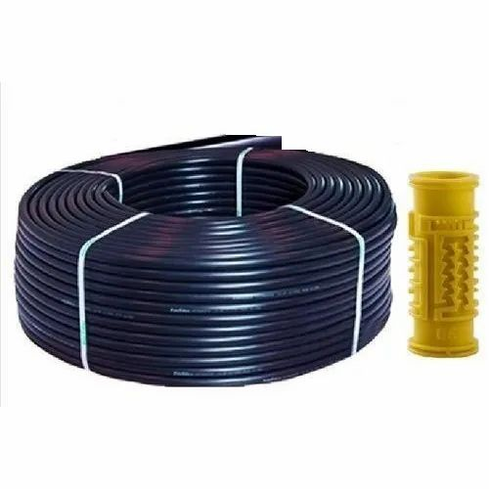
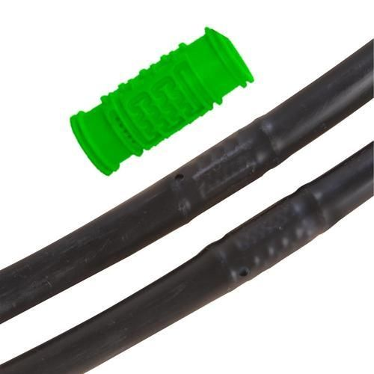

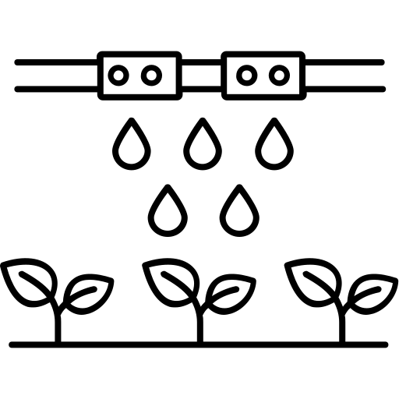

About IS 13487 : 2025 IRRIGATION EQUIPMENT — EMITIERS — SPECIFICATION (first revision)

Emitters/Drippers are small devices in drip irrigation systems that deliver water directly to plant roots in a controlled and precise manner. They regulate water flow, ensuring efficient use and minimizing wastage. Different types, like pressure-compensating and non-pressure-compensating emitters, cater to varying irrigation needs.

IS 13487 specifies mechanical and functional requirements of irrigation emitters, test methods and the data to be supplied by the manufacturer to permit correct installation and operation in the field.

NOTE - It applies to emitters, with or without pressure regulation, intended for irrigation; it does not apply to emitters which form an integral part of the pipe during manufacture as well as microtubes.

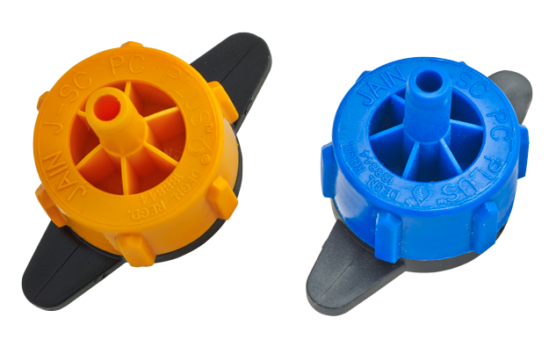
It classifies Emitters into different Categories:

Based on Mounting on Pipes
In-Line Emitters
On-Line Emitters

Based on Pressure Regulation
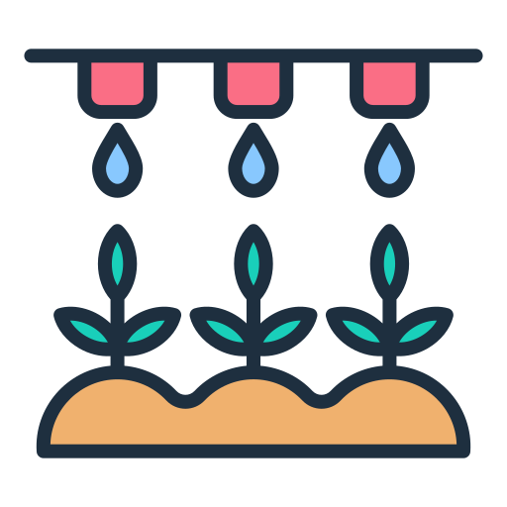
Unregulated Emitters
Regulated Emitters

Based on Uniformity
Uniformity Category A
Uniformity Category B

Based on Number of Outlets
Single Outlet
Multi Outlet

Material Requirement of Emitting Pipes:

The material used in the manufacture of emitting pipes and their fittings shall be resistant to fertilizers and chemicals commonly employed in irrigation, and shall be suitable for use with water at temperatures up to 60°C and at pressures designed for the emitting pipe.
The materials shall, as far as possible. not support the growth of algae and bacteria. The parts of the emitting pipe that are exposed to sunlight. shall be opaque and protected against UV degradation.

Mechanical Tests and Requirements

- Construction and Workmanship – visual inspection for manufacturing defects
- Flow Paths In Emitter – dimension measurement
- Resistance to Hydrostatic Pressure – performance of emitter against high pressure
- Emitter Pull-out Test

Functional Tests and Requirements

- Uniformly of Emission Rate: Ensures that nearly uniform water shall be delivered to crops from all emitters:
- Emission Rate as a Function of Inlet Pressure: Tells us how flow rate will vary for pressure fluctuations
- Determination of Emitter Exponent: This is an indicator for performance of the emitter.
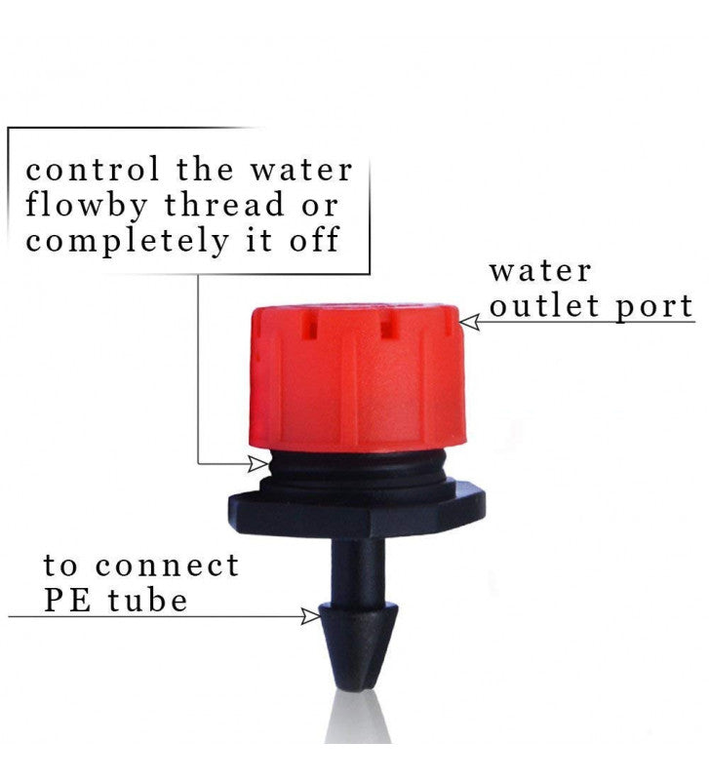

SPRINKLER IRRIGATION STANDARDS

Sprinkler irrigation systems mimic natural rainfall by spraying water over crops. These systems are versatile and suitable for a variety of terrains and crop types.

You may see the representation of a Drip Irrigation System in the below Picture:

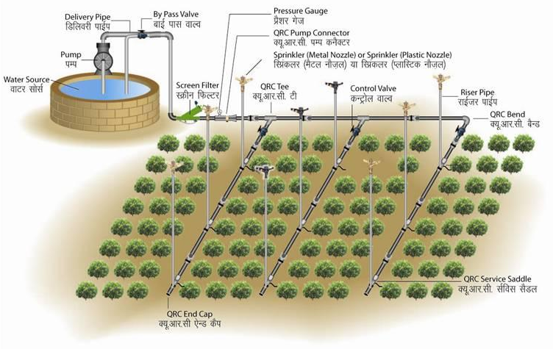

The key standards for sprinkler irrigation include:
1. IS 17425: 2020
2. IS 12232 (Parts 1 and 2)
3. IS 14605: 1998
4. IS 18286: 2023
5. IS 14792 : 2000

About IS 17425 : 2020 IRRIGATION EQUIPMENT - QUICK COUPLED POLYETHYLENE PIPES AND FITTINGS FOR SPRINKLER IRRIGATION SYSTEMS – SPECIFICATION

A vital component of MIS is the piping network, which transports water from the source to the sprinkler heads. Proper sizing, material selection, and installation of pipes are crucial to minimize pressure losses and optimize water distribution.

IS 17425 lays down the general requirements for raw materials, manufacturing, method of tests and testing of quick coupled and plain polyethylene pipes and fittings of outside diameters 40 mm to 200 mm used for portable sprinkler and drip irrigation systems as mains, sub mains or laterals.

Components of Quick Coupled Polyethylene Pipes:
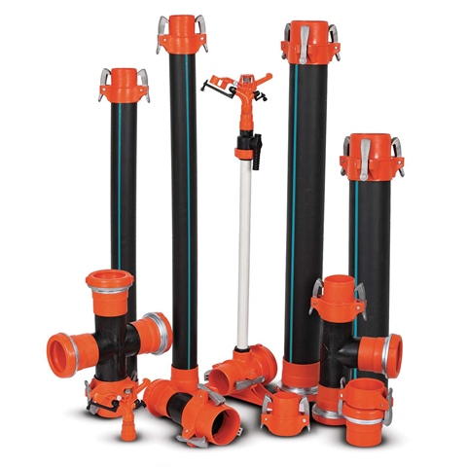
Sprinkler Pipe
Quick Coupled Sprinkler Pipe
Male Coupler
Female Coupler
Sprinkler Quick Coupled Fittings
Quick Coupled Tee
Quick Coupled Bend
Quick Coupled Pump Connector
Quick Coupled End Cap
Quick Coupled Reducer
Quick Coupled Foot Batten Assembly
Sprinkler Riser

Classification of Pipes Based on Working Pressures:

Class of Pipe | Maximum Permissible Working Pressure at 30 °C
Class 1 | 0.25 MPa
Class 2 | 0.32 MPa
Class 3 | 0.40 MPa
Class 4 | 0.60 MPa

Important Requirements of Quick Coupled Pipes and Fittings

SPECIFICATION | SIGNIFICANCE
Leakage Test | Fittings coupled to the pipe are tested for leakage with water as medium with pressure from 0.0 MPa to maximum working pressure.
Hydraulic Proof Test | Same assembly as above tested at higher pressures checking the Pressure withstanding capacity.
Weldability Test | Hydraulic performance test (7.1.2) performed, to establish the joint between the couplers and pipe.

Important Requirements of Plain Sprinkler Pipes

SPECIFICATION | SIGNIFICANCE
Visual Appearance and Workmanship  (7.1.1) | pipes shall be smooth, clean and free from grooving, pit marks and melt fractures.
Hydraulic Performance Characteristics  (7.1.2) | Pressure withstanding capacity of the pipe for ambient and elevated temperature.
Reversion Test (7.1.3) | Checks effect of air temperature on laying length of the lateral.
Tensile Test | Tube shall withstand pulling force while laying and retrieval
Fusion Compatibility Test | Testing the pipes joined with butt fusion, friction welding, socket fusion or using electro fusion fitting.
Environmental Stress Crack Resistance | Ensure that tube shall not crack due to environmental stresses

About IS 12232 Part 1 and Part 2 : ROTATING SPRINKLER

IS 12232 (Part 1) specifies the design and operational requirements of rotating sprinklers, sprinkler nozzles and their test methods.

On the other hand IS 12232 (Part 2) specifies the conditions and methods used for testing of uniformity of distribution of rotating sprinklers which is important parameter for sprinkler irrigation system to achieve uniform/even application over the covered land area.

Material Requirements:

- Sprinklers shall be made of metals or plastics. Metal sprinklers shall be made from a copper alloy or of other metals whose mechanical properties and resistance to corrosion when used with irrigation water are not less suitable than those of copper alloys.

- Plastics parts of the sprinklers which conduct water and which are exposed to sunlight shall be opaque. Plastics parts of sprinklers exposed to ultraviolet (UV) radiation shall contain an additive resistant to UV radiation.

Performance Requirements (apply to sprinklers having one or more nozzles)

- Effective pressures - The sprinkler shall rotate continuously and regularly in its designed direction within its entire range of effective pressure from the minimum effective pressure, P_{min} up to the maximum effective pressure, Pmax.

- Actuating mechanism - The actuating mechanism of the sprinkler shall operate in accordance with strength test and operating tests given in the standard at any inclination of the riser up to 10" from the vertical.

Important Requirements of Rotating Sprinkler

Specification | Significance
Resistance to threaded connection | Sprinkler shall withstand tightening torque
Hydrostatic Pressure | Performance against increase in pressure.
Uniformity of Flow Rate | Ensures that nearly uniform water shall be delivered to crops.
Water Distribution Curve | Ensures uniformity of water distribution
Durability Test | This test ensures performance against life of the sprinkler.
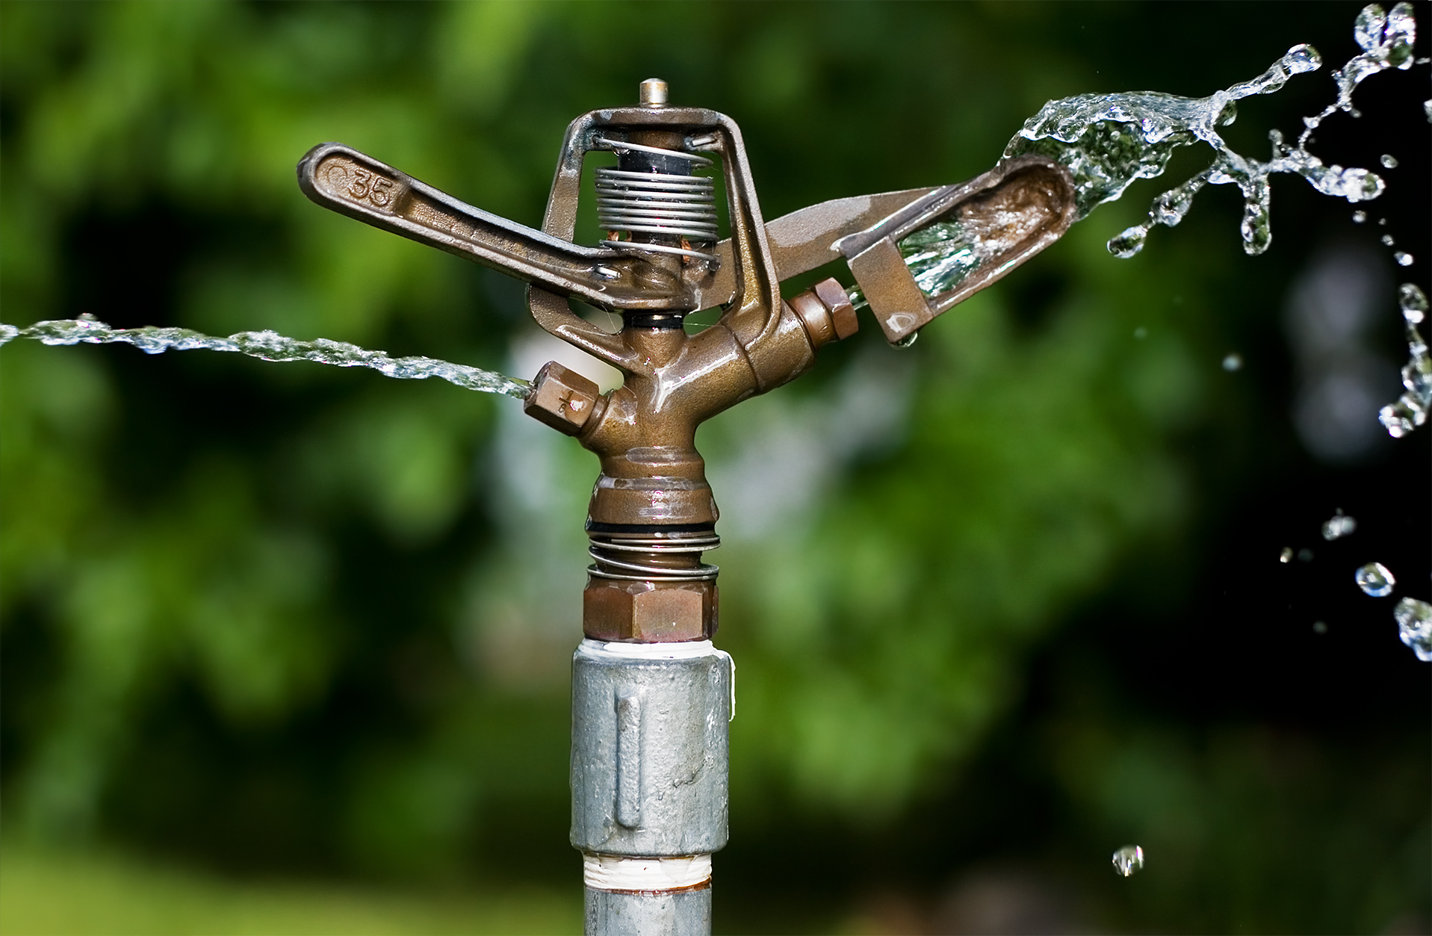

About IS 14605 : 1998 IRRIGATION EQUIPMENT — MICRO SPRAYERS — SPECIFICATION

Micro sprayers are type of sprinklers used to deliver water to the crops as a fine spray or mist, ensuring efficient coverage with minimal water wastage.
IS 14605 specifies the general requirements and test methods for micro sprayers. It applies to sprayers intended for assembly in pipeline networks for irrigation and for operation with irrigation water.

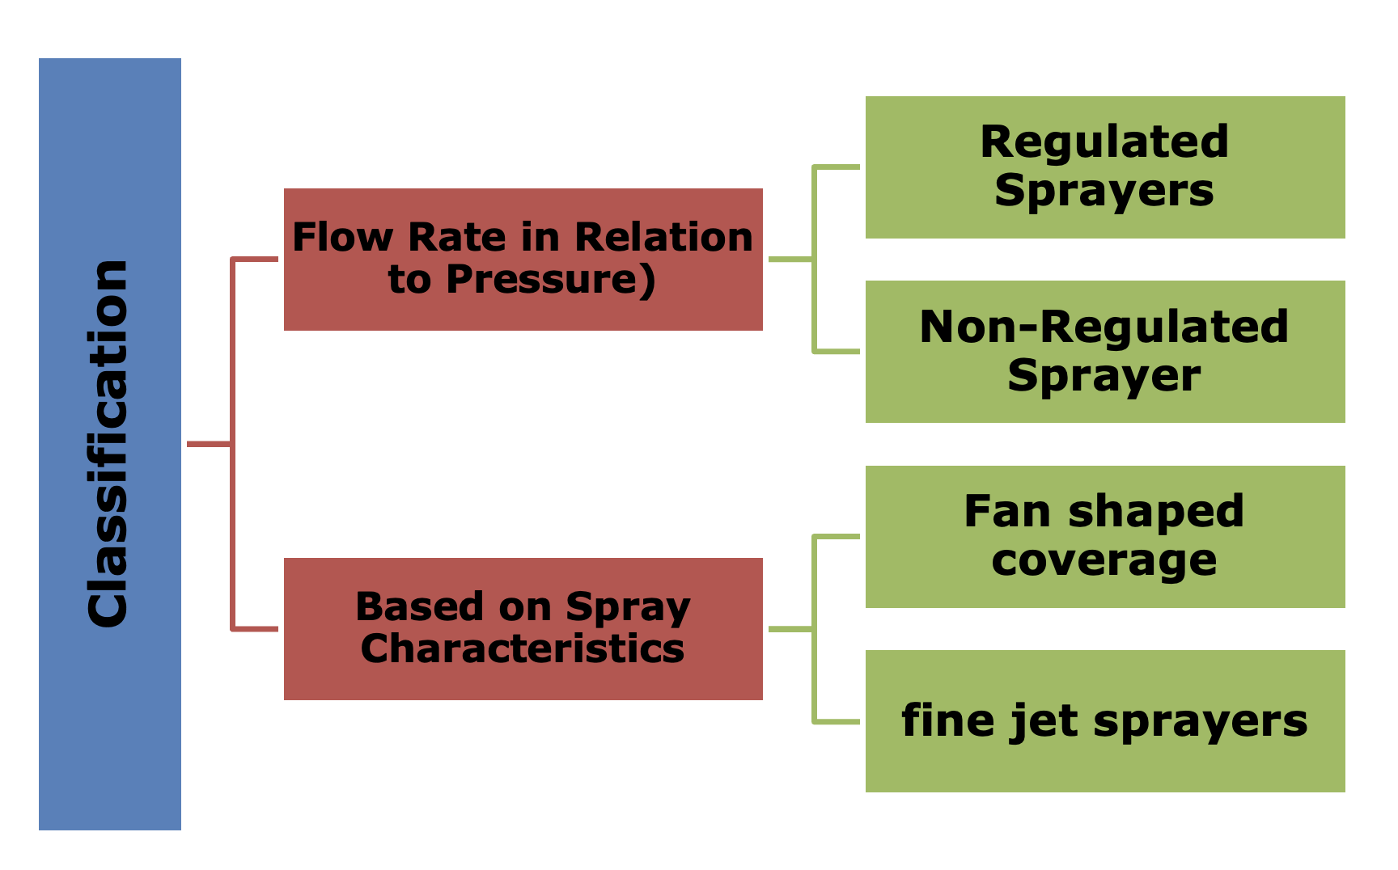
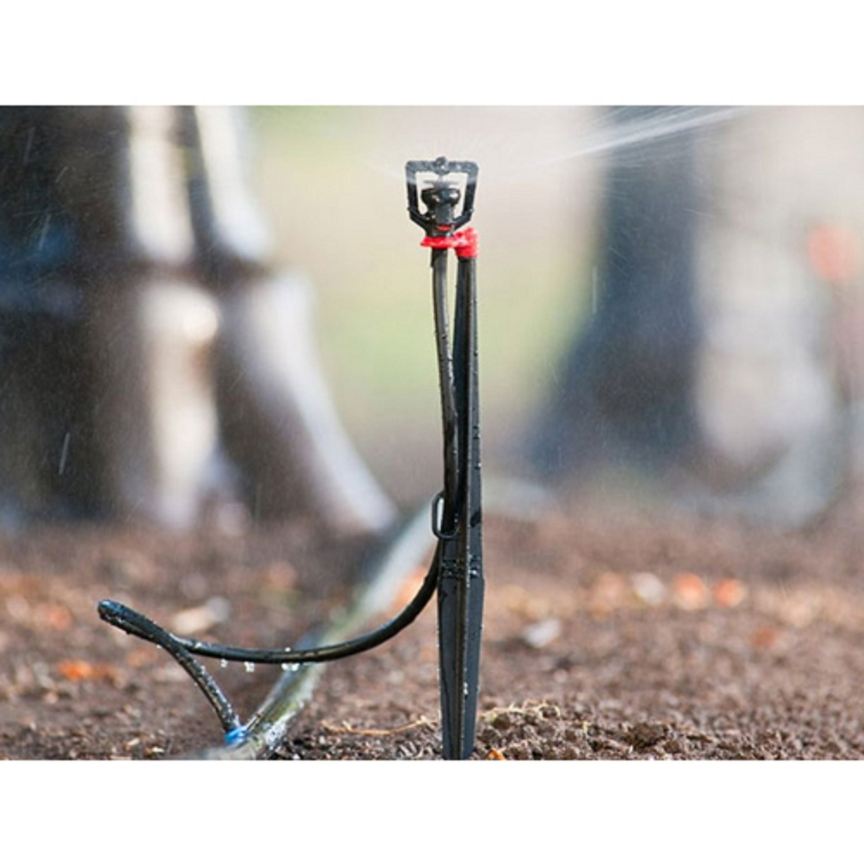
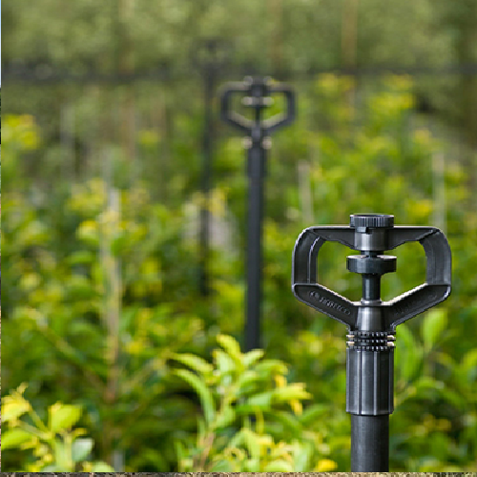

Important Requirements of Micro Sprayers

Specification | Significance
Hydrostatic Pressure | Performance against increase in pressure.
Uniformity of Flow Rate | Ensures that nearly uniform water shall be delivered to crops.
Water Distribution Curve | Ensures uniformity of water distribution

About IS 18286 : 2023 Agricultural Irrigation Equipment — Manually Operated Serviceable Plastics Valves — Specification

Valves in irrigation systems are essential components used to control the flow and distribution of water. They help regulate water supply, direct it to specific zones, and enable efficient operation of the system.

IS 18286 specifies the general requirements and test methods for manually operated serviceable plastics valves intended for operation in agricultural irrigation systems. It is applicable to manually operated plastics valves of diameter nominal (DN) 8 (1/4") to diameter nominal 110 (4") including angle, globe, diaphragm and ball valves.

The valves are intended for installation in irrigation piping networks, using water at temperatures from 5 °C to 60 °C. Nominal pressures of the valves are as designated by the manufacturer.

MATERIALS

PVC (Polyvinyl chloride)
PE (Polyethylene)
POM (Poly Oxy Methylene)
Poly Amide
PP (Polypropylene)
EPDM (Ethylene propylene diene monomer)
ABS (Acrylonitrile Butadiene Styrene)
NBR (Nitrile rubber)

All valve components those comes in contact with water shall not support the growth of algae and bacteria, nor be of metal which will corrode. Plastic parts of the valve that are exposed to sunlight shall be opaque and protected against UV degradation.

colour

Colour of Polyvinyl chloride (PVC), Polyethylene (PE), Polypropylene (PP) the compound should be either Grey or Black or as agreed between manufacturer and customer.

MECHANICAL AND FUNCTIONAL TESTS

Resistance to Increased Torque – to check the durability of the valve in opening and closing
Resistance of Valve and Valve Material to Internal Hydrostatic Pressure – performance of the valve against pressure variation
Seat and Stem Sealing Test
Valve Performance at Increased Hydraulic Pressure
Endurance Testing

Connections To Pipeline Shall Be in Accordance with Following Table

Material | Reference IS Standard
Polypropylene (PP) | IS 15801
Polyethylene (PE) | IS 4984/IS 17425
Unplasticized polyvinyl chloride (PVC-U) | IS 4985/IS 7834 (Part 1)
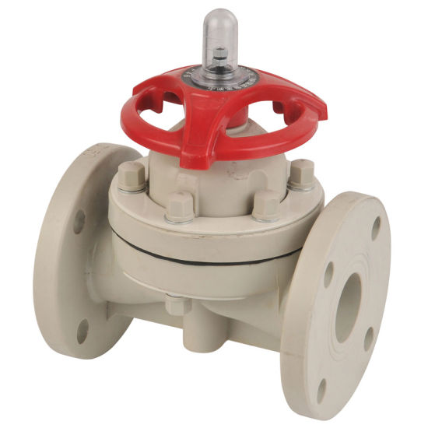

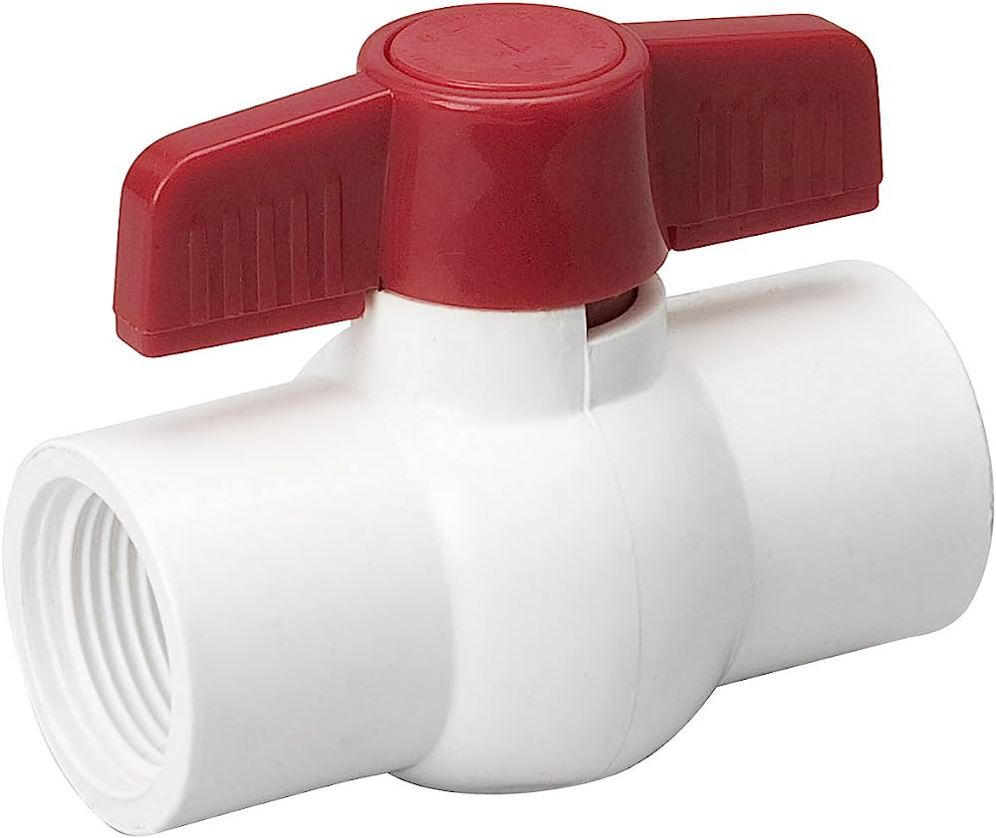

FILTERS

Filters are an essential component of micro-irrigation systems, designed to ensure clean and clog-free operation by removing debris, sediments, and other impurities from water before it enters the irrigation network.


The key standards for sprinkler irrigation include:

- IS 12785 : 1994
- IS 14743 : 2024
- IS 14606 : 2022

About IS 12785 : 1985 IRRIGATION EQUIPMENT — STRAINER-TYPE FILTERS – SPECIFICATION

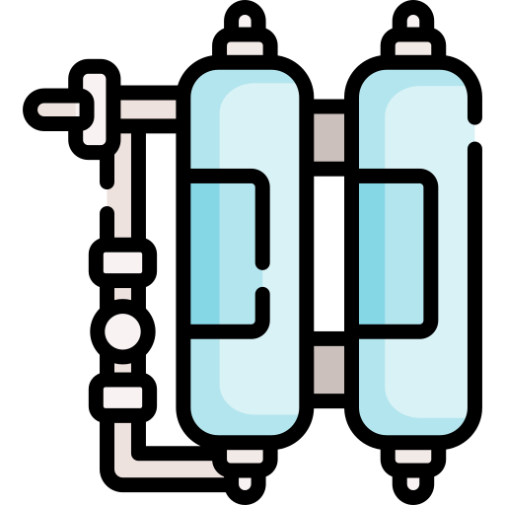
Strainer type Filters use a fine mesh, screen, disc or combination of these to trap debris/impurities contained in the irrigation water to prevent clogging in micro-irrigation systems.

It is a device containing one or more filtering elements, used for separating suspended solids/impurities from the water passing through the device and collecting them on the filter element.

IS 12785 specifies the general construction requirements and test methods for strainer type filters (hereinafter called filters) intended for operation in agricultural irrigation systems.

IS 12785 classify strainer-type filters into following types:

- Screen Filter
- Disc Filter

GENERAL REQUIRMENTS
- The filter parts that are in contact with the water shall be of non-toxic materials and shall be resistant to or protected against degradation caused by existing working conditions and types of water used in agricultural irrigation.

- The filter housing shall also be resistant to environmental conditions. Components belonging to filter of same size, type and model, and produced by the same manufacturer, shall be interchangeable.

- The filter element shall be either made of stainless steel or plastics or combination of both and should be detachable for cleaning

REQUIREMENTS FOR FILTER HOUSING

- The filter shall be so designed that contaminants accumulated on the filter element or in the filter housing, do not enter the supply line when cleaning or replacing the filter element. The construction of the filter element should allow disassembly, cleaning and reassembly of the without removal of the filter from the supply line.

PERFORMANCE TESTS

Tests | Significance
Resistance of Strainer to Internal Hydrostatic Pressure | Filter screen shall withstand pressure
Resistance to Internal Hydrostatic Pressure at High Temperature | Shall withstand even if water temperature is high
Resistance of Filter Element to Buckling or Tearing | Filter element shall not rupture even if filter is completely clogged
Tightness of Filter Element | Water shall not bypass the filter element
Clean Pressure Drop | Filters own pressure drop shall be considered for design of drip system

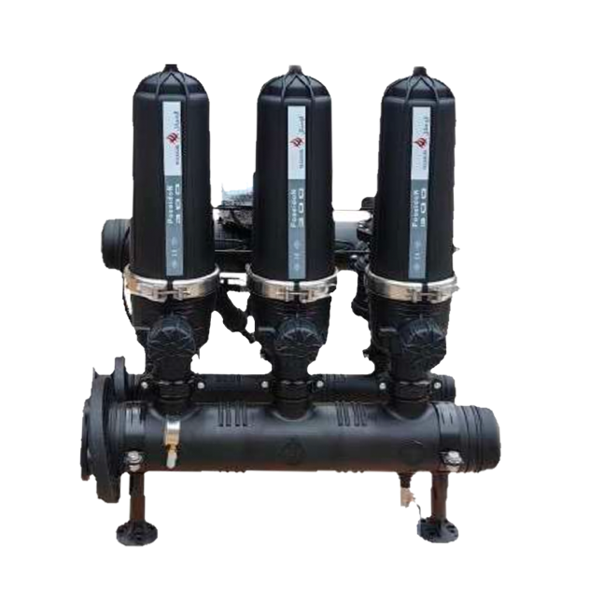

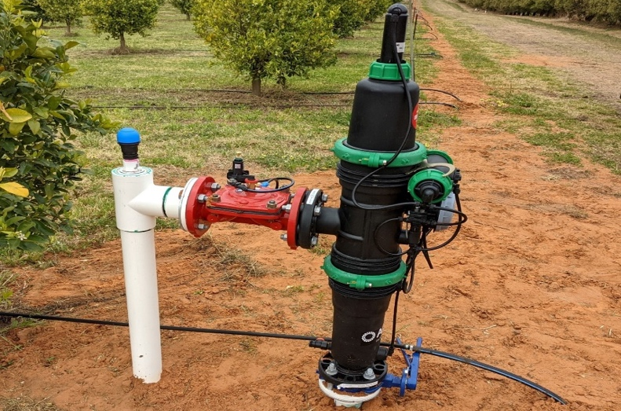

About IS 14743 : 2024 HYDROCYCLONE FILTERS — SPECIFICATION (first revision)
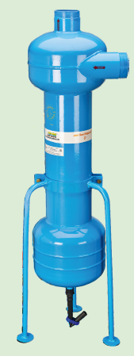
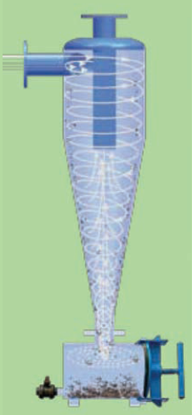
Hydrocyclone filter is an essential component of micro irrigation system used to separate sand from the river or tube-well water. It works on the principle of centrifugal force. it is also called centrifugal filter/sand separator.

It is filtration device consisting of a cyclonic vessel having an arrangement to create spiral vortex flow, an inlet, a centrally rising up outlet and an underflow chamber for sand collection tank connected at the lower end, essentially having an opening for removal of accumulated entrapped particles.

IS 14743 specifies the general constructional requirements and test methods of the hydrocyclone filters, intended for operation in agricultural irrigation systems.

The standard does not deal with filtration ability, efficiency and capacity nor it deals with the hydrocyclone filters that integrate automatic or continued flushing of accumulated sand.

TECHNICAL REQUIREMENTS

- Material

Metallic body or parts shall be coated with durable abrasion resistant coating having a coating thickness more than 70μm or hot dip galvanized to resist corrosion and under scouring.
Plastic body or parts of the filter that are exposed to ultraviolet (UV) radiation shall include additives to improve their resistance to UV radiation

- Construction

The filter shall be so designed that after assembly of the filter all the water flowing through the filter shall flow through inlet into cyclonic motion then to the outlet. The accumulated sand/slurry collected in the underflow tank should not be mixed with the processed water flowing through outlet.

- Cyclonic Vessel

The cyclonic vessel shall be so designed that the dirt separated should slide easily to the underflow chamber without stoppage on any step or shelf.

- Connections

PERFORMANCE TESTS
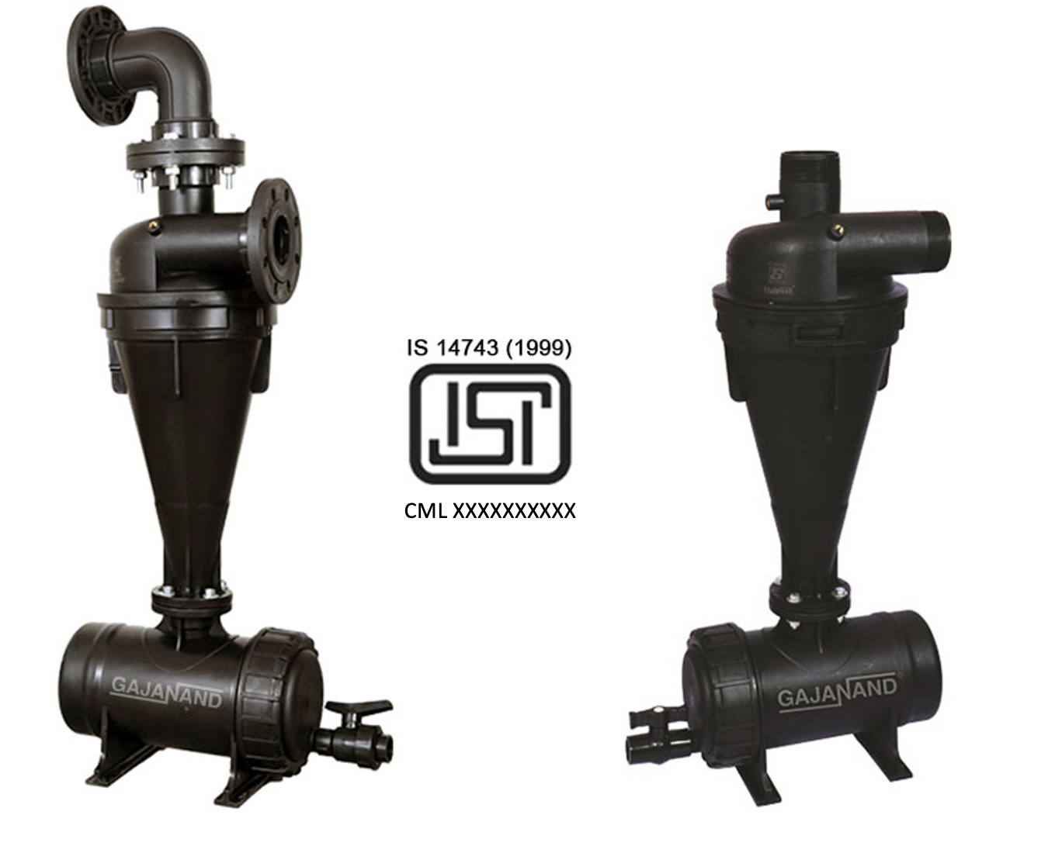
- Resistance to Internal Hydrostatic Pressure
- Resistance to Internal Hydrostatic Pressure at Elevated Temperatures
- Pressure Drop vs Flow
  - Test Period
  - Loading Rate
  - Flows
  - Testing Sequence
  - Results
  - Observations
- Cyclic Pressure Test

About IS 14606 : 2022 IRRIGATION EQUIPMENT — GRANULATED MEDIA FILTERS — SPECIFICATION

Media Filters also called as sand filters uses a bed of sand or granular media to trap particles/impurities, making them ideal for water sources with high organic loads, such as ponds or reservoirs.

IS 14606 specifies This standard specifies the construction requirements and test methods for “granulated media filters”,, intended for operation in agricultural irrigation systems. It includes manual cleaning media filters and automatic self-cleaning media filter “batteries” (2 units or more working in parallel).

This standard deals with manual and automatic backflow media filters and applies to:
- manually cleaning filters.
- complete automatic filters at a single unit level.
- a filtration battery which is a complete filter system that includes:
Inlet — Unfiltered supply water;
Outlet — Filtered water carried to the irrigation network; and
Back flush outlet — This is for the water and filtrate, flushed out during the backflow procedure.
- Command power source — Usually hydraulic-filtered water for automatic operation (can also be pneumatic or electric).

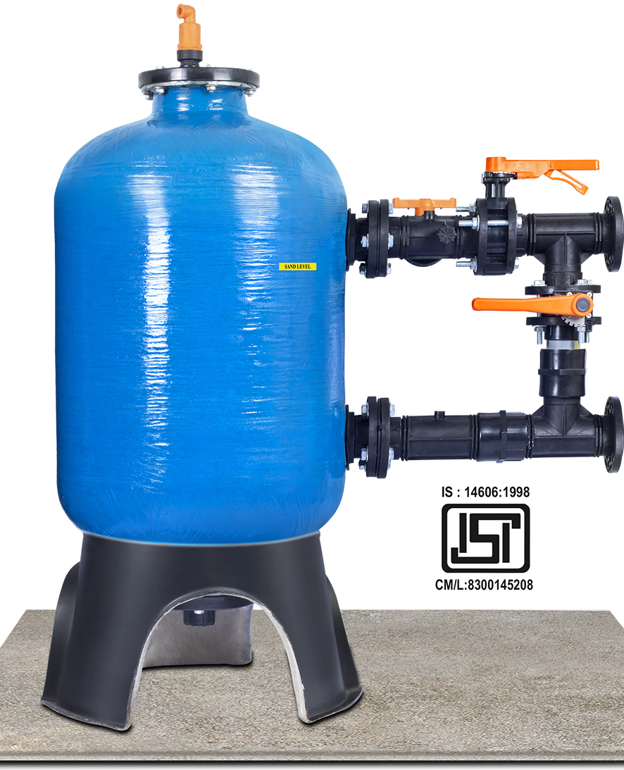
This standard deals with the operation and performance of a media filter including related valves, backwash mechanism, under-drains, manifolds and all related accessories necessary for the operation of the filter.

This standard deals only with pressurized filters operating in a range of filtration velocities declared by the manufacturer. The standard does not deal with filtration ability, efficiency and capacity (quality of filtered water, time of operation before media filter becomes entirely clogged, etc).

PERFORMANCE TESTS

TESTS | Significance
Resistance of Strainer to Internal Hydrostatic Pressure | Filter screen shall withstand pressure
Resistance to Internal Hydrostatic Pressure at High Temperature | Shall withstand even if water temperature is high
Requirements of Filter Housing (Metal and Plastic) | to ensure it can withstand operational pressures without leaks or structural failure
Resistance to cyclic pressure | evaluates their durability and reliability under fluctuating pressure conditions
Back flushing hydraulic parameters and tests | Backflushing is done to removes debris, contaminants, and blockages to maintain filter’s efficiency and ensure consistent fluid flow. Therefore the test is done to validate filter performance and prevents system damage by clearing clogs.

AUTOMATIC BACK FLUSHING AND CONTROLLER

- Backwash Initiation
- Flushing Control Mechanism Testing
  - Mechanism Activated by Pressure Differential Sensor
  - Mechanism Activated by Duration of Operation
  - Mechanism Activated by Volume of Filtered Water
  - Mechanism Activated by Some Other Physical Quantity
  - Test of Protective Device
  - Test for Flushing Mechanism
  - Detecting Media Escape

FERTIGATION

Fertigation is the process of delivering fertilizers/chemicals or nutrients directly to crops through an irrigation system. It ensures precise nutrient application, enhancing plant growth and minimizing waste.

The application of fertilizer or/and other chemicals via irrigation water to crops/plants is based on the principle that a swiftly moving stream of water is able to carry with it the dissolved substances and fine dispersed suspended particles of fertilizer material. Venturi injector, injector pump, fertilizer tank are such equipment used for this purpose

About IS 14483 (Part 1) : 2024 FERTILIZER AND CHEMICAL INJECTION SYSTEM : PART 1 VENTURI INJECTOR (first revision)
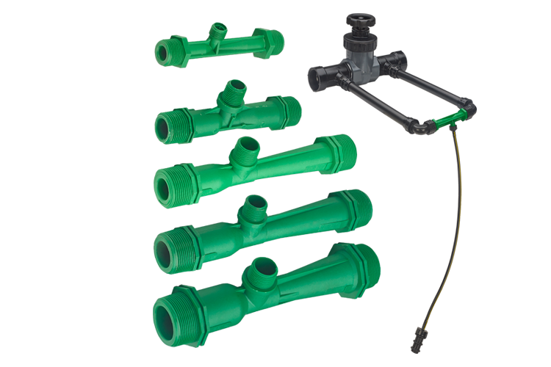
Venturi Injector is an appliance used for fertigation or chemigation, chlorinating or injecting chemicals in the sprinkler and drip irrigation systems. Venturi injector operates on the principle that, when a pressurized operating (motive) fluid enters the injector, it is constricted towards the injection chamber and changes into a high velocity jet stream. The increase in velocity inside the injection chamber results in decrease in pressure, thereby enabling an additive liquid material to be drawn through the suction port and entrained into the motive stream

IS 14483 (Part 1) prescribes the requirements of venturi injectors used for injecting fertilizer and chemicals in the sprinkler and drip irrigation systems.

MATERIAL REQUIREMENTS

- The material used in the manufacture of venturi injector and their fittings shall be resistant to fertilizers and chemicals commonly employed in irrigation and shall be suitable for use with water at temperatures up to 60°C and at pressures designed for the emitting pipe.

- The materials shall, as far as possible not support the growth of algae and bacteria. The parts of the emitting pipe that are exposed to sunlight. shall be opaque and protected against UV degradation.

CONSTRUCTIONAL REQUIREMENTS

- Should be detachable for removal when not in use. Suction port shall have suitable connection. inbuilt check valve may be provided. A metering device shall be provided pressure reducing device or flow control device to be provide

TESTS
- Resistance of Venturi Injector to Internal Hydrostatic Pressure.
- Performance Test as per manufacturer’s declaration

INSTALLATION OF THE VENTURI INJECTOR IN THE IRRIGATION SYSTEMS FOR PERFORMANCE TESTING
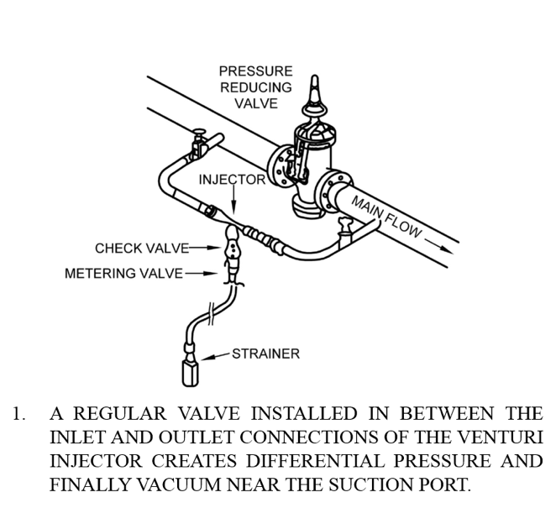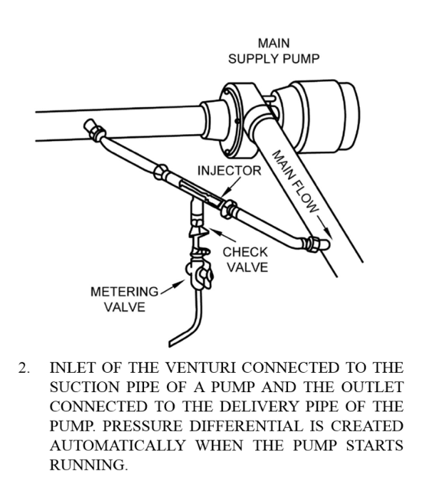
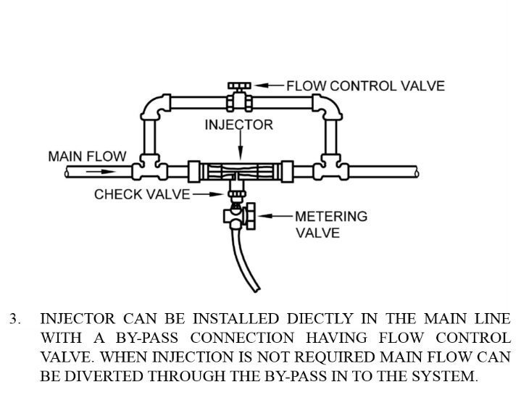

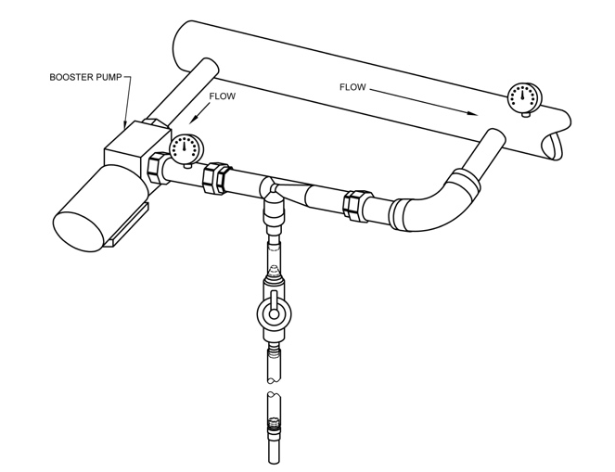
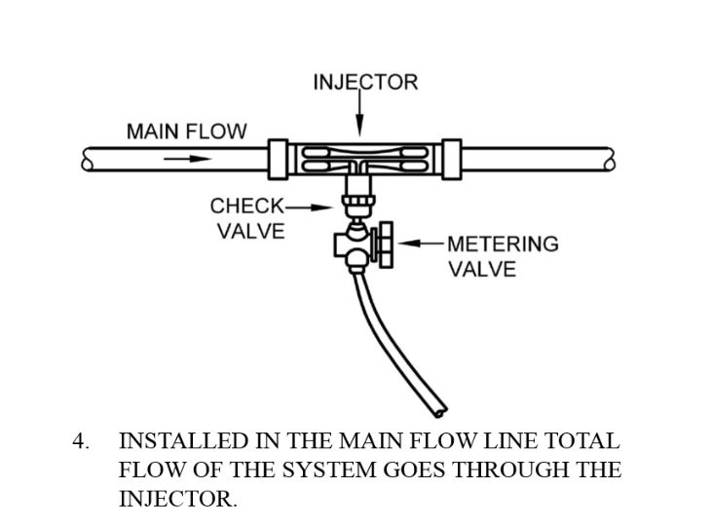
VENTURI INJECTOR WITH BOOSTER PUMP

About IS 14483 (Part 2) : 2025 FERTILIZER AND CHEMICAL INJECTION SYSTEM PART 2 WATER-DRIVEN CHEMICAL INJECTOR PUMP — SPECIFICATION (first revision)

These water-driven chemical injector pumps are used to inject chemicals into irrigation systems. The chemicals include liquid fertilizer, solutions of fertilizers and other soluble agricultural chemicals such as acids and pesticides.

IS 14483 (Part 2) This standard specifies the construction and operational requirements and methods for water driven chemical injector pumps. These injector pumps are intended to operate at water temperatures of up to 50°C and with the types and concentrations of chemicals routinely applied in irrigation.

CLASSIFICATION OF PUMPS

INSTALLATION OF INJECTOR PUMP IN THE IRRIGATION SYSTEMS FOR PERFORMANCE TESTING

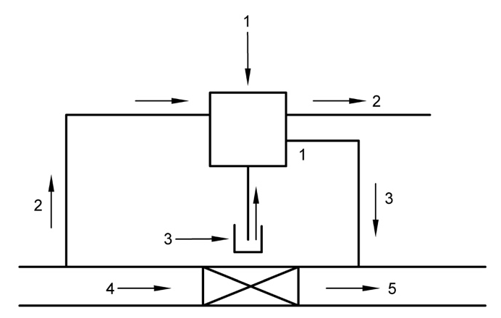
where
1 Injector pump
2 Drive water
3 Chemicals
4 Irrigation flow
5 Irrigation water with injected chemicals
ON-LINE

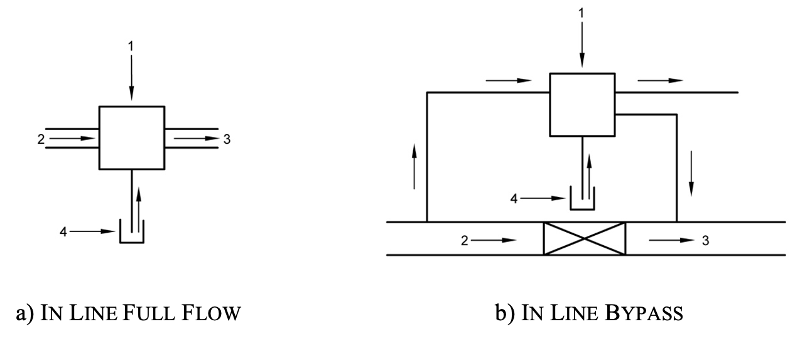

where
1 Injector pump
2 Irrigation flow
3 Irrigation water with injected chemicals
4 Chemicals

About IS 14483 (Part 3) : 2018 FERTILIZER AND CHEMICAL INJECTION SYSTEM PART 3 FERTILIZER TANL — SPECIFICATION

Fertilizer Tank is a component of fertigation systems used to mix and inject liquid or soluble fertilizers into irrigation water.

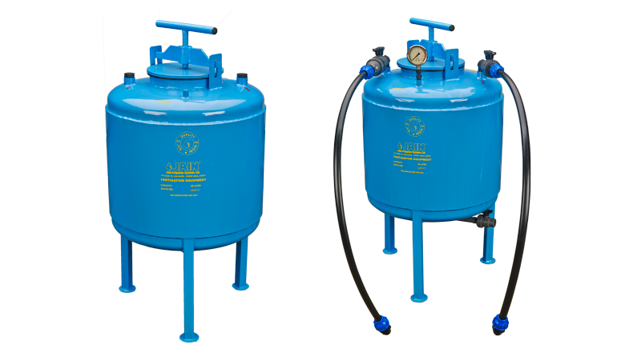
IS 14483 (Part 3) specifies the mechanical and functional requirements for fertilizer tanks used in irrigation systems, test methods and the data to be supplied by the manufacturer to permit correct installation and operation in the field.

This standard applies to fertilizer tanks working on the principle of differential pressure used in irrigation. systems. This standard also applies to the fittings used for connecting fertilizer tanks with the irrigation systems

REQUIREMENTS

- Resistance of Fertilizer Tanks to Hydrostatic Pressure at Ambient Temperature
- Resistance to Hydrostatic Pressure at Elevated Temperature
- Injection Rate Calibration
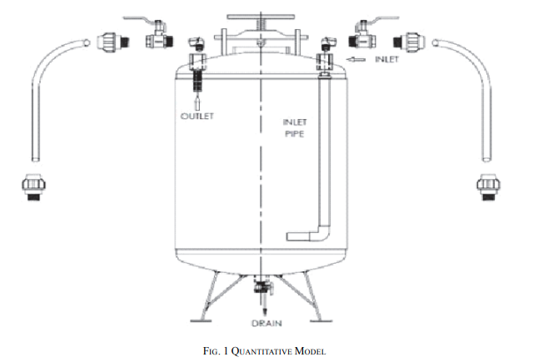
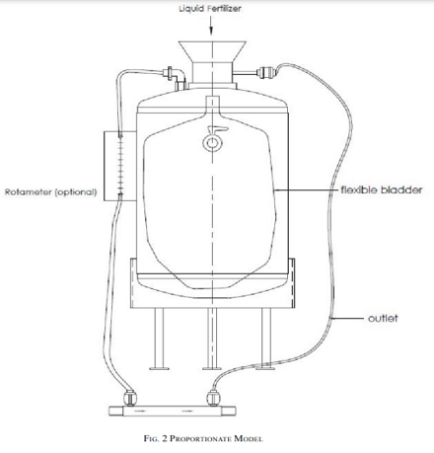

About IS 14791 : 2024 PREVENTION AND TREATMENT OF BLOCKAGE PROBLEM IN DRIP IRRIGATION SYSTEM — CODE OF PRACTICE (first revision)

Various Clauses under the Standard | What is Covered?
Quality of Water | Sample of water supplied to DIS is tested for different parameters such as Suspended Solids, pH, EC, Ca, Mg, Fe, Presence of oil etc.  Table 1 of IS 14791 provided the safe limits for presence of above-mentioned parameters in water.
Chemical Injection System Installed with DIS. | Chemical Inject Systems (venturi injector, injector pumps, differential pressure tanks) are used in conjunction with DIS for supplying fertilizers into the field. These equipment's should be well test before installing.
Different Blockage Problems associated with DIS. | - Solid Contaminants  - Dissolved Contaminants - Biological or Chemical Clogging Problem  - Emitter Suck-back  - Physical Blockage of Dripline/Lateral  - Failure of Main Filtration System  - Poor Maintenance of the System  - Quality of Water
Method of Assessment of blockage problems | Driplines on Ground Surface : When driplines are laid on the surface, the degree of blockage can be checked by means of visual inspection and measuring the amount and uniformity of discharge through the emitters or orifices and comparing it with the specified discharge.  Dripline Buried Under Ground : When driplines are buried, it is not possible to check individual emitters or orifices by visual inspection and the flow rates in the driplines should be checked by one or more of the following methods:  By inserting a pressure gauge into the tail end of the dripline.  By measuring wetted perimeter.  Visual inspection of the field block for uneven growth of crop.  Measurement of discharge.
Prevention and treatment of blockage problem. | - Physical Treatment :  - Use of silting reservoir  - use of Filters such as Hydrocyclone, screen filters, media filters, disc filters  - Flushing of irrigation pipelines  - Chemical Treatment :  - Bacterial precipitation of Iron, Sulphur,  - Aeration and settling, pH Control  - Chlorination of water, Acid Treatment  - Algae Control  - Emitter Clogging by Roots : trifluorine/ pendimethalin / copper can be used for prevention  - Emitter Suck-back
Safety Requirements | The resistance of drip irrigation components to the chemical used should be taken into consideration.  All chemicals-should be handled cautiously and should be stored in a secured place for the reasons of safety and hazardous nature of the products.  Irrigation water should not be used for consumption by human beings and animals.  - Do not inhale acid fumes or chlorine gas.

Table 1 of IS 14791 Interpretation of Water Analysis

Sl. No. | Parameters | Degree of Presence/Problem
 |  | Unit | Normal | Higher | Extreme
(1) | (2) | (3) | (4) | (5) | (6)
i) | pH |  | 6.5 - 8.5 | 4 - 6.5 & 8.5 - 10 | pH<4 & pH >10
ii) | Electrical Conductivity  (Salinity) | mmhos/cm | <0.8 | 0.8 - 3.0 | >3.0
iii) | Total dissolved solids | ppm | <500 | 500 - 600 | >600
iv) | Hardness | ppm | <200 | 200 - 300 | >300
v) | Calcium | ppm | <60 | 60 - 100 | >100
vi) | Magnesium | ppm | <25 | 25 - 40 | >40
vii) | Carbonate | ppm | <200 | 200 - 600 | >600
viii) | Bicarbonate | ppm | <200 | 200 - 600 | >600
ix) | Chloride (Toxic) | ppm | <140 | 140 - 350 | >350
x) | Sulphates | ppm | <20 | 20 - 50 | >50
xi) | Sodium | ppm | <100 | 100 - 200 | >200
xii) | SAR | - | <3 | 3 - 9 | >9
xiii) | Potassium | ppm | <10 | 10 - 20 | >20
xiv) | Sulphides | ppm | <15 | 15 - 25 | >25
xv) | Iron | ppm | <0.1 | 0.1 - 0.4 | >0.4
xvi) | Manganese | ppm | <0.2 | 0.2 - 0.4 | >0.4
xvii) | Suspended solids | ppm | <10 | 10 - 100 | >100
xviii) | Permeability  a) Caused by low salts (EC)  b) Caused by sodium | mmho/cm  SAR | >0.5  <6.0 | 0.5 - 0.2  6.0 - 9.0 | <0.2  >9.0
xix) | Toxicity  a) Sodium  b) Chloride  c) Boron | ppm  ppm  ppm | <3.0  <140  <0.5 | 3.0 - 9.0  140 - 350  0.5 - 2.0 | >9.0  >350  >2.0
xx) | Clogging  a) Iron  b) Manganese  c) Sulphides  d) Calcium carbonates | ppm  ppm  ppm  ppm | <0.1  <0.2  <0.1  No level Established | 0.1 - 0.4  0.2 - 0.4  0.1 - 0.2  No level Established | >0.4  >0.4  >0.4  No level Established

ABOUT IS 14792: 2000 IRRIGATION EQUIPMENT — DESIGN, INSTALLATION AND OPERATION OF SPRINKLER IRRIGATION SYSTEMS — CODE OF PRACTICE

This standard prescribes the procedure for the design, installation and operation of sprinkler systems used for irrigation of agricultural lands, orchards, lawns and land scoped areas.

HYDROLOGICAL DESIGN

Table : Potential Evapotranspiration (PET) (Clause 3.5)

Sl. No. | Climate | mm of Water Used per Day
(1) | (2) | (3)
i) | Cool humid | 2.5-3.8
ii) | Cool dry | 3.8-5.1
iii) | Warm humid | 3.8-5.1
iv) | Warm dry | 5.1-6.3
v) | Hot humid | 5.1-7.6

Table: Estimated Maximum Water Application Rates for Design

Sl. No. | Soil Groups Based on Texture and Profile | Slopes¹⁾  0-8º | Slopes²⁾  9º to 12.5º | Slopes³⁾  over 12.5º
i) | Sands and light sandy loams uniform in texture to 1.82 m pumice | 31.8 | 25.4 | 20.3
ii) | Sandy loams to 0.61 m overlaying a heavier subsoil | 20.3 | 16.5 | 12.7
iii) | Medium loams to sandy clays over a heavier subsoil | 16.5 | 12.7 | 10.2
iv) | Clay loams over a clay subsoil | 12.7 | 10.2 | 7.6
v) | Silt loams and silt clay | 10.2 | 7.6 | 5.1
vi) | Clays | 6.4 | 5.1 | 3.8
vii) | Peat | 16.5 | - | -
see IS 14792 for more details

Lateral spacing (6.2.4.1)
Sl.  No. | Wind Velocity  (km/h) | Lateral Spacing  (% of wetting diameter)
i) | No wind | 65
ii) | < 8 | 60
iii) | 8 to 16 | 50
iv) | > 16 | 30

Sprinkler spacing (6.2.4.2)
Sl.  No. | Pattern | Wind Velocity  (km/h | Sprinkler Spacing  (% of wetting diameter)
(1) | (2) | (3) | (4)
i) | Square  or  Rectangular | No wind | 65
ii) | Square  or  Rectangular | < 7 | 60
iii) | Square  or  Rectangular | 7 to 13 | 50
iv) | Square  or  Rectangular | > 13 | 30

INSTALLATION

Buried Mains - Particular attention is drawn to the necessity for concrete anchor blocks of sufficient size being provided at any significant change in direction or grade, change in diameter, major branch connection or terminal, and adjacent to any values or fittings that may give rise to hydraulic loading along the line.

Pumps and Prime Mover - Internal combustion engines shall be provided with protective devices. Devices shall be supplied that stop the engine if
a) engine temperature exceeds the safety point for the prime move and
b) oil pressure falls below the minimum specified; or pressure because of loss of suction or reduction in delivery pressure.

OPERATION

The purchaser shall be supplied with written operational data, performance, and layout details of the system and its components including:
  - sprinkler make model, performance, and nozzle diameter.
  - design layout of spraying.
  - design pump duty; and
  - correct range of operating pressures for the system.

The supplier or his agent shall demonstrate the important aspects regarding the operation, care, and maintenance of the unit including methods of shifting and setting up the portable components of the system. Wiring and starting equipment for electrically operated planta shall comply with Electrical Code 1985. Electric motors shall be provided with overload, low-voltage, and inter-phase variation protection. Pumps, power units, and transmission shall be effectively guarded.

RESPONSIBILITIES OF MANUFACTURER/DEALER
- Investigation
- Design and information to the purchaser before the sale
- Installation

RESPONSIBILITIES OF PURCHASER
- Request for service
- Purchase for equipment

About IS 11624 : 2019 QUALITY OF IRRIGATION WATER — GUIDELINES ( first revision )

The quality of irrigation water is important because it directly affects crop growth, soil health, and overall agricultural productivity. Poor-quality water can introduce salts, toxins, or harmful elements into the soil, leading to reduced crop yields, soil degradation, and long-term fertility issues. Proper water quality ensures efficient nutrient uptake, sustainable farming practices, and minimizes environmental damage.

The quality of irrigation water is evaluated in terms of degree of harmful effects on soil properties with respect to the soluble salts it contains in different concentrations and crop yield. To evaluate the quality of irrigation water, this standard was formulated as a guideline.

IS 11624 prescribes the guidelines for assessing the quality of irrigation water.

SUITABILITY CRITERIA

The suitability of irrigation water depends upon several factors, such as, water quality, soil type, plant characteristics, irrigation method, drainage, climate and the local conditions. The integrated effect of these factors on the suitability of irrigation water (SI) can be qualitatively expressed by the relationship:

$$SI∝QSPCD$$

Where,

- Q – quality of irrigation water, that is, total salt concentration, relative proportion of cations/ anions, etc;
- S – soil type, texture, structure, permeability, fertility, calcium carbonate content, type of clay minerals and initial level of salinity and alkalinity before irrigation;
- P – salt tolerance characteristics of the crop and its varieties to be grown, and growth stage usually categorized as tolerant, semi-tolerant and sensitive;
- C – climate, that is the total rainfall, its distribution and evaporation characteristics;
- D – drainage conditions, depth of water table, nature of soil profile, presence of hard pan or lime concentration and management practices.

WATER QUALITY CRITERIA FOR IRRIGATION

- Total salt concentration (electrical conductivity (EC)
- pH (6.5 to 8.4 pH)
- Sodium adsorption ratio;
- Residual sodium carbonate (RSC) or bicarbonate ion Concentration

RSC = (CO₃²⁻ + HCO³⁻) – (Ca²⁺ + Mg²⁺)

$$SAR=\frac{{Na}^{++}}{\sqrt{{\left({Ca}^{++}+{Mg}^{++}\right)}/2}}$$

where
SAR – sodium adsorption ratio (millimole/litre)^{1/2}
Na⁺ – sodium ion concentration, me/litre;
Ca₂ ⁺ – calcium ion concentration, me/litre; and
Mg₂⁺ – magnesium ion concentration, me/litre.

When SAR is more than 10, it could be high SAR saline or high SAR alkali depending upon the EC or RSC of the irrigation water.

- Mg/Ca Ratio - If Mg/Ca ratio is more than 3.0 addition of gypsum is required to minimize the Mg on the exchange complex of the soils. However, calcium: magnesium ratio above 2.0 in water is beneficial.

- Cl/SO4 Ratio - Cl salinity is more harmful than the salinity due to SO4 ions. If Cl/SO4 ratio is more than 2, additional steps are required to minimize the harmful effect of chloride ions. On the other hand, sulphate: chloride ratio of more than 2.0 is beneficial.

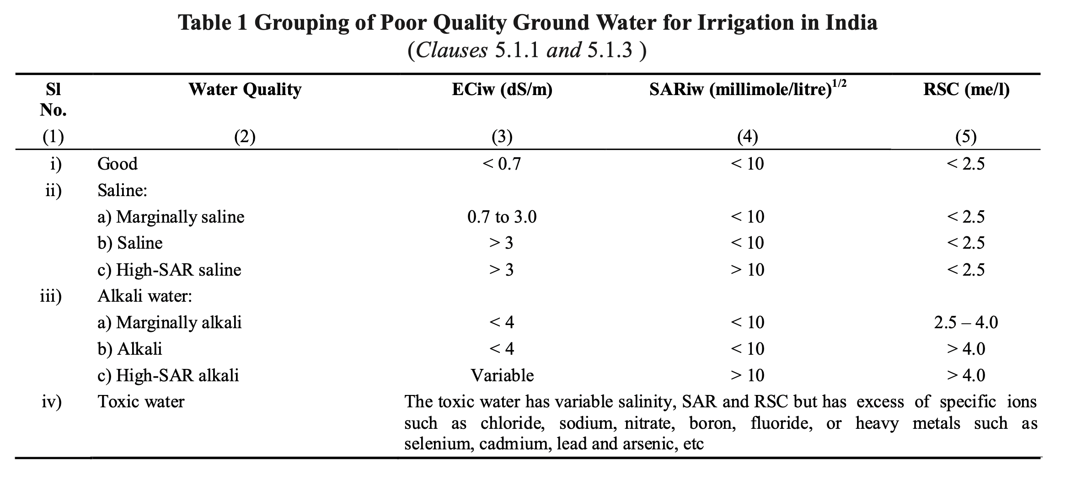
- Boron content - Boron, though a nutrient, becomes toxic if present in water beyond a particular level. In relation to boron toxicity, the irrigation water quality rating is given in Table 2.

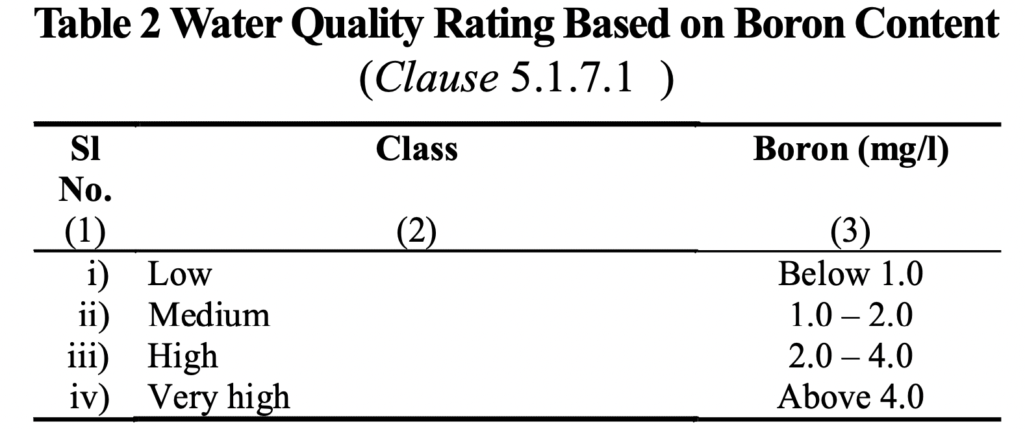

WATER QUALITY IN RELATION TO IMPROVED IRRIGATION TECHNIQUES

- Concentrations of ferrous iron as low as 0.15 - 0.20 mg/l are considered as a potential hazard for clogging of drip systems. Concentrations of manganese should be < 0.10 mg/l for no problem
- For sprinkler irrigation bicarbonate less than 1.5 me/l does not pose much problems but the problems increase and become severe when the bicarbonate content is 8.5 me/l.

WATER QUALITY RATING IN RELATION TO SOIL TYPE, RAINFALL AND CROP TOLERANCE TO SALTS

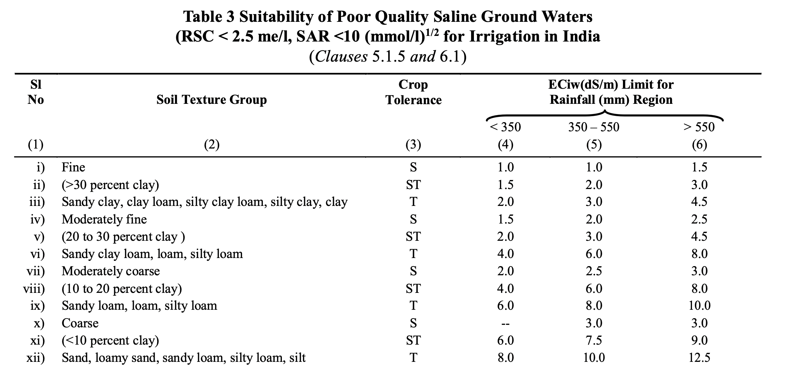
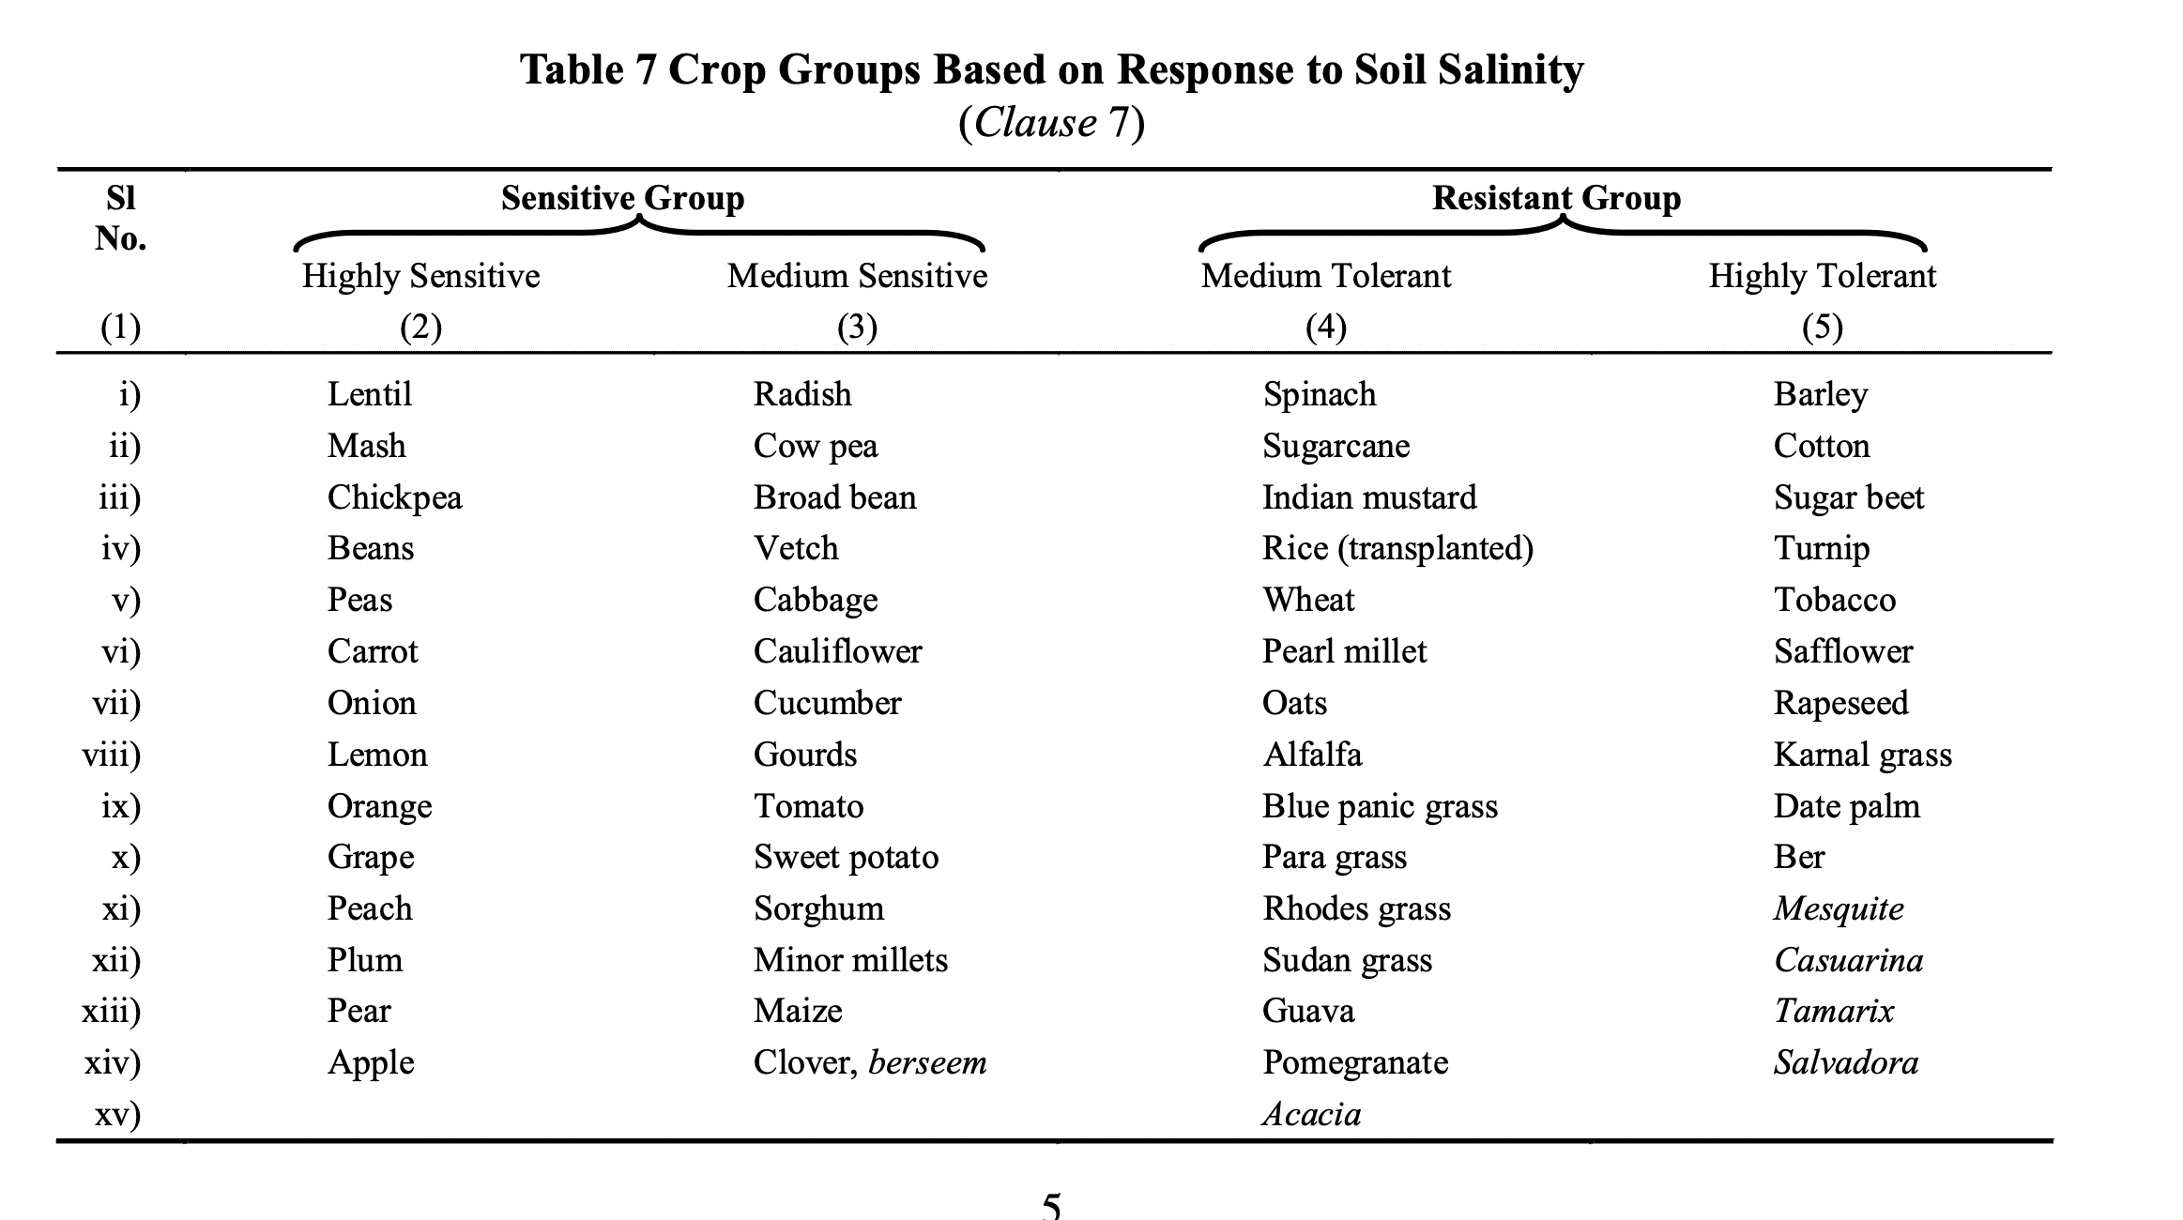
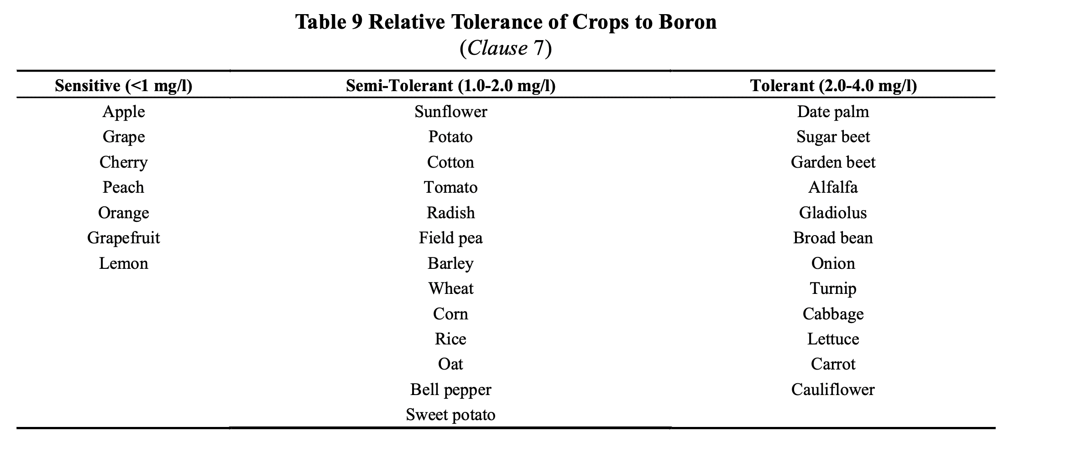

CONCLUSION

Key Specifications of few standards and Testing in Short

To ensure performance and reliability, the components of micro-irrigation systems undergo several tests as outlined in the standards.

These include:

- Hydrostatic pressure tests for pipes, emitters, sprinklers, valves assess their strength and performance under high pressure.
- Emitter pull-out tests to evaluate the robustness of emitters against mechanical stress.
- Uniformity tests for emitters and emitting pipes to ensure consistent water delivery across the system.
- Valve endurance tests to verify their performance under repeated use and varying pressures.

Importance of Standards

Why are these standards important?

- They ensure that irrigation systems perform optimally, even under challenging conditions.
- They promote water conservation by minimizing wastage and ensuring uniform application.
- They enhance compatibility between components, making installation and maintenance more straightforward.
- In essence, these standards are key to advancing sustainable agriculture in India.

Micro-irrigation systems are game-changer in modern agriculture. By adhering to established standards, we can ensure these systems deliver maximum efficiency, durability, and environmental sustainability.

LIST STANDARDS ON MICRO IRRIGATION

S.No. | IS No. | Title
 | IS 10799 : 1999 | Irrigation equipment — Design, installation and field evaluation of micro irrigation systems — Code of practice (first revision)
 | IS 11077 : 1984 | Glossary of Terms on Soil and Water
 | IS 11624 : 2019 | Quality of Irrigation Water — Guidelines (first revision)
 | IS 11711 : 1986 | Recommended Criteria for Adoptability of Different Irrigation Methods
 | IS 12232 : Part 1 : 1996/ISO 7749-1 : 1995 | Irrigation equipment — Rotating sprinkler: Part 1 Design and operational requirements (first revision)
 | IS 12232 (Part 2) : 1995 | Irrigation equipment — Rotating sprinkler: Part 2 Test method for uniformity of distribution (first revision)
 | IS 12785 : 1994 | Irrigation equipment — Strainer-type filters— Specification (first revision)
 | IS 12786 : 2024 | Irrigation equipment — Polyethylene pipes for irrigation laterals — Specification (first revision)
 | IS 13062 : 1991 | Irrigation Equipment and Systems — Evaluation of Field Irrigation Efficiencies — Guidelines
 | IS 13487 : 2024 | Irrigation Equipment — Emitters — Specification (first revision)
 | IS 13488 : 2008 | Irrigation Equipment - Emitting Pipe Systems - Specification (first revision)
 | IS 14178 : 1994 | Pressurized Irrigation Equipment Terminology
 | IS 14482 : 1997 | Irrigation Equipment — Polyethylene Micro Tubes for Drip Irrigation — Specification
 | IS 14483 (Part 1) : 2024 | Fertilizer and chemical injection system Part 1 Venturi injector — Specification (first revision)
 | IS 14483 (Part 2) : 2025 | Fertilizer and chemical injection system: Part 2 Water-driven chemical injector pump — Specification
 | IS 14483 (Part 3) : 2018 | Fertilizer and chemical injection system: Part 3 Fertilizer tank — Specification
 | IS 14605 : 1998 | Irrigation Equipment — Micro Sprayers — Specification
 | IS 14606 : 2022 | Irrigation Equipment — Granulated Media Filters — Specification (first revision)
 | IS 14743 : 2024 | Irrigation equipment - Hydrocyclone filters - Specification (first revision)
 | IS 14791 : 2024 | Prevention and treatment of blockage problem in drip irrigation system - Code of practice (first revision)
 | IS 14792 : 2000 | Irrigation equipment — Design, installation and operation of sprinkler irrigation systems — Code of practice
 | IS 15386 : 2003 | Pressurized Irrigation Systems — Graphic Symbols
 | IS 17425 : 2020 | Irrigation Equipment — Quick Coupled Polyethylene Pipes and Fittings for Sprinkler Irrigation Systems — Specification
 | IS 18286 : 2023 | Agricultural irrigation equipment — Manually operated serviceable plastics valves — Specification
 | IS 4984 : 2016 | Polyethylene pipes for water supply — Specification (fifth revision)
 | IS 4985 : 2021 | Unplasticized PVC pipes for potable water supplies — Specification (fourth revision)
 | FAD 17 (24278) WC | Irrigation techniques — Localized and remote monitoring and control system for irrigation — Tests

