Good Agricultural Practices (GAP)
Good Agricultural Practices (GAP) refer to a set of principles, standards, and technical recommendations applied at the farm level to ensure the safety and quality of agricultural products while safeguarding the environment, the health and safety of workers, and the well-being of farming communities.
The adoption of Good Agricultural Practices (GAP) is essential to address critical challenges in agriculture and ensure the sustainability of farming systems.
Below are the key reasons why GAP is needed:
1. Ensuring Food Safety and Quality
GAP minimizes the risk of contamination in food crops by addressing hygiene, pesticide residues, and safe water use. It ensures that agricultural products meet national and international food safety standards, enhancing consumer confidence.
2. Sustainable Use of Resources
Agriculture relies on natural resources like soil and water, and GAP promotes their efficient and sustainable use. Practices like crop rotation, water conservation, and soil management reduce resource depletion and maintain long-term productivity.
3. Environmental Protection
GAP reduces pollution from agricultural inputs like chemical fertilizers and pesticides by promoting judicious and integrated use. It supports eco-friendly practices such as organic farming, waste recycling, and biodiversity conservation.
4. Market Access and Trade
Many domestic and international markets demand compliance with GAP standards for agricultural imports. Certification under GAP increases competitiveness in global markets, especially for high-value crops like fruits, vegetables, and spices.
5. Improving Farmer Livelihoods
GAP helps farmers improve yield and reduce costs by promoting efficient input use and modern techniques. Traceability and certification add value to agricultural products, increasing farmers' income and market opportunities.
6. Addressing Climate Change
GAP promotes climate-resilient agricultural practices, such as precision farming and soil conservation, to adapt to changing weather patterns. These practices help reduce greenhouse gas emissions and mitigate climate impacts.
7. Promoting Worker Health and Welfare
Ensures better working conditions, safety protocols, and fair treatment of agricultural labourers. Emphasizes reducing exposure to harmful chemicals and ensuring access to protective equipment.
8. Meeting Consumer Expectations
With growing awareness, consumers demand safe, ethically produced, and environmentally friendly products. GAP bridges the gap between consumer expectations and agricultural production practices.
9. Enhancing Traceability
GAP includes record-keeping and traceability from farm to fork, ensuring accountability and quality assurance throughout the supply chain.
Benefits of GAP:
- Ensures food safety and compliance with national and international regulations.
- Enhances consumer confidence in agricultural products.
- Promotes sustainable use of natural resources.
- Improves market access, including exports.
- Supports social and economic sustainability in farming communities.
In India, IS 15930 (Part 1): 2010 Indian Standard developed by the Bureau of Indian Standards (BIS) to provide guidelines for Good Agricultural Practices (GAP) specific to crop production in India. Known as IndiaGAP, it focuses on ensuring food safety, environmental sustainability, and worker welfare in agricultural activities. The standard outlines key practices such as soil and water management, nutrient and fertilizer application, integrated pest management (IPM), and post-harvest handling. It emphasizes record-keeping and traceability to maintain accountability throughout the supply chain. Tailored to Indian agro-climatic conditions, IS 15930 (Part 1) aligns with international norms, ensuring compliance for domestic and global markets while addressing the needs of smallholder farmers and promoting sustainable agriculture.
IndiaGAP is a certification scheme developed to implement Good Agricultural Practices (GAP) tailored to the Indian context. It is based on the Indian Standard IS 15930 (Part 1): 2010 and aligns with international GAP frameworks, like GlobalGAP, while addressing local agricultural practices, challenges, and needs.
GlobalGAP is an internationally recognized standard for Good Agricultural Practices (GAP), developed to ensure food safety, environmental sustainability, and worker well-being in agricultural production worldwide. Originating in Europe, it is now a globally adopted certification framework.
IS 15930 (Part 1): 2011- Requirements for good agricultural practices
This standard (Part 1) covers the control points and compliance criteria necessary to be followed by the producers (individual growers and/or members of a grower group) of crops. This standard covers the following products in fresh form for direct human consumption or for further processing or for feed for animals producing food for human consumption:
- Fruits and vegetables;
- Food grains;
- Plantation crops;
- Spices and condiments; and
- Oilseeds and nuts.

CONTROL POINTS AND COMPLIANCE CRITERIA
- Control points and compliance criteria required to be followed by the applicant producer as well as by the certification body for independent verification of the agricultural practices that have gone into the production of the produce.
- ‘Major’ have a definite effect on the safety and quality of the produce and shall, therefore, be complied with, or shall give Adequate assurance about the safety and quality of the produce.
- ‘Minor’, though have a bearing on quality, are those which, if implemented, would provide an advantage to the assessment for IndiaGAP certification.
- ‘Reco’, are those, which though may not have direct bearing on Safety and quality of produce but may have other benefits to the producer and are recommended for implementation and are advisory in nature.
Category of Licence | Compliance of Major Requirements in Percent | Compliance of Minor Requirements in Percent
IndiaGAP-A | 100 | 90
IndiaGAP-B | 100 | 80
IndiaGAP-C | 100 | 75
- Site record and Traceability:
Identification  and Traceability | Major | IndiaGAP registered produce shall be traceable back to and trackable from the registered farm (and other relevant registered areas) where it has been grown.
Farm location | Minor | Survey No./Part-Survey No., village, tehsil district, state where the farm is located along with total area under cultivation and the area under IndiaGAP certification shall be specified.
Farm Layout | Minor | Fields/plots and structures shall be identified on the layout map of the farm.
Vicinity of Production Area to Potential Risk Source | Major | Location of the field with special reference to vicinity to brick kilns, chemical or other industries, rivers, canals, other water sources, hill rocks, forests, pastures and reclaimed land shall be specified and measures shall be in place to check contamination.

- Land and Soil Management:
Land Capability Classification and Soil Mapping | Reco | The land should be classified based on topography, texture and structure of soil, gradient, surroundings, etc. Soil maps should be prepared for the farm.
Soil Health | Minor | Soil health shall be determined based on physical, chemical composition and soil profile observation.
- Grower Record:
Type of Farming | Recommended | Records relevant for the type of farming, that is cooperative, contract, lease farming, individual farmer, group farming activity, public/Governmental agencies should be maintained.
Capability | Minor | Grower’s accomplishment in farming, technical background in crop production, the skills acquired and knowledge support available shall be documented.
Cropping plans | Minor | The cropping systems and farming systems shall be correctly planned, evaluated and documented, for the next 18 months.
Maintenance of records | Major | Records on crop production, sequence cropping, crop rotations, cropping systems shall be maintained for the cropped area under evaluation.
Retentions period for records | Minor | All records requested during the inspection shall be accessible and shall be kept for a minimum period of two years, unless a longer period is stated in specific requirement.
Internal evaluation | Major | The farmer/society/cooperative body shall undertake internal self inspection on scheduling of crop production practices and shall exercise necessary supervision in their adoption.
Corrective action | Major | Effective corrective actions shall be taken as a result of internal self inspections.
- Seed and Planting material
Seed Material
Type of Seeds Used | Major | Varieties of seeds recommended by the State Agriculture Universities (SAUs)/National Research Centres (NRCs)/other Government organizations/ Government approved organizations shall be used. If hybrid seeds are used the brand name and if Genetically Modified (GM) crops are used, the Genetic Engineering Approval Committee (GEAC) number, permitting its usage, along with evidence of the source of the seeds shall be recorded.
Quality of Seeds | Minor | The seeds shall have any special quality with reference to freedom from and/or resistance/tolerance to pests/diseases, nutritional / biochemical quality of the produce, germination rate, expiry date, physical or any other characteristics.
Seed treatment | Major | The seeds, if so, shall be treated with approved fungicides/pesticides. Treated seeds shall be properly identified to avoid accidental use in feed or food. Hazardous chemicals carrying residues to the produce shall not be used for seed treatment.

Planting material
Planting Material Used in the Crops | Major
Quality of the Scion Material Used for Grafting/Budding | Minor
Quality of the Clones Used or Hybrid Combination | Minor
Quality of Rootstock Used | Major
Rootstock Production | Minor
Rootstock Treatment Records | Minor
- Cultural Practices
Soil Preparation | Recommended | The preparation of the soil for growing crop should be according to norms set out by the NRCs/SAUs/other Government organizations/ Government approved organizations or as per the standard practices.
Soil maintenance | Major | Techniques that improve or maintain soil structure, soil solarization and avoid soil compaction and erosion should be used.
Weeding | Recommended | For weed control, approved weedicides or mechanical appliances shall be used or weeds shall be removed manually. Records of practices adopted for adequate weed control shall be maintained.
Field Cultivation | Recommended | Field cultivation techniques to reduce the possibility of soil erosion should be used.

- Plant Nutrient Management/Fertilizer Use
a) Organic Manure
Method of Organic Manure Preparation | Minor | Methods of organic manure preparation recommended by SAUs/ NRCs/other Government organizations/Government approved organizations shall be followed.
Soil Enrichment | Minor | The soils shall be enriched with adequate organic matter. The organic manure shall be of desired quality.
Nutrient in Organic Fertilizer | Reco | The nutrient contribution of organic fertilizer applications should be taken into account.
Green Manures | Reco | The green manures should be incorporated into the soil to improve soil health.
Bio-fertilizers | Minor | Bio-fertilizers approved by technically competent source shall be applied to the crop.
b) Inorganic Fertilizers/Nutrients
Balanced Use of Nutrients | Major | The doses shall be in tune with the soil test crop response studies and/ recommendations of SAUs/ NRCs/other Government organizations/ Government approved organizations for the crop.
Micro-nutrients | Major | The crop requirement of micro-nutrients shall be adequately provided. Compounds being used for micro-nutrients shall contain heavy metals under permissible limit.
Application of Nutrients | Minor | The major/minor nutrients shall be applied through recommended placement practices at appropriate stages of crop growth. Foliar sprays of nutrients shall be done as per standard recommendations.
Competence of the Grower | Reco | The grower should demonstrate her/his competence to determine the type and quantity of fertilizers/nutrients being used and its application.
Fertilizer Equipment | Minor | Fertilizer application machinery/equipment shall be kept in a condition recommended by the supplier.
Fertiliser storage |  | Fertilizer storage, Reduction in risk of contamination of water, Reduction in risk of contamination of environment, Reduction in risk of contamination of environment
- Irrigation/Fertigation
a) Irrigation/Fertigation Method
Method of Irrigation/ Fertigation | Minor | The producer shall use efficient method of irrigation/fertigation.
Water Optimization | Reco | There should be a water management plan to optimize water usage and reduce waste.
Record of Irrigation/ Fertigation | Minor | Records of irrigation/ fertigation water usage shall be maintained.
b) Quality of Irrigation Water
Quality of Water for Irrigation | Major | Irrigation water shall conform to IS 11624 (Verify the water analysis report).
Risk Assessment Against Contamination of Irrigation Water | Reco | A risk assessment for irrigation/fertigation water pollution should be done.
Frequency of Analysis | Reco | Irrigation water should be analyzed at a frequency in line with the risk assessment.
Competence of the Grower | Reco | The grower should demonstrate her/his competence to determine the type and quantity of fertilizers/nutrients being used and its application.

Source of Water | Minor | The source shall be dependable for assured supply under normal conditions during rain free period.
Water Harvesting and Conservation | Reco | Rain water harvesting and other water conservation techniques should be practiced by the farmer
Maintenance of Irrigation/Fertigation Equipment | Minor | The farmer shall maintain irrigation equipment as per guidelines provided by the manufacturer.
Ban on Untreated Sewage Water/ Industrial Waste Water | Major | The use of untreated sewage water/industrial waste water for irrigation/ fertigation shall be banned.
- Crop Protection
Pest Control | Minor | The common pests and diseases endemic to the area and those that occurred on the crop during the past three crop seasons shall be listed out.
Integrated Pest Management (IPM)  Integrated Pest Management (IPM) involves the careful consideration of all available pest control techniques and the subsequent integration of appropriate measures that discourage the development of pest populations, and keeps plant protection products and other interventions to levels that are economically justified and reduce or minimize risks to human health and the environment. |  |  | Preventive IPM Measures, Soil treatment, Cultural practices, IPM Control Practices, Use of mechanical methods, Use of biological methods, Use of CIB approved chemicals
Plant Protection Products  In situations where pest attack will adversely affect the economic value of a crop, it may be necessary to intervene with specific pest control methods, including Plant Protection Products (PPP). The correct use, handling and storage of plant protection products are essential. |  |  | Appropriateness of Chemical, Awareness of Banned Chemicals, Appropriate Dosage, Anti-resistance Label Recommendation, Label Instructions on Mixing of Plant Protection Products, Competence of the Grower, Method of Application, Pre-harvest Intervals (Waiting Period), Record of Applications, Disposal of Surplus Application Mix
Plant Protection Product Residue Analysis | Major | A residue analysis of the plant protection product on the produce shall be made at the time of harvest. The correct sampling procedures shall be followed.
Storage of Plant Protection Products | Major | Crop protection products shall be stored as per applicable regulations or as per labelled instructions. Only the authorized competent personnel shall manage the storage areas. All plant protection products shall be stored in their original package.
Handling of Plant Protection Products | Major | The crop protection products shall be handled appropriately and as per standard norms controlling spillage hazards. Only the  authorized personnel shall handle the chemicals.  Health check of workers , Procedures for re-entry of persons, Monitoring of re-entry times, Accident procedures, Prevention accidental contamination, Protective clothing
Measuring and Mixing Equipment | Major | The farm shall possess appropriate measuring devices and mixing equipment and containers for preparing the desired plant protection products
Storage of Empty Containers | Minor | Empty containers shall be kept secure until disposal is possible.
Disposal of Empty Containers and Obsolete Plant Protection Products | Major | Empty containers and obsolete plant protection products shall be disposed off according to the applicable laws and procedures and necessary records shall be maintained. Re-use of empty plant protection product containers for purposes other than containing and transporting of the identical product shall be avoided.
- Crop Maturity
Maturity Standards | Major | Prescribed maturity standards for the crops shall be followed before harvesting.
Quality Parameter | Minor | The prescribed quality parameters shall be accomplished at the time of harvest.

- Harvesting
Method of Crop Harvesting | Minor | The crop harvesting shall be carried out manually or mechanically. The entire crop shall be harvested in a single lot or at different stages depending upon the size of the farm and maturity levels of the produce.
Appliances used | Reco | Suitable appliances should be used for harvesting to avoid damage.
Hygiene | Major | Hygiene procedures shall be implemented for harvesting the produce
Workplace hygiene | Minor | Farm workers shall have access to clean water, toilets and washing place in the vicinity of their work.
- Post-Harvest handling
Collection and Assembling of Harvested Produce | Major | Facilities shall be available for assembling of harvested produce in a clean shaded place on the farm. Exclusive containers shall be available for handling of harvested produce.
Cleaning and Pre-cooling | Major | Cleaning of the harvested produce shall be done by the recommended methods. If required, clean water shall be available for cleaning the produce and for pre-cooling.
Post-harvest treatment | Major | All approved/recommended post-harvest treatments shall be given and recorded.
Grading and sorting | Minor | The product shall be graded, either by using mechanical graders or manually.
Disposal of Waste Produce | Major | All substandard produce and all waste materials shall be kept away from the graded produce and shall be suitably disposed off.
- Packaging
Packaging Materials | Major | Packaging materials shall be used in accordance with the recommended specifications, if any or as per the approved hygiene standards and shall have adequate holding strength. Primary packaging materials shall be of food grade quality.
Labelling and Coding | Major | The packages shall be properly labelled and coded for unique identification and traceability.
Cool Store Handling (Applicable for Fruits and Vegetables Only) |  | The packages/pallets shall be shifted to the cold store for stabilization of temperature before loading into refrigerated/insulated containers.
- Worker Health, Safety and Welfare
Working Conditions | Minor | The recommended working conditions for farm and other operating personnel like dust free environment, etc, shall be practiced.
Protective Clothing and Gadgets | Major | The workers shall be provided with necessary protective clothing, shoes and other gadgets in tune with the functions assigned to them.
Personal Health | Major | The workers shall be medically examined. The workers with infections diseases, skin infection and open lesion or any other source of microbial contamination shall be excluded from working in farm.
Training of Workers | Major | All workers shall be formally trained on operating farm equipments, application of chemicals, use of protective clothing, basic hygiene and first aid treatment.
Handling of Physical Hazards, for example, Paper, Plastic, Metal, Glass and Wood Residues | Minor | Physical hazards, for example, paper, plastic, metal, glass and wood residues shall be properly handled.
Electrical Installations | Major | All electrical installations on the farm and other working areas shall have adequate safety measures.
Workers’ Welfare | Major | A member of the management shall be identified responsible for workers’ health, safety and welfare matters.
- Environmental Issues
Environmental safety | Minor | The farming activities shall be environment friendly and compatible with the principles of sustainable agriculture and wild life conservation policy of the state.
- Complaint Procedure
Redress System and  Procedures | Major | A complaint form relating to issues of compliance shall be available. The complaints’ procedure shall ensure that complaints are adequately recorded, studied and followed up including a record of actions taken.
- Product Recall Procedure
Product Recall  Procedure | Major | All producers shall have a documented recall procedure to manage the withdrawal of registered products from the market.

Good Agricultural Practices (GAP), as outlined in IS 15930 (Part 1), provide a comprehensive framework for sustainable, safe, and efficient agricultural production in India. By integrating global GAP principles with the unique requirements of Indian agriculture, the standard promotes food safety, environmental protection, and worker welfare. Its emphasis on practices like soil and water management, pest control, nutrient optimization, and post-harvest handling ensures the production of high-quality, traceable, and market-ready crops.
Adopting GAP not only improves farm productivity and profitability but also positions Indian agriculture to meet global standards, fostering better market access and consumer trust. Challenges such as farmer awareness, cost of implementation, and infrastructure limitations need to be addressed collaboratively by stakeholders. Overall, IS 15930 (Part 1) is a crucial step toward achieving sustainable agricultural development in India, balancing productivity with environmental and social responsibility.

Standardization in Protected Cultivation and Urban Farming
Protected Cultivation:
Protected cultivation refers to the practice of growing crops in a controlled environment, where factors such as temperature, humidity, light, and ventilation are regulated to optimize plant growth. Protected cultivation involves growing crops in controlled environmental conditions to protect them from adverse weather, pests, and diseases.
It includes the use of various structures and techniques such as:

a) | Greenhouses | : | Enclosed structures with transparent walls and roofs to control temperature, humidity, and light
b) | Poly-house | : | Similar to greenhouses but covered with polythene for cost-effective protection
c) | Shade Nets | : | Provide partial shading to protect crops from excessive sunlight.
d | Hydroponics | : | Soilless cultivation where nutrients are supplied through water.
e | Vertical Farming | : | Multi-layer cultivation within a controlled environment.

The need for Protected Cultivation and Urban Farming has become critical in today's world due to various environmental, social, and economic challenges. Here's why these practices are essential:

1. Addressing Climate Change and Unpredictable Weather:
Traditional agriculture is heavily affected by erratic rainfall, extreme temperatures, and other climate-related disruptions. Protected Cultivation provides a controlled environment, allowing crops to grow year-round despite adverse weather conditions.

2. Ensuring Food Security:
The global population is projected to reach 10 billion by 2050, increasing the demand for food. Urban Farming can help cities become self-reliant by producing fresh, local food close to consumers, reducing the strain on rural farmland.

3. Optimal Resource Utilization:
Agriculture is a major consumer of natural resources, especially water and arable land. Protected Cultivation techniques like hydroponics and drip irrigation reduce water wastage. Urban Farming makes use of underutilized spaces like rooftops, vacant lots, and walls, conserving valuable land.

4. Reducing Carbon Footprint:

Long-distance transportation of food contributes to greenhouse gas emissions. Local production through Urban Farming significantly cuts down food miles, supporting sustainable practices.

5. Educational and Social Benefits:
Urban Farming serves as an educational tool to raise awareness about sustainability, food production, and environmental stewardship. Community-driven initiatives foster social cohesion and empower urban residents.
6. Adaptation to Space Constraints:
With limited arable land, vertical farming and other space-efficient techniques in Protected Cultivation and Urban Farming ensure higher productivity in smaller areas.
Indian standard related to Protected Cultivation technology
- IS 14461: 2024 Surface covered cultivation structures - Glossary of terms
- IS 14462:1997 Recommendations for layout, design and construction of greenhouse structures
- IS 14485: 1998 Recommendations for heating, - Ventilating and cooling of greenhouses
- IS 15175: 2002 Surface covered cultivation structure - Establishment and operation of mist chamber - Guidelines
- IS 15177: 2002 Surface covered cultivation - Plastics mulching - Code of practice
- IS 15827: 2019 Cladding Films for Greenhouse / Polyhouse - Specifications (First Revision)
- IS 15828: 2009 Design and Construction of Plastic Lined Farm Ponds - Code of Practice
- IS 15830: 2009 Surface Covered Cultivation - Plastics Mulching Laying Machine - Functional Requirements
- IS 14462: 1997- Recommendations for layout, design and construction of greenhouse structures
This standard covers recommendation for layout, design and construction of greenhouse structures.
Requirements:
- Minimum Design Loads for Greenhouse Mainframes
- Site selection and layout requirements-
  - Selection of Site and Location
  - Site Layout
  - Orientation
  - Headhouse and Storage Facilities
- Construction requirements
  - Foundation
  - Floor
  - Frame
  - Structural forms
  - Covering glazings and material
- Safety requirements (fire, mechanical, electrical and chemical)
- Climate Control System in Greenhouse Structures

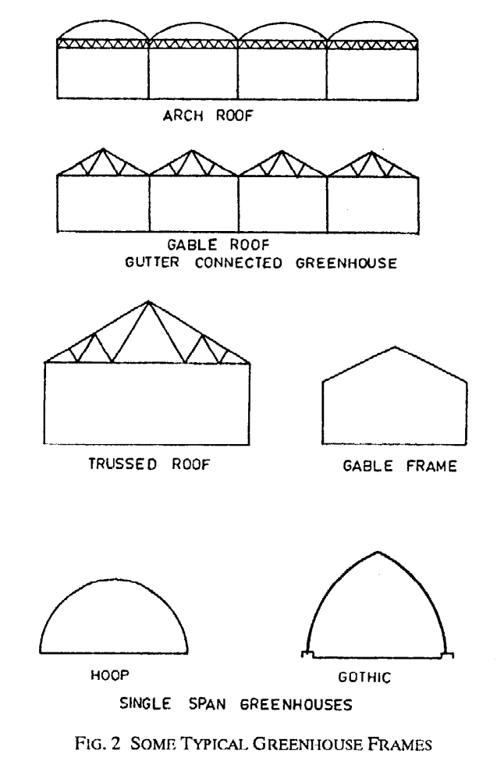

Urban farming technologies
Urban Farming
Urban farming refers to cultivating, processing, and distributing food within urban areas. This practice addresses food security challenges and promotes sustainability in densely populated cities.
It includes:
The agriculture which produces, processes and markets food to fulfill daily needs for consumers in a town, city, or metropolitan area by employing efficient methods of production, using and recycling natural resources and city wastes to produce a variety of products and livestock. Plant factories, hydroponics, vertical farming, and rooftop greenhouses are in fact components of a closed-field production system in urban agriculture.
a) | Rooftop Gardening | : | Utilizing rooftops for growing vegetables, fruits, or herbs
b) | Community Gardens | : | Shared plots where communities grow their own produce
c) | Aquaponics | : | Combining aquaculture (fish farming) with hydroponics.
d) | Indoor Farming | : | Using artificial light and climate control systems to grow crops indoors.

IS 18806: 2024-Hydroponic Farming Production System — Requirements
This standard covers the guideline for operation of hydroponic systems including requirements of substrates, nutrient solution and structure design.
- Technique of growing plants using a water-based nutrient solution rather than soil, and can include an aggregate substrate, or growing media. Hydroponics is soil-less farming. The word hydroponics comes from the root words ‘hydro’, meaning water, and ‘ponos’, meaning labor, literally ‘working water’.
- Hydroponic production systems are used by small farmers, hobbyists, and commercial enterprises.
- Hydroponics was a successful technique used to supply fresh vegetables in many countries and has been considered as the future of farming to grow foods for astronauts in space by NASA.
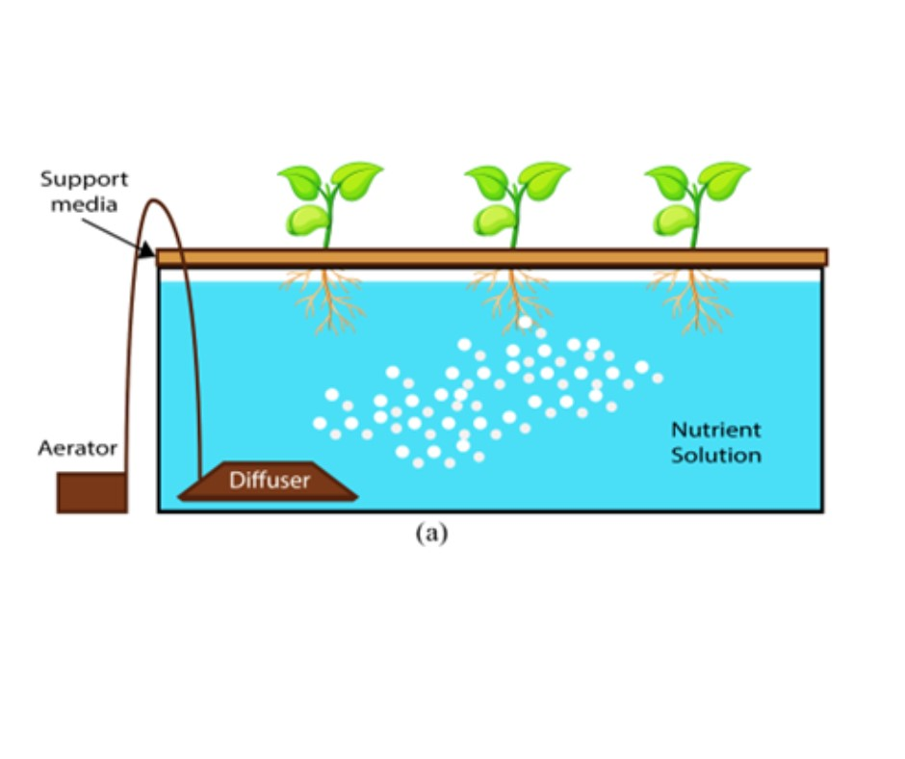

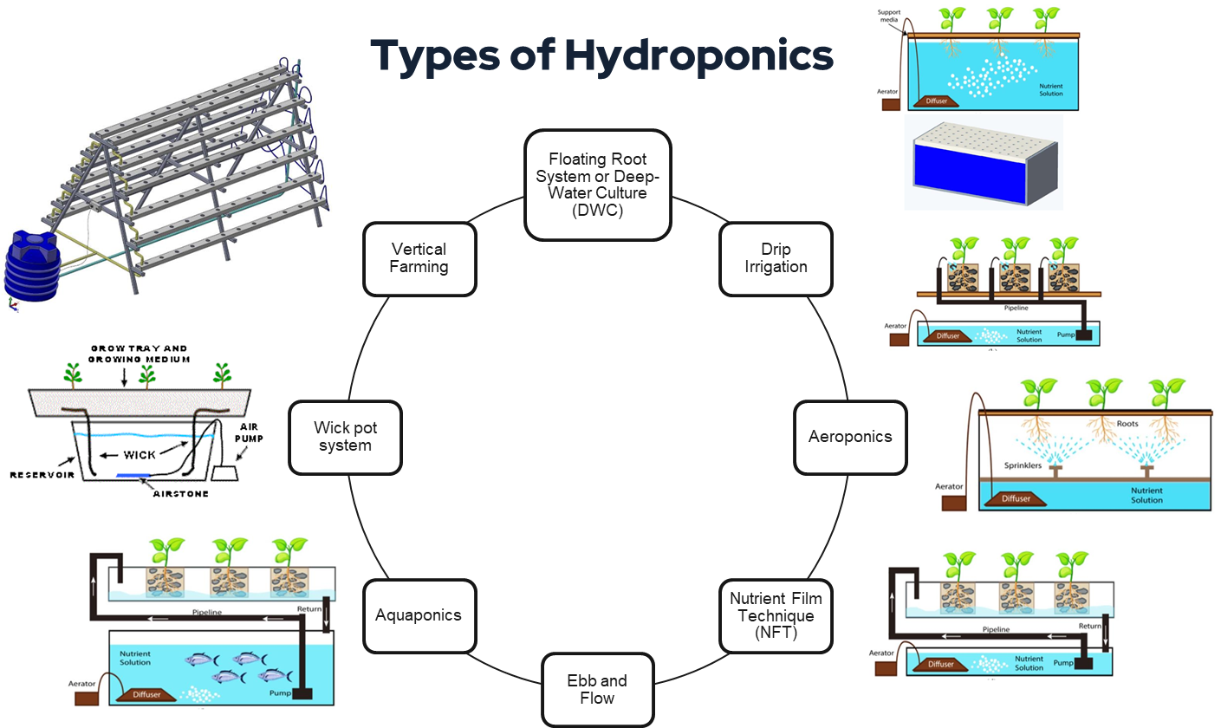
- Requirements of Hydroponic System
- Requirements of substrates used in hydroponics
- Characteristics of soil-less media substrates
- Sustainability criteria for choosing substrates
- Characteristics of nutrient solution
- Crop Selection for hydroponics
- Operational and maintenance requirements
IS 18807: 2024 Artificial Lighting System for Protected Cultivation —Requirements
This standard provides guidelines for the design, installation, operation, and maintenance of artificial lighting systems used in protected cultivation, including but not limited to indoor facilities, vertical farms, greenhouses, and other controlled environments.
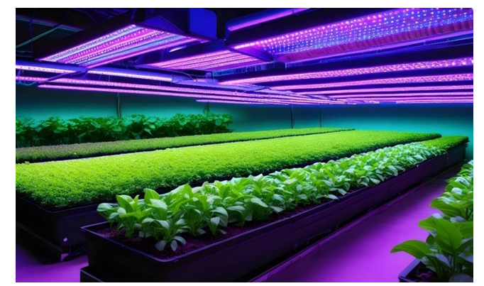

- Light is one of the key requirements for plant growth.
- Artificial lighting is needed to grow plants in spaces where, there is little or no natural light available or when the natural day length is artificially extended.
- Artificial lighting system is the electric lighting systems used as a primary or supplemental light source to support plant growth and development in Controlled Environment Agriculture.

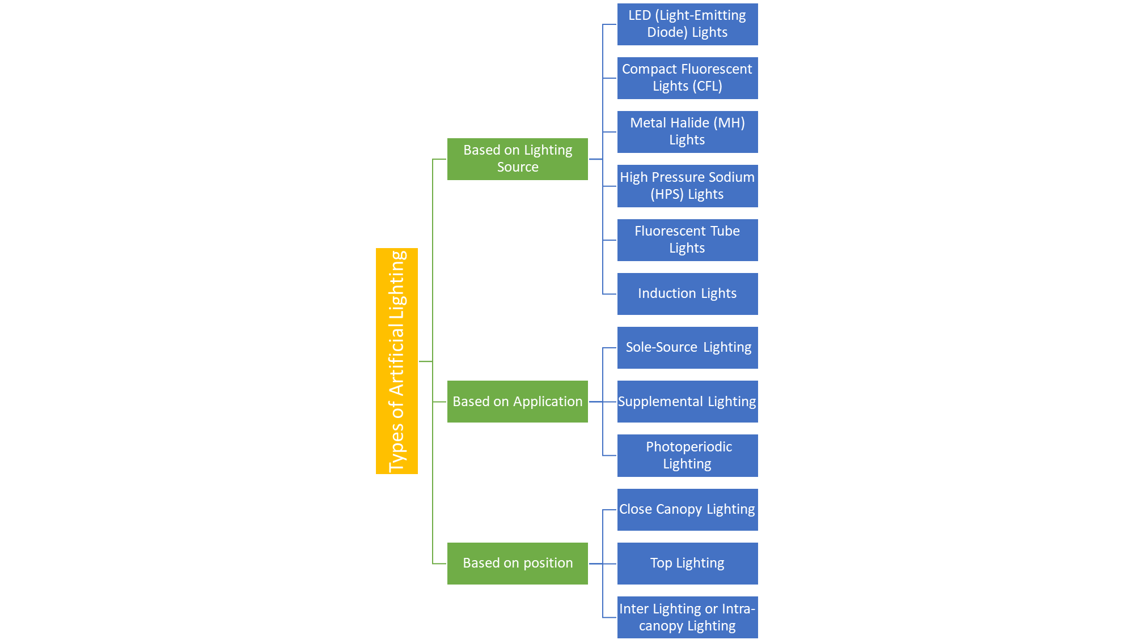
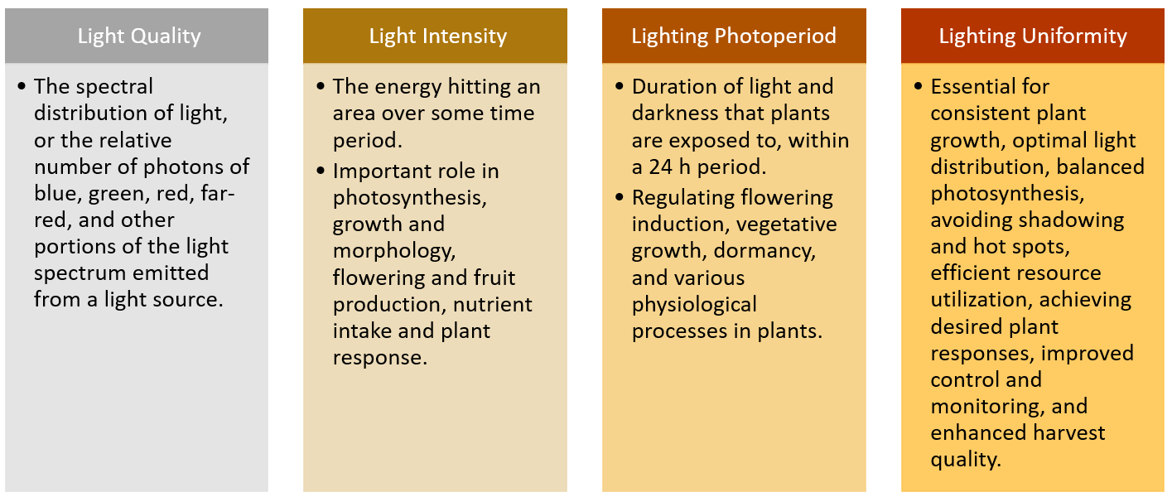

Standardization in Organic Farming
Conventional Farming
Conventional farming shall mean the farming systems dependent on input of synthetic fertilizers and/or synthetic chemicals and pesticides and synthetic hormones or which are not in conformity with the basic standards of organic production.
Organic Agriculture
Organic agriculture is a system of farm design and management to create an ecosystem, which can achieve sustainable productivity without the use of synthetic external inputs such as chemical fertilizers, pesticides and synthetic hormones.
Organic crop production management shall cover all agricultural food, fiber crops, herbal, medicinal and aromatic plant crops grown in the country from production to processing as well as collection of non-timber forest produce from the wild forests.
Need for Organic Farming:
1. Healthier Food Production
Organic farming produces food free from harmful chemicals and pesticides. It reduces the risk of health problems caused by long-term exposure to synthetic chemicals, such as allergies, hormonal disruptions, and certain cancers.
2. Environmental Conservation
Organic farming promotes biodiversity and improves soil health by avoiding synthetic inputs. It reduces soil erosion, conserves water, and prevents contamination of water resources by harmful chemicals. Encourages the use of renewable resources and reduces greenhouse gas emissions.
3. Resilience to Climate Change
Organic farming practices enhance soil structure and fertility, which improves its water retention capacity. By promoting biodiversity, it helps crops adapt to changing climate conditions.
4. Sustainability
It creates a balance between farming and nature, ensuring long-term agricultural productivity without depleting natural resources. Encourages recycling of organic waste back into the soil, closing nutrient loops.
5. Demand for Natural Products
Growing consumer awareness about food safety and nutrition is driving demand for organic produce. Organic food is often richer in essential nutrients, vitamins, and antioxidants.
6. Reduction of Agricultural Pollution
Eliminating synthetic chemicals reduces soil and water pollution. Organic pest management strategies reduce chemical residues in ecosystems.
7. Economic and Social Benefits
Organic farming creates rural employment opportunities, as it often requires more labour-intensive practices. Small-scale farmers can benefit by catering to niche markets for organic products, which typically command higher prices.
The growing need for organic farming reflects humanity’s response to the adverse effects of industrialized agriculture. It offers a holistic approach to farming that prioritizes the health of ecosystems, farmers, and consumers. Adopting organic farming practices is a step toward a more sustainable, equitable, and healthy future.
- Standardization in Organic Farming
- Global and National Context:
  - India ranks 5th globally in certified organic areas with 9.11 million hectares.
  - Organic farming contributes to a global market worth $100 billion.
  - 2.4 million farmers in India are certified for organic farming.
- National Initiatives:
a) The National Program on Organic Production (NPOP) was launched in 2000 and formally notified in 2001 under the FTDR Act.
b) The Participatory Guarantee System (PGS-India) is operated by the Department of Agriculture, Cooperation, and Farmers Welfare for domestic and export markets.
- IS 16550 Standard on Organic Production:
Part 1: Covers crop-based organic production systems and labelling.
Part 2: Covers animal-based organic production systems and labelling.
- Crop production Plan:
- Description of the crops in the production cycle (main crop, intercrop and relay crop) as per the agro climatic seasons.
- Description of practices and procedures to be performed and maintained.
- List of inputs used in production along with their composition, frequency of usage, application rate and source of availability.
- Source of organic seeds and planting material.
- Descriptions of monitoring practices and procedures to be performed and maintained to verify that the plan is being implemented effectively. Description of practices and procedures to be performed and maintained.
- Description of the management practices and physical barriers established to prevent mingling and contamination of organic production unit from conventional farms, split production and parallel production.
- Description of the record keeping system implemented to comply with the requirements of this standard.
- Procedures governing the production in different farming systems, their documentation, and for preventing ad-mixing of input and products.
- Conversion Requirement
- If the whole farm is not converted, it shall be ensured that the organic and conventional parts of the farm are separate and capable of being inspected individually.
- The requirements of this standard shall also be met during the conversion period. All the requirements shall be applicable from the commencement of the conversion period till its conclusion.
- Simultaneous production of conventional, in conversion and/or organic crops or which cannot be clearly distinguished from each other, shall not be permitted.
- In case of annual and biennial crops, plant products produced can be claimed as organic when the requirements of this standard have been met during the conversion period of at least 2 years (organic management) before sowing (the start of the production cycle). In case of perennial plants other than grassland (excluding pastures and meadows), the first harvest may be claimed as organic, after at least 36 months of organic management. Pastures, meadows and their products may be claimed as organic after 12 months of organic management.
- Landscape Requirement-
Organic farming shall contribute beneficially to the ecosystem.
- Choice of crop and diversity
- All seeds and planting material used, shall be certified organic. When certified organic seed and planting materials are not available, conventional seed and planting material (but not treated with chemicals) shall be used.
- Species and varieties cultivated shall be adapted to the soil and climatic conditions and be resistant to pests and diseases. In the choice of varieties, genetic diversity shall be taken into consideration.
- Use of genetically engineered seeds, transgenic plants or planting material is prohibited.
- Where appropriate, the organic farms shall maintain sufficient diversity in a manner that takes into account pressure from insects, weeds, diseases and other pests, while maintaining or increasing soil organic matter, soil fertility, microbial activity and general soil health.
- Permitted
- Not – permitted
- “restricted” means that the use of these inputs shall be subject to conditions. Factors such as contamination, risk of nutritional imbalances and depletion of natural resources shall be taken into consideration and as recommended by the relevant Government agencies of the region.
- Nutrient Management Requirement
- Sufficient quantities of biodegradable material of plant and/or animal origin produced on organic farms shall form the basis of the nutrient management Programme to increase or at least maintain soil fertility and the biological activity within it.
- Nutrient management should minimize nutrient losses.
- Accumulation of heavy metals and other pollutants shall be prevented.
- Non-synthetic mineral fertilizers and brought-in bio fertilizers (biological origin) shall be regarded as supplementary and not as a replacement for nutrient recycling.
- Non-synthetic fertilizers shall only be used in a supplementary role to carbon based materials. Only those organic or non-synthetic fertilizers that are brought in to the farm (including potting compost) shall be used when, the circumstances demand.
- Non-synthetic fertilizers shall be applied in their natural composition and shall not be rendered more soluble by chemical treatment.
- pH of the soil shall be maintained at optimum level.

- Pest, Disease and weed Management
- Weeds, pests and diseases shall be controlled through a number of preventive cultural techniques which limit their development, for example suitable rotations, green manures, early and pre drilling seedbed preparations, mulching, mechanical control and the disturbance of pest development cycles. Measures to prevent transmission of pests, parasites and infectious agents, shall be in place.
- Pest management shall be regulated by understanding and disrupting the ecological needs of the pests. The natural enemies of pests and diseases shall be protected and encouraged through proper habitat management of hedges, nesting sites etc. An ecological equilibrium shall be created to bring about a balance in the pest predator cycle.
- Products for pest, disease and weed management, prepared at the farm from local plants, animals and micro-organisms shall be used.
- Contamination Control
- All relevant measures shall be taken to minimize contamination from outside and within the farm.
- Buffer zones shall be maintained to prevent contamination from conventional farms. Polyethylene and polypropylene or other polycarbonates coverings such as plastic mulches, fleeces, insect netting and silage rapping, only are allowed. These shall be removed from the soil after use and shall not be burnt.

- Soil and Water conservation
- Soil and water resources shall be handled in a sustainable manner. Relevant measures shall be taken to minimize erosion and other forms of degradation of soil, excessive and improper use of water and the pollution of ground and surface water.
- Clearing of land through the means of burning organic matter, for example slash-and-burn, straw burning is prohibited. The clearing of primary forest is also prohibited
- Processing & handling requirements
- Any handling and processing of organic products should be carried out in a manner so as to maintain the organic integrity of the product. The operator shall develop an organic processing and handling plan.
- Pests should be avoided by good manufacturing practices. This includes general cleanliness and hygiene.
- There shall be no direct or indirect contact between organic products and prohibited substances (for example pesticides).
- Packaging requirements
- Biodegradable, recyclable, reusable systems and eco-friendly packaging materials shall be used wherever possible.
- Material used for packaging shall not contaminate food. Certain additives for use in manufacturing of packaging films for packaging of organic food stuffs are allowed for restricted use.
- Packaging and Labelling:
- Eco-friendly, recyclable, and reusable packaging is encouraged.
- Clear labeling requirements based on the percentage of organic ingredients
(e.g., “organic” for ≥95% certified organic ingredients).
- Labelling requirement
- When all the requirements of this standard are complied with, products shall be sold as “organic products”. Organic products in conversion shall be sold as “produce of organic agriculture in conversion” or of a similar description, when the requirements of this standard have been met for at least 12 months.
- Where a minimum of 95 percent of the ingredients are of certified organic origin, products shall be labelled “organic”.
- Where less than 95 percent but not less than 70 percent of the ingredients are of certified organic origin, products shall not be labelled “organic”. The word “organic” may be used on the principal display in statements like “made with organic ingredients” provided, there is a clear statement of the proportion of the organic ingredients.
- Where less than 70 percent of the ingredients are of certified organic origin, the indication that an ingredient is organic may appear in the ingredients list. Such a product shall not be labelled “organic”.
- Storage and Transportation
- Product integrity shall be maintained during storage and transportation of organic products.
- Where only part of the unit is certified and other products are non-organic, the organic products shall be stored and handled separately to maintain their identity.
- Bulk stores for organic products shall be separate from conventional product stores and clearly labelled to that effect.

