Agrotextiles are specialized technical textiles designed specifically for agricultural and horticultural applications to enhance productivity, protect crops, conserve resources, and promote sustainable farming practices.
1.1 The Need for Agrotextiles in Agriculture and Horticulture
The modern agriculture facing challenges due to the rapidly shrinking availability of arable land. Additionally, soil degradation caused by over-farming, erosion, and improper land management has further reduced the productivity of existing agricultural areas. To combat this, innovative solutions are required to optimize land use, enhance soil health, and maximize yields from smaller spaces. Agrotextiles play a crucial role in this context, offering products such as ground covers, vericompost beds, mulch mats that improve soil health, reduce erosion, and increase the efficiency of farming practices.
Climate change is another significant factor reshaping agriculture. Unpredictable weather patterns, including sudden storms, prolonged droughts, and extreme temperatures, are putting crops at risk and threatening food security worldwide. Traditional farming methods often fall short in mitigating these effects, leading to substantial losses in productivity. Agrotextiles provide resilience against such climatic uncertainties. Agrotextiles enable farmers to adapt to changing environmental conditions while maintaining consistent and sustainable production levels.
Drastically increasing population putting pressure on the demand for food and other agricultural products. This rapid growth requires a paradigm shift in agricultural practices to produce more with fewer resources. Agrotextiles contribute to this goal by improving efficiency across the agricultural value chain. Agrotextile products help farmers achieve higher yields per unit area, addressing the challenge of feeding a growing population without expanding the agricultural footprint.
Furthermore, the environmental impact of traditional agriculture has become a pressing concern. Excessive use of chemical fertilizers, pesticides, and water resources has led to soil degradation, water pollution, and loss of biodiversity. Agrotextiles provide a sustainable alternative by reducing the need for harmful agricultural inputs. For instance, crop covers and insect-proof nets protect plants from pests and diseases with minimal use of for chemical pesticides. By integrating these materials into farming systems, we can reduce the ecological footprint of agriculture and promote long-term environmental sustainability.
Agrotextiles represent a transformative opportunity by addressing the challenges of limited land availability, climate change, population growth, and environmental degradation. As the global community strives to achieve food security and environmental balance, agrotextiles will play an essential role in building a more resilient and sustainable agricultural future.
1.2 Benefits of Agrotextiles for Farmers
Agrotextiles offer a range of advantages that directly improve the livelihoods of farmers by addressing productivity, efficiency, and health concerns.
- Increased Productivity: Agrotextiles such as mulching fabrics and crop covers create an ideal microclimate for crops by regulating temperature, conserving moisture, and suppressing weeds. This leads to healthier plants and higher yields
- Reduction in Manual Labor: Weed control fabrics and other agrotextile solutions significantly reduce the need for time-intensive and laborious tasks such as manual weeding and pest management. This improve overall efficiency.
- Cost Efficiency: While agrotextiles require an initial investment, they reduce long-term costs associated with chemical inputs, labor for weeding, and crop losses, resulting in improved profitability for farmers.
- Positive Impact on Farmers’ Health: By reducing the need for chemical pesticides, insect-proof nets and crop protection covers lower farmers' exposure to harmful chemicals, thereby minimizing health risks. The decreased physical strain from manual labor further contributes to their well-being and quality of life.
1.3 Environmental Benefits of Agrotextiles
Traditional agricultural practices often have a negative impact on the environment, including soil degradation, water pollution, and excessive chemical use. Agrotextiles provide eco-friendly solutions that promote sustainable farming.
- Reduction in Chemical Usage: Crop covers, insect nets, and weed control fabrics reduce the need for chemical pesticides and herbicides, minimizing their harmful impact on soil, water, and biodiversity.
- Soil Health Improvement: Ground covers and erosion control mats prevent soil erosion, retain nutrients, and protect against compaction, helping to maintain soil fertility and structure.
- Water Resource Management: Agrotextiles used in irrigation systems reduce water evaporation and ensure uniform water distribution, conserving precious water resources.
- Mitigation of Climate Change Effects: By protecting crops from extreme weather conditions such as excessive heat, drought, and storms, agrotextiles help reduce agricultural losses caused by climate change and support climate-resilient farming.
1.3.1 Agrotextiles contribute significantly to achieving the United Nations Sustainable Development Goals (SDGs), particularly in the areas of food security, environmental conservation, and sustainable economic growth:
SDG 2: Zero Hunger
  - Agrotextiles improve agricultural productivity and ensure higher crop yields, contributing to food security and reducing hunger.
SDG 6: Clean Water and Sanitation
  - By conserving water resources and preventing runoff, agrotextiles support sustainable water management practices, addressing water scarcity and quality issues.
SDG 12: Responsible Consumption and Production
  - The use of biodegradable and durable agrotextiles reduces reliance on synthetic materials and promotes sustainable production practices in agriculture.
SDG 13: Climate Action
  - Agrotextiles mitigate climate change impacts by preventing soil erosion, reducing impact of extreme weather events enhancing and reducing the carbon footprint of agricultural practices through reduced need of input chemicals.

1.4 Benefits of Agrotextiles to a Economy
- Enhanced Agricultural Productivity and Food Security: Agrotextiles directly contribute to higher agricultural output by improving crop yields and reducing losses caused by pests, weeds, and extreme weather conditions.This translates to improved food security and the ability to meet the dietary needs of growing populations
- Reduction in Imports : By improving domestic agricultural productivity, agrotextiles reduce a nation’s dependence on food imports well as reduction in chemical imports. This strengthens food sovereignty, stabilizes local markets, and reduces the economic strain of importing essential food products.
- Promotion of Sustainable Development : Agrotextiles play a key role in achieving sustainable agricultural practices, which are vital for a nation’s long-term prosperityThis aligns with national and global efforts to combat climate change, promote eco-friendly practices, and achieve sustainable development goals (SDGs).
Agrotextile offers solutions for agriculture and horticulture for crop protection, efficient water management and soil health management.
2 AGROTEXTILES FOR CROP PROTECTION

2.1 Protection Against Sunlight
Excessive sunlight and UV radiation can cause heat stress, dehydration, and sunburn in crops, leading to reduced yields. Shade nets, agrotextiles, regulate light intensity by filtering sunlight and creating a microclimate that promotes optimal plant growth. By reducing temperature and evapotranspiration, they are particularly useful for nurseries, greenhouses, and crops sensitive to intense light.BIS has published IS 16008 standard for crop protection.
Shade nets, offer protection by creating a microclimate that shields crops from excessive sun, Made from high-density polyethylene (HDPE) tapes or monofilaments, shade nets work as a physical barrier. Shade nets porous structure allows light, and air to pass through, while diffusing the direct sunlight that could damage crop.
IS 16008 is published in 2 parts covering tapes and monofilament nets, shade nets are classified according to shading percentages: ranging from 35% to 90%, offering farmers flexibility to choose the ideal net for their crops according to climatic conditions and type of crop.
The IS 16008 (Part 1): 2016 Indian Standard prescribes constructional and other performance requirements for agro shade nets manufactured from tape yarns for agriculture and horticulture purposes in protecting/increasing crop yield by providing partially controlled climatic conditions for the intended crops. The materials used in the manufacture of shade nets include HDPE Tapes, which are UV stabilized by adding a suitable UV stabilizer
2.1.1 Classification of tape yarn shade nets
Agro shade nets are classified into Type I, Type II, and Type III based on their shading percentage.to ensure the quality of tape yarn shade nets, breaking strength, bursting strength is also specified in standard. The standard also requires a retention of 85% of the original breaking strength after UV exposure, ensuring durability in use which will enhance yields and improve the quality of crops (Table 1).
Table 1 Requirement of tape yarn shade nets
Sl. No. | Characteristic(s) | Requirements(s) |  |  | Method of Test, Ref. to
Sl. No. | Characteristic(s) | Type I | Type II | Type III | Method of Test, Ref. to
(1) | (2) | (3) | (4) | (5) | (6)
i) | Mass, g/m², Min | 100 | 120 | 140 | IS 1964
ii) | Average breaking strength of shade nets fabric (Strip method, 325 mm × 50 mm test piece with gauge length of 200 mm), N, Min: |  |  |  | IS 1969 (Part -1)
ii) | a) Warpway | 200 | 250 | 290
ii) | b) Weftway | 200 | 250 | 290
iii) | Retention of breaking strength after UV exposure, N, Min | 85 percent of original actual value (fabric) |  |  | Annex B and IS 1969 (Part 1)
iv) | Color fastness to artificial light¹⁾ | 4 or better | 4 or better | 4 or better | IS 1964
v) | Bursting pressure, kgf/cm², Min | 5 | 6 | 9 | IS 1969 (Part -1) or  IS 1969 (Part-2)
vi) | Shading percentage | 45 to 55 | 70 to 80 | 85 to 95 | Annex C
¹⁾ Applicable for colored shade nets only.
2.1.2 The IS 16008 (Part 2): 2016 Indian Standard prescribes constructional and other performance requirements for agro shade nets made from monofilament yarns. Shade nets are classified based on shading percentage. Monofilament shade nets offers the advantage of higher breaking and bursting strength.
Table 2 Requirements of Shade Nets Made from Monofilament Yarns

Sl No. | Characteristic (s) |  | Requirement (s) |  |  |  | Method of Test, Ref to
Sl No. | Characteristic (s) | Type I | Type II | Type IIA | Type III | Type IV | Method of Test, Ref to
(1) | (2) | (3) | (4) | (5) | (6) | (7) | (8)
i | Mass, g/m², Min | 95 | 125 | 105 | 310 | 460 | IS 1964
ii | Average breaking strength of shade nets fabric (Strip method,  325 mm × 50 mm test piece with gauge  length of 200 mm), N, Min |  |  |  |  |  | IS 1969 (Part 1)
ii | a) Warpway | 300  350 | 300  620 | 300  620 | 450  1700 | 650  4300 | IS 1969 (Part 1)
ii | b) Weftway
iii | Retention of breaking strength after UV IS exposure, N, Min | 85 Percent of original actual value (fabric) |  |  |  |  | Annex B and IS 1969 (Part 1)
iv | Colour fastness to artificial light¹⁾ | 4 or better | 4 or better | 4 or better | 4 or better | 4 or better | IS 2454
iv | Bursting pressure, kgf/cm², Min | 11 | 13 | 13 | 30 | 40 | IS 1966 (Part 1)  IS 1966 (Part 2)
v | Shading percentage | 30 to 40 | 45 to 55 | 45 to 55 | 70to 80 | 85 to 95 | Annex C
¹⁾ Applicable for coloured shade nets only
2.1.3 Installation Guidelines for shade nets
A shadenet house consists of two basic components: frame and cladding material. Frame materials must possess adequate strength to withstand design loads, such as wind load, crop load, live load, and snow load. To plan a shadenet house project, farmers must carefully study the climate, soil, water, topography, accessibility, protection against fluctuating temperatures, solar radiation, heavy rain, hail, and strong wind, type of soil, soil profile, location, adequate drainage of water, and infrastructure for transporting materials The design load includes dead load, live load, wind load, and snow load. Shadenet houses equipped with micro-irrigation and fertigation systems require regular maintenance, with frequency of services/examinations based on the extent of exposure to hazardous conditions. Tighten the shade nets during the first two months of cladding and maintain a tight stretch to prevent damage and extend their life span.
During installation, measure out about 25 percent more shade nets fabric than needed to cover the entire structure. Total requirements of shade nets depend entirely on the surface area of the shadenets house; as the area increases the requirement will decrease proportionally. It varies from approximately 2.5 times to 1.8 times of total surface area. Unroll the shade nets fabric across the structure, leaving at least one foot of nets fabric overhanging on all sides. Pull the nets fabric into position, straightening as needed.Start with the longest side one will be covering and affix the shade nets fabric with appropriate measures like aluminium profile with zig-zag spring, etc. Keep the fabric tight and the lines on the knitting straight while working across the length of the structure. Same procedure need to be followed for shorter side by keeping the shade nets fabric evenly lined up while heading in the direction away from the home. Always continue in the same clockwise or counter clockwise direction one began with. When attaching the nets fabric, after finishing the last edge, try to avoid any overlap in the fabric.

2.2 Shielding crops from hailstorms
Hailstorms can severely damage crops, especially delicate fruits, flowers, and leaves. Hail nets act as protective covers that prevent hailstones from directly hitting plants. These nets reduce physical damage while allowing sunlight and air to penetrate, ensuring that crop growth is not compromised during adverse weather conditions.
Hail protection nets are specialized textiles designed to prevent damage to flowers and fruits caused by hailstorms, particularly in vulnerable regions like hilly areas. They are instrumental in minimizing flower and fruit drop, ensuring healthier yields. BIS has published IS 17730 Part 1 and Part 2 for hail storm nets to cover knitted and woven hail protection nets.
Indian Standard IS 17730 Part 1:2021, which prescribes the construction and performance requirements for warp-knitted hail protection nets used in agriculture and horticulture.

2.2.1 Material Composition
The nets are manufactured using high-density polyethylene (HDPE) monofilament yarns, which are UV stabilized to resist degradation caused by prolonged exposure to sunlight. This ensures their durability under harsh environmental conditions. The yarn is available in a range of colors or mixtures, as agreed upon between the buyer and seller, and is stabilized to meet specific heat shrinkage tolerances.

2.2.2 Types and Characteristics
Hail protection nets are categorized into two types based on mass per unit area:
- Type I: 60 g/m² mass, suitable for areas requiring moderate protection.
- Type II: 70 g/m² mass, designed for more robust protection.
The nets are reinforced at their edges and joints to withstand stress during installation and usage. For wider nets exceeding 6 meters, additional reinforcements are provided at the center to enhance stability. Joints in the fabric are restricted to ensure uniformity and performance.

2.2.3 Performance Requirements
The standard specifies performance requirements for hail protection nets to ensure their quality and durability
Breaking Strength: The fabric must have a minimum breaking strength of 180 N in the wales direction and 250-300 N in the course direction, depending on the type.
- UV Resistance: After 144 hours of UV exposure, the fabric should retain at least 85% of its original breaking strength.
- Shading Efficiency: The shading percentage must not exceed 17% for Type I and 20% for Type II, ensuring adequate sunlight penetration while mitigating hail impact.
- Cold Crack Resistance: The nets must endure temperatures as low as -10°C without cracking or breaking.
Similarly, for woven hail protection nets BIS has published IS 17730 (Part 2) : 2021.
Table 3 Requirement of knitted hail protection nets
Sl. No. | Characteristic(s) | Requirements(s) |  |  | Method of Test, Ref. to
Sl. No. | Characteristic(s) | Type 1 | Type 2 |  | Method of Test, Ref. to
(1) | (2) | (3) | (4) |  | (5)
i) | Mass in g/m²  , (with a tolerance of ± 5 percent) | 60 | 70 |  | IS 1964
ii) | Average breaking strength of knitted hail protection fabric (Strip method, 325 × 50 mm  test piece with gauge length of 200 mm), N, Min |  |  |  | IS 1969 (Part 1)
ii) | a) Wales direction | 180 | 180
ii) | b) Course direction | 250 | 300
iii) | Retention of breaking strength after UV exposure of 144 hours, percent, Min | 85 percent of original actual value (fabric) |  |  | Annex B and IS 1969 (Part 1)
iv) | Colour fastness to artificial light¹⁾ | 5 or better |  |  | IS/ISO 105-B02
v) | Bursting pressure, kgf/cm², Min | 6 | 8 |  | IS 1966 (Part 1) or IS 1966 (Part 2)
vi) | Shading percentage, percent, Max | 17 | 20 |  | Annex C
vii) | Cold cracking resistance test at –10 °C | No specimen shall damage or broken |  |  | Annex D
viii) | Seam (joint) strength²), N, Min  a) Wales direction  b) Course direction | 155  215 |  | 155  255 | IS/ISO 13935-1
²⁾ The seam strength testing shall be done in the applicable direction of stitching.’

2.2.4 Installation Guidelines
Hail protection nets can be installed using two primary methods:
- Single-Tree Installation: Suitable for larger trees (up to 30 feet tall), where individual trees or pairs of trees are covered. Support structures such as bamboo or galvanized iron (GI) pipes are used to secure the nets.
- Trellis/Strip Method: Ideal for high-density plantations where trees have similar heights. The nets are installed over a framework of bamboo or GI pipes, providing efficient coverage.
Proper tensioning during installation is critical to prevent sagging and ensure durability during hailstorms. For more details please refer to Annex E of IS 17730 Part 1.
2.3 Protection Against Wind Damage
Strong winds can uproot plants, break stems, can cause damage to flowers, fruits and cause erosion of topsoil, which is crucial for plant nutrition. Wind protection nets, also known as windbreak nets, reduce wind velocity and create a calmer environment for crops. These nets also help retain soil moisture by minimizing evaporation, making them ideal for arid and semi-arid regions. BIS has published important standard IS 17356 : 2020 on windshield nets.
The Indian Standard windshield nets for agriculture and horticulture purposes prescribes constructional and other performance requirements for windshield nets manufactured from mono filament yarns for agriculture and horticulture purposes. The fabric used in the manufacture of windshield nets shall be knitted on the warp knitting machines. Eyelets shall be provided during knitting along the width of the net after every 1 m length or as agreed between the buyer and the seller
2.3.1 Classification of Windshield nets
Windshield nets are classified based on mass in g/m², with Type 1 having a mass of 100 g/m² suitable for wind speeds up to 55 km/h and Type 2 having a mass of 150 g/m² suitable for a wind speeds up to 80 km/h. Also, to ensure the durability and quality of windshield nets, the fabric shall confirm to the requirements specified in table 5.
Table 5 Requirements of Windshield Nets
Sl. No. | Characteristic(s) | Requirements(s) |  | Method of Test, Ref. to
Sl. No. | Characteristic(s) | Type 1, Mono × Mono construction | Type 2, Mono ×  Mono construction | Method of Test, Ref. to
(1) | (2) | (3) | (4) | (5)
i) | Mass g/m² , Min | 100 | 150 | IS 1964
ii) | Average breaking strength of wind shield net fabric (Strip method, 325×50 mm test piece with gauge length of 200 mm), N, Min; |  |  | IS 1969 (Part 1)
ii) | a) Warpway | 350 | 400
ii) | b) Weftway | 350 | 700
iii) | Retention of breaking strength after UV exposure of 144 h, percent, Min | 85 percent of original actual value (fabric) |  | Annex B and IS 1969 (Part 1)
iv) | Colour fastness to artificial light¹⁾ | 4 or better |  | IS 105-B02
v) | Bursting pressure, kgf/cm², Min | 10 | 14 | IS 1966 (Part 1) or IS 1966 (Part 2)
vi) | Wind blockage, percent, Min | 18 | 35 | Annex C
¹⁾Applicable for coloured windshield nets only

To ensure the nets can sustain high wind, standard also specify performance test in terms of Wind blockage percentage, expressing the quantification of the amount of wind passing through the sample and gives the capacity of the net sample to block the amount of wind passing through it.The wind blockage test is carried out at wind velocity of 55 km/h for type 1 wind shield nets and 80 km/h for type 2 wind shield nets.
2.3.2 Installation Guidelines for wind shield nets
The planning for windshield installation should consider factors such as crop type, local materials, finance budget, and climatic conditions. Use of hooks shall be avoided for loading and unloading of the rolls of windshield nets at site.The windshield nets shall be stored so as to be protected from damage, dirt, grease, water, moisture mud, mechanical abrasions, excessive heat or any other damage. The rolls/bundles shall be stored on a prepared surface and to be stacked not more than three rolls/ bundles. The ideal windshield net should be at right angles to the prevailing wind, and should be at least 11 times as long as the fence for best effect. The zone of protection on the down-wind side of the windshield should be 6 to 8 times the fence height. Support posts, such as timber posts, tapered hardwood, or pine, are typically used due to their availability and ease of use. Wire and cable are used to support the cloth and transfer loads to the posts. Post embedment depth is a critical factor for cantilever pole construction, with 30-40% of their height in the ground.
To improve the service of windshield nets, it is essential that the windshield nets are placed on suitable structures according to the dimensions. To achieve this proper onsite laying, joining and fixing of windshield net is imperative.Ideally, a windshield net should be at right angles to the prevailing wind. Note that there will be areas of high wind speed and turbulence around the ends of a windshield fence, so the fence should always be longer than the area requiring protection or it should have sides. It’s recommended that windshields net should not be less than 11 times as long as they are high for best effect. For example, 5 m high windshield should be at least (5 × 11) 55 m long.
Windshield should be installed in high speed wind affected areas to protect the crops from wind damage. The zone of protection on the down-wind side of the windshield will be 6 to 8 times the fence height. This distance of protection will be less if the ground rises on the down-wind side and will be more if the ground drops away. When calculating the required height or distance between windshield fences, consideration must be given to the crop height.
Zone of protection = (Actual windshield height – crop height) × 6
When selecting support posts, it is the strength at ground level which is the most important factor. Line diagram for installation of wind shield nets is shown in Fig. 1.
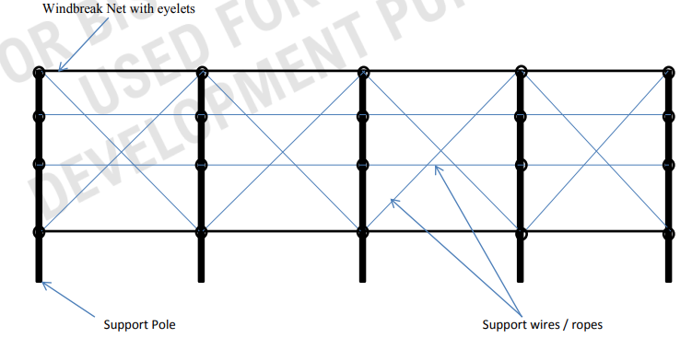
Fig. 1 Line Diagram for Installation of Wind Shield Nets
Wire or cable is used to support the cloth and transfer the loads to the posts. Multi strand high tensile cables are used on top and bottom edges of the cloth to support higher wind loadings.

2.4 Safeguarding Crops from Birds
Birds can cause significant damage to crops, particularly during the fruiting stage, by pecking at fruits and seeds. Bird nets are commonly used in orchards, vineyards, and vegetable farms to protect fruits and crops from bird-related losses. Bird protection nets are an essential agro-textile product designed to protect crops from damage caused by birds, ensuring higher agricultural yields and better crop quality. These nets serve as a physical barrier that prevents birds from accessing crops while allowing sunlight, moisture, and pollinating insects to pass through.
2.4.1 BIS has published anti bird nets standards based on the three different manufacturing technologies.IS 18310 Part 1 covers specifications for knotted anti bird nets, Part 2 covers Knitted bird protection nets and part 3 covers Extruded bird protection nets. The knotted bird protection nets outlined in the Indian Standard IS 18310 are specifically manufactured for use in agriculture and horticulture, with additional applications in domestic and commercial settings to restrict bird entry.
knotted nets are manufactured using high-density polyethylene (HDPE) monofilament yarns, which are UV-stabilized to resist long-term environmental exposure. This stabilization ensures the nets maintain their structural integrity even under prolonged sunlight. To further enhance durability, the yarn heat shrinkage testing is specified to ensure minimal deformation when exposed to elevated temperatures, providing confidence in its performance across varying climatic conditions.
The construction of knotted bird protection nets involves twisting HDPE filaments into three-ply twines, which are further converted into cables. This process ensures high strength and durability, making the nets capable of withstanding mechanical stresses during installation and use.
2.4.2 Classification of knotted bird protection nets
Knotted bird protection nets are classified into two types based on mass per unit area:
Type I with a mass of 56 g/m² for lighter applications and Type II with 80 g/m² for heavier-duty needs.
Both types feature square mesh configurations with mesh sizes of 25 mm for Type I and 19 mm for Type II. The breaking strength of the mesh is maintained at a minimum of 125 N to ensure reliability under field conditions. The nets also demonstrate excellent UV resistance, retaining at least 85% of their breaking strength after 144 hours of UV exposure.
Table 6 Requirements of Bird Protection Net Made from Filament Yarn Plied Knotted

Sl. No. | Characteristic(s) | Requirements(s) |  | Tolerance(s) | Method of Test, Ref. to
Sl. No. | Characteristic(s) | Type –I | Type -II | Tolerance(s) | Method of Test, Ref. to
(1) | (2) | (3) | (4) | (5) | (6)
i) | Mass, g/m² | 56 | 80 | +5 percent  0 percent | IS 1964
ii) | Mesh type | Square | Square | — | Visual
iii) | Average mesh size, mm | 25 | 19 | ± 2 mm | IS 15789
iv) | Average mesh breaking  strength, Min, N | 125 | 125 | — | IS 5815 (Part 5)
v) | Retention of breaking strength after UV exposure of 144 hours, percent, Min | 85 percent of original  actual value (fabric) |  | — | Annex B and  IS 5815 (Part 5)
vi) | Colour fastness to artificial light(see Note) | 4 or better |  | — | IS/ISO 105-B02
NOTE — Applicable for coloured bird protection nets only

2.4.3 Installation
Anti-Bird nets are installed using tie cords and border ropes, which ensure proper tensioning and prevent sagging. This setup is critical for maintaining the effectiveness of the nets, as sagging could allow birds to access crops.
Similarly, IS 18310 part 2 and part 3 covers specifications for knitted and extruded bird protection nets.

2.5 Harvest Nets
Harvesting fruits and nuts can lead to physical damage when they fall to the ground. Harvest nets are used to catch produce, preventing impact damage and contamination by soil and debris. These nets make harvesting more efficient and reduce post-harvest losses, particularly for crops like olives, almonds, and mangoes. BIS has published standard on harvest net IS 17357 : 2020.
3 AGROTEXTILES FOR EFFICIENT WATER MANAGEMENT
Efficient water management is a critical aspect of modern agriculture, particularly in regions facing water scarcity or erratic rainfall patterns. Agrotextiles play a pivotal role in optimizing water usage by reducing water loss, enhancing irrigation efficiency, and protecting water resources. BIS has published important standards on liners for ponds,woven flexible sotrgae tanks, woven lay flat tube for irrigation, flat tubes for rain irrigation systems etc.
3.1 Geomembrane liners for water conservation
Geomembrane liners are used in the ponds, canals and reservoirs to form an impermeable layer between the water and the soil. These liners are woven fabric of PP and HPDE material having surface coating. Geomembrane liners are effectively used for water conservation as well as environmental protection. When geomembranes are used in ponds and reservoirs, they limit water loss due to seepage. This helps to maintain a steady water level, which in turn contributes to the conservation of water. To prevent groundwater contamination, geomembrane liners also serve as a barrier that acts as a protective barrier between the water and the soil layer. This barrier prevents groundwater from becoming contaminated. Because of the impermeable layer that exists between the water and the soil, they are also excellent for aquaculture since they keep the pH of the water at a constant level. Liners made of geomembrane must to be lightweight in order to facilitate their handling and installation. It is necessary for them to be flexible in order to easily handle a variety of pond shapes. Therefore, in order to prevent the geomembrane liner from failing and water loss due to seepage, it is necessary for them to have a high level of puncture resistance. Additionally, the liner should not be affected by sunlight UV exposure in order to ensure its long-term durability. BIS has published standard on woven geomembrane for water proof lining.BIS has published standard on geomembrane for water proof liners IS 15351 : 2015. IS classifies geomembrane liners based on thickness and mass.

3.1.1 Classification of Geomembrane liners
Classified based on thickness and mass:
- Type I: Minimum thickness of 0.25 mm; minimum mass 250 g/m².
- Type II: Minimum thickness of 0.50 mm; minimum mass 420 g/m².
- Type III: Minimum thickness of 0.75 mm; minimum mass 650 g/m².
- Type IV: Minimum thickness of 1.00 mm; minimum mass 950 g/m².

The standard outlines essential physical and mechanical properties that laminated HDPE geomembranes shall meet, to ensure the durability of geomembrane liners in all types of terrains and climatic conditions.
- Breaking Load: Evaluated in warp and weft directions before and after UV exposure. For instance, Type I geomembranes must withstand a breaking load of 3,300 N in the warp direction.
- Tear Resistance: to assesses the material's ability to resist propagation of tears when subjected to force, to ensure the durability of geomembranes (e.g., Type I: 100 N, Type IV: 350 N).
Table 7 Requirement for HPPE woven geomembrane for water proof lining
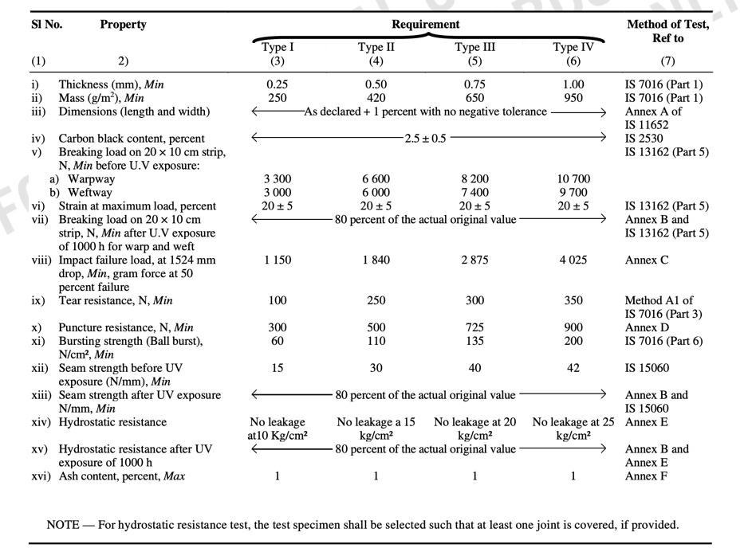
- Puncture Resistance: Specified thresholds ensure resistance to sharp objects which may occur during the installation or use (e.g., Type I: 300 N, Type IV: 900 N).
- Hydrostatic Resistance: This tests the geomembrane's ability to prevent water leakage under high pressure. Must withstand pressures without leakage (e.g., Type I: 10 kg/cm², Type IV: 25 kg/cm²).

3.1.2 Installation Guidelines for Geomembrane liners

Site Preparation
Remove organic material, sharp objects, and rocks to prevent punctures.Compact the sub-grade and ensure a smooth, uniform surface.Unroll geomembrane panels carefully to avoid scratches or crimps.Ensure overlaps of 50–75 mm between panels.Avoid installation during adverse weather (rain, high winds, or extreme temperatures).

Seaming and Protection
Seams should run parallel to slopes and be minimized at corners.Use hot air welding to bond overlapping edges.Seams must be inspected for defects like fish mouths or unbonded areas.Install fencing to prevent accidental punctures by animals or humans.

3.2 Flexible water storage tanks for irrigation
Flexible water storage tanks are an innovative solution for water storage needs in agriculture and horticulture, particularly in areas where rigid or concrete tanks are impractical. These tanks are designed to store rainwater effectively and are especially useful in remote or hilly regions. Their portability and ease of installation make them a preferred choice for farmers and agricultural professionals. Besides agricultural purposes, these tanks may be used in domestic and commercial applications, except for storing drinking water. BIS has published standard on flexible storage tank, IS 17729 : 2021.

3.2.1 Types of Flexible Water Storage Tanks
The tanks are classified into six categories based on their capacity to accommodate different needs. Type I has a minimum capacity of 2 kL, making it suitable for small-scale applications. Type II and Type III, with capacities of 6 kL and 12 kL, respectively, are ideal for moderate storage needs. Larger capacities, such as Type IV (25 kL), Type V (50 kL), and Type VI (100 kL), cater to extensive agricultural operations or commercial requirements. This variety ensures there is a tank available to suit diverse usage scenarios.

3.2.2 Material and Construction
The tanks are constructed with two primary layers: an inner layer and an outer layer, each serving a specific purpose. The inner layer is made from three tubular films, each consisting of seven sub-layers.These films are extruded simultaneously to ensure uniformity, resulting in a final thickness of 125 microns with a tolerance of ±10%. This structure ensures durability and resistance to environmental stress.
The outer layer is crafted from woven polypropylene (PP) tapes, providing additional strength and UV resistance. It is black in color to enhance durability under prolonged sunlight exposure. The fabric’s mass shall be 170 g/m² with a ±3% tolerance, and the tapes are tightly woven to prevent leaks and withstand wear and tear. This robust combination of inner and outer layers ensures the tanks are strong, durable, and suitable for various environmental conditions.

3.2.3 Performance Standards
The tanks are engineered to meet performance requirements to ensure reliability. The materials used in both the inner and outer layers possess high tensile strength to withstand mechanical stresses and environmental conditions. The tanks are also resistant to cracking, even at low temperatures of -20°C, making them suitable for use in cold climates.
Seam strength is another critical aspect, standard specifies seams retaining of 80% of their original strength even after prolonged UV exposure. Additionally, the tanks are designed to withstand puncture forces of at least 300 N, ensuring durability during installation and usage. UV resistance ensures the tanks maintain 85% of their tensile strength after extensive sunlight exposure, making them suitable for outdoor applications over extended periods.
Flexible water storage tanks are equipped with top and bottom butterfly valves for efficient water management. These valves facilitate easy filling and emptying of the tanks. An overflow system is also integrated to prevent water loss in case of excess rainwater collection. The tanks’ seams are stitched with UV-stabilized yarn to ensure long-lasting performance, and the stitching is done uniformly to avoid weak points.

3.2.4 Installation and Handling Guidelines
When selecting a site for installation, a flat and rock-free surface is recommended to prevent damage to the tank.
During installation, the flexible tanks should be spread evenly to avoid folds or creases, which could compromise their durability. The inlet valve should be oriented towards the rainwater source, and a filter should be used to prevent debris from entering the tank. After installation, regular inspections should be conducted to check for visible damages or leaks. To protect the tanks from rodents, measures such as maintaining clean surroundings, creating barriers, and using ultrasonic repellents should be implemented.
3.3 Light weight woven lay flat tubes for irrigation
The Indian Standard, IS 16190: 2014, focuses on the transportation of water from ponds, canals, or borewells to various parts of the field for agriculture. High density polyethylene laminated woven lay flat tubes have been developed to be lighter in weight and easier to transport in the agriculture field. These tubes do not require fixed installation and can transport water at the place of choice easily. Farmers are expected to incur less fixed expenditure to irrigate their fields at considerably lower running cost compared to existing piping systems.
IS 16190 : 2014 prescribes constructional and other requirements for high density polyethylene (HDPE) laminated woven lay flat tube for irrigation purposes. These lay flat tubes are used at the delivery lines of the agriculture pump sets, which may be exposed to atmosphere and sunlight. It specifies the minimum internal diameter and tolerance for nominal overlap.
3.3.1 Performance Requirements
The performance test includes (Table 8) breaking strength before UV exposure, elongation at break, retention of breaking strength after 85% of original actual value, abrasion resistance, tear strength, puncture strength, environmental stress cracking test, accelerated ageing test, and cold cracking resistance test.
Table 8 Requirements of woven lay flat tubes for irrigation
Sl. No. | Characteristics | Requirement(s) | Method of Test, Ref to
Sl. No. | Characteristics | Requirement(s) | Annex | IS No.
(1) | (2) | (3) | (4) | (5)
i) | Mass, g/m², Min | 260 | — | IS 1964
ii) | Breaking strength before UV exposure, N, Min | 1 200 (Warp)  900 (Weft) | — | IS 1969 (Part 1)
iii) | Elongation at break, percent | 20 ± 5 | — | IS 1969 (Part 1)
iv) | Retention of breaking strength after UV exposure of 500 h, N, Min | 85 percent of original actual value (fabric) | B | —
v) | Abrasion resistance | Loss in breaking strength shall not be more than 15 percent | — | IS 14714
vi) | Trapezoid tear strength, N, Min | 100 (Warp)  100 (Weft) | — | IS 14293
vii) | Puncture strength, N, Min | 300 | C | —
viii) | Environmental stress cracking test | There shall be no evidence of stress cracking | D | —
ix) | Accelerated ageing test for 72 h at 70 ± 1°C | Loss in breaking strength shall not be more than 15 percent | — | IS 7016 (Part 8) (Oven method)
x) | Cold cracking resistance test at –5°C | No specimen shall damage or broken | E | —

3.3.2 Workmanship is crucial, as lay flat tubes must be free from dirt, knots, lumps, irregularities of the tape, and other visible defects. A hydrostatic burst pressure test is specified in standard to ensure that a test length of lay flat tube does not burst before a pressure of 2.6 kg/cm2 is reached.
The proof pressure test ensures that the lay flat tube does not develop leakage or sweating, nor any thread in the jacket breaks when subjected to an internal hydraulic pressure of 1.3 kg/cm2.Standard also specifies The kink test which involves connecting a 3 meter length of lay flat tube to a suitable hydraulic pump, filling it with water, raising the pressure to 30 kPa, and kinking it through 180°. The pressure is increased to 0.6 kg/cm2 in 15 seconds and 30 seconds.

4 AGROTEXTILES FOR SOIL HEALTH
4.1 Woven Ground covers
Agro textiles are specialized fabrics used in horticulture, designed to support horticultural crops by suppressing weed growth, conserving water, moderating soil temperature, and enhancing yield.
BIS has published important standard on woven ground covers for horticulture applications as IS 16202 : 2014.These ground covers are made from UV-stabilized polypropylene tape yarns, offering durability and efficiency in various horticultural applications.
3.1.1 The manufacturing shall have polypropylene tapes, stabilized with UV additives to endure sunlight exposure. These tapes should exhibit minimal heat shrinkage (≤5% at 60°C and ≤8% at 95°C). Optional guiding stripes are incorporated to aid plant alignment during installation.
4.1.2 Performance requirements
The specifications of woven ground covers are critical to their performance.IS 16202 specifies that covers have a minimum mass of 100 g/m² and tensile strength requirements of at least 65 kgf in the warp direction and 35 kgf in the weft direction. They exhibit a tear strength of no less than 30 kgf in the warp and 18 kgf in the weft. The fabric must allow air permeability of minimum 150mm/sec and water permeability of no less than 7 lt/m²/s. Additionally, they must retain at least 70% strength after 144 hours of UV exposure.
To ensure the quality and durability of woven ground covers IS 16202 also specifies the requirement for puncture resistance
4.1.3 Installation Guidelines
To maximize the benefits of woven ground covers, proper training and usage are crucial. Before installation, the ground should be cleared of debris and leveled. The fabric must be measured and cut to fit the designated area. During installation, the guiding stripes should be aligned, and edges secured with pegs or weights to prevent displacement. Regular inspection for wear or damage is necessary, and any damaged sections should be replaced promptly to maintain effectiveness.
In conclusion, woven ground covers are vital tools in modern horticulture, offering benefits such as weed suppression, water conservation, and soil temperature moderation. Proper selection, installation, and maintenance ensure maximum performance and longevity of these agro textiles.
4.2 Vermicompost beds
Vermicompost beds play a critical role in organic farming by providing a controlled environment for producing high-quality vermicompost. The compost generated enriches the soil with essential nutrients and improves its texture, promoting healthier crop growth. BIS has published important standard on High density polyethylene (HDPE) woven beds for vermiculture IS 15907 : 2010. There are several benefits of HDPE Woven Beds
- Portability: Lightweight and easy to install, making it ideal for varied farming setups.
- Space Optimization: Requires less space compared to traditional methods.
- Eco-friendly: Reduces dependency on chemical fertilizers, promoting sustainable agriculture.
4.2.1 Construction
Manufactured from UV-stabilized HDPE granules, ensuring durability and resistance to sunlight. Composition: Seven-layer structure, combining three layers of HDPE fabric and four layers of laminated coating.
Cord Beading: Reinforced with jute or sisal ropes (minimum diameter of 6 mm) for structural support.The woven fabric is laminated using heat-sealed panels. Hemmed edges incorporate reinforcement ropes, ensuring structural integrity.
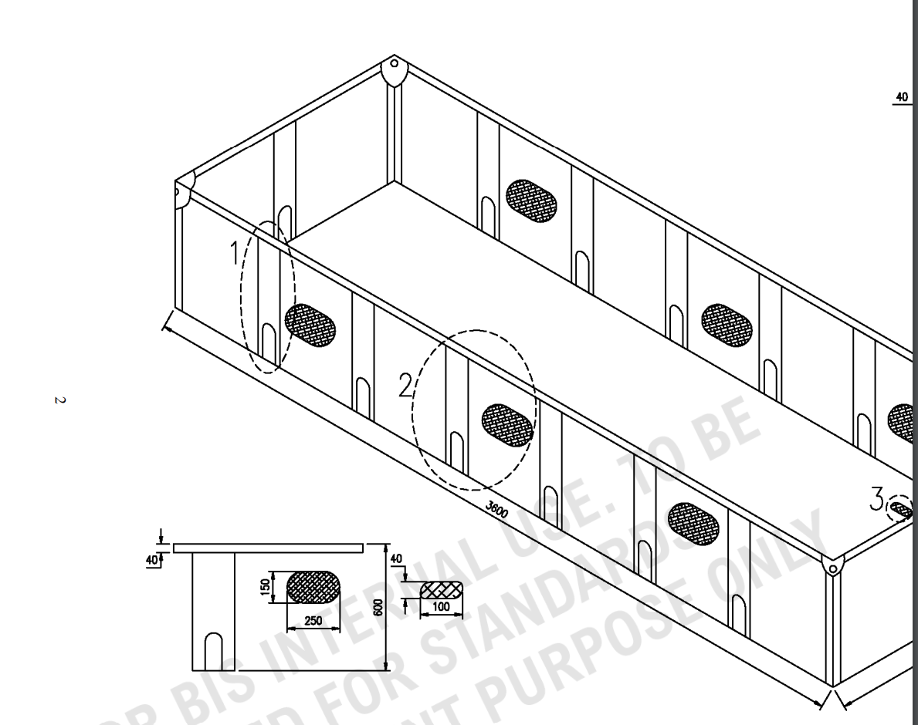
Fig 2 Vermibed
- Ventilation: Equipped with three net windows (260 mm × 150 mm) on each side for air circulation.
- Drainage System: Includes a bottom outlet (40 mm × 100 mm) covered with polyethylene nets for draining vermiwash.
- Support Mechanism: Fourteen pockets along the bed’s periphery accommodate wooden pegs for stability.
4.2.2 Performance requirements
To ensure the durability of vermibeds IS 15907 specifies performance requirements as listed in table 9.to ensure the workability of vermibeds in all weather conditions environment stress cracking test and UV strength retention test is included.
Table 9 Requirements of woven fabric for vermibeds

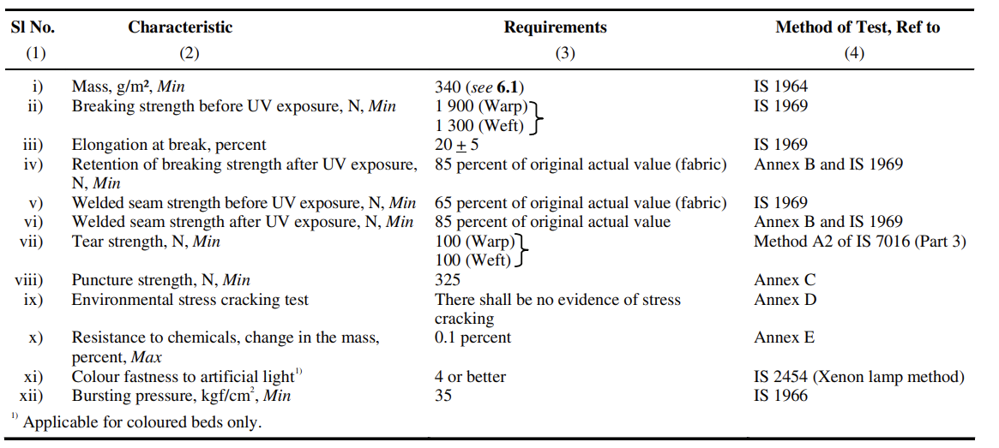
4.3 Mulch mat for weed control
Mulch mats are used for weed control, moisture conservation which helps to impove soil health while reducing need of chemical weedicides. Mulch mats are available in different types like nonowoven mulch mats which are light weight and easy to install while jute mulch mats are effective in improving soil nutrition health as they are biodegradable and also acts as organic manure. BIS has published standard on nonwoven much mat IS 17355 : 2020.
IS 17355 : 2020 standard prescribes the requirements for polypropylene spun bonded non-woven mulch mat used for weed control in agricultural and horticultural applications.
4.3.1 Non-woven mulch mats are classified into two main types based on mass per unit area:
- Type 1: Minimum mass of 50 g/m².
- Type 2: Minimum mass of 70 g/m².
4.3.2 Performance Requirements
To ensure the quality of non-woven much mats standard specifies performance requiremtns for tensile, tear, UV stability along with other requirements as listed in table 10.
- Tensile Strength:
  - Machine direction: Minimum 85 N for Type 1 and 115 N for Type 2.
  - Cross direction: Minimum 60 N for Type 1 and 80 N for Type 2.
- Elongation: Ranges between 60% and 110% in both machine and cross directions.
- UV Stability: Retains at least 50% of tensile strength after 144 hours of exposure to UV light.

Table 10 Requirements of Non-woven Polypropylene Spun-bonded Mulch Mat
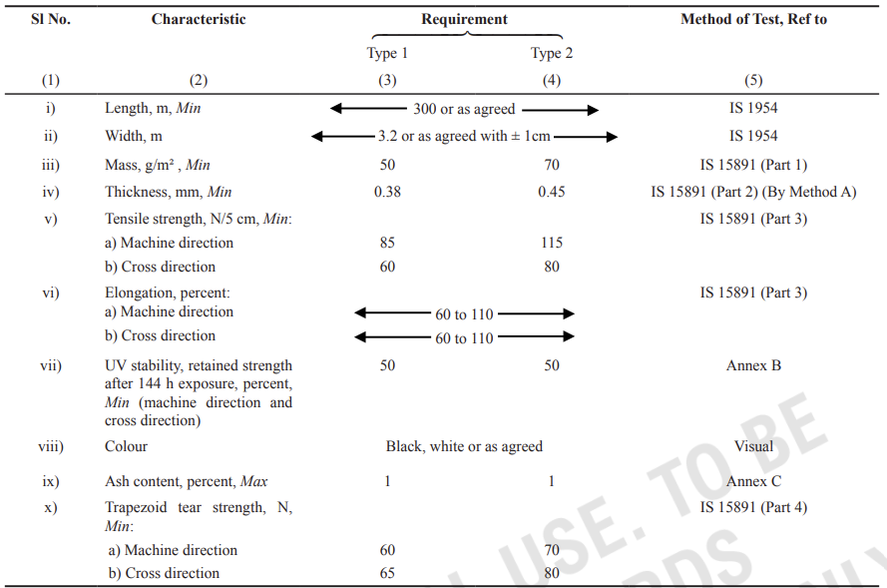
4.4 Jute Agrotextiles for weed suppression
Jute agrotextiles are used to support plant growth, suppress weeds, and conserve soil health. With high moisture retention capacity and the ability to moderate soil temperature, they contribute significantly to sustainable farming practices.Their natural biodegradability ensures that they enrich the soil upon degradation, providing an environmentally friendly alternative to synthetic materials. BIS has published important standard on Jute agrotextiles IS 17070 : 2019.
IS 17070 : 2019 standard provides requirements of nonwoven jute agrotextiles (JAT) for growth of plants and suppression of weeds.
4.4.1 Classifcation of nonwoven Jute agrotextiles
Jute agrotextiles are categorized based on their mass per unit area into three types:
- Type 1: Minimum mass of 500 g/m².
- Type 2: Minimum mass of 800 g/m².
- Type 3: Minimum mass of 1,000 g/m².
4.4.2 Standard specifies the performance requirements for jute agrotextiles for their usage in different terrains to ensure their durability, standard specifies bursting strength requirement, index puncture resistance along with other requirements as specified in table 11.

Table 11 Requirements for Nonwoven Jute Agrotextiles
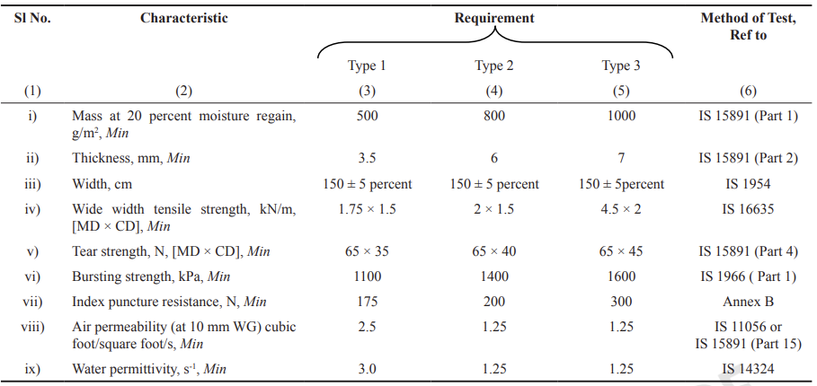
4.4.3 Installation Guidelines
For plantation purpose the surface of the ground to be dressed, cleared of all foreign materials and prepared to the required level before installation of non woven JAT. Two number of fabric pieces with proper cut marks ‘+’ to be laid side by side keeping no gap in between in such a manner that the plant is planted on the cut mark of the cloth. The four corners of each cut portion are to be inserted inside the cloth to keep the surroundings of the girth of the plant free. The plant of desired type that is vegetable or fruit or alike to be planted on to the exposed ground keeping a safe distance in between the plants.
5 CONCLUSION
Agrotextiles play a pivotal role in enhancing crop protection by acting as a barrier against environmental threats. These materials shield crops from adverse weather conditions such as heavy rainfall, hailstorm, wind and extreme sunlight. By regulating microclimatic conditions around crops, agrotextiles ensure consistent and optimal growth environments, leading to healthier yields.
In pest management, nettings and protective covers effectively prevent infestations by insects, birds, and other pests. Unlike chemical pesticides, agrotextiles provide a sustainable and eco-friendly solution, reducing the dependency on harmful chemicals and contributing to safer agricultural practices. Furthermore, the durability and reusability of agrotextile materials make them cost-effective over time, ensuring farmers achieve higher productivity with reduced financial burdens.
Water scarcity and inefficient usage are pressing challenges in agriculture. Agrotextiles, such as geomembrane liner, flexible water storage tanks, woven lay flat tubes address these issues by significantly improving water conservation and management. Mulch mats and woven ground covers made from materials like polypropylene and jute help reduce evaporation rates, maintaining soil moisture levels even in arid conditions. This ensures that plants receive a steady water supply, promoting consistent growth and reducing the frequency of irrigation.
Healthy soil is the cornerstone of successful agriculture, and agrotextiles play an integral role in preserving and improving soil quality. By preventing erosion, agrotextiles stabilize the topsoil, which is rich in organic matter and nutrients essential for plant growth. Additionally, materials like biodegradable jute agrotextiles enrich the soil as they decompose, increasing its organic content and fostering microbial activity.
The integration of agrotextiles into modern agriculture represents a significant step toward sustainability. These materials reduce the environmental footprint of farming by minimizing the need for chemical inputs and conserving natural resources. By enabling efficient water use and improving soil health, agrotextiles align with global efforts to achieve food security amidst climate challenges.Farmers adopting agrotextiles benefit from higher yields, reduced costs, and improved environmental stewardships. The long-lasting nature of agrotextiles further ensures economic viability, making them a practical investment for small-scale and large-scale agricultural operations alike.
As agriculture faces increasing pressure to feed a growing global population sustainably, the role of agrotextiles will continue to expand. Innovations in material science promise to enhance the performance and affordability of agrotextiles, making them accessible to a broader range of farmers. Research and development efforts are also focusing on integrating smart technologies, such as sensors and data analytics, into agrotextile applications, enabling precision farming.
By empowering farmers with knowledge and resources, agrotextiles can become a cornerstone of resilient and sustainable agricultural practices.
6 LIST OF AGROTEXTILES INDIAN STANDARDS UNDER TXD 35
SI.  No. | IS No. | TITLE
1 | IS 15907 : 2010 | Agro textiles — High density polyethylene (HDPE) woven beds for vermiculture — Specification
2 | IS 16089 : 2013 | Jute agro-textile — Sapling bags for growth of seedling/ sapling — Specification
3 | IS 16190 : 2014 | Agro textiles — High density polyethylene (HDPE) laminated woven lay flat tube for irrigation purpose — Specification
4 | IS 16202 : 2014 | Agro textiles — Woven ground covers for horticulture application — Specification
5 | IS 16390 : 2015 | Agro textiles — Nylon knitted seamless gloves for tobacco harvesters — Specification
6 | IS 16513 : 2016 | Agro textiles — Insect nets for agriculture and horticulture purposes — Specification
7 | IS 16627 : 2017 | Agro textiles — High density polyethylene (HDPE) laminated woven lay flat tube for use in mains and submains of drip irrigation system — Specification
8 | IS 16718 : 2021 | Textiles — Polypropylene Spun Bonded Non-Woven Crop Covers and Fruit Skirting Bags for Agricultural and Horticultural Applications —Specification (first revision)
9 | IS 17070 : 2019 | Jute agrotextiles for growth of plant and suppression of weeds — Specification
10 | IS 17355 : 2020 | Agro textiles — Propylene spun bonded non-woven mulch mat for agricultural and horticultural applications — Specification
11 | IS 17356 : 2020 | Agro textiles — Windshield nets for agriculture and horticulture purposes — Specification
12 | IS 17357 : 2020 | Agro textiles — Harvest nets for agriculture and horticulture purposes — Specification
13 | IS 17358 (Part 1) : 2020 | Agro textiles — Fencing nets for agriculture and horticulture purposes — Specification Part 1 Fencing nets made from extruded polymer mesh
14 | IS 17358 (Part 2) : 2020 | Agro textiles — Fencing nets for agriculture and horticulture purposes — Specification Part 2 Fencing nets made from mono filament yarns and combination of tape and mono filament yarns
15 | IS 17513 : 2020 | Agro Textiles — Plant Support Nets for Agriculture and Horticulture Purposes — Specification
16 | IS 17728 : 2021 | Agro Textiles — High Density Polyethylene (HDPE) Laminated Woven Lay Flat Tube and Fittings for use in Rain Irrigation System —Specification
17 | IS 17729 : 2021 | Agro-Textiles — Flexible Water Storage Tank for Agriculture and Horticulture Purposes — Specification
18 | IS 17730 (Part 1) : 2021 | Agro-Textiles — Hail Protection Nets for Agriculture and Horticulture Purposes — Specification Part 1 Warp Knitted Hail Protection Nets
19 | IS 17730 (Part 2) : 2021 | Agro-Textiles — Hail Protection Nets for Agriculture and Horticulture Purposes — Specification Part 2 Woven Hail Protection Nets
20 | IS 17731 : 2021 | Agro-textiles — Laminated woven orchard protection covers — Specification
21 | IS 18310 (Part 1) : 2023 | Agro textiles bird protection nets for agriculture and horticulture purposes specification part 1 knotted bird protection nets
22 | IS 18310 (Part 2) : 2023 | Agro textiles bird protection nets for agriculture and horticulture purposes specification part 2 knitted bird protection nets
23 | IS 18310 (Part 3) : 2023 | Agro textiles bird protection nets for agriculture and horticulture purposes specification part 3 extruded bird protection nets
24 | IS 16008 (Part 1) : 2016 | Agro textiles – Shade nets for agriculture and horticulture purposes – Specification Part 1 Shade nets made from tape yarns (first revision)
25 | IS 16008 (Part 1) : 2016 | Agro textiles – Shade nets for agriculture and horticulture purposes – Specification Part 2 Shade nets made from mono filament yarns (first revision)
26 | IS 16366 : 2015 | Glossary of terms used in agrotextile
27 | IS 15351 : 2015 | Agro textiles – Laminated high density polyethylene (HDPE) woven geomembrane for water proof lining – Specification (second revision)

