Sustainable Sanitation Solutions: Biodigesters as per IS 18150

- INTRODUCTION TO NON-SEWERED SANITATION SYSTEMS

Sanitation refers to the systems, practices, and infrastructure used to manage human excreta, wastewater, and solid waste in a safe and hygienic manner. Its primary goal is to protect human health, prevent environmental contamination, and ensure dignity. Sanitation is more than infrastructure; it is about dignity, health, and a commitment to building a safer, cleaner world for all.

Owing to the limited access of a high share of urban and rural population to sewerage systems in India, strengthening the ecosystem for non-networked sanitation becomes imperative.

Non-sewered sanitation systems (NSS) are on-site sanitation solutions that operate without the need for a connection to a centralized sewer system. They are designed to safely manage human waste and provide hygienic services in areas lacking conventional sewer infrastructure and operate independently of piped sewer networks. They Include containment, emptying, transport, treatment, and disposal/reuse of waste and are adaptable to various environmental and socio-economic contexts. Additionally, they can also be used in integration with centralized sewer systems leading to reducing load on sewage treatment plants (STPs).

Non-sewered sanitation systems are critical to addressing global sanitation challenges, particularly in under-served communities, while contributing to health, dignity, and environmental preservation. They are most appropriate for urban slums and remote or rural regions with limited infrastructure. Bio toilets have also been installed in Indian railway coaches to manage onboard human waste.

To facilitate the achievement of the desired public health and environmental outcomes through non-networked sanitation, it is crucial to safeguard the quality of existing on-site sanitation systems. Furthermore, the varying characteristics of settlements, hydrogeology, and environmental sensitivity necessitate innovations in product design to respond to the needs of these diverse contexts.

Biodigesters are systems that break down organic waste, such as human excreta, through anaerobic digestion (a process carried out by microorganisms in the absence of oxygen). This process and transforms organic waste into simpler organic molecule, effluent water and biogas.

- OVERVIEW OF IS 18150 AND BIODIGESTERS
- Key Components of a Biodigester
Inlet Chamber: Allows for the introduction of organic waste, such as food scraps, animal manure, or human waste, into the biodigester.
Digestion Tank/Chamber: The sealed, oxygen-free environment where anaerobic digestion occurs. It houses microorganisms that break down organic matter.
Gas Storage Chamber: A section of the biodigester designed to collect and store biogas produced during the digestion process.
Outlet for Bio-Slurry (simple organic molecules and effluent water): A system for discharging the nutrient-rich slurry, which can be used as organic fertilizer.
Piping and Valves: Facilitates the flow of biogas to appliances or storage and regulates pressure within the system.
- Design requirements as per IS 18150
1. Tank Design
- Multi-Chamber Structure: A biodigester tank must have at least two partition (baffle) walls, resulting in three chambers with a volumetric ratio of 4:3:3. This design increases the waste's path length, contact time, sedimentation, and degradation.
- Inlet and Outlet Provisions:
  - The inlet chamber should occupy approximately 40% of the total tank volume.
  - Outlets for treated effluent and biogas must be incorporated for efficient waste management and gas collection.
- Immobilization Matrix: Polyvinyl chloride (PVC) immobilization matrix should be provided on both sides of the partition walls and as hanging structures to enhance bacterial activity.
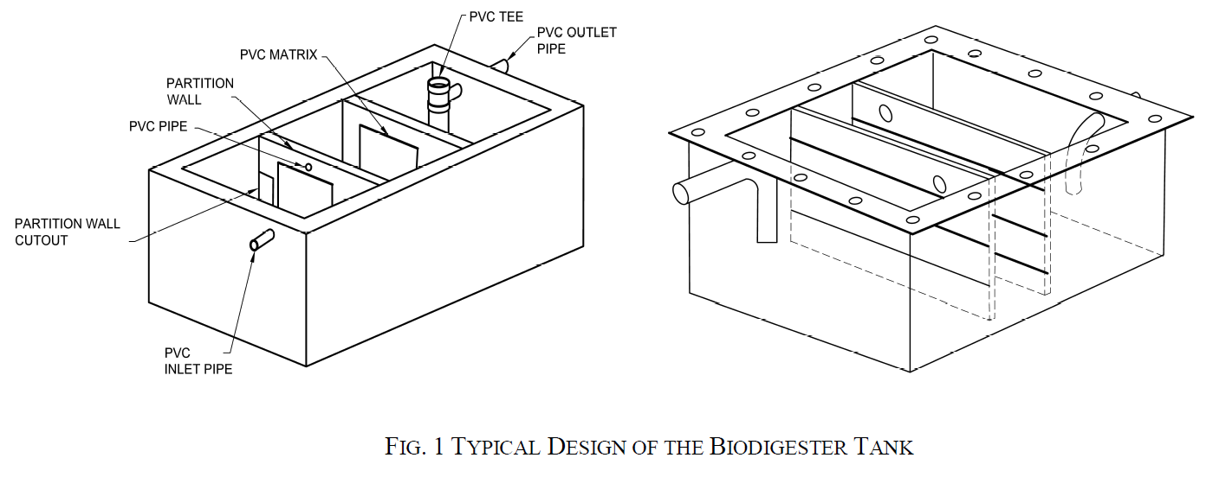
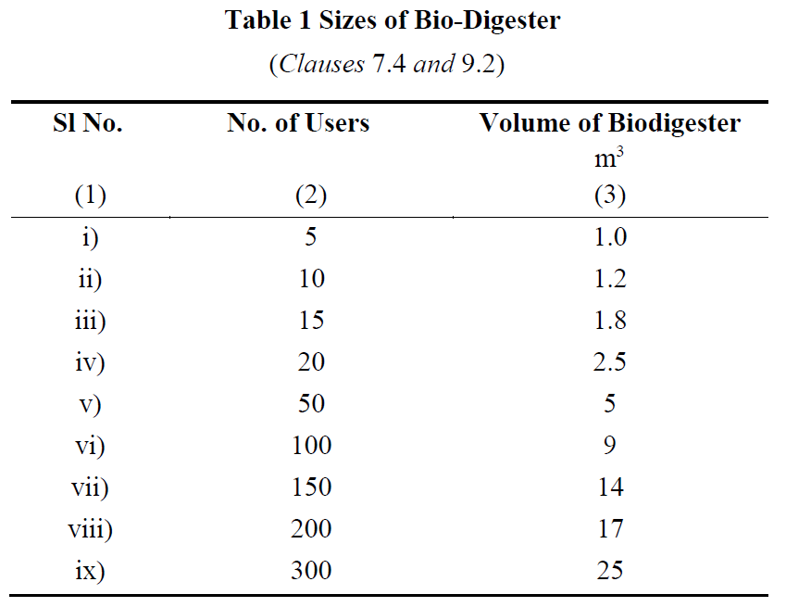
2. Material Specifications
- Fabrication Materials:
  - Fiber Reinforced Plastic (FRP), stainless steel (SS), or reinforced cement concrete (RCC) may be used, depending on the scale and application.
  - For larger volumes, on-site construction using RCC/PCC is recommended to reduce transportation and installation issues.
- FRP Specifications:
  - Resin properties, such as viscosity, acid value, gel time, and tensile strength, are defined to ensure durability and functionality.
  - Cured cast resin must be hard, tough, and have a specified impact resistance and density.
3. Capacity and Sizing
- The tank's size depends on the number of users:
  - A tank for 5 users requires 1 m³ volume.
  - Larger setups can be designed, with capacities ranging from 1.2 m³ for 10 users to 25 m³ for 300 users.
4. Key Design Considerations
- Chamber Configuration: Dimensions should cater to the required Hydraulic Retention Time (HRT) for effective digestion.
- Temperature Adaptation: Provisions for insulation, such as PUF panels, may be added for cold regions to maintain microbial efficiency.
- Anaerobic Microbial Inoculum (AMI) - Microbial consortium is a mixture of different types of bacteria (hydrolytic, acidogenic, acetogenic and methanogenic groups) responsible for breakdown of complex polymers into simple sugars which are further broken down into low chain fatty acids and finally into biogas.
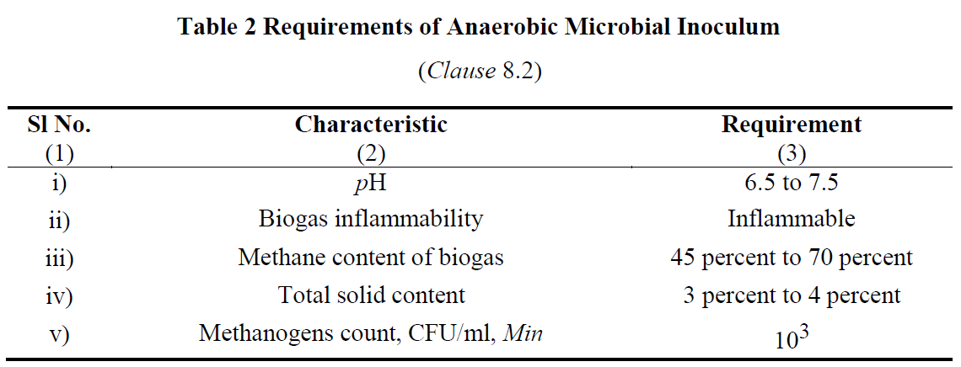
5. Effluent and Biogas Management
- The effluent must meet environmental standards, and biogas should be safely stored or utilized.
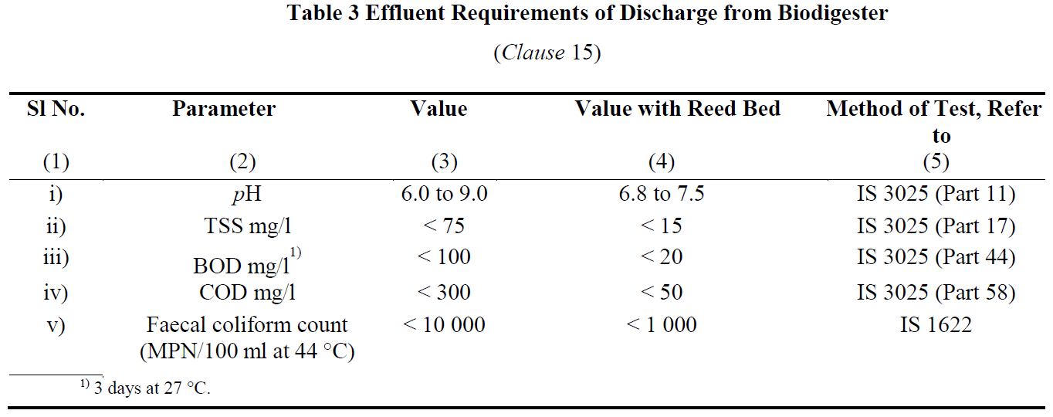
These specifications ensure the biodigester operates efficiently, minimizing health risks while promoting environmental sustainability.
- SITE SELECTION AND INSTALLATION OF BIODIGESTERS
Location of Biodigester Tank and Reed Bed
- Preferred Location:
  - The biodigester tank should ideally be installed underground, close to the toilet superstructure.
  - The reed bed can be placed above ground, either separately or on top of the tank.
- Placement Considerations:
  - The positioning of the tank and reed bed must account for the plinth height of the toilet and the site's ground level.
  - This ensures proper and effortless discharge of treated water into soak pits, open drains, or other designated areas.
Layout and Installation of FRP or SS Biodigesters
- Layout Guidelines:
  - The layout should be simple and direct to facilitate the smooth flow of waste from the toilet to the biodigester tank without blockages.
- Piping Arrangement:
  - Pipes should be configured to avoid hindrances or choking.
  - Cleaning eyes should be provided wherever pipe bends are necessary.
- Installation Considerations:
  - Selection of Location: Choose an area that is accessible and suitable for the biodigester.
  - Determination of Tank Size: The size must correspond to the number of users.
  - Pit Preparation:
    - The pit should be smooth and free from protruding stones or roots.
    - Excavated soil should be completely cleared from the pit edges to prevent collapse.
  - Base Construction:
    - A plain cement concrete (PCC) base layer is required at the bottom of the pit.
    - Concrete blocks may be added for additional support.
  - Connections:
    - Proper sealing of pipes and partitions is essential to prevent leaks.
    - Gas outlet placement must ensure safe gas release.
    - Effluent outlet pipes should lead to a soak pit or other designated area.
- Inoculum Addition:
  - Anaerobic microbial inoculum (30% of the tank volume) is added during installation or through the toilet itself.
On-Site Construction of RCC/PCC Biodigester Tanks
- Material Requirements:
  - Materials include bricks, cement, sand, stone chips, reinforcement for RCC, PVC pipes, and bacterial immobilization matrices.
- Construction Guidelines:
  - The tank is a rectangular structure with three chambers in a 4:3:3 volumetric ratio.
  - Partition walls should be 80% of the tank's length, allowing water flow through chambers.
- Tank Features:
  - Inlet Pipe: Positioned to allow 70% downward flow into the tank.
  - Outlet Pipe: Configured for proper effluent discharge, leading to a reed bed or soak pit.
- Bacterial Matrix Installation:
  - PVC matrices are hung inside the tank at specific intervals to enhance bacterial activity.
- Effluent Management:
  - Treated water exiting the reed bed can be safely released into the environment or reused for irrigation or other purposes.
- OPERATION AND MAINTENANCE
Operation and Maintenance Guidelines
- Start-Up of Biodigesters:
  - Once the biodigester is fabricated or constructed, anaerobic microbial inoculum (AMI) is added through the toilet or inlet pipe.
  - Care must be taken to minimize oxygen exposure during this process.
  - A properly functioning biodigester will produce colourless and odourless water at the outlet and maintain a clean, odour-free ambiance.
- Use of Detergents and Disinfectants:
  - Excessive use of detergents or disinfectants can harm the bacterial population and disrupt the anaerobic digestion process.
  - Adhere to the recommended dosage provided by the manufacturer to maintain system efficiency.
- Effluent Testing:
  - The biodigester's effluent must meet specific parameters (e.g., pH, BOD, COD, TSS, and fecal coliform counts).
  - Effluent testing should be conducted after one month of operation or after initial discharge to ensure compliance.
  - Testing is recommended to be carried out in DRDO-approved laboratories.
- General Maintenance Practices:
  - Regularly inspect connections, inlet and outlet pipes, and gas release mechanisms for leaks or blockages.
  - Clean the reed bed periodically to maintain its effectiveness in effluent quality improvement.
  - Monitor gas pressure and ensure safe storage or use of biogas.
- Instructions for Users:
  - Manufacturers must provide clear usage and maintenance instructions to the purchaser or operator.
  - Proper handling of biogas and bio-slurry byproducts is crucial for safety and resource recovery.
By following these guidelines, biodigesters can operate effectively, ensuring hygienic waste treatment, biogas production, and environmental protection.
- BENEFITS AND CHALLENGES
Benefits:
- Passive system for eco-friendly degradation of organic matter.
- Customizable sizes and pre-fabricated options available commercially.
- Promotes water recovery and recycling.
- Zero running cost and zero maintenance cost for primary treatment and negligible maintenance cost for periodic evaluation of secondary treatment.
- Does not require periodic replenishment of bacterial cultures and rigorous monitoring of performance.
- Does not have intermittent de-sludging requirement
- Does not restrict use of toilet cleaners
- Can be deployed even in extreme climatic conditions and areas with high water table or risk of flooding.
Risk & Limitations of Biodigester:
- Higher one time capital investment as compared to Leach Pits.
- Removal of nitrogen and phosphorous requires reed bed.
- Space constraints in urban areas could limit implementation of reed bed.

- CONCLUSION AND Q&A
Biodigesters represent a transformative solution in non-sewered sanitation systems, addressing critical challenges in waste management and environmental sustainability. By utilizing anaerobic digestion, biodigesters efficiently decompose organic waste into biogas and nutrient-rich effluent, offering multiple benefits such as renewable energy generation, reduced pathogen transmission, and resource recovery.
The design, installation, and maintenance of biodigesters, as outlined in the Indian Standard emphasize the importance of proper materials, site selection, and adherence to operational protocols for optimal performance. Integrating reed beds further enhances effluent treatment, ensuring safe discharge or reuse.
As a sustainable technology, biodigesters provide scalable solutions for households, communities, and institutions, particularly in areas lacking centralized sewer systems. Their role in reducing environmental pollution, conserving resources, and improving public health underscores their alignment with global sanitation and sustainability goals.
With proper implementation and regular maintenance, biodigesters can pave the way for a cleaner, greener, and healthier future, making them a vital component of modern waste management systems.

