REFERENCE MATERIAL
FOR
TWO-DAY CAPACITY BUILDING PROGRAMME FOR
SENIOR OFFICERS OF
PUBLIC HEALTH ENGINEERING DEPARTMENTS OF STATES

TABLE OF CONTENTS

Sl. No. | Chapter No. | Content | Page No
1 | Session 1 | Enhancing Building Utility: Good Practices for Water Supply, Drainage, and Sanitation
2 | Session 2 | Optimizing Services and Resources: Drinking Water Supply Services and Asset Management System
3 | Session 3 | Ensuring Safe Water: The Role of Standards in Drinking Water Quality, Sampling, and Testing
4 | Session 4 | Harvesting Sustainability: The Role of BIS Standards in Rainwater Management
5 | Session 5 | Optimizing Efficiency: Asset Management in Wastewater Supply Networks
6 | Session 6 | Sustainable Sanitation Solutions: Biodigestors as per IS 18150
7 | Session 7 | Advanced Sanitation Solutions: Packaged Sewage Treatment Plants as per IS 18797
8 | Session 8 | Modern Sanitation Solutions: Rotationally Moulded Polyethylene Septic Tanks as per IS 18666
9 | Session 9 | Standardization in Sewer Rehabilitation: Leading Steps and Best Practices
10 | Session 10 | Achieving Excellence: Standardization in Pumping Systems

CHAPTER 1

- INTRODUCTION

1.1 National Building Code of India in its Part 9/Section 2 ‘Plumbing Services, Section 2 Drainage and Sanitation’ covers the design, layout, construction and maintenance of drains for foul water, surface water, subsoil water and sewage together with all ancillary works, such as connections, manholes and inspection chambers used within the building and from building to the connection to a public sewer, private sewer, individual sewage-disposal system, cess-pool, soakaway or to other approved point of disposal/treatment work.

1.2 A sanitary drainage system consists of a building sewer, a building drain, a soil and/or waste stack, horizontal branches or fixture drain, and vents. The sanitary drainage of a large building may have a number of primary and secondary branches, and several soil and/or waste stacks, each of them in turn may have a number of horizontal branches.

- TYPES OF DRAINAGE PIPE SYSTEMS

2.1 The Code specifies that the pipe system to be adopted will depend on the type and planning of the building in which it is to be installed and can be one of the following:

  - Single stack system (see Fig. 1) – The piping system in which there is no trap ventilation and the stack itself acts as vent through roof. In this system care shall be taken for proper sizing of the pipes and the trap arm distance, specially the horizontal distance of sanitary fixtures from the drainage stack and vertical distance between connection of branches from fixtures to drainage stack.

  - One pipe – Partially ventilated system (see Fig. 2) – The piping system in which soil and waste pipes are connected to a single vertical stack with additional vent pipe for ventilation of traps of water closets.

  - One pipe – Fully ventilated system (see Fig. 3) – The piping system in which the waste pipes from the sinks, baths and wash basins, and the soil pipe from water closet are connected to a single vertical stack. The traps of the water closets, waste appliances, etc, are individually ventilated and connected with a separate stack to preserve the water seal.

  - Two pipe system

- Two pipe system with common vent pipe (see Fig. 4A) ‒ The piping system in which all soil appliances such as water closets, urinals, bidet and bedpan sinks are connected to soil stack and all other plumbing fixtures such as baths, sinks, and basins are connected to waste stack through deep seal trap. In addition, a common vent stack is provided for ventilation of soil and waste stacks.
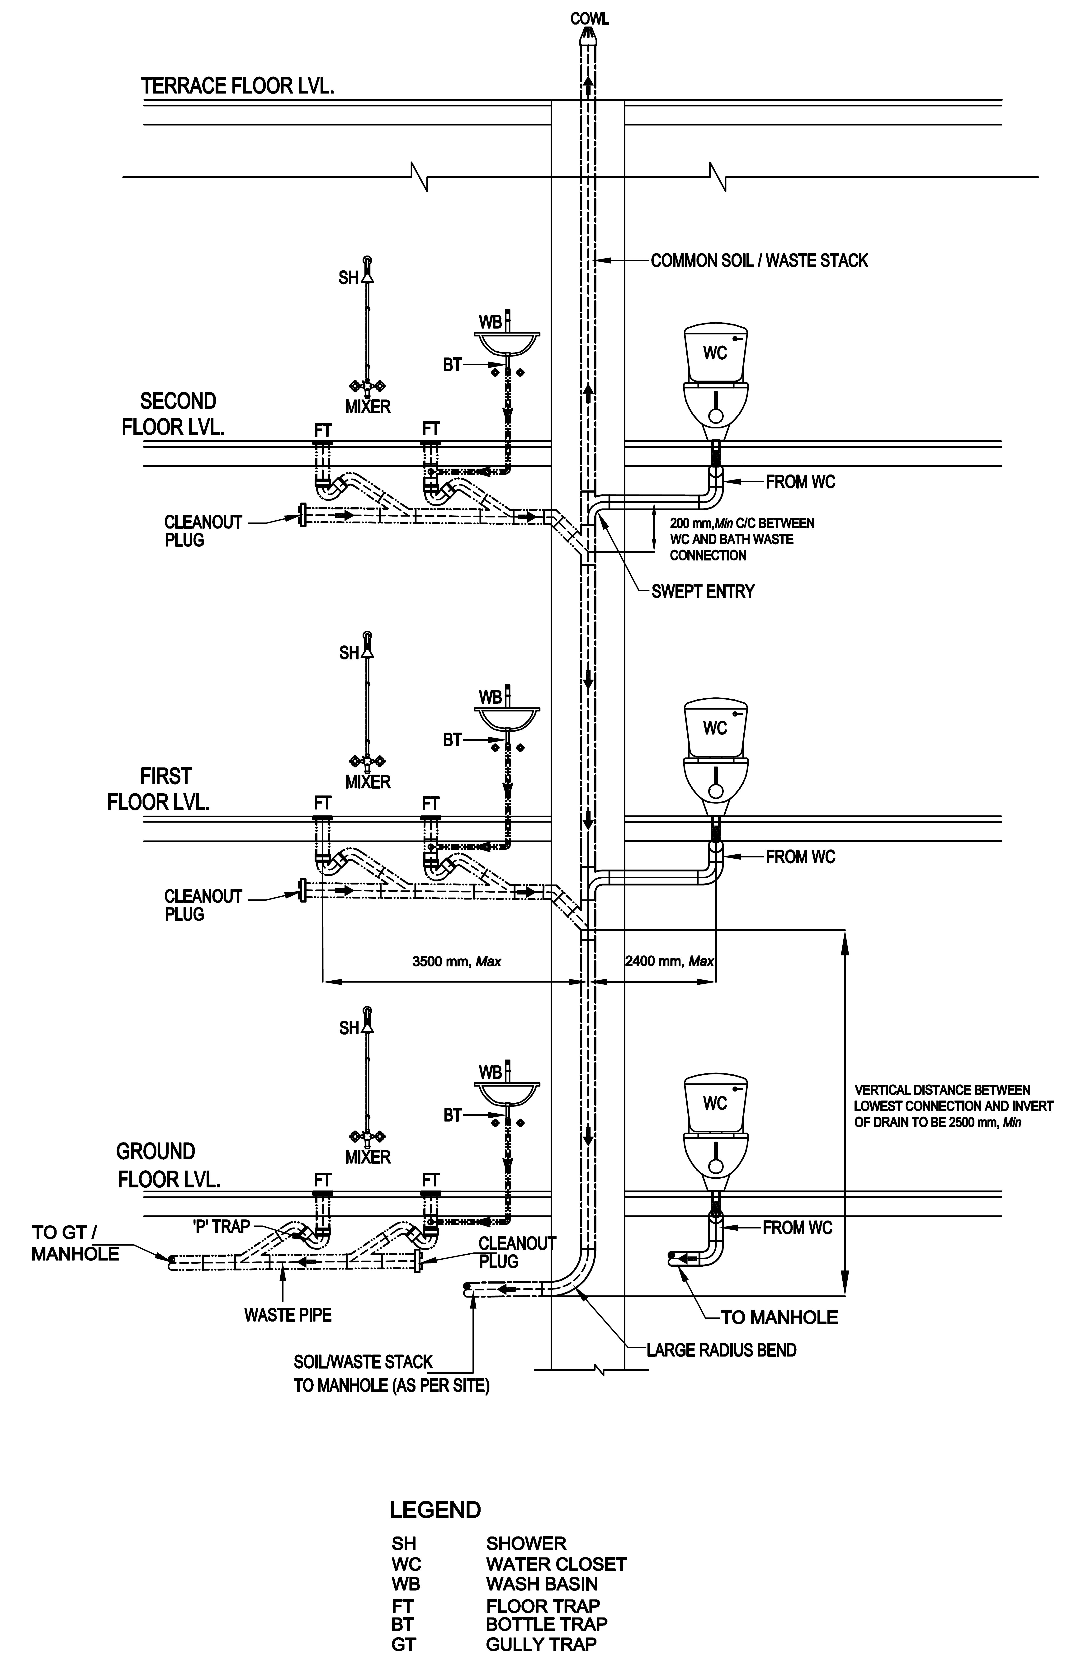

FIG. 1 SINGLE STACK SYSTEM
NOTES
1. Presentation of type of fixtures/drain and pipe route/layout is typical in nature.
2. Kitchen waste piping shall also be planned in a similar manner as for other waste appliance.

NOTES
1. Presentation of type of fixtures/drain and pipe route /layout is typical in nature.
2. Kitchen waste piping shall also be planned in a similar manner as for other waste appliance.

FIG. 2 ONE PIPE – PARTIALLY VENTILATED SYSTEM
From WC

NOTES
1. Presentation of type of fixtures/drain and pipe route /layout is typical in nature.
2. Kitchen waste piping shall also be planned in a similar manner as for other waste appliance.
3. The vent pipe shall be installed in the suspended ceiling or in the wall above toilet floor, depending upon space availability and structural arrangements.

FIG. 3 ONE PIPE – FULLY VENTILATED SYSTEM

- Two pipe system with independent vent pipes (see Fig. 4B) ‒ The piping system in which all soil appliances such as water closets, urinals, bidet and bedpan sinks are connected to soil stack, and all other plumbing fixtures such as baths, sinks, and basins are connected to waste stack through deep seal trap. In addition, there are independent vent stacks provided for respective ventilation of soil and waste stacks.

NOTES
1. Presentation of type of fixtures/drain and pipe route /layout is typical in nature.
2. Kitchen waste piping shall also be planned in a similar manner as for other waste appliance.

FIG. 4 TWO PIPE SYSTEM

3 BASIC PRINCIPLES FOR DESIGN OF DRAINAGE AND SANITATION

The Code covers the basic principles of water supply, drainage and sanitation and specifies that the design of drainage and sanitation should in general be guided by the applicable principles.

3.1.1 Potable Water

All premises intended for human habitation, occupancy, or use shall be provided with supply of potable water. This water supply shall not be connected with unsafe water resources, nor shall it be subject to the hazards of backflow.

3.1.2 Water Provision

Plumbing fixtures, devices and appurtenances shall be provided with water in sufficient volume and at pressures adequate to enable them to function properly and without undue noise under normal conditions of use.

There should be at least a residual head of 0.018 N/mm² at the consumer’s tap. There may be certain fixtures or appliances in the installation that may require a higher pressure, such as 0.05 N/mm² or even higher, in which case the system shall be designed using pumps, tanks or both to achieve the required minimum pressure.

NOTE – The residual head shall be taken at the highest/farthest outlets in the building.

3.1.3 Water Efficiency

Plumbing system shall be designed, installed and adjusted to use the optimum quantity of water consistent with proper performance and cleaning.

3.1.4 Safety Devices

Plumbing system shall be designed and installed with safety devices to safeguard against dangers from contamination, explosion, overheating, etc.

3.1.5 Minimum Amenities

Each dwelling unit on premises (abutting on a sewer or with a private sewage disposal system) shall have at least one water closet, one kitchen wash place or a sink, and one bathing place or shower to meet the basic requirements of sanitation and personal hygiene.

In case of a group housing, the requirements relating to toilet or sanitary room and kitchen as given in Part 3 ‘Development Control Rules and General Building Requirements’ of the Code shall also be complied with.

3.1.6 Drainage System

The drainage system shall be designed, installed and maintained to guard against fouling, deposit of solids and clogging and with adequate cleanouts so arranged that the pipes may be readily cleaned.

3.1.7 Materials and Workmanship

The plumbing system shall have durable material, free from defective workmanship and so designed and installed as to give satisfactory service for its reasonable expected life. The accessories of the plumbing system should be of such specifications as to meet the functional requirements of the installation, so as to also avoid any inconsistency leading to leakage and resultant seepage.

3.1.8 Fixture Traps and Vent Pipes

Each fixture directly connected to the drainage system shall be equipped with a liquid seal trap. Trap seals shall be maintained to prevent sewer gas, other potentially dangerous or noxious fumes, or vermin from entering the building. Further, the drainage system shall be designed to provide an adequate circulation of air in all pipes with no danger of siphonage, aspiration, or forcing of trap seals under conditions of ordinary use by providing vent pipes throughout the system.

3.1.9 Foul Air Exhaust

Each vent terminal shall extend to the outer air and be so installed as to minimize the possibilities of clogging and the return of foul air to the building, as it conveys potentially noxious or explosive gases to the outside atmosphere. All vent pipes shall be provided with a cowl.

3.1.10 Testing

The plumbing system shall be subjected to required tests to effectively disclose all leaks and defects in the work or the material.

3.1.11 Exclusion from Plumbing System

No substance that will clog or accentuate clogging of pipes, produce explosive mixtures, destroy the pipes or their joints, or interfere unduly with the sewage-disposal process shall be allowed to enter the drainage system.

3.1.12 Light and Ventilation

Wherever water closet or similar fixture is located in a room or compartment, it should be properly lighted and ventilated.

3.1.13 Individual Sewage Disposal Systems

If water closets or other plumbing fixtures are installed in buildings where connection to public sewer is not possible, suitable provision shall be made for acceptable treatment and disposal.

3.1.14 Maintenance

Plumbing systems shall be maintained in a safe and serviceable condition.

3.1.15 Approach for Use and Cleaning

All plumbing fixtures shall be so installed with regard to spacing as to be approachable for their intended use and for cleaning. All doors, windows and any other device needing access within the toilet shall be so located that they have proper approach.

3.1.16 Accessibility for Persons with Disabilities

All doors, windows and fixtures, including WC, urinals, grab bars, washbasin, mirror and all other accessories for use by persons with disabilities shall be so installed/located that they have proper access with appropriate width, height, space, centerlines, and ease of operation (see 13 of Part 3 ‘Development Control Rules and General Building Requirements’ of the Code).

3.1.17 Structural Safety

Plumbing system shall be installed with due regard to preservation of the structural members and prevention of damage to walls and other surfaces.

3.1.18 Protection of Ground and Surface Water

Sewage or other waste shall not be discharged into surface or sub-surface water without acceptable form of treatment.

4 PERMISSION FOR SANITARY OR DRAINAGE INSTALLATION

4.1 General

The Code specifies that no person shall install or carry out any water-borne sanitary installation or drainage installation or any works in connection with anything existing or new buildings or any other premises without obtaining the prior sanction of the Authority.

4.2 Application and Plans

The Code includes the format for application in which the Owner shall submit their application to the Authority. It also provides guidance on preparation of site plan and drainage plan to be submitted with the application. As per the Code, the following colours shall be used for indicating the different types of drainage pipes.

Description of Work Colour

Sewers Red
Waste water pipes and rainwater pipes Blue
Existing work Black

4.3 Alteration or Addition to an Existing Building

In the case of an alteration or addition to an existing building, this clause shall be deemed to be satisfied if the plans as furnished convey sufficient information for the proposals to be readily identified with previous sanctioned plans and provided the locations of tanks and other fittings are consistent with the structural safety of the building.

4.4 Specifications for Various Items

The Code further requires that the plans for the building drainage shall in every case be accompanied by specifications for the various items of work involved. The format for providing this information is also covered in the Code.

4.5 Licensed/Registered Plumbers

The Code further specifies that the work which is required to be carried out shall be executed only by a licensed/registered plumber under the control of the Authority and they shall be responsible to carry out all lawful directions given by the Authority.

It further specifies that no individual, firm, partnership or corporation shall engage in the business of installing, repairing or altering plumbing unless the plumbing work performed in the course of such business is under the direct supervision of a licensed/registered plumber from approved Authority. The Authority shall establish standards and procedure for the qualification, examination and licensing/registration of plumbers and shall issue licences to such persons who meet the qualifications thereof and successfully pass the examination.

For guidelines for registration of plumbers including the minimum standards for qualifications for the grant of licences, reference may be made to IS 11208. The Authority may also utilize the services of the certified plumbers who are certified for the required skill level under the appropriate scheme of the Government.

4.6 Completion Certificate

At the completion of the plumbing installation work, the licensed/registered plumber shall give a completion certificate, for which a form has been prescribed in the Code.

5 DRAINAGE AND SANITATION SYSTEMS

5.1 Types of Sanitary Appliances

- Soil Appliances – Water closet (Squatting Indian type water closet, Washdown type water closet, Siphonic washdown type water closet, and Universal or Anglo-Indian water closet); Bidet; Urinal (Bowl type urinal-flat back or angle back, Slab (single) type urinal, Stall (single) type urinal, Squatting plate type urinal, Syphon jet urinal with integral trap, Water less (non-water) urinal); Slop sink; Bed pan sink.

- Waste Appliances – Wash basin, Wash-trough, Sink, Bath tub, Drinking fountain

The requirements of various soil appliances and waste appliances shall be in accordance with the Indian Standards given in Annex A.

5.2 Drainage and Sanitation Requirements

5.2.1 There should be at least one water tap and arrangement for drainage in the vicinity of each water closet or group of water closet in all the buildings. Each dwelling unit on premises (abutting on a sewer or with a private sewage disposal system) shall have at least one water closet, one kitchen wash place or a sink, and one bathing place or shower to meet the basic requirements of sanitation and personal hygiene. In case of a group housing, the requirements relating to toilet or sanitary room and kitchen as given in Part 3 ‘Development Control Rules and General Building Requirements’ of the Code shall also be complied with.

5.2.2 All other structures for human occupancy or use on premises (abutting on a sewer or with a private sewage disposal system) shall have adequate sanitary facilities, but in no case less than one water closet and one other fixture for cleaning purposes.

5.2.3 For Residences

5.2.3.1 Dwelling with individual convenience shall have at least the following fitments:

a) One bath room provided with a tap and a floor trap;
b) One water closet with flushing apparatus with an ablution tap; and
c) One tap with a floor trap or a sink in kitchen or wash place.

Where only one water closet is provided in a dwelling, it is desirable to have the bath and water closet separately accommodated.

5.2.3.2 Dwellings without individual conveniences shall have the following fitments:

a) One water tap with floor trap in each tenement,
b) One water closet with flushing apparatus and one ablution tap bath for every two tenements, and
c) One bath with water tap and floor trap for every two tenements.

    - For Buildings Other than Residences

5.2.4.1 The requirements for fitments for drainage and sanitation in the case of buildings other than residences, which are also listed below are covered in Tables 1 to 15 of this Chapter:

- Office Buildings
- Factories
- Cinema, Multiplex Cinema, Concerts and Convention Halls, Theatres

Art Galleries, Libraries and Museums
- Hospitals with Indoor Patient Wards

Hospitals with Outdoor Patient Department

Hospitals, Administrative Buildings

Hospitals Staff Quarters and Nurses Homes

Hotels

Restaurants
- Schools and Educational Institutions

Hostels
- Fruit and Vegetable Markets

Bus Stations, Airports and Railway Stations
- Shopping Malls and Retail Buildings

5.2.4.2 Other important considerations are as below:

- The figures shown in the Tables are based upon one (1) fixture being the minimum required for the number of persons indicated or part thereof.

- Building categories not included in the tables shall be considered separately by the Authority.

- Drinking fountains shall not be installed in the toilets.

- Where there is the danger of exposure to skin contamination with poisonous, infectious or irritating material, washbasin with eye wash jet and an emergency shower (safety shower with eye wash unit) located in an area accessible at all times with the passage/right of way suitable for access to a wheel chair, shall be provided.

- When applying the provision of these tables for providing the number of fixtures, consideration shall be given to the accessibility of the fixtures. Using purely numerical basis may not result in an installation suited to the need of a specific building. For example, schools should be provided with toilet facilities on each floor. Similarly, toilet facilities shall be provided for temporary workmen employed in any establishment according to the needs; and in any case one WC and one washbasin shall be provided.

- All buildings used for human habitation for dwelling, work, occupation, medical care or any purpose detailed in the various tables, abutting a public sewer or a private sewage disposal system, shall be provided with minimum sanitary facilities as per the schedule in the tables. In case the disposal facilities are not available, they shall be provided as a part of the building design for ensuring high standards of sanitary conditions in accordance with this section.

- Workplaces where crèches are provided, they shall be provided with one WC for 10 persons or part thereof, one wash basin for 15 persons or part thereof, one kitchen sink with floor trap for preparing food/milk preparations. The sink provided shall with a drinking water tap.

- In all types of buildings, individual toilets and pantry should be provided for executives, and for meeting/seminar/conference rooms, etc as per the user requirement.

- Where food is consumed indoors, water stations may be provided in place of drinking water fountains.

6. The Code thus covers all aspects of Water Supply, Drainage and Sanitation for the copious implementation by the building professions and concerned authorities.

CHAPTER 2

Optimizing Services and Resources Drinking Water Supply Services and Asset Management System

STANDARDS REFERRED:
a. IS – 17482 : 2020 - Requirements for Piped Drinking Water Supply Services
b. IS 18182 : 2023 - Management of Assets in Drinking Water Supply System – Guidelines

Prepared by – Environment and Ecology Department

What’s Ahead?
This document focuses on understanding the broad framework of the management system of a Drinking Water Utility organization and its assets.
Water Facts and Figures
To start with, a global context is important to be understood. Globally, only 2.5% of water is freshwater, and a mere 0.3% is accessible in rivers and lakes. The rest is locked in ice or underground aquifers. These statistics, from the UNEP, highlight the critical need for effective management of drinking water.
India is a water-stressed country. Despite receiving 4000 BCM of precipitation annually, only 1869 BCM is available for use, and even less is utilizable. Per capita water availability has declined drastically—from 5178 m³ in 1951 to a projected 1228 m³ by 2051, which is below water scarcity thresholds.
Unfortunately, India is ranking 120th of 122 countries in the Water Quality Index. However, initiatives like the Jal Jeevan Mission are driving change.
Challenges for Water Utilities Management
Drinking water management in India faces several critical challenges. 2 most important being, lack of incentives to promote competitiveness and cooperation between utilities and poor service quality, such as low metering coverage, high non-revenue water (i.e. water that is produced and supplied but is lost or unaccounted for before it reaches the customer), and the absence of a Management Information System (MIS).
Why there is a requirement of Standards?
The lack of comprehensive standards has created operational and managerial gaps. There were no uniform guidelines for procurement processes of raw water, water treatment methods, or distribution practices, and water quality requirements remain inconsistent. To address these challenges, it is essential to establish a standardized framework that defines the roles and responsibilities of drinking water supply managers, minimizes costs, enhances reliability, and ensures consistent water quality. A standardized approach is critical to bridging these gaps and achieving efficient and sustainable drinking water management.
Brief About Standards on Drinking Water Utility
BIS has developed two key standards:
- IS 17482:2020 – Drinking Water Supply Management System — Requirements for Piped Drinking Water Supply Service
It sets out the requirements for water utilities service providers. The standard includes the expectations from the organization involved in raw water procurement, treatment, and distribution, to maintaining the quality of the water and ensuring that management takes responsibility for meeting these standards.
The standard emphasizes that the utilities should cater to the needs of individuals, communities, or organizations as per the specifications laid out by responsible authorities, working together with other stakeholders. It applies to any organization that provides water services be it government, private entities or any other non-governmental organizations.
- IS 18182:2023 – Management of Assets of Drinking Water Supply System — Guidelines
This standard ‘Management of Assets of Drinking Water Supply System — Guidelines’ is part of the larger concept of asset management and it focuses specifically on managing the physical assets of a drinking water supply system. When we say "physical assets," we’re talking about everything from the infrastructure used for collecting and treating water to the systems for pumping, storing, and distributing it.
This includes creating a detailed inventory, understanding historical failures, and keeping track of how these systems have been operating over time. Why is this important? For example, if a pipeline has had multiple issues, we can use the data to determine why it’s failing and decide whether it needs repair or replacement. By understanding the risks associated with each asset, we can prioritize which ones need immediate attention—whether it’s maintenance, rehabilitation, or even upgrading.
Moving ahead with IS – 17482:2020 - Drinking Water Supply Management System — Requirements for Piped Drinking Water Supply Service. IS 17428 is intended to facilitate dialogue between the stakeholders enabling them to develop a mutual understanding of the functions and takes that fall within the scope of water utilities.
This standard is applicable to and can be implemented by all such organizations which are either directly providing services to the society at large and to those organizations which indirectly offers the services to be/ being provided by these services. The main objectives of piped drinking water supply systems are:-
          - Minimizing cost of supplying water.
          - Maximization of reliability in the supply of water.
Scope of IS 17482 says:
This standard specifies the requirements for management system of drinking water supplier/utility and for the assessment of piped drinking water supply services where the water supplier/utility,
(a) needs to demonstrate its ability and performance to consistently provide drinking water and related utility services while ensuring compliance to applicable statutory and regulatory guidelines.
b) aims to ensure continuous supply of piped drinking water conforming to the acceptable limit of IS 10500.

First, the standard ensures that the water supplier or utility can consistently demonstrate its ability and performance to provide drinking water services. This includes adherence to all applicable statutory and regulatory guidelines, ensuring compliance with legal and safety requirements. Second, it emphasizes the need for a continuous supply of piped drinking water that meets the acceptable limits specified in IS 10500, which is the Indian Standard for drinking water quality. This means the water must be safe, reliable, and of a quality suitable for human consumption.

The term Water Utility refers to the entire system or organization involved in managing water services. This includes all the processes, activities, means, and resources necessary for key functions such as abstracting water from natural sources, transporting and treating it, and distributing it to consumers. It also covers associated services, such as risk management and disaster preparedness to ensure resilience and reliability in water supply operations.

Assistance from the following references has been derived for the developments of this standard.

- IS/ISO 9000:2015 Quality management systems — Fundamentals and vocabulary (Fourth revision)
- IS 10500:2012 Drinking Water – Specifications
- IS 16633 : 2017/ISO 24512 : 2007 Activities relating to drinking water and wastewater services— Guidelines for the management of drinking water utilities and for the assessment of drinking water services

This standard is organized into different clauses given in this slide including the following essential aspects and requirements related to Drinking Water Supply Management System:

- Understanding the Water Utility/Supplier and its Context
- Understanding the Needs and Expectations of Interested Parties
- Determining the Scope of the Piped Drinking Water Supply Service Management System;
- Addressing the risks and opportunities;
- Defining their Policy;
- Roles Responsibilities and Authorities of organization;
- Planning;
- Setting out the objectives;
- Support including Resources, People Infrastructure, Maintenance, and Environment
- Provision for MIS
- Production and Service Requirements
- Leadership and Commitment
- Customer feedback and satisfaction
- Internal Audit
- Water audit
- Performance review and
- Management review
For a more detailed understanding, consider the following hypothetical case study:
City X, a rapidly growing IT hub in India, was grappling with a severe water crisis. Despite having access to adequate raw water resources, the city struggled with poor service delivery, low water pressure, inconsistent water quality, and frequent disruptions. Complaints of unsafe drinking water, particularly during peak summer months, highlighted the urgent need for a structured approach to improve water supply services.

Key Issues Identified were
- Low Water Quality: Water samples collected from consumer points revealed non-compliance with IS 10500 standards, with high levels of contaminants and turbidity.
- Frequent Breakdowns: Aging pipelines and pumps resulted in frequent service interruptions, affecting supply reliability.
- Inefficient Management: Lack of documentation, monitoring, and a robust quality management system hampered effective operation and maintenance.
- Customer Grievances: Ineffective grievance redressal mechanisms led to public dissatisfaction and mistrust.
City X- Water Supply and Sewerage Board decided to adopt IS 17482:2020 to systematically address its challenges. The basic requirements of the standard are stated below. A detailed assessment was conducted to understand the city's water demand, the condition of the existing infrastructure, and the socio-economic characteristics of different areas.
This standard specifies that needs and expectations of various stakeholders, including residents, industries, and environmental groups, shall be carefully considered.
Determining the Scope: The scope of the drinking water supply service system shall be defined, focusing on improving water supply reliability, reducing water loss, promoting rainwater harvesting, and enhancing water quality.
The next few slides talk about General requirements of the drinking water supply system. First step being:
1. Intake of water from the source
2. Transportation till the treatment plant
3. Water treatment
4. Safe disposal of residues, and
5. Water distribution
A brief outline of the processes involved in the treatment of piped drinking water is provided in the flow chart-
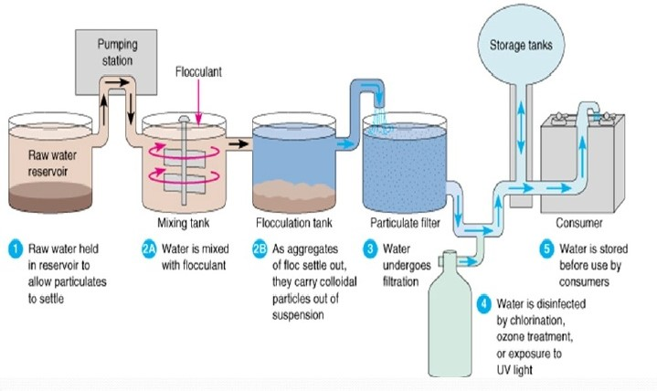
Different water sources from where the water can be procured shall be identified. Sometimes rainwater or seawater may also used as a source. So, identification of source of water is important. Service provider shall ensure functional water intake works and its transportation through pumping works. Now let’s focus on water intake and its transportation to the treatment facilities. Ensuring functional intake structures is a critical step in the water supply process. The service provider must guarantee the pumping system are properly designed and maintained to extract water from ground, or surface. The service provider shall ensure that the water shall be treated so that the final product confirms to IS 10500 ‘Drinking Water – Specifications’. Moreover, treated water must be stored and distributed at a specified pressure to maintain consistent flow and quality.
The management shall ensure that a Management Information System (MIS) is established. It shall determine the resources needed for all the above processes and ensure their availability, assign the responsibilities to the concerned for these processes and address the risks and opportunities.
Conforming to these items, City X – Established a robust management system, clearly defining roles and responsibilities for staff. An organizational hierarchy was created, ensuring accountability at every level of operation.
The standard also ensures that water supplier shall maintain and retain records to support operations, ensure processes follow planned schedules, document workforce requirements, and establish traceability for non-conformities.
Involvement of Leadership
The next is Leadership and commitment in which the top management shall be responsible for:
- Deviation from intended action of the organization.
- Suitable quality policy formulation
- Resource management as well as
- Ensuring that all is achieved.
Leadership and commitment shall also ensure customer satisfaction through identification of the same.Top management shall establish, implement and maintain a quality policy understanding its scope, objectives and commitment. This policy should be appropriate to the organization’s purpose, provide a framework for setting objectives, include a commitment to satisfy applicable requirements, and ensure continual improvement of the management system. The policy that the services manage should be documented, well-maintained, and effectively communicated to stakeholders. To ensure it remains relevant and effective, the policy should be periodically reviewed and updated as necessary.
Top management shall assign the responsibility and authority for ensuring that the management system conforms to the requirements of the standard. This includes reporting on the performance of the management system and opportunities for its improvement to top management, and ensuring the promotion of customer focus throughout the organization.
Planning for execution
Top management is responsible to plan actions to address risks and opportunities in a manner that ensures the management system can achieve its intended outcomes. These actions should help prevent or reduce undesired effects and promote continual improvement. Additionally, disaster management plans should be developed, implemented, and periodically evaluated. The standard elaborates it in its Annexure.
This chart outlines the essential factors to consider when planning and establishing quality objectives. The current status of the system and desired goal are to be determined and define clear and actionable objectives. These objectives must align with the organization’s quality policy and be measurable, achievable, and relevant. Additionally, the objectives should include a defined timeline and should be periodically reviewed to ensure progress and continued suitability.
When the water supplier/utility determines the need for changes to the management system, the changes shall be carried out in a planned manner considering the need and purpose of the changes, their potential consequences, the availability of required resources, and other relevant factors stated in the standard.
Support required to execute the task
Top management shall determine the resources required for the effective operation of the management system. This includes manpower, infrastructure, and the organizational environment necessary to establish, implement, maintain, and continually improve the system. Support requires competence to ensure effectiveness and thus training is important aspect of this clause. The workforce should be aware of the quality policy, objectives and implications of non conformance with the requirements of drinking water management system.
A robust Management Information System (MIS) shall be implemented to track water usage, monitor water quality, and identify areas for improvement.
Operation and Execution
The water supplier/utility is responsible for planning, operations (including extraction, treatment, and distribution), maintaining operational efficiency, conducting maintenance (inspection, repair, leak management), monitoring water quality and quantity, troubleshooting, preventive maintenance, safe residue disposal, reducing water pilferage to below 20%, and ensuring an alternative water supply in case of disruption beyond 36 hours.
Operation includes water sources, treatment, operation of distribution system, metering and release after sampling.
Customer communication: Regular surveys and feedback mechanisms shall be established to gather input from residents and industries on their water service experiences. The supplier/utility shall conduct review before committing to supply drinking water services to a customer. This review shall identify the needs to be fulfilled by the service provider.
In determining the stages and controls for design and development, the utility/supplier shall consider the nature, duration and complexity of the infrastructure. The organisation shall ensure to cater to each process, resource, responsibility and control points.
Operation also involves in preparation of risk mitigation plan, SOPs at all levels, maintenance of the stock and process checklists.
The water supplier/utility shall have record system, wherever required, to ensure the required maintenance of the equipment. The record shall contain all kinds of data relevant to the equipment.
In case of emergencies that may arise due to power failure, breakdown of water supply system units, vandalism, strikes by workforce, etc., a plan shall be prepared well in advance to meet such exigencies and shall be periodically rehearsed.
Records of mock drills shall also be kept in record.
A water audit is a calculation comparing the amount of water distributed with the amount consumed. It is recommended to be conducted quarterly and documented. The water agency aims to reduce water loss to 15% of total supply. Guidelines for conducting the audit are provided in Annex B of the IS 17482.
The water utility/services shall implement control and monitoring systems, at appropriate stages, to verify that the drinking water requirements have been met. The water quality shall conform to IS 10500 at consumer point of distribution.
Performance
The approach to move ahead for performance evaluation is given, the details of which is to be determined by the service provider. The customer satisfaction and effectiveness of the supply system shall be obtained through surveys and other feedback mechanism. All results shall be assessed for effective implementation and planning.
Internal Audits and Performance Reviews: Regular internal audits and performance reviews shall be conducted to assess the effectiveness of the water management plan and identify areas for improvement.
Assessment and Improvement
It highlights a framework for enhancing customer satisfaction and improving service quality. To enhance customer satisfaction, organizations focus on improving services to meet user requirements, anticipating future needs, and implementing risk assessment measures. Additionally, the framework emphasizes addressing non-conformities through corrective action and efficient complaint resolution mechanisms. Complaints can be made available to be registered through multiple digital channels.
Conclusion:
So, IS 17482:2020 provides a solid framework for managing piped drinking water services effectively. By following this standard, utilities can ensure quality, continuous supply and compliance with regulations. All of this leads to higher customer satisfaction and more efficient operations.
Coming to the issues of City X- Water Supply and Sewerage Board and how they managed to resolve their problems by adopting this standard:
- Problem 1 : Low Water Quality
Solution:
Clause 4.4(d): Ensures treated water conforms to IS 10500 standards.
Action to perform: Implement rigorous monitoring at the treatment plant and consumer points. Adjust treatment processes such as filtration and disinfection.
Clause 8.5.5: Details water treatment requirements.
Action to perform: Document treatment procedures, use advanced treatment technologies, and retain records of water quality tests.
Clause 8.6.1-8.6.2: Monitoring and sampling to ensure compliance with IS 10500 at all stages.
Action to perform: Establish a frequent water quality testing schedule and random sampling at critical points.
- Problem 2 - Frequent Breakdowns
Solution:

Clause 7.1.3.1: Addresses infrastructure maintenance and management.
Action to perform: Develop a preventive maintenance schedule for pipelines, pumps, and other infrastructure.
Clause 7.1.3.2: Provides guidance on risk assessment and mitigation plans for maintaining optimal working conditions.
Action to perform: Conduct risk assessments to identify potential failure points and create an inventory of spare parts.
Clause 8.5.3: Stresses maintaining the distribution system's integrity.
Action to perform: Use leak detection technologies, repair damaged sections promptly, and upgrade pipelines in high-risk areas.
- Problem 3 - Inefficient Management:
Solution:
Clause 4.5: Emphasizes maintaining documented information to support operational processes.
Action to perform: Implement a Management Information System (MIS) to centralize data on operations, maintenance, and performance.
Clause 5.1.1: Highlights leadership accountability and resource availability.
Action to perform: Assign roles and responsibilities for key processes and ensure resources are allocated effectively.
Clause 6.1.2: Planning actions to address risks and opportunities.
Action to perform: Identify risks in operational workflows and create contingency plans for disruptions.
- Problem 4 - Customer Grievances
Solution:

Clause 8.2.1: Focuses on customer communication, complaint handling, and feedback mechanisms.
Action to perform: Establish multiple complaint channels (e.g., helplines, apps, and social media) and ensure timely resolution of complaints.
Clause 9.1.2: Monitoring customer satisfaction through surveys and feedback.
Action to perform: Conduct regular satisfaction surveys and act on feedback to improve services.
Clause 5.1.2: Leadership focus on customer satisfaction.
Action to perform: Integrate customer satisfaction as a key performance indicator and make improvements based on grievances received.

Moving to IS 18182:2023 - Management of Assets in Drinking Water Supply System – Guidelines
This standard serves as a comprehensive guideline for managing the assets of drinking water supply systems. These systems form the backbone of public health, economic development, and environmental sustainability.
This standard addresses the growing need for systematic, efficient, and sustainable asset management in drinking water utilities. It provides a structured approach to manage physical assets like waterworks, treatment plants, pipelines, and reservoirs.
We will explore the key aspects of the standard, including its scope, objectives, functional requirements, risk-based assessments, and integrated asset management principles.
What does IS 18182: 2023 cover?

This standard provides guidelines for managing all components of a drinking water supply system, including waterworks, treatment facilities, pumping stations, pipelines, storage reservoirs, and distribution networks. It is applicable to utilities of all sizes, from small towns to large metropolitan areas.
The primary focus is on maintaining the value and functionality of existing assets. This is achieved by ensuring systematic planning, operation, and timely maintenance or rehabilitation. The standard recognizes that each utility is unique, so it allows flexibility in its application based on the system’s size, age, location, and material composition.
Recognizing the utility’s current practice will make it clear if the assets are managed systematically.
Assistance has been derived from the following documents to develop the IS 18182:
- ISO 24516-2 : 2016 Guidelines for the management of assets of water supply and wastewater systems — Part 2: Waterworks; and
- Operation and Maintenance of Water Supply Systems published by Central Public Health and Environmental Engineering Organization (CPHEEO), Ministry of Housing and Urban Affairs, New Delhi.
The standard emphasizes the need for systematic and data-driven management of drinking water supply systems. The key aspects of IS 18182 are as follows -
- Setting Objectives: Establish clear, measurable goals for the utility.
- Planning and Implementation: Develop actionable plans with resources and timelines.
- Predicting Future Demand: Forecast future water needs for long-term planning.
- Measuring Performance: Track progress with audits, benchmarks, and feedback.
- System Layout and Costs: Understand system structure and associated costs.
- Resource Availability: Manage manpower, equipment, and finances effectively.
- Material Selection and Installation: Choose durable materials and ensure proper installation.
- Quality Control: Maintain high standards in materials and installation.
- Maintenance and Inspection: Regularly inspect and maintain assets.
- Assessment and Monitoring Operations: Continuously monitor system performance.
- Education and Training: Equip the workforce with necessary skills.
- System Inventory: Keep an up-to-date inventory of all assets.
- Data Monitoring and Documentation: Leverage modern tools like GIS (Geographic Information Systems) and SCADA (Supervisory Control and Data Acquisition) for real-time monitoring and decision-making.
- System Assessment and Rehabilitation: Periodically assess and plan for maintenance or upgrades.
- Depreciation and Reinvestment: Plan for financial sustainability through depreciation and reinvestment.
- Risk Management: Identify and mitigate operational, financial, and environmental risks.
By adopting these principles, utilities can optimize resource use, reduce operational costs, and improve service reliability.
UNDERSTANDING THE DRINKING WATER UTILITY
Understanding your utility’s objectives and requirements is crucial for effective asset management. The standard identifies the approach for a well-managed utility system involved in drinking water asset management. This includes defining objectives for the management of assets, considering the economic and service level aspects that they consider achieving. Objectives are the “why” behind everything we do. To achieve those objectives functional requirements and performance requirements shall be defined. Functional requirements should be developed for activities undertaken by the utility which can include intake of water from source (catchments, wells and rivers), transmitting, storing prior to treatment, treatment up to a specified level, storage of treated water, continuous supply to distribution network etc.
Similarly, measurable performance requirements shall be developed, that needs to be identified through performance indicators for each requirement.
The standard identifies several core objectives for drinking water utilities, performance requirements and functional requirements which is stated below.

A Drinking Water Supply Service shall ensure clear objectives and functional requirements are in place. The relationship between functional requirements and objectives are an important aspect to understand the significance of each requirement.
Relationship between objectives and functional requirements (Informative)
Understanding the Relevance: The table given below outlines the correlation between functional requirements and objectives using a graded system which is shown as:
- XXX (HIGHLY RELEVANT to a certain objective)
- XX (MODERATELY RELEVANT to a certain objective)
- X (LEAST RELEVANT to a certain objective)
This grading helps prioritize actions and allocate resources effectively.
Functional requirements | Objectives
Functional requirements | Protection of public health and safety | Meeting users’ reasonable needs and expectations | Occupational health and safety | Providing services under usual and emergency situations | Promoting the sustainability of the drinking water utility | Promoting sustainable development of the community | Protection  of the environment
Quality of drinking water | XXX | XXX | XX | XX | XX | XX | XX
Continuity of service | XXX | XXX | — | XXX | XXX | XXX | X
Ensuring adequate pressure | XXX | XXX | X | XX | XX | — | X
Maintainability | XX | X | XXX | XX | XX | XX | XX
Providing service under emergency situations | XXX | XXX | X | XXX | XXX | — | XXX
Sustainability of products and materials | — | XX | — | XX | XXX | — | X
Sustainable use of energy | — | X | — | XX | XXX | — | XX
Long life of assets | X | XX | X | XX | XXX | — | XXX
Minimizing of leakages | XX | X | X | X | XXX | — | XXX
Minimizing of Failure | XX | X | X | X | XXX | — | XXX
Prevention of noise | XX | X | X | X | X | — | X
Not endangering adjacent structures and environment | XX | X | XX | X | XX | — | X
NOTE — The number of X indicates the relevance of the requirement in achieving the objectives.

Functional requirements for drinking water utilities are the nuts and bolts—the practical actions or systems we need to have in place to ensure everything runs smoothly.

1. ‘Quality of Drinking Water’ is one of the functional requirement stated at the top. This requirement targets two main objectives as can be seen from the chart depicting 3 –X marks under the following 2 objective-
- Protection of public health and safety.
- Meeting users’ reasonable needs and expectations

Rest all the objectives are moderately relevant to the ‘‘Quality of Drinking Water’’.
2. Continuity of Service is another ‘functional requirement’. This functional utility ensures a consistent supply of water, even during emergencies like fire. The chart identifies that this requirement has no relevance to Occupational Health and Safety but all other objectives are touched upon through this requirement.
In a similar approach, all functional requirements can be correlated to various objectives. The chart can be used by DW Supply Services to identify its gap and the areas of improvement, though they need to brainstorm while making this chart as per their social and economic condition.

Integrated Assets Management System

The Integrated Assets Management System, which encompasses investigation, assessment, planning, and implementation in a chronological order, forms the foundation for the "Management of Drinking Water Assets" standards.

INVESTIGATION

Investigation is the first step towards asset management. Investigation involves:
- Identification of damaged, defective or incorrectly sized assets
- Recording of data supporting the investigation and assessment
- Determination of choice of method, degree of detail, level of desired accuracy
The purpose of this investigation is to assess the system’s performance and identify any potential issues. For instance, we may need a detailed and accurate analysis if we're planning for a major system upgrade. The results of the investigation will help us decide the scope of future investigations and rehabilitation efforts.
There are several types of investigations that can be conducted, depending on the nature of the system and the issues we’re facing. 4 major types include:
- Hydraulic Investigation: This focuses on understanding how water flows through the system. We may use computer models to simulate the system’s performance and identify bottlenecks or inefficiencies.
- Process Investigation: Here, we examine the process control systems, including hardware and software.
- Structural Investigation: This is necessary when we observe deterioration in the physical infrastructure, such as wells, storage tanks, or pipelines. It helps us assess whether repairs or replacements are needed.
- Operational Investigation: We examine operational procedures, incident records, and maintenance schedules to identify any recurring problems or inefficiencies.
Investigation requires different types of data to be collected as the first stage. The drinking water utility must decide what data is essential to gather. This includes
  - Inventory data, which provides technical details about the system’s assets,
  - Failure data, which tracks when and where problems occur, and
  - Historical data that gives us insight into the asset’s life cycle.
  - Operational data - For example, we need to monitor the hours of operation, flow rates, and pressure levels to identify any irregularities. Advanced systems like SCADA can be used to collect and analyze operational data, allowing us to monitor the system in real time and respond to issues quickly.

Under each type of data, many data attributes are defined.
- Inventory data
Thus, Inventory Data involves the following, though the list is not exhaustible:
- Location (location, address)
- Description of the functional specification of technical equipment and process technology
- Manufacturer of the relevant equipment
- Outdoor facilities
- Drainages
- As built documentation of structures, equipment, schematics, drawings
- Structural calculations, Building physics, structural design
- Environmental conditions (soil conditions,, sanitation etc.)
- Year of installation, rehabilitation, decommissioning
- Installation/rehabilitation cost

Inventory data attribute, if applicable | Assets
Inventory data attribute, if applicable | Facilities, buildings and structures | Mechanical installations | Treatment facilities/ processes (filters, sedimentation etc.) | Piped installation | Electrical/ electronic installation/ equipment
Location, (location, address) | X | X | X | X | X
Description of the functional specification of technical equipment and process technology | X | X | X | O | X
Manufacturer of the relevant equipment | O | X | X | O | X
Outdoor facilities | X | O | O | O | O
Drainages | X | — | O | — | —
As built documentation of structures, equipment, schematics, drawings | X | X | X | X | X
Structural calculations (static and dynamic loadings) | X | O | O | O | —
Building physics, structural design | X | — | O | — | —
Environmental conditions (soil conditions, sanitation etc.) | X | X | O | O | —
Year of installation | X | X | X | X | X
Year of rehabilitation | X | X | X | X | X
Type of rehabilitation | X | X | X | X | X
Year of decommissioning | X | X | X | X | X
Installation/rehabilitation cost | X | X | X | X | X
NOTE
i. The list of inventory parameters can be modifying as per the requirements of drinking water utility. ii. X stands for applicable and O stands for Optional in all the tables representing ‘Types of data’.

Thus, we see that data on ‘location’ is applicable for all kinds of assets but data on ‘structural calculations’ are most pertinent for only facilities and buildings. The structural calculations data is optional for other assets in one of the cases. This may vary with each service provider.
This reduces the work of data collection practice and ensures the cost and work is optimized.
ii) Failure Data includes-
- Date of documentation, after final remedy.
- Date of failure occurrence, if known.
- Location (coordinates, address), point, type and cause (ageing, damage due to other construction, etc.) of failure.
- Type of remedy (repair, renovation, replacement)
- Costs of eliminating failure; and
- Consequence of failure (road collapse, leakage volume, number of customers without service).

iii) Historic data for different assets includes the following, though the list is not exhaustible: –
- Performance of asset (pump, motor, switch etc.)
- Documentation of operating conditions
- Maintenance and inspection documentation
- Tightness of the structure
- Documentation of repair
- Water tightness of the structure
- Proof of stability
- Energy efficiency
- Corrosion/abrasion/cracks
- Environmental conditions (soil conditions, groundwater contamination, sanitation)

The relevance of the data for each asset is also indicated in the chart.

Historical data attribute,  if applicable | Assets
Historical data attribute,  if applicable | Facilities, buildings and structures | Mechanical installations | Treatment facilities/ processes | Piped installation | Electrical/ electronic installation/ equipment
Performance of asset (pump, motor, switch etc.) | X | X | X | X | X
Documentation of operating conditions | X | X | X | O | X
Maintenance and inspection documentation | X | X | X | X | X
Tightness of the structure | X | O | X | — | —
Documentation of repair | X | X | X | X | X
Water tightness of the structure | X | O | O | O | —
Proof of stability | X | — | — | — | —
Energy efficiency | — | X | O | — | X
Corrosion/abrasion/cracks | X | X | X | X | X
Environmental conditions (soil conditions, groundwater contamination, sanitation) | X | X | O | O | —
NOTE
i. The list of inventory parameters can be modifying as per the requirements of drinking water utility.
ii. X stands for applicable and O stands for Optional in all the tables representing ‘Types of data’.

iv) Operational Data –
- Hours of operation per day
- Total hours of operation annually
- Volume, flow, Pressure/water level
- Vibrations, sounds and many more stated in the table.

And others can be seen on the table on ‘Operational Data’. The importance of each data with assets can be easily correlated from the table. The variation of importance of each data type can also be used to determine the resources to allocate to the work of data collection.

Table: Investigation – Operational Data

Operational Data attribute, if applicable | Assets
Operational Data attribute, if applicable | Facilities, buildings and structures | Mechanical installations | Treatment facilities/ processes (filters, sedimentation etc.) | Piped installation | Electrical/ electronic installation/ equipment | SCADA/  software/  IoT
Hours of operation per day | O | X | X | O | — | X
Total hours of operation annually | O | X | X | O | — | X
Volume, flow | X | X | X | O | — | X
Pressure/water level | X | X | X | O | O | X
Vibrations, sounds | O | X | X | — | X | —
Temperature of bearings/ motors, pumps | — | X | O | — | O | —
Energy use of relevant equipment | O | X | X | O | X | X
Annual energy consumption | X | X | X | — | X | X
Energy costs (specific) | O | X | X | — | X | —
Chemical use | O | O | X | X | — | X
Source water analysis | X | X | X | X | X | X
Water analysis at various  treatment steps | X | — | X | — | — | X
Drinking water analysis in distribution network | X | X | X | X | X | X

ASSESSMENT PROCESS
Once the drinking water supply system has been thoroughly inspected, the next step is to examine the results. This is where we assess the system’s performance and compare it against predefined performance requirements. The aim is to identify areas where the system is not meeting expectations or where performance could be improved.
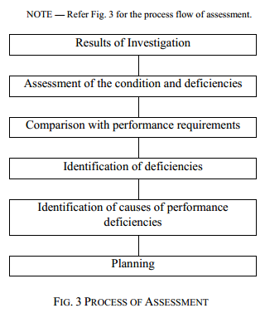
The flow chart illustrates a structured “Process of Assessment” that can be applied to integrated drinking water supply systems management plans. The steps in the process include:
  - Results of Investigation: This involves collecting and analyzing data from inspections, monitoring, or other investigative activities to understand the current state of the system.
  - Assessment of the Condition and Deficiencies: Based on the investigation, the current condition of the water supply system and any deficiencies are identified.
  - Comparison with Performance Requirements: The identified deficiencies are evaluated against the required performance standards or benchmarks for the water supply system.
  - Identification of Deficiencies: Specific shortcomings or gaps in the system’s performance are clearly outlined.
  - Identification of Causes of Performance Deficiencies: The root causes contributing to the identified deficiencies are analyzed and documented.
The areas of assessment are mentioned below as an example:
- performance of the drinking water supply system against the requirements for the maximum required power demand.
- treatment and pumping process performance should be assessed
- serviceability, stability, protection of the escape routes, structure against environmental influences, natural calamities, fire, sabotage and protection against unauthorized access should be assessed
- operational performance of the system as measured by the number of operational incidents or failures should be assessed
PLANNING
The process of planning is to meet the performance requirements. The process involves several important steps:
- Results of Assessment: We begin by assessing the current system to understand its condition and identify areas that need improvement.
- Develop Integrated Solutions: Based on the assessment, we develop solutions that meet the performance requirements while considering future conditions.
- Assess Feasibility of Solutions: Next, we evaluate the proposed solutions for their practicality and effectiveness.
- Select Optimal Solution: We choose the best solution based on various factors such as safety, cost, and sustainability.
- Prepare Action Plan: We then create a detailed action plan that includes the selected solution, timeline, and resources.
- And it is followed by Implementation and Monitoring
The planning process can take two main forms after the assessment result and development of integrated solution:
- Approach Specific Plan: This is a general outline of the approach to be taken. More detailed information will be provided in specific parts of the distribution system.
- Proposed Activities and Resources Specific Plan: This is a more detailed plan that outlines the activities, resources required, and timelines for implementation."
Planning for integrated drinking water supply systems is typically divided into three categories based on timeframes:
- Strategic/Long-Term Plan: This covers a period of 20 to 30 years.
- Tactic/Medium-Term Plan: This plan spans 8 to 10 years.
- Operational/Short-Term Plan: This plan focuses on up to 5 years."

The solutions should be developed to meet the performance requirements, while also considering future conditions and sustainability. This ensures that the system can handle future demands and challenges.
When assessing solutions, several factors must be considered such as safety, social impact, maintenance liabilities, organisation's constraints. As per optimal solution, document an action plan containing detailed objectives, timescales, priorities, performance criteria and other relevant information.
The action plan may include four main types of plans:
- New Development Plan: For new infrastructure.
- Operations and Maintenance Plan: To ensure the system runs smoothly.
- Rehabilitation Plan: For upgrading or replacing existing infrastructure.
- Contingency and Emergency Plan: To address unexpected situations and emergencies."
This approach ensures that drinking water supply systems are planned and implemented effectively, considering both current needs and future challenges.
IMPLEMENTATION

Now that we have our action plan ready, let's talk about how we will implement it using the PDCA approach. This approach helps us manage the process systematically and ensures continuous improvement.
- Plan (Create/Update Plan): First, we create or update our plan based on the results of our assessment. This involves setting clear objectives, timelines, priorities, and performance criteria for the drinking water supply system. For example, planning might include upgrading pipelines, ensuring water quality compliance, and meeting community demands.
- Do (Carry Out Work): Next, we carry out the work according to our plan. This includes implementing activities such as pipeline replacements, treatment plant upgrades, and emergency response preparations. For instance, we initiate the installation of a new water pipeline in a rural area to ensure uninterrupted supply and improve water quality.
- Check (Monitor Performance): We then monitor the performance of our actions. This involves collecting and analyzing data to ensure the work is achieving the desired outcomes. For example, we measure the water quality and pressure in the newly installed pipeline to confirm it meets IS 10500 standards and is sufficient for household needs.
- Act (Review Performance): Finally, we review the performance and make necessary adjustments. If issues or areas for improvement are identified, we update the plan accordingly. For instance, if water pressure in the new pipeline is found to be inadequate during peak demand, we may decide to add booster pumps or modify the distribution strategy.

In this section, we will walk through the steps involved in the implementation process, focusing on how to effectively carry out the plans we have developed to ensure a reliable and efficient water supply system.
General Overview of Implementation
The implementation plan for drinking water systems should consider the financial risks to the utility. It should also be based on the ‘Plan-Do-Check-Act’ (PDCA) approach.
"First, in creating or updating the plan, we need to establish clear objectives and technical processes to ensure the system’s performance is maintained or improved."
"Next, updating the implementation plan is essential, as it helps enhance asset management, minimize costs, and effectively manage risks."
"When carrying out the work, it’s important to design the components properly, select the right technologies, and ensure quality control while evaluating performance."
"Afterward, we must monitor performance by tracking the effectiveness of the work and updating the plan using performance indicators and simulation models."
"It’s also crucial to review performance periodically to ensure the system continues to meet its objectives and make necessary adjustments for improved efficiency."
"In conclusion, the implementation of the system requires careful planning, execution, and continuous improvement to ensure success."
OPERATION, MAINTENANCE AND REHABILITATION
Operation, Maintenance, and Rehabilitation serves different yet overlapping purposes. If the performance requirements are met, the operations are continuous which includes functions such as monitoring water flow, regulating water quality, operating pumps, valves, and treatment equipment, as well as flushing filters.
Maintenance, on the other hand, is about keeping the system functioning at its original performance level and restoring the performance. This involves routine tasks like cleaning or flushing pipes, replacing or lubricating pumps and valves, replacing electromechanical equipment, or repairing broken pipes and pumps.
Rehabilitation is necessary when the system needs to be restored or upgraded to improve its performance and involves repairing broken pipes, pumps, or valves, relining pipes, or replacing and enlarging assets.
Potential hazard
All operations can be hampered by numerous ways that needs to be chalked out and understood to take immediate action. To list out a few potential hazards, we have:
- Incorrect dimensioning of equipment
- Inappropriate choice of materials and components
- Unsuitable or faulty design or construction method
- Poor commissioning/decommissioning activities
- Operating with critical flow conditions (flushing)
- Unsafe treatment concepts
- Unsafe distribution concepts
- Unacceptable water pressures
- Impairment caused by environmental factors
- Poor third-party construction work
- Insufficient numbers or qualification of staff
- Inadequate plant management
- Infiltration or feeding of non-potable water
- Stagnant water, high water losses, frequent failures
Risk Based Assessment
To analyze the risk of failure, hazard can be assessed on different factors, which includes asset age, operational data, and local conditions.
Estimation by Age:
One important factor in risk assessment is the age of the assets. The older the asset, the higher the risk. We use a scale to categorize this:
- 4: Assets that are 30 to 50 years old are at higher risk.
- 3: Assets between 15 and 30 years old also carry a moderate risk.
- 2: Assets that are 5 to 15 years old are in relatively better condition.
- 1: Newer assets, less than 5 years old, generally have lower risk.
Operational and Maintenance Information:
Interviewing personnel with experience in managing the system, reviewing maintenance records, and looking at data on user complaints can help us identify areas where the system may be struggling.
Peculiar Local and Environmental Conditions:
For example, unusual pressure regimes in the system, areas with frequent complaints, or components showing signs of wear, such as temperature changes, vibrations, or frequent failures, all indicate a higher risk of system failure.
Planning for Rehabilitation
Operation and maintenance may lead to restoration of activity, but a water utility system always have to go a process of rehabilitation. This broadly involves 3 kinds of approach :
Short-Term Activities (Up to 5 years): In the short term, the focus is on collecting and monitoring operational data, as well as assessing the condition of the assets. This helps in planning preventive maintenance schedules to avoid unexpected failures.
Medium-Term Activities (8-10 years): In the medium term, it’s important to plan the operational information that needs to be collected and establish a Management Information System (MIS) to track this data. The analysis of asset performance, costs related to planning, operation, maintenance, and rehabilitation is crucial for long-term decision-making. Maintaining an accurate asset database and identifying risks of asset failure are also key tasks during this period. Preselecting the appropriate rehabilitation technologies and materials ensures that the system is ready for future upgrades.
Long-Term Activities (20-30 years): Long-term planning focuses on ensuring the system meets future demands and maintains a high level of service. This includes setting acceptable levels of service, public safety, and health protection, along with ensuring environmental sustainability and user satisfaction. It’s also important to assess the system’s capacity to handle future demands and implement effective risk control measures.
EFFICIENCY REVIEW
The Efficiency Review is crucial for evaluating the success of rehabilitation efforts and identifying areas for improvement. In this process, we ask several important questions to assess the overall effectiveness:
- Have the rehabilitation objectives been reached?
- Were the rehabilitation techniques and materials adequate or were there better solutions?
- Is there a need to modify any evaluation criteria and/or standards?
- Was the cost per service or capital spent target achieved?
- Were the infrastructure asset condition indicators accurate and useful?
- Do the indicators need to be adjusted?
- Where the rehabilitation works carried out without negative impact on the network users or the environment?

Questions such as these can lead to better assessment, further investigation and improvement of the asset management system.

CHAPTER 3

A. BRIEF OVERVIEW
Major technical work in standard formulation is done by Sectional committees. These Sectional Committees are set up by the concerned Division Council. Division Council defines the subject areas to be taken up for formulation of standards keeping in view the national needs and priorities; Set up Sectional Committees within their areas, define their scopes. Sectional committees prepare standard or group of standards relevant the area of their scope. Subcommittees & Panels are set up by Sectional Committees to attend to a specific tasks.
The Food and Agriculture Department (FAD) under the BIS is entrusted with the task of formulation of national standards in the field of food and agriculture under the aegis of the Food and Agriculture Division Council (FADC) which oversees and supervises its work.
Drinking Water and Carbonated Beverages Sectional Committee, FAD 14 is one of the significant committees under FADC with the following scope:
Standardization in the field of:
- Drinking water, packaged or supplied in unpackaged form through organized water supply;
- Water used in any food processing industry for the manufacture, processing, preservation, or marketing of products or substances intended for human consumption;
- Carbonated beverages;
- Physical, chemical and microbiological methods of test pertaining to this Committee including sensory evaluation.
Indian Standards formulated by Bureau of Indian Standards (BIS) are the national standards of the country, formulated by subject specific technical committees. It is important that interest of all stakeholders are well represented in the standard development process which is why, BIS Technical Committee structure bring together all relevant stakeholders such as manufacturer, consumer, R&D and scientific institutions, academia, Govt. departments/ Ministries, Regulators and testing laboratories. This ensures that the national standards are developed keeping in view national interest and taking into account all the viewpoints through a process of consultation.
Under FAD 14, BIS has formulated 3 Indian Standards on Drinking Water for human consumption, out of which 2 are on packaged forms (IS 14543 & IS 13428) and one (IS 10500) is for the potable water (treated or untreated) from any source such as piped drinking water.
- IS 10500: 2012 for Drinking Water — Specification prescribes the requirements and the methods of sampling and test for drinking water from any source and includes water (treated or untreated) supplied by any means for human consumption.
- IS 14543: 2024 is for Packaged Drinking Water (Other than Packaged Natural Mineral Water) which may be subjected to various treatments such as decantation, filtration, combination of filtration, cartridge filter, activated carbon filtration, demineralization, remineralization, reverse osmosis and packed after disinfecting the water and is offered or sold in packaged form.
- IS 13428: 2024 covers various mineral waters in packaged form such as Naturally Carbonated Natural Mineral Water, Non-carbonated Natural Mineral Water, decarbonated Natural Mineral Water, Natural Mineral Water Fortified with Carbon Dioxide from the Source, Carbonated Natural Mineral Water.
B. OVERVIEW OF INDIAN STANDARD IS 10500: 2012
Water is essential for life and so is Indian standard on drinking water quality.
Indian Standard IS 10500 for Drinking Water is an important standard formulated by BIS with the objective of assessing the quality of water resources, and to check the effectiveness of water treatment and supply by the concerned authorities. It includes water (treated or untreated) supplied by any means for human consumption.
1) SCOPE
This standard prescribes the requirements and the methods of sampling and test for drinking water.
Note: Drinking water is water intended for human consumption for drinking and cooking purposes from any source. It includes water (treated or untreated) supplied by any means for human consumption.
2) FORMULATION & IMPLEMENTATION

This standard was originally published in 1983. It was the time when, there was a global concern over availability of safe water supplies to millions of people across the world. A report prepared by the World Health Organization in cooperation with the World Bank showed that in 1975, some 1 230 million people were without safe water supplies. These appalling facts were central to the United Nations decision to declare an International Drinking Water Supply and Sanitation decade, beginning in 1981. Further, the VI Five-Year Plan of India had made a special provision for availability of safe drinking water for the masses. Therefore, the standard was formulated with the objective of assessing the quality of water resources, and to check the effectiveness of water treatment and supply by the concerned authorities.
As per the eleventh five-year plan document of India (2007-12), there were about 2.17 lakh quality affected habitations in the country with more than half affected with excess iron, followed by fluoride, salinity, nitrate and arsenic in that order. The eleventh five year plan document of India (2007-2012) recognized dealing with the issue of water quality as a major challenge and aims at addressing water quality problems in all quality affected habitations with emphasis on community participation and awareness campaigns as well as on top most priority to water quality surveillance and monitoring by setting up of water quality testing laboratories strengthened with qualified manpower, equipment and chemicals. The second revision was undertaken to upgrade the requirements of the standard and align with the internationally available specifications on drinking water.
3) DOCUMENTS REFERRED WHILE FORMULATING THE STANDARD
This Indian Standard IS 10500 has been formulated with considerable assistance from the following:
- EU Directives relating to the quality of water intended for human consumption (80/778/EEC) and Council Directive 98/83/EC.
- USEPA standard — National Primary Drinking Water Standard. EPA 816-F-02-013
- WHO Guidelines for Drinking Water Quality
- Manual on Water Supply and Treatment, third edition — Ministry of Urban Development, New Delhi.
The requirements for drinking water quality as given in IS 10500 : 2012 are thus aligned with and are at par with WHO Guidelines for drinking water quality, which are the international standards for drinking water quality used by various countries and regions across the world including CODEX, EU Directives, etc. The primary purpose of the Guidelines for drinking-water quality is the protection of public health.
4) REQUIREMENTS COVERED
The Standard covers requirements and test methods for drinking water:
Sl. No. | Requirement
 | Organoleptic & Physical requirements (6 test parameters)
 | Chemical requirements affecting acceptability (24 test parameters)
 | Toxic metals and anions (15 test parameters)
 | Pesticide residues (20 residues);
 | Radioactive residues (2 tests for alpha & beta emitters);
 | Biological requirements
 | - Bacteria (2 requirements for E. coli & Total coliforms)
 | - Virus (MS 2 virus)
 | iii) Protozoans (2 requirements for Cryptosporidium & Giardia)
The standard states that routine surveillance of drinking water supplies should be carried out by the relevant authorities to understand the risk of specific pathogens and to define proper control procedures.
5) ACCEPTABILITY CRITERIA
This standard specifies the acceptable limits and the permissible limits in the absence of alternate source. Acceptable limits are the values in excess of which the water is not suitable for drinking purposes. Such a value may, however, be tolerated in the absence of an alternative source. However, if the value exceeds the limits indicated under ‘permissible limit in the absence of alternate source’, the sources will have to be rejected.
6) ORGANOLEPTIC & PHYSICAL REQUIREMENTS
These parameters in drinking-water may be indicative of some form of pollution or of a malfunction during water treatment or distribution. It may therefore be an indication of the presence of potentially harmful substances. Taste and odour can originate from natural inorganic and organic chemical contaminants and biological sources or processes. The cause should be investigated and the appropriate health authorities should be consulted, particularly if there is a sudden or substantial change. Colour, cloudiness, particulate matter and visible organisms may also be noticed by consumers and may create concerns about the quality and acceptability of a drinking-water supply.
The organoleptic and physical requirements specified under Table 1 of the standard are as follows:
S. No. | Requirements | IS 10500 : 2012 Drinking Water – Specification
 |  | Acceptable | Permissible
 | Colour, Hazen units, Max | 5 | 15
2. | Odour & Taste | Agreeable | Agreeable
3. | pH | 6.5-8.5 | No relaxation
4. | Turbidity, NTU, Max | 1 | 5
5. | Total dissolved solids, mg/l | 500 Max | 2000 Max

(i) Colour
Drinking-water should ideally have no visible colour. Colour in drinking-water is usually due to the presence of coloured organic matter associated with the humus fraction of soil. Colour is also strongly influenced by the presence of iron and other metals, either as natural impurities or as corrosion products. It may also result from the contamination of the water source with industrial effluents and may be the first indication of a hazardous situation.

(ii) Odour & Taste
Water should be free of tastes and odours that would be objectionable to most consumers. Microbial, chemical and physical constituents of water may affect odour or taste of the water, and the consumer will evaluate the quality and acceptability of the water on the basis of these criteria.
Changes in the normal appearance, taste or odour of a drinking-water supply may signal changes in the quality of the raw water source or deficiencies in the treatment process and should be investigated.
(iii) Turbidity
Turbidity, typically expressed as nephelometric turbidity units (NTU), describes the cloudiness of water caused by suspended particles (e.g. clay and silts), chemical precipitates (e.g. manganese and iron), organic particles (e.g. plant debris) and organisms. Turbidity can be caused by poor source water quality, poor treatment and, within distribution systems, disturbance of sediments and biofilms or the ingress of dirty water through main breaks and other faults.
(iv) pH
The pH level of drinking water is important because it affects many aspects of the water, including its taste, odor, and nutritional content. It also affects the water's ability to dissolve substances, how aquatic life can use it, and how well it can be disinfected.
High pH causes a bitter taste, water pipes and water-using appliances become encrusted with deposits, and it depresses the effectiveness of the disinfection of chlorine, thereby causing the need for additional chlorine when pH is high. Low-pH water will corrode or dissolve metals and other substances.
(v) Total dissolved solids
The palatability of water with a total dissolved solids (TDS) level of less than about 500 mg/l is generally considered to be good; drinking-water becomes significantly and increasingly unpalatable at TDS levels greater than about 1000 mg/l. The presence of high levels of TDS may also be objectionable to consumers, owing to excessive scaling in water pipes, heaters, boilers and household appliances.
7) CHEMICAL REQUIREMENTS AFFECTING ACCEPTABILITY (24 Test Parameters)
Chemical contaminants have been shown to cause adverse health effects in humans as a consequence of prolonged exposure through drinking-water. The substances considered here have been assessed for possible health effects, and guideline values have been established only on the basis of health concerns. Additional consideration have been given to the potential effects of chemical contaminants on the acceptability (i.e. taste, odour and appearance) of drinking-water to consumers.

The standard considers both health risks and possible impacts on water quality, as well as associated risks from long-term or short-term exposure. Drinking water shall comply with the following requirements concerning substances undesirable in excessive amounts:
Sl. No. | Requirements | Acceptable limit | Permissible limit | Significance
1. | Aluminium (as Al), mg/l, Max | 0.03 | 0.2 | High concentrations of aluminium in drinking water can cause neurotoxic effects, particularly in individuals with pre-existing neurological conditions. It is linked to Alzheimer’s disease.
2. | Ammonia (as total ammonia-N), mg/l, Max | 0.5 | No relaxation | Ammonia in water is a product of organic decay and can be toxic, especially in aquatic ecosystems. At high concentrations, it can affect the taste and odour of drinking water. Ammonia is not typically considered a direct health risk at concentrations up to 0.5 mg/l but may indicate contamination from sewage or industrial activities.
3. | Anionic detergents (as MBAS) mg/l, Max | 0.2 | 1.0 | Anionic detergents can cause foaming, which can affect the appearance of drinking water. While not considered highly toxic, high concentrations (greater than 0.2 mg/l) can impair the aesthetic quality of water and may also indicate contamination from industrial activities.
4. | Barium (as Ba), mg/l, Max | 0.7 | No relaxation | Barium can have cardiovascular effects and may cause hypertension and other health issues. Long-term exposure to high levels can also lead to kidney damage.
5. | Boron (as B), mg/l, Max | 0.5 | 2.4 | Boron, found in natural water sources, has potential toxic effects on reproductive health and development. The permissible limit of 2.4 mg/l is set to avoid long-term exposure risks, especially to vulnerable groups like pregnant women and children.
6. | Calcium (as Ca), mg/l, Max | 75 | 200 | Calcium is a naturally occurring mineral in water and is essential for human health, particularly for bone and dental health. However, excess calcium may cause scaling in pipes and water heaters.
7. | Chloramines (as Cl2), mg/l, Max | 4 | No relaxation | Chloramines are used as disinfectants but may cause adverse health effects, including respiratory issues and skin irritation, when concentrations are too high.
8. | Chloride (as Cl), mg/l, Max | 250 | 1000 | High chloride concentrations are associated with saline intrusion or pollution from industrial processes. Chlorides can cause a salty taste and affect the aesthetic quality of water.
9. | Copper (as Cu), mg/l, Max | 0.05 | 1.5 | Copper is essential in small amounts for human health, but long-term exposure to high concentrations can lead to liver damage and gastrointestinal issues.
10. | Fluoride (as F) mg/l, Max | 1.0 | 1.5 | Fluoride is beneficial for dental health but can cause dental and skeletal fluorosis at high concentrations, leading to discoloration of teeth and weakening of bones.
11. | Iron (as Fe), mg/l, Max | 1.0 | No relaxation | Iron is necessary for human health, but high concentrations can cause water to appear discoloured and affect the taste, as well as create scaling in pipes.
12. | Magnesium (as Mg), mg/l, Max | 30 | 100 | Magnesium is essential for health, and its presence in water contributes to the hardness of the water. High concentrations may cause water to be "hard," leading to scaling.
13. | Manganese (as Mn), mg/l, Max | 0.1 | 0.3 | Manganese at high concentrations can cause neurological issues and impact water quality by causing discoloration.
14. | Mineral oil, mg/l, Max | 1.0 | No relaxation | Mineral oil can cause taste and odour problems and may have long-term health effects, including carcinogenic risks if consumed in large amounts.
15. | Nitrate (as NO3) mg/l, Max | 45 | No relaxation | Excessive nitrate levels in drinking water can contribute to the formation of carcinogens. Nitrates can lead to methemoglobinemia (blue baby syndrome) in infants by reducing the ability of blood to carry oxygen.
16. | Phenolic compounds (as C6H5OH), mg/l, Max | 0.001 | 0.002 | Phenolic compounds, even in low concentrations, can cause a strong taste and odour in water and can have toxic effects on the liver and kidneys. The very low acceptable limit (0.001 mg/l) ensures that drinking water is free from these compounds, which are typically industrial pollutants.
17. | Residual free chlorine, mg/l, Min | 0.2 | 1 | Residual chlorine is necessary for disinfection but can cause irritation to the skin, eyes, and respiratory system at high concentrations.
18. | Selenium (as Se), mg/l, Max | 0.01 | No relaxation | Selenium is an essential trace element, but excessive intake can lead to selenosis, with symptoms such as hair and nail loss, fatigue, and gastrointestinal problems.
19. | Silver (as Ag), mg/l, Max | 0.1 | No relaxation | Silver has antibacterial properties, but high concentrations in drinking water may cause argyria, a condition that turns the skin a blue-grey colour. The permissible limit of 0.1 mg/l is sufficient to avoid health risks while maintaining its utility in water treatment. High levels of silver can also accumulate in organs, particularly in the liver and kidneys, leading to potential toxicity.
20. | Sulphate (as SO4), mg/l , Max | 200 | 400 | High concentrations of sulphates can lead to gastrointestinal issues such as diarrhoea. It can also cause scaling and taste problems.
21. | Sulphide (as H2S), mg/l , Max | 0.05 | No relaxation | Sulphides contribute to a rotten egg smell and can cause nausea and headaches in high concentrations.
22. | Total alkalinity (as CaCO3), mg/l , Max | 200 | 600 | Alkalinity is important for buffering capacity in water. High alkalinity levels can lead to scaling and affect the water's taste.
23. | Total hardness (as CaCO3), mg/l , Max | 200 | 600 | Hard water, which contains high levels of calcium and magnesium, can cause scaling in pipes and appliances, and affect soap efficiency.
24 | Zinc (as Zn), mg/l , Max | 5 | 15 | Zinc is an essential nutrient but in high amounts, it can cause gastrointestinal distress and affect the taste of water.

8) TOXIC METALS AND ANIONS (15 Test Parameters)
The Indian Standard identifies metals and anions which are toxic in nature and poses serious risk to human health is present in concentrations above the specified limit. Accordingly, only acceptable limits are specified in the standard and no relaxation for same has been prescribed as permissible limit. Drinking water shall comply with the following requirements concerning toxic substances:

S. No. | Requirements | Acceptable limit | Concern
1. | Cadmium (as Cd), mg/l, Max | 0.003 | Exposure to cadmium primarily affects the kidneys and bones. Chronic exposure can lead to kidney damage, skeletal weakening, and the development of bone diseases like osteomalacia. Long-term exposure has also been associated with increased risks of cancer, particularly in the lungs.
2. | Chromium (as Cr), mg/l, Max | 0.05 | Hexavalent chromium can cause serious health issues, including lung cancer, skin ulcers, and kidney and liver damage.
3. | Cyanide (as CN), mg/l, Max | 0.05 | Cyanide is acutely toxic and can cause severe poisoning by interfering with oxygen transport in cells, leading to symptoms like dizziness, headaches, nausea, and in high doses, even death.
4. | Lead (as Pb), mg/l, Max | 0.01 | Lead is a neurotoxin, particularly harmful to children. It can affect brain development, causing learning difficulties, reduced IQ, and behavioural problems. In adults, it can lead to high blood pressure, kidney damage, and reproductive issues.
5. | Mercury (as Hg), mg/l, Max | 0.001 | Mercury is a neurotoxin that can cause neurological damage, including tremors, memory loss, and developmental delays in children. It can also harm the kidneys and the immune system.
6. | Molybdenum (as Mo), mg/l, Max | 0.07 | High concentrations of molybdenum may cause gout-like symptoms, including joint pain, and in severe cases, it can interfere with copper absorption, leading to copper deficiency.
7. | Nickel (as Ni), mg/l, Max | 0.02 | Higher levels of nickel can cause allergic reactions, increase cancer risk, and lead to kidney and liver damage
8. | Polychlorinated biphenyls, mg/l, Max | 0.0005 | PCBs are synthetic chemicals used in electrical equipment and other industrial products. PCBs are persistent in the environment and can accumulate in living organisms, leading to various health problems such as cancer, liver damage, and developmental defects in children.
9. | Polynuclear aromatic hydrocarbons (as PAH), mg/l, Max | 0.0001 | PAHs are a group of chemicals that can enter drinking water through pollution from industrial processes, vehicular emissions, or the combustion of fossil fuels. Many PAHs are carcinogenic and can lead to lung, skin, or bladder cancer. Prolonged exposure to PAHs can also damage the liver and immune system.
10. | Total Arsenic (as As), mg/l, Max | 0.01 | Arsenic is a toxic metalloid that can enter drinking water through natural sources (e.g., rock dissolution) or human activities (e.g., mining, industrial pollution). Chronic exposure to arsenic can lead to skin lesions, cardiovascular disease, neurological effects, and various cancers (e.g., skin, bladder, lung).
11. | Bromoform, mg/l, Max | 0.1 | Bromoform is a by-product of disinfection processes, especially when chlorine interacts with organic matter in water. Bromoform is considered a potential carcinogen, and prolonged exposure can lead to liver and kidney damage.
12. | Dibromochloromethane, mg/l, Max | 0.1 | Di-bromochloromethane is another disinfection by-product created when chlorine is used in water treatment. It is potentially carcinogenic, and long-term exposure can result in liver and kidney toxicity.
13. | Bromodichloromethane, mg/l, Max | 0.06 | Similar to other disinfection by-products, bromo-di-chloromethane is formed when chlorine is used in water treatment, especially when there is organic matter in the water. It is considered a possible carcinogen and can cause liver and kidney damage over prolonged exposure.
14. | Chloroform, mg/l, Max | 0.2 | Chloroform is another common by-product of chlorination in water treatment. Long-term exposure to chloroform may increase the risk of liver cancer and kidney damage. It is also considered a possible carcinogen.
15. | Uranium, mg/l, Max | 0.03 | Specified limit is based on chemical toxicity from Uranium. Nephritis is the primary chemically induced effect of uranium in humans.

*The requirement for Uranium was introduced through Amendment no. 3 to IS 10500: 2012
9) PESTICIDE RESIDUES
Long-term exposure to pesticide residues in drinking water can have serious, lasting health effects. These include:
Cancer: Many pesticides are classified as carcinogenic, meaning long-term exposure can increase the risk of developing cancer. For example, herbicides like atrazine, and insecticides like DDT and organophosphates, have been linked to various cancers, including leukemia, lymphoma, and other solid tumors.
- Endocrine Disruption: Some pesticides are known as endocrine disruptors, which means they can interfere with hormone systems. These chemicals can affect the thyroid, reproductive organs, and overall hormonal balance, potentially leading to developmental and reproductive issues.
- Reproductive and Developmental Toxicity: Long-term exposure to certain pesticides has been associated with infertility, birth defects, and developmental delays in children. These effects can be especially concerning for pregnant women and young children.
- Neurological Damage: Certain pesticides, such as organophosphates and pyrethroids, affect the nervous system, and prolonged exposure may cause neurodevelopmental disorders, including attention deficits, motor coordination problems, and learning disabilities. In extreme cases, it can lead to neurodegenerative diseases such as Parkinson's disease.
- Kidney and Liver Damage: Chronic exposure to pesticides, especially those that are fat-soluble and bioaccumulate in the body, can lead to long-term damage to the liver and kidneys. This can result in conditions such as liver fibrosis or kidney failure in severe cases.
Pesticide residues limits and test methods given in Table 5 of IS 10500: 2012 are based on consumption pattern, persistence and available manufacturing data. The limits have been specified based on WHO guidelines, wherever available. Considering the health risk involved, only acceptable limits are specified in the standard and no relaxation for same has been prescribed as permissible limit. In cases where WHO guidelines are not available, the standards available from other countries have been examined and incorporated, taking in view the Indian conditions.

S. No. | Requirements | Acceptable  (µg/l) | Permissible
1. | Alachlor | 20 | No relaxation
2. | Atrazine | 2 | No relaxation
3. | Aldrin/ Dieldrin | 0.03 | No relaxation
4. | Alpha HCH | 0.01 | No relaxation
5. | Beta HCH | 0.04 | No relaxation
6. | Butachlor | 125 | No relaxation
7. | Chlorpyriphos | 30 | No relaxation
8. | Delta HCH | 0.04 | No relaxation
9. | 2,4- Dichlorophenoxyacetic acid | 30 | No relaxation
10 | DDT (o, p and p, p – Isomers of DDT, DDE and DDD) | 1 | No relaxation
11. | Endosulfan (alpha, beta, & sulphate) | 0.4 | No relaxation
12. | Ethion | 3 | No relaxation
13. | Gamma — HCH (Lindane) | 2 | No relaxation
14. | Isoproturon | 9 | No relaxation
15. | Malathion | 190 | No relaxation
16. | Methyl parathion | 0.3 | No relaxation
17. | Monocrotophos | 1 | No relaxation
18. | Phorate | 2 | No relaxation

10) RADIOACTIVE RESIDUES
Water sources can contain radionuclides of natural and artificial origin (i.e. humanmade):
    - Natural radionuclides, including potassium-40, and those of the thorium and uranium decay series, in particular radium-226, radium-228, uranium-234, uranium-238 and lead-210, can be found in water as a result of either natural processes (e.g. absorption from the soil) or technological processes involving naturally occurring radioactive materials (e.g. the mining and processing of mineral sands or phosphate fertilizer production).

    - Human-made radionuclides may be present in water from several sources, such as:
  - radionuclides discharged from nuclear fuel cycle facilities;
  - manufactured radionuclides (produced and used in unsealed form in medicine or industry) entered into drinking-water supplies as a result of regular or incidental discharges;
- radionuclides released in the past into the environment, including drinking water sources.
As per WHO Guidelines 2017, 4th Edition, Radiation protection is based on the assumption that any exposure to radiation involves some level of risk. For prolonged exposures, as is the case for ingestion of drinking water containing radionuclides over extended periods of time, evidence of an increased cancer risk in humans is available at doses above 100 mSv (Brenner et al., 2003). Below this dose, an increased risk has not been identified through epidemiological studies. It is assumed that there is a linear relationship between exposure and risk, with no threshold value below which there is no risk.
The process of identifying individual radionuclides in drinking-water and determining their concentration is time-consuming and expensive. Because, in most circumstances, the concentrations are low, such detailed analysis is normally not justified for routine monitoring. A more practical approach is to use a screening procedure, where the total radioactivity present in the form of alpha and beta radiation is first determined, without regard to the identity of specific radionuclides.

S. No. | Requirements | Acceptable | Permissible
1. | Alpha emitters Bq/l, Max | 0.1 | No relaxation
2. | Beta emitters Bq/l, Max | 1.0 | No relaxation

In case of non-conformity of radioactive residues, the source of water shall be abandoned and water shall be recalled immediately.
11) BIOLOGICAL REQUIREMENTS
Drinking water shall comply with the following biological requirements substances:
. No. | Organisms | Requirements
1. | E. coli or thermos-tolerant coliform bacteria | shall not be detectable in any 100 ml sample
2. | Coliforms | shall not be detectable in any 100 ml sample
3. | MS2 phage (indicator of viral contamination) | shall be absent in 1 liter water
4. | Cryptosporidium | shall be absent in 10 liter of water
5. | Giardia | shall be absent in 10 liter of water

With regard to failure in the requirement for E. Coli, the Indian standard further provides following guidelines:
- Immediate investigative action shall be taken if either E.coli or total coliform bacteria are detected. The minimum action in the case of total coliform bacteria is repeat sampling; if these bacteria are detected in the repeat sample, the cause shall be determined by immediate further investigation.
- Although, E. coli is the more precise indicator of faecal pollution, the count of thermos-tolerant coliform bacteria is an acceptable alternative. If necessary, proper confirmatory tests shall be carried out. Total coliform bacteria are not acceptable indicators of the sanitary quality of rural water supplies, particularly in tropical areas where many bacteria of no sanitary significance occur in almost all untreated supplies.
- It is recognized that, in the great majority of rural water supplies in developing countries, faecal contamination is widespread. Under these conditions, the national surveillance agency should set medium-term targets for progressive improvement of water supplies.
The Indian standard further provides that Chlorination, at the dosages normally employed in waterworks, is ineffective against certain parasites, including amoebic cysts; they can be excluded only by effective filtration or by higher chlorine doses than can be tolerated without subsequent dechlorination. Amoebiasis can be conveyed by water completely free from enteric bacteria; microscopic examination after concentration is, therefore, the only safe method of identification.
12) METHOD OF TESTS
Indian Standards on methods of test (IS 3025 series of standards) for determination of various parameters specified in Indian Standard based on international methods (ISO) and are revised from time to time taking into consideration the technical advancement in testing methodology. The Indian standard also recognizes use of International test methods for testing various parameters specified in the Indian Standard. For determination of trihalomethanes, the standard refers to ASTM methods. Likewise, for determination of pesticides, the Indian Standard refers to USEPA/ AOAC/ISO standard test methods. The standard also allows that approved and validated international test methods from ISO/ APHA/ ASTM/ AOAC/ EPA/ EN may also be followed.
C. INDIAN STANDARD RELATING TO DRINKING WATER SUPPLY AND DISTRIBUTION SYSTEM
IS 17482 : 2020 Drinking Water Supply Management System - Requirements for Piped Drinking Water Supply Service
The standard specifies the requirements for management system of drinking water supplier/utility and for the assessment of piped drinking water supply services where the water supplier/utility,
a) needs to demonstrate its ability and performance to consistently provide drinking water and related utility services while ensuring compliance to applicable statutory and regulatory requirements;
b) aims to ensure continuous supply of piped drinking water conforming to the acceptable limits of IS 10500
BIS has launched Drinking Water Supply Management System Certification Scheme as per IS 17482:2020 for the Water Utilities which include Public Health Engineering Departments (PHEDs), Municipal Corporations, Jal Boards of the states and Union Territories responsible for supply of drinking water to the people of the country. Further details regarding the certification process may be obtained from the BIS website - https://manakonline.in
D. INDIAN STANDARDS ON PACKAGED WATERS
1) BIS has formulated following two Indian Standards on packaged waters:
- IS 14543 : 2024 is for Packaged Drinking Water (Other than Packaged Natural Mineral Water) is for Packaged Drinking Water (Other than Packaged Natural Mineral Water). The standard prescribes the requirements and methods of sampling and test for packaged drinking water (other than natural mineral water) offered for consumption and/or for sale in packaged form

The Packaged Drinking Water (PDW) shall be derived from surface water or civic water supply or underground water or sea water or any other consistent source of water which may be subjected to specified treatments, namely, decantation, distillation, filtration, combination of filtration, aerations, filtration with membrane filter, depth filter, cartridge filter, activated carbon filtration, demineralization, remineralization, reverse osmosis and packed after disinfecting the water to a level that shall not lead to any harmful effect in the drinking water by means of chemical agents or physical methods to reduce the number of micro-organisms to a level below scientifically accepted level for food safety or its suitability: Provided that sea water, before being subjected to the above treatments, shall be subjected to desalination and related processes.
- IS 13428 : 2024 covers various mineral waters in packaged form such as Naturally Carbonated Natural Mineral Water, Non-carbonated Natural Mineral Water, decarbonated Natural Mineral Water, Natural Mineral Water Fortified with Carbon Dioxide from the Source, Carbonated Natural Mineral Water. It is clearly distinguishable from ordinary drinking water because:
a) It is obtained directly from natural or drilled sources from underground water-bearing strata for which all possible precautions should be taken within the protected perimeters to avoid any pollution of, or external influence on, the chemical and physical qualities;
b) It is characterized by its content of certain mineral salts and their relative proportions and the presence of trace elements or other constituents;
c) Of the constancy of its composition and the stability of its discharge and its temperature, due account being taken of the cycles of minor natural fluctuations;
d) It is collected under conditions which guarantee the original microbiological purity and chemical composition of essential components;
e) It is packaged close to the point of emergence of the source with particular hygienic precautions; and
f) It is not subjected to any treatment other than those permitted by this standard (filtration up to 0.5 microns).
The microbiological requirements for IS 14543 : 2024 are more elaborate than those in IS 10500 in terms of the variety of microbiological parameters tested. Even in case of common parameters like E. coli & coliforms, the microbial stringency required is more in case of IS 14543 (absent in 250 ml) as compared to IS 10500 (Not Detectable in 100 ml). This pattern is similar to the EU Directives for drinking water. This is understandably due to the treatments involved or being done for PDW which are more complex and multiple (with the processing units employing RO systems) than in case of potable water sources/ supply under IS 10500.
The biological requirements specified in IS 10500 are generally based on the recommendations given in WHO Guidelines and prescribe requirements of specified indicator/ representative organisms for virus (MS2 phage) and protozoans (Cryptosporidium & Giardia). These requirements are understandably due to the nature of treatments done and largely because of the intermediary supply systems employed for distribution of treated water which may cause the contamination of potable water and thus needs to be checked at end-user point. These biological requirements have not been prescribed for packaged drinking waters (IS 14543 & IS 13428) as these are required to be packed and sealed under controlled conditions and also because of the usage of RO membranes during processing which filter out these organisms.
Other physiochemical requirements in IS 14543, IS 13428 & IS 10500 (acceptable limits) are generally comparable.
2) Packaging Requirement

- The standard specifies that the water shall be packed in clean, hygienic and tamperproof containers/bottles/pouches made of food grade plastic material or other food grade packaging materials, namely paper and paper board materials; glass; and metal and metal alloys which may or may not contain plastic as component, compatible with the water to be packaged.
- Plastic containers shall conform to IS 15410 and polyethylene flexible pouches shall conform to IS 15609. Guidelines for handling of polyethylene flexible pouches are given in Annex E.
- Paper based multilayer laminated/extruded composite cartons shall conform to IS 17753 and aluminium cans shall conform to Indian standard on 'Aluminium cans for packaged natural mineral water and packaged drinking water — Specification
- All packaging materials of plastic origin shall pass the overall migration, colour migration and specific migration limits for toxic substances as laid down in IS 15410’
3) Hygiene Conditions
The standard for packaged waters (IS 14543 & IS 13428) prescribe hygienic practices in accordance with which that source water shall be collected, processed, handled, packaged and marketed. These hygienic practices cover the appropriate general techniques for collecting drinking water, its treatment, bottling, packaging, storage, transport, distribution and sale for direct consumption, so as to guarantee a safe, healthy and wholesome product. A check list for good hygienic practices and food safety system for packaged water processing units is given.

CHECKLIST FOR GOOD HYGIENE PRACTICES AND FOOD SAFETY SYSTEMS FOR PACKAGED DRINKING WATER PROCESSING UNITS

Sl No. | Requirements | Answers |  | Remarks
Sl No. | Requirements | Applied | Not Applied
(1) | (2) | (3) | (4) | (5)
i) Building, Facilities and Locations
a) | Is the facility location area free from objectionable odour, smoke, dust or other contaminants and not subject to flooding?
b) | Are the areas immediately surrounding the buildings, roads, packing places, suitably paved, grassed and kept clean?
c) | Is adequate facility for drainage of surroundings which is designed to handle peak load?
d) | Is the facility used for processing water free from domestic animals?
e) | Is the facility surroundings free from refuse, waste materials, rubbish, overgrown weeds and grasses?
f) | Are there adequate facilities for the disposal of effluents and wastes?
g) | Are the buildings and facilities of sound construction and maintained in good repair?
h) | Are the buildings and facilities designed and maintained to prevent entrance and harboring of pests and entry of contaminants?
j) | Are building and facilities designed to facilitate hygienic operations?
ii) Plant and Physical Facilities

a) | Is adequate lighting provided at working station, hand washing area, and storage areas?
b) | Is the lighting intensity adequate:  1) 540 lux in all inspection area, and  2) 220 lux in work areas and walls
c) | Are light fixtures safety type and protected to prevent contamination in the event of breakage in the processing and packing area?
d) | Is adequate ventilation provided in processing areas to minimize odours, noxious fumes and condensates?
e) | Are the barriers/traps provided at drains to prevent the entry of rodents from the drains into the facility?
f) | Is effective screening provided against entry of birds, animals, insects, rodents, etc.?
g) | Are doors, hatches and other openings to the building constructed to render opening pest proof?
h) | Are floors, walls, ceilings, windows and doors so designed and constructed as to prevent accumulation of dust, dirt and render them washable?
j) | Is product in process and storage area adequately protected from any leakage from external surfaces and other sources of contamination?
k) | Are immediate surroundings of extraction or collection protected from entry of unauthorized persons?
iii) Raw Water Processing

a) | In case of extraction/collection for processing are the sources free from contaminations/ impurities?
b) | Are water storage tanks, pipe lines utilized for handling water constructed and so designed as to facilitate cleaning and inspection?
c) | Are inspections of containers/carriers/pipe lines of raw water supply performed for the material of construction and cleanliness?
d) | Are possible chances of contamination from incoming water assessed?
e) | Are water storage tanks effectively cleaned to prevent entry of pests and potential contaminator?
f) | Are the storage tanks periodically cleaned and records maintained?
g) | Are the processed water contact surfaces regularly cleaned and sanitized?
h) | Are all equipment utensils so designed and constructed as to prevent hygiene hazards and prevent easy cleaning and sanitation?
iv) Post-processing Handling

 | Are cleaning operation of bottles/containers so done as to preclude contamination of product and product contact services with residues?
 | Has absence of residual cleaning chemicals been ensured?
 | Is preventive maintenance in place for all processing machinery and equipment?
 | Are the primary packing materials and containers of food grade conforming to relevant Indian Standards?
 | Are packing and sealing, where required, monitored?
 | Are containers visually /electronically inspected for their soundness?
 | Are physical hazards prevented from entering into processed water?
 | Are glassware excluded from production area?
v) Packaging Material and Finished Goods Storage

 | Are the primary packing materials and containers of food grade conforming to relevant Indian Standards?
 | Are packaging material inspected to ensure their suitability?
 | Are the packing materials especially primary packing material properly stored and properly handled to preclude contamination?
 | Are packaging material purchased, stored and handled in sanitary manner?
vi) Finished Product Storage and Distribution

 | Is first-in-first out (FIFO) of stored product maintained?
 | Is storage properly sanitized and disinfected periodically?
 | Are stores protected from pest infestations?
 | Are coding and tracking clear and in place?
 | Are the instruction clear and in place?
 | Are hold/release procedure in place and product identified?
 | Are the records maintained for batch number, date of and volume of production?
 | Are transport containers/vehicles maintained in clean condition?
vii) Customer Handling of Products

 | Are the storage instructions provided on containers?
 | Is the shelf life period/best before mentioned on containers in accordance with FSSAI requirements?
 | Are instructions provided for handling defective/damaged products?
viii) Sanitary Facilities and Control

Are toilets provided in sufficient numbers and are they provided with:
1) Doors of self-closing type?
2) Opening directly into processing areas?
3) Hand washing signs provided in appropriate language?
4) Proper lighting and ventilation?
5) Proper maintenance to keep in clean and tidy manner?
 | Are hand washing facilities provided adequately and conveniently to wash hands, foot, elbow or sensor operated taps?
 | Are germicidal soaps/soap solution and hand drying facility provided?
 | Are notice/ instructions prominently pasted in toilet directing employees to wash their hands on entry and re-entry into the packaged drinking water handling areas?
 | Are the refuse receptacles self-closing type maintained in a manner to protect from contaminations?
ix) Personnel Hygiene and Habits

 | Is any individual assigned to supervise overall sanitation of plant and personnel?
 | Is there any person responsible for day-to-day monitoring of health and hygiene?
 | Have the employees in processing, packing and maintenance been medically examined?
 | Are the personnel with infectious diseases, skin infection and open lesion or any other source of microbial contamination excluded from working in process/packing areas?
Are the following personnel hygiene practices regularly maintained and monitored:
1) Clean outer garments-protective clothing?
2) Personal cleanliness-finger nails?
3) Head cover-hair restraints, caps, head bands, beard cover?
4) No tobacco in any form-smoking, chewing?
5) No eating at work stations?
 | Are protective clothing stored on the premises and not allowed to be used for outside wear?
 | Are there clear legible notices defining limits of no smoking areas such as ‘NO SMOKING BEYOND THIS POINT' displayed?
 | Are personnel imparted regular training or hygienic food handling, processing food and personal hygiene?

The Chemical Division Council (CHDC) is one of the key Division Councils in BIS which is engaged in standardization through its 22 Sectional Committees in diversified fields such as Chemicals and Chemical products including Photographic materials, Electroplating chemicals, Paints and related products, Glass, Ceramic wares, Soaps and Other Surface Active Agents, Lac and Lac Products, Industrial Gases, Explosives and Pyrotechnics, Water Quality, Air Quality, Water Quality for industrial purposes, Thermal Insulation, and Nuclear Materials; including nano materials and standards for synthetic nano materials, Paper, Stationery items, Leather, Leather Products, Footwear and Brushware, Occupational Health, Safety, and Chemical Hazards.
Water Quality Sectional Committee, CHD 36 is one of the significant committees under CHDC with the following scope:
Standardization in the field of:
a) Terminology,
b) Methods of sampling and analysis (physical, chemical and biochemical) of water, sewage, industrial effluents and marine water.
Indian Standards formulated by Bureau of Indian Standards (BIS) are the national standards of the country, formulated by subject specific technical committees. It is important that interest of all stakeholders are well represented in the standard development process which is why, BIS Technical Committee structure bring together all relevant stakeholders such as manufacturer, consumer, R&D and scientific institutions, academia, Govt. departments/ Ministries, Regulators and testing laboratories. This ensures that the national standards are developed keeping in view national interest and taking into account all the viewpoints through a process of consultation.
Under CHD 36, BIS has formulated more than 80 Indian Standards on method of test for drinking water and 2 standards related to sampling of drinking water for further assessment of its quality.
E. DRINKING WATER SAMPLING TECHNIQUES
1) What is Drinking Water Sampling?
Drinking water sampling is a critical process in water quality management and public health management, involving the collection of water from various points within a supply system to assess its quality. This practice ensures that the water provided for human consumption adheres to health and safety standards, safeguarding public health. Sampling should be conducted systematically, with specific protocols and guidelines to obtain samples that accurately represent the drinking water's condition at the time of collection.
The process starts with careful planning to identify sampling locations, such as water sources, treatment facilities, distribution networks, and consumer outlets. This ensures a comprehensive evaluation of the entire supply chain. Drinking water sampling is not only a tool for compliance but also a proactive measure to monitor treatment efficiency, detect potential hazards, and ensure the safety of water throughout the supply chain. Regular sampling fosters transparency, builds public trust, and supports the sustainable management of water resources. By adhering to systematic protocols and leveraging advanced testing techniques, drinking water sampling remains a cornerstone of effective public health protection.
2) Need of Water Sampling Techniques

a) Quality Control Measurements
- Ensuring Compliance: Sampling techniques verify that water meets national quality standards, such as IS 10500.
- Process Monitoring: Regular sampling evaluates the efficiency of treatment processes, such as filtration, sedimentation, and disinfection.
- Early Detection of Deviations: Identifies changes in water quality that might indicate issues in the supply system, enabling prompt corrective actions.
- Consumer Assurance: Consistent quality control fosters public trust in the water supply system.

b) Quality Characterization Measurements
- Comprehensive Assessment: Sampling provides a detailed analysis of physical (turbidity, temperature), chemical (pH, heavy metals, organic compounds), and biological (pathogens, biofilms) parameters.
- Understanding Seasonal Variability: Monitors how water quality changes with seasons, environmental conditions, or usage patterns.
- Source Protection: Characterization helps evaluate the quality of raw water sources, such as rivers, lakes, and aquifers, to ensure sustainable use.
- Benchmarking: Establishes baseline quality for comparing future changes or impacts of human activities.

c) Identification and Control of Sources of Contamination
- Tracing Contaminants: Sampling helps locate and identify contamination sources, such as industrial discharges, agricultural runoff, or microbial infiltration.
- Preventative Measures: Enables early identification of pollution, allowing for actions like improved land use practices, source protection, or changes in treatment protocols.
- Emergency Response: Facilitates rapid identification of contaminants during incidents like chemical spills or pathogen outbreaks, reducing risks to public health.
- Mitigation Strategies: Helps design effective strategies to control or eliminate contamination at its source, improving overall water quality.
F. INDIAN STANDARDS RELATED TO SAMPLING OF DRINKING WATER
- IS 17614 (Part 5) Water Quality- Sampling Part 5 Guidance On Sampling of Drinking Water from Treatment Works and Piped Distribution Systems
This standard provide guidance on sampling of water drawn from municipal or similar distribution systems (including individual systems) where prior treatment and/or quality assessment has resulted in the water being classified as suitable for drinking or potable process purposes. Specifically, this part of ISO 5667 is applicable to water that is in continuous supply relative to any stage of use up to and including the point of consumption in a distribution system. This includes distribution within large buildings in which additional water quality management might be applicable.
- IS 17614 (Part 21) Water Quality — Sampling Part 21 Guidance on Sampling of Drinking Water Distributed by Tankers or Means Other than Distribution Pipes
This standard provide guidance on sampling of water from those circumstances where water is drawn from municipal or similar public or private abstraction, treatment or distribution systems for which prior treatment or quality assessment has resulted in the water being classified as suitable for drinking or potable process purposes. Specifically, this part of ISO 5667 is applicable to water that is supplied by tanker or other non-contiguous bulk means, but not contiguously as part of a piped distribution system, during any stage of use up to and including the point of consumption or transfer to a piped distribution system.
G. GUIDANCE ON HOW TO DO SAMPLING OF DRINKING WATER FROM DIFFERENT SOURCES
1) Criteria for selection of sampling site
a) The chosen collection locations should yield samples that are representative of the system as a whole, or representative of its main components.
b) For each treatment plant, there should be at least one sample collection location on the water intake and at least one sample collection location immediately after the processed water outlet.
c) In systems with more than one water source, sample collection locations should reflect the output of each source, the demand on each source and the relative population using each source.
d) Sample collection locations should be widely distributed throughout a piped distribution system, the number being proportional to the number of links or branches in the system.
e) Sample collection locations should include locations representative of the most unfavourable sources and locations considered vulnerable to contamination such as loops, low-pressure zones and ends of systems.
f) Where waters from different sources mix within a complex piping system, sample collection locations should permit identification of relative proportions from each source through the system.
g) Where a distribution system connects to large buildings such as hotels or office blocks, there should be sample collection locations at the intake and throughout each building consistent with the principles in d) and e) above
h) There should be at least one sampling point on the inlet to the bulk storage container and one sampling point on the outlet from the bulk storage container. Water extracted from these sampling points should represent water within the storage container and should not be extracted from the source or from a secondary distribution system.
i) In systems with more than one inlet or outlet, sample locations should reflect the potential differences in water quality, in accordance with the determination to be made.
j) Sampling points should include locations representative of the most unfavourable sources and locations considered vulnerable to contamination.
k) Where waters from different sources mix within the bulk storage container, sample locations should be chosen to be representative of the quality of the water from each source.
l) If a distribution system includes many similar inlets or outlets, sample at least the most remote and the closest points to the reservoir.
m) Caution is required that the sampling process does not itself convey water into the system to avoid risk of injecting contaminants.
2) Pre-collection cleaning, disinfection and flushing
- Cleaning, disinfection and flushing prior to sample collection depend on specific objectives of the monitoring program.
- Record detailed information regarding cleaning, disinfection and flushing. Site reports should include mention of any device at the sampling point which might have a negative effect on the representativeness of collected samples, or which impede disinfection.
- Generally, 2 min or 3 min of free flow should be allowed to flush out any stale water within the sampling line before taking a sample.
3) Precaution to minimize contamination (Sample Collection and Handling)
The following precautions should be taken during sample collection and handling to minimize contamination of samples:
a) Thoroughly wash hands and/or wear disposable gloves;
b) Never smoke while taking samples and always avoid breathing on the samples;
c) Do not eat or drink while taking samples;
d) Only use laboratory-provided sample bottles and containers;
e) Only use laboratory-supplied reagents;
f) Where reagents are used for preservation, sequence the order of sample collection to minimize the
chance of cross-contamination of samples by reagents;
g) Do not use reagents that have passed an expiry date or that have an abnormal colour;
h) Avoid contamination of the outside of sample containers;
i) Remove the cap from a sample bottle immediately before sample collection and place the top in a clean/sterile bag or container while the sample is being collected;
j) Never insert any foreign object (such as a thermometer or pH probe) into a bottle intended for other analyses;
k) Avoid use of sample splitters unless specifically required;
l) Never use metal sampling devices if the analysis is to detect trace metals;
m) Prior to use, ensure that sample bottles are stored in clean areas and are capped and/or wrapped;
n) Ensure that all sample bottles or containers are closed hand-tight after sampling;
o) If possible, pre-cool samples and keep them dark before shipping, especially in summer months.
4) How to decide correct order of Sampling?
The order in which samples are collected should be based on the purpose of the sampling and the potential for cross contamination or other adverse effects on sampling.
For routine sampling for checking the quality of water as supplied, or at a specific point within the treatment and distribution systems, the following order of sampling is suggested:
a) First draw samples;
b) Flush (if total organic carbon sample required);
c) Take total organic carbon samples;
d) Turn off the faucet;
e) Clean the faucet;
f) Flush;
g) Take all other samples for physico-chemical parameters (including field determinations) in an order designed to minimize cross contamination of samples by reagents;
h) Turn off the faucet;
i) Disinfect the faucet ;
j) Flush the faucet ;
k) Take samples for microbiological parameters.
A different order of sampling may be required for other purposes, when special precautions may be needed to prevent contamination of samples.
5) Aspect to be covered in Sampling Manual
The Sampling manual provide specific guidance regarding sampling methods to be employed, sample handling and preservation, analytical methods for measurements to be performed at the sampling site, procedures to be followed when transporting samples to the laboratory and method details pertaining to any on-line continuous sensor type equipment to be utilized. The sampling manual should additionally detail all sampling quality procedures to be employed when collecting samples, when taking on-site measurements, when transporting samples to laboratory and when using or checking continuous monitoring equipment.
The sampling manual should specify:
a) The types of bottles or containers, their closures and the specific purposes for which they are to be used;
b) Where relevant, the cleaning procedure and shelf life for bottles, containers and closures used for each parameter, including the amount and type of preservative to be added;
c) The sampling procedure for each parameter, including the type of sample to be collected (e.g. first draw, flushed, stagnation) and the procedure for collecting samples for different parameters;
d) The frequency and order of sampling;
e) The conditions of storage and transport of samples and the maximum time that can elapse before analysis should commence for each parameter;
f) Description of preservation reagents (including usual colour), plus appropriate safety measures in case of spill, or contact with skin or eyes.
6) How to decide frequency and timing of sample?
For Drinking Water from treatment Works and Piped Distribution Systems
The sampling frequency depends, among other factors, on:
a) The purpose for which sampling is being performed;
b) The number of consumers served;
c) The volume of water distributed;
d) The specific residence time or turnover rate = daily volume distributed/ total system volume;
e) The quality of the raw water;
f) The variability of the raw water quality;
g) The parameters that require monitoring;
h) The complexity and characteristics of the specific distribution system being sampled;
i) Specific chemical and biological parameters.
For Drinking Water Distributed by Tankers or Means Other Than Distribution Pipes
The sampling frequency depends, among other factors, on:
a) The purpose for which sampling is being performed;
b) The number of consumers served;
c) The volume of water distributed;
d) The quality of the source water;
e) The variability of the raw-water quality;
f) The water treatment required;
g) The health hazard involved;
h) The complexity and characteristics of the specific distribution system being sampled;
i) Specific parameters.

H. INDIAN STANDARDS RELATED TO METHOD OF TESTS
Indian Standards on methods of test (IS 3025 series of standards) for determination of various parameters (physical and chemical) are harmonized with international methods (ISO), and American Public Health Association (APHA) and are revised from time to time taking into consideration the technical advancement in testing methodology. The Indian standard also recognizes use of International test methods for testing various parameters specified in the Indian Standard.
The IS 3025 standard and its various parts detail the analytical and instrumental methods for determining individual parameters in drinking water. These methods play a crucial role in ensuring water quality and compliance with safety standards.
With advancements in technology, instrumental methods have significantly evolved. Modern instruments now offer the capability to analyze and provide results for approximately 65 parameters simultaneously in a single run. This development marks a considerable improvement over traditional methods, enabling faster, more precise, and comprehensive water quality assessments.
1) What are advantages of instrumental methods over wet chemistry method for determination of water quality?

a) Accuracy and Precision
- Instrumental methods generally offer higher accuracy and precision due to reduced human error and advanced detection technologies.

b) Sensitivity
- Instruments like spectrophotometers and chromatographs can detect trace levels of contaminants (e.g., in parts per billion or trillion), which are often undetectable by wet chemistry.

c) Speed and Efficiency
- Automated and simultaneous multi-parameter measurements significantly reduce the time required for analysis compared to labour-intensive wet chemistry methods.

d) Automation and Ease of Use
- Modern instruments often feature user-friendly software interfaces, automated sample handling, and data processing, reducing operator workload.

e) Reproducibility

The standardized and automated nature of instrumental methods ensures reproducible results, which is crucial for regulatory compliance and research.

f) Reduced Reagent Use
- Instrumental methods typically require less chemical reagents and generate less waste, making them more environmentally friendly.

g) Multivariate Analysis
- Instruments like ICP-MS (Inductively Coupled Plasma Mass Spectrometry) or GC-MS (Gas Chromatography-Mass Spectrometry) can simultaneously analyze multiple parameters in a single run.

h) Data Documentation
- Instruments allow for digital data storage, real-time monitoring, and easy integration into Laboratory Information Management Systems (LIMS).

i) Regulatory Compliance
- Instrumental methods align with international and national standards (e.g., ISO, EPA, BIS), ensuring that results meet regulatory requirements.

j) Reduced Analyst Dependency
- Since many instrumental methods are automated, they reduce reliance on skilled analysts, minimizing variability between operators.
2) Indian Standards related to instrumental methods for determination of parameters in drinking water
IS 3025 (Part 65) : 2022 Methods of Sampling and Test ( Physical And Chemical ) for Water and Wastewater Part 65 Application Of Inductively Coupled Plasma Mass Spectrometry ( ICP-MS ) — Determination of Selected Elements Including Uranium Isotopes ( First Revision )
This standard specifies a method for the determination of the elements aluminium, antimony, arsenic, barium, beryllium, bismuth, boron, cadmium, caesium, calcium, cerium, chromium, cobalt, copper, dysprosium, erbium, gadolinium, gallium, germanium, gold, hafnium, holmium, indium, iridium, iron, lanthanum, lead, lithium, lutetium, magnesium, manganese, mercury, molybdenum, neodymium, nickel, palladium, phosphorus, platinum, potassium, praseodymium, rubidium, rhenium, rhodium, ruthenium, samarium, scandium, selenium, silver, sodium, strontium, terbium, tellurium, thorium, thallium, thulium, tin, tungsten, uranium and its isotopes, vanadium, yttrium, ytterbium, zinc and zirconium in drinking water.
- IS 3025 (Part 2) : 2019 Methods of Sampling and Test (Physical And Chemical) for Water and Wastewater Part 2 Determination of Selected Elements of Selected Elements by Inductively Coupled Plasma Optical Emission Spectrometry (ICP-OES) ( First Revision )
This standard specifies a method for the determination of dissolved elements, elements bound to particles (“particulate”) and total content of elements in different types of water (e.g. ground, surface, raw, potable and waste water) for the following elements: aluminium, antimony, arsenic, barium, beryllium, bismuth, boron, cadmium, calcium, chromium, cobalt, copper, gallium, indium, iron, lead, lithium, magnesium, manganese, molybdenum, nickel, phosphorus, potassium, selenium, silicon, silver, sodium, strontium, sulfur, tin, titanium, tungsten, vanadium, zinc and zirconium.
I. INDIAN STANDARDS RELATED TO PORTABLE FIELD TESTING KIT FOR ONSITE TESTING OF DRINKING WATER
IS 18283: 2023 Portable Field Testing Kit for Onsite Testing of Drinking Water — Specification
Water quality is a critical component in ensuring the provision of safe drinking water, directly impacting public health and overall well-being. The lack of laboratory facilities presents a major obstacle to monitoring water quality in rural India. Field Testing Kits offer a viable and effective alternative, addressing the immediate need for water quality assessment. Moreover, they contribute to long-term improvements in water safety and community health by promoting education and encouraging participatory engagement.
The Field-testing kit (FTK) is designed for rapid and onsite preliminary qualitative and quantitative assessment of certain critical water quality parameters with reference to acceptable limits prescribed in IS 10500 ‘Drinking Water- Specification’. The proposal to formulate the standard on this subject was received from Department of Drinking Water and Sanitation, Ministry of Jal Shakti.
IS 18283: 2023 prescribes the requirements of Field Test Kits (FTKs) for onsite testing of drinking water for measurement of specified parameters namely- pH, chloride, iron, turbidity, sulphates, nitrates, residual free chlorine, total alkalinity, total hardness, fluoride, arsenic (optional), TDS, total coliform bacteria, and E. Coli or thermos-tolerant coliform bacteria in drinking water.
These FTKs are intended to be used at Gram Panchayat level by grass root field functionaries to know the water quality, extent of contamination, and refer the positively tested samples to the nearby water quality testing laboratory for detailed analysis. FTKs may also be used to generate awareness and education programmes on water quality in schools, anganwadi centers, health centers, gram panchayat etc.
J. HOW TO GET ENGAGED IN NATIONAL STANDARDIZATION?
BIS standards development processes are open to participation by anyone interested. Any individual/organization that is interested has different options of participation. These are:
- By commenting on our published standards and/or draft standards. All published standards and draft standards are accessible on BIS website with a provision to also comment on such document.
- By proposing a subject for standardization – Any individual/organization can propose a subject for development of a new standard to BIS, on BIS Website
- By becoming a member of a technical committee - Any organization can express their interest to play an active role in standards development and membership of a technical committee. The request is then considered by the technical committee for co-option, subject to limitations on maintaining balance of representation of all interested groups and a workable size of committees.
All Indian standards are accessible and freely downloadable from BIS website, except for Indian Standards that are adoptions of international standards.

CHAPTER 4

Rainwater Harvesting Structures
Water : Some Facts
- Water is a basic human necessity, something that cannot be denied to people, because water is life
- Water is not free, it costs a lot… Managing water costs money, Treating it, Storing it, Pumping water … all of that costs money
- Severe water shortages around the world
- Cities in difficulty: Cape Town
Bengaluru , in Indian context
Tackle the water crisis - before it is too late
Rainwater Harvesting
- Practiced in various forms across different cultures and is increasingly being integrated into urban and rural planning, especially in water-stressed regions.
- Refers to the process of collecting and storing rainwater from rooftops, land surfaces, or other catchment areas using suitable storage systems like tanks, ponds, or groundwater recharge structures.
- The collected water can be used for drinking, irrigation, industrial purposes, or groundwater replenishment.
Importance of Rainwater Harvesting
- Crucial strategy for sustainable water management, effectively addressing water scarcity by capturing and utilizing rainwater.
- Reduces dependence on conventional water sources thereby promoting ecological balance.
Types of Rainwater Harvesting Systems
- Rooftop Rainwater Harvesting (RRWH)
- Surface Water Harvesting
- Groundwater Recharge Systems
The Standardization Context
- IS 15797: 2008 – Roof Top Rainwater Harvesting - Guidelines
Provides guidelines for designing and implementing groundwater recharge systems, including methods for capturing and infiltrating rainwater into the ground. It provides detailed instructions for the construction of recharge wells, pits, and trenches, and emphasizes the importance of groundwater conservation.
- IS 14961: 2024 – Surface Water Management in Hilly Areas (Including Rainwater Harvesting) — Guidelines
Provides comprehensive guidelines for sustainable surface water management in hilly regions, including methods of rainwater harvesting.
- National Building Code of India
ROOFTOP RAINWATER HARVESTING
IS 15797 : 2008
ROOF TOP RAINWATER HARVESTING–GUIDELINES
Scope:
This standard lays down guidelines for roof top rainwater harvesting.
The Standard outlines the following ways of rainwater storage:
- Storage of water in a storage tank for direct use
- Recharge of harvested rainwater in Aquifers
Rooftop Rainwater Harvesting (RRWH)

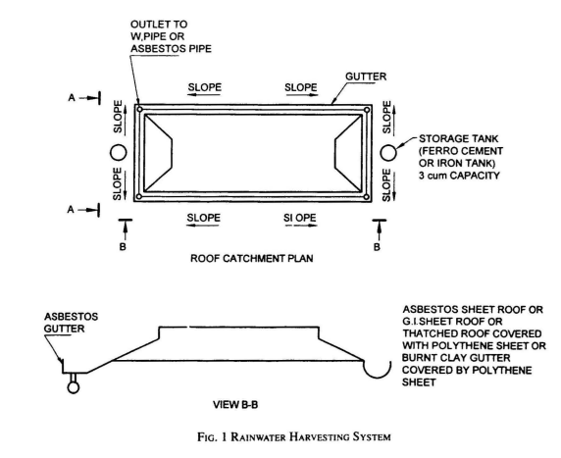
General Design Features

1) STORAGE OF WATER IN A STORAGE TANK FOR DIRECT USE:
Following aspects are covered:
- Design of System Components (Roof, Guttering and First-Flush Device, Tank (Manhole, Overflow pipe & Drain pipe))
- Site Assessment (Availability of suitable roof catchment, Foundation Characteristics, Estimated runoff to be captured, Availability of construction material)
- Estimating the Size of the Required System
- General Design Features
- Management and Maintenance
Annual Rainfall (Delhi)- 600mm (600 l/ sqm)
Roof area - 100 sqm
Harvesting efficiency- 80%
Volume of water harvested = 600 x 100 x 0.8 = 48,000 litres
Min. water requirement (WHO Guidelines) = 20 litres per capita per day (basic hygiene & food needs)
Avg urban consumption = 135 lpcd (45 lpcd flushing requirements)
(source: IS 1172: 1993 Code of Basic Requirements for water supply, drainage and sanitation)
Volume of the tank can be calculated by the formula:
V = t x n x q
where
V = volume of tank, in litres;
t = length of the dry season (days);
n = number of people using the tank; and
q = consumption in litres per capita per day.
If, for example, 20 lpd (q) is agreed upon and a dry period of 100 days (t) is normally not exceeded, a storage volume of 10 m3 would be required for a family of 5 members (n).
V =100 (t) x 5 (n) x 20 (q) =10 000 litre or 10 m3
2) RECHARGE OF HARVESTED RAINWATER IN AQUIFERS
- Design of Efficient Artificial Recharge Structures
- Types of Recharge Structures
a) Recharge pits ;
b) Recharge trenches;
c) Recharge through dry or operational dug wells ;
d) Recharge through abandoned/existing tubewells; and
e) Recharge wells
- Filters
- Maintenance of Recharge Structures
Requirements of the Standard (which can be verified)
Design of System components
- Roof
- Guttering and First-Flush Device
- Tank
- Site assessment
- Estimating the Size of the Required System
- General Design Features
- Management and Maintenance
- Recharge of harvested rainwater in Aquifers
Check List for Compliance to IS 15797
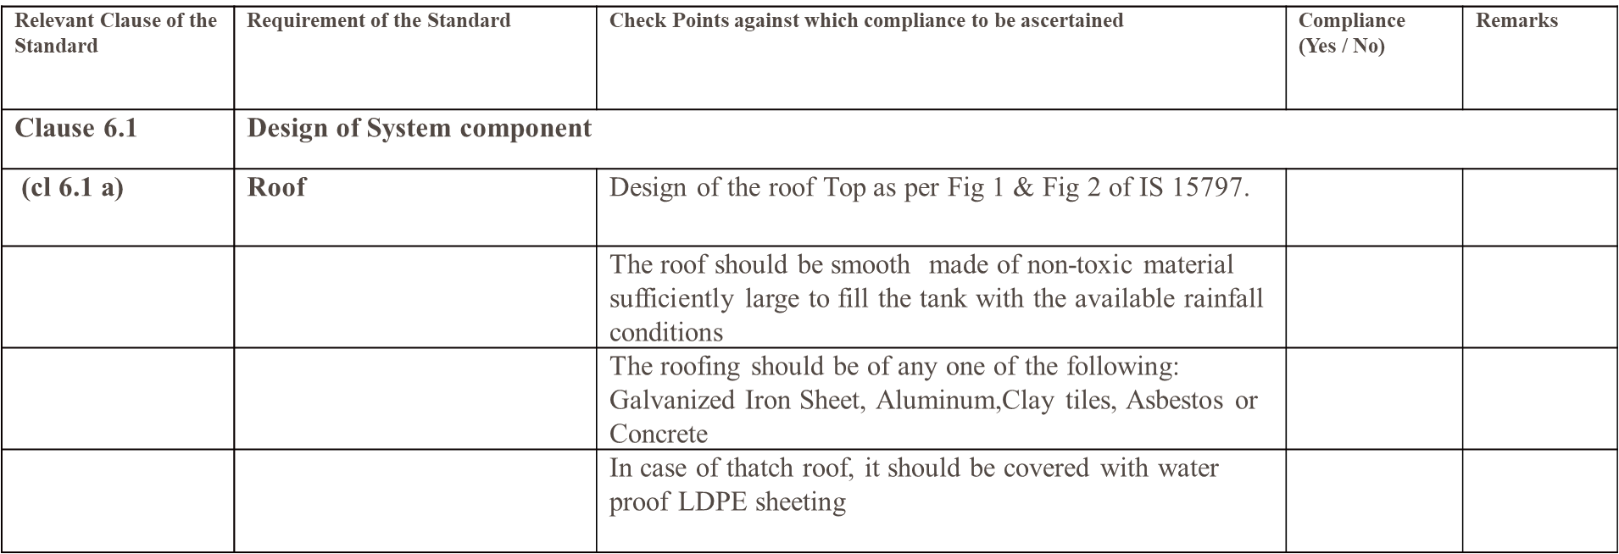

Techniques and Structures for Surface Water Management
IS 14961: 2024 – Surface Water Management in Hilly Areas (Including Rainwater Harvesting) — Guidelines
Scope:
This standard provides guidelines for surface water management in hilly areas, with a focus on sustainable practices and the integration of rainwater harvesting techniques.
Types of Water Conservation Structures addressed
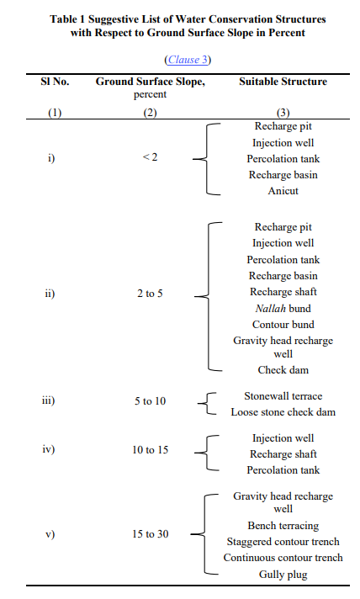
Recharge Pits
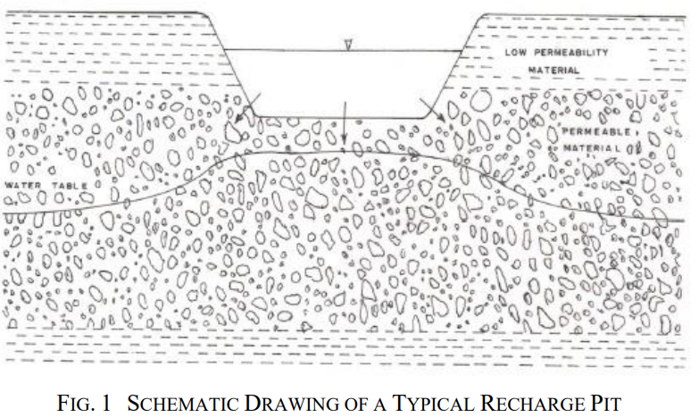
Recharge pits are closed well like structure, which is covered by filling the stones, after digging the pit. It allows the rainwater to recharge the groundwater. The pit, if aimed for recharging the bore well, must be constructed near the bore well, as close as possible.
The site is well suited if:
- It has a sufficiently clean and large catchment area;
- The location permits fast infiltration and percolation of water; and
- In a more ideal situation, it is in the valley of the surface layout.
Injection Wells
Injection wells are structures similar to bore wells or tube wells and are constructed for augmenting the groundwater storage in deeper aquifers through supply of water either under gravity or under pressure. Types:
Gravel-packed injection wells in alluvial areas.
Fracture-based recharge wells in hard rock areas.
Design Considerations:
Sealed upper sections to prevent leakage.
Suitable for coastal areas to prevent seawater ingress.
Limitations:
Effectiveness depends on aquifer properties.
Percolation Tanks
Artificially created small surface water body submerging a highly permeable land so that surface runoff is made to percolate and recharge the ground water storage.
Key Features:
  - Typically 0.1–0.5 million cubic meters in capacity.
  - Best suited for fractured, weathered rock terrain.
Important aspects to consider:
  - The aquifer to be recharged should have sufficient thickness (about 3 m) of permeable vadose zone to accommodate recharge.
  - The recharge area downstream should have sufficient number of wells and cultivable land to benefit from the augmented ground water.
  - The size of percolation tank should be governed by percolation capacity of strata in the tank bed; and
  - To minimize the silting at the bottom of the tank, soils in the catchment area should preferably be of light sandy type.
Uses:
  - Recharge groundwater in agricultural zones.
  - Minimize evaporation losses.
Recharge Basins
- Temporarily store runoff but release at least a portion of that runoff by infiltrating the water into the ground.
- The recharge volume is stored and allowed to infiltrate into the underlying soils over a period of time following a storm event. The storage volume above this level may be released by an outlet structure designed to bypass all excess flows.
Design Aspects:
  - Constructed with permeable soils to prevent flooding.
  - Include outlets for excess water.
Applications:
  - Commonly used in areas prone to high runoff.
Anicuts
Small dam-like structures built across rivers to store water for supplemental uses.
Purpose:
Irrigation, groundwater recharge, and wildlife support.
Benefits:
Increase water residence time and reduce downstream erosion.
Recharge Shafts
Vertical shafts dug into low-permeability strata to augment deeper aquifers.
Construction:
Backfilled with coarse materials like gravel and boulders.
Designed to intercept more permeable layers.
Cost-effectiveness:
Suitable for areas with deep water tables.
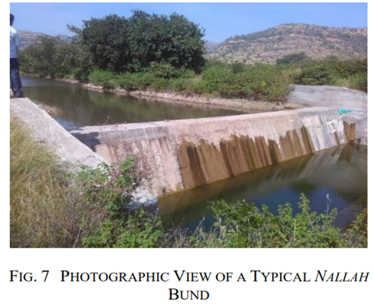
Nallah Bunds and Contour Bunds
Nallah Bunds: Bunds constructed across streams to hold water and prevent erosion.
Contour Bunds: Linear embankments on slopes to break the slope length and enhance soil moisture.
Applications:
Suitable for arid and semi-arid regions and Minimize water runoff and improve soil conservation.
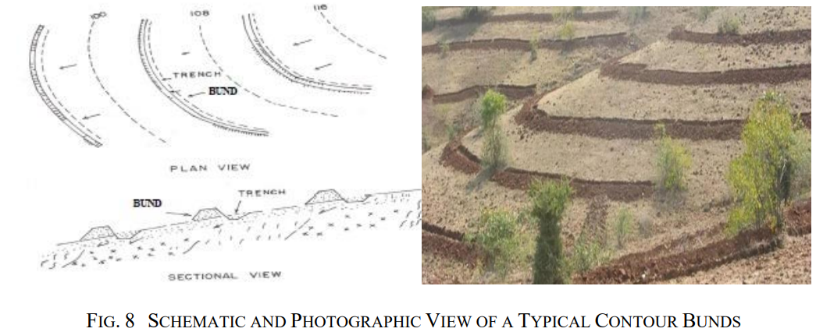
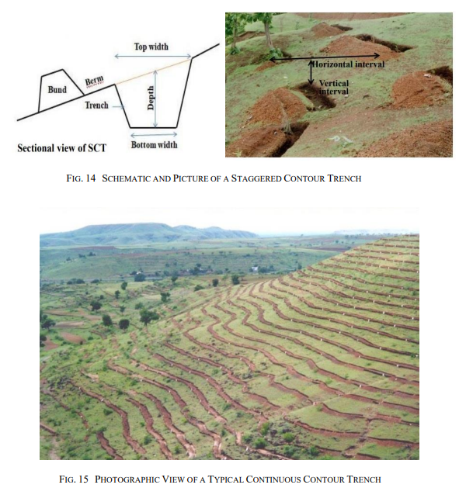
Stonewall and Bench Terracing
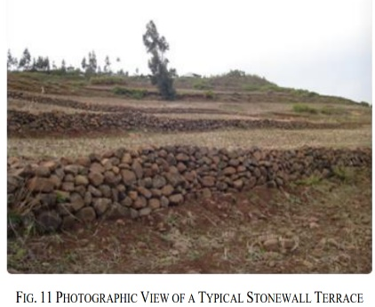
- Stonewall Terrace: Protects slopes with stone structures to conserve soil moisture.
- Bench Terracing: Creates level platforms on slopes for agriculture.
- Purpose:
  - Control erosion.
  - Enable cultivation on steep terrain.
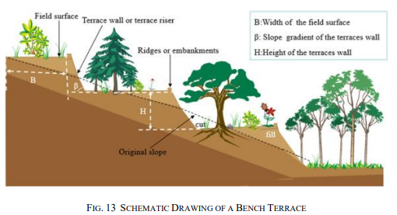
Loose Stone Check Dams and Gully Plugs
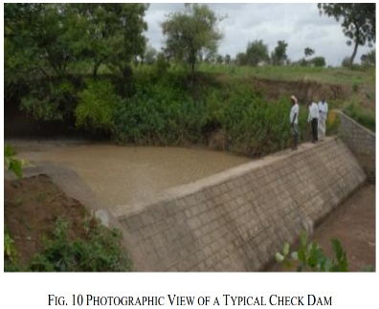
- Loose Stone Check Dams: Small barriers across gullies made of stones to slow water flow.
- Gully Plugs: Temporary dams to conserve soil and water in hilly terrain.
- Benefits:
  - Reduce erosion.
  - Enhance water retention in soil.
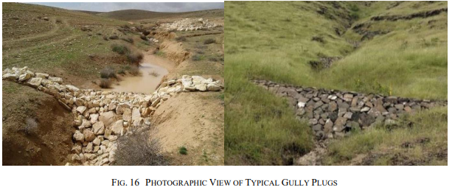
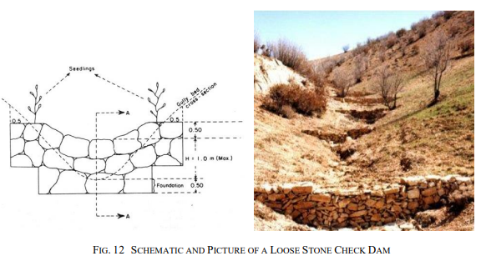

Roof Top Rainwater Harvesting Systems
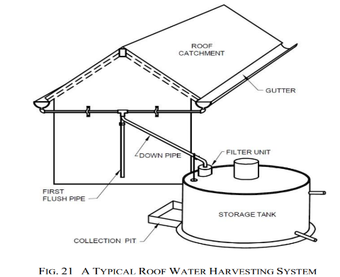
Rainwater from rooftops is collected and stored for domestic or agricultural use.
Components:
Catchment: Roof surface for rain collection.
Gutters and Downpipes: Transport water to storage tanks.
Filters: Remove debris and improve water quality.
Storage Tanks: Overground or underground structures for holding harvested water.
Maintenance:
Regular cleaning of filters and tanks to prevent contamination.
IS 14961: 2024 – Surface Water Management in Hilly Areas (Including Rainwater Harvesting) — Guidelines
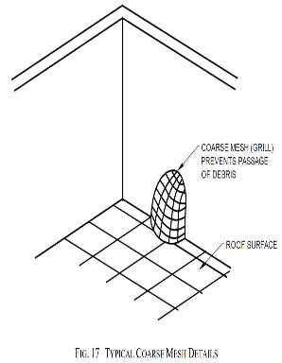
5.2.1 Catchment
The catchment of a roof top water harvesting system is the roof surface which directly receives the rainfall and provides water to the system. The style, construction and material of the roof determine its suitability as a catchment.
5.2.2 Coarse Mesh
It is provided at the roof to prevent the passage of debris to storage tank (Fig. 17). The approximate size of course mesh is 850 microns (20 mesh). The minimum size of mesh should be 100 microns for proper filtration of water.
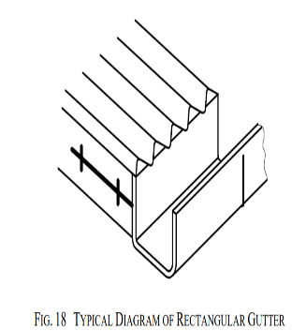
5.2.3 Gutters
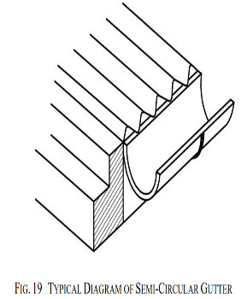
These are channels all around the edge of a sloping roof to collect and transport rainwater to the storage tank. Gutters can be a semi-circular or rectangular gutter (Fig. 18 and Fig. 19). They are provided with an end cap.

5.2.4 Down Pipes (Drain Pipes)
- Pipe that carries the rainwater from the gutters to the storage tank.
- It is joined with the gutters at one end, whereas the other end is connected to the filter unit of the storage tank.
5.2.6 Filtration Unit
- To keep water clean, prevent clogging and sediment buildup, basic filtration is needed.
- The type and number of filtering components on a system depend on the amount of roof debris.
- 5.2.7 Storage Tank
- These are provided to store the harvested water.
- The typical maximum size for a domestic system is 20 or 30 cubic metres.
- The size of the tank depends upon factors like daily demand, duration of dry spell, catchment area and rainfall.
- It will also depend upon a number of technical and economic considerations such as space availability, options available locally, local traditions for water storage, cost of purchasing new tank, cost of materials, labour for construction, materials and skills available locally, ground conditions and use of rainwater harvesting.
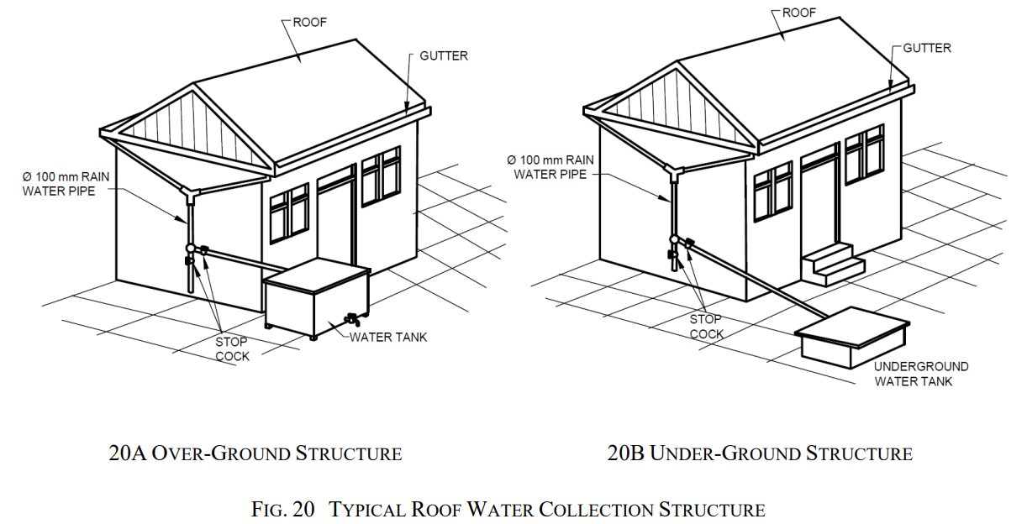
5.2.5 First Flush
Incorporated to avoid contaminating storable/rechargeable water by the probable contaminants of the atmosphere and the catchment roof so that it does not enter the storage tank.
Design Considerations for Rainwater Harvesting and Surface Water Management
Designing a rainwater harvesting system or surface water management structure requires careful consideration of multiple factors to ensure efficiency, sustainability, and long-term utility.
Catchment Suitability
The type and condition of the catchment area (usually a roof or designated surface) significantly impact the efficiency of the system.
Material Selection:
Ideal materials: Corrugated iron sheets, tiles, asbestos sheets, or concrete.
Avoid thatched roofs as they shed material and may contaminate water.
Painted roofs should use non-toxic paints to avoid chemical contamination.
Slope and Shape:
Gentle slopes (10°–30°) allow smooth water flow to collection points.
Steeper slopes (>30°) may cause overflow and water loss.
Maintenance:
Regular cleaning of the catchment area to prevent debris accumulation.
Avoid areas where birds nest to minimize contamination.
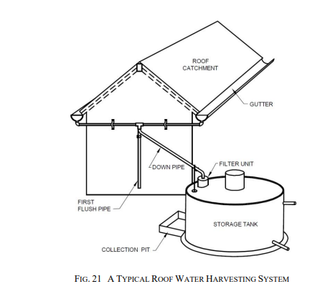
Estimating Quantity of Harvestable Water
Effective design involves calculating the potential volume of rainwater that can be harvested.
Key Formulas:
Rainwater Endowment (m³) = Catchment Area (m²)× Annual Rainfall (m)
Harvestable Water Potential (m³) = Rainwater Endowment× Runoff Coefficient (0.7 to 0.9)
Effectively Harvested Water (m³) = 0.8× Harvestable Water Potential
Runoff Coefficient: Smooth and non-porous materials have higher coefficients (e.g., metal or tiles). Porous or uneven surfaces, such as thatched roofs, have lower coefficients.
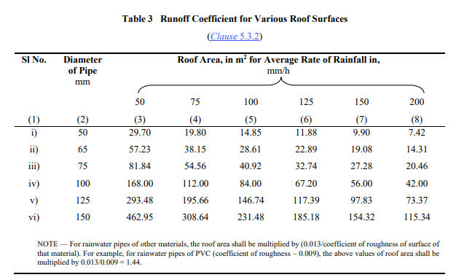
Storage Design
Storage is a critical component, requiring careful planning based on the anticipated volume and usage.
Capacity Considerations:
Calculate based on catchment area, rainfall, daily consumption, and dry periods.
Example formula for demand-based sizing:
S=C×n×D
where
S is storage capacity,
C is per capita daily consumption,
n is the number of people, and
D is the longest dry period (days).
Storage Types:
Above-ground tanks: Easier inspection and maintenance but require more space.
Underground cisterns: Space-efficient but harder to inspect and clean.
Gutters and Downpipes
Efficient water conveyance systems ensure minimal loss and contamination.
Gutter Design:
Material: Galvanized iron, PVC, or bamboo.
Shape: Semi-circular or rectangular for optimal water flow.
Slope: A recommended slope of 6 mm per 3,000 mm ensures effective drainage.
Size: Over-design gutters by 10–15% to handle peak rainfall intensities.
Downpipes:
Typically PVC or galvanized iron pipes.
Ensure proper joining with gutters to avoid leaks.
Sized based on the maximum expected rainfall intensity and roof area.
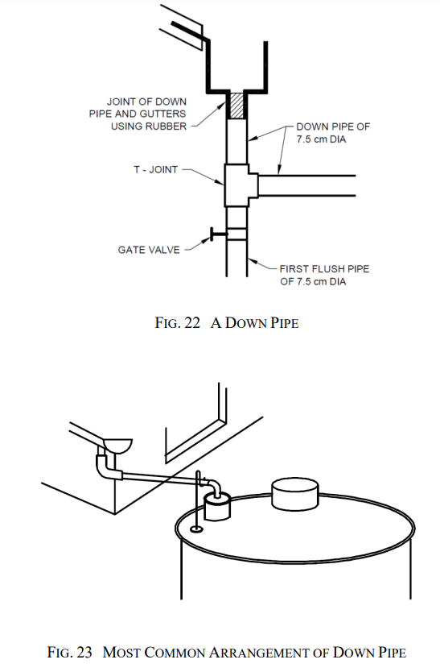
Filtration Units
Filtration is critical to ensure harvested water is clean and usable.
Types of Filters:
  - Sand-Gravel Filters: Effective for sediment removal, constructed with layers separated by wire mesh.
  - Charcoal Filters: Adsorb pollutants and improve water quality.
  - Sponge Filters: Suitable for residential setups, using a sponge layer for debris filtration.
  - Piped Filtration Units: Pressure-based systems used in large-scale setups.
Placement:
Filters should be located immediately before the storage tank or recharge pit.
Regular cleaning of filters is essential to maintain efficiency.
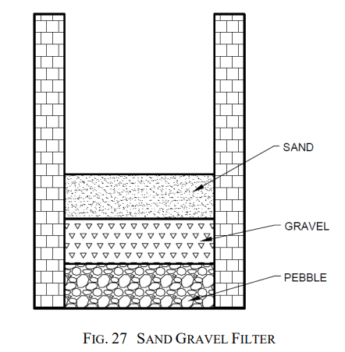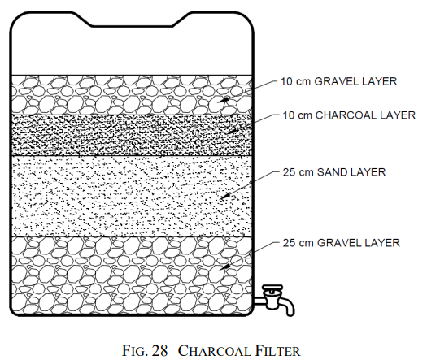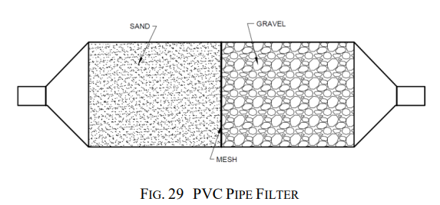

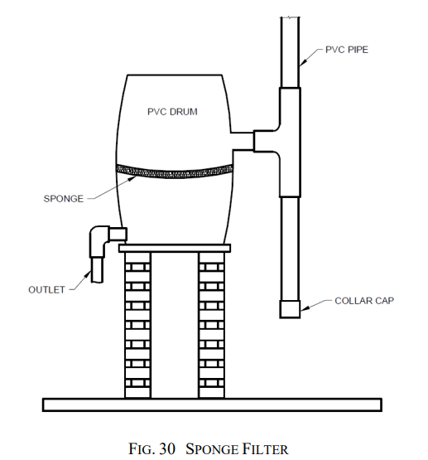
First Flush Mechanism
To prevent initial contaminants from entering the storage system, a first flush mechanism is crucial.
Methods:
Manual diversion of initial rainwater.
Automatic systems using tipping gutters, floating ball devices, or vertical diversion pipes.
Design Tip:
Include this mechanism at each downpipe to optimize efficiency.
IS 14961: 2024 – Surface Water Management in Hilly Areas (Including Rainwater Harvesting) — Guidelines
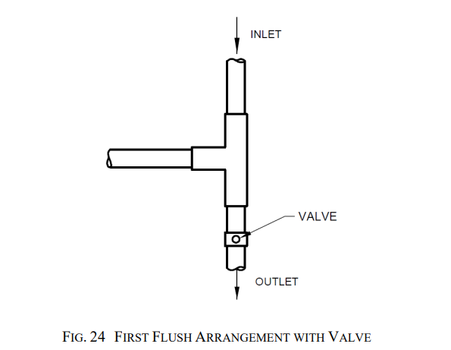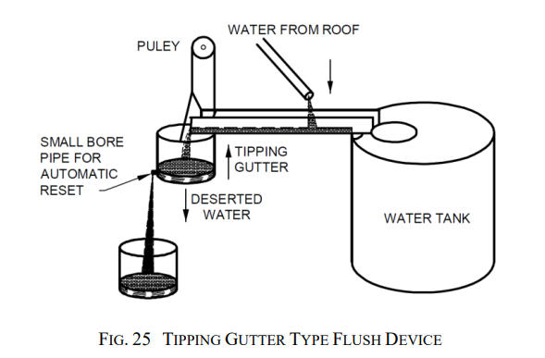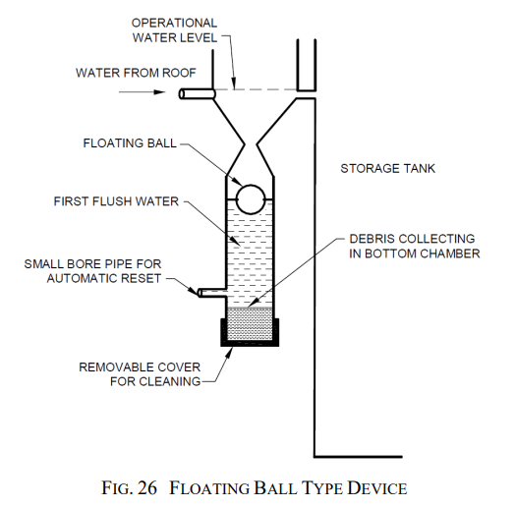

Storage tanks

Storage tanks: Specifications

Structural Stability
Ensure the stability of all components to avoid failures.
Tank Placement:
Above-ground tanks should be on level, stable platforms to avoid tilting.
Underground tanks must be waterproof and designed to withstand soil pressure.
Reinforcement:
Use high-grade materials such as reinforced cement concrete (RCC) for durability.
IS 14961: 2024 – Typical Roofing Material
- Galvanized steel strips and sheets as per IS 277;
- Corrugated and semi — Corrugated asbestos cement sheets as per IS 459;
- Corrugated aluminium sheet as per IS 1254;
- Asbestos cement flat sheets as per IS 2096;
- Hollow clay tiles as per [see IS 3951 (Part 1) and (Part 2)];
- Roofing slate tiles as per IS 6250;
- Corrugated coir wood wool cement roofing sheets as per IS 10388;
- Corrugated bitumen roofing sheets as per IS 12583;
- Silica-asbestos-cement flat sheets as per IS 13000;
- Shallow corrugated asbestos cement sheets as per IS 13008;
- Clay roofing country tiles, half round and flat tiles as per IS 13317;
- Continuously pre-painted galvanized steel sheets and strips as per IS 14246;
- Fibre cement flat sheets as per IS 14862; and
- Fibre reinforced cement sheets as per IS 14871.
Material Selection
Materials must be durable, cost-effective, and locally available.
Roofing Materials:
Corrugated sheets, tiles, or concrete are preferred.
Avoid materials that release harmful substances.
Gutter and Pipe Materials:
Non-corrosive materials such as PVC, HDPE, or GI are ideal.
Tank Materials:
For large capacities: RCC or ferrocement.
For small capacities: Plastic or steel.
5.5 Recharge Structures
- For selecting the site and type of recharge structures knowledge of hydrological and geological features of the area (aquifers) is required.
- The aquifers best suited for the purpose are those which absorb large quantity of water but do not release the same quickly.
- The various recharge structures are:
  - Abandoned dug well;
  - Hand pump/bore well;
  - Recharge pit;
  - Recharge trench;
  - Gravity head recharge tube well; and
  - Recharge shaft.
5.6 Operation and Maintenance
Frequency:
Regularly clean gutters, filters, and tanks before and during the rainy season.
Inspection:
Periodically check for leaks, rust, and blockages in gutters and pipes.
Disinfection:
Use chlorine or potassium permanganate for tank cleaning. The quantity of bleaching powder to be added for different water depths in the storage tank is shown in Table 5
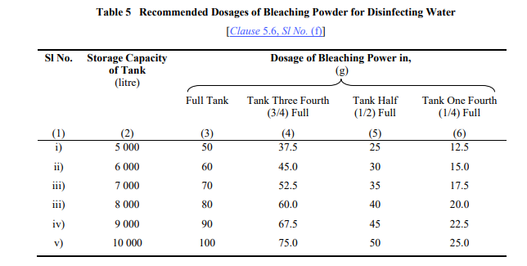
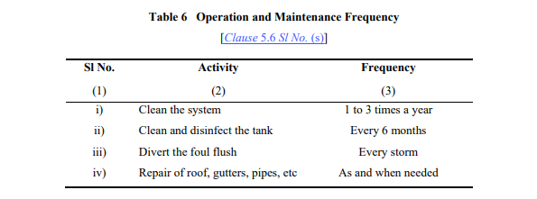
Environmental and Safety Considerations
Site Location:
Avoid locating systems near septic tanks or other contamination sources.
Ensure the area is clean and away from cattle sheds.
Overflow Management:
Install an overflow pipe connected to non-flooding areas or recharge systems.
Child Safety:
Cover storage tanks and gutters to prevent accidents.
5.7.1 Do's for Rainwater Harvesting
5.7.2 Don’ts for Rainwater Harvesting

National Building Code – RWH
Part 2 Administration
Section 3 Permit & Inspection
12.2.6 Service Plan of buildings to include details of rainwater system
Part 9 Plumbing Services
Covers details of RWH such as
- Groundwater recharge
- Rooftop rainwater harvesting
Regulatory Authority

Steps taken by the Govt. to make rain water harvesting mandatory

Regions which have made rainwater harvesting mandatory
- Andhra Pradesh, Gujarat, Haryana, Himachal Pradesh, Kerala, Madhya Pradesh, Maharashtra, Tamil Nadu, Ranchi Regional Development Authority, Bombay Municipal Corporation and Pimpri – Chinchwad Municipal Corporation, Municipal Corporation of Ludhiana, Jalandhar, Jaipur Municipal Corporation, Mussorie Dehradun Development Authority, and Union Territories of Delhi, Daman & Diu and Puducherry
- These have made necessary provision in their building bye-laws to make installation of rain water harvesting system mandatory.
Rainwater Harvesting Provisions in Delhi
Regulations from Ministry of Urban Development
- Mandatory for all NEW buildings or plots of 100 sqm
Regulations from Delhi Jal Board
- Water permission to be granted to new house, only when a certificate given by the concerned Zonal Engineer, DJB that applicant has provided the requisite systems in the building plans sanctioned by MCD/DDA
- Failing to install RWH structure invites penalty of 1.5 times the water bill for 500 sq. m and above
- Where water table is reasonably high (shallower than 5m ), (East Delhi, Okhla, Civil Lines, etc), RWH is voluntary
- Rebate of 10% of water bill for properties above 100 sq m for installing functional RWH structure
- Rebate of 10% of water bill for each member of society, if the residential society has installed a functional RWH structure
Best Practices for Rainwater Harvesting Systems
- Size Systems Appropriately:
  - Design the system to match the local rainfall pattern, roof area, and water consumption needs. IS 15797: 2008 provides detailed guidelines on calculating water collection potential based on roof area and expected rainfall.
- Quality Filters and First Flush Mechanism:
  - Install filters and a first flush diversion system to reduce contamination. IS 14961: 2024 emphasizes the importance of high-quality filtration systems for the safe use of harvested rainwater.
- Regular Maintenance:
  - Clean gutters, pipes, filters, and tanks periodically to avoid blockages and contamination. Check for leaks and ensure that the first flush system is working efficiently.

- Proper Storage:
  - Use food-grade, UV-resistant tanks for water storage to prevent algae growth and ensure water quality.
- Groundwater Recharge:
  - Encourage the use of recharge wells and percolation pits to enhance groundwater replenishment, as outlined in IS 14961: 2024

CHAPTER 5

Optimizing Efficiency: Asset Management in Wastewater Supply Networks

STANDARD REFERRED:
IS 17395 (Part 3) : 2020 ISO 24516-3 : 2017 - Guidelines for the Management of Assets of Water Supply and Wastewater Systems Part 3 Wastewater Collection Networks

Prepared by – Environment and Ecology Department

Introduction to Waste Water Asset Management
Wastewater utilities undertake programmes of activities to manage the assets to ensure they continue to meet the needs of the community and best utilisation of resources. The activities can be part of a formal management system, the result of specific legislative requirements, or simply the result of due diligence by the service operators and managers.
Management of assets is an activity all organizations undertake in some manner and to some degree. It focuses mainly on the details of managing the physical assets at the operational level rather than the organizational (corporate management, structural or process) level
Physical Infrastructure/or Assets represents a major societal investment in essential services contributing to public health and the protection of the environment.
In many countries, these assets have been identified as critical infrastructure, and programmes are in place to ensure their protection or their sustainability
In many other countries, there is a recognized sustainability problem, sometimes referred to as the infrastructure gap, which recognizes that for various reasons, the infrastructure has not been maintained over the years on a truly sustainable basis, i.e. funding of rehabilitation programmes has been postponed, with a focus instead on short-term repairs or an allowed decrease in the level of service provided.
Talking about waste water(WW) infra, the condition of wastewater infrastructure greatly influences wastewater service aspects such as quantity, quality, safety, reliability, environmental impact, degree of treatment and economic efficiency.
In India, Urban Waste-Water Management is performed in two ways:
- On-site systems and
- Off-site systems.
An onsite system retains wastewater in the vicinity of the toilet in a pit or tank, and the produced sludge is removed periodically to the faecal sludge treatment system.
While an off-site system removes wastewater from the vicinity of the toilet for disposal elsewhere. An off-site system comprises of a sewerage network to transport sewage to a sewage treatment plant (STP)
This flowchart depicts the process of domestic sewage management, starting with storage, transport, and treatment. Domestic sewage is managed through two systems: off-site and on-site. In the off-site system, sewage is directed to a sewer network for transport. In the on-site system, sewage is stored in septic tanks, and sludge is periodically transported.
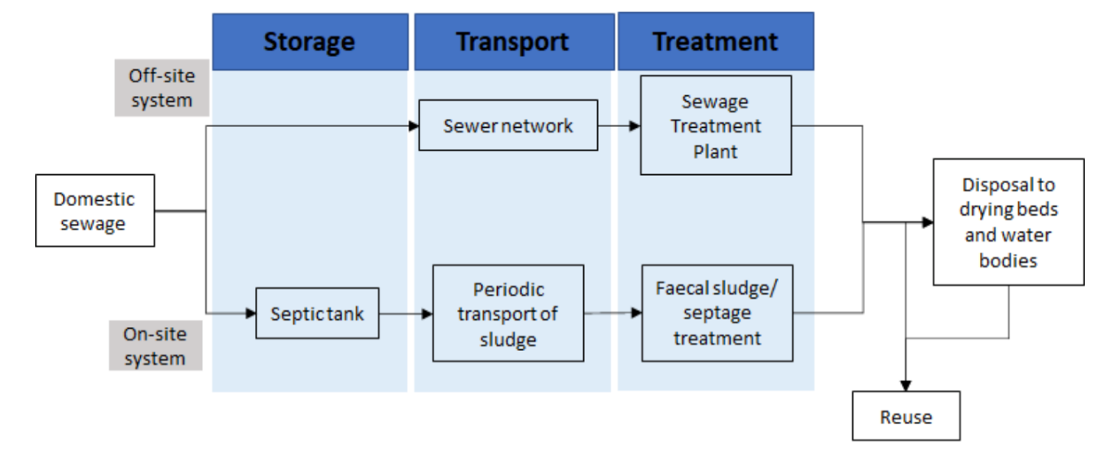
As we all know, in the treatment phase, the off-site sewage is processed at a Sewage Treatment Plant (STP), while sludge from on-site systems undergoes faecal sludge or septage treatment. The treated waste is then either disposed of in drying beds and water bodies or reused, completing the cycle.
A very usual challenge faced by the Authorities is - Sewer and storm water systems in cities worldwide suffer from ageing and inappropriate wastewater networks. This challenge shall be met by systematic upgrading and preventive maintenance.
How do we that? So, in order to counter this challenge, It is necessary to analyse the current performance of the wastewater networks, to determine the system bottlenecks and resolve the issues.
To start with, it becomes important to identify what are these assets?
An asset in a management system, is an item of value that an organization or company benefits from. Assets can be tangible, like equipment, machinery, or vehicles, or intangible, like software licenses or intellectual property. For Waste water Management systems, tangible assets are underground pipes, retention and detention tanks, treatment plants, intangible assets are: software, databases.
Waste Water assets collectively form physical infrastructure of the wastewater utilities and it results from-
a. accumulated capital investments and
b. operational expenditures on maintenance and rehabilitation over many years.
The standard IS 17395 (Part 3) : 2020 ISO 24516-3 : 2017 Guidelines for the Management of Assets of Water Supply and Wastewater Systems Part 3 Wastewater Collection Networks focuses on the details of managing the physical assets at the operational level. These management activities can be at the strategic, tactical or operational level.
The standard can serve as a supporting document for utilities operating an asset management system of Waste water.
What does IS 17395 (Part 3) : 2020, ISO 24516-3 : 2017 cover?
The Indian Standard IS 17395 (Part 3) : 2020, ISO 24516-3 : 2017 Guidelines for the Management of Assets of Water Supply and Wastewater Systems’, specifies guidelines for technical aspects, tools and good practices for the management of assets of wastewater networks to maintain value from existing assets. However, this standard does not apply to the management of assets of treatment plants, which are also physically part of the wastewater system and can influence the management of network assets.
This document is applicable to all types and sizes of organizations and/or utilities operating wastewater networks, and all different roles/functions for the management of assets within a utility (e.g. asset owner/responsible body, asset manager/operator, service provider/operator).
Depending on the size and structure of an organization, the utility can decide to what extent it applies the guidance in this document, but in any case, the philosophy of this document remains applicable to small and medium utilities.
Objective of Management of Assets this Management system
The objective includes:
- Protection of Public Health and Safety: Ensuring wastewater systems do not pose health risks.
- Meeting Users’ Needs: Addressing reasonable demands and expectations of users.
- Occupational Health and Safety: Safeguarding the well-being of workers involved in wastewater management.
- Sustainability of the Utility: Promoting the long-term viability of wastewater utilities.
- Service Continuity: Providing reliable services during both normal and emergency situations.
- Environmental Protection: Preventing adverse impacts on the environment.
- Sustainable Community Development: Supporting the long-term growth and sustainability of the community.

Wastewater utilities are encouraged to manage their facilities systematically and efficiently by establishing clear objectives. These objectives should be based on assessments and forecasts of the condition of their often complex and extensive infrastructure. Effective asset management ensures compliance with a sustainable level of service, which is crucial for the utility's economic performance.
The "level of service" should be:
- Clearly defined and communicated,
- Linked to risk management,
- Customized to the specific wastewater utility.
Ultimately, the objectives for asset management shall align with the functional requirements of wastewater networks, ensuring sustainable operations and community well-being.
What does a functional requirement mean?
These requirements encompass the impact of WW discharges on the receiving surface water bodies and wastewater facilities. In order to facilitate the attainment of objectives, functional requirements should be established. The wastewater networks, which are a component of the wastewater system, are subject to functional requirements.
In order to prevent the system from failing to meet the target due to additions or modifications, functional requirements should be assessed in the context of the entire system.
When establishing functional requirements, it is important to consider sustainable development and whole-life costs, including indirect costs such as traffic congestion and military aid provided to civil authorities. This will ensure that wastewater networks convey and discharge their contents without causing an unacceptable environmental nuisance, risk to public health, or risk to personnel working in the network.
Each functional requirement may be associated with multiple objectives.
Understanding the Waste Water Utility
It depicts, what could be a functional requirement and How it can be associated with the objective.
So, The count of X gives guidance on the importance of the requirement in achieving the objectives. More the X’s more the importance(referred ahead as ‘most likely manner’ for most important achievement).
Table: Relationship between objectives and functional requirements (Informative)
Functional requirements | Objectives
Functional requirements | Protection of public health and safety | Occupational health and safety | Protection  of the environment | Meeting users’ reasonable needs and expectations | Promoting the sustainability of the waste-water utility | Providing services in usual and emergency situations | Promoting sustainable development of the community
Protection from flooding | XXX | XX | XXX | XXX | X | XXX | XXX
Maintainability | XX | XXX | XX | XX | XX | XX | XX
Surface water bodies | XXX | X | XXX | XX | XX | XX | XX
Protection of groundwater | XXX | - | XXX | XXX | XX | X | XXX
Prevention of odours and toxic, explosive and corrosive gases | XXX | XXX | XXX | XXX | XX | XXX | XXX
Prevention of Noise and Vibration | XX | XXX | X | XXX | X | XX | X
Sustainable use of products and material | _ | _ | XX | XX | XXX | X | XXX
Sustainable use of energy | _ | _ | XX | XX | XXX | X | XXX
Structural integrity and design life | XXX | XXX | XXX | XXX | XXX | XXX | XXX
Maintaining the flow | XXX | _ | XXX | XXX | XX | XXX | X
Water Tightness | XXX | X | XXX | XX | XXX | X | XX
Not endangering adjacent structures/utility | XXX | XXX | X | XX | XXX | XX | XX
Inputs Quality | XX | XXX | XXX | XXX | XX | XXX | XX
NOTE: The number of X gives guidance on the importance of the requirement in achieving the objectives.

Keeping a note of the functional requirement – for example, ‘Protection from Flooding’, this requirement will help achieve the objective of
1. Protection of Public Health and Safety
2. Protection of the environment
3. Help the utilities to meet user’s reasonable needs and expectations,
4. Providing services in usual and emergency situations and promoting sustainable development of a community, in the most likely manner.

And achieve the objective of occupational health and safety in a likely manner.
Along with promoting the sustainability of waste water utility comparatively in a little less likely manner to Occupational health and safety.
Performance Requirement
To evaluate the performance of the network and to allow the development of design criteria, measurable performance requirements should be determined from each functional requirement.
For each functional requirement, there can be legal requirements, public expectations and financial constraints which will influence the performance requirements. Public expectations should be reflected in the levels of service set by the utility to provide to its users. For each aspect of performance, different levels can be required, for example:
a) trigger levels, which justify early upgrading action according to priority;
b) target levels to aim for in upgrading, which should be equal to the requirements for new construction, but which sometimes can only be achievable or necessary in the longer term.
Performance requirements should be reviewed periodically and updated, if necessary. The performance requirements for the network should be updated after major extension, maintenance or rehabilitation.
Performance indicators are an essential tool in understanding a utility’s infrastructure conditions and needs and, in parallel, enable indicator-supported infrastructure planning and decision making.
Properly implemented indicators provide information on the condition of the assets and the level of their contribution to the achievement of the utility’s objectives.
The Whole objective of this is that the networks should be maintained in a correct operating condition in order to reduce the life cycle cost. This should encompass the following:
- Optimized maintenance planning;
- inspection;
- use of suitable construction methods and durable materials;
- co-operation with other organizations;
- energy management; etc

For instance, in order to renovate facilities, the priority of a project should be established within the budgetary framework, with the objective of reducing the life cycle cost of each facility.

Investigation
The hierarchy of the Integrated Asset Management System is as follows:

Investigation is the initial phase in the integrated management of wastewater network assets, aiming to assess the condition and performance of the `networks and their components.
Let's discuss the investigation phase with a specific example of drainage system of Delhi City.
The purpose of this investigation can be broken down into three key points:
1. The primary aim of our investigation is to identify any assets within the wastewater network that are damaged, defective, or incorrectly sized. For example, identifying the pipes that were incorrectly sized, leading to frequent blockages and overflows.
2. We have to carefully record the findings to support current and future assessments. For instance, in Delhi, carefully recording the exact locations of improperly sealed manholes and signs of groundwater contamination may lead us to track repairs and plan future maintenance effectively.
3. We need to choose methods that fit our network's needs. This ensures our investigation is detailed and accurate, meeting our asset management goals. For example, in Delhi, if we use advanced CCTV inspection technologies to investigate the sewer lines. This method provided high-detail, real-time footage of the internal condition of the pipes. By analyzing this detailed footage, we can accurately identify cracks and potential blockages, leading to informed decisions on necessary repairs and maintenance."
What to Investigate?
What components must we investigate as part of our assessment of wastewater networks? Let's break it down:
If we take the various elements within the wastewater network itself, This includes drains, stormwater systems, sanitary sewers, and combined sewers. We also need to look at manholes, inspection chambers, control facilities, outfalls, gravel and sand traps, sedimentation tanks, light liquid/grease separators, and other access points.
Also, we must consider data from assets that interact with the network but are not directly part of it. This includes pumping stations, detention and retention tanks, and treatment plants.
Investigation Types
For different components, different type of investigation may be required. We have four main types of investigations that are crucial for assessing wastewater networks,
1. Hydraulic investigations : This basically refers to flow conditions that can help to identify critical areas needing capacity upgrades. For example, in a scenario where heavy monsoon rains cause significant infiltration and overflow through gaps in manhole tops, it becomes essential to analyse precipitation patterns, resulting flows, and groundwater levels. By identifying wrong connections and understanding the system's response to different weather conditions, we can pinpoint areas that require capacity upgrades to prevent blockages and ensure smooth operation during peak flows.
2. Environmental Investigation: Monitoring wastewater discharge into a local river and addressing odour complaints can help identify and mitigate environmental concerns. For instance, conducting regular water quality tests and installing odour control systems in affected areas can ensure compliance with environmental standard.
3. Structural Investigation: Using advanced inspection technologies to inspect sewer lines and identify structural issues such as cracks or blockages can prevent overflow problems. As an example, imagine a scenario where CCTV inspections detect a significant crack in a major sewer line under a busy street in Delhi. By detecting this issue early, we can schedule targeted repairs during off-peak hours to minimize disruption.
4. Operational Investigation: Optimizing pump schedules based on real-time data can improve system reliability and reduce energy consumption. In a busy city, real-time data analysis showed that peak wastewater flow occurred in the early morning and late evening. By adjusting pump operations to ramp up during these peak times and scale back during low-demand periods, we can effectively manage the flow, prevent overloading the system, and reduce the risk of overflows.
Types of Data in Investigation
When investigating a sewage flow system, we need to collect essential data promptly and identify any additional data needed during hydraulic, environmental, structural, and operational investigations. The purpose is to gather accurate data for decision-making. As you can see in the slide prominent data types i.e. Inventory Data, failure Data, Condition Data are collected.
Inventory Data
The table shows which inventory data attributes are mandatory, optional, or not applicable for different sewer system assets (pipeline sections, manholes, drains, and outfalls). In the table there is inventory data type in the column and Types of Assets in the row. You may take 2 minutes to compile the data you feel is important.

Table: Types of Inventory Data
Inventory data attribute, if applicable | Assets
Inventory data attribute, if applicable | Pipeline section | Manhole | Drain | Outfall
Location, (location, address) | X | X | X | X
ID of connected sewer/drain/manhole | X | X | O | O
Catchment area | X | X | X | X
Type of pipeline (sewer, drain) | X | - | O | -
Type of system | X | X | X | X
Type of asset (pipe, screen, valve, siphon, life-detention tank) | X | O | - | -
Combined sewer overflow | X | O | O | X
Material | X | X | X | X
Manufacturer | O | O | O | O
Cross section/shape/dimension | X | X | X | X
Ground level | O | X | O | X
Depth of covering material | O | X | O | X
Sewer invert elevation | - | X | - | X
Gradient | X | - | X | -
Year of installation/decommissioning/rehabilitation | X | X | X | X
Type of rehabilitation | X | X | X | X
Installation/rehabilitation cost | X | X | X | X
Connected main’s ID and manhole’s ID | - | - | X | X
‘X’ should be mandatory; ‘O’ should be optional; ‘-’ is not applicable;

The data that can be gathered from the evaluation are these, though it is not exhaustive and changes as per the need of the utility service;

- Location: The address or exact location (GPS) of each asset (Needed for all assets).
- Connected Sewer/Drain/Manhole ID: The identification number of connected infrastructure (mandatory for pipelines and manhole and optional for others).
- Catchment Area: The area from which wastewater is collected and directed to the system (required for all assets). In our example, the catchment area covers several neighbourhoods in central Delhi.
- Type of Pipeline: Whether it's a sewer or a drain (important for pipelines and optional for drain)
- Asset Type related to the system (e.g., pipes, valves, screens): Required for pipelines and optional for manholes.
- Combined Sewer Overflow Information: Optional for manhole, drains, and outfalls and Mandatory for Pipeline.
- Material: What the asset is made of. (concrete, plastic) and this is necessary for all components.
- Manufacturer: Optional for all assets.
- Dimensions: The shape and size of the asset (Required for all assets)
- Ground Level: The height of the ground surface above the asset (Required for manhole and outfall, Optional for the others)
- Depth of Covering Material: How deep the asset is buried (Required for manhole and outfall, Optional for the others).
- Year of Installation/Rehabilitation: When the asset was installed or last repaired (Required for all).
- Rehabilitation Type and Cost: Details about any repairs or upgrades made and their cost (Required for all).
- Connected Main’s ID and Manhole’s ID: Mandatory for drains and outfalls. Not Applicable for pipeline sections and manhole

Failure Data
The failure data discuss more about the technical information on the failure found in the waste water network. We are going to discuss the different type of data that we need to document. Let’s use the drainage system in Delhi as an example:

- Date of Documentation:This is when we record the failure information. Example: We documented the sewer failure on January 1, 2025.
- Date of Failure Occurrence: This is the actual date when the problem happened. Example: The sewer pipe in Delhi failed on December 28, 2024.
- Location: Where did the problem occur?
Such as the sewer's identification number, coordinates, or address. Example: The failure occurred at sewer pipe ID #12345, located at coordinates 28.6139° N, 77.2090° E, near India gate , Delhi.
- Point of Failure: The exact spot where the problem occurred. Example: The failure point was on the bottom left of the sewer pipe.
- Type of Failure: The nature of the problem, Is it a crack, blockage, or overflow? Example: The sewer pipe suffered a major crack.
- Cause of Failure: The reason behind the problem, such as natural deterioration or damage from construction work. Example: The crack was caused by natural disaster like heavy rain happened in Delhi. In this data will be crucial because this can be used in rehabilitation strategy as well as for future planning.
- Type of Remedy:The method used to fix the problem, such as repair, renovation, or replacement. Example: In the case of sewage pipes What caused the problem? Roots, debris, or structural damage?
Condition Data
Apart from the failure data we also need to know the whole system of wastewater network. Gathering the information involves different methods like inspections and tests and this data helps us decide which parts need fixing first.
Types of Condition Data that we need to collect are-
1. Date of Condition Data Collection: The date when we record the condition of the sewer. Example: We checked the sewer pipe on January 1, 2025.
2. Location of Investigation: Where exactly the investigation takes place. This could be the sewer's ID, coordinates, or address. Example: The sewer pipe is located at coordinates 28.6139° N, 77.2090° E, near Connaught Place, Delhi.
3. Identification and Plausibility Information: Details about the sewer pipe, like what it's made of and its size. Example: The pipe is made of concrete and has a diameter of 600 mm
4. Bedding: The material around the sewer pipe that supports it. Example: The pipe is surrounded by gravel to keep it stable.
5. Sewer Depth: How deep the sewer pipe is buried. Example: The pipe is buried 1 meters below the ground.
6. Overbuilding: Any structures built above the sewer pipe. Example: There's a road built over the pipe.
7. Sewer’s Condition/Failure: The current state of the sewer pipe and any problems it has, like cracks or deformations. Example: The pipe has some cracks and is slightly bent.
8. Internal Deposits: Any buildup inside the sewer pipe, like sediment or debris.
9. Operational Incidents: Any past issues with the sewer, like overflows or backups. Example: There have been overflows during heavy rains.

Context data
Context data is a type of condition data that provides technical information about the local surroundings of wastewater networks. This data plays a significant role in the risk assessment process.
The example of the context data will be explained using the table given. The Rows of the table contains assets of the network and the column contains the attributes of context data.
- Date of Context Data Collection:
Mandatory for all assets.
- Location (Pipeline ID, Coordinates, Address):
Mandatory for all assets.
- Catchment Area:
Mandatory for all assets.
- Type of Soil: The classification of the soil around the pipeline. Here, the soil is sandy loam, which affects stability. pH affects the corrosion of the pipes.
Mandatory for pipeline sections, ancillary structures, and drains.
Optional for manholes and outfalls.
- Soil Assessment: By testing the soil, we can predict the drainage and leaching chances.
Mandatory for manholes and ancillary structures.
Optional for pipeline sections , drains and outfalls.
- Critical Building Area (Adjacent Vulnerable Structures): Identifying adjacent vulnerable structures. For example, a historic building is located 100 meters from our pipeline like in Old Delhi.
Mandatory for all assets.
- Distance to Building Site: The proximity of the pipeline to nearby buildings or construction sites. In our example, the pipeline is 200 meters away from a new residential construction site.
Mandatory for pipeline sections, manholes, and ancillary structures.
Not Applicable for drains and outfalls.
- Distance to Long-Haul Traffic Routes (e.g., Highways, Railways): Proximity to major roads, motorways, or railway lines. Example: Our pipeline runs 500 meters from the New Delhi railway station which is busy.
Mandatory for pipeline sections, manholes, and ancillary structures.
Not Applicable for drains and outfalls.
- Traffic Load: The volume of traffic near the pipeline. If we take an example of daily traffic load of 15,000 vehicles.
Mandatory for pipeline sections.
Optional for manholes, ancillary structures, drains, and outfalls.
- Protection Strip, Working Width: The designated area for safe operations and maintenance. Most like designated protection strip area and working area.
Mandatory for pipeline sections.
Optional for ancillary structures.
Not Applicable for manholes , drains, and outfalls.
- Underground Facilities (e.g., Water Pipes, Cables): Presence of other buried utilities like drinking water pipes or electricity cables. For instance, there is a buried electricity cable running parallel to our pipeline.
Mandatory for pipeline sections, manholes, and ancillary structures.
Optional for drains.
Not Applicable for outfalls.
- Major Adjacent Structures (e.g., Towers, Bridges, Buildings): Significant nearby structures such as high voltage transmission line towers, bridges, or buildings. Example: A high voltage transmission line tower is located 50 meters from our site.
Mandatory for pipeline sections, for ancillary structures and manholes.
Optional for drains
Not Applicable for outfalls.

- Surface Utilization: The current use of the land surface. Example: the area is used for residential housing and commercial activities.
Mandatory for pipeline
Optional for manhole, ancillary structures, drains, and outfalls.

- Earth Movements/Mining Activities: Any geological activities in the area. Example: Historical mining activities or seismic activities were recorded 2 kilometres from the site.
Mandatory for pipeline
Optional for manhole, ancillary structures, drains, and outfalls.
- Topography: The physical features of the landscape. Our area has a flat terrain with slight undulations.
Mandatory for Pipeline
Optional for manhole, ancillary structures, drains, and outfalls.
- Risk Factor (Impact and Likelihood): Assessment of potential risks, including their impact and likelihood. Example: There is a high risk of flooding with a likelihood of 70% due to heavy rains nearby river banks.
Mandatory pipeline, manhole and ancillary structures
Optional for others.
- Criticality Factor (Relative to Risk Criteria): The relative importance of the site concerning risk criteria. Our pipeline has a criticality factor of some “n” number indicating high importance due to its location and potential impact on surrounding infrastructure.
Mandatory pipeline, manhole and ancillary structures
Optional for others.
Assessment Process
After we have completed our investigation of the system, the next step is the assessment process. Let’s use the example of the same Delhi drainage network to understand this better.
Data Analysis and Result: After gathering all the data during the investigation, we carefully analyse it. We look at everything we found and summarize the results. This helps us understand the current state of the drainage system.
Hydraulic Performance: We assess the hydraulic performance by checking how well the system handles water flow, especially during heavy rains. For example, in Delhi, we might find that certain areas struggle to manage the monsoon rains, leading to potential flooding. These areas will need capacity upgrades.
Environmental Impact: We evaluate the environmental impact by examining how the drainage system affects local water bodies and the surrounding environment. For instance, in Delhi, we assess if wastewater discharge is contaminating the Yamuna River and causing odour issues. Addressing these problems helps protect the environment.
Structural Condition: We check the structural condition by looking for any damage or weaknesses in the system. For example, we might find cracks or blockages in sewer pipes in Delhi. Identifying these issues allows us to plan targeted repairs and maintain the network's integrity.
Operational Deficiency: We evaluate the operational performance by reviewing any incidents or failures that occurred, such as blockages or overflows. For example, we might find that certain pumps in Delhi are frequently failing, indicating a need for maintenance or replacement to improve reliability.
Comparison with performance requirements: We compare the Investigation results against set performance requirements. This helps us identify any gaps or areas that need improvement. For example, if certain parts of the Delhi network are not meeting the required flow capacity, we know where to focus our efforts.
Identification of Deficiencies: Finally, we identify the specific deficiencies and associated risks. This allows us to prioritize which areas need immediate action. For example, if we find that a key sewer pipe in Delhi is severely damaged and poses a high risk of failure, we prioritize its repair or replacement because the risk of flooding in a low-lying area of Delhi might be high during monsoon season.
Planning Process
After completing the assessment of our sewer system, the next step is the planning process. Let’s walk through this with an example of the drainage system in Delhi.
1. Result Assessment: First, we look at the results from our assessment. We have identified the areas in the Delhi drainage system that need attention, such as parts that struggle during heavy rains or pipes that are damaged.
2. Developing Integrated Solutions: Next, we develop solutions that address these issues. We make sure these solutions meet performance requirements, like handling water flow efficiently and ensuring safety. For example, we might decide to upgrade certain pipes to handle more water during monsoon rains.
3. Feasibility Assessment: We then assess if these solutions are feasible. We check if they are safe, have minimal social impact, are manageable in terms of maintenance, and fit within our organization's constraints. For instance, upgrading pipes should not disrupt daily life in Delhi too much and should be within our budget.
4. Preparing the Action Plan: Based on the optimal solutions, we prepare a detailed action plan. This plan includes specific goals, timelines, priorities, performance criteria, and other relevant information.
We typically create four types of action plans:
- New Development Plan: This involves building new infrastructure, such as extending the drainage network to new areas in Delhi.
- Operations and Maintenance Plan: This plan focuses on maintaining and operating the existing drainage system efficiently. For example, scheduling regular inspections and cleanings.
- Rehabilitation Plan: This plan addresses repairs and upgrades needed for existing infrastructure. For instance, fixing or replacing damaged pipes in Delhi's drainage network.
- Contingency and Emergency Plan: This plan prepares us for emergencies, like unexpected floods. It outlines steps to quickly respond and manage such situations.
Example: Let’s take the example of a critical sewer pipe in Delhi that frequently overflows during heavy rains. Our action plan might include upgrading this pipe (Rehabilitation Plan), ensuring regular maintenance checks (Operations and Maintenance Plan), and having a backup plan ready for heavy rain events (Contingency and Emergency Plan).
Implementation
Now that we have our action plan ready, let's talk about how we will implement it using the PDCA approach. This approach helps us manage the process systematically and ensures continuous improvement. We'll use the example of the Delhi drainage system to make it clear.
1. Plan (Create/Update Plan): First, we create or update our plan based on the results of our assessment. This involves setting clear objectives, timelines, priorities, and performance criteria. For example, we decide to upgrade the critical sewer pipe in Delhi to handle more water during monsoon rains.
2. Do (Carry Out Work): Next, we carry out the work according to our plan. This means executing the planned activities, such as upgrading the sewer pipe, conducting regular maintenance, and preparing for emergencies. For instance, we start the construction work to upgrade the sewer pipe in Delhi and schedule regular inspections.
3. Check (Monitor Performance): We then monitor the performance of our actions. This involves collecting data and evaluating whether the work is achieving the desired outcomes. For example, we monitor the upgraded sewer pipe during the monsoon season to see if it effectively handles the increased water flow and prevents overflows.
4. Act (Review Performance): Finally, we review the performance and make necessary adjustments. If we find any issues or areas for improvement, we update our plan accordingly. For instance, if the upgraded sewer pipe in Delhi still experiences minor overflow, we might decide to further increase its capacity or enhance other parts of the network.
As we move forward with implementing our plan for the Delhi drainage system, there are some important points to keep in mind to ensure successful execution:
- Establish Clear Objectives: We need to set clear objectives, functional requirements, and technical processes for investigating, assessing, and creating our maintenance, rehabilitation, and operation plans. This helps us stay focused and organized.
- Update the Plan as Necessary: Our plan should be flexible. If performance requirements change, we shall update the plan accordingly. This means repeating the planning process to ensure everything remains up to date and relevant.
- Use Appropriate Technology and Resources: The work should be carried out using the right technology, assets, and trained personnel. We need to ensure we have the necessary tools and skilled workers to complete the tasks efficiently.
- Ensure Quality Control: It's essential to maintain quality control throughout the implementation process. This means regularly checking the work to ensure it meets the required standards and making adjustments as needed.
- Review Performance Requirements Periodically: We should periodically review our performance requirements to make sure they are still appropriate and achievable. This helps us stay on track and make any necessary improvements.
Operation, Maintenance and Rehabilitation
Operations: You must be knowing what purpose the Operations hold, it is to ensure that the wastewater network perform in accordance with its functional requirements and in accordance with any operational plan. It includes: controlling gates and dam boards; regulating valves and weirs; acting in accordance with contingency and emergency plans; monitoring and controlling flow and wastewater quality; processing complaints etc.
As per the Standard Practice, Urgent interventions that are generally intended to be temporary are also included in operation.
Maintenance: The purpose of maintenance is to ensure that the wastewater network performs in accordance with its functional requirements and in accordance with any maintenance plan.
— pursuing a complementary balance of proactive maintenance with reactive maintenance to enable a more strategic approach to better enable cost savings and risk mitigation;
— local repair or local replacement of damaged pipes, valves or other structures including their accessories in order to maintain their functioning;
— cleaning and removal of sediments, obstructions etc. to restore hydraulic capacity
Briefly summing it up, The purpose of operation and maintenance is to ensure that the wastewater network performs in accordance with the functional requirements defined earlier in Slide no 10 (Show if needed) and in accordance with any operation and maintenance plans.
Operation and maintenance should ensure that:
— the entire network is operationally ready at all times and functions within the performance requirements
— the operation of the network is safe, environmentally acceptable, and economically efficient;
— as far as possible, the failure of one section of the wastewater network does not adversely affect the performance of the other parts.
Coming to rehabilitation - What creates a difference in the entire wastewater management systems in rehabilitation?
It is the disturbance arising in the routine activities, due to rehabilitation. For example: relining of pipes is being done, utilities may be working on replacement and enlarging of pumps and valves etc.
The whole rehabilitation process will affect the routine purposes but it will restore the original performance and will upgrade performance.
Rehabilitation
Why a system would need to undergo rehabilitation?
It may need to align the existing system with the Technological advancements, due to change in source parameters, some physical damage due to traffic loads or disaster or other maintenance work or some time it could be a legal requirement. While determining the strategy of rehabilitation works it is imperative to identify the scope of rehabilitation works required and check with the pertinent budget on the basis of a long-term perspective so as to obtain and/or maintain adequate system condition and service quality levels. The tactic includes identifying and defining the sequence of rehabilitation measures required in the medium term and pre-selecting the rehabilitation technology and materials. The operation level includes reviewing the actual execution of the rehabilitation work and taking into account possible alternative options.
Strategic Approaches

While rehabilitating a system, all aspects should be taken into consideration, of selection, installation, maintenance, repair, renovation, replacement and decommissioning to fulfil the objectives.
Once an asset system is installed and operated, the highest expenditure in costs over the life cycle is determined by the decision on rehabilitation of the single assets.
The preferred manner and timing of the rehabilitation of the assets essentially influence life cycle costs. Hence, to do it more sustainably, assets should be divided
How the strategy shall be worked out?
A rehabilitation strategy should be worked out for the entire catchment of the wastewater network. In larger networks, it can be necessary to develop specific strategies for sub-catchments. The rehabilitation strategy should consider all components of the wastewater network and their interaction.
The rehabilitation strategy should be defined at a point in time that permits identifying and responding appropriately to the probable long-term need for rehabilitation.
How to review the strategy?
Any subsequent review should be sufficiently frequent to address developments affecting the wastewater network. Function, condition and operation of all components of the wastewater network should be considered while designing the review period.
Summing it up,
A number of different approaches are possible for the formulation of the strategic plan for rehabilitation. These approaches can be combined to achieve the optimal strategy for a wastewater network. Different approaches can be suitable for different parts of the network, depending on local conditions and the risk attached to the consequences of failure.
These are the possible approaches which could be adopted, depending upon the organizational context and planning horizon with their possible advantages and disadvantages. These are mentioned in the IS standard.
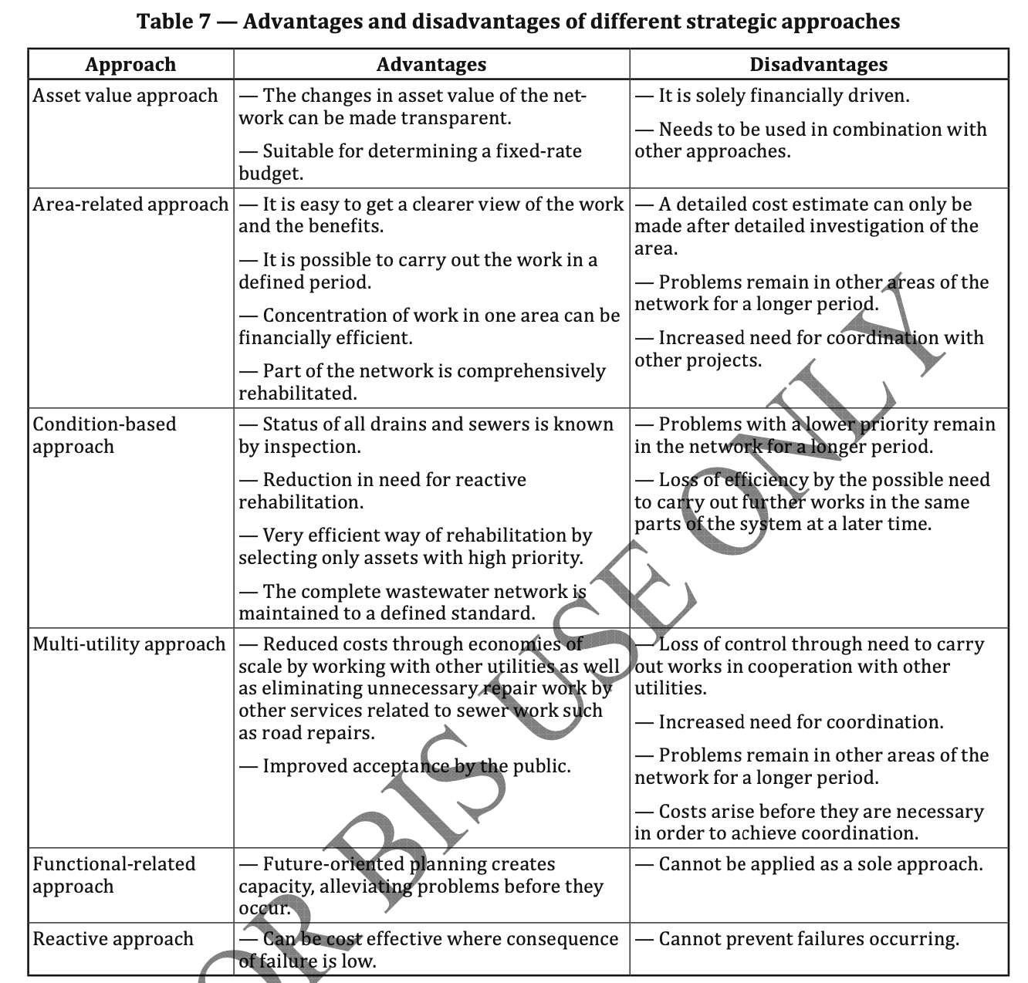
So far you have identified, whether the system needs to undergo rehabilitation or not? If yes, how it should be worked out, timeline of review etc.
Planning For Rehabilitation
The planning for rehabilitation can be simplified in the following manner:
When you plan for immediate action, you plan operationally – Hence, it is Operational Planning. It may start immediately to say planning upto 5 years. In the “operational planning” phase, the actual execution is then examined and fixed taking possible alternative measures into consideration (e.g. execution of the rehabilitation measures in terms of line routing, nominal width, material and construction method).
When you tactically plan, you plan for 8 to 10 years. The required measures will be determined and prioritized for a medium-term period based on a network evaluation and at that time, the technology and material will be preselected.
And lastly, when you plan for strategic planning you plan for 20 to 40 years.
Strategic planning for a long-term period focuses on the scope of measures and the budgets required to achieve and to maintain network condition levels.

Efficiency Review
From the initial strategy approach to the last execution of the activity, all important outcomes and choices should be recorded so as to be able to grasp the particular process steps. In this regard, care should be made to adapt past experience with such procedures to planning future projects. The materials have to be safely retained, shared publicly, and easily available.
To be able to modify the rehabilitation strategy and plan, performance evaluations should be conducted at regular intervals encompassing all people engaged in the corresponding activities.
An example of a set of questions could be referred, is shared with you in this slide. (May read out questions)
Lastly, I would say, an Efficient asset management is a balance of minimizing life cycle costs while continuously providing the levels of service and risk control established by the utility to meet users’ and stakeholders’ expectations. For a Wastewater Management System, risks can be categorized into the two groups:
a) non-influenceable risks - such as natural disasters (earthquakes, storms, floods, etc.) or economic situations;
b) influenceable risks, such as accidents due to facility deterioration, service restriction or interruption due to blockages, asset malfunction, a deterioration of effluent quality.
The objective is to design, construct, operate, maintain and rehabilitate the wastewater network at the best environmental, social and economic costs so that it:
— uses materials that minimize the depletion of finite resources;
— can be operated with the minimum practicable use of energy;
— can be constructed, operated and, at the end of their life, decommissioned with the minimum practicable impact on the environment.
-------------------------------------------------xxxx---------------------------------------------------------

CHAPTER 6

Sustainable Sanitation Solutions: Biodigesters as per IS 18150

- INTRODUCTION TO NON-SEWERED SANITATION SYSTEMS

Sanitation refers to the systems, practices, and infrastructure used to manage human excreta, wastewater, and solid waste in a safe and hygienic manner. Its primary goal is to protect human health, prevent environmental contamination, and ensure dignity. Sanitation is more than infrastructure; it is about dignity, health, and a commitment to building a safer, cleaner world for all.

Owing to the limited access of a high share of urban and rural population to sewerage systems in India, strengthening the ecosystem for non-networked sanitation becomes imperative.

Non-sewered sanitation systems (NSS) are on-site sanitation solutions that operate without the need for a connection to a centralized sewer system. They are designed to safely manage human waste and provide hygienic services in areas lacking conventional sewer infrastructure and operate independently of piped sewer networks. They Include containment, emptying, transport, treatment, and disposal/reuse of waste and are adaptable to various environmental and socio-economic contexts. Additionally, they can also be used in integration with centralized sewer systems leading to reducing load on sewage treatment plants (STPs).

Non-sewered sanitation systems are critical to addressing global sanitation challenges, particularly in under-served communities, while contributing to health, dignity, and environmental preservation. They are most appropriate for urban slums and remote or rural regions with limited infrastructure. Bio toilets have also been installed in Indian railway coaches to manage onboard human waste.

To facilitate the achievement of the desired public health and environmental outcomes through non-networked sanitation, it is crucial to safeguard the quality of existing on-site sanitation systems. Furthermore, the varying characteristics of settlements, hydrogeology, and environmental sensitivity necessitate innovations in product design to respond to the needs of these diverse contexts.

Biodigesters are systems that break down organic waste, such as human excreta, through anaerobic digestion (a process carried out by microorganisms in the absence of oxygen). This process and transforms organic waste into simpler organic molecule, effluent water and biogas.

- OVERVIEW OF IS 18150 AND BIODIGESTERS
- Key Components of a Biodigester
Inlet Chamber: Allows for the introduction of organic waste, such as food scraps, animal manure, or human waste, into the biodigester.
Digestion Tank/Chamber: The sealed, oxygen-free environment where anaerobic digestion occurs. It houses microorganisms that break down organic matter.
Gas Storage Chamber: A section of the biodigester designed to collect and store biogas produced during the digestion process.
Outlet for Bio-Slurry (simple organic molecules and effluent water): A system for discharging the nutrient-rich slurry, which can be used as organic fertilizer.
Piping and Valves: Facilitates the flow of biogas to appliances or storage and regulates pressure within the system.
- Design requirements as per IS 18150
1. Tank Design
- Multi-Chamber Structure: A biodigester tank must have at least two partition (baffle) walls, resulting in three chambers with a volumetric ratio of 4:3:3. This design increases the waste's path length, contact time, sedimentation, and degradation.
- Inlet and Outlet Provisions:
  - The inlet chamber should occupy approximately 40% of the total tank volume.
  - Outlets for treated effluent and biogas must be incorporated for efficient waste management and gas collection.
- Immobilization Matrix: Polyvinyl chloride (PVC) immobilization matrix should be provided on both sides of the partition walls and as hanging structures to enhance bacterial activity.
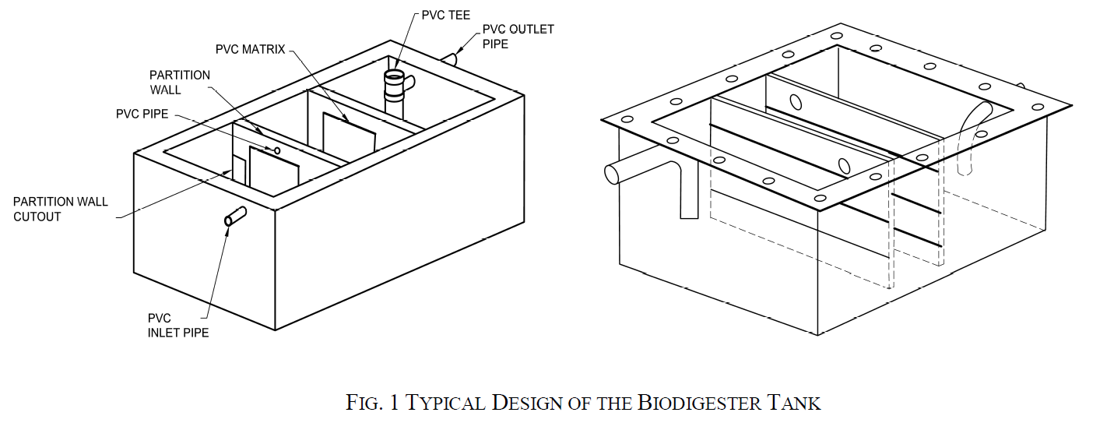
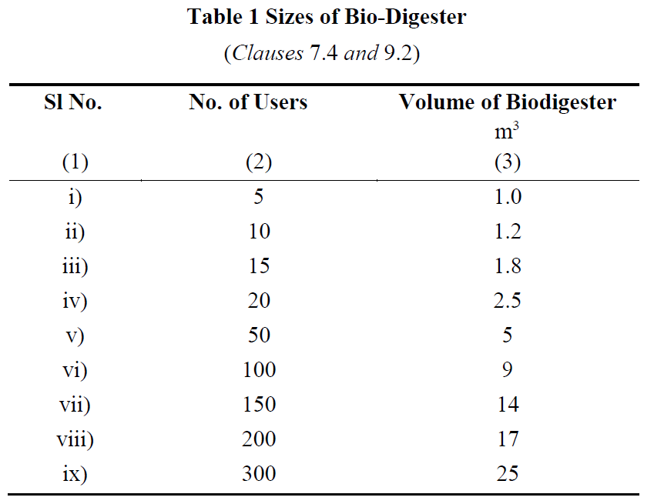
2. Material Specifications
- Fabrication Materials:
  - Fiber Reinforced Plastic (FRP), stainless steel (SS), or reinforced cement concrete (RCC) may be used, depending on the scale and application.
  - For larger volumes, on-site construction using RCC/PCC is recommended to reduce transportation and installation issues.
- FRP Specifications:
  - Resin properties, such as viscosity, acid value, gel time, and tensile strength, are defined to ensure durability and functionality.
  - Cured cast resin must be hard, tough, and have a specified impact resistance and density.
3. Capacity and Sizing
- The tank's size depends on the number of users:
  - A tank for 5 users requires 1 m³ volume.
  - Larger setups can be designed, with capacities ranging from 1.2 m³ for 10 users to 25 m³ for 300 users.
4. Key Design Considerations
- Chamber Configuration: Dimensions should cater to the required Hydraulic Retention Time (HRT) for effective digestion.
- Temperature Adaptation: Provisions for insulation, such as PUF panels, may be added for cold regions to maintain microbial efficiency.
- Anaerobic Microbial Inoculum (AMI) - Microbial consortium is a mixture of different types of bacteria (hydrolytic, acidogenic, acetogenic and methanogenic groups) responsible for breakdown of complex polymers into simple sugars which are further broken down into low chain fatty acids and finally into biogas.
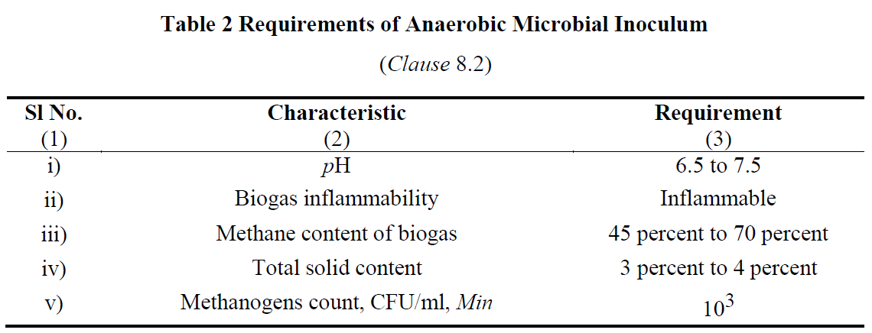
5. Effluent and Biogas Management
- The effluent must meet environmental standards, and biogas should be safely stored or utilized.
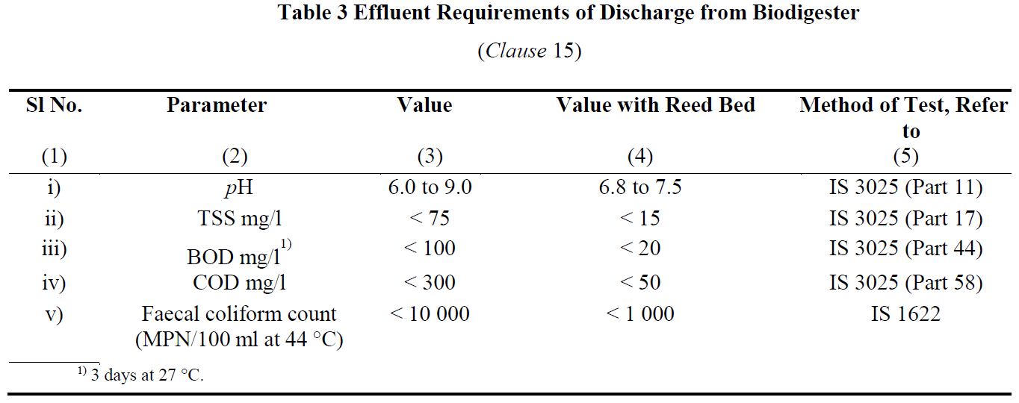
These specifications ensure the biodigester operates efficiently, minimizing health risks while promoting environmental sustainability.
- SITE SLECTION AND INSTALLATION OF BIODIGESTERS
Location of Biodigester Tank and Reed Bed
- Preferred Location:
  - The biodigester tank should ideally be installed underground, close to the toilet superstructure.
  - The reed bed can be placed above ground, either separately or on top of the tank.
- Placement Considerations:
  - The positioning of the tank and reed bed must account for the plinth height of the toilet and the site's ground level.
  - This ensures proper and effortless discharge of treated water into soak pits, open drains, or other designated areas.
Layout and Installation of FRP or SS Biodigesters
- Layout Guidelines:
  - The layout should be simple and direct to facilitate the smooth flow of waste from the toilet to the biodigester tank without blockages.
- Piping Arrangement:
  - Pipes should be configured to avoid hindrances or choking.
  - Cleaning eyes should be provided wherever pipe bends are necessary.
- Installation Considerations:
  - Selection of Location: Choose an area that is accessible and suitable for the biodigester.
  - Determination of Tank Size: The size must correspond to the number of users.
  - Pit Preparation:
    - The pit should be smooth and free from protruding stones or roots.
    - Excavated soil should be completely cleared from the pit edges to prevent collapse.
  - Base Construction:
    - A plain cement concrete (PCC) base layer is required at the bottom of the pit.
    - Concrete blocks may be added for additional support.
  - Connections:
    - Proper sealing of pipes and partitions is essential to prevent leaks.
    - Gas outlet placement must ensure safe gas release.
    - Effluent outlet pipes should lead to a soak pit or other designated area.
- Inoculum Addition:
  - Anaerobic microbial inoculum (30% of the tank volume) is added during installation or through the toilet itself.
On-Site Construction of RCC/PCC Biodigester Tanks
- Material Requirements:
  - Materials include bricks, cement, sand, stone chips, reinforcement for RCC, PVC pipes, and bacterial immobilization matrices.
- Construction Guidelines:
  - The tank is a rectangular structure with three chambers in a 4:3:3 volumetric ratio.
  - Partition walls should be 80% of the tank's length, allowing water flow through chambers.
- Tank Features:
  - Inlet Pipe: Positioned to allow 70% downward flow into the tank.
  - Outlet Pipe: Configured for proper effluent discharge, leading to a reed bed or soak pit.
- Bacterial Matrix Installation:
  - PVC matrices are hung inside the tank at specific intervals to enhance bacterial activity.
- Effluent Management:
  - Treated water exiting the reed bed can be safely released into the environment or reused for irrigation or other purposes.
- OPERATION AND MAINTENANCE
Operation and Maintenance Guidelines
- Start-Up of Biodigesters:
  - Once the biodigester is fabricated or constructed, anaerobic microbial inoculum (AMI) is added through the toilet or inlet pipe.
  - Care must be taken to minimize oxygen exposure during this process.
  - A properly functioning biodigester will produce colourless and odourless water at the outlet and maintain a clean, odour-free ambiance.
- Use of Detergents and Disinfectants:
  - Excessive use of detergents or disinfectants can harm the bacterial population and disrupt the anaerobic digestion process.
  - Adhere to the recommended dosage provided by the manufacturer to maintain system efficiency.
- Effluent Testing:
  - The biodigester's effluent must meet specific parameters (e.g., pH, BOD, COD, TSS, and fecal coliform counts).
  - Effluent testing should be conducted after one month of operation or after initial discharge to ensure compliance.
  - Testing is recommended to be carried out in DRDO-approved laboratories.
- General Maintenance Practices:
  - Regularly inspect connections, inlet and outlet pipes, and gas release mechanisms for leaks or blockages.
  - Clean the reed bed periodically to maintain its effectiveness in effluent quality improvement.
  - Monitor gas pressure and ensure safe storage or use of biogas.
- Instructions for Users:
  - Manufacturers must provide clear usage and maintenance instructions to the purchaser or operator.
  - Proper handling of biogas and bio-slurry byproducts is crucial for safety and resource recovery.
By following these guidelines, biodigesters can operate effectively, ensuring hygienic waste treatment, biogas production, and environmental protection.

- BENEFITS AND CHALLENGES
Benefits:
- Passive system for eco-friendly degradation of organic matter.
- Customizable sizes and pre-fabricated options available commercially.
- Promotes water recovery and recycling.
- Zero running cost and zero maintenance cost for primary treatment and negligible maintenance cost for periodic evaluation of secondary treatment.
- Does not require periodic replenishment of bacterial cultures and rigorous monitoring of performance.
- Does not have intermittent de-sludging requirement
- Does not restrict use of toilet cleaners
- Can be deployed even in extreme climatic conditions and areas with high water table or risk of flooding.
Risk & Limitations of Biodigester:
- Higher one time capital investment as compared to Leach Pits.
- Removal of nitrogen and phosphorous requires reed bed.
- Space constraints in urban areas could limit implementation of reed bed.

- CONCLUSION AND Q&A
Biodigesters represent a transformative solution in non-sewered sanitation systems, addressing critical challenges in waste management and environmental sustainability. By utilizing anaerobic digestion, biodigesters efficiently decompose organic waste into biogas and nutrient-rich effluent, offering multiple benefits such as renewable energy generation, reduced pathogen transmission, and resource recovery.
The design, installation, and maintenance of biodigesters, as outlined in the Indian Standard emphasize the importance of proper materials, site selection, and adherence to operational protocols for optimal performance. Integrating reed beds further enhances effluent treatment, ensuring safe discharge or reuse.
As a sustainable technology, biodigesters provide scalable solutions for households, communities, and institutions, particularly in areas lacking centralized sewer systems. Their role in reducing environmental pollution, conserving resources, and improving public health underscores their alignment with global sanitation and sustainability goals.
With proper implementation and regular maintenance, biodigesters can pave the way for a cleaner, greener, and healthier future, making them a vital component of modern waste management systems.

Sustainable Sanitation Solutions: Biodigesters as per IS 18150

- INTRODUCTION TO NON-SEWERED SANITATION SYSTEMS
Sewer rehabilitation refers to the process of restoring aging, deteriorated, or damaged sewer systems to ensure their functionality, structural integrity, and longevity. It involves the application of advanced technologies and materials to address challenges such as leaks, structural weaknesses, and reduced hydraulic performance, all while minimizing disruptions to urban environments.
The primary objectives of sewer rehabilitation include restoring structural capacity, ensuring water tightness, sealing leaks, and improving the sewer\u2019s hydraulic efficiency. This is achieved through modern techniques that protect against chemical and biological attacks, enhance abrasion resistance, and extend the economic lifespan of the sewer systems to 50 years.
Innovative technologies such as Cure In Place Pipe (CIPP), Glass Reinforced Plastic (GRP) liners, Machine Wound Spiral Lining (MWSL), and Spin-Cast Geopolymer Spray Linings offer targeted solutions tailored to the specific conditions of the sewer system. These techniques not only address immediate concerns but also ensure long-term sustainability and efficiency.
With the absence of Indian Standards, rehabilitation projects in India often rely on international benchmarks, including ASTM, ISO, and European Standards. As the sector evolves, there is a push to develop comprehensive Indian Standards, incorporating inputs from various stakeholders to suit local environmental and operational conditions.
Sewer rehabilitation represents a crucial step in maintaining urban infrastructure, ensuring environmental safety, and meeting the growing demands of modern urbanization.
- Prime Objectives of Rehabilitation
- Structural Capacity: Restore or increase the structural capacity of the sewer.
- Leak Sealing: Seal all opened-up and leaking joints.
- Gradient Correction: Remove reverse gradients and improve the sewer’s gradient.
- Surface Protection: Protect the internal surface of the sewer from chemical and biological attack in tropical climates.
- Abrasion Resistance: Provide adequate resistance to prevent structural degradation due to silt, sand, debris migration, and movement of cleaning equipment.
- Hydraulic Performance: Improve hydraulic performance using materials with minimal flow resistance.
- Water Tightness: Ensure complete water tightness of the sewer.
- Extended Lifespan: Enhance the economic lifespan of sewers to 50 years.

- Sewer Rehabilitation Technologies
- Cure In Place Pipe (CIPP) Technology
- Glass Reinforced Plastic (GRP) Technology
- Machine Wound Spiral Lining (MWSL) Technology
- Spin Cast Geopolymer Spray Lining Technology
Rehabilitation Technologies
Cure In Place Pipe (CIPP) Technology
- Process: A resin-impregnated fabric liner is inserted into the host pipe using an inversion process.
- Curing: Heating cures the liner, forming a self-supporting pipe inside the host pipe.
- Features: Jointless, close-fit liner prevents water infiltration and exfiltration.
Spiral Wound Liner Technology
- Process: A single PVC or HDPE strip is spirally wound into the host pipe using a winding machine in a manhole.
- Man Entry Sizes: Larger pipes allow for spiral winding inside the host pipe by a travelling winding machine.
- Features: Interlocked strips form a continuous, watertight liner. The strip can be reinforced based on structural requirements.
Glass Reinforced Plastic (GRP) Liner Technology
- Application: Used worldwide for structural strengthening of deteriorated, man-entry-sized sewers.
- Material Composition: Fiberglass mats, glass fibers, resins, and silica sand. The inner surface incorporates a 2-3 mm thick resin layer for corrosion resistance.
- Manufacturing: Pipes are produced off-site under factory-controlled conditions.
Spin-Cast Geopolymer Pipe (SCGP)
- Process: Structural geopolymer lining is spin-cast or hand-sprayed onto various pipe surfaces, including brick, concrete, and metal.
- Application: Used for the rehabilitation of sewer pipelines and manholes.
- Features: Provides structural or protective coating and includes a geopolymer coat applied to prepared surfaces.

- Present Status of Standards for Sewer Rehabilitation Technologies
Cure In Place Pipe (CIPP) Technology
- Process: A resin-impregnated fabric liner is inserted into the host pipe using an inversion process.
- Curing: Heating cures the liner, forming a self-supporting pipe inside the host pipe.
- Features: Jointless, close-fit liner prevents water infiltration and exfiltration.
Spiral Wound Liner Technology
- Process: A single PVC or HDPE strip is spirally wound into the host pipe using a winding machine in a manhole.
- Man Entry Sizes: Larger pipes allow for spiral winding inside the host pipe by a travelling winding machine.
- Features: Interlocked strips form a continuous, watertight liner. The strip can be reinforced based on structural requirements.
Glass Reinforced Plastic (GRP) Liner Technology
- Application: Used worldwide for structural strengthening of deteriorated, man-entry-sized sewers.
- Material Composition: Fiberglass mats, glass fibers, resins, and silica sand. The inner surface incorporates a 2-3 mm thick resin layer for corrosion resistance.
- Manufacturing: Pipes are produced off-site under factory-controlled conditions.
Spin-Cast Geopolymer Pipe (SCGP)
- Process: Structural geopolymer lining is spin-cast or hand-sprayed onto various pipe surfaces, including brick, concrete, and metal.
- Application: Used for the rehabilitation of sewer pipelines and manholes.
- Features: Provides structural or protective coating and includes a geopolymer coat applied to prepared surfaces.
Status of Technologies and Standards
- Indian Standards: Not available.
- Current Practices: Rehabilitation works in India rely on:
  - ASTM Standards

Standard | Subject
ASTM F1216 | Standard Practice for Rehabilitation of Existing Pipelines and Conduits by the Inversion and curing of a Resin- Impregnated Tube.
ASTM F1743 | Standard Practice for Rehabilitation of Existing Pipelines and Conduits by Pulled-in-Place Installation of Cured-in-Place Thermosetting Resin Pipe ( CIPP)
ASTM F2019 | Standard Practice for Rehabilitation of Existing Pipelines and Conduits by Pulled-in-Place Installation of Glass Reinforced Plastic (GRP) Cured-in-Place Thermosetting Resin Pipe (CIPP)
ASTM D5813 | Standard specification for Cured-in-Place Thermosetting Resin Sewer Piping System
ASTM D683 | Standard Test Method for Tensile Properties of Plastics
ASTM D790 | Standard Test Method for Flexural Properties of Unreinforced and Reinforced plastics and Electrical Insulating Materials
ASTM D2412 | Test for Apparent Tensile Strength of Reinforced Thermosetting Plastic Pipes and Tubes.

  - WRC Manual
  - ISO Standards (recently published for sewer pipe rehabilitation)
  - Australian Standards (AS), British Standards (BS), and European Standards (EN)
Standard | Subject
BS EN 13566-1 | Plastics piping systems for renovation of underground non-pressure drainage and sewerage networks  Part 1: General
BS EN 13566-2 | Part 2: Lining with continuous pipes;
BS EN 13566-3 | Part 3: Lining with close-fit pipes;
BS EN 13566-4 | Part 4: Lining with cured-in-place pipes;
BS EN 13566-7 | Part 7: Lining with spirally-wound pipes;

Standard | Subject
ISO 11296-1 | Plastics piping systems for renovation of underground non-pressure drainage and sewerage networks —  Part 1: General
ISO 11296-2 | Part 2: Lining with continuous pipes;
ISO 11296-3 | Part 3: Lining with close-fit pipes;
ISO 11296-4 | Part 4: Lining with cured-in-place pipes;
ISO 11296-5 | Part 5: Lining with discrete pipes
ISO 11296-7 | Part 7: Lining with spirally-wound pipes;
ISO 11296-8 | Part 8: Lining with pipe segments;
ISO 11296-9 | Part 9: Lining with a rigidly anchored plastics inner layer
ISO 11296-10 | Part 10: Lining with sprayed polymeric materials
ISO/TS 23818-1 | Assessment of conformity of plastics piping systems for the rehabilitation of existing pipelines —  Part 1: Polyethylene (PE) material
ISO/TS 23818-2 | Part 2: Resin-fibre composite (RFC) material
ISO/TS 23818-3 | Part 3: Unplasticised poly(vinyl chloride) (PVC-U) material

- Way Forward
- Draft Standard Development: A working group is finalizing a draft standard for the CIPP lining system.
- Comprehensive Approach:
  - A single standard for one technology (e.g., CIPP) is insufficient for India.
  - A broader study of all standards (ASTM, BS/EN, ISO) is required to develop a comprehensive set of Indian Standards.
  - Indian environmental conditions and feedback from relevant departments will be considered.
- Timeline: Approximately six months for drafting the standards.

Sanitation Solutions: Rotationally Moulded Polyethylene Septic Tanks and IS 18666
- Introduction to Polyethylene Septic Tanks
Overview - This session equips participants with a comprehensive understanding of polyethylene septic tanks, IS 18666 standards, and their application for sustainable wastewater management.
- Introduction to Polyethylene Septic Tanks – Definition and advantages,
- Overview of IS 18666 Standards – Scope, material specifications, design requirements, Design and Manufacturing Process – design principles, load requirements, compliance significance,
- environmental impact; rotational moulding steps,
- Installation and Maintenance Guidelines, cost-effectiveness, long-term benefits.
Introduction - Sanitation refers to the systems, practices, and infrastructure used to manage human excreta, wastewater, and solid waste in a safe and hygienic manner. Its primary goal is to protect human health, prevent environmental contamination, and ensure dignity. Sanitation is more than infrastructure; it is about dignity, health, and a commitment to building a safer, cleaner world for all.
Owing to the limited access of a high share of urban and rural population to sewerage systems in India, strengthening the ecosystem for non-networked sanitation becomes imperative.
Non-sewered sanitation systems (NSS) are on-site sanitation solutions that operate without the need for a connection to a centralized sewer system. They are designed to safely manage human waste and provide hygienic services in areas lacking conventional sewer infrastructure and operate independently of piped sewer networks. They Include containment, emptying, transport, treatment, and disposal/reuse of waste and are adaptable to various environmental and socio-economic contexts. Additionally, they can also be used in integration with centralized sewer systems leading to reducing load on sewage treatment plants (STPs).
Non-sewered sanitation systems are critical to addressing global sanitation challenges, particularly in under-served communities, while contributing to health, dignity, and environmental preservation.
To facilitate the achievement of the desired public health and environmental outcomes through non-networked sanitation, it is crucial to safeguard the quality of existing on-site sanitation systems. Furthermore, the varying characteristics of settlements, hydrogeology, and environmental sensitivity necessitate innovations in product design to respond to the needs of these diverse contexts.
A septic tank is an underground system designed to treat wastewater from homes or businesses, especially in areas without municipal sewage systems. It consists of three main components: Inlet Pipe, Septic Tank Chamber, and Outlet Pipe.
Basic Functioning of a septic tank is as below:
- Separation: Solid waste is separated from liquid waste.
- Treatment: Biological bacteria break down solids inside the tank.
- Filtration: Effluent is further treated and filtered through soil in the drain field.
Proper maintenance is essential to prevent issues such as backups, clogs, and contamination, ensuring both environmental protection and public health.
Polyethylene tanks are a popular choice for septic systems due to their numerous advantages:
- Durability:
  - Polyethylene is highly resistant to cracking, corrosion, and impact, making these tanks long-lasting and reliable in harsh environmental conditions.
  - They can withstand extreme temperatures and chemical exposure, providing years of service without degradation.
- Cost-Effectiveness:
  - Polyethylene tanks are generally more affordable than tanks made from materials like concrete or fiberglass, offering a cost-effective solution for homeowners and businesses.
  - Their long lifespan and minimal maintenance needs help reduce long-term costs.
- Ease of Installation:
  - Lightweight and easy to transport, polyethylene tanks are quicker and easier to install than heavier alternatives.
  - Their flexibility and resistance to damage during installation reduce the likelihood of costly repairs.
- Overview of IS 18666 Standards
Scope and Applicability of IS 18666:2024, “Rotationally moulded polyethylene septic tanks"
Introduction to IS 18666:2024:
"This standard has been developed by the Bureau of Indian Standards to address the growing reliance on on-site sanitation systems, both in urban and rural areas. It ensures the quality and performance of polyethylene septic tanks, which are widely adopted for decentralized wastewater treatment."
Scope:
- Design & Installation: Specifies requirements for design, materials, sizing, performance, and testing of septic tanks for underground use.
- Exclusions: Does not cover effluent disposal mechanisms, which require further treatment as per IS 2470 (Part 2).
Applicability:
- Supports on-site sanitation systems in urban and rural areas, especially where centralized sewerage is unavailable.
- Ensures environmental and public health protection by standardizing tank quality and performance.
Key standards for the design, material specifications, and construction requirements in IS 18666
Design Standards:
General Design: "The tanks are intended for underground installation and must ensure durability, watertightness, and effective wastewater treatment. Hydraulic retention time must be at least 24 hours, with a minimum sludge storage period of two years."
Inlets and Outlets: "Inlets and outlets should minimize disturbance of settled solids and prevent scum escape, with minimum pipe diameters of 110 mm for tanks up to 6,000 liters and 150 mm for larger tanks."
Ventilation and Access: "Adequate ventilation must be provided, and tanks must feature accessible openings for maintenance and inspection."
Material Specifications:
Primary Raw Materials: "The tanks must be made of polyethylene with a density of at least 0.935 g/cm³ and comply with environmental stress cracking resistance and UV stability requirements."
Additives: "UV stabilizers, antioxidants, and pigments must ensure durability, with carbon black content at 2.5% ± 0.5% for UV protection."
Construction Requirements:
Structural Strength: "The design must account for soil pressure, hydrostatic groundwater pressure, and thermal loads. A minimum wall thickness of 8 mm is required, with safety factors ranging from 3 to 5."
Shape and Dimensions: "Cylindrical tanks are preferred for durability, with a length-to-width ratio of at least 2:1 for rectangular tanks. All tanks must include a freeboard of at least 300 mm."
Compartmentation: "Tanks over 2,000 litres must have at least two chambers, with partitions designed to withstand mechanical desludging."
In summary, the standards ensure that septic tanks are robust, efficient, and safe for long-term wastewater management. By adhering to these guidelines, manufacturers and installers contribute to better public health and environmental sustainability.
- Design and Manufacturing Process
Let’s delve into the critical design considerations focusing on capacity, load-bearing requirements, and environmental impact.
Capacity:
Hydraulic Retention Time: "The tanks must provide a minimum retention time of 24 hours to settle solids and support anaerobic digestion."
Population and Usage: "Capacity should align with user requirements, with a minimum effective volume of 1,000 liters. For residential use, the recommended size increases with the number of users, ensuring proper sludge storage for at least two years."
Design Flexibility: "Designs must accommodate both blackwater and combined wastewater scenarios, as detailed in the standard."

Load-Bearing Requirements:
Structural Strength: "Septic tanks must withstand vertical and lateral soil pressure, hydrostatic groundwater pressure, and any surcharge loads. The minimum design must accommodate 18 kPa of soil loading per meter of depth."
Wall Thickness: "A minimum wall thickness of 8 mm is required, with a safety factor of 3 to 5 to ensure durability under varied stress conditions."
Testing: "Load-bearing tests, including wet and dry conditions, ensure no structural failures occur under operational loads."

Environmental Impact:
Leakage Prevention: "The tanks must be watertight to prevent contamination of surrounding soil and groundwater, meeting stringent pneumatic and water-tightness testing requirements."
Material Selection: "Materials must be non-toxic, durable, and resistant to UV degradation to ensure long service life and minimal environmental impact."
Effluent Treatment: "Septic tanks are designed for primary treatment, but effluent must undergo secondary treatment before disposal to comply with environmental standards and reduce pollution risks."

Steps Involved in the Rotational Moulding Process
- Preparation of the Mould and Material: "Finely divided plastic powder is prepared and measured. The mould is cleaned and assembled, ensuring proper alignment."
- Loading: "The required amount of plastic powder is loaded into the mould. This powder must meet specific particle size and flow characteristics for even distribution."
- Heating and Rotation: "The mould is placed in a rotational moulding machine and simultaneously rotated on two axes while being heated. This ensures the plastic powder melts and coats the interior surface of the mould uniformly."
- Cooling: "After achieving the desired wall thickness, the mould is cooled while still rotating to solidify the plastic and prevent warping."
- Demoulding: "Once cooled, the mould is opened, and the finished product is carefully removed, ensuring no damage occurs during handling."

Quality Control Measures
- Material Specifications: "The base resin must meet density, melt flow index, and environmental stress cracking resistance requirements as specified in Indian Standard."
- 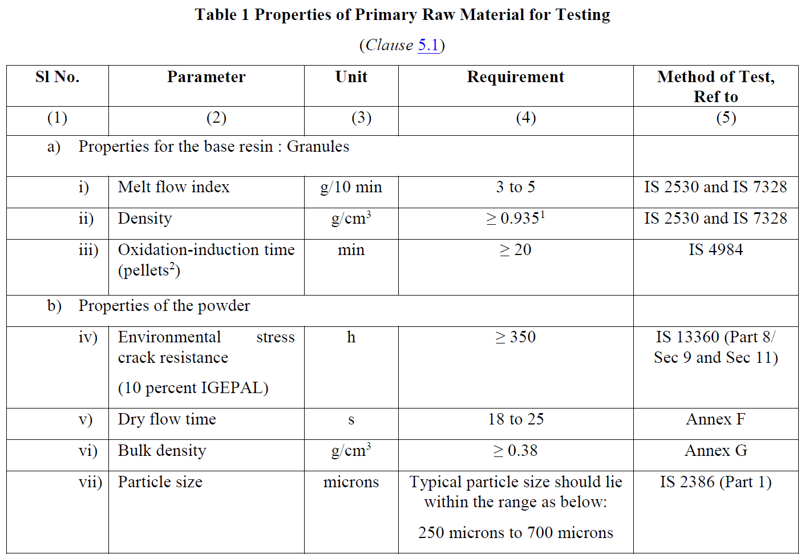
- Additives: "UV stabilizers, antioxidants, and pigments must be evenly distributed to ensure durability and performance."
- Dimensional Accuracy: "Regular checks ensure adherence to design specifications, including wall thickness, shape, and size tolerances of ±3%."
- Visual Inspection: "The surface of the tank is checked for defects such as air bubbles, cracks, or uneven coloration that could compromise performance."

Testing Procedures
- Water Tightness Tests: "Tanks are subjected to water and pneumatic pressure tests to ensure no leakage occurs under operating conditions."
- Load-Bearing Tests: "Vertical and lateral load tests verify the tank's structural integrity under soil and groundwater pressure."
- Hydraulic Efficiency: "Tests using simulated sludge confirm the tank’s ability to achieve efficient wastewater treatment."
- Material Properties Testing: "Tests for tensile strength, elongation, flexural modulus, and UV resistance ensure the tank can withstand environmental and operational stresses."
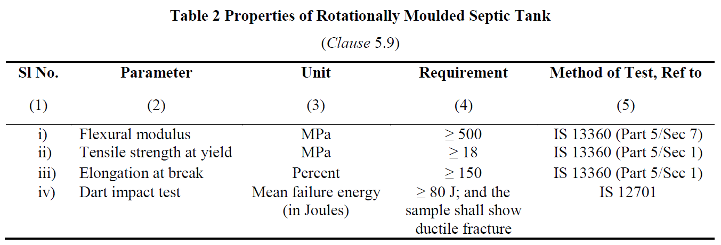
The rotational moulding process is a precise and controlled method, ensuring septic tanks meet the highest standards of quality and performance. Combined with rigorous testing, this process guarantees reliability and durability.
Advantages of rotational moulding include:
- Seamless Construction
- Material Efficiency
- Design Flexibility
- Cost-Effectiveness
- Structural Integrity
- Installation and Maintenance Guidelines
The manufacturer shall provide installation instructions with each septic tank, covering the following:
a) Installation, including duplicating tanks for larger capacities;
b) Pipe connections;
c) Commissioning and start-up;
d) Backfill material properties (Φ and ρ);
e) Designed water table level;
f) Maximum service temperature;
g) Tank depth;
h) Top load limits and maximum cover depth;
i) Hydraulic efficiency.

Maintenance and Troubleshooting

Routine maintenance and timely troubleshooting are key to ensuring the long-term performance and safety of septic tanks. By following the best practices, we can prevent costly repairs and safeguard public health.

Routine Maintenance Tasks
- Sludge Removal: "Periodic desludging is crucial to maintain the tank’s efficiency. Ideally, sludge should be removed every 2–3 years, depending on the tank’s usage and capacity. This prevents clogging and ensures the system operates effectively."
- Component Checks:
  - Inlets and Outlets: "Inspect inlets and outlets to ensure they’re clear and functioning properly, minimizing disturbance to sludge and scum layers."
  - Ventilation Systems: "Check vent pipes for blockages to avoid the buildup of harmful gases."
  - Access Covers and Seals: "Ensure covers are intact and sealed to prevent unauthorized access and water intrusion."
- System Cleaning:
  - Effluent Filters: "Clean effluent filters regularly to prevent the accumulation of solids in the disposal system."
  - Dispersion Trenches or Soak Pits: "Inspect and clean to maintain proper drainage of effluent into the surrounding soil."

Troubleshooting Common Issues
- Slow Draining or Backup:
  - Cause: Blockages in pipes or excessive sludge accumulation.
  - Solution: Check for blockages and schedule desludging if the sludge layer is too high.
- Foul Odors:
  - Cause: Poor ventilation or excessive buildup of scum and sludge.
  - Solution: Inspect and clean the vent pipe, and schedule routine maintenance.
- Surface Water Pooling:
  - Cause: System overload, poor soil absorption, or damage to the dispersion trench.
  - Solution: Reduce water usage, inspect the trench, and repair or extend it as needed.
- Structural Damage:
  - Cause: Soil pressure, improper installation, or physical impact.
  - Solution: Conduct a structural integrity assessment and repair or replace the tank if necessary.
- Frequent Clogging of Effluent Filters:
  - Cause: High solid content or improper cleaning.
  - Solution: Increase cleaning frequency and ensure filters are properly maintained.

Environmental Benefits
- Reduction in Pollution: "Septic tanks effectively treat wastewater on-site, preventing untreated effluent from contaminating groundwater or surface water."
- Support for Decentralized Sanitation: "By eliminating the need for large-scale sewer infrastructure, septic tanks reduce the ecological footprint of sanitation systems."
- Recyclable Materials: "Rotationally moulded polyethylene tanks are made from recyclable materials, minimizing environmental impact at the end of their lifecycle."
- Water Conservation: "The treated effluent can be safely reused for irrigation or groundwater recharge when paired with secondary treatment systems."

Cost Savings
- Lower Installation Costs: "Septic tanks are more affordable than centralized sewage systems, especially in rural or remote areas."
- Minimal Operating Costs: "They require no continuous energy supply, making them cost-efficient to operate and maintain."
- Reduced Infrastructure Dependency: "By treating wastewater on-site, households and communities save on utility bills and avoid infrastructure-related costs."
- Durability and Low Maintenance: "With proper maintenance, these tanks have a long service life, reducing the need for frequent replacements or repairs."

Long-Term Benefits
- Sustainability: "Septic tanks contribute to sustainable wastewater management by offering a decentralized solution that works efficiently for decades."
- Health and Hygiene: "Properly functioning septic systems prevent exposure to untreated waste, safeguarding public health in the long run."
- Property Value Enhancement: "A well-maintained septic system is an asset that adds value to properties, particularly in areas without access to centralized sewage systems."
- Flexibility in Expansions: "Septic systems can be adapted or upgraded as needs change, providing scalability for growing households or communities."

- Conclusion and Q&A (5 minutes)
We discussed the scope and applicability of IS 18666:2024, focusing on its standards for septic tank design, material specifications, and environmental impact. Key points included design considerations like capacity, load-bearing requirements, and maintenance practices. We also highlighted the benefits of rotational moulding, routine maintenance tasks, troubleshooting common issues, and the long-term environmental and cost-saving advantages of septic tanks.

Why follow Indian Standards

- Optimal Performance: Clear guidelines ensure efficient wastewater treatment.
- Durability: Tanks withstand environmental stresses, preventing failures.
- Public Health: Reduces contamination risks, safeguarding hygiene.
- Environmental Protection: Promotes sustainable and eco-friendly practices.
- Cost Savings: Minimizes maintenance and repair expenses.
- Regulatory Compliance: Aligns with policies, avoiding penalties.

CHAPTER 7

Advanced Sanitation Solutions: Packaged Sewage Treatment Plants as per IS 18797

- Introduction to Packaged Sewage Treatment Plants
Overview - This session provides a comprehensive understanding of Packaged Sewage Treatment Plants (PSTPs), focusing on their concept, design, operation, and real-world applications. It begins with an introduction to PSTPs, their significance, and applications in areas without centralized sewage systems, followed by an overview of the IS 18797 standards governing their design and construction. Participants will explore the design and installation guidelines, operational best practices, and maintenance protocols necessary for optimal performance. The session also examines the benefits, challenges, and practical applications, culminating in a summary and an interactive Q&A segment to clarify doubts and solidify learning.
Introduction - Sanitation refers to the systems, practices, and infrastructure used to manage human excreta, wastewater, and solid waste in a safe and hygienic manner. Its primary goal is to protect human health, prevent environmental contamination, and ensure dignity. Sanitation is more than infrastructure; it is about dignity, health, and a commitment to building a safer, cleaner world for all.
Owing to the limited access of a high share of urban and rural population to sewerage systems in India, strengthening the ecosystem for non-networked sanitation becomes imperative.
Non-sewered sanitation systems (NSS) are on-site sanitation solutions that operate without the need for a connection to a centralized sewer system. They are designed to safely manage human waste and provide hygienic services in areas lacking conventional sewer infrastructure and operate independently of piped sewer networks. They Include containment, emptying, transport, treatment, and disposal/reuse of waste and are adaptable to various environmental and socio-economic contexts. Additionally, they can also be used in integration with centralized sewer systems leading to reducing load on sewage treatment plants (STPs).
Non-sewered sanitation systems are critical to addressing global sanitation challenges, particularly in under-served communities, while contributing to health, dignity, and environmental preservation.
To facilitate the achievement of the desired public health and environmental outcomes through non-networked sanitation, it is crucial to safeguard the quality of existing on-site sanitation systems. Furthermore, the varying characteristics of settlements, hydrogeology, and environmental sensitivity necessitate innovations in product design to respond to the needs of these diverse contexts.
Packaged sewage treatment systems are compact, self-contained units designed to treat wastewater from small-scale applications such as homes, businesses, or remote locations. These systems use a combination of physical, biological, and chemical processes to remove contaminants, producing treated water suitable for discharge or reuse. Typically pre-engineered and modular, they are easy to install, require minimal space, and offer efficient wastewater treatment solutions. They are especially useful in areas without access to centralized sewage networks, providing a sustainable and cost-effective alternative for wastewater management.
- Overview of IS 18797 and PSTP Components (15 minutes)
The IS 18797:2024 standard ensures PSTPs are designed and built for reliable, sustainable, and efficient sewage treatment while meeting stringent safety and environmental criteria.
Key Components of Packaged Sewage Treatment Plants (PSTPs) are:
- Primary Treatment:
- Purpose: Removal of large solids, grit, and scum from raw sewage.
- Features:
  - Bar screens, grit chambers, and oil/grease traps.
  - Settling chambers for sedimentation of suspended solids.
  - Design to minimize disturbance to sludge or scum during inflow.
- Secondary Treatment:
- Purpose: Biological treatment for organic matter removal.
- Features:
  - Aerobic processes using blowers and diffusers for oxygenation.
  - Compartmentalized design for optimized microbial activity.
  - Ensures compliance with effluent Biological Oxygen Demand (BOD) and Total Suspended Solids (TSS) limits.
- Tertiary Treatment:
- Purpose: Advanced treatment for polishing and disinfection.
- Features:
  - Disinfection methods: Chlorination, ozonation, or UV treatment.
  - Nutrient removal (Nitrogen and Phosphorous) as per environmental standards.
  - Final effluent quality: pH 5.5–9.0, BOD ≤ 30 mg/L, and TSS ≤ 100 mg/L.
- Sludge Management:
- Purpose: Safe and efficient handling of settled solids.
- Features:
  - Adequate storage capacity for 6 months' sludge production.
  - Desludging access with a minimum opening diameter of 400 mm.
  - Durable filter media and structural integrity for long-term use.
Standards for Design, Materials, and Construction of PSTPs
- Design Principles:
- PSTPs must provide complete treatment and disinfection of incoming wastewater, ensuring no untreated or partially treated effluent is discharged into the environment.
- Systems must have two or more compartments, maintain a minimum Hydraulic Retention Time (HRT) of 16.5 hours at 25°C or higher, and accommodate variations in colder climates.
- The inlet and outlet designs must prevent sludge disturbances and ensure efficient scum management.
- Material Standards:
- Constructed from durable materials like Glass Fibre Reinforced Plastic (GFRP), Polyethylene (PE), Polypropylene (PP), or Dicyclopentadiene (DCPD).
- All components, including internal partitions and ancillary parts, must resist corrosive wastewater environments and support a minimum service life of 15 years.
- Structural Strength:
- Systems must withstand hydrostatic, pedestrian, and backfill loads without failure.
- Tanks must pass stringent watertightness, pneumatic pressure, and leakage tests.
- Efficiency & Safety:
- Effluent discharge must meet standards set by the Ministry of Environment, Forest, and Climate Change (MoEFCC):
  - BOD: ≤ 30 mg/L
  - COD: ≤ 250 mg/L
  - TSS: ≤ 100 mg/L
- Systems must be safe, energy-efficient, and operate within acceptable noise levels.
- Maintenance & Durability:
- Access openings for maintenance must have a locking mechanism and corrosion-resistant components.
- Desludging capacity of six months or more is mandatory under normal operating conditions.
Importance of Compliance with IS 18797
Adhering to IS 18797 is vital for ensuring the efficiency, safety, and sustainability of Packaged Sewage Treatment Plants, while also protecting public health and the environment.
- Enhanced System Efficiency:
- Design Optimization: Ensures systems are tailored for effective sewage treatment, meeting discharge standards for BOD, TSS, and nutrient removal.
- Hydraulic Retention Time (HRT): Minimum of 16.5 hours to optimize treatment processes, reducing the risk of untreated discharges.
- Testing and Quality Assurance: Regular type and acceptance tests validate system performance under diverse conditions.
- Safety and Reliability:
- Structural Integrity: Design standards ensure resistance to hydrostatic and backfill loads, preventing failures during operation.
- Watertight Construction: Prevents leakage and contamination of surrounding areas.
- Ventilation and Access: Adequate ventilation and secure access openings protect operators during maintenance.
- Environmental Protection:
- Effluent Standards Compliance: Discharge aligned with Ministry of Environment, Forest, and Climate Change (MoEFCC) norms to safeguard water bodies.
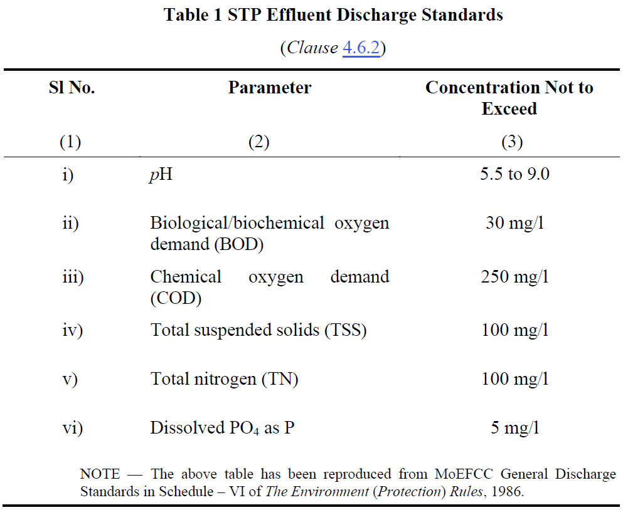
- Nutrient Removal: Controls nitrogen and phosphorus levels, mitigating risks of eutrophication.
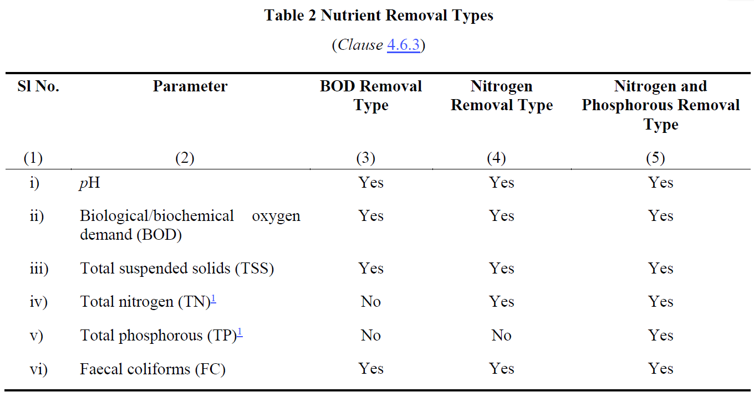
- Longevity and Sustainability:
- Durable Materials: Use of GFRP, PE, PP, and DCPD ensures systems endure harsh environments for 15+ years.
- Energy Efficiency: Declared power consumption promotes sustainable operations.
- Regulatory and Operational Confidence:
- BIS Certification: Builds trust among stakeholders, from manufacturers to users.
- Periodic Assessments: Ongoing monitoring of effluent quality ensures continued compliance and reliability.
- Design and Installation Guidelines
Design considerations for PSTPs
PSTP design prioritizes appropriate capacity, the ability to handle diverse inflow characteristics, and the production of high-quality effluent that meets stringent environmental standards.
- Capacity:
- Designed to serve a population equivalent to at least 5 individuals.
- Adequate sizing to store at least 6 months' sludge production without compromising performance.
- Flexibility to meet varying wastewater generation rates as per local authority regulations (e.g., 108 LPCD for residential areas).
- Inflow Characteristics:
- Handles raw sewage with standard characteristics:
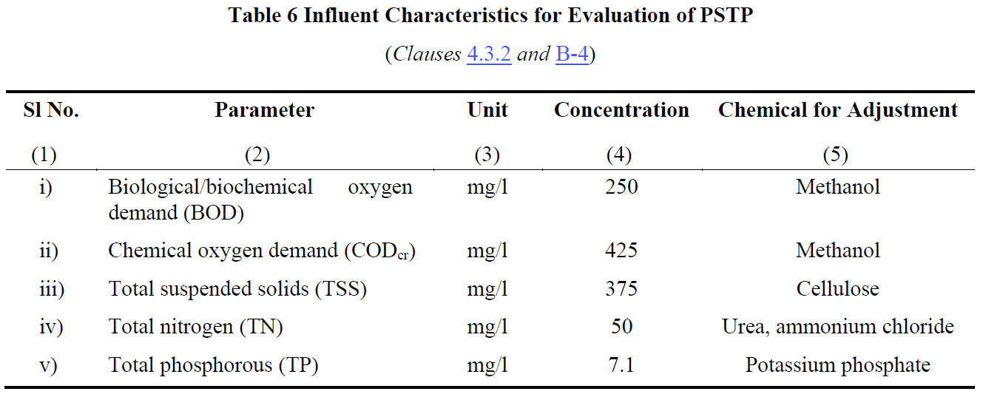
- Equipped to manage flow variations:
  - Normal flow (Q), low flow (0.5Q), and high flow (1.25Q) conditions during a 48-week evaluation period.
- Effluent Quality:
- Meets Ministry of Environment, Forest, and Climate Change (MoEFCC) General Discharge Standards:
- Final effluent ensures environmental protection and compliance with regulatory norms.
Installation
Proper installation and adherence to best practices ensure the long-term efficiency, safety, and reliability of PSTPs while minimizing operational challenges.
The manufacturer must provide installation instructions covering the following aspects:
- System installation, including other tanks for large capacities.
- Pipe and valve connections.
- Commissioning and start-up procedures.
- Properties of backfill material.
- Maximum backfill height.
- Suitability for dry/wet sites.
- Top load limitations.
- Maximum depth of extension shaft.
- Treatment efficiency.
- Anchoring arrangement.
- Foundation preparation.

- Operation, Maintenance, and Performance Monitoring
Regular operation, maintenance, and performance monitoring are critical for the efficiency, compliance, and longevity of PSTPs, ensuring they meet environmental and safety standards.
- Routine Operation:
- Ensure regular functioning of:
  - Pretreatment units (bar screens, grit chambers, oil/grease traps).
  - Pumps, blowers, and aeration systems.
  - Disinfection systems like UV, ozonation, or chlorination.
- Maintenance Schedule:
- Weekly:
  - Inspect pretreatment units for blockages or wear.
  - Check the operation of mechanical components (e.g., blowers, pumps).
- Monthly:
  - Clean air filters and inspect pipes for leaks or clogs.
  - Check filter media condition.
- Biannually:
  - Desludge the tank and inspect sludge levels.
  - Replace air filters and clean all chambers.
  - Inspect scum levels and remove any accumulation.
- Performance Monitoring:
- Conduct regular assessments of influent and effluent quality:
  - Key Parameters: pH, BOD, COD, TSS, Total Nitrogen, and Phosphorous.
  - Frequency: Weekly for critical parameters like BOD and COD.
- Monitor and maintain a record of sludge levels and scum accumulation.
- Regular assessments conducted in accordance with Indian Standards for accurate measurement of water quality.
- Documentation and Reporting:
- Maintain detailed records of maintenance activities, performance tests, and operational data.
- Ensure records are stored for a minimum of 5 years for compliance and troubleshooting.
- Best Practices:
- Use only trained personnel for maintenance tasks.
- Ensure adequate ventilation during maintenance.
- Follow safety protocols to prevent exposure to hazardous materials.
- Benefits and Challenges
Benefits:
- Cost-Effective Solution:
  - Reduces the need for extensive sewer networks.
  - Ideal for decentralized wastewater management.
- Environmental Protection:
  - Treats sewage to meet discharge standards, minimizing pollution.
  - Supports nutrient removal, reducing risks of water body eutrophication.
- Adaptability and Scalability:
  - Suitable for individual households, small communities, or specific industries.
  - Modular designs allow easy scaling based on population needs.
- Ease of Installation and Maintenance:
  - Prefabricated units simplify setup and reduce installation time.
  - Low-maintenance systems with long-lasting materials (e.g., GFRP, PE).
- Regulatory Compliance:
  - Ensures adherence to IS 18797 and environmental guidelines for effluent quality.
Challenges:
- Initial Investment:
  - Higher upfront costs compared to traditional septic tanks.
- Maintenance Requirements:
  - Regular desludging, inspections, and component checks needed to maintain efficiency.
  - Dependence on skilled operators for complex systems.

- Site-Specific Limitations:
  - Performance can be impacted by extreme environmental conditions, such as low temperatures or high water tables.
- Effluent Standards Monitoring:
  - Consistent monitoring of effluent quality is critical to avoid non-compliance.
- Energy Dependency:
  - Systems with aeration or disinfection units rely on stable energy supplies, increasing operational costs in energy-scarce areas.
- Conclusion and Q&A
Key Takeaway: PSTPs are essential for achieving sustainable and efficient wastewater management, with proper adherence to design, installation, and operational practices ensuring long-term success.
- PSTPs provide efficient on-site sewage treatment for decentralized systems.
- Compliance with IS 18797:2024 ensures safety, performance, and environmental protection.
- Primary Treatment, Secondary Treatment, Tertiary Treatment, Sludge Management.
- Capacity, inflow characteristics, and effluent quality tailored to local requirements.
- Best practices in installation ensure long-term system stability and efficiency.
- Routine checks for mechanical components, filter media, and sludge levels.
- Performance monitoring for compliance with discharge standards.
- Benefits and Challenges.

CHAPTER 8

Sanitation Solutions: Rotationally Moulded Polyethylene Septic Tanks and IS 18666
- Introduction to Polyethylene Septic Tanks
Overview - This session equips participants with a comprehensive understanding of polyethylene septic tanks, IS 18666 standards, and their application for sustainable wastewater management.
- Introduction to Polyethylene Septic Tanks – Definition and advantages,
- Overview of IS 18666 Standards – Scope, material specifications, design requirements, Design and Manufacturing Process – design principles, load requirements, compliance significance,
- environmental impact; rotational moulding steps,
- Installation and Maintenance Guidelines, cost-effectiveness, long-term benefits.
Introduction - Sanitation refers to the systems, practices, and infrastructure used to manage human excreta, wastewater, and solid waste in a safe and hygienic manner. Its primary goal is to protect human health, prevent environmental contamination, and ensure dignity. Sanitation is more than infrastructure; it is about dignity, health, and a commitment to building a safer, cleaner world for all.
Owing to the limited access of a high share of urban and rural population to sewerage systems in India, strengthening the ecosystem for non-networked sanitation becomes imperative.
Non-sewered sanitation systems (NSS) are on-site sanitation solutions that operate without the need for a connection to a centralized sewer system. They are designed to safely manage human waste and provide hygienic services in areas lacking conventional sewer infrastructure and operate independently of piped sewer networks. They Include containment, emptying, transport, treatment, and disposal/reuse of waste and are adaptable to various environmental and socio-economic contexts. Additionally, they can also be used in integration with centralized sewer systems leading to reducing load on sewage treatment plants (STPs).
Non-sewered sanitation systems are critical to addressing global sanitation challenges, particularly in under-served communities, while contributing to health, dignity, and environmental preservation.
To facilitate the achievement of the desired public health and environmental outcomes through non-networked sanitation, it is crucial to safeguard the quality of existing on-site sanitation systems. Furthermore, the varying characteristics of settlements, hydrogeology, and environmental sensitivity necessitate innovations in product design to respond to the needs of these diverse contexts.
A septic tank is an underground system designed to treat wastewater from homes or businesses, especially in areas without municipal sewage systems. It consists of three main components: Inlet Pipe, Septic Tank Chamber, and Outlet Pipe.
Basic Functioning of a septic tank is as below:
- Separation: Solid waste is separated from liquid waste.
- Treatment: Biological bacteria break down solids inside the tank.
- Filtration: Effluent is further treated and filtered through soil in the drain field.
Proper maintenance is essential to prevent issues such as backups, clogs, and contamination, ensuring both environmental protection and public health.
Polyethylene tanks are a popular choice for septic systems due to their numerous advantages:
- Durability:
  - Polyethylene is highly resistant to cracking, corrosion, and impact, making these tanks long-lasting and reliable in harsh environmental conditions.
  - They can withstand extreme temperatures and chemical exposure, providing years of service without degradation.
- Cost-Effectiveness:
  - Polyethylene tanks are generally more affordable than tanks made from materials like concrete or fiberglass, offering a cost-effective solution for homeowners and businesses.
  - Their long lifespan and minimal maintenance needs help reduce long-term costs.
- Ease of Installation:
  - Lightweight and easy to transport, polyethylene tanks are quicker and easier to install than heavier alternatives.
  - Their flexibility and resistance to damage during installation reduce the likelihood of costly repairs.
- Overview of IS 18666 Standards
Scope and Applicability of IS 18666:2024, “Rotationally moulded polyethylene septic tanks"
Introduction to IS 18666:2024:
"This standard has been developed by the Bureau of Indian Standards to address the growing reliance on on-site sanitation systems, both in urban and rural areas. It ensures the quality and performance of polyethylene septic tanks, which are widely adopted for decentralized wastewater treatment."
Scope:
- Design & Installation: Specifies requirements for design, materials, sizing, performance, and testing of septic tanks for underground use.
- Exclusions: Does not cover effluent disposal mechanisms, which require further treatment as per IS 2470 (Part 2).
Applicability:
- Supports on-site sanitation systems in urban and rural areas, especially where centralized sewerage is unavailable.
- Ensures environmental and public health protection by standardizing tank quality and performance.
Key standards for the design, material specifications, and construction requirements in IS 18666
Design Standards:
General Design: "The tanks are intended for underground installation and must ensure durability, watertightness, and effective wastewater treatment. Hydraulic retention time must be at least 24 hours, with a minimum sludge storage period of two years."
Inlets and Outlets: "Inlets and outlets should minimize disturbance of settled solids and prevent scum escape, with minimum pipe diameters of 110 mm for tanks up to 6,000 liters and 150 mm for larger tanks."
Ventilation and Access: "Adequate ventilation must be provided, and tanks must feature accessible openings for maintenance and inspection."
Material Specifications:
Primary Raw Materials: "The tanks must be made of polyethylene with a density of at least 0.935 g/cm³ and comply with environmental stress cracking resistance and UV stability requirements."
Additives: "UV stabilizers, antioxidants, and pigments must ensure durability, with carbon black content at 2.5% ± 0.5% for UV protection."
Construction Requirements:
Structural Strength: "The design must account for soil pressure, hydrostatic groundwater pressure, and thermal loads. A minimum wall thickness of 8 mm is required, with safety factors ranging from 3 to 5."
Shape and Dimensions: "Cylindrical tanks are preferred for durability, with a length-to-width ratio of at least 2:1 for rectangular tanks. All tanks must include a freeboard of at least 300 mm."
Compartmentation: "Tanks over 2,000 litres must have at least two chambers, with partitions designed to withstand mechanical desludging."
In summary, the standards ensure that septic tanks are robust, efficient, and safe for long-term wastewater management. By adhering to these guidelines, manufacturers and installers contribute to better public health and environmental sustainability.
- Design and Manufacturing Process
Let’s delve into the critical design considerations focusing on capacity, load-bearing requirements, and environmental impact.
Capacity:
Hydraulic Retention Time: "The tanks must provide a minimum retention time of 24 hours to settle solids and support anaerobic digestion."
Population and Usage: "Capacity should align with user requirements, with a minimum effective volume of 1,000 liters. For residential use, the recommended size increases with the number of users, ensuring proper sludge storage for at least two years."
Design Flexibility: "Designs must accommodate both blackwater and combined wastewater scenarios, as detailed in the standard."

Load-Bearing Requirements:
Structural Strength: "Septic tanks must withstand vertical and lateral soil pressure, hydrostatic groundwater pressure, and any surcharge loads. The minimum design must accommodate 18 kPa of soil loading per meter of depth."
Wall Thickness: "A minimum wall thickness of 8 mm is required, with a safety factor of 3 to 5 to ensure durability under varied stress conditions."
Testing: "Load-bearing tests, including wet and dry conditions, ensure no structural failures occur under operational loads."

Environmental Impact:
Leakage Prevention: "The tanks must be watertight to prevent contamination of surrounding soil and groundwater, meeting stringent pneumatic and water-tightness testing requirements."
Material Selection: "Materials must be non-toxic, durable, and resistant to UV degradation to ensure long service life and minimal environmental impact."
Effluent Treatment: "Septic tanks are designed for primary treatment, but effluent must undergo secondary treatment before disposal to comply with environmental standards and reduce pollution risks."

Steps Involved in the Rotational Moulding Process
- Preparation of the Mould and Material: "Finely divided plastic powder is prepared and measured. The mould is cleaned and assembled, ensuring proper alignment."
- Loading: "The required amount of plastic powder is loaded into the mould. This powder must meet specific particle size and flow characteristics for even distribution."
- Heating and Rotation: "The mould is placed in a rotational moulding machine and simultaneously rotated on two axes while being heated. This ensures the plastic powder melts and coats the interior surface of the mould uniformly."
- Cooling: "After achieving the desired wall thickness, the mould is cooled while still rotating to solidify the plastic and prevent warping."
- Demoulding: "Once cooled, the mould is opened, and the finished product is carefully removed, ensuring no damage occurs during handling."

Quality Control Measures
- Material Specifications: "The base resin must meet density, melt flow index, and environmental stress cracking resistance requirements as specified in Indian Standard."
- Additives: "UV stabilizers, antioxidants, and pigments must be evenly distributed to ensure durability and performance."
- Dimensional Accuracy: "Regular checks ensure adherence to design specifications, including wall thickness, shape, and size tolerances of ±3%."
- Visual Inspection: "The surface of the tank is checked for defects such as air bubbles, cracks, or uneven coloration that could compromise performance."

Testing Procedures
- Water Tightness Tests: "Tanks are subjected to water and pneumatic pressure tests to ensure no leakage occurs under operating conditions."
- Load-Bearing Tests: "Vertical and lateral load tests verify the tank's structural integrity under soil and groundwater pressure."
- Hydraulic Efficiency: "Tests using simulated sludge confirm the tank’s ability to achieve efficient wastewater treatment."
- Material Properties Testing: "Tests for tensile strength, elongation, flexural modulus, and UV resistance ensure the tank can withstand environmental and operational stresses."
The rotational moulding process is a precise and controlled method, ensuring septic tanks meet the highest standards of quality and performance. Combined with rigorous testing, this process guarantees reliability and durability.
Advantages of rotational moulding include:
- Seamless Construction
- Material Efficiency
- Design Flexibility
- Cost-Effectiveness
- Structural Integrity

- Installation and Maintenance Guidelines
The manufacturer shall provide installation instructions with each septic tank, covering the following:
a) Installation, including duplicating tanks for larger capacities;
b) Pipe connections;
c) Commissioning and start-up;
d) Backfill material properties (Φ and ρ);
e) Designed water table level;
f) Maximum service temperature;
g) Tank depth;
h) Top load limits and maximum cover depth;
i) Hydraulic efficiency.

Maintenance and Troubleshooting

Routine maintenance and timely troubleshooting are key to ensuring the long-term performance and safety of septic tanks. By following the best practices, we can prevent costly repairs and safeguard public health.

Routine Maintenance Tasks
- Sludge Removal: "Periodic desludging is crucial to maintain the tank’s efficiency. Ideally, sludge should be removed every 2–3 years, depending on the tank’s usage and capacity. This prevents clogging and ensures the system operates effectively."
- Component Checks:
  - Inlets and Outlets: "Inspect inlets and outlets to ensure they’re clear and functioning properly, minimizing disturbance to sludge and scum layers."
  - Ventilation Systems: "Check vent pipes for blockages to avoid the buildup of harmful gases."
  - Access Covers and Seals: "Ensure covers are intact and sealed to prevent unauthorized access and water intrusion."
- System Cleaning:
  - Effluent Filters: "Clean effluent filters regularly to prevent the accumulation of solids in the disposal system."
  - Dispersion Trenches or Soak Pits: "Inspect and clean to maintain proper drainage of effluent into the surrounding soil."

Troubleshooting Common Issues
- Slow Draining or Backup:
  - Cause: Blockages in pipes or excessive sludge accumulation.
  - Solution: Check for blockages and schedule desludging if the sludge layer is too high.
- Foul Odors:
  - Cause: Poor ventilation or excessive buildup of scum and sludge.
  - Solution: Inspect and clean the vent pipe, and schedule routine maintenance.
- Surface Water Pooling:
  - Cause: System overload, poor soil absorption, or damage to the dispersion trench.
  - Solution: Reduce water usage, inspect the trench, and repair or extend it as needed.
- Structural Damage:
  - Cause: Soil pressure, improper installation, or physical impact.
  - Solution: Conduct a structural integrity assessment and repair or replace the tank if necessary.
- Frequent Clogging of Effluent Filters:
  - Cause: High solid content or improper cleaning.
  - Solution: Increase cleaning frequency and ensure filters are properly maintained.

Environmental Benefits
- Reduction in Pollution: "Septic tanks effectively treat wastewater on-site, preventing untreated effluent from contaminating groundwater or surface water."
- Support for Decentralized Sanitation: "By eliminating the need for large-scale sewer infrastructure, septic tanks reduce the ecological footprint of sanitation systems."
- Recyclable Materials: "Rotationally moulded polyethylene tanks are made from recyclable materials, minimizing environmental impact at the end of their lifecycle."
- Water Conservation: "The treated effluent can be safely reused for irrigation or groundwater recharge when paired with secondary treatment systems."

Cost Savings
- Lower Installation Costs: "Septic tanks are more affordable than centralized sewage systems, especially in rural or remote areas."
- Minimal Operating Costs: "They require no continuous energy supply, making them cost-efficient to operate and maintain."
- Reduced Infrastructure Dependency: "By treating wastewater on-site, households and communities save on utility bills and avoid infrastructure-related costs."
- Durability and Low Maintenance: "With proper maintenance, these tanks have a long service life, reducing the need for frequent replacements or repairs."

Long-Term Benefits
- Sustainability: "Septic tanks contribute to sustainable wastewater management by offering a decentralized solution that works efficiently for decades."
- Health and Hygiene: "Properly functioning septic systems prevent exposure to untreated waste, safeguarding public health in the long run."
- Property Value Enhancement: "A well-maintained septic system is an asset that adds value to properties, particularly in areas without access to centralized sewage systems."
- Flexibility in Expansions: "Septic systems can be adapted or upgraded as needs change, providing scalability for growing households or communities."

- Conclusion and Q&A (5 minutes)
We discussed the scope and applicability of IS 18666:2024, focusing on its standards for septic tank design, material specifications, and environmental impact. Key points included design considerations like capacity, load-bearing requirements, and maintenance practices. We also highlighted the benefits of rotational moulding, routine maintenance tasks, troubleshooting common issues, and the long-term environmental and cost-saving advantages of septic tanks.

Why follow Indian Standards

- Optimal Performance: Clear guidelines ensure efficient wastewater treatment.
- Durability: Tanks withstand environmental stresses, preventing failures.
- Public Health: Reduces contamination risks, safeguarding hygiene.
- Environmental Protection: Promotes sustainable and eco-friendly practices.
- Cost Savings: Minimizes maintenance and repair expenses.
- Regulatory Compliance: Aligns with policies, avoiding penalties.

CHAPTER 9

NON-SEWERED SANITATION SYSTEMS

- INTRODUCTION TO NON-SEWERED SANITATION SYSTEMS
Sewer rehabilitation refers to the process of restoring aging, deteriorated, or damaged sewer systems to ensure their functionality, structural integrity, and longevity. It involves the application of advanced technologies and materials to address challenges such as leaks, structural weaknesses, and reduced hydraulic performance, all while minimizing disruptions to urban environments.
The primary objectives of sewer rehabilitation include restoring structural capacity, ensuring water tightness, sealing leaks, and improving the sewer\u2019s hydraulic efficiency. This is achieved through modern techniques that protect against chemical and biological attacks, enhance abrasion resistance, and extend the economic lifespan of the sewer systems to 50 years.
Innovative technologies such as Cure In Place Pipe (CIPP), Glass Reinforced Plastic (GRP) liners, Machine Wound Spiral Lining (MWSL), and Spin-Cast Geopolymer Spray Linings offer targeted solutions tailored to the specific conditions of the sewer system. These techniques not only address immediate concerns but also ensure long-term sustainability and efficiency.
With the absence of Indian Standards, rehabilitation projects in India often rely on international benchmarks, including ASTM, ISO, and European Standards. As the sector evolves, there is a push to develop comprehensive Indian Standards, incorporating inputs from various stakeholders to suit local environmental and operational conditions.
Sewer rehabilitation represents a crucial step in maintaining urban infrastructure, ensuring environmental safety, and meeting the growing demands of modern urbanization.
- Prime Objectives of Rehabilitation
- Structural Capacity: Restore or increase the structural capacity of the sewer.
- Leak Sealing: Seal all opened-up and leaking joints.
- Gradient Correction: Remove reverse gradients and improve the sewer’s gradient.
- Surface Protection: Protect the internal surface of the sewer from chemical and biological attack in tropical climates.
- Abrasion Resistance: Provide adequate resistance to prevent structural degradation due to silt, sand, debris migration, and movement of cleaning equipment.
- Hydraulic Performance: Improve hydraulic performance using materials with minimal flow resistance.
- Water Tightness: Ensure complete water tightness of the sewer.
- Extended Lifespan: Enhance the economic lifespan of sewers to 50 years.

- Sewer Rehabilitation Technologies
- Cure In Place Pipe (CIPP) Technology
- Glass Reinforced Plastic (GRP) Technology
- Machine Wound Spiral Lining (MWSL) Technology
- Spin Cast Geopolymer Spray Lining Technology
Rehabilitation Technologies
Cure In Place Pipe (CIPP) Technology
- Process: A resin-impregnated fabric liner is inserted into the host pipe using an inversion process.
- Curing: Heating cures the liner, forming a self-supporting pipe inside the host pipe.
- Features: Jointless, close-fit liner prevents water infiltration and exfiltration.
Spiral Wound Liner Technology
- Process: A single PVC or HDPE strip is spirally wound into the host pipe using a winding machine in a manhole.
- Man Entry Sizes: Larger pipes allow for spiral winding inside the host pipe by a travelling winding machine.
- Features: Interlocked strips form a continuous, watertight liner. The strip can be reinforced based on structural requirements.
Glass Reinforced Plastic (GRP) Liner Technology
- Application: Used worldwide for structural strengthening of deteriorated, man-entry-sized sewers.
- Material Composition: Fiberglass mats, glass fibers, resins, and silica sand. The inner surface incorporates a 2-3 mm thick resin layer for corrosion resistance.
- Manufacturing: Pipes are produced off-site under factory-controlled conditions.
Spin-Cast Geopolymer Pipe (SCGP)
- Process: Structural geopolymer lining is spin-cast or hand-sprayed onto various pipe surfaces, including brick, concrete, and metal.
- Application: Used for the rehabilitation of sewer pipelines and manholes.
- Features: Provides structural or protective coating and includes a geopolymer coat applied to prepared surfaces.

- Present Status of Standards for Sewer Rehabilitation Technologies
Cure In Place Pipe (CIPP) Technology
- Process: A resin-impregnated fabric liner is inserted into the host pipe using an inversion process.
- Curing: Heating cures the liner, forming a self-supporting pipe inside the host pipe.
- Features: Jointless, close-fit liner prevents water infiltration and exfiltration.
Spiral Wound Liner Technology
- Process: A single PVC or HDPE strip is spirally wound into the host pipe using a winding machine in a manhole.
- Man Entry Sizes: Larger pipes allow for spiral winding inside the host pipe by a travelling winding machine.
- Features: Interlocked strips form a continuous, watertight liner. The strip can be reinforced based on structural requirements.
Glass Reinforced Plastic (GRP) Liner Technology
- Application: Used worldwide for structural strengthening of deteriorated, man-entry-sized sewers.
- Material Composition: Fiberglass mats, glass fibers, resins, and silica sand. The inner surface incorporates a 2-3 mm thick resin layer for corrosion resistance.
- Manufacturing: Pipes are produced off-site under factory-controlled conditions.
Spin-Cast Geopolymer Pipe (SCGP)
- Process: Structural geopolymer lining is spin-cast or hand-sprayed onto various pipe surfaces, including brick, concrete, and metal.
- Application: Used for the rehabilitation of sewer pipelines and manholes.
- Features: Provides structural or protective coating and includes a geopolymer coat applied to prepared surfaces.
Status of Technologies and Standards
- Indian Standards: Not available.
- Current Practices: Rehabilitation works in India rely on:
  - ASTM Standards
Standard | Subject
ASTM F1216 | Standard Practice for Rehabilitation of Existing Pipelines and Conduits by the Inversion and curing of a Resin- Impregnated Tube.
ASTM F1743 | Standard Practice for Rehabilitation of Existing Pipelines and Conduits by Pulled-in-Place Installation of Cured-in-Place Thermosetting Resin Pipe ( CIPP)
ASTM F2019 | Standard Practice for Rehabilitation of Existing Pipelines and Conduits by Pulled-in-Place Installation of Glass Reinforced Plastic (GRP) Cured-in-Place Thermosetting Resin Pipe (CIPP)
ASTM D5813 | Standard specification for Cured-in-Place Thermosetting Resin Sewer Piping System
ASTM D683 | Standard Test Method for Tensile Properties of Plastics
ASTM D790 | Standard Test Method for Flexural Properties of Unreinforced and Reinforced plastics and Electrical Insulating Materials
ASTM D2412 | Test for Apparent Tensile Strength of Reinforced Thermosetting Plastic Pipes and Tubes.

  - WRC Manual
  - ISO Standards (recently published for sewer pipe rehabilitation)
  - Australian Standards (AS), British Standards (BS), and European Standards (EN)
Standard | Subject
BS EN 13566-1 | Plastics piping systems for renovation of underground non-pressure drainage and sewerage networks  Part 1: General
BS EN 13566-2 | Part 2: Lining with continuous pipes;
BS EN 13566-3 | Part 3: Lining with close-fit pipes;
BS EN 13566-4 | Part 4: Lining with cured-in-place pipes;
BS EN 13566-7 | Part 7: Lining with spirally-wound pipes;

Standard | Subject
ISO 11296-1 | Plastics piping systems for renovation of underground non-pressure drainage and sewerage networks —  Part 1: General
ISO 11296-2 | Part 2: Lining with continuous pipes;
ISO 11296-3 | Part 3: Lining with close-fit pipes;
ISO 11296-4 | Part 4: Lining with cured-in-place pipes;
ISO 11296-5 | Part 5: Lining with discrete pipes
ISO 11296-7 | Part 7: Lining with spirally-wound pipes;
ISO 11296-8 | Part 8: Lining with pipe segments;
ISO 11296-9 | Part 9: Lining with a rigidly anchored plastics inner layer
ISO 11296-10 | Part 10: Lining with sprayed polymeric materials
ISO/TS 23818-1 | Assessment of conformity of plastics piping systems for the rehabilitation of existing pipelines —  Part 1: Polyethylene (PE) material
ISO/TS 23818-2 | Part 2: Resin-fibre composite (RFC) material
ISO/TS 23818-3 | Part 3: Unplasticised poly(vinyl chloride) (PVC-U) material

- Way Forward
- Draft Standard Development: A working group is finalizing a draft standard for the CIPP lining system.
- Comprehensive Approach:
  - A single standard for one technology (e.g., CIPP) is insufficient for India.
  - A broader study of all standards (ASTM, BS/EN, ISO) is required to develop a comprehensive set of Indian Standards.
  - Indian environmental conditions and feedback from relevant departments will be considered.
- Timeline: Approximately six months for drafting the standards.

CHAPTER 10

PUMPS AND PUMPING SYSTEMS
Transaction Script for Pumps
Good [morning/afternoon], everyone.
Welcome to today’s presentation on “Pumps and Indian Standards.” This presentation will explore the essential role of pumps in various industries and discuss how Indian Standards ensure their efficiency, safety, and reliability. Let’s begin!
To start, let’s define what a pump is.
A pump is a device that moves fluids—whether liquids or gases—by mechanical action.
It operates by creating a pressure difference. Fluids naturally move from areas of higher pressure to areas of lower pressure, and pumps exploit this principle to achieve the desired flow .For example, in water supply systems, pumps create the pressure needed to transport water from reservoirs to households.
Pumps are broadly classified into two types: Positive Displacement Pumps and Dynamic Pumps.
- Positive Displacement Pumps:
  - These pumps trap a fixed amount of fluid and displace it to create flow.
  - There are two main subcategories:
    - Reciprocating Pumps, such as piston and diaphragm pumps, are ideal for high-pressure applications and hydraulic systems.
    - Rotary Pumps, such as gear and screw pumps, are commonly used in lubrication systems, fuel transfer, and chemical processing.
- Dynamic Pumps:
  - These pumps work differently. They add energy to the fluid through dynamic action.
  - Centrifugal Pumps are the most common type, used in water supply, sewage treatment, and chemical industries.
  - Axial Flow Pumps are designed for high flow, low head applications like irrigation and flood control.
Now, let’s discuss the working principles of centrifugal pumps and some key terminologies.
- Centrifugal Pump Working Principle:
  - These pumps rely on a simple yet powerful principle: liquid enters the pump at the impeller's hub and is flung outward by centrifugal force.
  - The impeller converts rotational kinetic energy into hydrodynamic energy, enabling the fluid to move efficiently.
- Key Terminologies:
  - Total Suction Head: The height the pump can lift fluid, minus frictional losses in the suction pipeline.
  - Total Delivery Head: The total energy imparted to the fluid, including friction and exit losses in the delivery pipeline.
  - Net Positive Suction Head (NPSH): A measure to prevent cavitation, critical for pump performance.
  - Specific Speed: A parameter to classify pumps based on performance and dimensional proportions.
These terms are crucial for understanding pump efficiency and performance.
Next, let’s talk about impellers and other key components of centrifugal pumps.
- Impeller Classification:
  - Impellers may be single suction or double suction.
  - Based on their design, they can be open, semi-open, or enclosed, affecting efficiency and suitability for different fluids.
- Diffusers:
  - Some pumps contain diffusers to enhance efficiency. They gradually reduce the fluid's velocity, converting kinetic energy into pressure energy, which increases efficiency.
- Main Components:
  - Impeller: Rotates to impart kinetic energy to the fluid.
  - Casing: Encases the impeller and directs fluid flow.
  - Pump Shaft: Transfers power from the motor to the impeller.
  - Suction and Discharge Nozzles: These direct fluid into and out of the pump.
Standards serve as the backbone of engineering, ensuring that products, systems, and services consistently meet specific criteria for quality, safety, and performance. When it comes to pumps, adhering to established standards is critical for their design, operation, and testing. Here’s an in-depth explanation of why standards are indispensable in the pump industry.

1. Structured Technical Information
Standards provide clear, structured technical guidelines that address every aspect of a pump’s design and functionality.
- Material Selection: Standards outline the types of materials suitable for pump components. For instance, materials used for impellers or casings must withstand the operational pressures, temperatures, and fluid characteristics (e.g., corrosiveness or abrasiveness). Using non-standard materials could result in premature failure or inefficiencies.
- Dimensional Consistency: Standards define precise dimensions for parts, ensuring compatibility and interchangeability across different manufacturers. This reduces the need for custom designs and simplifies maintenance.
- Performance Criteria: Standards also specify performance benchmarks, such as flow rates, head capacities, and efficiency levels. This ensures that pumps meet their intended functional requirements under specified conditions.
By providing this structured technical information, standards eliminate guesswork and create a strong foundation for pump manufacturing and design.

2. Benchmarking Parameters
Standards establish a uniform set of parameters to benchmark the quality and performance of pumps.
- Consistency: When all manufacturers adhere to the same standards, their products can be evaluated on a common scale. This consistency makes it easier to compare different pumps and select the right one for specific applications.
- Quality Assurance: Standards ensure that pumps deliver predictable, reliable performance. For instance, an agricultural pump designed according to IS 6595 must meet its stipulated efficiency and durability criteria, ensuring it performs as expected in the field.
- Reputation and Trust: Adhering to benchmarks fosters trust in a manufacturer’s brand, as customers are assured of receiving products that meet universally accepted criteria.
Benchmarking ensures that the pumps in the market are not just functional but also competitive and efficient.

3. Safety Requirements
Safety is a paramount concern in the design and operation of pumps, as they often handle high pressures, hazardous fluids, or extreme operating conditions.
- User Safety: Standards define safeguards to protect operators from potential hazards, such as leaks, explosions, or electrical malfunctions. For example, IS 5600 specifies requirements for pumps used in sewage systems, ensuring they can safely handle corrosive and abrasive materials without posing risks to personnel.
- Equipment Protection: Standards also emphasize features like cavitation resistance, proper sealing, and robust construction to prevent equipment damage, extending the pump's operational life.
- Environmental Safety: Pumps designed according to standards minimize leakage and energy wastage, contributing to environmental protection.
By mandating rigorous safety requirements, standards prevent accidents and protect investments in equipment.

4. Conformity Assessment
Standards simplify the process of evaluating a pump's compliance with design and performance criteria.
- Simplified Quality Checks: Manufacturers can perform routine and type tests defined by standards to verify that their pumps meet prescribed requirements. For instance, IS 11346 specifies testing methods for hydraulic performance, flow measurement, and head measurement, ensuring reproducibility and reliability.
- Third-Party Certification: Standards enable independent certification bodies to assess and certify pumps, adding an extra layer of trust. For example, pumps marked with the BIS Standard Mark signify adherence to Bureau of Indian Standards (BIS) guidelines.
- Ease of Regulation: Governments and institutions rely on standardized products for procurement, as conformity assessments ensure that pumps meet their technical and operational needs without requiring additional specifications.
Conformity assessments streamline the approval and market entry process, benefiting manufacturers and buyers alike.

Benefits of Standards for Manufacturers and Users
Adhering to standards creates a win-win situation for all stakeholders involved:
- Manufacturers:
  - Ensures product quality and performance.
  - Facilitates entry into competitive markets with globally recognized certifications.
  - Reduces production errors and costs by following predefined guidelines.
- Users:
  - Provides confidence in product reliability and safety.
  - Simplifies the decision-making process when selecting pumps, as performance and quality are assured.
  - Reduces the likelihood of costly failures or downtime.
Standards play an indispensable role in the pump industry by providing a clear framework for design, operation, and testing. They ensure technical precision, facilitate quality benchmarking, enforce safety, and simplify conformity assessments. For manufacturers, standards represent a path to credibility and market competitiveness. For users, they ensure access to reliable, high-quality products that meet their needs effectively.
By adhering to these standards, the industry not only enhances efficiency and innovation but also fosters trust, sustainability, and a culture of excellence.
Let’s now look at some specific Indian Standards that guide pump design and usage:
- IS 5600 – Pumps - Sewage and drainage - Specification
- IS 6595 (Part 1) – Horizontal centrifugal pumps for clear, cold water - Specification: Part 1 agricultural and rural water supply purposes
- IS 9079 – Monoset pumps for clear, cold water for agricultural and water supply purposes – Specification
- IS 9201 – Specification for pumps for handling slurry
Now lets talk about these standards in details one by one.
IS 5600 specifies the technical requirements for rotodynamic pumps, such as centrifugal and axial flow pumps, used for handling sewage and drainage. These pumps are typically used when sewage and drainage from buildings is below sewer level and needs to be pumped or ejected into the sewer, or when gravity flow is not sufficient.
The standard outlines typical characteristics of sewage, including total solids, suspended solids, oxygen consumption, BOD, alkalinity, chloride, free nitrogen, albuminoid nitrogen, pH value, and specific gravity. It also provides guidance on the materials used for pump components like the casing, impeller, casing and impeller rings, shaft sleeve, shaft, and bush, noting that these are typical examples and not exhaustive. Essential design features for sewage and drainage pumps are included, such as limitations on solid size, casing and impeller design, an inspection hole, and a preference for end suction types with vertical or horizontal delivery. The standard emphasizes the need for clear water or grease lubrication for stuffing boxes, or easy replacement of gland packing. Furthermore, the standard lists required markings on the pump, including manufacturer's details, type, speed, performance data, and direction of rotation. These standards ensure pumps meet industry-specific requirements for performance and safety.
IS 6595 (Part 1) specifies the technical requirements for horizontal centrifugal pumps used for handling clear, cold water in agricultural and rural water supply applications.The standard provides technical specifications for non-self-priming horizontal centrifugal pumps. It defines key terms such as static water depth, draw down, static suction lift, and manometric suction lift. It also specifies the characteristics of clear, cold water, including limits for turbidity, chlorides, total solids, pH value, temperature, specific gravity, and hardness. The standard also covers the materials used for pump construction, listing typical materials for components like the volute casing, impeller, wearing rings, shaft sleeve, shaft, and bush. It allows for the use of thermoplastic materials for pump parts. It emphasizes that gaskets, seals, and packings must be compatible with the water being pumped.
The standard details design features, including that pumps must operate without overloading the prime-mover within a specified head range. Minimum pump efficiency is specified based on the pump's speed. The standard also specifies manometric suction lift requirements for different discharge rate and speed ranges. The volute casing must withstand a hydrostatic test pressure of 1.5 times the maximum discharge pressure. Impellers should be statically or dynamically balanced depending on the pump's rotational speed
IS 9079 specifies the requirements for monoset pumps designed for handling clear, cold water in agricultural and water supply applications. It defines monoset pumps as single or multi-stage pumps using single or three-phase AC induction motors for clear, cold water, and specifies the characteristics of clear, cold water, including limits for turbidity, chlorides, total solids, pH value, temperature, specific gravity, and hardness. If the water characteristics differ, the pump's construction should be agreed upon between the manufacturer and the user.
The standard details typical materials of construction for components like the casing, impeller, casing and impeller rings, shaft, shaft sleeve, and bush. The standard includes design features to ensure satisfactory performance. Pumps should have replaceable bearings and wearing rings and should perform at the guaranteed duty point at the specified manometric suction lift. It provides acceptable ranges for voltage and frequency variation. The manufacturer must have a system to control dimensional accuracy for interchangeability of parts. Pump efficiency must meet the requirements detailed in the standard. The standard also specifies the rated voltage and frequency for single and three phase motors, as well as their preferred output ratings. It includes details on electrical performance tests such as insulation resistance, high voltage, and temperature rise tests.
IS 9201 specifies the technical requirements for centrifugal pumps designed for handling slurry with particles. The standard provides guidance on materials, construction, and testing of pumps for this purpose. The pump components should be made of abrasion-resistant hard material, or rubber-lined with good quality hard rubber (ebonite). The rubber lining should comply with IS 4682 (Part 1). The standard specifies stuffing box sealing water connections should be provided to lantern rings. The standard also specifies optional locations for inspection hand holes. Suction conditions are critical, and high suction lifts beyond the pump's rating can lead to reduced capacity, head, efficiency, vibration, and cavitation. Cavitation occurs when pressure falls below the liquid's vapor pressure, causing vapor bubbles which can damage the pump material and cause noise and vibration.
The pumps may use the hydroseal principle, with linings of natural rubber, neoprene, or other synthetic materials. Pumps may be made with enclosed chambers and wide passages for lower speed operation, reducing abrasive wear. For semi-open designs, wear adjustment at the bearing frame are provided to allow for impeller clearance.
Now the next important point is testing of pumps, testing is essential to ensure pump reliability.
- Hydraulic Performance Testing:
  - Common methods include the volumetric tank method, vee-notch method, and orifice plate method for flow measurement.
- Routine vs. Type Tests:
  - Routine tests are conducted on every pump, while type tests are done selectively, especially after design changes.
Standardized testing minimizes errors and ensures results are reproducible and reliable.
Let’s briefly touch on SPV water pumping systems.
- These systems integrate components like motors, pumpsets, controllers, and module mounting structures.
- Testing is done under simulated solar radiation conditions to ensure they perform well on both hot and cold days.
- They are energy-efficient, environmentally friendly, and crucial for sustainable water management.
To conclude:
- For Consumers: Standards provide essential information for making informed purchases.
- For Manufacturers: They offer a competitive edge and assurance of quality.
- For Government Departments: They eliminate the need for separate technical specifications.
- For Society: They promote a culture of quality, safety, and environmental efficiency.
By adhering to these standards, we can ensure better performance and sustainability.
Thank you for your attention!
I hope this presentation has given you valuable insights into pumps and the critical role of Indian Standards. I’m now open to questions.

