Advanced Sanitation Solutions: Packaged Sewage Treatment Plants as per IS 18797

- Introduction to Packaged Sewage Treatment Plants
Overview - This session provides a comprehensive understanding of Packaged Sewage Treatment Plants (PSTPs), focusing on their concept, design, operation, and real-world applications. It begins with an introduction to PSTPs, their significance, and applications in areas without centralized sewage systems, followed by an overview of the IS 18797 standards governing their design and construction. Participants will explore the design and installation guidelines, operational best practices, and maintenance protocols necessary for optimal performance. The session also examines the benefits, challenges, and practical applications, culminating in a summary and an interactive Q&A segment to clarify doubts and solidify learning.

Introduction - Sanitation refers to the systems, practices, and infrastructure used to manage human excreta, wastewater, and solid waste in a safe and hygienic manner. Its primary goal is to protect human health, prevent environmental contamination, and ensure dignity. Sanitation is more than infrastructure; it is about dignity, health, and a commitment to building a safer, cleaner world for all.
Owing to the limited access of a high share of urban and rural population to sewerage systems in India, strengthening the ecosystem for non-networked sanitation becomes imperative.
Non-sewered sanitation systems (NSS) are on-site sanitation solutions that operate without the need for a connection to a centralized sewer system. They are designed to safely manage human waste and provide hygienic services in areas lacking conventional sewer infrastructure and operate independently of piped sewer networks. They Include containment, emptying, transport, treatment, and disposal/reuse of waste and are adaptable to various environmental and socio-economic contexts. Additionally, they can also be used in integration with centralized sewer systems leading to reducing load on sewage treatment plants (STPs).
Non-sewered sanitation systems are critical to addressing global sanitation challenges, particularly in under-served communities, while contributing to health, dignity, and environmental preservation.
To facilitate the achievement of the desired public health and environmental outcomes through non-networked sanitation, it is crucial to safeguard the quality of existing on-site sanitation systems. Furthermore, the varying characteristics of settlements, hydrogeology, and environmental sensitivity necessitate innovations in product design to respond to the needs of these diverse contexts.
Packaged sewage treatment systems are compact, self-contained units designed to treat wastewater from small-scale applications such as homes, businesses, or remote locations. These systems use a combination of physical, biological, and chemical processes to remove contaminants, producing treated water suitable for discharge or reuse. Typically pre-engineered and modular, they are easy to install, require minimal space, and offer efficient wastewater treatment solutions. They are especially useful in areas without access to centralized sewage networks, providing a sustainable and cost-effective alternative for wastewater management.
- Overview of IS 18797 and PSTP Components (15 minutes)
The IS 18797:2024 standard ensures PSTPs are designed and built for reliable, sustainable, and efficient sewage treatment while meeting stringent safety and environmental criteria.
Key Components of Packaged Sewage Treatment Plants (PSTPs) are:
- Primary Treatment:
- Purpose: Removal of large solids, grit, and scum from raw sewage.
- Features:
  - Bar screens, grit chambers, and oil/grease traps.
  - Settling chambers for sedimentation of suspended solids.
  - Design to minimize disturbance to sludge or scum during inflow.
- Secondary Treatment:
- Purpose: Biological treatment for organic matter removal.
- Features:
  - Aerobic processes using blowers and diffusers for oxygenation.
  - Compartmentalized design for optimized microbial activity.
  - Ensures compliance with effluent Biological Oxygen Demand (BOD) and Total Suspended Solids (TSS) limits.
- Tertiary Treatment:
- Purpose: Advanced treatment for polishing and disinfection.
- Features:
  - Disinfection methods: Chlorination, ozonation, or UV treatment.
  - Nutrient removal (Nitrogen and Phosphorous) as per environmental standards.
  - Final effluent quality: pH 5.5–9.0, BOD ≤ 30 mg/L, and TSS ≤ 100 mg/L.
- Sludge Management:
- Purpose: Safe and efficient handling of settled solids.
- Features:
  - Adequate storage capacity for 6 months' sludge production.
  - Desludging access with a minimum opening diameter of 400 mm.
  - Durable filter media and structural integrity for long-term use.
Standards for Design, Materials, and Construction of PSTPs
- Design Principles:
- PSTPs must provide complete treatment and disinfection of incoming wastewater, ensuring no untreated or partially treated effluent is discharged into the environment.
- Systems must have two or more compartments, maintain a minimum Hydraulic Retention Time (HRT) of 16.5 hours at 25°C or higher, and accommodate variations in colder climates.
- The inlet and outlet designs must prevent sludge disturbances and ensure efficient scum management.
- Material Standards:
- Constructed from durable materials like Glass Fibre Reinforced Plastic (GFRP), Polyethylene (PE), Polypropylene (PP), or Dicyclopentadiene (DCPD).
- All components, including internal partitions and ancillary parts, must resist corrosive wastewater environments and support a minimum service life of 15 years.
- Structural Strength:
- Systems must withstand hydrostatic, pedestrian, and backfill loads without failure.
- Tanks must pass stringent watertightness, pneumatic pressure, and leakage tests.
- Efficiency & Safety:
- Effluent discharge must meet standards set by the Ministry of Environment, Forest, and Climate Change (MoEFCC):
  - BOD: ≤ 30 mg/L
  - COD: ≤ 250 mg/L
  - TSS: ≤ 100 mg/L
- Systems must be safe, energy-efficient, and operate within acceptable noise levels.
- Maintenance & Durability:
- Access openings for maintenance must have a locking mechanism and corrosion-resistant components.
- Desludging capacity of six months or more is mandatory under normal operating conditions.
Importance of Compliance with IS 18797
Adhering to IS 18797 is vital for ensuring the efficiency, safety, and sustainability of Packaged Sewage Treatment Plants, while also protecting public health and the environment.
- Enhanced System Efficiency:
- Design Optimization: Ensures systems are tailored for effective sewage treatment, meeting discharge standards for BOD, TSS, and nutrient removal.
- Hydraulic Retention Time (HRT): Minimum of 16.5 hours to optimize treatment processes, reducing the risk of untreated discharges.
- Testing and Quality Assurance: Regular type and acceptance tests validate system performance under diverse conditions.
- Safety and Reliability:
- Structural Integrity: Design standards ensure resistance to hydrostatic and backfill loads, preventing failures during operation.
- Watertight Construction: Prevents leakage and contamination of surrounding areas.
- Ventilation and Access: Adequate ventilation and secure access openings protect operators during maintenance.
- Environmental Protection:
- Effluent Standards Compliance: Discharge aligned with Ministry of Environment, Forest, and Climate Change (MoEFCC) norms to safeguard water bodies.
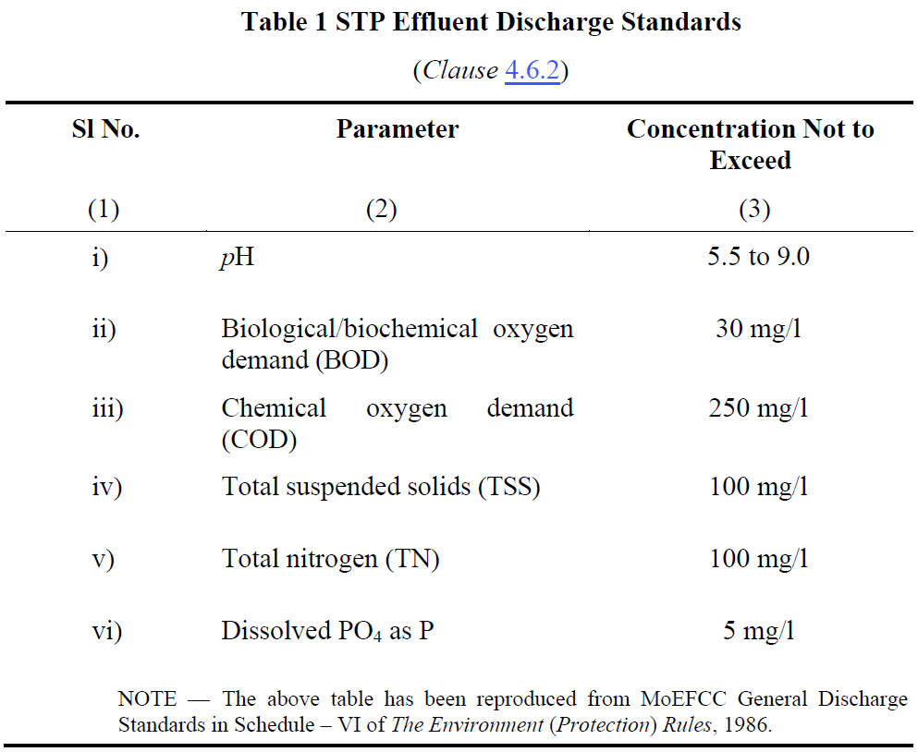
- Nutrient Removal: Controls nitrogen and phosphorus levels, mitigating risks of eutrophication.
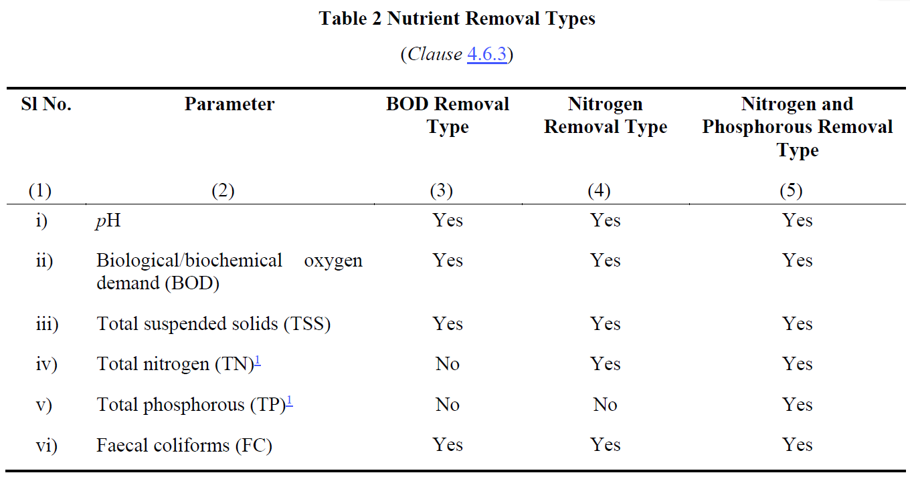
- Longevity and Sustainability:
- Durable Materials: Use of GFRP, PE, PP, and DCPD ensures systems endure harsh environments for 15+ years.
- Energy Efficiency: Declared power consumption promotes sustainable operations.
- Regulatory and Operational Confidence:
- BIS Certification: Builds trust among stakeholders, from manufacturers to users.
- Periodic Assessments: Ongoing monitoring of effluent quality ensures continued compliance and reliability.
- Design and Installation Guidelines
Design considerations for PSTPs
PSTP design prioritizes appropriate capacity, the ability to handle diverse inflow characteristics, and the production of high-quality effluent that meets stringent environmental standards.
- Capacity:
- Designed to serve a population equivalent to at least 5 individuals.
- Adequate sizing to store at least 6 months' sludge production without compromising performance.
- Flexibility to meet varying wastewater generation rates as per local authority regulations (e.g., 108 LPCD for residential areas).
- Inflow Characteristics:
- Handles raw sewage with standard characteristics:
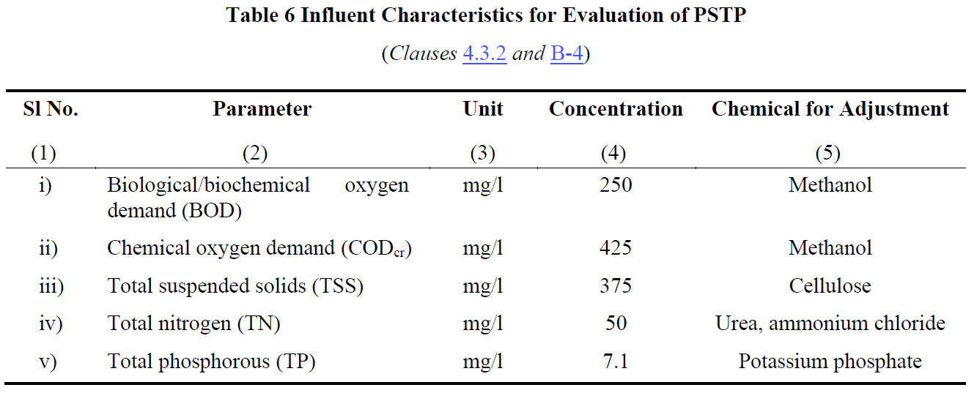
- Equipped to manage flow variations:
  - Normal flow (Q), low flow (0.5Q), and high flow (1.25Q) conditions during a 48-week evaluation period.
- Effluent Quality:
- Meets Ministry of Environment, Forest, and Climate Change (MoEFCC) General Discharge Standards:
- Final effluent ensures environmental protection and compliance with regulatory norms.
Installation
Proper installation and adherence to best practices ensure the long-term efficiency, safety, and reliability of PSTPs while minimizing operational challenges.
The manufacturer must provide installation instructions covering the following aspects:
- System installation, including other tanks for large capacities.
- Pipe and valve connections.
- Commissioning and start-up procedures.
- Properties of backfill material.
- Maximum backfill height.
- Suitability for dry/wet sites.
- Top load limitations.
- Maximum depth of extension shaft.
- Treatment efficiency.
- Anchoring arrangement.
- Foundation preparation.

- Operation, Maintenance, and Performance Monitoring
Regular operation, maintenance, and performance monitoring are critical for the efficiency, compliance, and longevity of PSTPs, ensuring they meet environmental and safety standards.
- Routine Operation:
- Ensure regular functioning of:
  - Pretreatment units (bar screens, grit chambers, oil/grease traps).
  - Pumps, blowers, and aeration systems.
  - Disinfection systems like UV, ozonation, or chlorination.
- Maintenance Schedule:
- Weekly:
  - Inspect pretreatment units for blockages or wear.
  - Check the operation of mechanical components (e.g., blowers, pumps).
- Monthly:
  - Clean air filters and inspect pipes for leaks or clogs.
  - Check filter media condition.
- Biannually:
  - Desludge the tank and inspect sludge levels.
  - Replace air filters and clean all chambers.
  - Inspect scum levels and remove any accumulation.
- Performance Monitoring:
- Conduct regular assessments of influent and effluent quality:
  - Key Parameters: pH, BOD, COD, TSS, Total Nitrogen, and Phosphorous.
  - Frequency: Weekly for critical parameters like BOD and COD.
- Monitor and maintain a record of sludge levels and scum accumulation.
- Regular assessments conducted in accordance with Indian Standards for accurate measurement of water quality.
- Documentation and Reporting:
- Maintain detailed records of maintenance activities, performance tests, and operational data.
- Ensure records are stored for a minimum of 5 years for compliance and troubleshooting.
- Best Practices:
- Use only trained personnel for maintenance tasks.
- Ensure adequate ventilation during maintenance.
- Follow safety protocols to prevent exposure to hazardous materials.
- Benefits and Challenges
Benefits:
- Cost-Effective Solution:
  - Reduces the need for extensive sewer networks.
  - Ideal for decentralized wastewater management.
- Environmental Protection:
  - Treats sewage to meet discharge standards, minimizing pollution.
  - Supports nutrient removal, reducing risks of water body eutrophication.
- Adaptability and Scalability:
  - Suitable for individual households, small communities, or specific industries.
  - Modular designs allow easy scaling based on population needs.
- Ease of Installation and Maintenance:
  - Prefabricated units simplify setup and reduce installation time.
  - Low-maintenance systems with long-lasting materials (e.g., GFRP, PE).
- Regulatory Compliance:
  - Ensures adherence to IS 18797 and environmental guidelines for effluent quality.
Challenges:
- Initial Investment:
  - Higher upfront costs compared to traditional septic tanks.
- Maintenance Requirements:
  - Regular desludging, inspections, and component checks needed to maintain efficiency.
  - Dependence on skilled operators for complex systems.
- Site-Specific Limitations:
  - Performance can be impacted by extreme environmental conditions, such as low temperatures or high water tables.
- Effluent Standards Monitoring:
  - Consistent monitoring of effluent quality is critical to avoid non-compliance.
- Energy Dependency:
  - Systems with aeration or disinfection units rely on stable energy supplies, increasing operational costs in energy-scarce areas.
- Conclusion and Q&A
Key Takeaway: PSTPs are essential for achieving sustainable and efficient wastewater management, with proper adherence to design, installation, and operational practices ensuring long-term success.
- PSTPs provide efficient on-site sewage treatment for decentralized systems.
- Compliance with IS 18797:2024 ensures safety, performance, and environmental protection.
- Primary Treatment, Secondary Treatment, Tertiary Treatment, Sludge Management.
- Capacity, inflow characteristics, and effluent quality tailored to local requirements.
- Best practices in installation ensure long-term system stability and efficiency.
- Routine checks for mechanical components, filter media, and sludge levels.
- Performance monitoring for compliance with discharge standards.
- Benefits and Challenges.

