Rainwater Harvesting Structures
Water : Some Facts
- Water is a basic human necessity, something that cannot be denied to people, because water is life
- Water is not free, it costs a lot… Managing water costs money, Treating it, Storing it, Pumping water … all of that costs money
- Severe water shortages around the world
- Cities in difficulty: Cape Town
Bengaluru , in Indian context
Tackle the water crisis - before it is too late
Rainwater Harvesting
- Practiced in various forms across different cultures and is increasingly being integrated into urban and rural planning, especially in water-stressed regions.
- Refers to the process of collecting and storing rainwater from rooftops, land surfaces, or other catchment areas using suitable storage systems like tanks, ponds, or groundwater recharge structures.
- The collected water can be used for drinking, irrigation, industrial purposes, or groundwater replenishment.
Importance of Rainwater Harvesting
- Crucial strategy for sustainable water management, effectively addressing water scarcity by capturing and utilizing rainwater.
- Reduces dependence on conventional water sources thereby promoting ecological balance.
Types of Rainwater Harvesting Systems
- Rooftop Rainwater Harvesting (RRWH)
- Surface Water Harvesting
- Groundwater Recharge Systems
The Standardization Context
- IS 15797: 2008 – Roof Top Rainwater Harvesting - Guidelines
Provides guidelines for designing and implementing groundwater recharge systems, including methods for capturing and infiltrating rainwater into the ground. It provides detailed instructions for the construction of recharge wells, pits, and trenches, and emphasizes the importance of groundwater conservation.
- IS 14961: 2024 – Surface Water Management in Hilly Areas (Including Rainwater Harvesting) — Guidelines
Provides comprehensive guidelines for sustainable surface water management in hilly regions, including methods of rainwater harvesting.
- National Building Code of India
ROOFTOP RAINWATER HARVESTING
IS 15797 : 2008
ROOF TOP RAINWATER HARVESTING–GUIDELINES
Scope:
This standard lays down guidelines for roof top rainwater harvesting.
The Standard outlines the following ways of rainwater storage:
- Storage of water in a storage tank for direct use
- Recharge of harvested rainwater in Aquifers
Rooftop Rainwater Harvesting (RRWH)

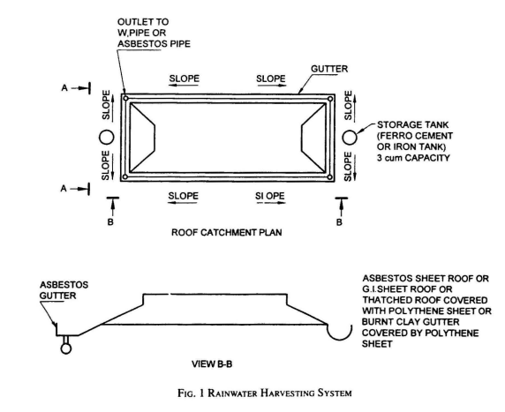
General Design Features

1) STORAGE OF WATER IN A STORAGE TANK FOR DIRECT USE:
Following aspects are covered:
- Design of System Components (Roof, Guttering and First-Flush Device, Tank (Manhole, Overflow pipe & Drain pipe))
- Site Assessment (Availability of suitable roof catchment, Foundation Characteristics, Estimated runoff to be captured, Availability of construction material)
- Estimating the Size of the Required System
- General Design Features
- Management and Maintenance
Annual Rainfall (Delhi)- 600mm (600 l/ sqm)
Roof area - 100 sqm
Harvesting efficiency- 80%
Volume of water harvested = 600 x 100 x 0.8 = 48,000 litres
Min. water requirement (WHO Guidelines) = 20 litres per capita per day (basic hygiene & food needs)
Avg urban consumption = 135 lpcd (45 lpcd flushing requirements)
(source: IS 1172: 1993 Code of Basic Requirements for water supply, drainage and sanitation)
Volume of the tank can be calculated by the formula:
V = t x n x q
where
V = volume of tank, in litres;
t = length of the dry season (days);
n = number of people using the tank; and
q = consumption in litres per capita per day.
If, for example, 20 lpd (q) is agreed upon and a dry period of 100 days (t) is normally not exceeded, a storage volume of 10 m3 would be required for a family of 5 members (n).
V =100 (t) x 5 (n) x 20 (q) =10 000 litre or 10 m3
2) RECHARGE OF HARVESTED RAINWATER IN AQUIFERS
- Design of Efficient Artificial Recharge Structures
- Types of Recharge Structures
a) Recharge pits ;
b) Recharge trenches;
c) Recharge through dry or operational dug wells ;
d) Recharge through abandoned/existing tubewells; and
e) Recharge wells
- Filters
- Maintenance of Recharge Structures
Requirements of the Standard (which can be verified)
Design of System components
- Roof
- Guttering and First-Flush Device
- Tank
- Site assessment
- Estimating the Size of the Required System
- General Design Features
- Management and Maintenance
- Recharge of harvested rainwater in Aquifers
Check List for Compliance to IS 15797


Techniques and Structures for Surface Water Management
IS 14961: 2024 – Surface Water Management in Hilly Areas (Including Rainwater Harvesting) — Guidelines
Scope:
This standard provides guidelines for surface water management in hilly areas, with a focus on sustainable practices and the integration of rainwater harvesting techniques.
Types of Water Conservation Structures addressed
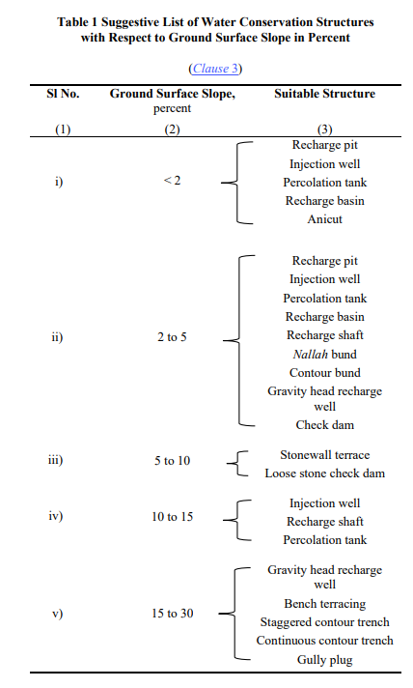
Recharge Pits
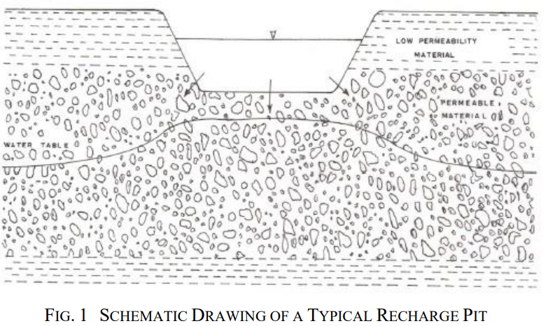
Recharge pits are closed well like structure, which is covered by filling the stones, after digging the pit. It allows the rainwater to recharge the groundwater. The pit, if aimed for recharging the bore well, must be constructed near the bore well, as close as possible.
The site is well suited if:
- It has a sufficiently clean and large catchment area;
- The location permits fast infiltration and percolation of water; and
- In a more ideal situation, it is in the valley of the surface layout.
Injection Wells
Injection wells are structures similar to bore wells or tube wells and are constructed for augmenting the groundwater storage in deeper aquifers through supply of water either under gravity or under pressure. Types:
Gravel-packed injection wells in alluvial areas.
Fracture-based recharge wells in hard rock areas.
Design Considerations:
Sealed upper sections to prevent leakage.
Suitable for coastal areas to prevent seawater ingress.
Limitations:
Effectiveness depends on aquifer properties.
Percolation Tanks
Artificially created small surface water body submerging a highly permeable land so that surface runoff is made to percolate and recharge the ground water storage.
Key Features:
  - Typically 0.1–0.5 million cubic meters in capacity.
  - Best suited for fractured, weathered rock terrain.
Important aspects to consider:
  - The aquifer to be recharged should have sufficient thickness (about 3 m) of permeable vadose zone to accommodate recharge.
  - The recharge area downstream should have sufficient number of wells and cultivable land to benefit from the augmented ground water.
  - The size of percolation tank should be governed by percolation capacity of strata in the tank bed; and
  - To minimize the silting at the bottom of the tank, soils in the catchment area should preferably be of light sandy type.
Uses:
  - Recharge groundwater in agricultural zones.
  - Minimize evaporation losses.
Recharge Basins
- Temporarily store runoff but release at least a portion of that runoff by infiltrating the water into the ground.
- The recharge volume is stored and allowed to infiltrate into the underlying soils over a period of time following a storm event. The storage volume above this level may be released by an outlet structure designed to bypass all excess flows.
Design Aspects:
  - Constructed with permeable soils to prevent flooding.
  - Include outlets for excess water.
Applications:
  - Commonly used in areas prone to high runoff.
Anicuts
Small dam-like structures built across rivers to store water for supplemental uses.
Purpose:
Irrigation, groundwater recharge, and wildlife support.
Benefits:
Increase water residence time and reduce downstream erosion.
Recharge Shafts
Vertical shafts dug into low-permeability strata to augment deeper aquifers.
Construction:
Backfilled with coarse materials like gravel and boulders.
Designed to intercept more permeable layers.
Cost-effectiveness:
Suitable for areas with deep water tables.
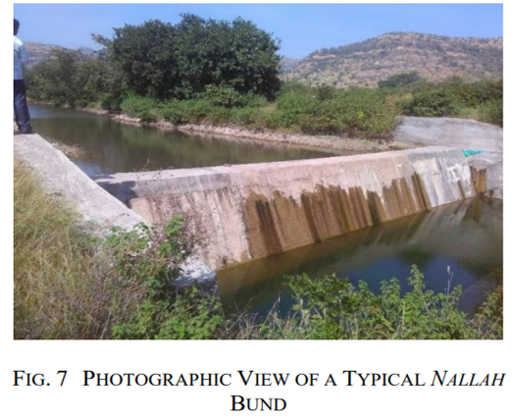
Nallah Bunds and Contour Bunds
Nallah Bunds: Bunds constructed across streams to hold water and prevent erosion.
Contour Bunds: Linear embankments on slopes to break the slope length and enhance soil moisture.
Applications:
Suitable for arid and semi-arid regions and Minimize water runoff and improve soil conservation.
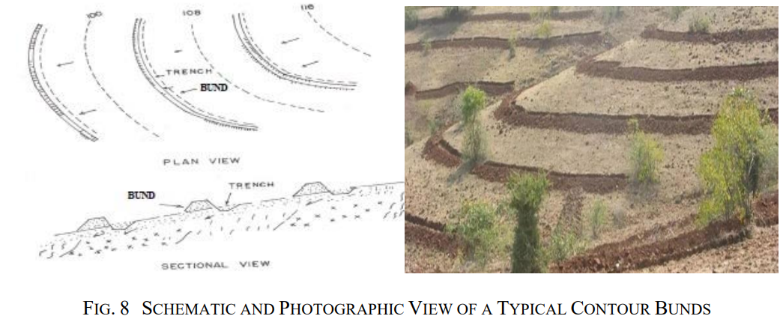
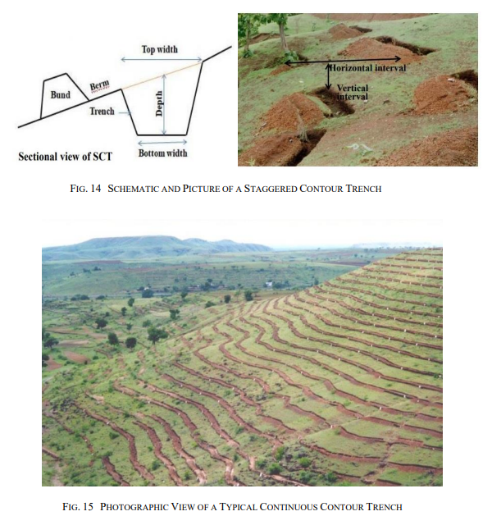
Stonewall and Bench Terracing
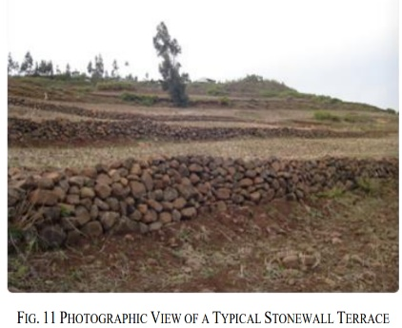
- Stonewall Terrace: Protects slopes with stone structures to conserve soil moisture.
- Bench Terracing: Creates level platforms on slopes for agriculture.
- Purpose:
  - Control erosion.
  - Enable cultivation on steep terrain.
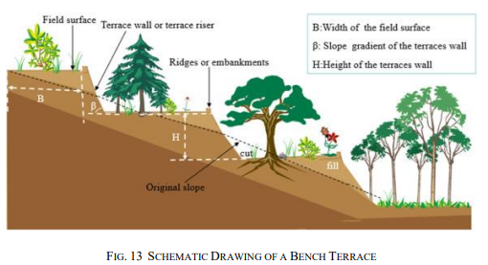
Loose Stone Check Dams and Gully Plugs
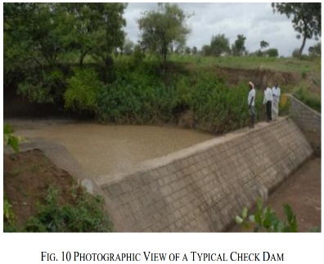
- Loose Stone Check Dams: Small barriers across gullies made of stones to slow water flow.
- Gully Plugs: Temporary dams to conserve soil and water in hilly terrain.
- Benefits:
  - Reduce erosion.
  - Enhance water retention in soil.
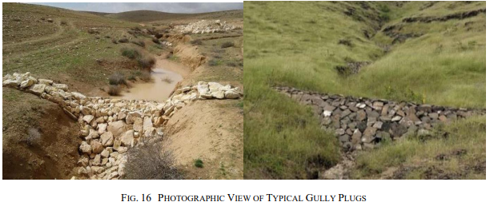
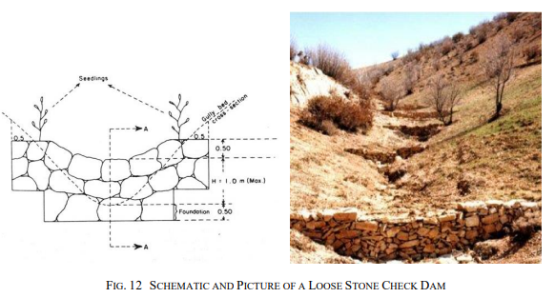
Roof Top Rainwater Harvesting Systems
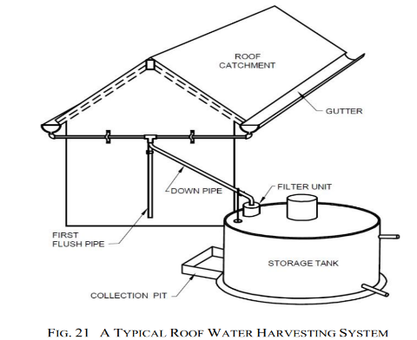
Rainwater from rooftops is collected and stored for domestic or agricultural use.
Components:
Catchment: Roof surface for rain collection.
Gutters and Downpipes: Transport water to storage tanks.
Filters: Remove debris and improve water quality.
Storage Tanks: Overground or underground structures for holding harvested water.
Maintenance:
Regular cleaning of filters and tanks to prevent contamination.
IS 14961: 2024 – Surface Water Management in Hilly Areas (Including Rainwater Harvesting) — Guidelines
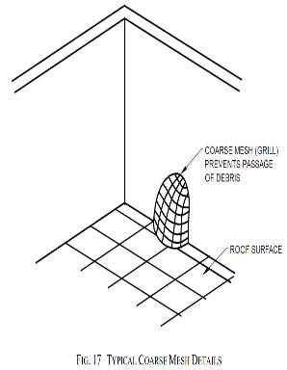
5.2.1 Catchment
The catchment of a roof top water harvesting system is the roof surface which directly receives the rainfall and provides water to the system. The style, construction and material of the roof determine its suitability as a catchment.
5.2.2 Coarse Mesh
It is provided at the roof to prevent the passage of debris to storage tank (Fig. 17). The approximate size of course mesh is 850 microns (20 mesh). The minimum size of mesh should be 100 microns for proper filtration of water.
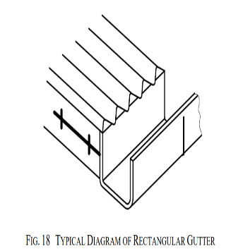
5.2.3 Gutters
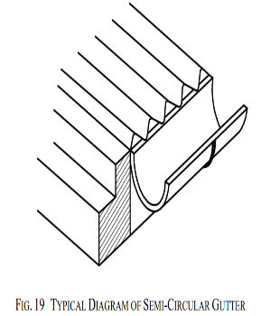
These are channels all around the edge of a sloping roof to collect and transport rainwater to the storage tank. Gutters can be a semi-circular or rectangular gutter (Fig. 18 and Fig. 19). They are provided with an end cap.

5.2.4 Down Pipes (Drain Pipes)
- Pipe that carries the rainwater from the gutters to the storage tank.
- It is joined with the gutters at one end, whereas the other end is connected to the filter unit of the storage tank.
5.2.6 Filtration Unit
- To keep water clean, prevent clogging and sediment buildup, basic filtration is needed.
- The type and number of filtering components on a system depend on the amount of roof debris.
- 5.2.7 Storage Tank
- These are provided to store the harvested water.
- The typical maximum size for a domestic system is 20 or 30 cubic metres.
- The size of the tank depends upon factors like daily demand, duration of dry spell, catchment area and rainfall.
- It will also depend upon a number of technical and economic considerations such as space availability, options available locally, local traditions for water storage, cost of purchasing new tank, cost of materials, labour for construction, materials and skills available locally, ground conditions and use of rainwater harvesting.
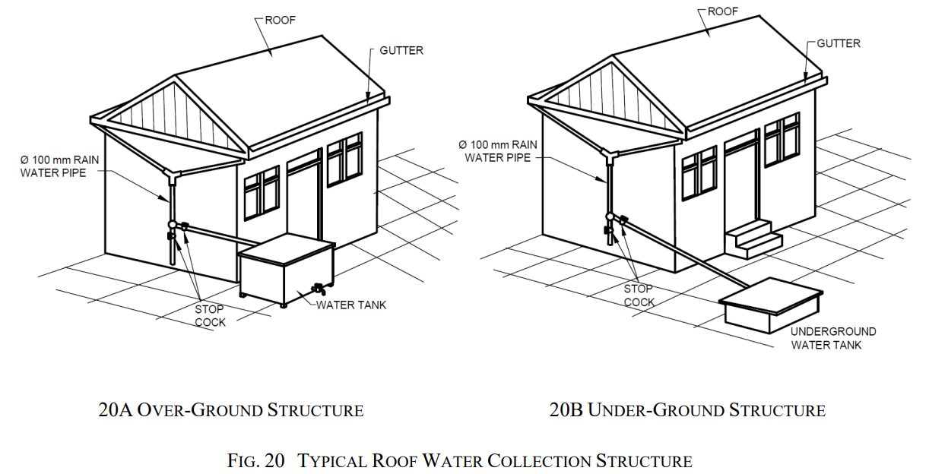
5.2.5 First Flush
Incorporated to avoid contaminating storable/rechargeable water by the probable contaminants of the atmosphere and the catchment roof so that it does not enter the storage tank.
Design Considerations for Rainwater Harvesting and Surface Water Management
Designing a rainwater harvesting system or surface water management structure requires careful consideration of multiple factors to ensure efficiency, sustainability, and long-term utility.
Catchment Suitability
The type and condition of the catchment area (usually a roof or designated surface) significantly impact the efficiency of the system.
Material Selection:
Ideal materials: Corrugated iron sheets, tiles, asbestos sheets, or concrete.
Avoid thatched roofs as they shed material and may contaminate water.
Painted roofs should use non-toxic paints to avoid chemical contamination.
Slope and Shape:
Gentle slopes (10°–30°) allow smooth water flow to collection points.
Steeper slopes (>30°) may cause overflow and water loss.
Maintenance:
Regular cleaning of the catchment area to prevent debris accumulation.
Avoid areas where birds nest to minimize contamination.
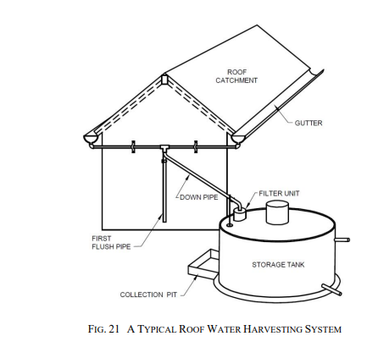
Estimating Quantity of Harvestable Water
Effective design involves calculating the potential volume of rainwater that can be harvested.
Key Formulas:
Rainwater Endowment (m³) = Catchment Area (m²)× Annual Rainfall (m)
Harvestable Water Potential (m³) = Rainwater Endowment× Runoff Coefficient (0.7 to 0.9)
Effectively Harvested Water (m³) = 0.8× Harvestable Water Potential
Runoff Coefficient: Smooth and non-porous materials have higher coefficients (e.g., metal or tiles). Porous or uneven surfaces, such as thatched roofs, have lower coefficients.
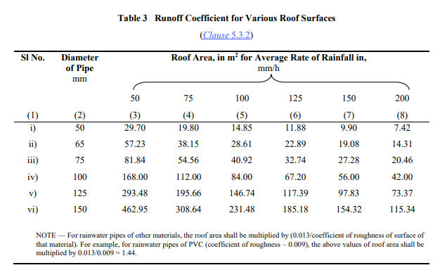
Storage Design
Storage is a critical component, requiring careful planning based on the anticipated volume and usage.
Capacity Considerations:
Calculate based on catchment area, rainfall, daily consumption, and dry periods.
Example formula for demand-based sizing:
S=C×n×D
where
S is storage capacity,
C is per capita daily consumption,
n is the number of people, and
D is the longest dry period (days).
Storage Types:
Above-ground tanks: Easier inspection and maintenance but require more space.
Underground cisterns: Space-efficient but harder to inspect and clean.
Gutters and Downpipes
Efficient water conveyance systems ensure minimal loss and contamination.
Gutter Design:
Material: Galvanized iron, PVC, or bamboo.
Shape: Semi-circular or rectangular for optimal water flow.
Slope: A recommended slope of 6 mm per 3,000 mm ensures effective drainage.
Size: Over-design gutters by 10–15% to handle peak rainfall intensities.
Downpipes:
Typically PVC or galvanized iron pipes.
Ensure proper joining with gutters to avoid leaks.
Sized based on the maximum expected rainfall intensity and roof area.
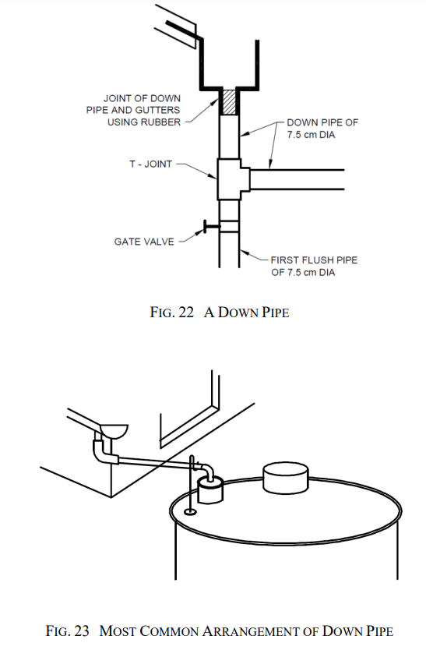
Filtration Units
Filtration is critical to ensure harvested water is clean and usable.
Types of Filters:
  - Sand-Gravel Filters: Effective for sediment removal, constructed with layers separated by wire mesh.
  - Charcoal Filters: Adsorb pollutants and improve water quality.
  - Sponge Filters: Suitable for residential setups, using a sponge layer for debris filtration.
  - Piped Filtration Units: Pressure-based systems used in large-scale setups.
Placement:
Filters should be located immediately before the storage tank or recharge pit.
Regular cleaning of filters is essential to maintain efficiency.
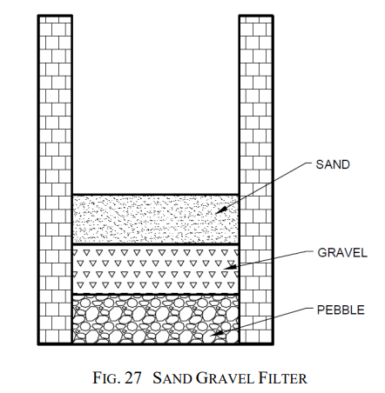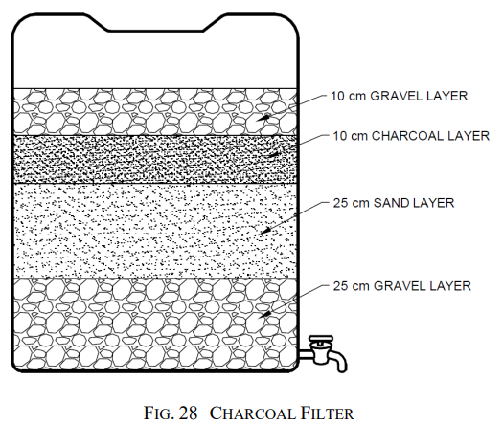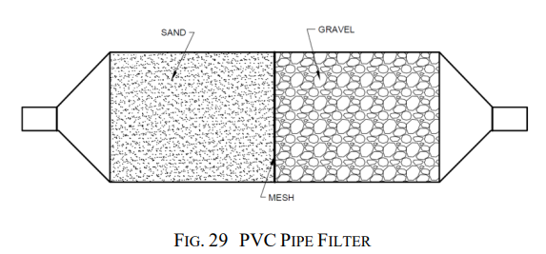

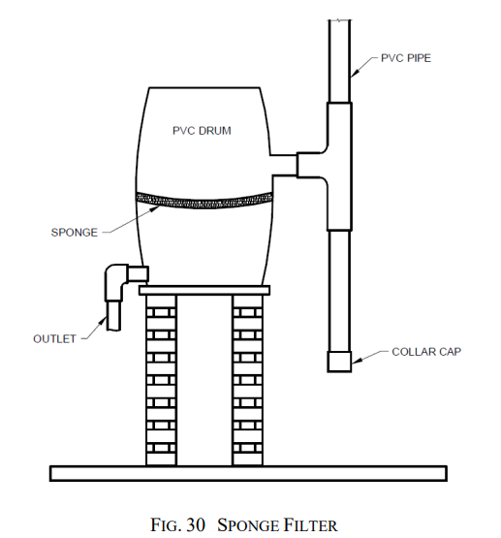
First Flush Mechanism
To prevent initial contaminants from entering the storage system, a first flush mechanism is crucial.
Methods:
Manual diversion of initial rainwater.
Automatic systems using tipping gutters, floating ball devices, or vertical diversion pipes.
Design Tip:
Include this mechanism at each downpipe to optimize efficiency.
IS 14961: 2024 – Surface Water Management in Hilly Areas (Including Rainwater Harvesting) — Guidelines
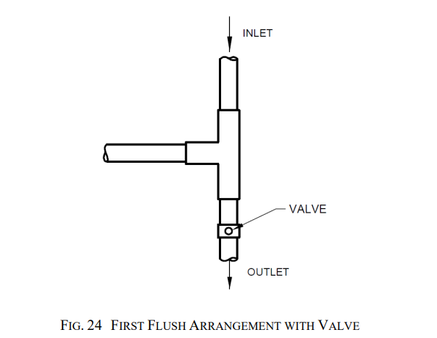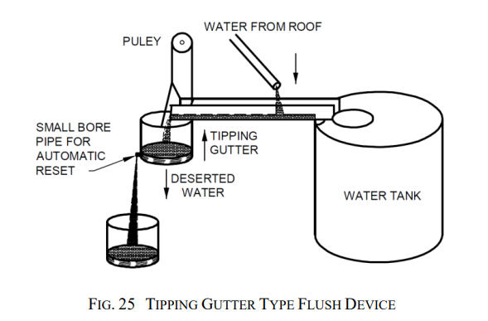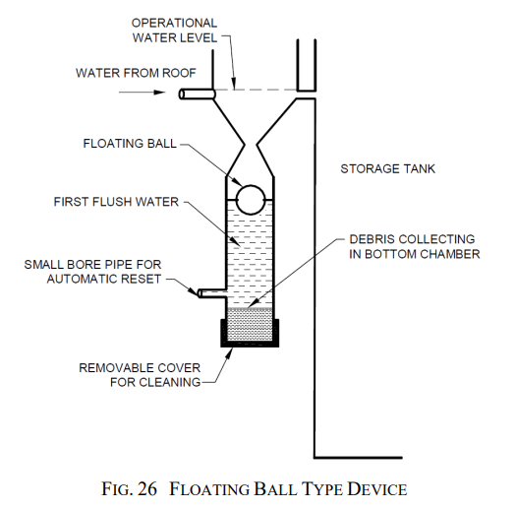

Storage tanks

Storage tanks: Specifications

Structural Stability
Ensure the stability of all components to avoid failures.
Tank Placement:
Above-ground tanks should be on level, stable platforms to avoid tilting.
Underground tanks must be waterproof and designed to withstand soil pressure.
Reinforcement:
Use high-grade materials such as reinforced cement concrete (RCC) for durability.
IS 14961: 2024 – Typical Roofing Material
- Galvanized steel strips and sheets as per IS 277;
- Corrugated and semi — Corrugated asbestos cement sheets as per IS 459;
- Corrugated aluminium sheet as per IS 1254;
- Asbestos cement flat sheets as per IS 2096;
- Hollow clay tiles as per [see IS 3951 (Part 1) and (Part 2)];
- Roofing slate tiles as per IS 6250;
- Corrugated coir wood wool cement roofing sheets as per IS 10388;
- Corrugated bitumen roofing sheets as per IS 12583;
- Silica-asbestos-cement flat sheets as per IS 13000;
- Shallow corrugated asbestos cement sheets as per IS 13008;
- Clay roofing country tiles, half round and flat tiles as per IS 13317;
- Continuously pre-painted galvanized steel sheets and strips as per IS 14246;
- Fibre cement flat sheets as per IS 14862; and
- Fibre reinforced cement sheets as per IS 14871.
Material Selection
Materials must be durable, cost-effective, and locally available.
Roofing Materials:
Corrugated sheets, tiles, or concrete are preferred.
Avoid materials that release harmful substances.
Gutter and Pipe Materials:
Non-corrosive materials such as PVC, HDPE, or GI are ideal.
Tank Materials:
For large capacities: RCC or ferrocement.
For small capacities: Plastic or steel.
5.5 Recharge Structures
- For selecting the site and type of recharge structures knowledge of hydrological and geological features of the area (aquifers) is required.
- The aquifers best suited for the purpose are those which absorb large quantity of water but do not release the same quickly.
- The various recharge structures are:
  - Abandoned dug well;
  - Hand pump/bore well;
  - Recharge pit;
  - Recharge trench;
  - Gravity head recharge tube well; and
  - Recharge shaft.
5.6 Operation and Maintenance
Frequency:
Regularly clean gutters, filters, and tanks before and during the rainy season.
Inspection:
Periodically check for leaks, rust, and blockages in gutters and pipes.
Disinfection:
Use chlorine or potassium permanganate for tank cleaning. The quantity of bleaching powder to be added for different water depths in the storage tank is shown in Table 5
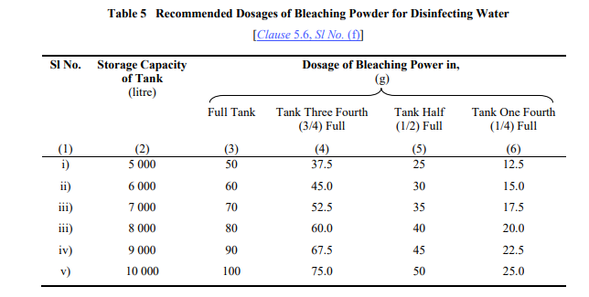
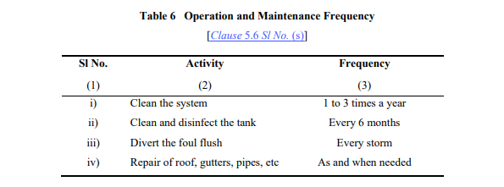
Environmental and Safety Considerations
Site Location:
Avoid locating systems near septic tanks or other contamination sources.
Ensure the area is clean and away from cattle sheds.
Overflow Management:
Install an overflow pipe connected to non-flooding areas or recharge systems.
Child Safety:
Cover storage tanks and gutters to prevent accidents.
5.7.1 Do's for Rainwater Harvesting

5.7.2 Don’ts for Rainwater Harvesting

National Building Code – RWH
Part 2 Administration
Section 3 Permit & Inspection
12.2.6 Service Plan of buildings to include details of rainwater system
Part 9 Plumbing Services
Covers details of RWH such as
- Groundwater recharge
- Rooftop rainwater harvesting
Regulatory Authority

Steps taken by the Govt. to make rain water harvesting mandatory

Regions which have made rainwater harvesting mandatory
- Andhra Pradesh, Gujarat, Haryana, Himachal Pradesh, Kerala, Madhya Pradesh, Maharashtra, Tamil Nadu, Ranchi Regional Development Authority, Bombay Municipal Corporation and Pimpri – Chinchwad Municipal Corporation, Municipal Corporation of Ludhiana, Jalandhar, Jaipur Municipal Corporation, Mussorie Dehradun Development Authority, and Union Territories of Delhi, Daman & Diu and Puducherry
- These have made necessary provision in their building bye-laws to make installation of rain water harvesting system mandatory.
Rainwater Harvesting Provisions in Delhi
Regulations from Ministry of Urban Development
- Mandatory for all NEW buildings or plots of 100 sqm
Regulations from Delhi Jal Board
- Water permission to be granted to new house, only when a certificate given by the concerned Zonal Engineer, DJB that applicant has provided the requisite systems in the building plans sanctioned by MCD/DDA
- Failing to install RWH structure invites penalty of 1.5 times the water bill for 500 sq. m and above
- Where water table is reasonably high (shallower than 5m ), (East Delhi, Okhla, Civil Lines, etc), RWH is voluntary
- Rebate of 10% of water bill for properties above 100 sq m for installing functional RWH structure
- Rebate of 10% of water bill for each member of society, if the residential society has installed a functional RWH structure
Best Practices for Rainwater Harvesting Systems
- Size Systems Appropriately:
  - Design the system to match the local rainfall pattern, roof area, and water consumption needs. IS 15797: 2008 provides detailed guidelines on calculating water collection potential based on roof area and expected rainfall.
- Quality Filters and First Flush Mechanism:
  - Install filters and a first flush diversion system to reduce contamination. IS 14961: 2024 emphasizes the importance of high-quality filtration systems for the safe use of harvested rainwater.
- Regular Maintenance:
  - Clean gutters, pipes, filters, and tanks periodically to avoid blockages and contamination. Check for leaks and ensure that the first flush system is working efficiently.
- Proper Storage:
  - Use food-grade, UV-resistant tanks for water storage to prevent algae growth and ensure water quality.
- Groundwater Recharge:
  - Encourage the use of recharge wells and percolation pits to enhance groundwater replenishment, as outlined in IS 14961: 2024

