Sanitation Solutions: Rotationally Moulded Polyethylene Septic Tanks and IS 18666
- Introduction to Polyethylene Septic Tanks
Overview - This session equips participants with a comprehensive understanding of polyethylene septic tanks, IS 18666 standards, and their application for sustainable wastewater management.
- Introduction to Polyethylene Septic Tanks – Definition and advantages,
- Overview of IS 18666 Standards – Scope, material specifications, design requirements, Design and Manufacturing Process – design principles, load requirements, compliance significance,
- environmental impact; rotational moulding steps,
- Installation and Maintenance Guidelines, cost-effectiveness, long-term benefits.
Introduction - Sanitation refers to the systems, practices, and infrastructure used to manage human excreta, wastewater, and solid waste in a safe and hygienic manner. Its primary goal is to protect human health, prevent environmental contamination, and ensure dignity. Sanitation is more than infrastructure; it is about dignity, health, and a commitment to building a safer, cleaner world for all.
Owing to the limited access of a high share of urban and rural population to sewerage systems in India, strengthening the ecosystem for non-networked sanitation becomes imperative.
Non-sewered sanitation systems (NSS) are on-site sanitation solutions that operate without the need for a connection to a centralized sewer system. They are designed to safely manage human waste and provide hygienic services in areas lacking conventional sewer infrastructure and operate independently of piped sewer networks. They Include containment, emptying, transport, treatment, and disposal/reuse of waste and are adaptable to various environmental and socio-economic contexts. Additionally, they can also be used in integration with centralized sewer systems leading to reducing load on sewage treatment plants (STPs).
Non-sewered sanitation systems are critical to addressing global sanitation challenges, particularly in under-served communities, while contributing to health, dignity, and environmental preservation.
To facilitate the achievement of the desired public health and environmental outcomes through non-networked sanitation, it is crucial to safeguard the quality of existing on-site sanitation systems. Furthermore, the varying characteristics of settlements, hydrogeology, and environmental sensitivity necessitate innovations in product design to respond to the needs of these diverse contexts.
A septic tank is an underground system designed to treat wastewater from homes or businesses, especially in areas without municipal sewage systems. It consists of three main components: Inlet Pipe, Septic Tank Chamber, and Outlet Pipe.
Basic Functioning of a septic tank is as below:
- Separation: Solid waste is separated from liquid waste.
- Treatment: Biological bacteria break down solids inside the tank.
- Filtration: Effluent is further treated and filtered through soil in the drain field.
Proper maintenance is essential to prevent issues such as backups, clogs, and contamination, ensuring both environmental protection and public health.
Polyethylene tanks are a popular choice for septic systems due to their numerous advantages:
- Durability:
  - Polyethylene is highly resistant to cracking, corrosion, and impact, making these tanks long-lasting and reliable in harsh environmental conditions.
  - They can withstand extreme temperatures and chemical exposure, providing years of service without degradation.
- Cost-Effectiveness:
  - Polyethylene tanks are generally more affordable than tanks made from materials like concrete or fiberglass, offering a cost-effective solution for homeowners and businesses.
  - Their long lifespan and minimal maintenance needs help reduce long-term costs.
- Ease of Installation:
  - Lightweight and easy to transport, polyethylene tanks are quicker and easier to install than heavier alternatives.
  - Their flexibility and resistance to damage during installation reduce the likelihood of costly repairs.
- Overview of IS 18666 Standards
Scope and Applicability of IS 18666:2024, “Rotationally moulded polyethylene septic tanks"
Introduction to IS 18666:2024:
"This standard has been developed by the Bureau of Indian Standards to address the growing reliance on on-site sanitation systems, both in urban and rural areas. It ensures the quality and performance of polyethylene septic tanks, which are widely adopted for decentralized wastewater treatment."
Scope:
- Design & Installation: Specifies requirements for design, materials, sizing, performance, and testing of septic tanks for underground use.
- Exclusions: Does not cover effluent disposal mechanisms, which require further treatment as per IS 2470 (Part 2).
Applicability:
- Supports on-site sanitation systems in urban and rural areas, especially where centralized sewerage is unavailable.
- Ensures environmental and public health protection by standardizing tank quality and performance.
Key standards for the design, material specifications, and construction requirements in IS 18666
Design Standards:
General Design: "The tanks are intended for underground installation and must ensure durability, watertightness, and effective wastewater treatment. Hydraulic retention time must be at least 24 hours, with a minimum sludge storage period of two years."
Inlets and Outlets: "Inlets and outlets should minimize disturbance of settled solids and prevent scum escape, with minimum pipe diameters of 110 mm for tanks up to 6,000 liters and 150 mm for larger tanks."
Ventilation and Access: "Adequate ventilation must be provided, and tanks must feature accessible openings for maintenance and inspection."
Material Specifications:
Primary Raw Materials: "The tanks must be made of polyethylene with a density of at least 0.935 g/cm³ and comply with environmental stress cracking resistance and UV stability requirements."
Additives: "UV stabilizers, antioxidants, and pigments must ensure durability, with carbon black content at 2.5% ± 0.5% for UV protection."
Construction Requirements:
Structural Strength: "The design must account for soil pressure, hydrostatic groundwater pressure, and thermal loads. A minimum wall thickness of 8 mm is required, with safety factors ranging from 3 to 5."
Shape and Dimensions: "Cylindrical tanks are preferred for durability, with a length-to-width ratio of at least 2:1 for rectangular tanks. All tanks must include a freeboard of at least 300 mm."
Compartmentation: "Tanks over 2,000 litres must have at least two chambers, with partitions designed to withstand mechanical desludging."
In summary, the standards ensure that septic tanks are robust, efficient, and safe for long-term wastewater management. By adhering to these guidelines, manufacturers and installers contribute to better public health and environmental sustainability.
- Design and Manufacturing Process
Let’s delve into the critical design considerations focusing on capacity, load-bearing requirements, and environmental impact.
Capacity:
Hydraulic Retention Time: "The tanks must provide a minimum retention time of 24 hours to settle solids and support anaerobic digestion."
Population and Usage: "Capacity should align with user requirements, with a minimum effective volume of 1,000 liters. For residential use, the recommended size increases with the number of users, ensuring proper sludge storage for at least two years."
Design Flexibility: "Designs must accommodate both blackwater and combined wastewater scenarios, as detailed in the standard."

Load-Bearing Requirements:
Structural Strength: "Septic tanks must withstand vertical and lateral soil pressure, hydrostatic groundwater pressure, and any surcharge loads. The minimum design must accommodate 18 kPa of soil loading per meter of depth."
Wall Thickness: "A minimum wall thickness of 8 mm is required, with a safety factor of 3 to 5 to ensure durability under varied stress conditions."
Testing: "Load-bearing tests, including wet and dry conditions, ensure no structural failures occur under operational loads."

Environmental Impact:
Leakage Prevention: "The tanks must be watertight to prevent contamination of surrounding soil and groundwater, meeting stringent pneumatic and water-tightness testing requirements."
Material Selection: "Materials must be non-toxic, durable, and resistant to UV degradation to ensure long service life and minimal environmental impact."
Effluent Treatment: "Septic tanks are designed for primary treatment, but effluent must undergo secondary treatment before disposal to comply with environmental standards and reduce pollution risks."

Steps Involved in the Rotational Moulding Process
- Preparation of the Mould and Material: "Finely divided plastic powder is prepared and measured. The mould is cleaned and assembled, ensuring proper alignment."
- Loading: "The required amount of plastic powder is loaded into the mould. This powder must meet specific particle size and flow characteristics for even distribution."
- Heating and Rotation: "The mould is placed in a rotational moulding machine and simultaneously rotated on two axes while being heated. This ensures the plastic powder melts and coats the interior surface of the mould uniformly."
- Cooling: "After achieving the desired wall thickness, the mould is cooled while still rotating to solidify the plastic and prevent warping."
- Demoulding: "Once cooled, the mould is opened, and the finished product is carefully removed, ensuring no damage occurs during handling."

Quality Control Measures
- Material Specifications: "The base resin must meet density, melt flow index, and environmental stress cracking resistance requirements as specified in Indian Standard."
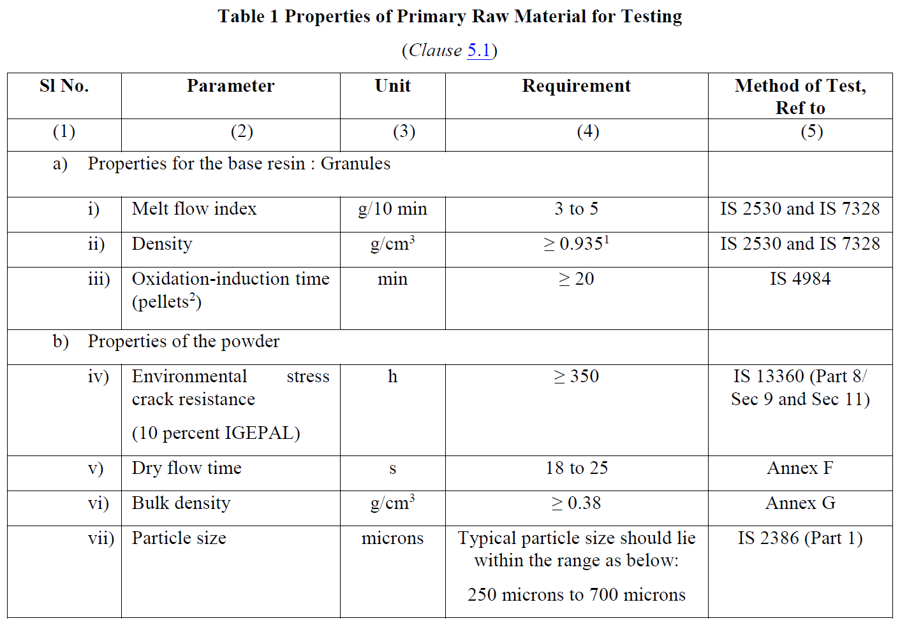
- Additives: "UV stabilizers, antioxidants, and pigments must be evenly distributed to ensure durability and performance."
- Dimensional Accuracy: "Regular checks ensure adherence to design specifications, including wall thickness, shape, and size tolerances of ±3%."
- Visual Inspection: "The surface of the tank is checked for defects such as air bubbles, cracks, or uneven coloration that could compromise performance."

Testing Procedures
- Water Tightness Tests: "Tanks are subjected to water and pneumatic pressure tests to ensure no leakage occurs under operating conditions."
- Load-Bearing Tests: "Vertical and lateral load tests verify the tank's structural integrity under soil and groundwater pressure."
- Hydraulic Efficiency: "Tests using simulated sludge confirm the tank’s ability to achieve efficient wastewater treatment."
- Material Properties Testing: "Tests for tensile strength, elongation, flexural modulus, and UV resistance ensure the tank can withstand environmental and operational stresses."
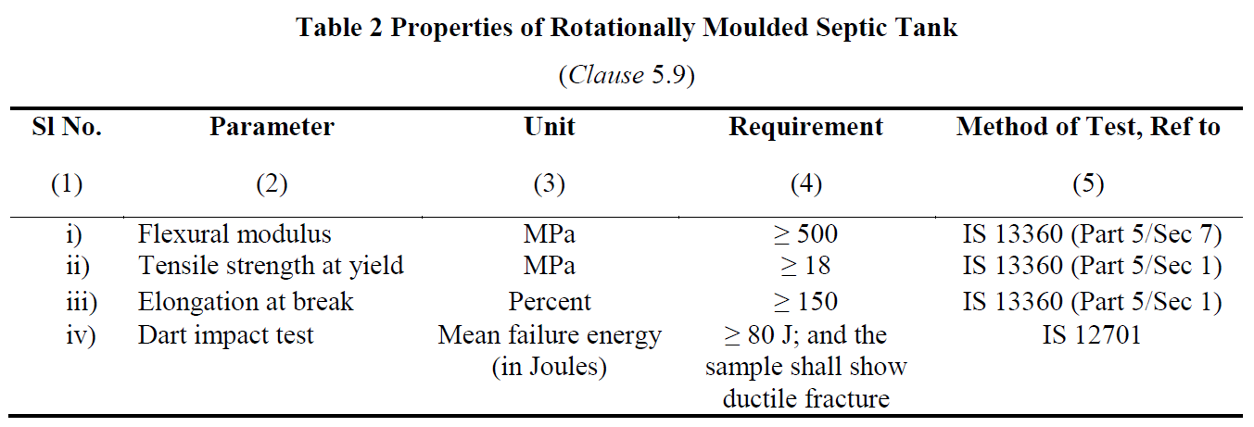
The rotational moulding process is a precise and controlled method, ensuring septic tanks meet the highest standards of quality and performance. Combined with rigorous testing, this process guarantees reliability and durability.
Advantages of rotational moulding include:
- Seamless Construction
- Material Efficiency
- Design Flexibility
- Cost-Effectiveness
- Structural Integrity

- Installation and Maintenance Guidelines
The manufacturer shall provide installation instructions with each septic tank, covering the following:
a) Installation, including duplicating tanks for larger capacities;
b) Pipe connections;
c) Commissioning and start-up;
d) Backfill material properties (Φ and ρ);
e) Designed water table level;
f) Maximum service temperature;
g) Tank depth;
h) Top load limits and maximum cover depth;
i) Hydraulic efficiency.

Maintenance and Troubleshooting

Routine maintenance and timely troubleshooting are key to ensuring the long-term performance and safety of septic tanks. By following the best practices, we can prevent costly repairs and safeguard public health.

Routine Maintenance Tasks
- Sludge Removal: "Periodic desludging is crucial to maintain the tank’s efficiency. Ideally, sludge should be removed every 2–3 years, depending on the tank’s usage and capacity. This prevents clogging and ensures the system operates effectively."
- Component Checks:
  - Inlets and Outlets: "Inspect inlets and outlets to ensure they’re clear and functioning properly, minimizing disturbance to sludge and scum layers."
  - Ventilation Systems: "Check vent pipes for blockages to avoid the buildup of harmful gases."
  - Access Covers and Seals: "Ensure covers are intact and sealed to prevent unauthorized access and water intrusion."
- System Cleaning:
  - Effluent Filters: "Clean effluent filters regularly to prevent the accumulation of solids in the disposal system."
  - Dispersion Trenches or Soak Pits: "Inspect and clean to maintain proper drainage of effluent into the surrounding soil."

Troubleshooting Common Issues
- Slow Draining or Backup:
  - Cause: Blockages in pipes or excessive sludge accumulation.
  - Solution: Check for blockages and schedule desludging if the sludge layer is too high.
- Foul Odors:
  - Cause: Poor ventilation or excessive buildup of scum and sludge.
  - Solution: Inspect and clean the vent pipe, and schedule routine maintenance.
- Surface Water Pooling:
  - Cause: System overload, poor soil absorption, or damage to the dispersion trench.
  - Solution: Reduce water usage, inspect the trench, and repair or extend it as needed.
- Structural Damage:
  - Cause: Soil pressure, improper installation, or physical impact.
  - Solution: Conduct a structural integrity assessment and repair or replace the tank if necessary.
- Frequent Clogging of Effluent Filters:
  - Cause: High solid content or improper cleaning.
  - Solution: Increase cleaning frequency and ensure filters are properly maintained.

Environmental Benefits
- Reduction in Pollution: "Septic tanks effectively treat wastewater on-site, preventing untreated effluent from contaminating groundwater or surface water."
- Support for Decentralized Sanitation: "By eliminating the need for large-scale sewer infrastructure, septic tanks reduce the ecological footprint of sanitation systems."
- Recyclable Materials: "Rotationally moulded polyethylene tanks are made from recyclable materials, minimizing environmental impact at the end of their lifecycle."
- Water Conservation: "The treated effluent can be safely reused for irrigation or groundwater recharge when paired with secondary treatment systems."

Cost Savings
- Lower Installation Costs: "Septic tanks are more affordable than centralized sewage systems, especially in rural or remote areas."
- Minimal Operating Costs: "They require no continuous energy supply, making them cost-efficient to operate and maintain."
- Reduced Infrastructure Dependency: "By treating wastewater on-site, households and communities save on utility bills and avoid infrastructure-related costs."
- Durability and Low Maintenance: "With proper maintenance, these tanks have a long service life, reducing the need for frequent replacements or repairs."

Long-Term Benefits
- Sustainability: "Septic tanks contribute to sustainable wastewater management by offering a decentralized solution that works efficiently for decades."
- Health and Hygiene: "Properly functioning septic systems prevent exposure to untreated waste, safeguarding public health in the long run."
- Property Value Enhancement: "A well-maintained septic system is an asset that adds value to properties, particularly in areas without access to centralized sewage systems."
- Flexibility in Expansions: "Septic systems can be adapted or upgraded as needs change, providing scalability for growing households or communities."

- Conclusion and Q&A (5 minutes)
We discussed the scope and applicability of IS 18666:2024, focusing on its standards for septic tank design, material specifications, and environmental impact. Key points included design considerations like capacity, load-bearing requirements, and maintenance practices. We also highlighted the benefits of rotational moulding, routine maintenance tasks, troubleshooting common issues, and the long-term environmental and cost-saving advantages of septic tanks.

Why follow Indian Standards

- Optimal Performance: Clear guidelines ensure efficient wastewater treatment.
- Durability: Tanks withstand environmental stresses, preventing failures.
- Public Health: Reduces contamination risks, safeguarding hygiene.
- Environmental Protection: Promotes sustainable and eco-friendly practices.
- Cost Savings: Minimizes maintenance and repair expenses.
- Regulatory Compliance: Aligns with policies, avoiding penalties.

