- INTRODUCTION

1.1 National Building Code of India in its Part 9/Section 2 ‘Plumbing Services, Section 2 Drainage and Sanitation’ covers the design, layout, construction and maintenance of drains for foul water, surface water, subsoil water and sewage together with all ancillary works, such as connections, manholes and inspection chambers used within the building and from building to the connection to a public sewer, private sewer, individual sewage-disposal system, cess-pool, soakaway or to other approved point of disposal/treatment work.

1.2 A sanitary drainage system consists of a building sewer, a building drain, a soil and/or waste stack, horizontal branches or fixture drain, and vents. The sanitary drainage of a large building may have a number of primary and secondary branches, and several soil and/or waste stacks, each of them in turn may have a number of horizontal branches.

- TYPES OF DRAINAGE PIPE SYSTEMS

2.1 The Code specifies that the pipe system to be adopted will depend on the type and planning of the building in which it is to be installed and can be one of the following:

  - Single stack system (see Fig. 1) – The piping system in which there is no trap ventilation and the stack itself acts as vent through roof. In this system care shall be taken for proper sizing of the pipes and the trap arm distance, specially the horizontal distance of sanitary fixtures from the drainage stack and vertical distance between connection of branches from fixtures to drainage stack.

  - One pipe – Partially ventilated system (see Fig. 2) – The piping system in which soil and waste pipes are connected to a single vertical stack with additional vent pipe for ventilation of traps of water closets.

  - One pipe – Fully ventilated system (see Fig. 3) – The piping system in which the waste pipes from the sinks, baths and wash basins, and the soil pipe from water closet are connected to a single vertical stack. The traps of the water closets, waste appliances, etc, are individually ventilated and connected with a separate stack to preserve the water seal.

  - Two pipe system

- Two pipe system with common vent pipe (see Fig. 4A) ‒ The piping system in which all soil appliances such as water closets, urinals, bidet and bedpan sinks are connected to soil stack and all other plumbing fixtures such as baths, sinks, and basins are connected to waste stack through deep seal trap. In addition, a common vent stack is provided for ventilation of soil and waste stacks.
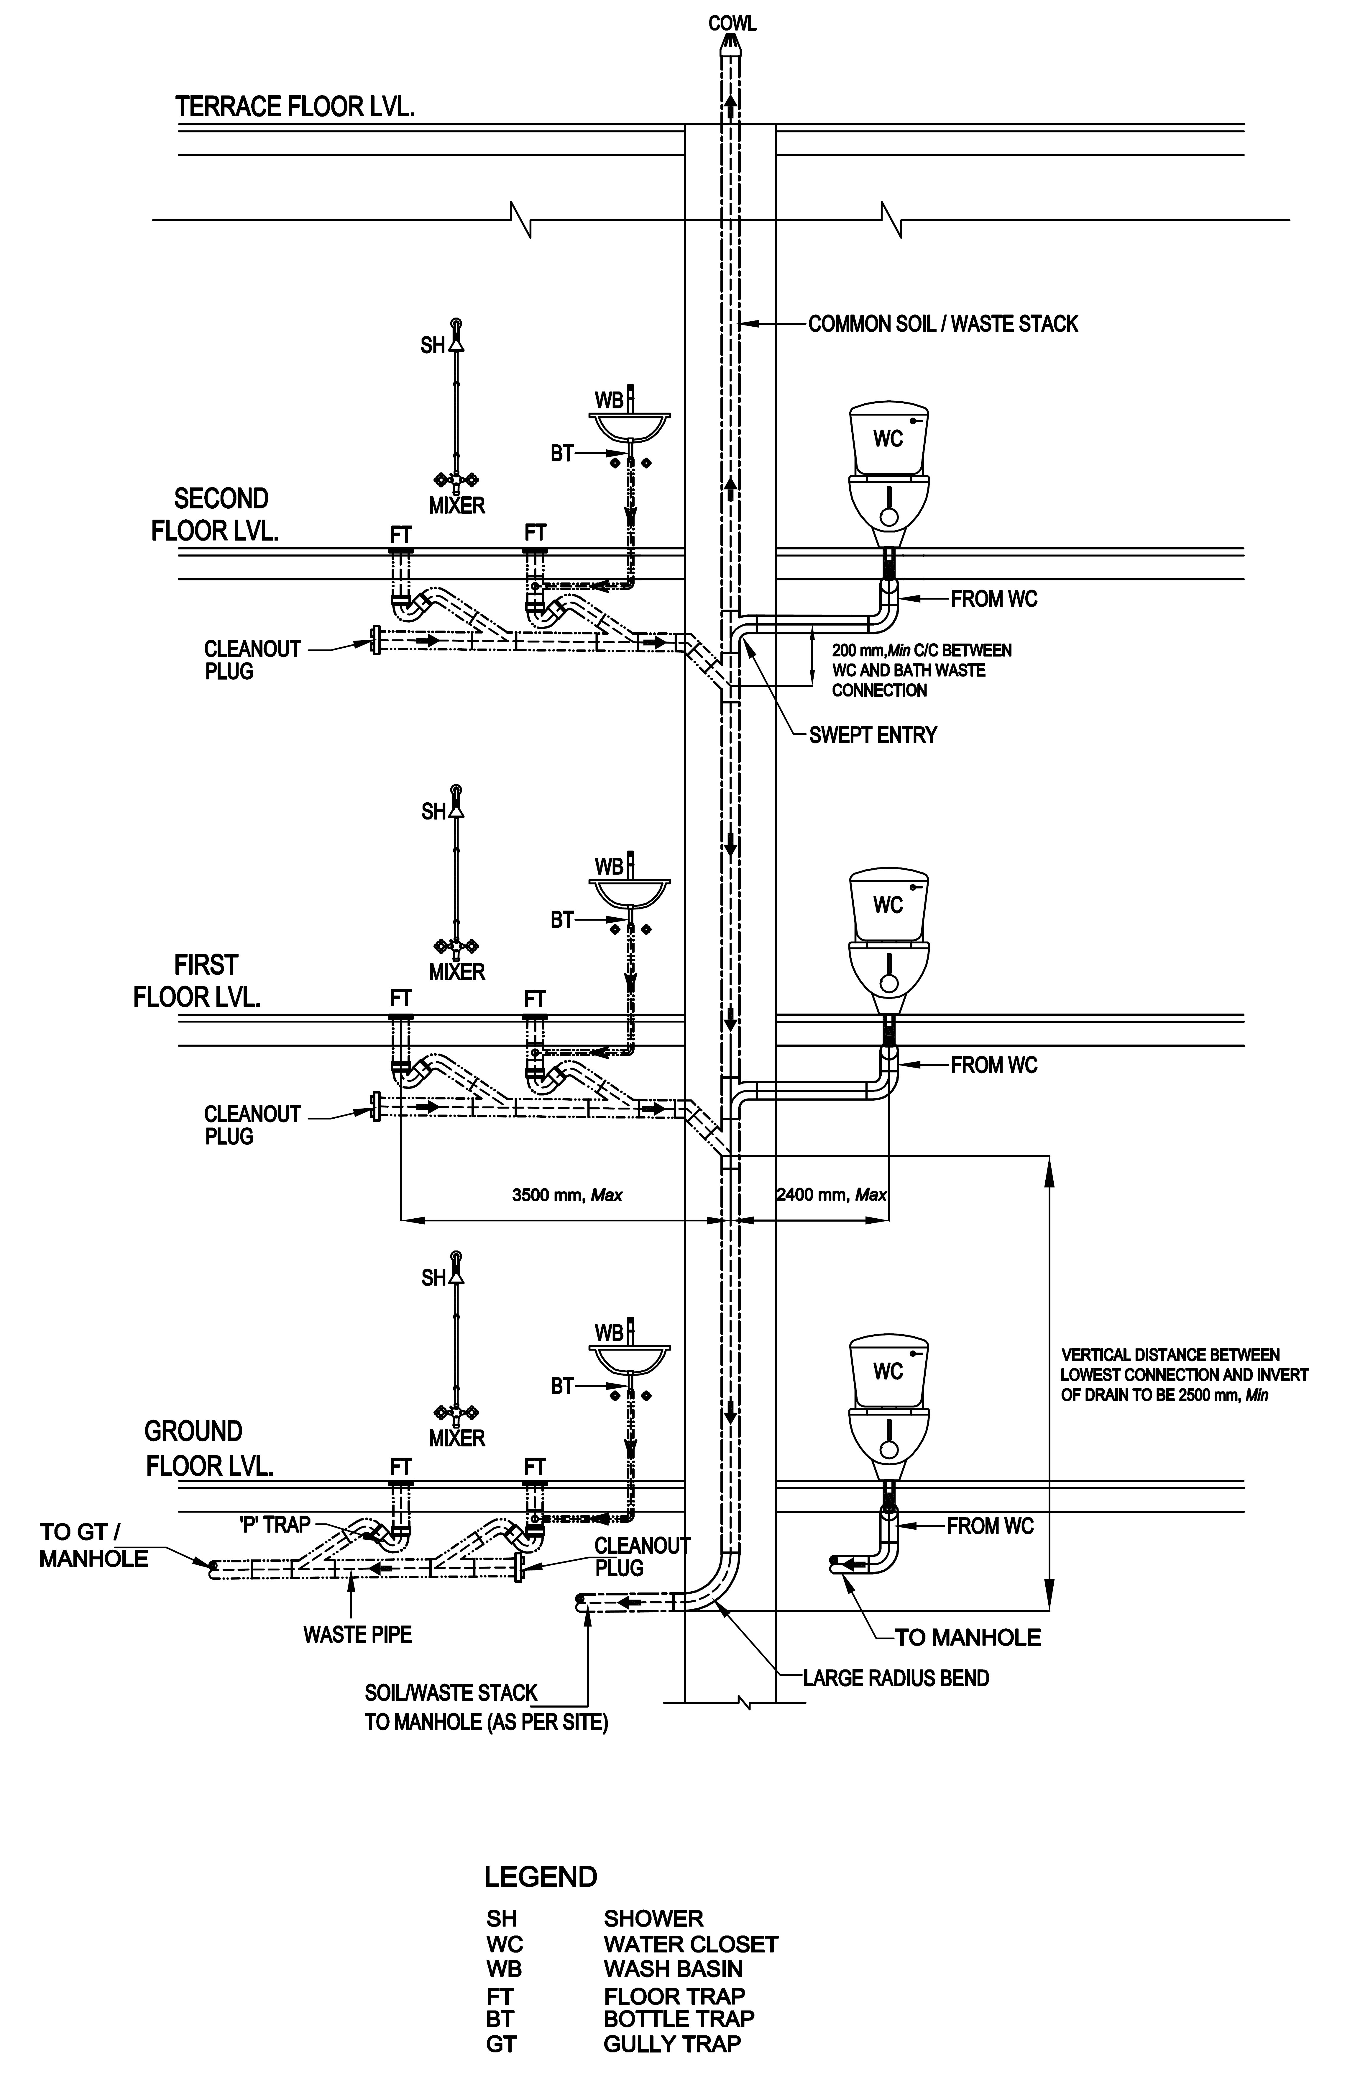

FIG. 1 SINGLE STACK SYSTEM
NOTES
1. Presentation of type of fixtures/drain and pipe route/layout is typical in nature.
2. Kitchen waste piping shall also be planned in a similar manner as for other waste appliance.

NOTES
1. Presentation of type of fixtures/drain and pipe route /layout is typical in nature.
2. Kitchen waste piping shall also be planned in a similar manner as for other waste appliance.

FIG. 2 ONE PIPE – PARTIALLY VENTILATED SYSTEM
From WC

NOTES
1. Presentation of type of fixtures/drain and pipe route /layout is typical in nature.
2. Kitchen waste piping shall also be planned in a similar manner as for other waste appliance.
3. The vent pipe shall be installed in the suspended ceiling or in the wall above toilet floor, depending upon space availability and structural arrangements.

FIG. 3 ONE PIPE – FULLY VENTILATED SYSTEM

- Two pipe system with independent vent pipes (see Fig. 4B) ‒ The piping system in which all soil appliances such as water closets, urinals, bidet and bedpan sinks are connected to soil stack, and all other plumbing fixtures such as baths, sinks, and basins are connected to waste stack through deep seal trap. In addition, there are independent vent stacks provided for respective ventilation of soil and waste stacks.

NOTES
1. Presentation of type of fixtures/drain and pipe route /layout is typical in nature.
2. Kitchen waste piping shall also be planned in a similar manner as for other waste appliance.

FIG. 4 TWO PIPE SYSTEM

3 BASIC PRINCIPLES FOR DESIGN OF DRAINAGE AND SANITATION

The Code covers the basic principles of water supply, drainage and sanitation and specifies that the design of drainage and sanitation should in general be guided by the applicable principles.

3.1.1 Potable Water

All premises intended for human habitation, occupancy, or use shall be provided with supply of potable water. This water supply shall not be connected with unsafe water resources, nor shall it be subject to the hazards of backflow.

3.1.2 Water Provision

Plumbing fixtures, devices and appurtenances shall be provided with water in sufficient volume and at pressures adequate to enable them to function properly and without undue noise under normal conditions of use.

There should be at least a residual head of 0.018 N/mm² at the consumer’s tap. There may be certain fixtures or appliances in the installation that may require a higher pressure, such as 0.05 N/mm² or even higher, in which case the system shall be designed using pumps, tanks or both to achieve the required minimum pressure.

NOTE – The residual head shall be taken at the highest/farthest outlets in the building.

3.1.3 Water Efficiency

Plumbing system shall be designed, installed and adjusted to use the optimum quantity of water consistent with proper performance and cleaning.

3.1.4 Safety Devices

Plumbing system shall be designed and installed with safety devices to safeguard against dangers from contamination, explosion, overheating, etc.

3.1.5 Minimum Amenities

Each dwelling unit on premises (abutting on a sewer or with a private sewage disposal system) shall have at least one water closet, one kitchen wash place or a sink, and one bathing place or shower to meet the basic requirements of sanitation and personal hygiene.

In case of a group housing, the requirements relating to toilet or sanitary room and kitchen as given in Part 3 ‘Development Control Rules and General Building Requirements’ of the Code shall also be complied with.

3.1.6 Drainage System

The drainage system shall be designed, installed and maintained to guard against fouling, deposit of solids and clogging and with adequate cleanouts so arranged that the pipes may be readily cleaned.

3.1.7 Materials and Workmanship

The plumbing system shall have durable material, free from defective workmanship and so designed and installed as to give satisfactory service for its reasonable expected life. The accessories of the plumbing system should be of such specifications as to meet the functional requirements of the installation, so as to also avoid any inconsistency leading to leakage and resultant seepage.

3.1.8 Fixture Traps and Vent Pipes

Each fixture directly connected to the drainage system shall be equipped with a liquid seal trap. Trap seals shall be maintained to prevent sewer gas, other potentially dangerous or noxious fumes, or vermin from entering the building. Further, the drainage system shall be designed to provide an adequate circulation of air in all pipes with no danger of siphonage, aspiration, or forcing of trap seals under conditions of ordinary use by providing vent pipes throughout the system.

3.1.9 Foul Air Exhaust

Each vent terminal shall extend to the outer air and be so installed as to minimize the possibilities of clogging and the return of foul air to the building, as it conveys potentially noxious or explosive gases to the outside atmosphere. All vent pipes shall be provided with a cowl.

3.1.10 Testing

The plumbing system shall be subjected to required tests to effectively disclose all leaks and defects in the work or the material.

3.1.11 Exclusion from Plumbing System

No substance that will clog or accentuate clogging of pipes, produce explosive mixtures, destroy the pipes or their joints, or interfere unduly with the sewage-disposal process shall be allowed to enter the drainage system.

3.1.12 Light and Ventilation

Wherever water closet or similar fixture is located in a room or compartment, it should be properly lighted and ventilated.

3.1.13 Individual Sewage Disposal Systems

If water closets or other plumbing fixtures are installed in buildings where connection to public sewer is not possible, suitable provision shall be made for acceptable treatment and disposal.

3.1.14 Maintenance

Plumbing systems shall be maintained in a safe and serviceable condition.

3.1.15 Approach for Use and Cleaning

All plumbing fixtures shall be so installed with regard to spacing as to be approachable for their intended use and for cleaning. All doors, windows and any other device needing access within the toilet shall be so located that they have proper approach.

3.1.16 Accessibility for Persons with Disabilities

All doors, windows and fixtures, including WC, urinals, grab bars, washbasin, mirror and all other accessories for use by persons with disabilities shall be so installed/located that they have proper access with appropriate width, height, space, centerlines, and ease of operation (see 13 of Part 3 ‘Development Control Rules and General Building Requirements’ of the Code).

3.1.17 Structural Safety

Plumbing system shall be installed with due regard to preservation of the structural members and prevention of damage to walls and other surfaces.

3.1.18 Protection of Ground and Surface Water

Sewage or other waste shall not be discharged into surface or sub-surface water without acceptable form of treatment.

4 PERMISSION FOR SANITARY OR DRAINAGE INSTALLATION

4.1 General

The Code specifies that no person shall install or carry out any water-borne sanitary installation or drainage installation or any works in connection with anything existing or new buildings or any other premises without obtaining the prior sanction of the Authority.

4.2 Application and Plans

The Code includes the format for application in which the Owner shall submit their application to the Authority. It also provides guidance on preparation of site plan and drainage plan to be submitted with the application. As per the Code, the following colours shall be used for indicating the different types of drainage pipes.

Description of Work Colour

Sewers Red
Waste water pipes and rainwater pipes Blue
Existing work Black

4.3 Alteration or Addition to an Existing Building

In the case of an alteration or addition to an existing building, this clause shall be deemed to be satisfied if the plans as furnished convey sufficient information for the proposals to be readily identified with previous sanctioned plans and provided the locations of tanks and other fittings are consistent with the structural safety of the building.

4.4 Specifications for Various Items

The Code further requires that the plans for the building drainage shall in every case be accompanied by specifications for the various items of work involved. The format for providing this information is also covered in the Code.

4.5 Licensed/Registered Plumbers

The Code further specifies that the work which is required to be carried out shall be executed only by a licensed/registered plumber under the control of the Authority and they shall be responsible to carry out all lawful directions given by the Authority.

It further specifies that no individual, firm, partnership or corporation shall engage in the business of installing, repairing or altering plumbing unless the plumbing work performed in the course of such business is under the direct supervision of a licensed/registered plumber from approved Authority. The Authority shall establish standards and procedure for the qualification, examination and licensing/registration of plumbers and shall issue licences to such persons who meet the qualifications thereof and successfully pass the examination.

For guidelines for registration of plumbers including the minimum standards for qualifications for the grant of licences, reference may be made to IS 11208. The Authority may also utilize the services of the certified plumbers who are certified for the required skill level under the appropriate scheme of the Government.

4.6 Completion Certificate

At the completion of the plumbing installation work, the licensed/registered plumber shall give a completion certificate, for which a form has been prescribed in the Code.

5 DRAINAGE AND SANITATION SYSTEMS

5.1 Types of Sanitary Appliances

- Soil Appliances – Water closet (Squatting Indian type water closet, Washdown type water closet, Siphonic washdown type water closet, and Universal or Anglo-Indian water closet); Bidet; Urinal (Bowl type urinal-flat back or angle back, Slab (single) type urinal, Stall (single) type urinal, Squatting plate type urinal, Syphon jet urinal with integral trap, Water less (non-water) urinal); Slop sink; Bed pan sink.

- Waste Appliances – Wash basin, Wash-trough, Sink, Bath tub, Drinking fountain

The requirements of various soil appliances and waste appliances shall be in accordance with the Indian Standards given in Annex A.

5.2 Drainage and Sanitation Requirements

5.2.1 There should be at least one water tap and arrangement for drainage in the vicinity of each water closet or group of water closet in all the buildings. Each dwelling unit on premises (abutting on a sewer or with a private sewage disposal system) shall have at least one water closet, one kitchen wash place or a sink, and one bathing place or shower to meet the basic requirements of sanitation and personal hygiene. In case of a group housing, the requirements relating to toilet or sanitary room and kitchen as given in Part 3 ‘Development Control Rules and General Building Requirements’ of the Code shall also be complied with.

5.2.2 All other structures for human occupancy or use on premises (abutting on a sewer or with a private sewage disposal system) shall have adequate sanitary facilities, but in no case less than one water closet and one other fixture for cleaning purposes.

5.2.3 For Residences

5.2.3.1 Dwelling with individual convenience shall have at least the following fitments:

a) One bath room provided with a tap and a floor trap;
b) One water closet with flushing apparatus with an ablution tap; and
c) One tap with a floor trap or a sink in kitchen or wash place.

Where only one water closet is provided in a dwelling, it is desirable to have the bath and water closet separately accommodated.

5.2.3.2 Dwellings without individual conveniences shall have the following fitments:

a) One water tap with floor trap in each tenement,
b) One water closet with flushing apparatus and one ablution tap bath for every two tenements, and
c) One bath with water tap and floor trap for every two tenements.

    - For Buildings Other than Residences

5.2.4.1 The requirements for fitments for drainage and sanitation in the case of buildings other than residences, which are also listed below are covered in Tables 1 to 15 of this Chapter:

- Office Buildings
- Factories
- Cinema, Multiplex Cinema, Concerts and Convention Halls, Theatres

Art Galleries, Libraries and Museums
- Hospitals with Indoor Patient Wards

Hospitals with Outdoor Patient Department

Hospitals, Administrative Buildings

Hospitals Staff Quarters and Nurses Homes

Hotels

Restaurants
- Schools and Educational Institutions

Hostels
- Fruit and Vegetable Markets

Bus Stations, Airports and Railway Stations
- Shopping Malls and Retail Buildings

5.2.4.2 Other important considerations are as below:

- The figures shown in the Tables are based upon one (1) fixture being the minimum required for the number of persons indicated or part thereof.

- Building categories not included in the tables shall be considered separately by the Authority.

- Drinking fountains shall not be installed in the toilets.

- Where there is the danger of exposure to skin contamination with poisonous, infectious or irritating material, washbasin with eye wash jet and an emergency shower (safety shower with eye wash unit) located in an area accessible at all times with the passage/right of way suitable for access to a wheel chair, shall be provided.

- When applying the provision of these tables for providing the number of fixtures, consideration shall be given to the accessibility of the fixtures. Using purely numerical basis may not result in an installation suited to the need of a specific building. For example, schools should be provided with toilet facilities on each floor. Similarly, toilet facilities shall be provided for temporary workmen employed in any establishment according to the needs; and in any case one WC and one washbasin shall be provided.

- All buildings used for human habitation for dwelling, work, occupation, medical care or any purpose detailed in the various tables, abutting a public sewer or a private sewage disposal system, shall be provided with minimum sanitary facilities as per the schedule in the tables. In case the disposal facilities are not available, they shall be provided as a part of the building design for ensuring high standards of sanitary conditions in accordance with this section.

- Workplaces where crèches are provided, they shall be provided with one WC for 10 persons or part thereof, one wash basin for 15 persons or part thereof, one kitchen sink with floor trap for preparing food/milk preparations. The sink provided shall with a drinking water tap.

- In all types of buildings, individual toilets and pantry should be provided for executives, and for meeting/seminar/conference rooms, etc as per the user requirement.

- Where food is consumed indoors, water stations may be provided in place of drinking water fountains.

6. The Code thus covers all aspects of Water Supply, Drainage and Sanitation for the copious implementation by the building professions and concerned authorities.

