ACCESSIBILITY IN BUILDINGS AND BUILT ENVIRONMENT

- INTRODUCTION

  - Objective
Accessibility in buildings refers to the ease with which people can access and use a building, regardless of their abilities. It ensures barrier-free access and movement for elderly persons and individuals with disabilities, including those with non-ambulatory, ambulatory, sight, hearing, and hidden disabilities.

Accessible design principles aim to eliminate obstacles and ensure that buildings cater to diverse needs, fostering independence and dignity for all users. The incorporation of universal design benefits a wider audience, including parents with strollers, delivery workers, and temporary injury victims.

  - Significance of Accessibility

- Social Inclusion: Promotes integration of individuals with disabilities into the community, ensuring equal participation in social, economic, and cultural life.

- Improved Usability: Enhances ease of navigation and functionality for all users, including children, elderly individuals, and people with temporary injuries.

- Positive Impact: Reflects a compassionate and inclusive societal approach, encouraging a sense of belonging.

- Legal Compliance: Meets mandates under laws like the RPwD Act of 2016 and UN Convention on Rights of Persons with Disabilities (Article 9), ensuring adherence to international and national standards.

- LEGAL FRAMEWORK

  - Rights of Persons with Disabilities (RPwD) Act, 2016

- Enforces accessibility in public spaces with features like ramps, accessible toilets, lifts with Braille, and tactile flooring.

- Calls for provision of visual and auditory guidance systems, aiding individuals with sensory impairments.

- Requires retrofitting of existing structures to meet accessibility norms.

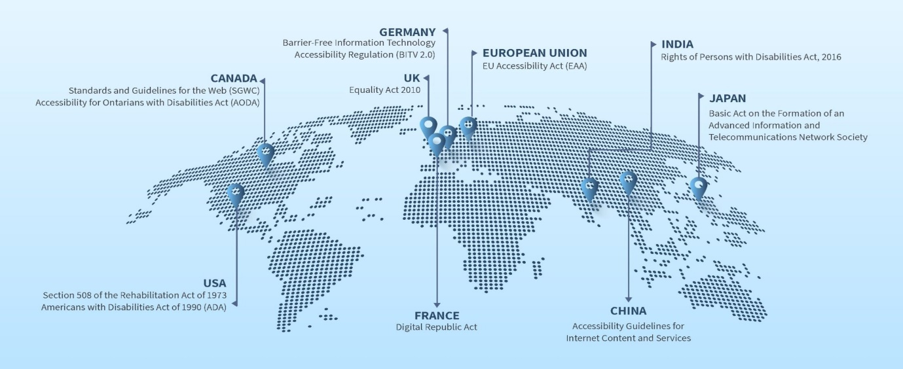

Fig. 1 REPRESENTATION OF REGULATIONS IMPLEMENTED BY SEVERAL COUNTRIES

- BIS STANDARDS FOR ACCESSIBILITY

  - For Buildings and Built Environment

- Clause 13 and Annex B of Part 3 ‘Development Control Rules and General Building Requirements’ of SP 7:2016 ‘National Building Code of India 2016’: Establishes design, planning, and construction requirements for accessible spaces and facilities, integrating universal design principles to create barrier-free environments.

- SP 73:2023 ‘Standardized Development and Building Regulations’: Integrates accessible built spaces and facilities with mainstream building requirements facilitating ease of locating and referring such provisions.

- IS 4963:1987: Comprehensive guidelines for public buildings and facilities to ensure usability by individuals with physical disabilities. (currently under revision)

  - Other Standards relating to Accessibility

- IS 17802 (Part 1 & Part 2): Accessibility standards for ICT products and services, addressing functional needs of users with varied disabilities such as visual, auditory, and mobility challenges.
- Several other standards on assistive products, which may be accessed from the link given below using the keyword:

https://www.services.bis.gov.in/php/BIS_2.0/bisconnect/knowyourstandards/indian_standards/isdetails

- ANTHROPOMETRIC CONSIDERATIONS

The requirements for accessible design are governed by the anthropometric considerations, some of which are listed below:

- Wheelchair Dimensions: Length: 1,000–1,100 mm, Width: 650–720 mm, Height: 910–950 mm. Footplate clearance should be 350 mm.

- Turning Radius: Provide turning spaces of at least 1,500 mm for minimum comfort, with 2,000 mm for optimal maneuverability.

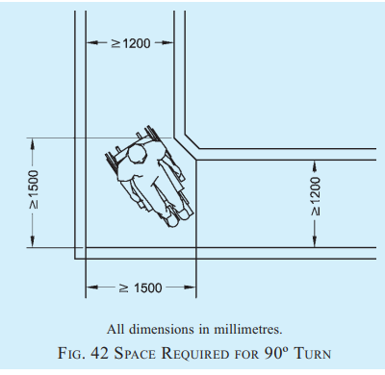

- Reach Zones:
  - Forward Reach: Without obstruction: 400-1,200 mm; With obstruction: 500-1,000 mm.
  - Side Reach: Without obstruction: 250-1,300 mm; With obstruction: Up to 1,200 mm.

- Vision Zone: Place maps and signs at 900-1,800 mm to ensure visibility for both seated and standing users. Ensure fonts are large and legible.

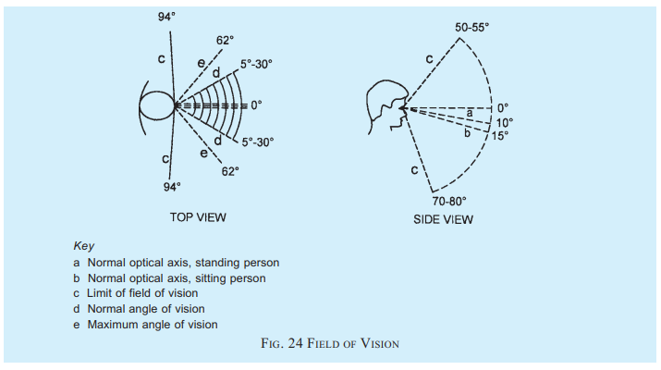

- KEY DESIGN ELEMENTS FOR ACCESSIBILITY

5.1 General Building Design

- Circulation Pathways: Ensure clear, unobstructed pathways with a minimum width of 1,500 mm, preferably 1,800 mm, allowing for smooth wheelchair navigation and safe passage. Resting areas should be provided every 30 m in long corridors or walkways.

- Corridor Specifications: Include turning spaces with a diameter of 1,500 mm for 90° turns and 2,000 mm for 180° turns. These dimensions accommodate smooth wheelchair maneuvering.
- Flooring: Use non-slip, matte-finish surfaces with contrasting colours to aid individuals with visual impairments and prevent accidents.

5.2 Entrances and Internal Layouts

- Entrance Door Width: Maintain a minimum width of 900 mm to allow easy wheelchair access and accommodate diverse users.
- Floor Texture Differences: Incorporate contrasting textures around doorways to assist visually impaired individuals in locating entrances.
- Beepers and Tactile Ground Surface Indicators: Install sound-emitting devices and tactile pavers at main entrances to facilitate navigation for visually impaired users.

5.3 Toilets and Sanitary Facilities

- Accessible Toilets: Ensure a minimum clear floor space of 1,500 mm x 1,500 mm for easy maneuverability of wheelchairs.
- Fixtures: Include grab bars that are securely fixed with a clearance of 50-65 mm from the wall. These bars should withstand a load of 1.7 kN and have slip-resistant, round ends.
- Signage: Provide tactile and Braille signs to indicate the type of toilet, transfer directions (left/right), and other essential information for users.

5.4 Vertical and Horizontal Circulation

5.4.1 Ramps

- Gradient Requirements:
  - For height differences up to 150 mm: Maximum Gradient of 1:12, minimum width 1,200 mm.
  - For height differences above 3,000 mm: MaximumGradient of 1:20, width 1,800 mm.
- Landings: Provide level landings after every 9 m of ramp run for safety and ease of use.
- Tactile Warning Blocks: Install blocks 300 mm before and after the start of ramps to alert visually impaired users.
- Surface Material: Ensure ramp surfaces are non-glare, slip-resistant, and free of obstacles.

5.4.2 Stairs

- Landing Dimensions: Maintain a minimum depth of 1,500 mm for safe navigation. The surface should be non-slip and non-glare.
- Step Uniformity: Ensure consistent height and depth for all steps to minimize tripping risks. Open risers and projecting nosings should be avoided.
- Tactile Indicators: Place ground surface indicators 300 mm before and after stair flights to aid individuals with visual impairments.

5.4.3 Lifts

- Dimensions: Minimum lift size should be 1,500 mm x 1,500 mm, allowing for wheelchair users to comfortably maneuver inside.
- Doors: Ensure clear openings of at least 900 mm, equipped with automatic horizontal sliding mechanisms.
- Controls: Position buttons at a height of 800-1,100 mm, with tactile markings and Braille inscriptions for easy identification.

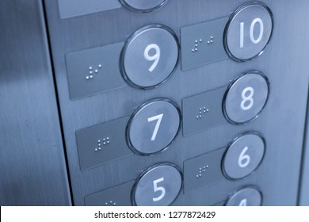

- Safety Features: Install voice announcements and visual displays to indicate floor levels, as well as non-contact sensors to prevent door closures during entry/exit.

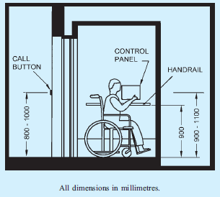

- Handrails: Provide handrails at a height of 900 mm on all sides inside the lift for additional support.

  - Wayfinding and Signage

- Tactile and Braille Features: Include tactile surfaces and Braille inscriptions on all key signage. Ensure high contrast between text and background for readability.
- Illumination: Maintain a minimum of 200 lux for directional and informative signage.
- Height and Placement: Position signs at 900-1,800 mm, ensuring visibility for both seated and standing users. Avoid reflective materials that cause glare.
- Colour Contrast: Avoid red-green combinations; instead, use contrasting colours that are easier to distinguish.



- CHALLENGES AND ISSUES ADDRESSED BY THE STANDARDS

- Lack of interpretation and improper implementation: With the help of more than 100 pages of detailed provisions and more than 100 illustrations, NBC 2016 very lucidly explains accessibility provisions, which can be easily understood and implemented.

- Unwillingness to Adopt: NBC 2016 explains the science behind the requirements specified in the code which will encourage building professionals particularly builders to appreciate and implement these in their projects.

- Quantification of Accessibility Requirements: Often Authorities and professionals are not sure about number of accessible toilets or parking spaces to be provided in a building complex or number of accessible seats to be provided in an auditorium or conference hall. The Code provides answers to all such questions.

Photographs for discussion with participants: They may be asked to identify the mistakes in the accessibility facilities provided in the buildings and built environment as per these photos
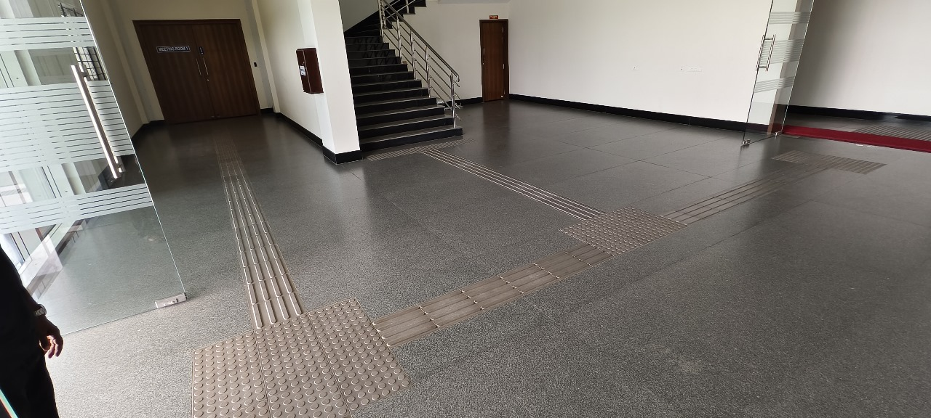

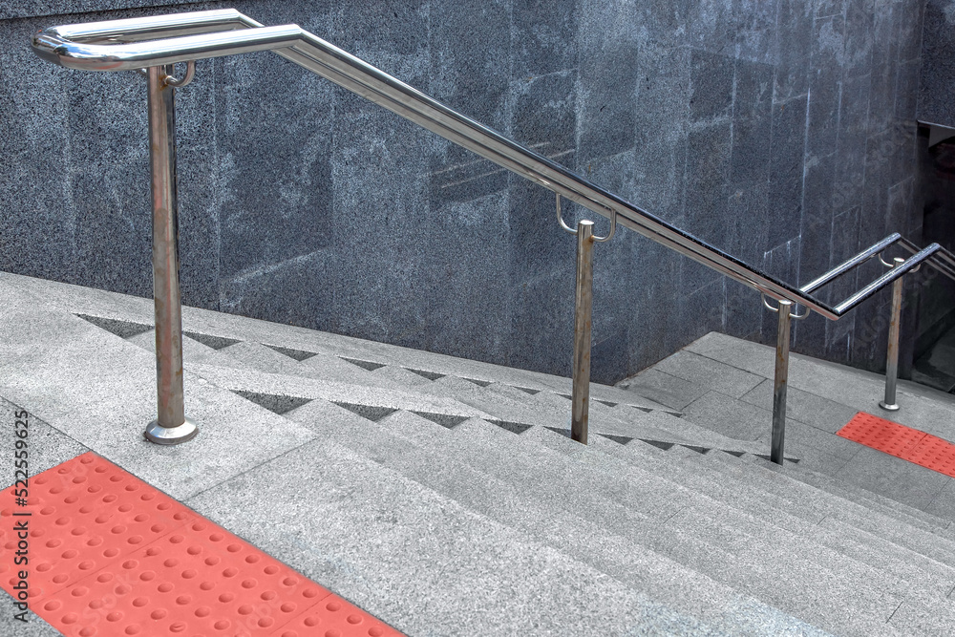

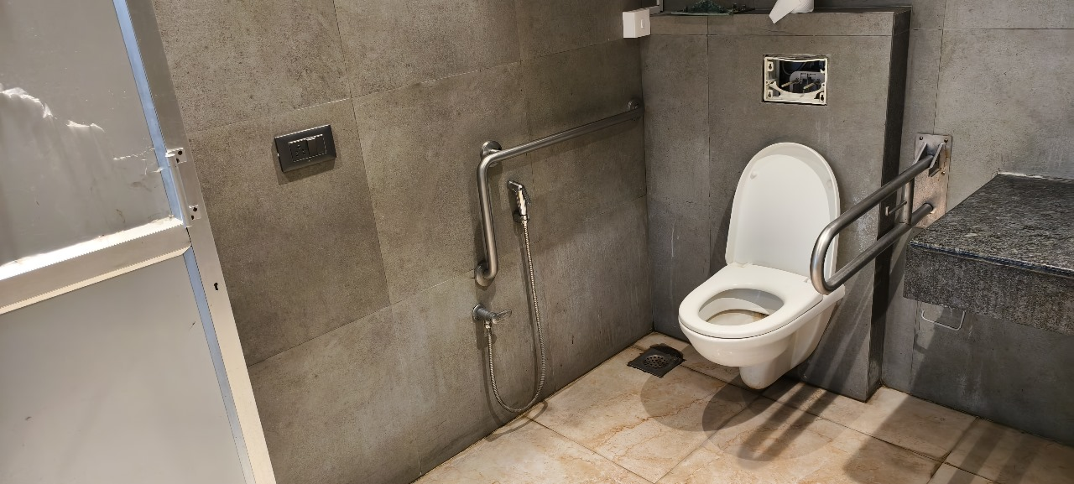

- CONCLUSION

By adhering to these detailed standards and guidelines, architects and planners can ensure that buildings are inclusive and accessible. This fosters a society where individuals of all abilities can navigate and utilize built environments with ease, independence, and dignity.

