Building HVAC & Plumbing Systems

- Introduction:

- ESSENTIAL ROLE OF HVAC SYSTEMS - HVAC systems regulate indoor temperature and air quality, crucial for health and comfort in buildings

- IMPORTANCE OF PLUMBING SYSTEMS -Plumbing ensures safe water supply and waste disposal, vital for hygiene and public health

- BIS STANDARDS FOR QUALITY - Standards by BIS ensure high-quality installations, reducing risks and enhancing safety

- PROMOTING ENERGY EFFICIENCY - BIS standards encourage energy-efficient designs, leading to lower operational costs and sustainability

- REGULATORY COMPLAINCE - Adhering to BIS standards helps businesses meet legal requirements and avoid penalties.

- Overview of HVAC Systems
- HVAC - stands for Heating, Ventilation and Air Conditioning, crucial for indoor climate control
- Heating Functionality - Heating maintains comfortable indoor temperatures during winters
- Importance of Ventilation - Ventilation ensures fresh air circulation, preventing indoor air quality issues and promoting health.
- Air Conditioning - Air conditioning cools and dehumidifies indoor air, ensuring comfort during hot weather.
- Heating Equipment Types - Includes reverse cycle operations, solar heating systems, electric heat pumps and ground source heat pumps that provide essential warmth to living spaces
- Ventilation System Components - Ductwork, fans, and air filters work together to circulate and purify indoor air effectively
- Cooling Equipment Overview - Cooling equipment like air conditioners and chillers regulate temperature and humidity
- Control Systems Functionality - Thermostats and automation controls manage HVAC operations for optimal comfort and efficiency

- Key Benefits of HVAC Standards

- Health and Safety – Effective ventilation is essential to minimize indoor air pollutants, ensuring a healthier environment for occupants.
- Energy Efficiency - HVAC standards promote systems that significantly reduce energy consumption, leading to lower utility bills.
- Comfort - Standards guarantee consistent temperature control, enhancing overall comfort in indoor spaces.
- Regulatory Compliance - Adhering to HVAC standards helps businesses comply with local and national regulations, avoiding legal issues.

- Overview of Plumbing Systems

  - Plumbing systems are crucial for managing water delivery, heating, sanitation, and drainage
  - Water Supply Systems - These include pipes, fixtures, and valves essential for delivering clean water.
  - Drainage and Sanitation Systems - Composed of waste and vent pipes, these systems remove wastewater safely. Toilets and sinks are key components for maintaining hygiene and sanitation
  - Solid Waste Management - Collection, conveyance, treatment, and disposal of solid waste in plumbing designs for buildings
  - Gas Supply - Design, installation, and maintenance of gas plumbing systems for safe and efficient distribution of gases in buildings
  - Compliance with hospital-grade standards for oxygen and other gases

- Key Benefits of Plumbing Standards

  - Public Health Protection - Plumbing standards are crucial for preventing contamination and ensuring clean water access.
  - Water Efficiency - Promotes efficient water use and waste management, contributing to sustainability efforts.
  - Safety Measures - Standards help reduce risks associated with leaks and flooding, ensuring safer environments.
  - Regulatory Compliance - Ensures compliance with local building codes, protecting both builders and consumers.

- Design Principles for HVAC Systems

  - Heating Systems - Use energy-efficient boilers, heat pumps, or furnaces for effective space heating. Consider renewable options like geothermal or solar heating systems.
  - Ventilation Systems - Incorporate mechanical ventilation with heat recovery (MVHR) to improve air quality and conserve energy. Ensure proper airflow distribution through ducts to all zones.
  - Air Conditioning Systems - Use split systems, centralized chillers, or variable refrigerant flow (VRF) units based on building size and load. Focus on equipment with high Coefficient of Performance (COP) for energy savings.
  - Load Calculations
    - Cooling Load -Calculate based on factors like occupancy, equipment heat generation, and solar heat gain. Use weather data and building orientation to fine-tune cooling requirements.
    - Heating Load - Consider building insulation, external temperatures, and air infiltration. Incorporate heating requirements for specific zones and operations.
    - Peak Demand - Design for peak load scenarios while ensuring systems can operate efficiently at part loads

  - Energy Efficiency
    - Equipment Selection - Opt for high-efficiency compressors, motors, and fans.
    - Use energy-efficient systems like VRF or chilled beams for large buildings.
    - Thermal Insulation - Insulate ducts, pipes, and building envelopes to reduce thermal losses.
    - Use materials with high R-values for insulation effectiveness.
    - Energy Recovery - Include heat exchangers for recovering energy from exhaust air.
    - Integrate renewable energy sources like solar or wind for supplementary power.

  - Indoor Air Quality (IAQ)
    - Filtration Systems - Install HEPA filters for removing particulate matter.
    - Use activated carbon filters to eliminate odours and harmful gases.
    - Fresh Air Ventilation - Maintain a minimum outdoor air exchange rate as per occupancy and building use.
    - Include demand-controlled ventilation (DCV) to adjust fresh air intake dynamically.
    - Humidity Control - Use dehumidifiers or humidifiers to maintain indoor humidity levels between 30%-60%.
    - Prevent Mold growth and improve occupant comfort.

  - Air Distribution
    - Ductwork Design - Use smooth, straight ducts to minimize pressure drops.
    - Include dampers for zoning and airflow adjustments.
    - Zoning Systems - Divide buildings into zones with individual controls to optimize energy use.
    - Use VAV (Variable Air Volume) systems for dynamic adjustments.
    - Noise Control - Install silencers and acoustic linings in ducts to minimize operational noise.
    - Use vibration isolators for fans and compressors.

  - Safety and Maintenance
    - Fire Safety – Install fire dampers in ducts to prevent fire spread.
    - Use smoke management systems for emergency evacuation scenarios.
  - Accessibility
    - Provide easy access to air filters, fans, and compressors for maintenance.
    - Include inspection ports in duct systems.
  - Leak Testing
    - Perform regular checks for refrigerant leaks.
    - Monitor pressure and airflow for early detection of system issues.

- Design Principles for Plumbing Systems

- Water Supply Design
- Minimum Residual Pressure - Ensure a pressure of at least 10–15 psi at all outlets to maintain effective water flow. Design systems to prevent pressure drops during peak usage.
- Pipe Sizing - Calculate pipe diameters based on flow rates and demand.
Use the Hazen-Williams formula or equivalent for determining pipe sizes.

- Material Selection –
    - Opt for durable materials like PVC, CPVC, or copper based on water quality and temperature.
    - Use non-toxic, corrosion-resistant materials for potable water systems.

- Hot Water Systems - Incorporate insulated pipes to minimize heat loss.
- Use energy-efficient heaters, such as solar water heaters, for sustainability.

- Drainage and Sanitation
    - Backflow Prevention - Install backflow preventers at key points to protect potable water lines from contamination.
    - Ventilation Systems - Use vent pipes to release trapped air and avoid pressure build-up in drainage systems Ensure vents extend above rooflines to disperse foul air.
    - Traps and Seals - Include P-traps and water seals to block sewer gases from entering indoor spaces. Use grease traps for commercial kitchens to separate oil and grease from wastewater.
- Slope Design
    - Maintain a gradient of 1:40 or steeper for horizontal drainage pipes to prevent clogs and ensure free flow.

- Waste Management
- Grease and Oil Interceptors - Install interceptors in kitchens and industrial facilities to capture grease and solids before discharge.
- Solid Waste Handling - Design pipes and storage systems to handle sludge and solid waste effectively.
- Incorporate organic waste converters for onsite processing.
- Onsite Wastewater Treatment
    - Use septic tanks or small-scale treatment plants for areas without sewer networks.
    - Provide dual-chamber systems for efficient sludge separation and treatment.

- Rainwater Harvesting and Greywater Recycling
- Rainwater Harvesting Systems - Design rooftop catchments and storage tanks to collect rainwater.
    - Include first-flush diverters to eliminate debris and contaminants.
    - Greywater Systems – Use greywater from washing and bathing for landscaping or flushing. Incorporate filters and sedimentation tanks for pre-treatment.

- Gas Supply Systems
- Pipe Sizing - Size pipes according to the building’s gas demand and pipeline pressure.
- Safety Devices - Install gas leak detectors in critical areas like kitchens and basements. Use automatic shut-off valves to halt supply during emergencies.
- Pipe Materials - Use approved materials like galvanized steel, copper, or flexible gas pipes. Avoid joint leaks by using compression fittings or brazed joints.
- Ventilation - Provide proper ventilation in areas with gas appliances to prevent buildup of combustible gases.

- Safety Considerations
- Cross-connection Control -Avoid direct connections between potable water and drainage systems. Install air gaps or backflow prevention devices at high-risk points.
- Accessibility - Design systems with adequate access points for inspection and repairs. Include cleanouts at critical locations to address blockages quickly.
- Compliance - Follow BIS standards (e.g., IS 1172 for water supply, IS 2470 for septic tanks).
- Obtain certification for key installations like gas lines and large storage tanks.

- Major Standards for HVAC Systems
  - National Building Code (NBC) 2016 – Part 8/ Section 3 - Air Conditioning, Heating and Mechanical Ventilation
Covers planning, design, installation, testing, and maintenance.
Incorporates sustainable practices like VRF systems, geothermal cooling, and IAQ provisions.
  - IS 12976 Solar Water Heating Systems
  - IS 3103 Code of Practice for Industrial Ventilation
  - IS 4894 Specification for Centrifugal fans
  - IS 2312 Specification for propeller type AC ventilating fans
  - IS 3362 Code of practice for natural ventilation of residential buildings
  - IS 3646 (Part 1) Code of practice for interior illumination Part 1 General requirements and recommendations for working interiors
  - IS 7662 (Part 1) Recommendations for orientation of buildings : Part 1 Non-industrial buildings
  - SP 32 Handbook on functional requirements of industrial buildings (lighting and ventilation)
  - SP 41 Handbook on functional requirements of buildings other than industrial buildings
  - IS 659 Safety codes for air conditioning
  - IS 16656/ISO 817 Refrigerants — Designation and safety classification
  - IS 1391 Specification for room air conditioners:
    - (Part 1) : Unitary air conditioners
    - (Part 2) : Split air conditioners
  - IS 2379 Colour code for identification of pipelines
  - IS 3315 Direct Evaporative Air Cooler
  - IS 8148 Ducted and packaged air conditioners

- Major Standards for Plumbing Systems
  - National Building Code (NBC) 2016 – Part 9 - Plumbing Services (Including Solid Waste Management)
Covers water supply, drainage, solid waste management, and gas systems.
Encourages rainwater harvesting, greywater recycling, and sustainable resource use.
  - IS 4984 Polyethylene Pipes for Water Supply
  - IS 4985 UPVC Pipes for Potable Water Supplies
  - IS 13592 PVC-U) Pipes for Soil and Waste Discharge System Inside and Outside Buildings Including Ventilation and Rainwater System
  - IS 15778 CPVC pipes for potable hot and cold-water distribution supplies
  - IS 12818 PVC-U Screen and casing pipes for bore/tubewell
  - IS 14885 Specification for polyethylene pipe for the supply of gaseous fuel
  - IS 17650 Water efficient plumbing products - Requirements:
    - Part 1 – Sanitaryware
    - Part 2 – Sanitary fittings
  - IS 1172 Code of basic requirements for water supply, drainage and sanitation
  - IS 2065 Code of practice for water supply in buildings
  - IS 6295 Code of practice for water supply and drainage in high altitudes and or sub-zero temperature regions
  - IS 7558 Code of practice for domestic hot water installations
  - IS 12183 (Part 1) Code of practice for plumbing in multistoried buildings: Part 1 Water supply
  - IS 1742 Code of practice for building drainage
  - IS 4111 (Part 1) Code of practice for ancillary structures in sewage system: Part 1 Manholes
  - IS 5329 Code of practice for sanitary pipe work above ground for buildings
  - IS 6924 Code of practice for the construction of refuse chutes in multistoried buildings
  - 16557 Guidelines for solid waste management — Segregation, collection and utilization at household/community level
  - IS 15663 Code of practice for design and installation of natural gas pipelines:
    - (Part 1) : Laying of pipelines
    - (Part 2) : Laying of pipelines in crossings
    - (Part 3) : Pre-commissioning and commissioning of pipelines
  - IS 6044 Liquefied petroleum gas storage installations — Code of practice:
    - (Part 1) : Residential, commercial and industrial cylinder installations
    - (Part 2) : Commercial, industrial and domestic bulk storage installations
  - IS/ISO 7396-1 Medical gas pipelines systems Pipelines systems for compressed medical gases and vacuum

- Best Practices in Installation

    - HVAC Installation
Ductwork -Ensure proper sealing to avoid air leakage and maintain efficiency. Use insulated ducts to reduce energy loss and prevent condensation.
Equipment Placement - Install HVAC units in accessible areas for maintenance. Ensure proper clearance around equipment for air circulation.
System Calibration - Balance airflow to ensure uniform distribution across all zones. Test and adjust refrigerant levels for optimal cooling and heating performance.
Fire and Safety Compliance - Install fire dampers and smoke detectors in ventilation systems.

ii. Plumbing Installation
Pipe Layout - Ensure straight runs wherever possible to reduce pressure loss. Use supports and hangers to prevent sagging and damage.
Material Selection – Choose corrosion-resistant materials (e.g., PVC, CPVC, copper) based on application. Follow standards for joint fittings to prevent leaks.
Slope and Venting - Provide adequate slope in drainage systems to avoid blockages. Install vent pipes to release trapped air and maintain flow.
Backflow Prevention - Install backflow preventers to protect potable water supplies.

- Best Practices for Maintenance

HVAC Maintenance
Routine Inspections - Check for blockages in ducts, filters, and vents. Inspect belts, motors, and fans for wear and tear.
Seasonal Maintenance - Clean evaporator and condenser coils to maintain efficiency. Test heating systems before winter and cooling systems before summer.
Energy Monitoring - Use smart systems to track energy usage and detect anomalies.
Emergency Protocols - Train staff on emergency shutdown procedures for HVAC systems.

Plumbing Maintenance
Leak Detection - Regularly inspect joints, valves, and pipes for leaks. Use smart leak detectors for early identification in hidden areas.
Clog Prevention - Avoid dumping grease or solids into drainage systems. Schedule regular cleaning of grease traps and interceptors.
Water Quality Testing - Periodically test for contaminants in potable water supply.
Gas System Checks - Inspect for leaks and pressure consistency in gas pipelines. Test shut-off valves and detectors for functionality.

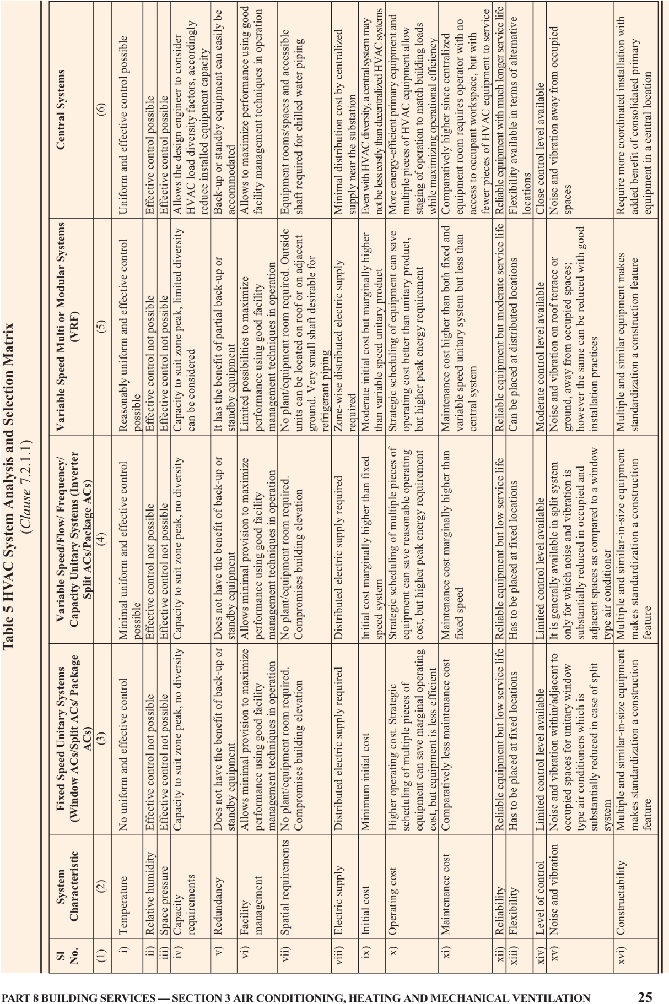
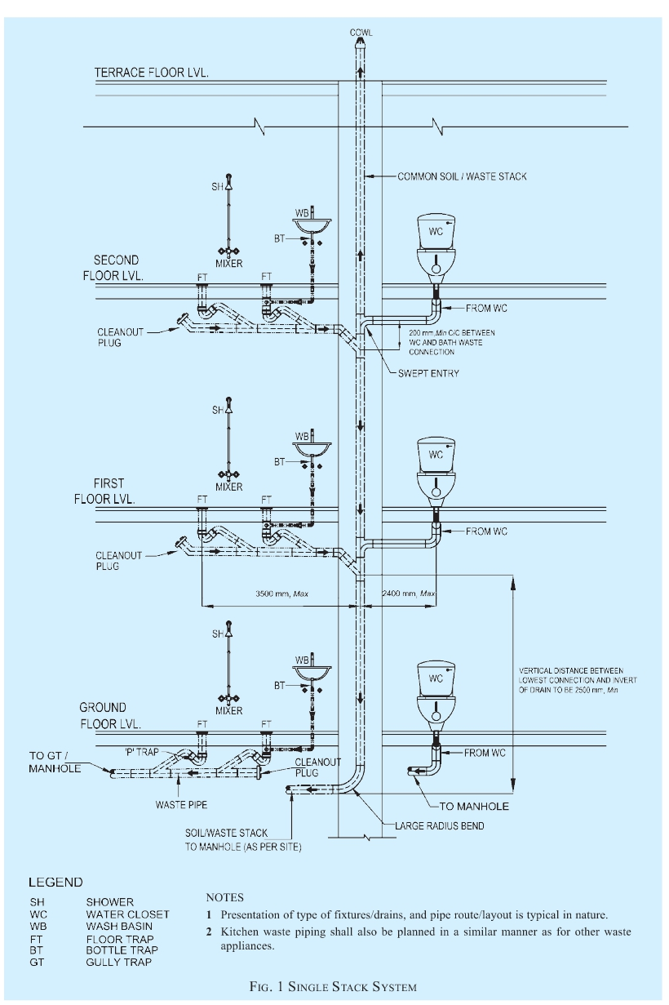

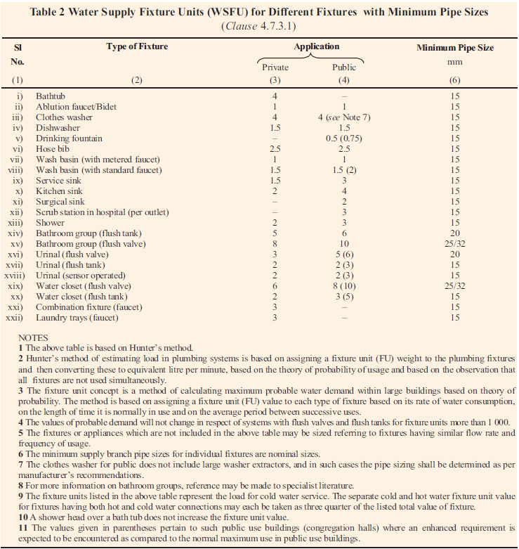

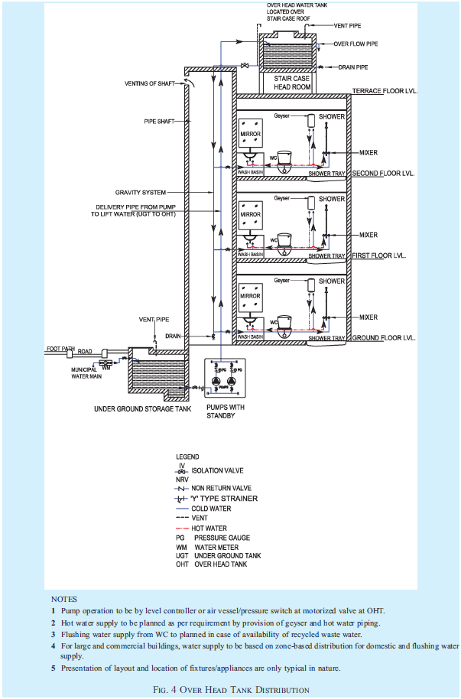
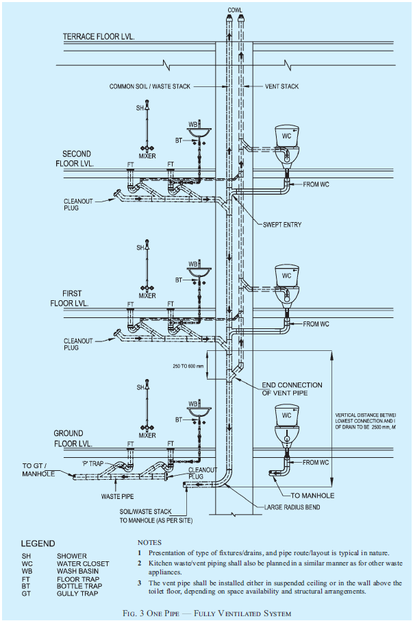
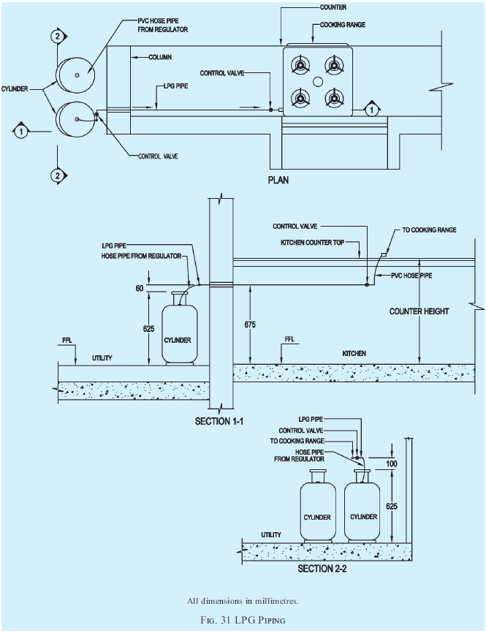

- State Government Responsibilities
Legislation - Develop and enforce laws that align with BIS standards to ensure compliance across sectors.
Inspection and Enforcement -Conduct regular inspections to verify adherence to established standards and regulations.
Public Awareness -Educate the community and professionals about the significance of maintaining standards for safety and quality.
Collaboration with BIS -Engage with BIS to stay updated on standards and provide necessary training for effective implementation.

- Barriers to Implementation of Standards
Lack of Awareness-Many stakeholders are unaware of existing standards, leading to ineffective implementation.
Insufficient Training- Professionals often lack adequate training on BIS standards, hindering compliance efforts.
High Initial Costs -The upfront costs associated with compliance can discourage organizations from adopting standards.
Inadequate Infrastructure -Existing infrastructure may not align with current standards, complicating the adoption process.

- Future: Exploring innovations & Stakeholders’ involvement
Smart Technologies - Integration of IoT for enhanced monitoring and control in HVAC and plumbing systems.
Sustainability- A strong focus on energy-efficient and eco-friendly solutions to reduce environmental impact.
Regulatory Updates- Adapting existing standards to accommodate new technologies and best practices in the industry.
Public Engagement- Increased emphasis on community involvement in the formulation of standards for better results.

- Conclusion
The Need for Standards –
Adhering to BIS standards as outlined in NBC 2016 ensures that HVAC and plumbing systems meet modern safety, sustainability, and efficiency requirements.
Impact of Proper Design –
Thoughtful design and regular maintenance of HVAC and plumbing systems lead to reduced energy consumption, minimized environmental impact, and safer buildings
Approach to be taken -
Engineers, architects, and decision-makers should prioritize the integration of BIS standards in all projects. This approach not only ensures compliance but also sets a benchmark for quality infrastructure in India.
Future Outlook –
Embracing innovative technologies, sustainable practices, and rigorous maintenance regimes will pave the way for smarter, greener, and safer building environments.

