CONSTRUCTION PRACTICES
MASONRY
Masonry construction technique involved building of various structures such as walls, columns , arches etc. using blocks laid in specific pattern and jointed by Cementous material such as mortar, hydrated lime, chemical adhesive etc.
Commonly used masonry constructions are
- BRICK MASONRY IS 2212
- STONE MASONRY IS 1597
- CEMENT BLOCK MASONRY IS 2185
MAJOR COMPONENTS OF MASONRY CONSTRUCTION
A combination of bricks/ stone/cement blocks etc. with mortar, and workmanship to create structures.
blocks+ Mortar + Workmanship = Masonry
SELECTION OF MATERIAL FOR MASONRY CONSTRUCTION IS MAINLY BASED ON FOLLOWING REQUIREMENTS
- local availability,
- compressive strength,
- durability,
- cost, and
- ease of construction
- Brick/Cement block construction has the advantage over stone that it lends itself to easy construction and requires less labour for laying. Stone masonry, because of practical limitations of dressing to shape and size, usually has to be thicker and results in unnecessary extra cost. Thus, the first choice for a building at any place, would be brick/cement blocks, if it is available at reasonable cost with requisite strength and good quality.
- Decoding the Durability Factor in Masonry Materials
- Utility and Functionality: Masonry Material for Every
- Purpose
- Longevity and Maintenance: Masonry’s Lifespan Matters
- Considering the Resale Value: How Masonry Affects Your Home’s Worth
Brick Masonry: Relevant Indian Standards
- Design and Structural Use of Masonry (IS 1905) - Ensure that the design of masonry elements like walls and columns considers the load-bearing capacity as specified in IS1905
- IS 2212:1991 - Code of Practice for Brickwork: Provides guidelines on construction practices for brickwork in buildings, covering aspects like bonding patterns, jointing techniques, plastering, curing, and other relevant construction practices.
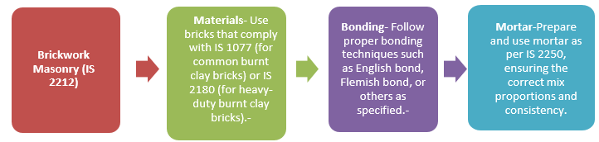
Common bonding patterns: IS 2212:1991
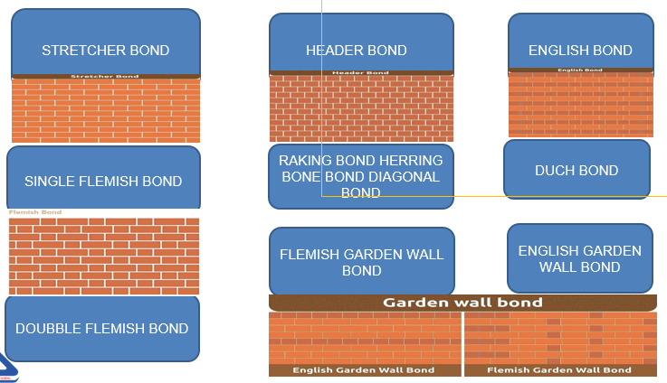
Use of stone masonry work is known and practised froth the earlier days and natural stone is extensively available in many parts of this country.
The types of stone masonry construction followed depends on local factors like physical characteristics of the stone, climatic conditions, workmanship, etc.
Certain broad principles in laying, bonding, breaking of joints and finish should be complied with in order that the masonry develops adequate strength and presents a neat appearance.
Testing of bricks:
- IS 3495 (Part 1) Determination of compressive strength
- IS 3495 (Part 2) Determination of water absorption
- IS 3495 (Part 3) Determination of efflorescence
- IS 3495 (Part 4) Determination of warpage
- IS 3495 (Part 5) Determination of initial rate of absorption
- IS 3495 (Part 6) Determination of Modulus of Rupture
STONE MASONRY
Involves detailing the selection of materials, preparation, construction practices, and quality control measures.
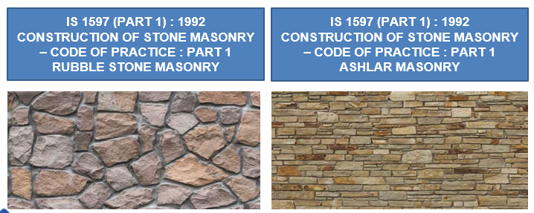
IMPORTANT INDIAN STANDARDS
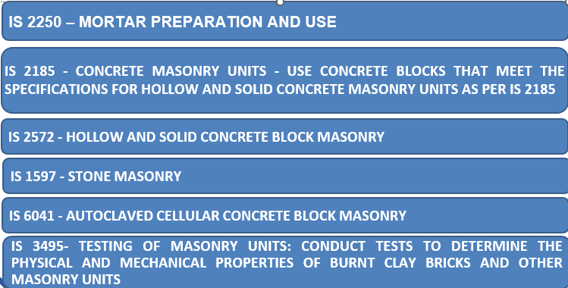
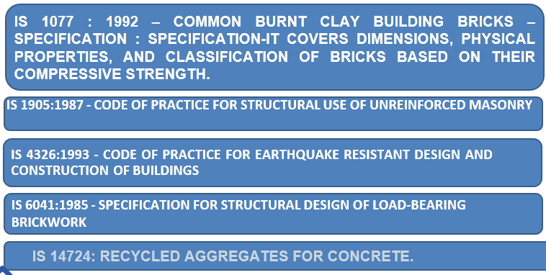
REINFORCED CEMENT CONCRETE
TYPE OF CONCRETE :
- Plain Cement Concrete
- Reinforced Cement Concrete
- High Strength Concrete BASED ON STRENGTH OF CONCRETE
- Self compacting concrete
- Mass concrete (BASED ON SITE CONDITIONS)
- Ready mixed concrete (METHOD OF MANUFCATURING)
Plain Cement concrete
Main components
cement, coarse aggregates and sand with specific amount of water.
Common mix proportions
1:2:4, 1:3:6 and 1:4:8
Density :
NORMALLY 220 kg/CUM to 2500 kg/CUM
Compressive strength
M10, M15 and M 20 are commonly used
High durability
Indian Standards:
The relevant standards for PCC in India are mentioned in IS 456:2000 (Code of Practice for Plain and Reinforced Concrete).
IS 383 specifies the quality and grading of aggregates used.
IS 10262 provides guidelines for concrete mix design.
Reinforced Cement Concrete
Material Composition:
Concrete: A mixture of cement, sand, aggregates, and water.
Steel Reinforcement: High-strength Deformed steel bars or Mild steel bars embedded in the concrete to resist tensile stresses.
Primary Indian Standard:
IS 456:2000 (Code of Practice for Plain and Reinforced Concrete):
This is the main code that governs the design, construction, and material requirements for RCC in India. It covers the design philosophy (limit state method), specifications for materials, construction practices, and quality control measures.
Design Guidelines:
Limit State Design: IS 456:2000 provides guidelines for designing RCC structures based on the limit state method, ensuring safety and serviceability.
Structural Elements: Guidelines are provided for the design of various RCC elements like beams, columns, slabs, and foundations.
Material Specifications:
Cement: Must conform to IS standards like IS 269 (Ordinary Portland Cement).
Aggregates: Quality and grading as per IS 383:2016.
Steel Reinforcement: Must comply with IS 1786:2008 (for high-strength deformed bars) or IS 432 (for mild steel) etc.
Concrete Grades:
Concrete used in RCC is classified by its grade (e.g., M20, M25), which indicates the compressive strength of the concrete mix in MPa after 28 days.
Construction Practices:
Mixing, Placing, and Curing: Detailed in IS 456:2000 to ensure uniformity and strength in RCC construction.
Quality Control: Emphasizes the need for stringent quality control at all stages of RCC construction, from material selection to the finished structure.
Seismic Considerations:
IS 13920:2016 provides additional guidelines for the ductile detailing of RCC structures in seismic zones to ensure they can withstand earthquake forces.
High strength concrete (HSC)
Compressive Strength:
HSC Definition: As per Indian practices, concrete is usually categorized as HSC when its compressive strength exceeds 60 MPa. This can include grades like M60, M70, M80, and higher.
IS 456 (Code of Practice for Plain and Reinforced Concrete): While this standard provides general guidelines for concrete up to M60, for higher grades, more specialized considerations are required.
Design Considerations:
IS 10262 (Concrete Mix Proportioning – Guidelines): This standard provides guidelines for mix design of concrete, including HSC. However, for very high-strength concrete (above M60), additional considerations such as admixtures, precise aggregate grading, and lower water-cement ratios are necessary.
Use of Admixtures: The mix design often requires high-quality superplasticizers and other chemical admixtures to achieve the necessary workability and strength.
Self compacting concrete
- Definition:
  - SCC Characteristics: SCC is a highly flowable concrete mix that spreads into place, fills formwork, and encapsulates reinforcements without requiring any mechanical compaction or vibration.
  - Workability: The primary characteristic of SCC is its excellent workability, achieved through the use of superplasticizers and viscosity-modifying agents (VMAs).
- Relevant Indian Standards:
  - IS 456:2000 (Code of Practice for Plain and Reinforced Concrete):
While IS 456:2000 provides general guidelines for concrete, it doesn't specifically cover SCC. However, it is referred to in conjunction with international standards and guidelines tailored for SCC.
  - IS 10262:2019 (Concrete Mix Proportioning – Guidelines):
This standard includes provisions for the mix design of SCC. It provides guidelines on achieving the desired workability, strength, and durability specific to SCC.
    - The mix design must ensure that SCC achieves the necessary self-compactability, stability, and strength.
- Properties and Mix Design:
  - High Flowability: SCC has a slump flow typically ranging from 650 to 800 mm. The mix design ensures the concrete is highly flowable without segregation.
  - Passing Ability: SCC can pass through densely packed reinforcement without getting blocked, which is essential in structures with complex geometries or congested reinforcement.
  - Filling Ability: SCC can fill intricate formwork completely and uniformly, reducing the likelihood of voids or honeycombing.
- Admixtures:
  - Superplasticizers: These are essential in SCC to reduce water content while maintaining workability.
  - Viscosity-Modifying Agents (VMAs): Used to enhance the stability of the mix by controlling segregation and bleeding, especially important in SCC.
  - Air-Entraining Agents: Sometimes used to improve the freeze-thaw resistance of SCC, though typically not required for general applications.
- Applications:
  - Complex Structures: SCC is ideal for casting in situations with complex formwork, dense reinforcement, or inaccessible areas where conventional vibration methods would be difficult or impossible.
  - Precast Concrete: SCC is widely used in the precast concrete industry due to its ability to produce smooth, defect-free surfaces without the need for additional finishing.
  - Repair and Rehabilitation: SCC's ability to flow into and fill voids makes it suitable for repairing and rehabilitating existing structures.
- Testing and Quality Control:
  - Slump Flow Test: Measures the horizontal spread of SCC when it is released from a slump cone, indicating its flow ability.
  - L-Box Test: Assesses the passing ability of SCC through reinforcements.
  - V-Funnel Test: Measures the time it takes for SCC to flow through a narrow opening, indicating its viscosity and flow rate.
  - Compressive Strength: Like conventional concrete, SCC is tested for compressive strength,
  - These standard test methods are outlined in IS 516.
- Durability Considerations:
  - Segregation Resistance: SCC must resist segregation to ensure uniform strength and durability throughout the structure.
  - Curing: Proper curing is critical to maintaining the desired properties of SCC, similar to conventional concrete.
Ready Mix Concrete
IS 4926 is the key standard for "Ready-Mixed Concrete - Specification" in India. It provides detailed guidelines for the production, transportation, and use of ready-mixed concrete (RMC).
IS 4926 covers all aspects of RMC production, including materials, equipment, and procedures.
STEEL STRUCTURES
Why Steel?
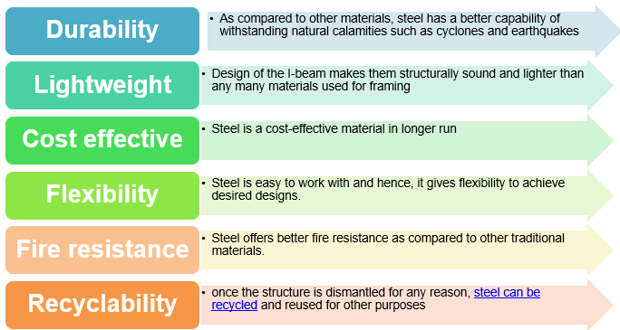
Under the Steel Economy Programme of Erstwhile Indian Standards Institution (now BIS), with the objective of achieving economy in the use of structural steel by establishing rational, efficient and optimum standards for structural steel products and their use, the first version of IS 800 got published as
IS 800:1956 (First version)
Subsequently revision took place in
IS 800 : 1962 (First Revision)
IS 800 : 1984 (Second Revision)
IS 800 : 2007 (Third Revision)

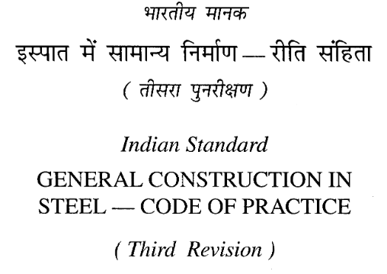
IS 800 - divided into 17 Sections
1. General
2. Materials
3. General Design Requirements
4. Methods of Structural Analysis
5. Limit State Design
6. Design of Tension Members
7. Design of Compression Members
8. Design of Members subjected to Bending
9. Member subjected to combined forces
10. Connections
11. Working Stress Design
12. Design and Detailing for Earthquake Loads
13. Fatigue
14. Design Assisted by Testing
15. Durability
16. Fire Resistance
17. Fabrication and Erection
Cl 1: Scope and Application
- Covers general construction in steel for buildings and other structures.
- Applicable to hot-rolled steel sections, built-up sections, and steel pipes.
Cl 2: Materials for Steel Construction
- Cl 2.1 Structural Steel - All structural steels used in general construction shall conform to IS 2062.
- Any structural steel other than that specified in 2.1 may also be used provided that the characteristic yield stresses and other design provisions are suitably modified and the steel is also suitable for the type of fabrication adopted.
- Other Material - All other materials including manufactured products, welding consumables, steel castings, bolts and nuts and cement concrete shall confirm to the requirements of the appropriate Indian Standards.
CL 3.1 : General Design Requirements
- Cl 3.1.1 Basic Principles of Structural Design
- Safety: Ensuring the structure can withstand loads and forces.
- Serviceability: Structure must remain functional and comfortable.
- Economy: Efficient use of materials and resources.
- Cl 3.1.3 Objectives of Structural Design
- Stability under various load conditions.
- Strength to resist failure.
- Durability to ensure long-term performance
Cl 3.2 : Loadings and Combinations
- Dead loads (Cl 3.2.1.1);
- Imposed loads (live load, crane load, snow load, dust load, wave load, earth pressures, etc) (Cl 3.2.1.2);
- Wind loads (Cl 3.2.1.3) ;
- Earthquake loads (Cl 3.2.1.4); ;
- Erection loads (Cl 3.3); ;
- Accidental loads such as those due to blast, impact of vehicles, etc;
- Secondary effects due to contraction or expansion resulting from temperature changes, differential settlements of the structure as a whole or of its components, eccentric connections, rigidity of joints differing from design assumptions. (Cl 3.4); and
- Load Combination (Cl 3.5).
Cl 3.7 Classification of Cross Section
Class 1 (Plastic) — Cross-sections, which can develop plastic hinges and have the rotation capacity required for failure of the structure by formation of plastic mechanism [Cl 3.7.2 (a)].
Class 2 (Compact) — Cross-sections, which can develop plastic moment of resistance, but have inadequate plastic hinge rotation capacity for formation of plastic mechanism, due to local buckling. [Cl 3.7.2 (b)].
Class 3 (Semi-compact) — Cross-sections, in which the extreme fiber in compression can reach yield stress, but cannot develop the plastic moment of resistance, due to local buckling. [Cl 3.7.2 (c)].
Class 4 (Slender) — Cross-sections in which the elements buckle locally even before reaching yield stress. [Cl 3.7.2 (d)].
The maximum value of limiting width to thickness ratios of elements for different classifications of sections are given in Table 2.
CL 4: METHODS OF STRUCTURAL ANALYSIS
The methods of analysis that have been defined are (Cl 4.1.1):
- Elastic analysis (Cl 4.4):
- Plastic analysis (Cl 4.5):
- Frame Buckling Analysis (Cl 4.6):
- Advanced analysis (Annex B):
- Dynamic analysis (as per IS 1893)
Cl 10: Connections
To combine two members to act as a single member and to share the loads.
Many members in a steel structure may themselves be made of different components such as plates, angles, I-beams, or channels. These different components have to be connected properly by means of fasteners, so that they will act together as a single composite unit.
Connections between different members of a steel framework not only facilitate the flow of forces and moments from one member to another but also allow the transfer of forces up to the foundation level.
Cl 15: Durability
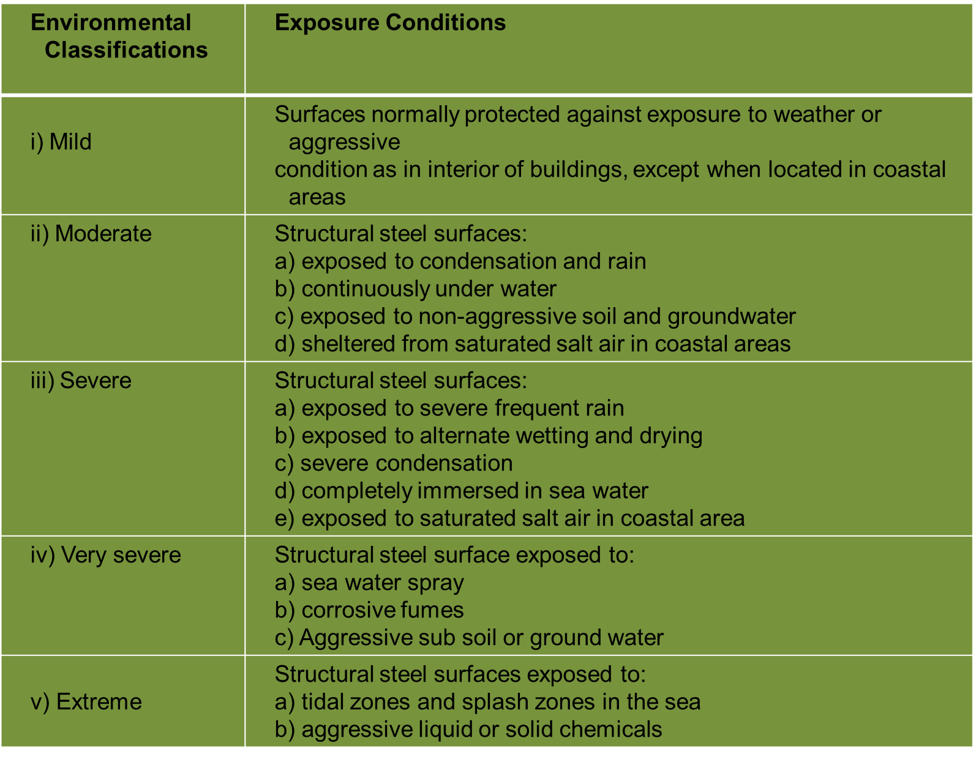
TIMBER STRUCTURES
Examples of buildings where timber has been prominently featured
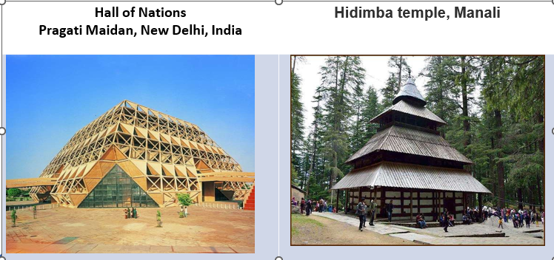
- Timber is a versatile building material used in various structural applications due to its strength, flexibility, and aesthetic appeal.
- Here are some of the main types of timber structures and their applications:
- Timber Frame Structures(IS 883:2016)
Post-and-Beam Construction: involves vertical posts and horizontal beams forming a skeleton.
- Used in residential buildings, barns, and some commercial structures as per IS 883:2016 - Code of Practice for Design of Structural Timber in Building
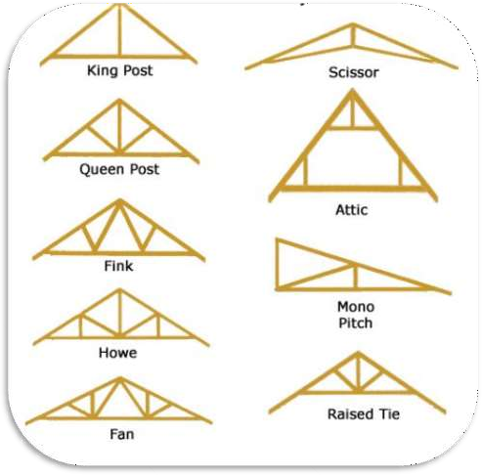
- Timber Roof Trusses (IS 883:2016)
- King Post Truss: Simplest type with a central vertical post and two angled beams. Common in smaller spans.
- Queen Post Truss: Similar to king post but with
two vertical posts, allowing for longer spans.
- Fink Truss: Triangular units with internal web members, widely used in residential and commercial buildings.
- Scissors Truss: Has two angled bottom chords that create a vaulted ceiling.

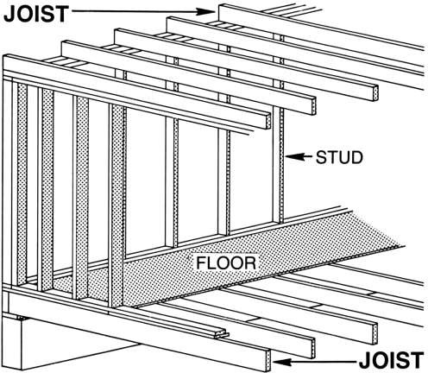
- Timber Beams and Joists(IS 883:2016)
  - Solid Timber Beams: Used in traditional construction for supporting floors and roofs.
  - Glulam (Glued Laminated Timber) Beams: Made by gluing together layers of timber, allowing for longer spans and more complex shapes.
  - I-Joists: Engineered wood products that resemble the letter "I", used for floor and roof joists due to their strength and lightweight.
- Timber Decking -

  - Outdoor Decking: Used for patios, balconies, and garden walkways. Designed to withstand weather and load conditions
- Timber Cladding
  - Weatherboards: Horizontal or vertical boards used to clad the exterior of buildings.
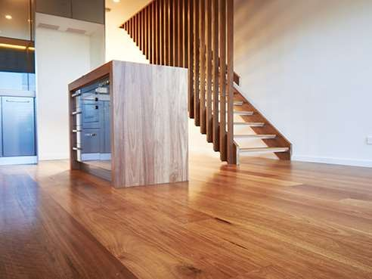
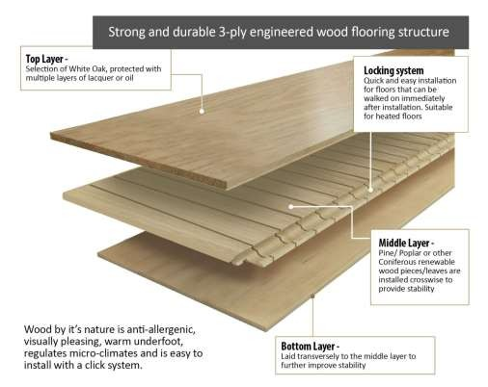
- Timber Flooring
Solid Wood Flooring: Made from single pieces of timber, offering durability and a traditional look
- Engineered Wood Flooring: Layers of wood glued together, providing stability and resistance to moisture changes.
- IS 3670 : 1989-Code of practice for of construction timber floors

- Timber Piles- (IS 2911 (Part 2) : 2021) Used in foundation systems where timber posts are driven into the ground to support structures, especially in areas with poor soil conditions.
- Timber Retaining Walls -Structures used to hold back soil or water, commonly used in landscaping and civil engineering projects.
- Timber Scaffolding (IS 3696 (Part 1/2):1987) : Temporary structures used construction for access to high areas
Relevant Indian Standards
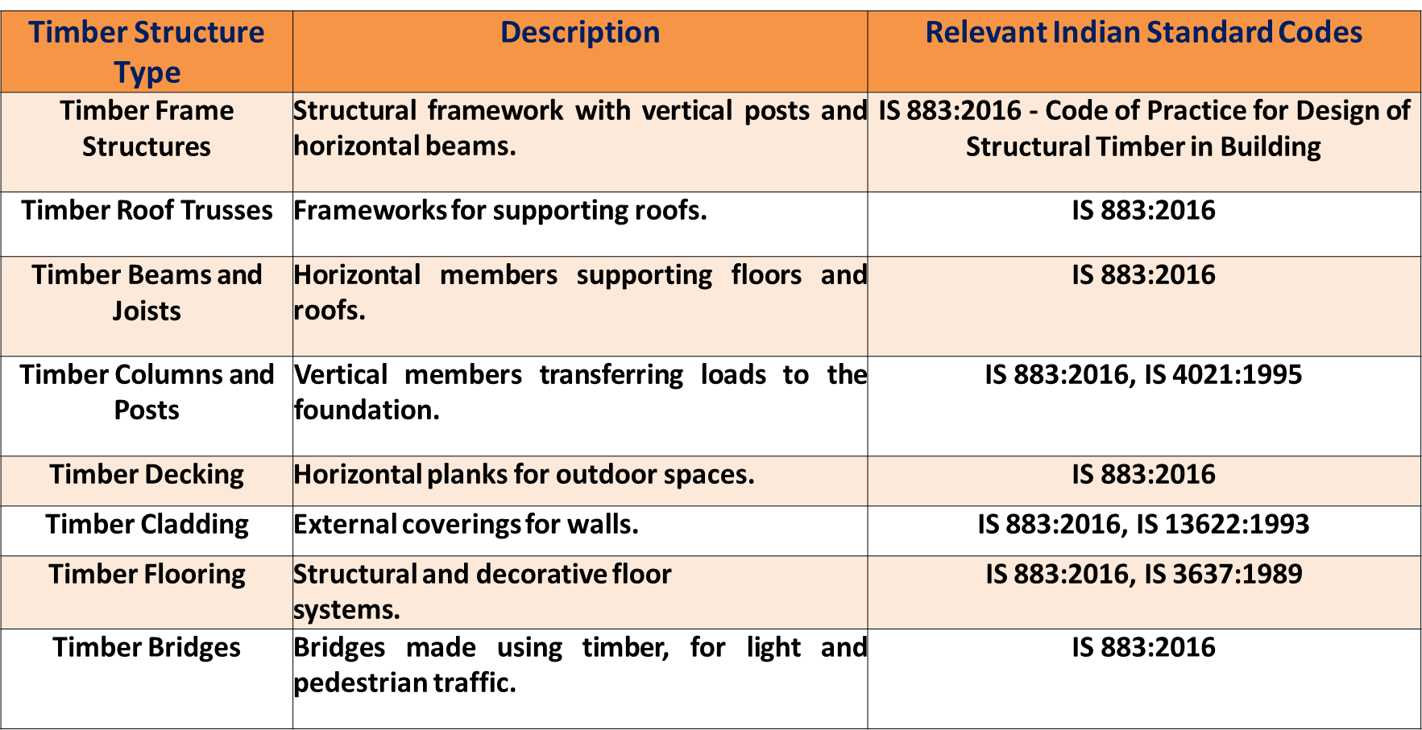
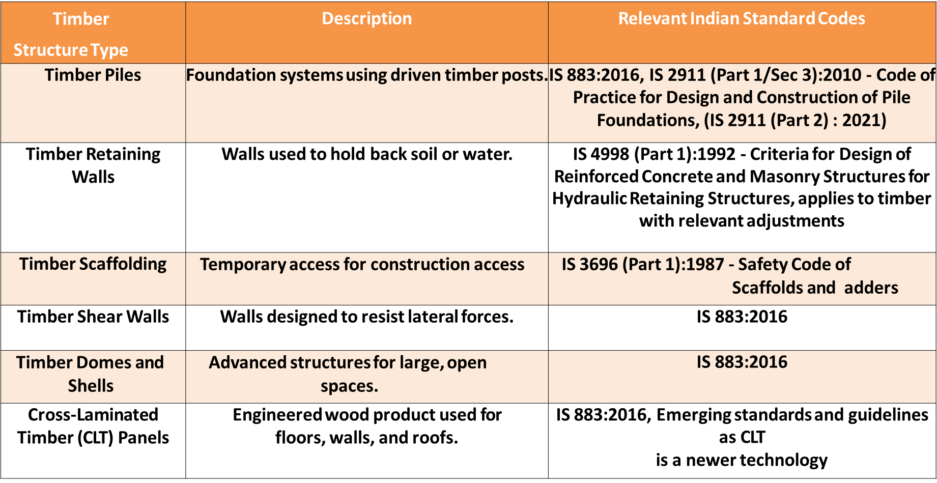
GLASS STRUCTURES
Types of glass and their common applications
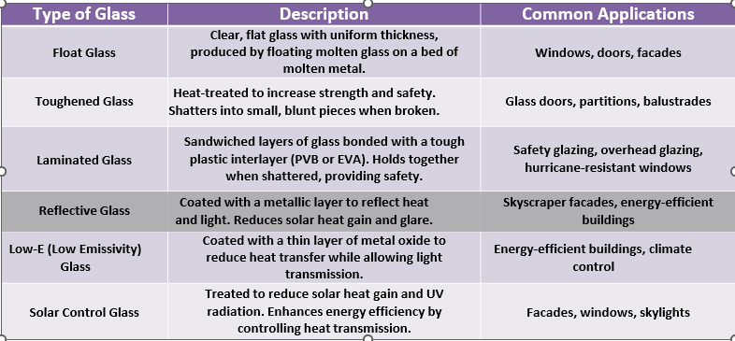
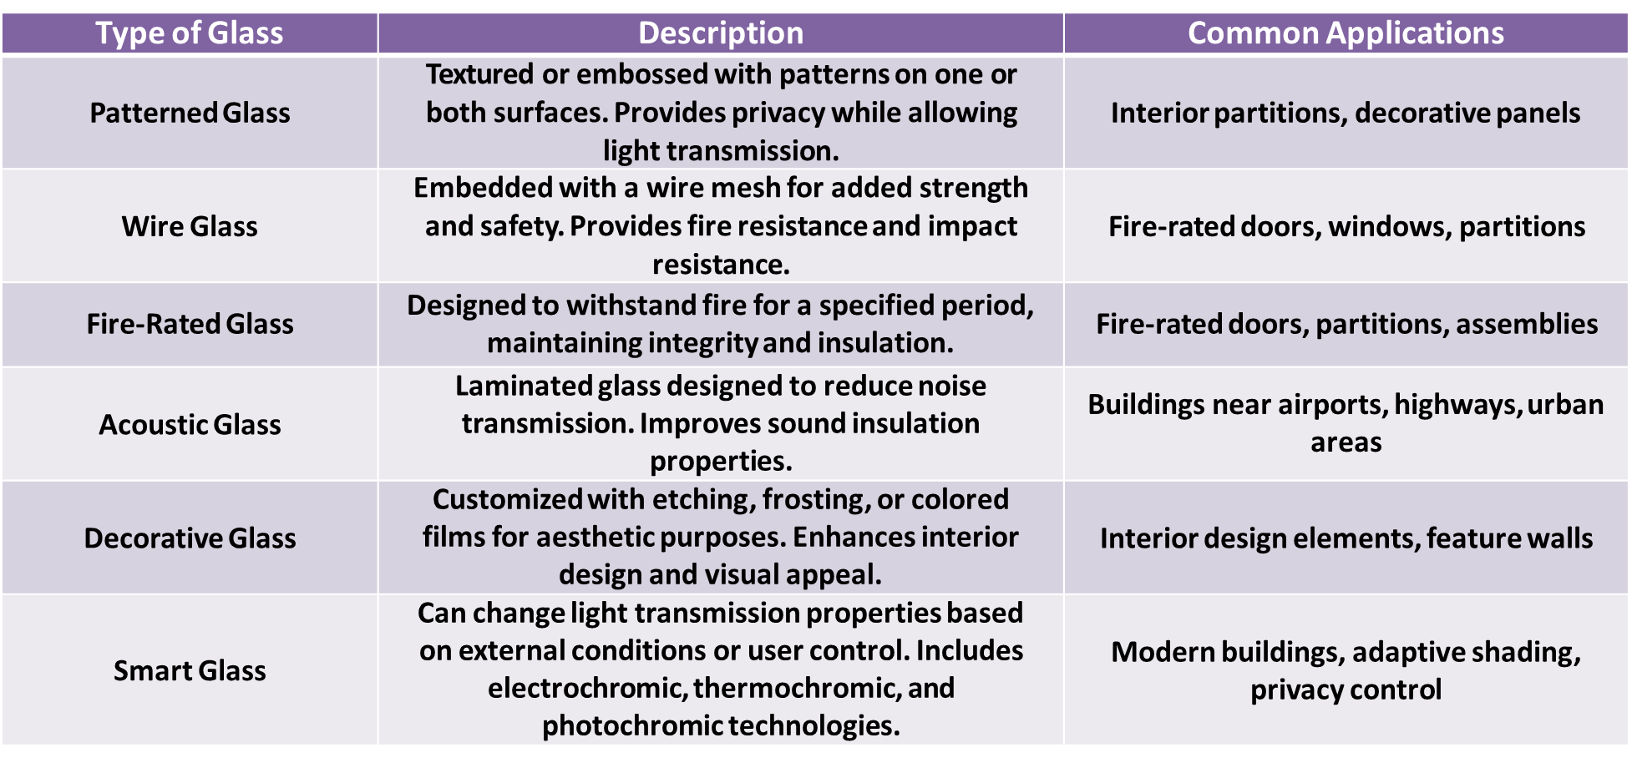
Relevant Indian Standards
IS 14900:2000 - Glass for Buildings:
- This standard covers requirements for various types of glass used in buildings, including float glass, tinted glass, reflective glass, laminated glass, etc.
- It specifies dimensions, tolerances, safety requirements, and quality control measures for different types of architectural glass.
IS 2553 (Part 1):1990 - Safety Glass, Part 1: Non-wired Glass:
- Part 1 of IS 2553 deals with non-wired safety glass, including toughened (tempered) glass and heat-strengthened glass.
- It provides specifications for the manufacture, testing, and installation of safety glass to ensure resistance to impact and safety in case of breakage.
IS 2553 (Part 2):1992 - Safety Glass, Part 2: Wired Glass
Part 2 of IS 2553 covers wired safety glass, which includes wired glass panels used for fire-resistant glazing and safety applications. It specifies the requirements for wire mesh embedded in the glass and its impact resistance properties.
IS 16231:2016 (Part 1 to 4) – Use of Glass in Building
- This standard provides guidelines for the design, installation, and use of glass in buildings.It covers aspects such as structural design considerations, safety criteria, thermal performance, and maintenance requirements for glass installations.
National Building Codes (NBC):
- The National Building Code of India (NBC) includes provisions related to the use of glass in building construction.
- Covers aspects such as safety, fire resistance, and energy efficiency requirements for glass installations.
Green Building Standards (e.g., IGBC, GRIHA):
- Provide guidelines for sustainable building practices, including the use of energy-efficient materials such as low-e glass and solar control glass.
Energy Conservation Building Code (ECBC):
- Includes provisions for energy-efficient building design, which may affect the use of glass for thermal insulation and solar control.
