FIRE AND LIFE SAFETY
- INTRODUCTION
Fire and life safety are fundamental to the built environment, ensuring the protection of lives, property, and communities. Effective fire safety measures, such as early detection systems, fire-resistant materials, and evacuation protocols, minimise risks and save lives during emergencies. They also safeguard property, reduce economic losses, and ensure compliance with fire safety regulations. In addition, robust fire safety systems enhance the resilience of critical infrastructure, promote sustainable building practices, and instil confidence in occupants. As urbanisation grows and architectural designs evolve, prioritising fire and life safety is essential for creating secure and sustainable spaces.
Indian Standards for fire and life safety play a crucial role in safeguarding lives, property, and the environment by providing a robust framework for designing, constructing, and maintaining fire-safe buildings and infrastructure. These standards, developed by BIS, incorporate global best practices while addressing local needs, ensuring compliance with safety regulations tailored to India's diverse conditions. By standardising fire protection systems, evacuation protocols, and material specifications, they reduce fire hazards, enhance resilience, and promote uniform safety practices across industries. Furthermore, adherence to these standards fosters public confidence, supports sustainable development, and mitigates the economic and social impacts of fire incidents.
- OVERVIEW OF THE IMPORTANT INDIAN STANDARDS
- IS 15683: 2018 & IS 16018: 2012 — IS 15683: 2018 ‘Portable Fire Extinguishers — Performance and Construction — Specification’ and IS 16018: 2012 ‘Wheeled Fire Extinguishers — Performance and Construction — Specification’ lay down requirements for performance, reliability and safety of portable and wheeled fire extinguishers respectively.
- IS 2190: 2024 — IS 2190: 2024 ‘Selection, Installation, and Maintenance of First-Aid Fire Extinguishers — Portable and Mobile — Code of Practice,’ provides comprehensive guidance for ensuring the effective use of fire extinguishers as a first line of defence against small fires. The standard covers critical aspects such as proper selection, installation, periodic inspection, and maintenance of extinguishers to ensure their readiness and functionality throughout their service life. It emphasizes the importance of matching the extinguisher type to specific fire hazards and includes provisions for operational testing, hydrostatic testing, and recharging.
- IS 3614: 2021 — IS 3614: 2021, ‘Fire Doors and Doorsets — Specification’, outlines the quality requirements for fire-rated doors, including their materials, construction, testing, installation, and maintenance. It addresses various types of fire doors such as insulated, uninsulated, hinged, sliding, and rolling shutters, ensuring their capability to act as effective barriers against fire and smoke. By ensuring proper compartmentation, it plays a crucial role in enhancing the safety of human lives and property in buildings, especially during fire emergencies​.
- IS 15105: 2021 — IS 15105:2021 outlines the design, installation, and maintenance of fixed automatic sprinkler fire extinguishing systems. This code of practice serves as a comprehensive guideline for ensuring effective fire suppression in various building occupancies. The standard details the components of a sprinkler system, which consists of a water supply, control valves, and a network of pipes fitted with sprinkler heads designed to detect and suppress fires by discharging water. It emphasizes the importance of proper installation and routine maintenance to ensure operational reliability during emergencies. Additionally, the standard addresses considerations for fire protection in high-rise buildings and reinforces the need for integrating sprinkler systems with other fire safety measures to protect life and property effectively.
- IS 2189: 2008 — IS 2189:2008 provides comprehensive guidelines for the selection, installation, and maintenance of automatic fire detection and alarm systems. This standard aims to ensure that fire detection systems can effectively identify fire at the earliest possible moment and provide timely alarms to facilitate appropriate responses such as evacuation and activation of firefighting measures. The document outlines the essential requirements for various types of detectors, including heat-sensitive devices, smoke detectors, flame detectors, and more. It emphasizes the need for reliability in detecting fires while minimizing false alarms and ensuring system integrity against disturbances.
- IS 18190: 2023 — IS 18190:2023 outlines methods for testing the fire resistance of perimeter fire barrier joint systems, particularly in buildings with gaps between floor slabs and external walls. These joints, vulnerable to smoke and fire propagation, must be sealed with fire-resistant materials matching the slab's fire rating. The standard includes test methods to evaluate performance under various conditions, such as thermal and various movements.
- IS 12458: 2019 — IS 12458:2019 specifies the method for testing and determining the fire resistance rating of through penetration firestops used in openings in fire-resistive walls or floor-ceiling assemblies. This standard evaluates firestops based on their ability to maintain integrity and insulation under fire exposure and a subsequent hose stream test.
- National Building Code of India 2016, Part 4: Fire and Life Safety — The National Building Code of India 2016, Part 4: Fire and Life Safety establishes comprehensive guidelines to ensure fire safety and life protection in buildings. It encompasses fire prevention measures, life safety provisions, and fire protection systems, tailored for various building occupancies. The Code emphasizes demarcation of fire zones, classification of building types based on fire resistance, and regulations for means of egress to minimize fire-related risks. It integrates passive and active fire protection strategies, such as compartmentation, fire detection, and suppression systems, while accommodating modern design considerations like atriums, glass facades, and high-rise buildings.
- FIRE SAFETY MEASURES IN BUILDING DESIGN
The National Building Code of India 2016, Part 4 Fire and Life Safety have the following approach for the fire & life safety:
- Fire Prevention
- Life Safety
- Fire Protection
3.1 Fire Prevention
3.1.1 Classification of Buildings Based on Occupancy
Group A | Residential
Group B | Educational
Group C | Institutional
Group D | Assembly
Group E | Business
Group F | Mercantile
Group G | Industrial
Group H | Storage
Group J | Hazardous
Group A Residential Buildings
These shall include any building in which sleeping accommodation is provided for normal residential purposes with or without cooking or dining or both facilities, except any building classified under Group C.
Buildings and structures under Group A shall be further subdivided as follows:
- Subdivision A-1 Lodging and rooming houses
- Subdivision A-2 One or two family private dwellings
- Subdivision A-3 Dormitories
- Subdivision A-4 Apartment houses
- Subdivision A-5 Hotels
- Subdivision A-6 Starred hotels
Group B Educational Buildings
These shall include any building used for school, college, other training institutions involving assembly for instruction, education or recreation for not less than 20 students.
Buildings and structures under Group B shall be further subdivided as follows:
- Subdivision B-1 Schools up to senior secondary level
- Subdivision B-2 All others/training institutions

Group C Institutional Buildings
These shall include any building or part thereof, which is used for purposes, such as medical or other treatment or care of persons suffering from physical or mental illness, disease or infirmity; care of infants, convalescents or aged persons and for penal or correctional detention in which the liberty of the inmates is restricted. Institutional buildings ordinarily provide sleeping accommodation for the occupants.
Buildings and structures under Group C shall be further subdivided as follows:
- Subdivision C-1 Hospitals and sanatoria
- Subdivision C-2 Custodial institutions
- Subdivision C-3 Penal and mental institutions
Group D Assembly Buildings
These shall include any building or part of a building, where not less than 50 persons congregate or gather for amusement, recreation, social, religious, patriotic, civil, travel and similar purposes, for example, theatres; motion picture houses; assembly halls; auditoria; exhibition halls; museums; skating rinks; gymnasiums; restaurants; places of worship; dance halls; club rooms; passenger stations and terminals of air, surface and marine public transportation services; and stadia.
Buildings under Group D shall be further subdivided as follows:
- Subdivision D-1 Buildings having a theatrical or motion picture or any other stage and fixed seats for over 1 000 persons
- Subdivision D-2 Buildings having a theatrical or motion picture or any other stage and fixed seats up to 1 000 persons
- Subdivision D-3 Buildings without a permanent stage having accommodation for 300 or more persons but no permanent seating arrangement
- Subdivision D-4 Buildings without a permanent stage having accommodation for less than 300 persons with no permanent seating arrangement
- Subdivision D-5 All other structures including temporary structures designed for assembly of people not covered by Subdivisions D-1 to D-4, at ground level
- Subdivision D-6 Buildings having mixed occupancies of assembly and mercantile (for example, shopping malls providing facilities such as shopping, cinema theatres, multiplexes and restaurants/food courts)
- Subdivision D-7 Underground and elevated mass rapid transit system
Group E Business Buildings
These shall include any building or part thereof which is used for transaction of business for keeping of accounts and records and similar purposes, professional establishments, service facilities, etc. City halls, town halls, courthouses and libraries shall be classified in this group so far as the principal function of these is transaction of public business and keeping of books and records.
Buildings under Group E shall be further subdivided as follows:
- Subdivision E-1 Offices, banks, professional establishments, like offices of architects, engineers, doctors, lawyers, post offices and police stations
- Subdivision E-2 Laboratories, outpatient clinics, research establishments, libraries and test houses
- Subdivision E-3 Electronic data processing centres, computer installations, information technology parks and call centres
- Subdivision E-4 Telephone exchanges
- Subdivision E-5 Broadcasting stations, T.V. stations and air traffic control towers
Group F Mercantile Buildings
These shall include any building or part thereof, which is used as shops, stores, market, for display and sale of merchandise, either wholesale or retail.
Mercantile buildings shall be further subdivided as follows:
- Subdivision F-1 Shops, stores, departmental stores, markets (any with covered area up to 500 m²)
- Subdivision F-2 Shops, stores, departmental stores, markets (any with covered area more than 500 m²)
- Subdivision F-3 Underground shopping centres
Group G Industrial Buildings
These shall include any building or part of a building or structure, in which products or materials of all kinds and properties are fabricated, assembled, manufactured or processed, for example, assembly plants, industrial laboratories, dry cleaning plants, power plants, generating units, pumping stations, fumigation chambers, laundries, buildings or structures in gas plants, refineries, dairies and saw-mills, etc.
Buildings under Group G shall be further subdivided as follows:
- Subdivision G-1 Buildings used for low hazard industries
- Subdivision G-2 Buildings used for moderate hazard industries
- Subdivision G-3 Buildings used for high hazard industries
Group H Storage Buildings
- Buildings used primarily for storage or sheltering of goods, vehicles, or animals, such as warehouses, cold storages, transit sheds, garages, hangars, barns, and stables, including servicing, processing, or repairs incidental to storage, excluding highly combustible or explosive materials.
- Storage properties are characterized by a relatively small number of occupants in proportion to the area, maintaining a focus on storage rather than human occupancy.
- Any change in use that increases the number of occupants to levels comparable with other occupancy types, such as warehouses converted to office spaces or hangars used for assembly purposes, will require reclassification of the building.
Group J Hazardous Buildings
- Includes buildings or parts thereof used for storage, handling, manufacturing, or processing of highly combustible or explosive materials that burn with extreme rapidity or may produce poisonous fumes or explosions.
- Covers activities involving highly corrosive, toxic, or noxious substances such as alkalis, acids, or chemicals that produce flames, fumes, explosive, poisonous, irritant, or corrosive gases.
- Applies to the storage, handling, or processing of materials capable of producing explosive dust mixtures or fine particles subject to spontaneous ignition.
Minor Occupancy — This is purely incidental to operations in a main occupancy, which shall be considered as part of the main occupancy and shall be classified under the relevant group for the main occupancy.
Mixed Occupancy — Where two or more types of occupancies intermingle in the same building, the entire building shall be treated as mixed occupancy.
3.1.2 Fire Zones
- Fire Zone No. 1 — This shall comprise areas having residential (Group A), educational (Group B), institutional (Group C), assembly (Group D), small business (Subdivision E-1) and mercantile (Group F) buildings, or areas which are under development for such occupancies.
- Fire Zone No. 2 — This shall comprise business (Subdivisions E-2 to E-5) and industrial buildings (Subdivisions G-1 and G-2), except high hazard industrial buildings (Subdivision G-3) or areas which are under development for such occupancies.
- Fire Zone No. 3 — This shall comprise areas having high hazard industrial buildings (Subdivision G-3), storage buildings (Group H) and buildings for hazardous uses (Group J) or areas which are under development for such occupancies.
3.1.3 Types of Construction
The types of construction according to fire resistance shall be classified into four categories, namely,
- Type 1 Construction
- Type 2 Construction
- Type 3 Construction and
- Type 4 Construction.
The minimum fire resistance ratings of structural and non- structural members for various types of construction shall be as given in Table 1.
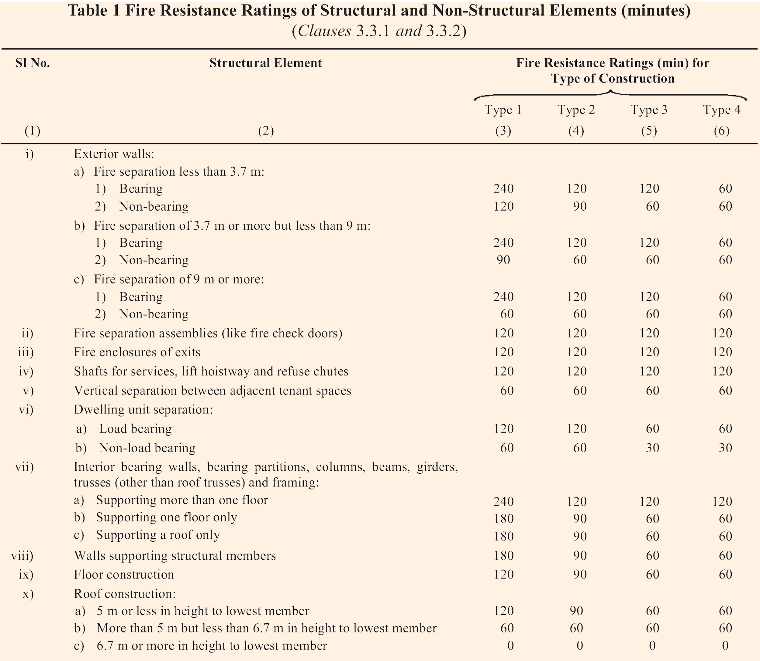
NOTE - Table 1 should be read with its NOTES.
3.1.4 General Requirements of All Individual Occupancies
This shall cover the following:
- Maximum Height, Open Spaces
- Floor area ratio
- Openings in Fire Resistant Walls and Floors
- Air Conditioning, Ventilation and Smoke Control
- Fire Command Centre (FCC)
- Surface Interior Finishes
- Electrical Installations
- Escape Lighting and Exit Signage

Floor Area Ratio — It is defined as below:
$$\text{FAR= }\frac{\text{Total Covered Area of All Floors}}{\text{Plot Area}}$$
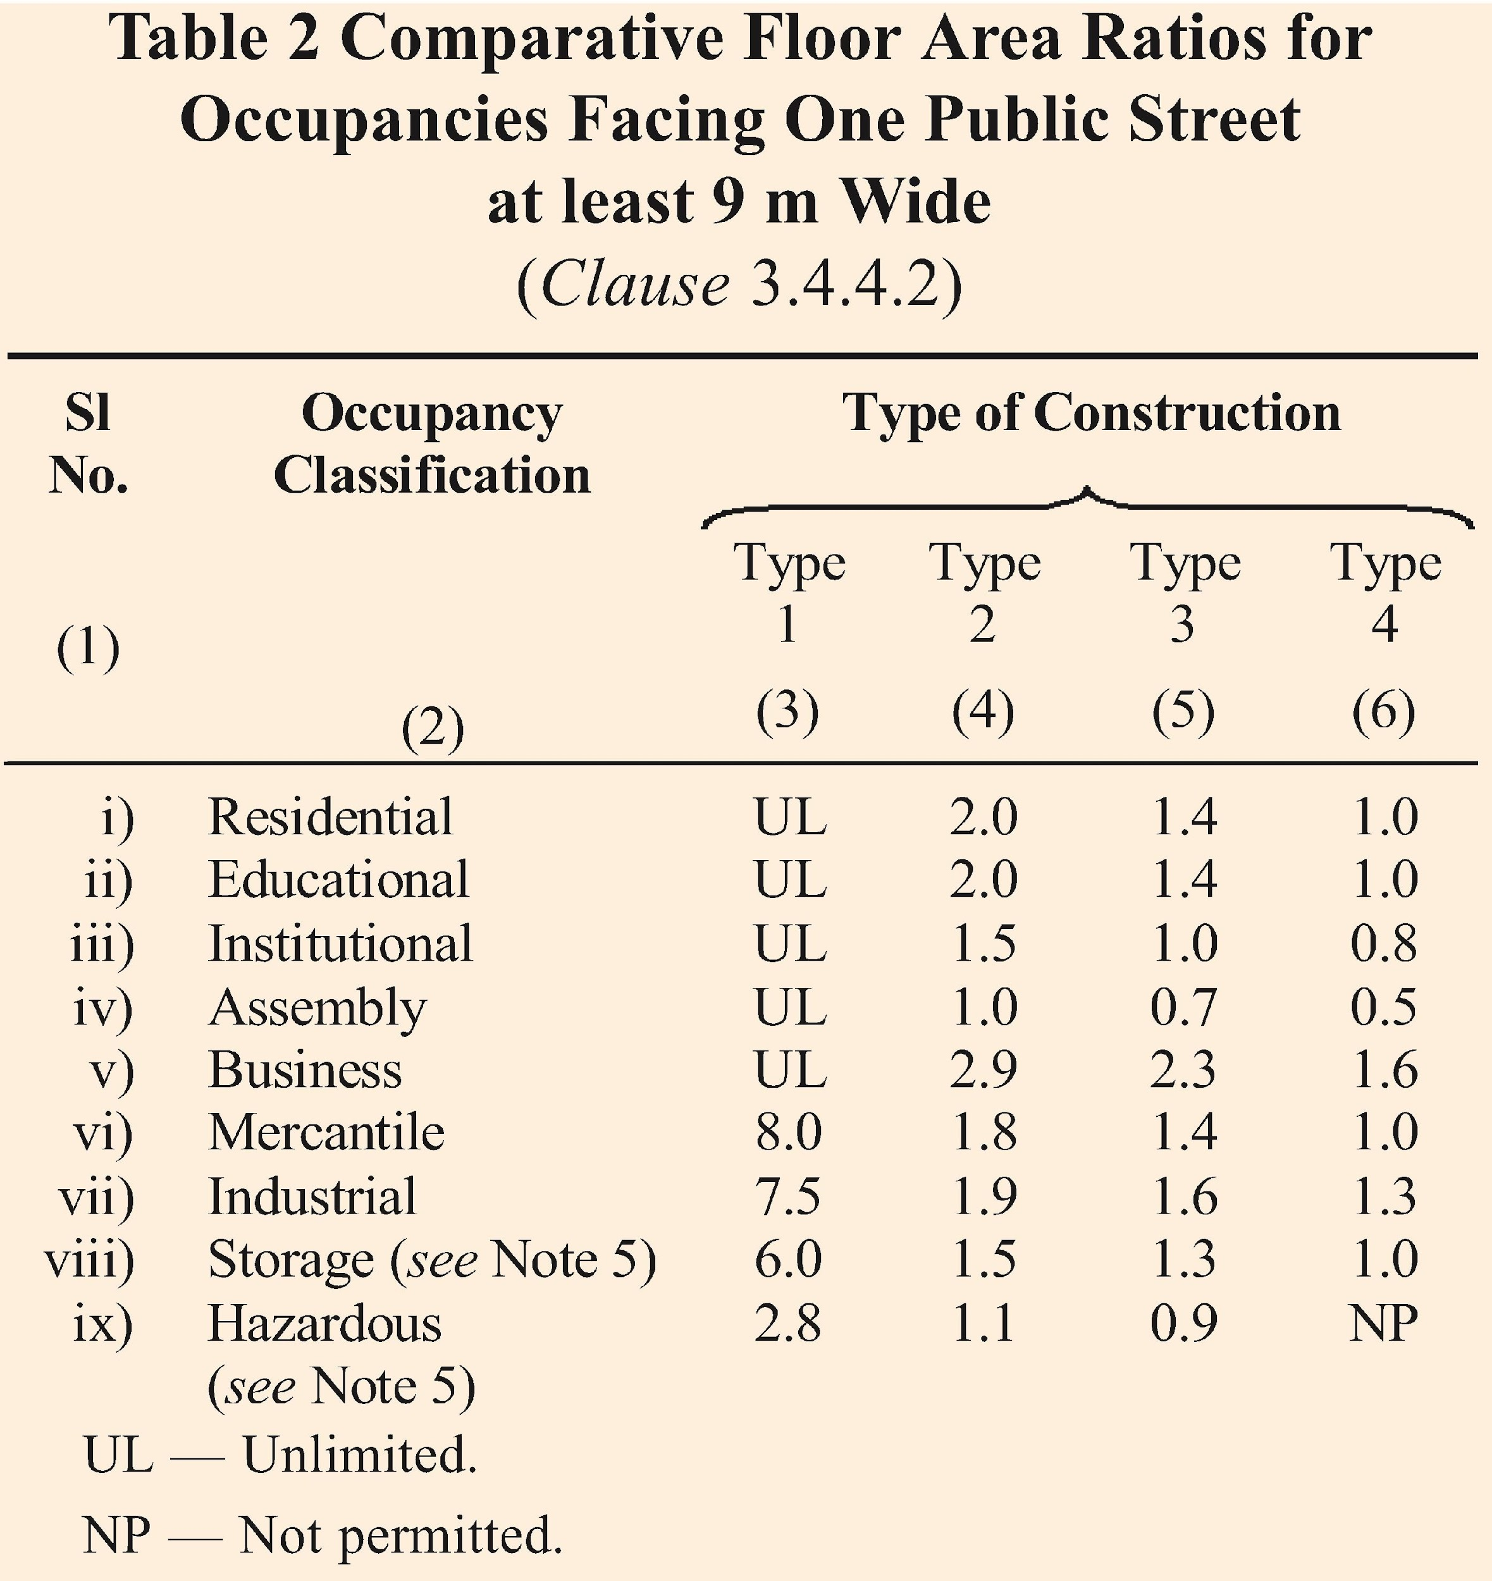
NOTE - Table 2 should be read with its NOTES.
Electrical Installations — Emergency lighting plays a critical role in ensuring fire and life safety by providing illumination during power outages, aiding safe evacuation and emergency response. These systems rely on emergency power sources to ensure uninterrupted functionality of life safety systems, even in the event of main power failure. Substations and transformers are designed to support emergency power supply, while standby power systems, such as generators or battery backups, ensure redundancy. Additionally, buildings must incorporate effective lightning protection systems to safeguard electrical infrastructure, maintaining the reliability of emergency lighting during adverse weather conditions.
Surface Interior Finishes — The susceptibility of various types of wall surfaces to fire is determined in terms of the rate of spread of flame. Based on the rate of spread of flame, surfacing material shall be considered as divided into four classes as follows:
- Class 1 Surfaces of very low flame spread.
- Class 2 Surfaces of low flame spread.
- Class 3 Surfaces of medium flame spread.
- Class 4 Surfaces of rapid flame spread.
3.2 Fire Protection
- Fire extinguishing systems must be installed based on building occupancy and height, including fire extinguishers, hose reels, wet risers, down-comers, hydrants, sprinklers, and other systems, as specified in applicable Indian standards.
- Fire extinguishers should be mounted at a convenient height for easy access, with installation and maintenance conforming to IS 2190.
- Pressure at hydrants should range between 3.5 bar (minimum) and 7.0 bar (maximum), with pressure control mechanisms like orifice plates or pressure-reducing devices as needed.
- Firefighting hydrants and hose reels should be located in firefighting shafts or within 5 metres of fire exit doors, marked with visible "FIRE HOSE CABINET" signage.
- Valves in fixed firefighting systems must include tamper-proof security measures (e.g., supervisory switches, padlocks, or tags) and be maintained in their intended "open" position.
- Firefighting equipment must be periodically maintained to ensure serviceability and conform to various Indian standards like IS 884, IS 903, IS 5290, IS 2097, IS 8442, IS 15683, IS 16018, etc.
Table 7 on National Building Code of India, Part 4 Fire & Life Safety gives the minimum requirement for the various fire fighting installations like fire extinguishers, hydrant systems, automatic sprinkler system, automatic detection and alarm system etc.
- LIFE SAFETY FEATURES AND EMERGENCY PLANNING
Life safety in 'Fire and Life Safety' focuses on protecting occupants by ensuring safe evacuation during emergencies, minimizing exposure to fire, smoke, and toxic gases. It emphasizes designing buildings with adequate exits, fire-resistant materials, and effective fire detection and suppression systems. Life safety encompasses the following:
- General Exit Requirements
- Egress Components
- Compartmentation
- Smoke Control, Fire Detection and Alarm
- Fire Drills and Fire Orders
- Occupant Load
General Exit Requirements
- Exits may include fire exit doorways, internal/external staircases, exit passageways, and horizontal exits leading to adjoining buildings or compartments, provided they lead to unlocked or public exits.
- Lifts, escalators, moving walks, and revolving doors are not considered exits and cannot be included in the required means of egress.
- Exits, passageways, and discharges must remain unobstructed and fully usable during emergencies, with buildings having sufficient exits to ensure safe evacuation.
- Fire doors with a 120-minute fire resistance rating must be installed in non-naturally ventilated areas, especially at lift lobbies and stairwell entrances to prevent the spread of fire and smoke.
- Exit doors must open in the direction of exit travel, and they should not directly open onto stairs without a landing to ensure unobstructed movement.
- At least half of the required stairways from upper floors must discharge directly to the exterior or through protected exit passageways.
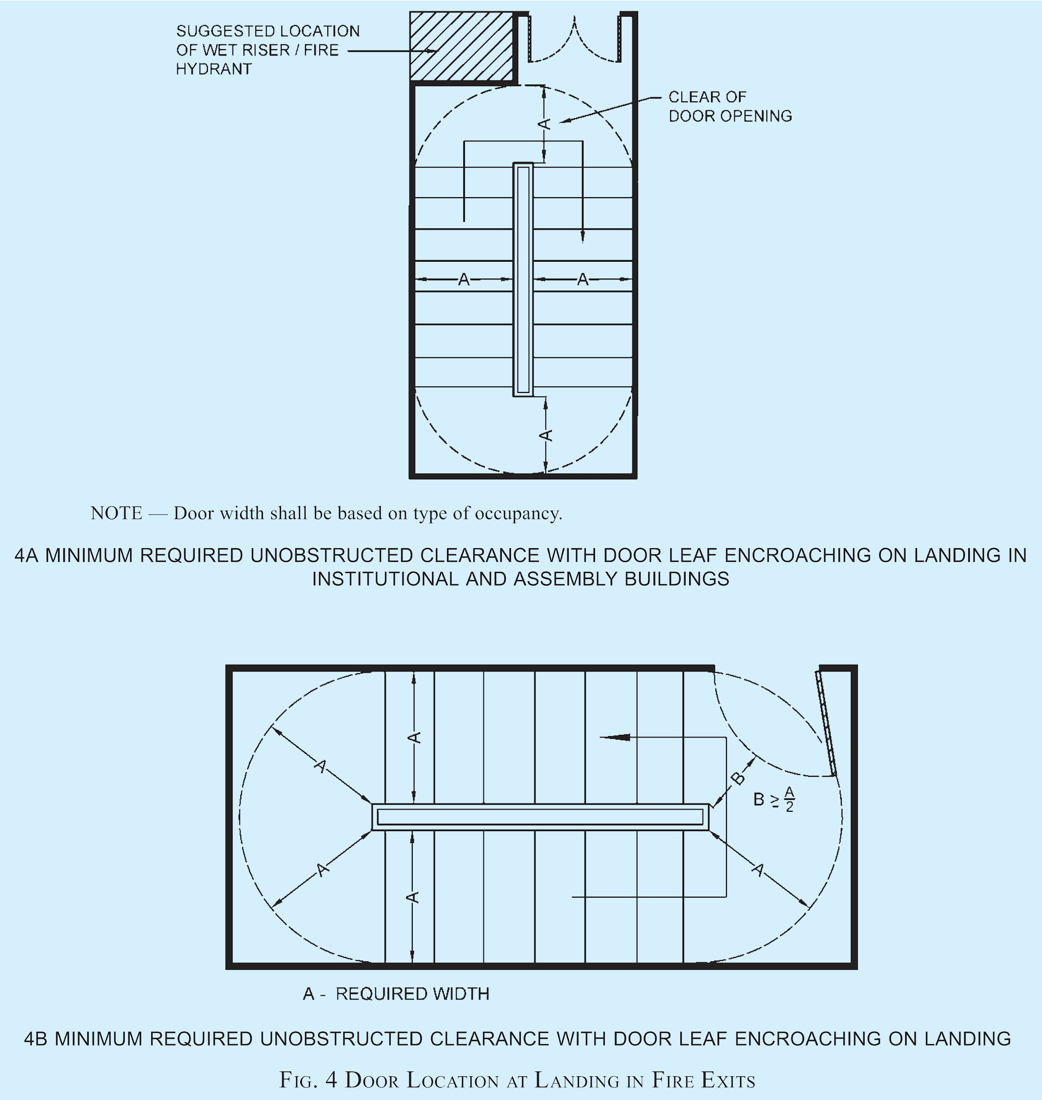
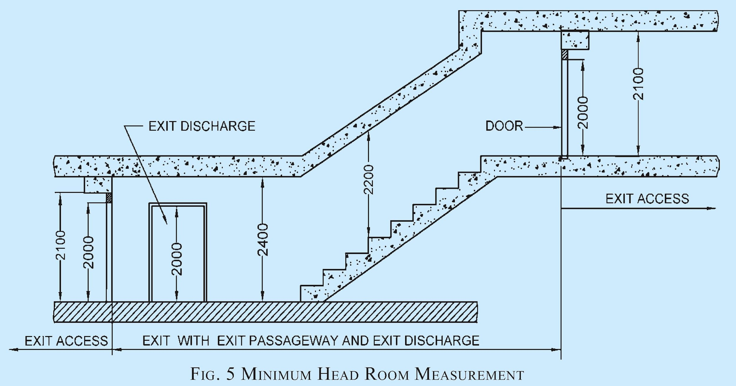
Occupant Load
- The number of exits required shall be determined based on the actual number of occupants declared, but not less than the minimum occupant load specified in Table 3 of NBC 2016.
- The occupant load of a mezzanine floor discharging to a floor below shall be added to the occupancy of that floor, and exit capacity shall be designed for the total occupant load.
- The occupant load of each storey shall be considered individually when computing the number of means of egress, ensuring that the required egress is not reduced along the direction of egress travel.
- Assembly occupancies and call centres must display occupant load details conspicuously near the entrance to prevent overcrowding and overloading.
- The displayed occupant load details should be engraved on a metal plate (minimum size 300 mm × 200 mm) with lettering at least 50 mm in height and width, including details of occupancy, area, and occupant load.
- For determining exit capacity, the occupant load of any open mezzanine or balcony shall be added to the capacity of the floor below.
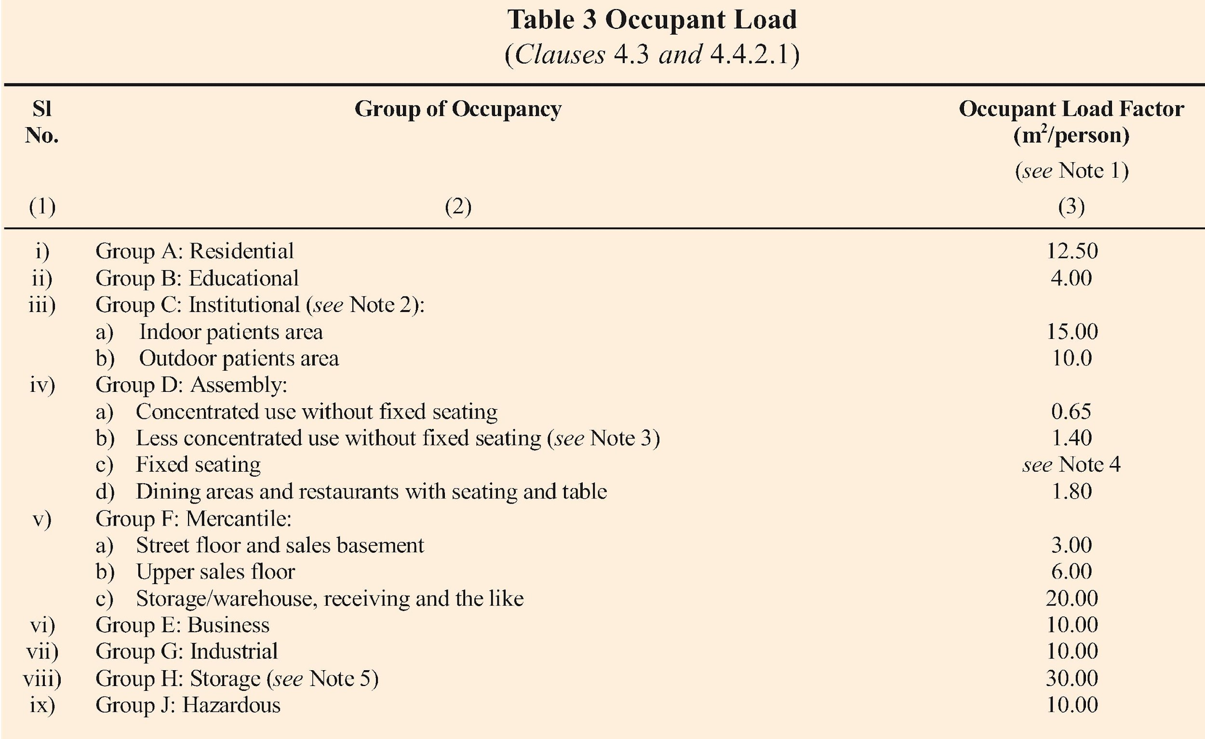
The assembly occupancies and call centres shall be required to display, limiting occupant load details positioned in a conspicuous place near the entrance of each of such respective occupancy to avoid possible overcrowding and overloading.
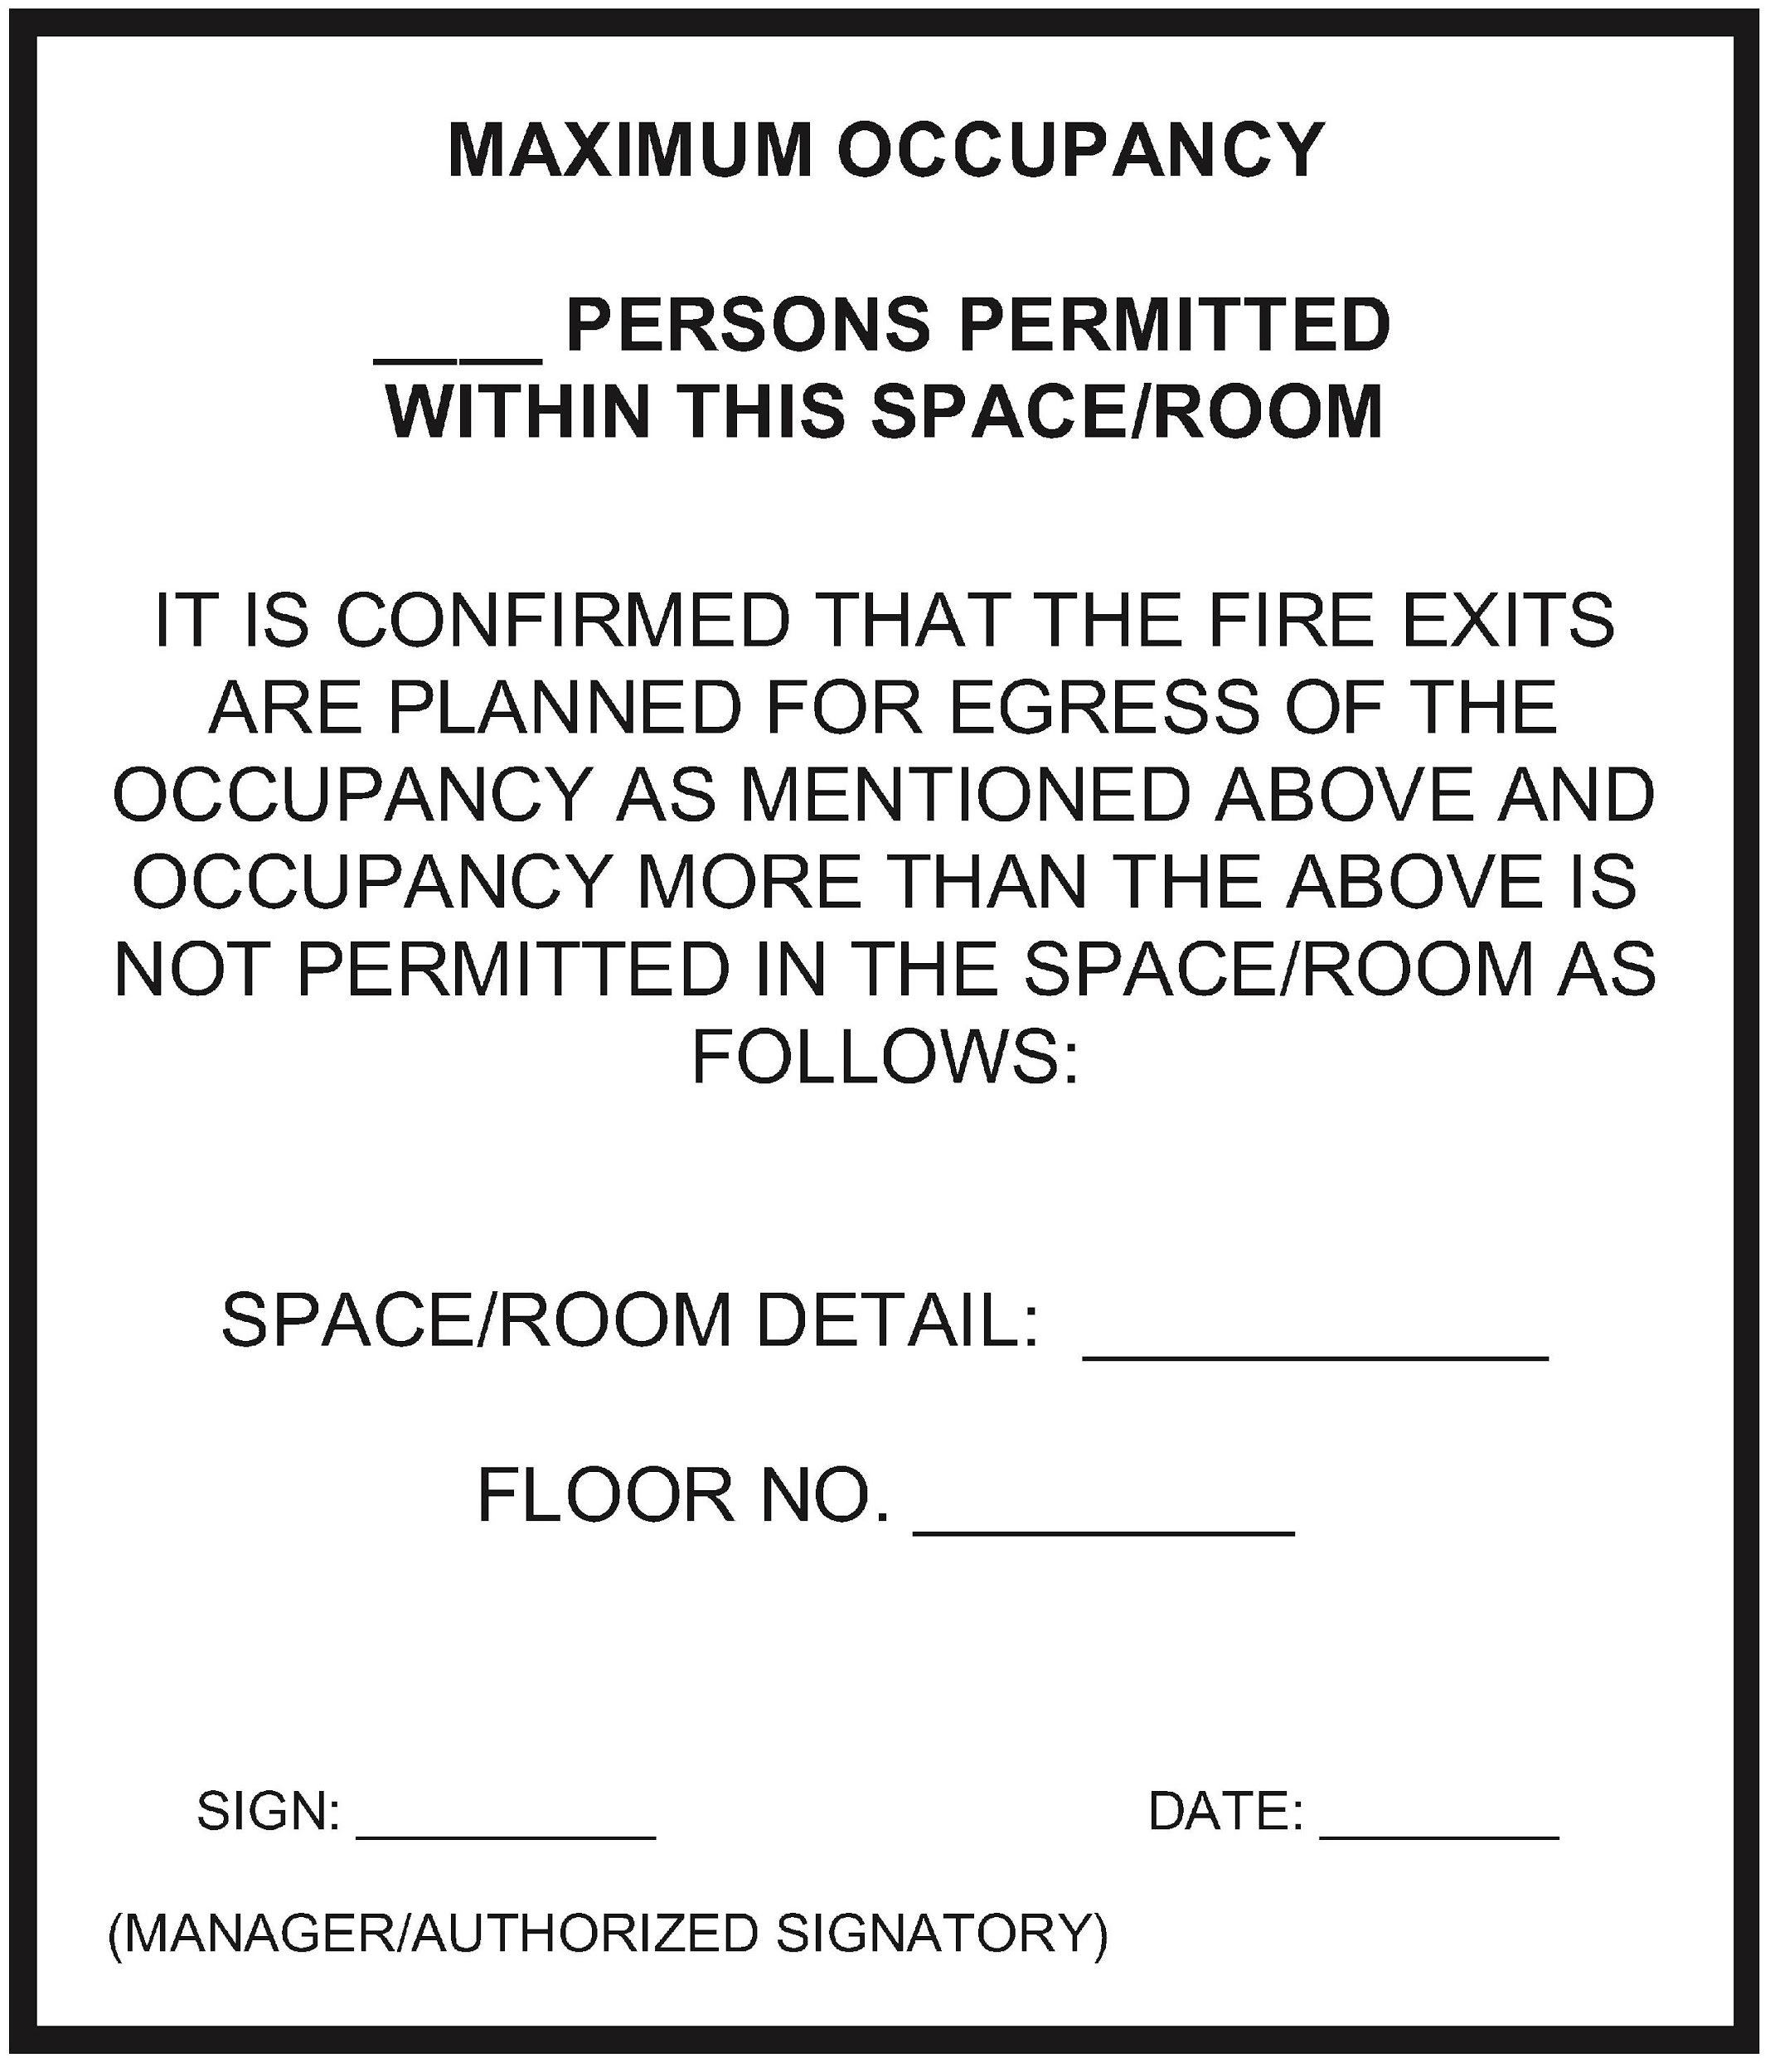
Egress Components
Egress components to be considered are the number of exits to which access is provided, capacity of exit access, travel distance to an exit, the obviousness of the direction to an exit, and any hindrance including due to security issues involved.
Exit Access — Exit access should lead to two independent directions to separate exits and have sufficient width to ensure smooth occupant flow. Corridors must be clear of obstructions and properly lit with emergency power backup, along with adequately marked exit signs. Access to fireman’s lifts and refuge areas should be step-free, signposted, and must not pass through storage or similar spaces.
Exits — Exits shall encompasses the following:
- Number of exits
- Arrangement of exits
- Capacities of means of egress
- Types of exit access and exits
- Smoke control of exits
- Number of exits — The minimum number of exits required in a building shall be determined based on the occupant load as specified in Table 3 of NBC 2016.
The width of exits per person shall conform to the requirements outlined in Table 4 of NBC 2016, considering the type of exit for the respective occupancies.
The number and width of exits must also comply with the maximum travel distance requirements provided in Table 5 of NBC 2016.
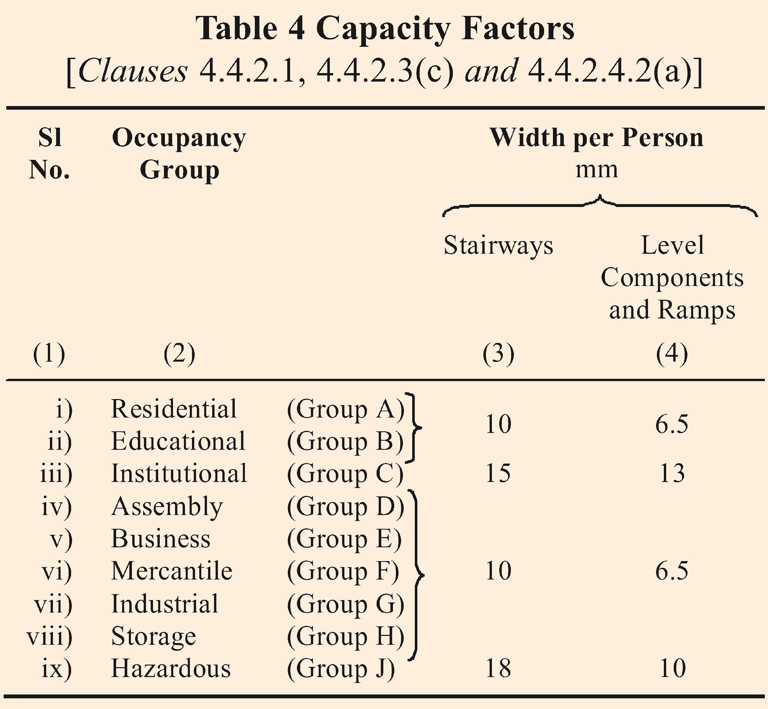
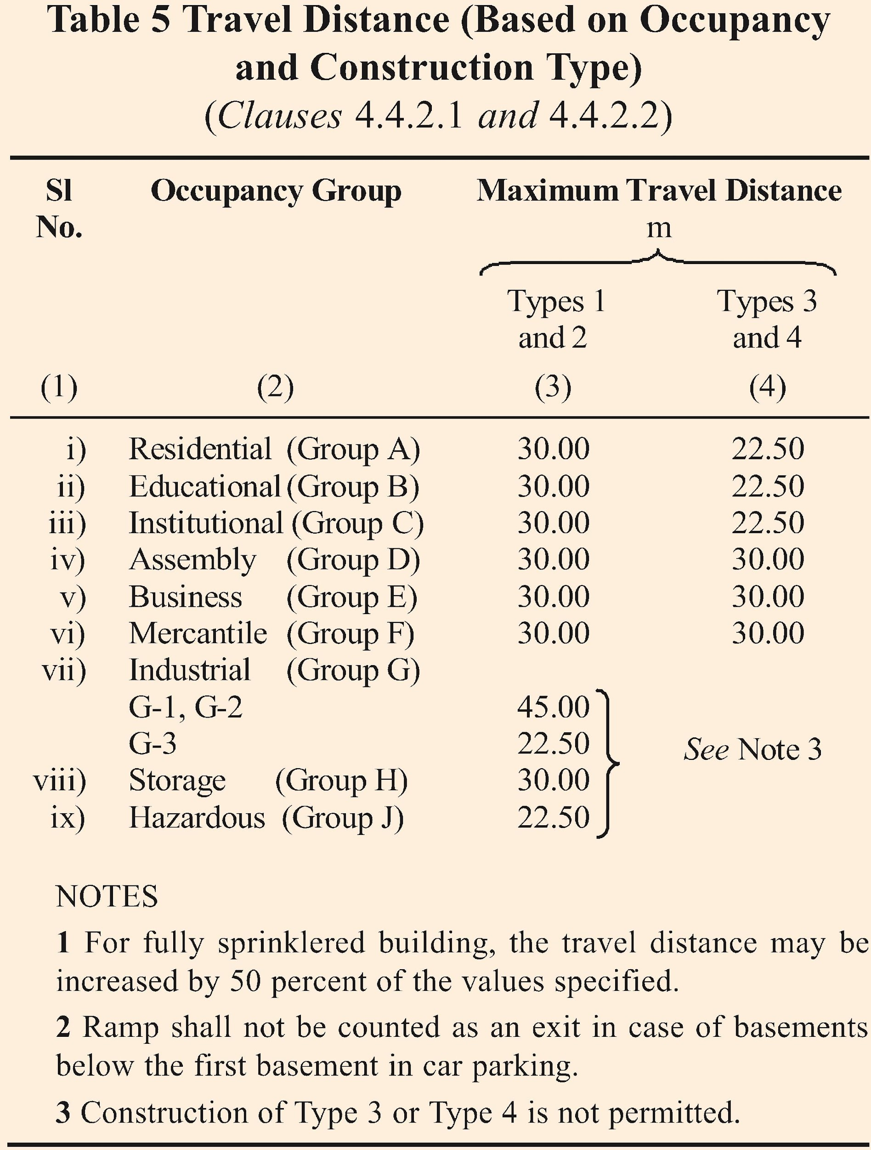
- Arrangement of exits — Exits must be located so that the travel distance on a floor does not exceed the limits specified in Table 5 of NBC 2016.
Travel distance shall be measured from the most remote point within a storey or mezzanine along an unobstructed horizontal or vertical egress path to the door of an exit.
Dead-end corridors in exit access shall not exceed 6 m for educational, institutional, and assembly occupancies, and 15 m for other occupancies.
Exits shall be positioned as far apart as possible and arranged to provide direct access in separate directions from any point in the area served.
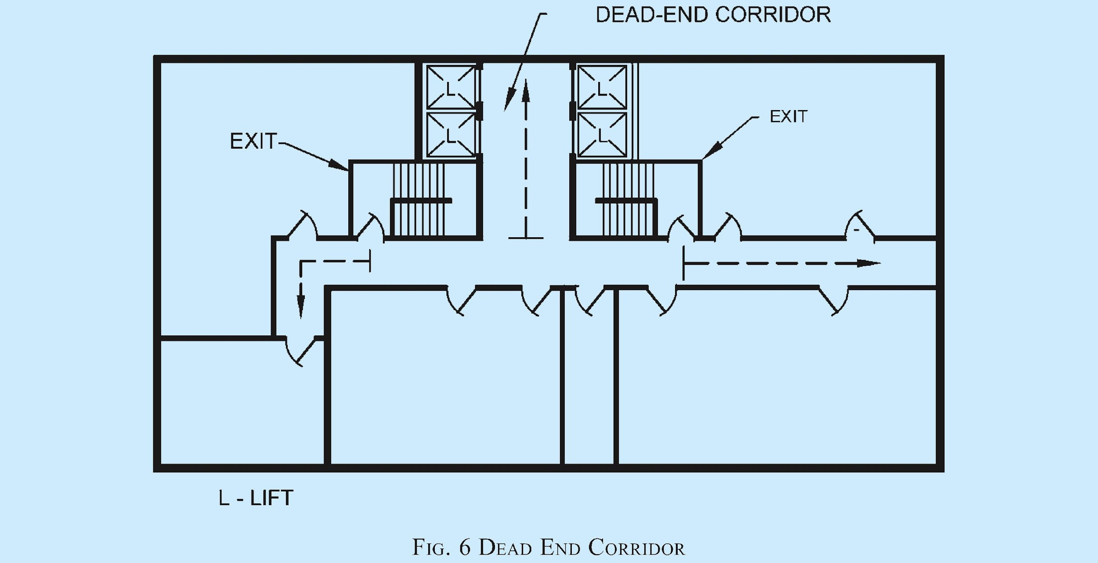
- Capacities of Means of Egress — Exit capacity refers to the number of people that can pass through stairways, doors, corridors, and ramps, and it must accommodate the entire population of the floor served.
The unit of exit width is 500 mm, with a clear width of 250 mm counting as an additional half unit; clear widths under 250 mm are not considered.
Exit widths for stairways, ramps, and level components are calculated using capacity factors from Table 4. For instance, a 1,000 mm doorway provides an exit capacity for 150 persons.
The capacity of the entire exit system is determined by the minimum capacity of its components, such as stairways, doors, or corridors, and the overall system is limited by the most restrictive element.
Exit planning must account for the adequacy of corridors and ensure compatibility between components like doors and stairways to maintain a seamless egress flow.
Egress capacity is calculated floor-by-floor, but the number of means of egress must not decrease as occupants proceed along the egress path.
- Smoke control of exits — Compartmentation in building design is crucial for limiting the spread of fire and smoke; all leakage openings in compartment enclosures, such as cracks, pipe openings, and airflow grills, must be sealed to prevent smoke ingress.
Staircase pressurization, achieved by injecting air to create a pressure differential, prevents smoke and toxic gases from entering exits, especially in high-rise buildings, with specific pressure values outlined for staircases and lobbies.
Ductwork and equipment for pressurization must be designed to prevent hot gases and smoke from entering staircases, using non-combustible materials and proper grill positioning.
Normal air conditioning systems must interface with the pressurization system during emergencies, stopping air recirculation, venting exhaust air to the atmosphere, and ensuring airflow does not impede egress.
Pressurized stair enclosure systems must activate through fire alarm panel signalling and integrate with the automatic/manual fire alarm system for supervision.
Pressurized staircases connecting to unpressurized areas must be segregated by a 120-minute fire-resistant wall, and fresh air intakes for pressurization must be at least 4 m away from exhaust outlets.
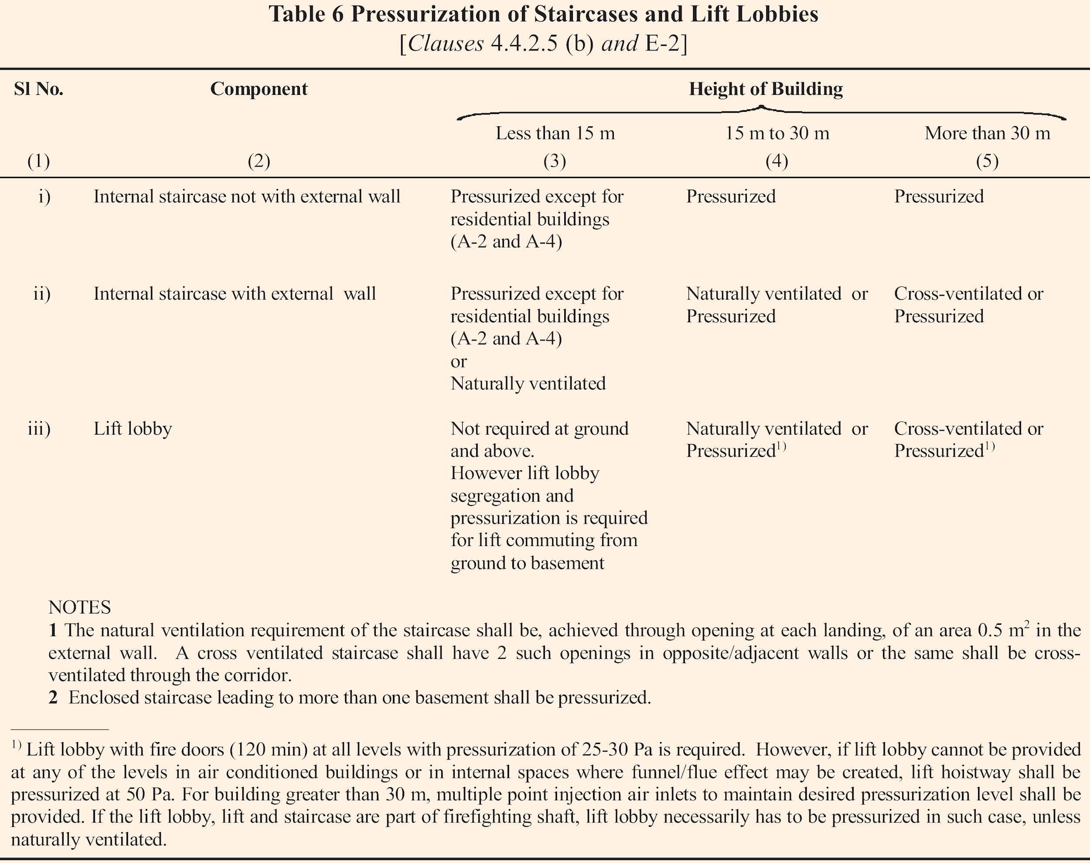
- Compartmentation — It is important to limit the spread of fire in any building, typically achieved using fire barriers.
When fire barriers are penetrated for ductwork, plumbing, or electrical systems, passive fire protection measures must be employed to maintain their integrity.
Floors must be compartmented with a maximum area of 750 m² per compartment.
For floor plates larger than 750 m², a minimum of two compartments is required.
Floor plates less than or equal to 750 m² do not require a minimum of two compartments.
Compartmentation must be achieved using fire barriers with a fire resistance rating of 120 minutes.
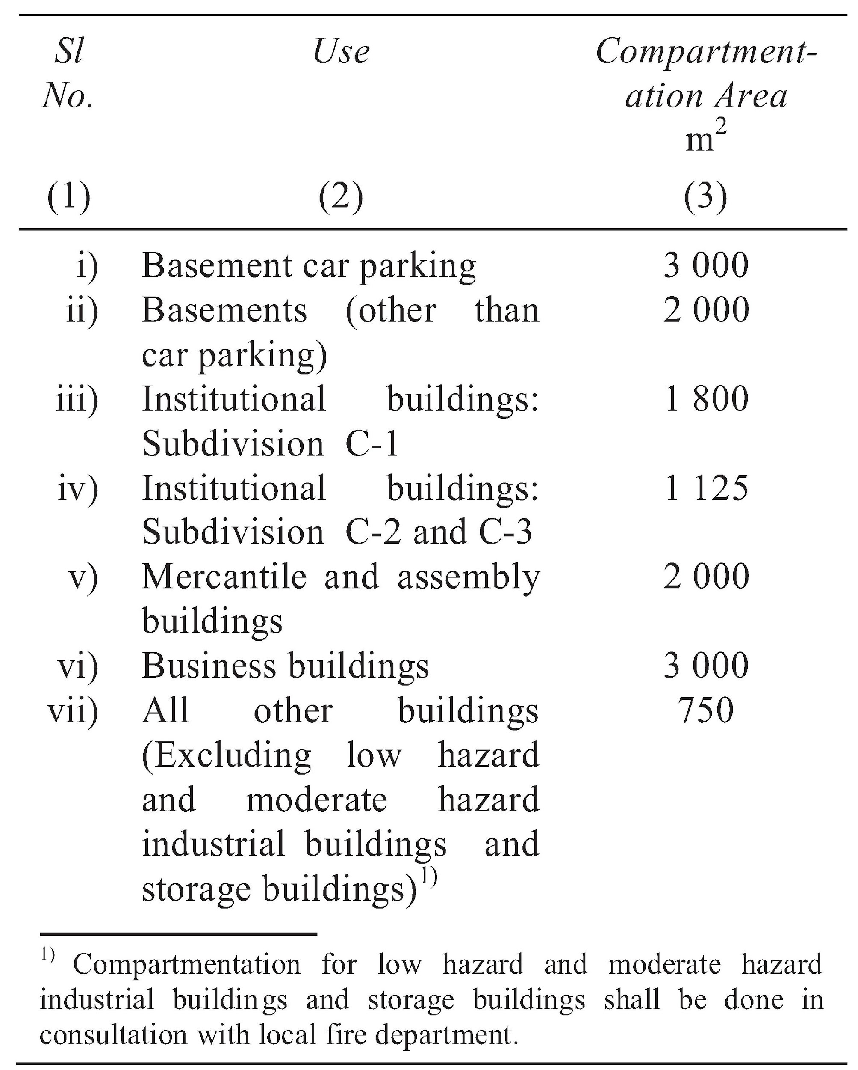
Following are the importance components to achieve the fire compartmentation:
- Fire Door (IS 3614)
- Through Penetration Fire Stops (IS 18190)
- Perimeter Fire Barrier Joint Systems (IS 12458)
- Fire resistant Walls (IS/ISO 834)
- CONCLUSION
Fire and life safety are critical aspects of building design and maintenance, ensuring the protection of life, property, and the environment. Adherence to Indian Standards, including guidelines from the National Building Code and specific standards for fire safety equipment and systems, provides a robust framework for mitigating fire risks. Implementing these measures not only enhances resilience but also fosters public confidence, supports sustainable development, and minimizes the social and economic impacts of fire incidents. As urbanization and complex architectural designs evolve, prioritizing fire and life safety remains essential for building a safer, more sustainable future for all.

