Revitalizing Structures: Retrofitting Of Existing Buildings

1. INTRODUCTION TO RETROFITTING
Retrofitting refers to the process of physical intervention (upgrading or modifying) in existing structures, systems, or equipment to enhance the structural characteristic such as structural configuration, strength, stiffness or deformability or to make them more energy efficient.

2. WHY RETROFITTING IS REQUIRED
- Damage to structural members
- Excessive loading
- Errors in design or Construction
- Modification of structural system
- Seismic damage
- Structural cracks
- Deterioration due to Corrosion
- Changes/Modifications in the design codes
3. OBJECTIVE OF RETROFITTING
- Retrofitting of buildings can be an effective way to improve the energy efficiency and sustainability of existing buildings and homes. By reducing energy consumption and reducing waste, retrofitting can also help reduce environmental impact and save property owners money on utility bills.
- Retrofitting of RCC structural members is carried out to regain the strength of deteriorated structural concrete elements.
- The main objective of retrofitting is to stabilize the current structure of buildings and make them earthquake-resistant.
4. BENEFITS OF RETROFITTING
- Structural Safety – Ensures buildings are stable and secure for occupants.
- Energy Efficiency – Reduces energy consumption and operational costs.
- Code Compliance – Meets modern building regulations and standards
- Lifespan Prolongation – Extends the usable life of existing structures
- Disaster Resilience – Enhances protection against natural disasters
- Sustainability – Supports environmental goals by reusing structures

5. STEPS IN THE RETROFITTING PROCESS
- Assessment – Conduct structural analysis to identify deficiencies
- Design – Develop retrofitting plans and choose appropriate materials and methods
- Implementation – Execute retrofitting tasks with minimal disruption to occupants
- Validation – Test the upgraded systems for performance and obtain certification to ensure regulatory adherence
6. INDIAN STANDARDS ON SEISMIC RETROFITTING
- IS 15988:2013 – Seismic Evaluation and Strengthening of Existing Reinforced Concrete Buildings — Guidelines
This standard is particularly concerned with the seismic evaluation and strengthening of existing buildings and it is intended to be used as a guideline. It describes a set of key steps and procedures for the assessment of the expected seismic performance of existing building in the event of a design level earthquake and where found necessary, strengthening of existing structural systems and elements for improved seismic performance.
This standard provides a method to assess the ability of an existing building to reach an adequate level of performance related to life-safety of occupants. Therefore, the emphasis is on identification of unfavourable characteristics of the building that could result in damage to either part of a building or the entire structure
- IS 13935:2009 - Seismic Evaluation, Repair and Strengthening of Masonry Buildings – Guidelines
This standard covers the selection of materials and techniques to be used for repair and seismic strengthening of damaged buildings during earthquakes. It also covers the damageability assessment and retrofitting for upgrading of seismic resistance of existing masonry buildings covered under IS 4326 and IS 13828.
The repair materials and techniques described herein may be used for all type of masonry buildings and construction.
- IS 13828 : 1993 - Improving Earthquake Resistance of Low Strength Masonry Buildings — Guidelines
This standard covers the special features of design and construction for improving earthquake resistance of buildings of low-strength masonry located in seismic zones III to V. No special provisions are considered necessary for buildings in seismic zone II.
The various provisions of IS 4326 : 1993 regarding general principles, special construction features, types of construction, categories of buildings and masonry construction with rectangular masonry units are generally applicable to the masonry buildings of low strength dealt with in this standard. There are however certain restrictions, exceptions and additional details which are specifically included herein.
7. METHODS OF ASSESSMENT OF BUILDINGS
For Reinforced Concrete Buildings
There are two levels of evaluation:
- Preliminary Evaluation – It is a quick procedure to establish actual structural layout and assess its characteristics that may affect its seismic vulnerability. It consists of:
- Site visit to collect data regarding general information of the building, structural system description, building typology, soil class, building use and nature of occupancy, and other general conditions.
- Configuration related checks such as load transfer path, geometry, redundancy, weak and soft storey, vertical discontinuities, mass and stiffness, torsion, adjacent buildings, etc.
- Strength related checks such as shear and axial stresses.

- Detailed Evaluation - The detailed evaluation procedure is based on determining the probable strength of lateral load resisting elements and comparing them with the expected seismic demands. The probable strengths determined from conventional methods and applicable codes shall be modified with appropriate knowledge factor as given in IS 15988.

For Masonry Buildings
The assessment of possible grade of damage in an existing masonry building under earthquake occurrences will mainly depend on
- Probable maximum intensity of the earthquake,
- Building typology,
- Building configuration, and
- Quality of construction and maintenance over time.
For initial quick assessment a rapid visual screening of the building may be carried out as given in Annex A of IS 13935. Besides the above factors, consideration of importance factor of 1.5 as per IS 1893 (Part 1) has also been considered by raising the earthquake Intensity for assessment of damageability. Based on assessed damageability of the building, the retrofitting actions can be planned.
8. METHODS OF RETROFITTING
The methods or techniques of retrofitting will depend upon the typology of the buildings whether it is a RC building or Masonry building.
- Retrofitting techniques for RC Framed Structures
- Jacketing of beams and columns
- Addition of reinforced concrete shear wall
- Addition of steel bracings
- Epoxy injection
- External steel plate bonding
- Jacketing

Members requiring strengthening or enhanced ductility shall be jacketed by reinforced concrete jacketing, steel profile jacketing, and steel encasement or wrapping with FRPs where possible, the deficient members shall first be stress relieved by propping.
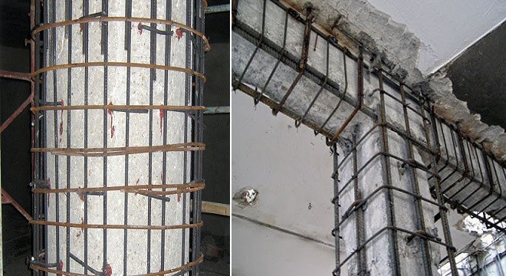
- Reinforced Concrete Jacketing - Reinforced concrete jacketing involves placement of new longitudinal reinforcement and transverse reinforcement bars in the new concrete overlay around existing member.
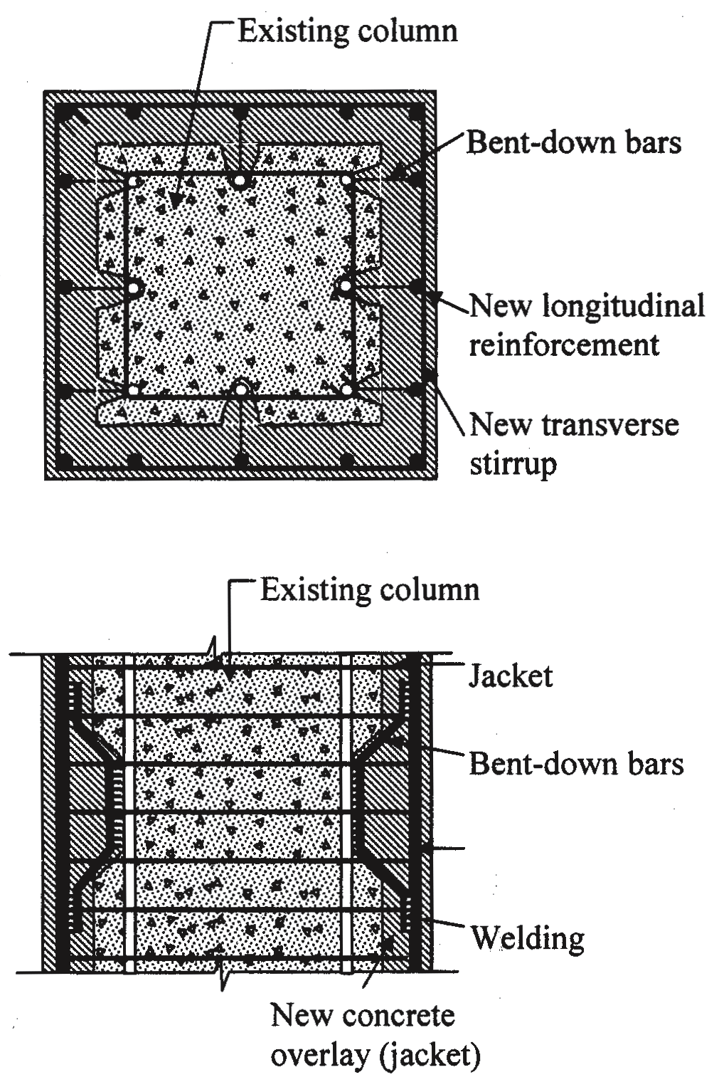
- Steel Profile Jacketing - Steel profile jacketing shall be done through steel angle profiles placed at each corner of the existing reinforced concrete member and connected together as a skeleton with transverse steel straps. Another way is by providing steel encasement. Steel encasement is the complete covering of the existing member with thin plates.

- FRP Jacketing - Retrofitting using FRPs involves placement of composite material made of continuous fibres with resin impregnation on the outer surface of the reinforced concrete member. Dimensions of FRP jacket is determined assuming composite action between fiber and existing concrete. The rupture strength of FRP is used as its limiting strength.
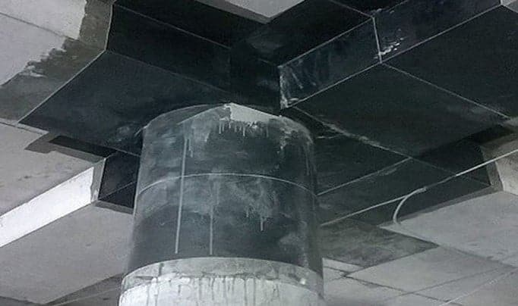

- Addition of RC Shear Wall
- Addition of new reinforced concrete shear walls provides the best option of strengthening an existing structure for improved seismic performance.
- It adds significant strength and stiffness to framed structures.
- The design of shear walls shall be done as per IS 13920 - Ductile Design and Detailing of Reinforced Concrete Structures Subjected to Seismic Forces - Code of Practice (first revision).
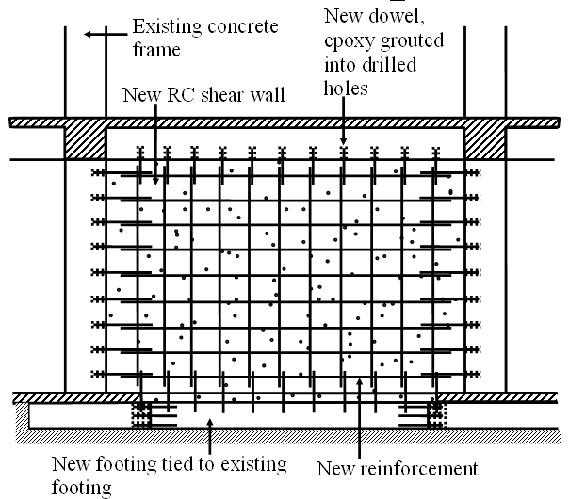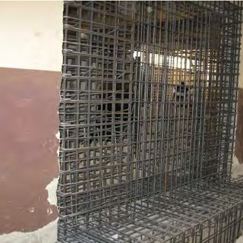

- Addition of Steel Bracing
- Steel diagonal braces shall be added to existing concrete frames.
- Braces shall be arranged so that their centre line passes through the centres of the beam-column joints.
- Angle or channel steel profiles shall be used.
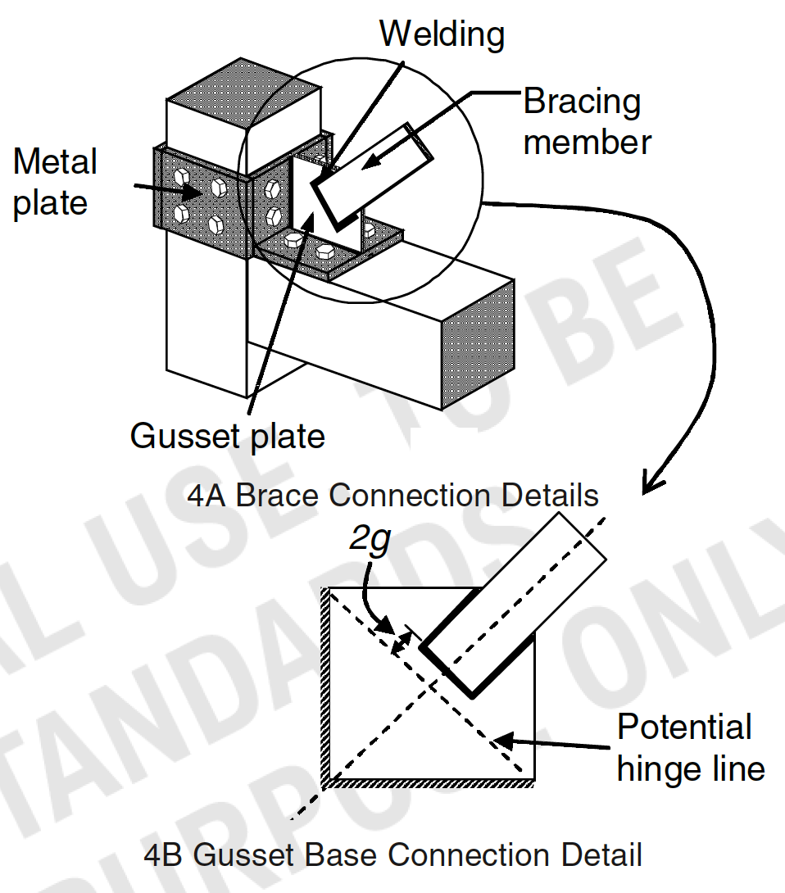
- Prefabricated Steel Bracing
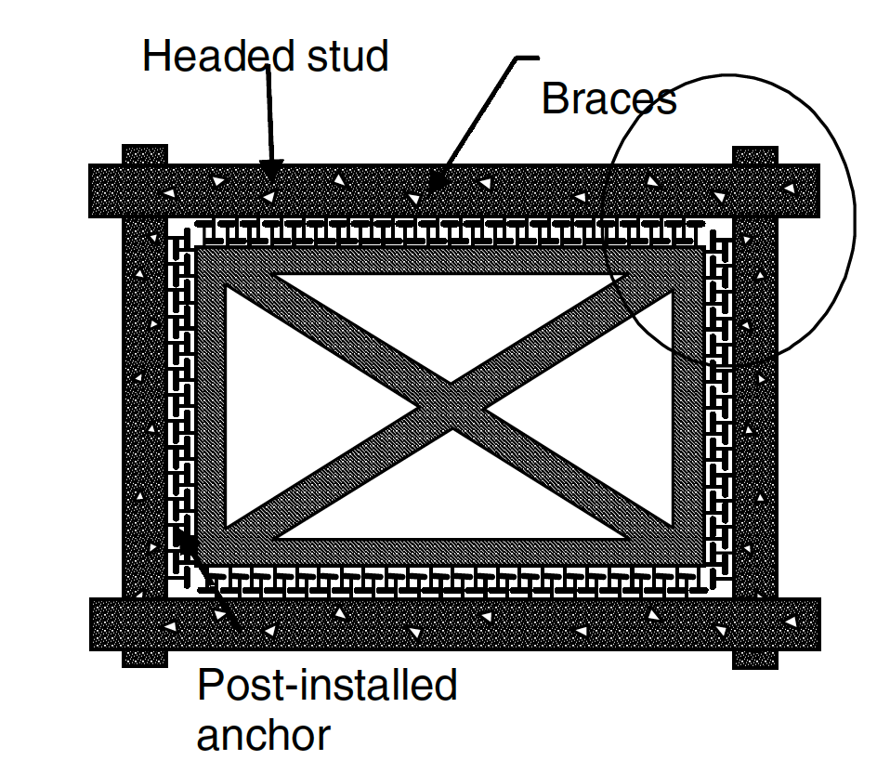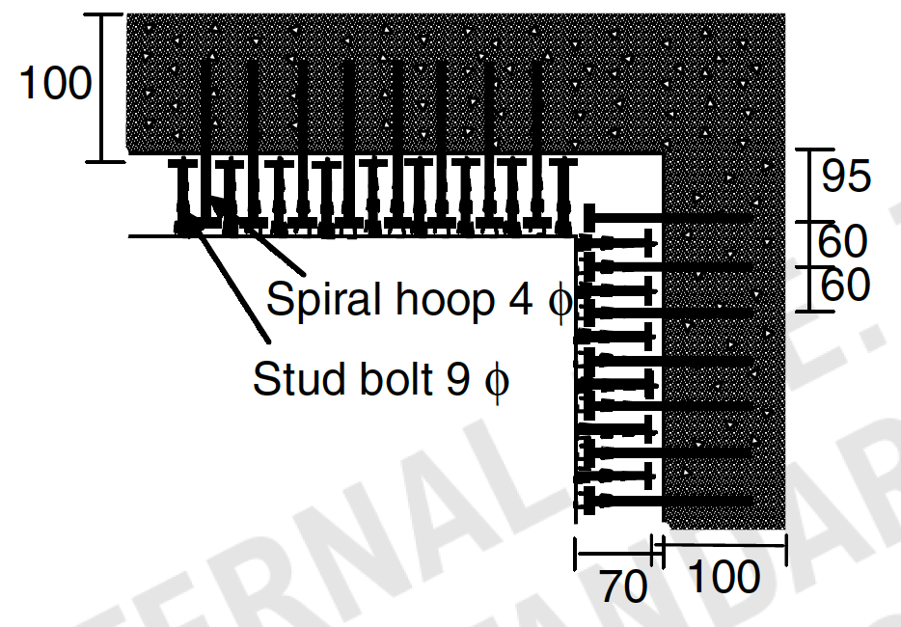

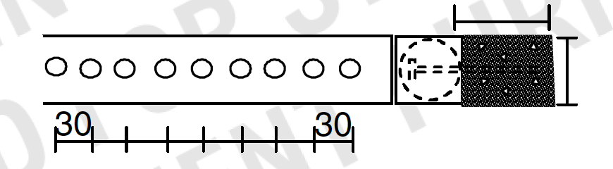

- Epoxy Injection
- Epoxy injection is an economical method of repairing non-moving cracks in concrete walls, slabs, columns, and piers. In retrofitting buildings, epoxy injection is used to fill and repair the structural fault.
- It is capable of restoring the strength of concrete to its pre-cracked strength. The epoxy tensile bond to the concrete is stronger than the tensile strength of concrete.
- Strengthening is provided by installing additional reinforcement across the failure plane in combination with the epoxy resin injection.
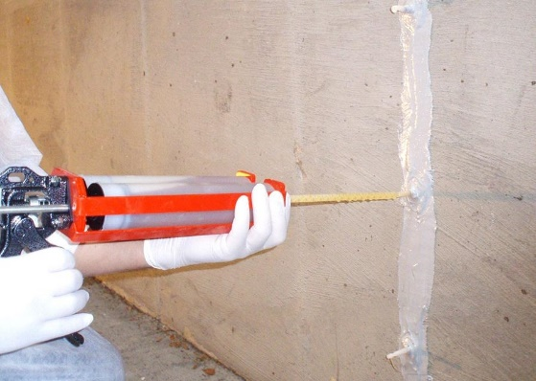
- External Steel Plate bonding
Strengthening of reinforced concrete beams with external plates or strips is a conventional method and has been utilized for many decades. The external plate bonding method can be used for increasing the shear strength of reinforced concrete beams by completely or partially wrapping steel plates at the joint of a column and beam
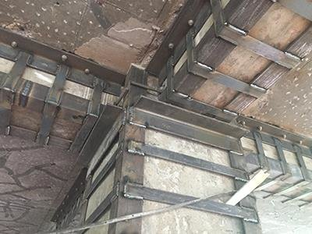

- Alternative Strengthening Options
- Seismic isolation and supplemental damping are rapidly evolving strategies for improving the seismic performance of structures. Base isolation reduces the demands on the elements of the structure. This technique is most effective for relatively stiff buildings with low profiles and large mass compared to light, flexible structures.
- Energy dissipation helps in the overall reduction in displacements of the structure.
- This technique is most effective in structures that are relatively flexible and have some inelastic deformation capacity.
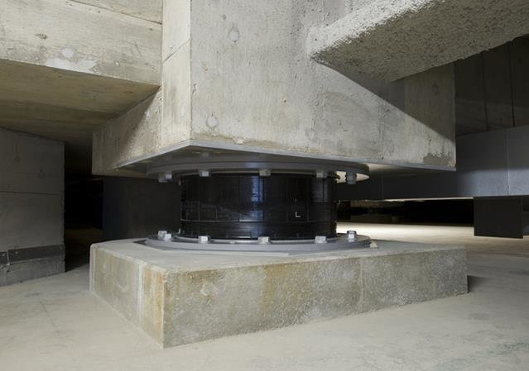

- Retrofitting in Masonry Buildings
Retrofit of masonry buildings should address first the deficiencies at the structural level and then those at the member level
- Retrofit at the Structural Level is targeted to improve one or all of the following, namely:
- Overall integrity of the structure using measures like steel or reinforced concrete bands or connections between adjoining walls along the vertical joint, and between walls and roof slab along the horizontal joint.
- Load paths in the structure by enhancing existing load paths in the form of additional structural walls or braces, or creating alternate load paths in the form of buttressing of the deficient building with an adjoining structure built snugly with the deficient structure.
- Foundations of the structure using measures like strengthening rubble masonry footings, enlarging area of RC footing, underpinning the foundation by drilling micro-piles, etc.
- Connections with walls, using measures like anchorage of reinforcement, screed concrete, or wood planks nailed with cross battens, and diaphragm action using measures like anchorage of reinforcement in roof and floors of the building.
- Jacketing of the columns and piers of the building.
- Member level of retrofit shall be undertaken only after it is established that the building meets the system deficiencies
- Buildings with sufficient stiffness and strength at the Structure level may have some members (or components), which lack adequate strength, stiffness or ductility. If the number of such deficient members is small, an economical and appropriate strategy is to modify these deficient members alone while retaining the existing lateral-force resisting system.
- Member level modification shall be undertaken to improve strength, stiffness and/or ductility of deficient members and their connections. For instance, modifications may be made to meet the desired strength demand-capacity ratio.
- Member level strengthening measures that enhance ductility of the member without significantly increasing its strength/stiffness are useful when analysis indicates that a few members of the lateral-load resisting system are deficient. For instance, modifications may be made to meet the desired plastic rotation capacity of specific members.
- All structural members after retrofit shall be capable of carrying the code specified static loads.

9. POSSIBLE RETROFIT SCHEMES IN MASONRY BUILDINGS
- The choice of retrofit depends on available options, feasibility of implementing the retrofit measures, and the cost of retrofit.
- The spirit of retrofit of masonry buildings is confining them with external and internal supports.
The simplest retrofit measures for masonry buildings are:
- Addition of horizontal steel twin belts in case of brick masonry
- Addition of horizontal steel twin ties in case of stone masonry
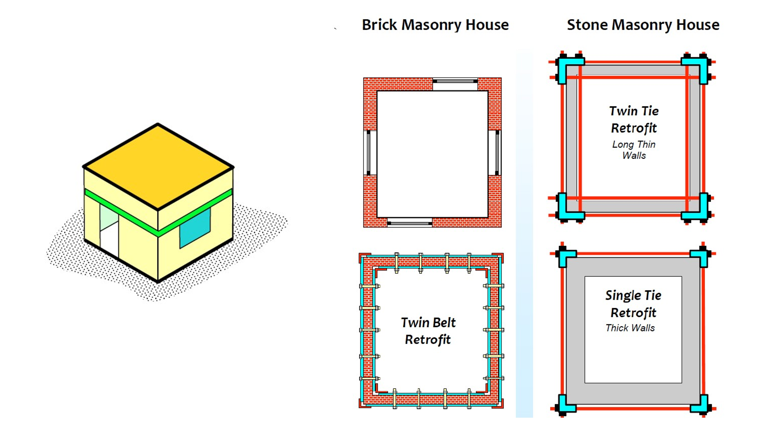

10. CHALLENGES IN UNDERTAKING RETROFITTING
- Technical challenges
  - Compatibility issues
  - Limited Design Flexibility
  - Material Availability
- Regulatory Hurdles
  - Compliance with Modem Standards
  - Permit Delays
- Technological Limitations
  - Lack of Advanced Tools
  - Training Gaps
- Cost Factors
  - High initial investment
  - Hidden Costs
  - Funding Challenges
- Logistical issues
  - Occupant Disruption
  - Construction Safety
  - Time Constrinsts
11. CONCLUSION
Retrofitting is a valuable approach to enhancing the safety, efficiency, and longevity of existing buildings. By addressing structural weaknesses, upgrading outdated systems, and improving energy efficiency, retrofitting can significantly enhance the functionality and value of buildings. However, retrofitting also presents challenges, such as high initial costs, complex planning, and potential disruptions during construction. Careful planning, collaboration with experts, and a clear understanding of the building’s needs can help ensure a successful retrofit, resulting in safer, more efficient, and sustainable buildings.
*******

