BASIC SAFETY OF MEDICAL EQUIPMENT
Electrical safety of a medical equipment is of utmost importance whenever the quality and performance of the equipment is in question.
Electrical Hazards
Electricity can cause a number of physiological effects on the human body, including burns, muscle spasms, and loss of consciousness.
- Burns:
  - Electricity can burn tissue, including internal organs, with the same effect as an open flame.
  - The amount of heat generated determines the severity of the burn.
- Muscle spasms:
  - Electricity stimulates muscles, causing them to involuntarily contract.
  - The intensity of the current and the type of muscle it passes through determine the effect.
- Loss of consciousness: Electricity can cause a loss of consciousness, especially if it passes through the brain.
- Other effects:
  - Nerve damage: Electricity can damage nerves, which are cells that transmit signals to regulate body functions.
  - Organ damage: Electricity can damage organs.
  - Internal bleeding: Electricity can cause internal bleeding.
  - Irregular heartbeat: Electricity can cause an irregular heartbeat.
  - Ventricular fibrillation: Electricity can trigger ventricular fibrillation, which can lead to cardiac arrest.
  - Headache: Electricity can cause headaches.
  - Breathing problems: Electricity can cause breathing problems.
  - Vision or hearing problems: Electricity can cause vision or hearing problems.
There are two distinct types of electrocution which need to be considered in healthcare environments: macro-shock and micro-shock.
Macro-shock occurs when current passes through the body via contact with the skin and this aspect applies to all types of electrical safety. However, external dry skin has high resistance, which limits current flow through the body. Many medical procedures involve moistening the skin, which lowers skin resistance significantly, such as ultrasound gel and surgical applicants. Furthermore, patients are often in constant physical contact with medical electrical (ME) equipment, both directly and indirectly e.g., electrical monitoring systems and electrically powered beds. The results from macro-shock lead to loss of voluntary muscle control at currents as low as 10mA and ventricular fibrillation at currents of approximately 100mA.
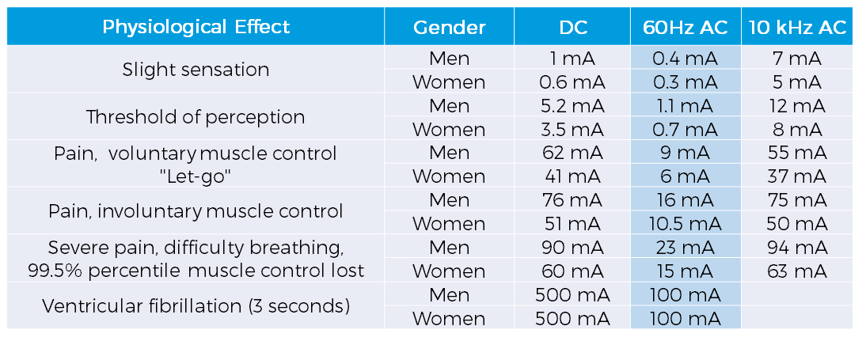
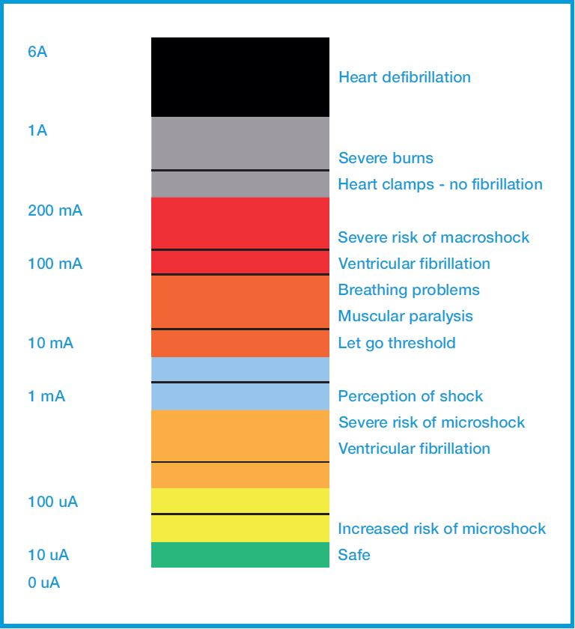
Micro-shocks occur when invasive patient connections are placed across or in close proximity to myocardial tissue and nerves and blood components have relatively low resistance. Therefore, very small levels of electrical current can induce ventricular fibrillation because tissue impedance below the skin surface is low and current is focussed at an invasive location. Death by micro-shock is known as micro-electrocution and both catheters and pacemakers carry this risk. It has been repeatedly estimated that currents of over 20 microamps can lead to micro-electrocution. Patients in medical environments are uniquely vulnerable to the risks from micro-shock.
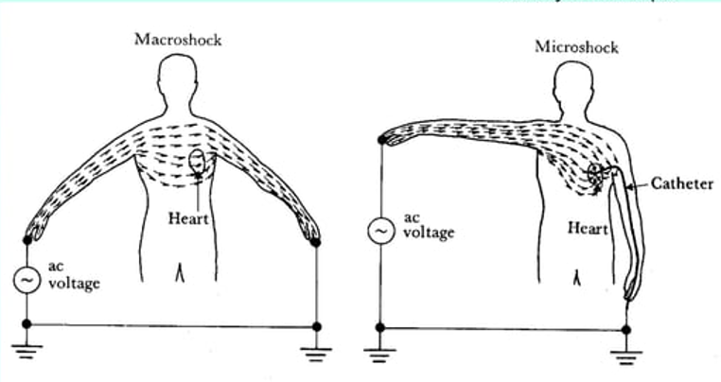

The Indian Standards pertaining to Medical Equipment have been listed in Annex-A.
The IS 13450 series of standards are a set of standards that establish safety and performance requirements for medical electrical equipment. The standards in this series for particular requirements for a type of medical equipment refer to IS 13450 (Part 1) for general safety.
Aspects covered by IS 13450 Part 1:
- General requirements for ME EQUIPMENT
- Classification of ME EQUIPMENT and ME SYSTEMS
- ME EQUIPMENT identification, marking and documents
- Protection against electrical HAZARDS from ME EQUIPMENT
- Protection against MECHANICAL HAZARDS of ME EQUIPMENT and ME SYSTEMS
- Protection against unwanted and excessive radiation HAZARDS
- Protection against excessive temperatures and other HAZARDS
- Accuracy of controls and instruments and protection against hazardous outputs
- HAZARDOUS SITUATIONS and fault conditions for ME EQUIPMENT
- Construction of ME EQUIPMENT
- Electromagnetic compatibility of ME EQUIPMENT and ME SYSTEMS

