

MEDICAL TEXTILES FOR HEALTH DEPARTMENT/MINISTRY OF HEALTH AND FAMILY WELFARE

भारतीय मानक ब्यूरो
BUREAU OF INDIAN STANDARDS
उपभोक्ता मामले, खाद्य और सार्वजनिक वितरण मंत्रालय, भारत सरकार
Ministry of Consumer Affairs, Food and Public Distribution, Government of India

OVERVIEW OF MEDICAL TEXTILES, IMPORTANCE AND THEIR APPLICATIONS

Medical textiles are defined as a textile structure which has been designed and produced for use in any of a variety of medical applications, including implantable applications”.

Medtech, or medical textiles, holds a unique and critical position among the 12 segments of technical textiles due to its direct impact on health, hygiene, and life-saving applications. Unlike other segments, medtech is deeply intertwined with public health and healthcare systems, making it essential for addressing challenges like infection control, patient safety, and emergency medical needs.
Medical textiles are essential to the healthcare and hygiene sectors, providing solutions that ensure women’s safety and health through effective menstrual and personal hygiene management. These textiles also play a critical role in safeguarding patients, healthcare professionals, and doctors, offering solutions for infection control and treatment.

This segment caters to a wide array of healthcare applications, including wound care, surgical procedures, hygiene, and therapeutic solutions. Products like sutures, wound dressings, sanitary pads, diapers, and surgical gowns play a pivotal role in both routine and critical medical care. Furthermore, protective equipment such as masks, coveralls, and gowns is indispensable for healthcare workers, particularly during pandemics, to prevent the spread of infections.

The other key applications include menstrual and personal care items like sanitary pads and diapers, which address hygiene needs for women, infants, and incontinence patients, while advanced wound care dressings facilitate healing and infection prevention. In surgical settings, medical textiles such as sutures, gowns, and drapes ensure successful operations and sterile environments. Protective equipment like masks and gloves, antimicrobial fabrics, and therapeutic devices such as compression garments further enhance patient care and healthcare worker safety.

Out of total Indian textile industry, only 13% contributes to technical textiles, and out of this 13%, the share of Meditech, in technical textiles market is in the range of 6-8%.

Global Medical Textiles Market Size is expected to reach around USD 26 billion by 2028 and expected to grow at a CAGR of approx. 4.5 % from 2022-2028 according to a market report.

The demand for medical textiles in India is increasing due to several key factors: -

- Growing Healthcare Sector: India's healthcare sector is expanding rapidly, with increasing investments in hospitals, clinics, and healthcare infrastructure. This growth fuels the demand for medical textiles such as surgical gowns, drapes, and wound care products.The main volume growth driver in Meditech is the non-implantable segment which includes nonwoven, surgicals & healthcare/hygiene products.

- Rising Population and Aging Demographics: With a large and growing population, including an increasing elderly demographic, there is a higher demand for healthcare services and related products, including medical textiles.

- Increased Awareness of Hygiene and Infection Control: The COVID-19 pandemic heightened awareness of hygiene and infection control, leading to a surge in demand for disposable medical textiles like masks, PPE kits, and surgical gloves.

- Expansion of Health Insurance Coverage: The broader availability of health insurance in India has increased access to healthcare, driving up the need for medical textiles used in various medical procedures.

- Government Initiatives: Government initiatives for infrastructure and technological advancements, R & D, skill development through Atmanirbhar Bharat, Production Linked Incentive (PLI) scheme and National Technical Textiles Mission,National Health Mission, Ayusman Bharat Yojna, Pradhan Mantri Jan Arogya Yojana.

Classification of Medical Textiles

Depending upon the usage, they are classified as:

a) Healthcare and Hygiene products
b) Non-implantable materials
c) Implantable materials
d) Extracorporeal devices

Medical textiles can be classified as follows:

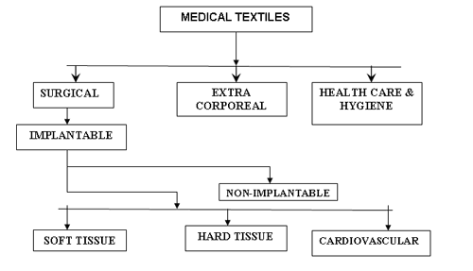
Classification of Medical Textiles
1. Health Care & Hygienic Products: An important area of ​​medical textile is healthcare and hygiene assurance. These textile materials are used to protect physicians and health workers and to equip wards when treating patients in the hospital and will have non-toxic, non-carcinogenic etc. properties.
Healthcare and hygiene textiles materials are mainly used for protection from infections in hospital environment. They are used either in the operation theatre or in the hospital wards for hygiene care safety for the staff, doctor and patients.
Product applications: Surgical masks, PPE Coverall, Surgical Gown and Drape, Disposable Sanitary Pad, Reusable Sanitary Pad/Period Panties, baby diapers, Caps, Wipes etc.
2. Non-Implantable Materials: Non - Implantable medical textiles are used for external applications on body that means those are used outside the human body to assist the recovery of wounds are called non-implantable medical textiles. Non-implantable products are typically used to provide protection against infection, to absorb blood and exudates and to promote healing. The term non-implantable is used generally to indicate surface wound treatments of different parts of the human body.
Product Applications: Absorbent Pads, Bandages, Plasters, swab, Gauze Pads, Lint, Wound Dressing etc.
3. Implantable Materials: There is a special type of textile structure that is used for various purposes inside the human body. The use of implantable material can be observed in wound closure or replacement surgery. For example: Satures, Soft tissue implants, Orthopedic implants, cardiovascular implants, etc. are used in textiles.
Implantable products are biomaterials which are used for wound closure (e.g. suture), replacement surgery (e.g. vascular graft, artificial ligaments etc.) Another important category of implantable products is soft-tissue implants. These are ﬂexible strong materials commonly used to replace tendons, ligaments and cartilage in both reconstructive and corrective surgery. Suspensors and reinforcing surgical meshes are used in plastic surgery for repairing defects of the abdominal wall.
Product Applications: Suture, vascular graft, artificial ligaments, heart valves, Artificial Tendon, Artificial Ligament, Artificial Skin, Artificial Bone, Artificial Cornea etc.
4. Extra Corporal Devices:
Extra corporal devices are mechanical organs that are used for blood purification such as apheresis, hemodialysis, hemofiltration, plasma-pheresis or extra corporeal membrane oxygenation. There have been artificial kidney, liver and mechanical lung. The making of these devices requires precise design and manufacture. These products are used to replace various organs inside the body of infected people. These devices must have non-toxic, non-carcinogenic, bio-compatibility properties.
Product Applications: Artificial Kidney, Artificial Lung, Artificial Liver etc.

STANDARDIZATION IN THE FIELD OF MEDICAL TEXTILES

- Standardization in the field of Medical Textiles has been undertaken by Technical Textiles for Medtech Application Sectional Committee, TXD 36 under Textiles Division Council at BIS:

- Scope of TXD 36 : To formulate Indian Standards for terminology, testing and specifications for technical textiles for medtech applications (including medical devices made of textile material) such as healthcare and hygiene textile products, implantable and non-implantable and extra corporeal textile products.

- Number of standards formulated: 76
- Product Standards: 64
- Method of Tests: 12
- Number of standards under development: 04

STANDARDS CONSIDERED FOR QCO

Section 16 of BIS Act - Authorizes the Central Govt to issue Quality Control Orders to make BIS certification mandatory for protection of human health, animal or plant health, safety of environment, prevention of unfair trade practices, national security etc.

Initially a list of 54 product standards published on Medical Textiles was considered by Ministry of Textiles for Quality Control Orders, out of these 48 medical textiles products are covered under ambit of Central Drugs Standard Control Organization (CDSCO).

Ministry of Textiles, Govt. of India issued Quality Control Orders dated 27 September, 2023 for the following 6 standards for mandatory BIS Certification from 01 January 2025

Sl No | IS Number | Title
1) | IS 5405 : 2019 | Sanitary napkins – Specification (Second Revision)
2) | IS 17514 : 2021 | Reusable Sanitary Pad/Sanitary Napkin/Period panties —Specification
3) | IS 17509 : 2021 | Disposable Baby Diaper — Specification
4) | IS 17349:2020 | Medical textiles – Shoe covers – Specification
5) | IS 17354:2020 | Medical textiles – Dental bib/Napkins – Specification
6) | IS 17630:2021 | Medical Textiles – Bedsheet and Pillow Cover –Specification

IMPORTANT INDIAN STANDARDS OF MEDICAL TEXTILES FOR INFECTION CONTROL, SUPPORT FOR RECOVERY OF INJURY AND WOUND MANAGEMENT PRODUCTS

Sl No | IS No | Title
 | IS 16289 : 2014 | Medical Textiles - Surgical Face Masks - Specification
 | IS 17423 : 2021 | Medical Textiles — Bio-Protective Coveralls — Specification (First Revision)
 | IS 17334 : 2019 | Medical textiles — Surgical gowns and surgical drapes — Specification
 | IS 18266 : 2023 | Textiles — Medical Respirator — Specification
 | IS 17630 : 2021 | Medical Textiles — Bedsheet and Pillow Cover — Specification
 | IS 758 : 2023 | Medical Textiles — Absorbent Cotton Gauze — Specification (Fifth Revision)
 | IS 863 : 2023 | Medical Textiles - Cotton bandage cloth - Specification (Third Revision)
 | IS 16468 : 2016 | Medical Textiles - Absorbent Cotton (Sterile and Non-Sterile) - Specification
 | IS 4738 : 2020 | Medical Textiles - Bandage, Plaster of Paris - Specification (Third Revision)
 | IS 4605 : 2020 | Crepe Bandage - Specification (Second Revision)
 | IS 16111 : 2013 | Elastic Bandage
 | IS 17351 : 2020 | Medical textiles – Dressing, shell compressed – Specification
 | IS 17528 : 2021 | Medical Textiles – Chlorhexidine Gauze Dressing –Specification

IMPORTANCE AND SIGNIFICANCE OF MEDICAL TEXTILES IN INFECTION CONTROL MANAGEMENT

Medical textiles are fundamental in the fight against healthcare-associated infections (HAIs), which are a significant concern in hospitals and other healthcare settings. These textiles are specially designed to offer protection against the transmission of infectious agents, such as bacteria, viruses, and fungi, thus ensuring the safety of both patients and healthcare professionals. The importance and significance of medical textiles in infection control management cannot be overstated, as they serve as a first line of defense in maintaining a sterile and hygienic environment.

Role in Infection Control

The primary role of medical textiles is to act as a protective barrier, preventing the spread of pathogens in healthcare environments. Medical textiles, such as surgical gowns, drapes, face masks, medical respirator, caps, and bedsheet/pillow cover, are designed with specific properties that make them effective in infection control. For example, surgical gowns and drapes are designed to be fluid-resistant, preventing the transfer of body fluids and microbes during surgical procedures. Similarly, face masks and medical respirator are essential in protecting both patients and healthcare workers from airborne pathogens and bloodborne infections.
Role in Reducing Healthcare-Associated Infections (HAIs)

Healthcare-associated infections (HAIs) are infections that patients acquire while receiving treatment for other conditions in a healthcare facility. These infections can occur during surgical procedures, from contact with contaminated surfaces, or through exposure to infectious materials. Medical textiles play a vital role in preventing HAIs by providing protective barriers that prevent the transfer of infectious agents. For example, surgical masks prevent the transmission of airborne pathogens from healthcare workers to patients, while gowns and drapes protect both parties during procedures.

Durability and Barrier Effectiveness

Medical textiles are engineered to meet stringent performance criteria, ensuring that they remain effective throughout their use. They must be durable enough to withstand repeated exposure to fluids, pressure, and wear, especially in environments such as operating rooms and intensive care units (ICUs). For instance, surgical gowns and drapes are designed to maintain their barrier effectiveness even after being exposed to bodily fluids during surgeries. This durability is essential to prevent any breaches in infection control during critical procedures. Medical textiles are also designed to be breathable, which helps maintain comfort for healthcare workers without compromising their protective properties.

Global Health Impact

Medical textiles also have a significant global impact, especially in low-resource settings. In developing countries, where healthcare infrastructure may be limited, medical textiles play a crucial role in controlling infections and ensuring the safety of patients and healthcare workers. The accessibility and affordability of high-quality medical textiles can help bridge gaps in healthcare provision and improve the overall outcomes of medical care. Moreover, during global health crises like the COVID-19 pandemic, the role of medical textiles became even more pronounced, with face masks, PPE kits, and other textiles being essential in controlling the spread of the virus.

Innovation and Future Trends

As the healthcare sector evolves, so do the demands for more advanced medical textiles that provide higher levels of protection and comfort. The future of medical textiles in infection control management looks promising with ongoing innovations. For example, the development of biodegradable medical textiles is an exciting area of research, aiming to reduce environmental waste while maintaining effectiveness in infection prevention. Furthermore, the use of nanotechnology and smart textiles in medical applications is on the rise. These innovations include fabrics embedded with sensors that can detect infections or materials that change properties in response to environmental stimuli, such as temperature or moisture.

Compliance with Standards and Guidelines

The Central Drugs Standard Control Organization (CDSCO) in India regulates medical textiles as medical devices under the Drugs and Cosmetics Act, 1940, and the Medical Device Rules, 2017.

The significance of medical textiles in infection control management is further enhanced by their compliance with established standards and guidelines. Compliance with these standards ensures that healthcare providers use products that meet rigorous performance criteria, which are essential for infection control.

In conclusion, medical textiles are indispensable in infection control management, providing essential protective barriers against the spread of infectious agents in healthcare environments. Their antimicrobial properties, durability, and compliance with Indian standards make them critical tools in maintaining sterile and hygienic conditions for both patients and healthcare professionals. As healthcare demands evolve, ongoing innovation in medical textiles will continue to play a vital role in improving infection control and safeguarding public health.

IS 16289 : 2014 ‘MEDICAL TEXTILES — SURGICAL FACE MASKS — SPECIFICATION’

SURGICAL FACE MASK


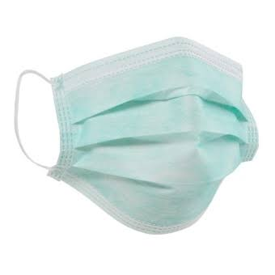

Surgical Face Mask — A medical device covering the mouth, nose and chin providing a barrier to minimize the direct transmission of infective agents between staff and patient.

Medical Professional (Staff and Doctor) involved in treating and caring for patients or individuals injured or sick, can be exposed to biological liquids capable of transmitting disease. These diseases, which may be caused by a variety of microorganisms and infective agents, can pose significant risks to life and health.

The transmission of infective agents during surgical procedures in operating theatres and other medical settings can occur in several ways. Sources are, for example noses and mouths of the surgical team. The main intended use of surgical masks is to protect the patients from infective agents from the noses and mouths of the staff and, in certain situations, additionally to protect the wearer against splashes of potentially contaminated liquids. Face masks may also be intended to be worn by patients and other persons to reduce the risk of spread of infections, particularly in epidemic or pandemic situations.

This standard specifies the performance requirements and test methods of surgical face masks intended to limit the transmission of infective agents from staff to patients and (in certain situations) vice-versa during surgical procedures in operating theatres and other healthcare services such as patient care, with similar requirements.

Design: The surgical face mask shall have a means by which it can be fitted closely over the nose, mouth and chin of the wearer and which ensures that the mask fits closely at the sides.

The surgical masks have been categorized into three classes based on the barrier performance properties of the surgical face mask materials (fluid resistance, bacterial filtration efficiency, and sub-micron filtration efficiency, splash resistance), i.e., Class 1, Class 2 and Class 3.

The key performance requirements specified in IS 16289 Surgical Facemask include Bacterial filtration efficiency and Sub-micron particulate filtration efficiency at 0.1 micron for safety, Differential pressure for comfort, splash resistance to protect from blood and body fluids during surgery.

Bacterial Filtration Efficiency (BFE) — The effectiveness of a surgical face mask to filter (prevent passage of) aerosol droplets containing bacteria of a specified particle size of 3.0 µm (micron) ± 0.3 µm. This is expressed as a percentage of a quantity that does not pass through the material.

Differential Pressure/Delta P — It is the pressure drop across a surgical mask under specific conditions of air flow, temperature and humidity. This is an indicator of the breathability of the mask.

A device which measures the pressure differential required to draw air through a measured surface area at a constant air flow rate is used to measure the air exchange pressure of the surgical mask material. The test specimen is placed across the 2.5 cm diameter orifice (total area 4.9 cm²) and clamped into place so that the tested area of the specimen will be in line and across the flow of air. The pump is started and the flow of air adjusted to 8 litre/minute.

Sub-micron Particle Filtration Efficiency (PFE) — It is the effectiveness of a material to filter aerosol droplets containing bacteria of a specified particle size range 0.1 µm. This is expressed as a percentage of a quantity that does not pass through the material.

Fluid/Splash Resistance — It is defined as the ability of a facemask’s material construction to minimize fluids from traveling through the material and potentially coming into contact with the user of the facemask. Fluid resistance helps reduce potential exposure to blood and body fluids caused from splashes, spray or splatter. Resistance to penetration by synthetic blood is indicated as pass/fail at velocity of 120 mm of Hg. Penetration (visual evidence of synthetic blood on the side opposite impact results in fail at that pressure. Non -penetration results in a pass.

A volume of synthetic blood is disbursed at a specimen mask by a pneumatically controlled valve from a set distance at specified pressure to simulate the impact of blood or other body fluid onto the specimen. The velocity and volume of fluid are set to simulate a given health care scenario 120 mm Hg.

- PERFORMANCE REQUIREMENT FOR SURGICAL FACE MASK

Sl.  No. | Characteristic | Requirements
Sl.  No. | Characteristic | Class 1 | Class 2 | Class 3
i) | Bacterial Filtering  Efficiency, Min | 95 | 98 | 98
ii) | Differential Pressure, Pa, Max | 29.4 | 29.4 | 49.0
iii) | Splash resistance, mm Hg Min | - | - | 120
iv) | Sub-micron particulate  filtration Efficiency at 0.1  µ, Percent, Min | - | - | 99

IS 17423 : 2021, Medical Textiles — Bio-Protective Coveralls — Specification (First Revision)

COVERALL

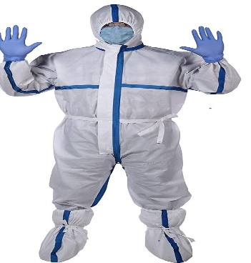

Coveralls are designed to protect the healthcare professional from exposure to virus/bacterial/infective agents. Although coveralls typically provide higher protection because they are designed to cover the whole body, including back and lower legs and sometimes head and feet as well.

By using coverall, it is possible to create a barrier to eliminate or reduce contact and droplet exposure, both known to transmit COVID-19, thus protecting healthcare workers working in close proximity (within 1 meter) of suspect/confirmed COVID-19 cases or their secretions.

Coverall is a type of personal protective equipment (PPE) intended to be worn by healthcare personnel for the purpose of isolating all parts of the body from a potential hazard. The bio-protective coveralls provide protection against various biological agents due to their material sealing arrangements.

This standard specifies the requirements for single use and reusable bio-protective coveralls intended for medical use.

The fabric used for the manufacturing of coverall shall be a single or multi-layered textile structure made of woven or non-woven (spunlace or spunbond or combination of spunbond and meltblown) or knitted structure with or without coating / lamination engineered to fulfil the functional requirements. The bio-protective coveralls consists of an integrated hood with elastic around face opening. It shall be provided with suitable fastening arrangement which shall be covered with a storm flap provided with suitable self-adhesive sealing arrangement such as a double-sided tape etc.

Coverall shall be joined by sewing, adhesion, thermally/ultrasonically welding or any other suitable technique. The seams shall be sealed with a tape of suitable material of medical grade of minimum 16 mm width or any other sealing arrangement that ensure that the seam shall pass the same tests as the body.

Coverall may also be provided with elastic wrists and ankles for convenience and freedom for movement. It shall also be provided with thumb loop for better and secure fit during overhead work. The seams shall be sealed with a tape of suitable material of medical grade of minimum 16 mm width or any other sealing arrangement. Each coverall shall be provided with a pair of shoe covers with an elastic strip to tighten it with the coverall, so that there is no passage for air through it.

- Depending upon the end use the Bio-protective coveralls have been classified into four performance levels (level 1 to level 4)

Requirements | Level 1 | Level 2 | Level 3 | Level 4 | Test method
Synthetic blood penetration resistance | up to  1.75 kPa | up to  3.5 kPa | up to  7 kPa | up to  14 kPa | IS 16546/ISO 16603
Resistance to viral penetration | NA | NA | up to  3.5 kPa | up to  7 kPa | IS 16545/ISO 16604
Breathability (water vapour transmission rate), g/m²/day, Min | 1200 | 1200 | 800 | 800 | Annex F of IS 16390
Tensile strength (dry and wet), N | ≥ 20 | ≥ 20 | ≥ 40 | ≥ 40 | Non woven  IS 15891-3, Woven IS 1969 (Part 1)
Seam strength (dry and wet) (N) | ≥ 20 | ≥ 20 | ≥ 32 | ≥ 32 | Nonwoven: IS 15891  (Part18), Woven: IS/ISO 13935 (Part  1)
Bursting strength (dry & wet) (kPa) | ≥ 40 | ≥ 40 | ≥ 40 | ≥ 40 | IS 1966  (Part 1)
Cleanliness –microbial (CFU/100 cm²) | < 300 | < 300 | < 300 | < 300 | ISO 11737  (Part 1)
Resistance to dry microbial penetration ,(log cfu) | NA | NA | < 1 | < 1 | IS 16548/ISO 22612

Physical Significance of requirements for Bio-protective coveralls

1. Synthetic Blood Penetration Resistance (IS 16546 : 2016 ISO 16603 : 2004): This test method is required to simulate the actual conditions of blood splash observed by the healthcare personnel, when splashes of blood falls (projectile) onto the surface of coverall.

Workers, primarily those in the health care profession, involved in treating and caring for individuals injured or sick, can be exposed to biological liquids capable of transmitting disease. These diseases, which may be caused by a variety of microorganisms, can pose significant risks to life and health. This is especially true of blood-borne viruses which cause hepatitis [hepatitis B virus (HBV) and hepatitis C virus (HCV)] and acquired immune deficiency syndrome (AIDS) [human immunodeficiency viruses (HIV)]. Since engineering controls cannot eliminate all possible exposures, attention is placed on reducing the potential of direct skin contact through the use of protective clothing.

The resistance of a protective clothing material to penetration by blood and body fluids is determined by subjecting the material to synthetic blood as a body fluid simulant for a specified time and pressure sequence and observing if visible penetration of the liquid occurs. In the penetration test apparatus, the clothing material acts as a partition separating the body fluid simulant from the viewing side of the test cell. Any evidence of synthetic blood penetration constitutes failure. Results are reported as “pass/fail”

The synthetic blood shall meet the following requirements:
surface tension: (0,042 ± 0,002) N/m
pH: (7,3 ± 0,1)
viscosity: (2,7 ± 0,3) mPa⋅s (millipascal second)
conductivity: (12,0 ± 1,2) mS/cm (microSiemen per cm)

Dissolve the carboxymethyl cellulose (CMC) in half the amount of water and mix 60 min on a magnetic stirring plate. Weigh the Tween 20 in a small beaker, add water and mix. Dissolve the sodium chloride, potassium dihydrogen phosphate, disodium hydrogen phosphate, amaranth dye in the solution Dilute the solution with water up to 1 000 g.

0 kPa for 5 min, followed by 1,75 kPa for 5 min, followed by 3,5 kPa for 5 min, followed by 7 kPa for 5 min, followed by 14 kPa for 5 min.

Procedure D involves the use of a retaining screen to support extensible or elastomeric materials. When distortion of the test material is suspected of causing failure with Procedure C, Procedure D may be used.

2. Resistance to Viral Penetration (IS 16545 : 2016/ ISO 16604 : 2004) : Bacteriophage Phi-X-174 has been used because of its structural properties are quite similar to virus structure. The fabric of the coverall is subject to bacteriophage under certain pressure and performance of the fabric is observed, whether the bacteriophage has passed the fabric or not.

This test method for measuring the resistance of materials used in protective clothing to penetration by blood-borne pathogens. This test method uses a surrogate microbe under conditions of continuous liquid contact. Protective clothing “pass/fail” determinations are based on the detection of viral penetration.

A specimen is subjected to a nutrient broth containing a virus for a specified time and pressure sequence. Visual detection of penetration is supplemented with an assay procedure that will detect viable viruses which penetrate the material even when liquid penetration is not visible. Any evidence of viral penetration for a test specimen constitutes failure. This test method requires a working knowledge of basic microbiological techniques.

The surrogate microbe, Phi-X174 bacteriophage, was selected as the most appropriate model for blood-borne pathogens because of its small size, spherical (icosahedral) morphology, environmental stability, non-human infectivity, high assay sensitivity, rapid assay, and high titre. The Phi-X174 bacteriophage has no envelope and is one of the smallest known viruses (0,027 µm in diameter).

3. Breathability (water vapour transmission rate) (Annex F OF IS 16390) : This test method is practiced to simulate the comfort or to determine the wearability of the fabric. The amount of water vapours transmitted over the surface of coverall fabric is detected.

4. Mechanical and physical properties like Tensile strength, Bursting strength and Seam strength in both dry and wet conditions need to be tested in order to ensure the life of the product or to withstand severe loads and pulls during the procedures.

Bursting strength – dry and wet

This test is designed to assess the device’s ability to withstand pressure over, for example, a clinician’s elbow and to ensure its barrier properties are not prejudiced by mechanical failure. Materials with more than one layer can show several break points when tested for bursting strength, e.g. one corresponding to each layer. In order to address the scope of the requirement it was agreed to evaluate the performance of the material based on the pressure needed to break or compromise the barrier of the sample.

Tensile strength – dry and wet/Seam Strength

The ‘tensile strength’ of a material is the maximum stress, generated by pulling or stretching the material that a material can withstand before failing. The test is designed to assess whether the basic strength of the device material is sufficient to ensure its barrier properties are not prejudiced. It is a standard textile material test. Materials with more than one layer can show several break points when tested for tensile strength, e.g. one corresponding to each layer.

5. Cleanliness–microbial: The test for microbial cleanliness is intended to estimate the numbers of viable organisms on the products, before they are sterilized. This is frequently referred to as the ‘bioburden’, which are used to determine the appropriate sterilization criteria for their products.. In a bioburden (cleanliness) test, the presence of microorganisms is expected, and the test is designed to quantify the amount of microorganisms present. The method/s shall comprise techniques for the following:
a) neutralization of inhibitory substances, if needed;
b) removal of microorganisms, if appropriate;
c) culturing of microorganisms;
d) enumeration of microorganisms

The total no. of colony forming units in CFU/100 cm² is determined and shall be less than or equal to 300 CFU/100 cm².

Resistance to microbial penetration – Dry bacterial penetration IS 16548

is a test method that was designed to simulate the penetration of bacteria-carrying skin scales through fabrics. This test provides a means for assessing the resistance to penetration through barrier materials of bacteria-carrying particles. Whilst the relationship between contamination and infection is complex - contamination of the surgical field does not necessarily lead to infection - it is generally agreed that healthcare facilities should consider methods to reduce levels of airborne particles carrying bacteria in operating rooms.

6 Biocompatibility test

- Biocompatibility Evaluation — Cytotoxicity, Irritation and Skin Sensitization : The material shall be ‘Non-reactive, Non-irritant and Non-sensitizer’ respectively.

Biocompatibility - Quality of being accepted in a specific living environment without adverse or unwanted side effects.

These methods specify the incubation of cultured cells in contact with a device and/or extracts of a device either directly or through diffusion. These methods are designed to determine the biological response of mammalian cells in vitro using appropriate biological parameters.

Many products have chemical additives for the purposes of

- To Improve barrier property/stain resistance

- Leach Out

The raw material used for manufacturing the final product are safe for user based on its known toxicological characteristics at intended use. The biocompatibility of the material shall be detected by evaluating cytotoxicity, irritation and skin sensitization test as per IS/ISO 10993 (Part 5) and IS/ISO 10993 (Part 10) respectively. For cytotoxicity, the material shall show reactivity as “None” when tested as per IS/ISO 10995 (Part 5). Similarly, the material shall be “Non-irritant and Non-sensitizer” when tested as per IS/ISO 10993 (Part 10).

Confirm the biocompatibility of raw material at designed stage. The biocompatibility evaluation shall be carried out once for existing raw material and whenever there is a change in the raw material or source of supply for manufacturing

The importance of conducting cytotoxicity, irritation, and sensitization testing, as outlined in ISO 10993, is given below

- Ensuring Biocompatibility:
  - ISO 10993 is an international standard that provides guidelines for the biological evaluation of medical devices, including menstrual hygiene products. The tests for cytotoxicity, irritation, and sensitization are essential to assess the biocompatibility of these products with human tissues.
  - Cytotoxicity testing determines whether the materials used in menstrual products safe at the cellular level and does not cause adverse effects like cell death, inflammation, or other toxic reactions in the body. This is critical because menstrual hygiene products are made from various materials, such as super absorbent polymers, adhesives, and nonwoven fabrics, that could potentially release harmful substances.
- Preventing Irritation:

  - Irritation testing assesses the potential of menstrual hygiene products to cause irritation to the skin and mucous membranes. Given the prolonged contact with sensitive areas, even mild irritants can cause discomfort, redness, itching, and inflammation, affecting the user's quality of life.
  - Ensuring that these products do not cause irritation is essential for user comfort and to prevent dermatological conditions.

- Avoiding Allergic Reactions (Sensitization):
  - Sensitization testing evaluates whether the product can induce an allergic response after repeated exposure. Allergic reactions can range from mild discomfort to severe allergic dermatitis, which can significantly impact a user's health.
  - By identifying potential sensitizing agents, manufacturers can modify the product formulation to minimize or eliminate the risk of allergic reactions, ensuring safer usage.

IS 17334 : 2019 SURGICAL GOWNS AND SURGICAL DRAPES

SURGICAL DRAPE/ GOWN
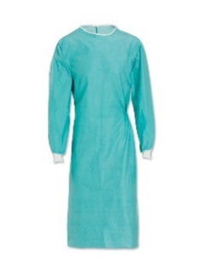

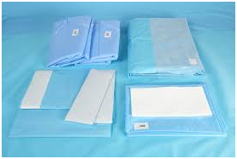

Surgical Gown — Protective clothing that is intended to be worn by healthcare workers during surgical procedures to protect both the surgical patient and the operating room personnel from the transfer of microorganisms, body fluids and particulate matter.

Surgical Drape — A covering for the patient for the prevention of transfer of infective agents, such as microorganisms, body fluids and particulate material. “Surgical drapes are used during surgery to prevent contact with unprepared surfaces and to maintain the sterility of environmental surfaces, equipment and the patient’s surroundings”.

Surgical drapes, including the intended use as a sterile field, and surgical gowns are used to minimize the spread of infective agents to and from patients’ operating wounds, thereby helping to prevent postoperative wound infections.

Surgical gowns and surgical drapes are intended to be used to minimize the transmission of infective agents between patients and clinical staff during the surgical and other invasive procedures. This standard addresses the performance of surgical gowns and surgical drapes designed to protect against exposure of healthcare workers to blood, body fluids, and other potentially infectious materials during surgery and other healthcare procedures.

Depending upon the various end uses, surgical gowns and surgical drapes have been categorized into four levels (Level 0, level 1, level 2 and level 3). The final performance requirement level shall be based on the performance of the critical zone component. The information for principle of critical area has been specified in the standard.

The following important performance requirements have been covered in this standard for surgical gowns and drapes:

- Impact penetration (g)
- Hydrostatic resistance (cmwc)
- Blood resistance and viral resistance
- Particle release
- Tensile strength and bursting strength (dry and wet)
- Resistance to microbial penetration – dry and wet
- Biocompatibility evaluation (cytotoxicity and irritation sensitization)
- To ensure the comfort, requirement for moisture vapour transmission rate has also been specified for level 3 gowns

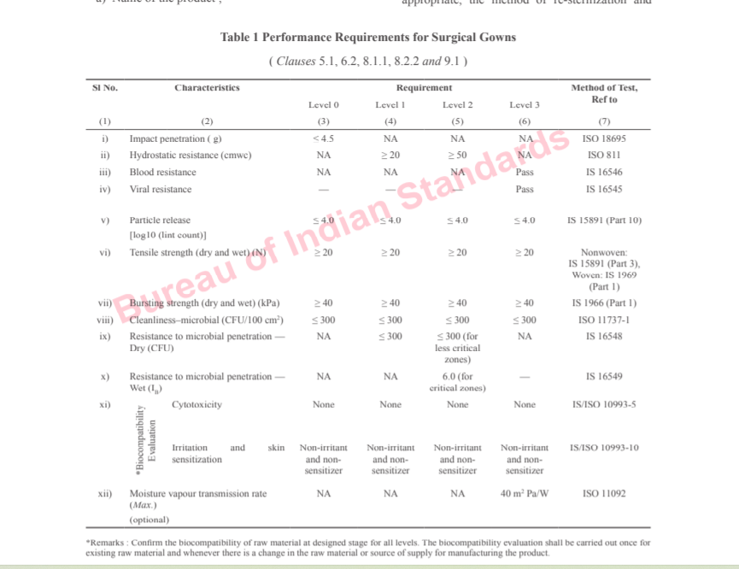

Particle release IS 15891 (Part 10)

This method is designed to measure the release of particles from the product. Particle release is a concern during surgery as foreign body contamination can cause an increased frequency of post-operative complications such as keloids, wound dehiscence, incisional hernias, chronic abscesses, intestinal obstruction and, in some circumstances, even death. Fibres from gowns and drapes which have been deposited in wounds have been shown to cause post-operative granulomas . Blood clots around fibres can cause emboli, obstructing vital blood vessels. Fibres can also reduce the ability of tissue to resist infection, due to impaired function of the blood and tissue macrophage systems.

Resistance to liquid penetration/ hydrostatic head test’

This test is a standard test used for textiles, which measures how high a column of water has to be before it penetrates through the material under test. It is generally accepted to be a measure of the water-resistant properties of a material. It is relevant to surgical fabrics as it is related to the ability of the fabric to prevent splashes of fluid and droplets penetrating the fabric under mechanical pressure.

Bursting strength – dry and wet

This test is designed to assess the device’s ability to withstand pressure over, for example, a clinician’s elbow and to ensure its barrier properties are not prejudiced by mechanical failure. Materials with more than one layer can show several break points when tested for bursting strength, e.g. one corresponding to each layer. In order to address the scope of the requirement it was agreed to evaluate the performance of the material based on the pressure needed to break or compromise the barrier of the sample.

Tensile strength – dry and wet

The ‘tensile strength’ of a material is the maximum stress, generated by pulling or stretching the material that a material can withstand before failing. The test is designed to assess whether the basic strength of the device material is sufficient to ensure its barrier properties are not prejudiced. It is a standard textile material test. Materials with more than one layer can show several break points when tested for tensile strength, e.g. one corresponding to each layer.

Resistance to microbial penetration – Dry bacterial penetration IS 16548

is a test method that was designed to simulate the penetration of bacteria-carrying skin scales through fabrics. This test provides a means for assessing the resistance to penetration through barrier materials of bacteria-carrying particles. Whilst the relationship between contamination and infection is complex - contamination of the surgical field does not necessarily lead to infection - it is generally agreed that healthcare facilities should consider methods to reduce levels of airborne particles carrying bacteria in operating rooms.

Resistance to microbial penetration – wet (IS 16549)

This test determines the resistance of a material to the penetration of bacteria from a dry surface through a material by the combined effect of friction, pressure and wetting [34]. The pressure is intended to mimic the type of pressure exerted by a surgeon's elbow during a procedure [35] and was developed specifically to measure the penetration by bacteria through operation materials of reusable or single-use material. The method has been difficult to standardize, and multiple inter-laboratory comparisons have taken place where it has been difficult to demonstrate consistent results between laboratories. The method went into immediate revision after initial publication.

- IS 18266 : 2023, TEXTILES — MEDICAL RESPIRATOR — SPECIFICATION

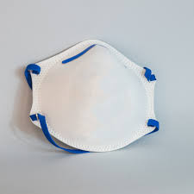

Workers, primarily those in the health care profession, involved in treating and caring for individuals injured or sick, can be exposed to biological liquids capable of transmitting disease. These diseases, which may be caused by a variety of microorganisms, can pose significant risks to life and health.

A medical respirator is a respiratory protective device designed to achieve a very close facial fit and covers at least the nose, mouth and may cover the chin. A respirator is worn by healthcare personnel (HCP) to reduce the wearer’s risk of inhaling hazardous airborne particles such as dusts, fumes, vapors, infectious agents and aerosol/fluids (for example splashes, sprays) for use in healthcare settings.

Medical respirators have been categorized into two classes based on performance IN95 and IN99 based on degree of protection offered by them.

The key aspects of medical respirators are filtration efficiency, Comfort and Breathability, Fit and seal , Durability and Use and protection against different hazard like

• Particulate Protection: Filters out particles, dust, allergens, and pathogens (like bacteria or viruses).
• Chemical Protection: Some respirators also offer protection against harmful gases and vapors

The important test like Penetration of filter, Inward leakage, CO2 content, Cleanliness microbial ensure the protection from inhaling harmful airborne particles, gases, or vapors. Splash resistance protects from biological liquids capable of transmitting disease.
Breathing resistance check for ease of breathing while wearing the medical respirator. Biocompatibility Evaluation ensure that respirator are non-irritant and non-sensitizer to skin and free from cytotoxicity .Flammability (resistance to flame) to avoid the fire hazard while storage and use. The head harness are to designed for good fit and ease of wear-removal.

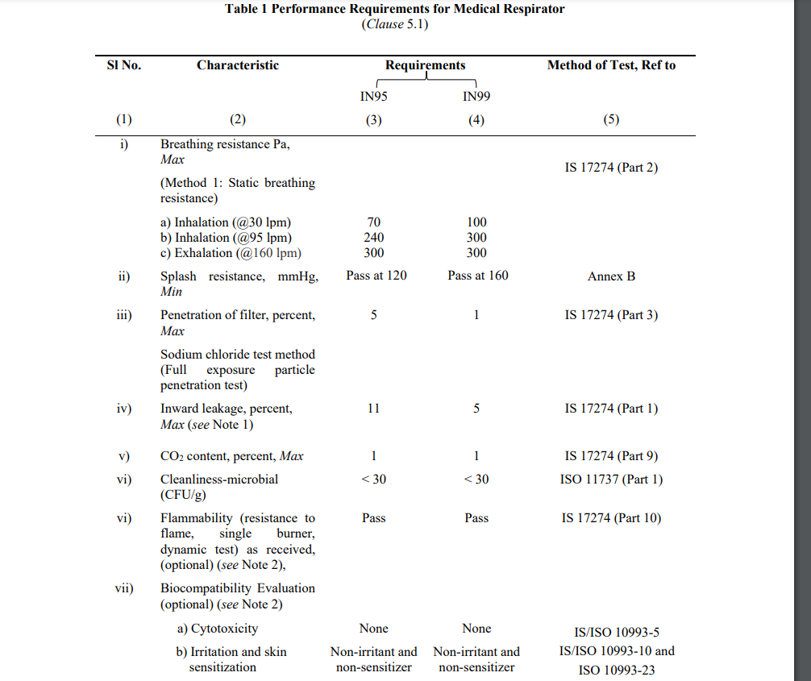

The markings requirement provide crucial information like Class of medical respirator; Instruction for use; Disposability instructions ― for safe disposal of the product as per Biomedical Waste Rules 2016; features of flammability (if availble); biocompatible product — cytotoxicity, irritation and skin sensitization and other requirement as per Medical Device Rules, 2017.

IS 17630 : 2021, MEDICAL TEXTILES — BEDSHEET AND PILLOW COVER — SPECIFICATION

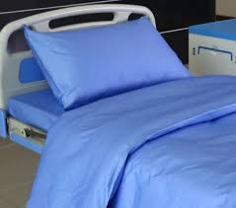

Bedsheets and pillow covers used in hospitals are critical components of patient care and hospital hygiene. These linens serve not only as a foundation for patient comfort but also play a vital role in infection control. In a healthcare setting, where patients may be vulnerable to infections, the quality and cleanliness of bedsheets and pillow covers are paramount. These items must be made from materials that are soft, breathable, and non-irritating to protect patients' skin, especially for those who are bedridden or have limited mobility, as they help prevent pressure sores and other skin conditions.
Moreover, hospital bedsheets and pillow covers are subject to frequent laundering and sterilization processes, so they need to be highly durable, retaining their integrity and effectiveness after repeated use. The professional appearance of clean, well-maintained linens also contributes to the overall atmosphere of care in the hospital, influencing patient perceptions and confidence in the treatment they receive.

Bedsheets and pillow covers are useful in providing an aid to infection control in hospitals and nursing homes.

1 SCOPE
1.1 This standard specifies the requirements for single use and reusable bedsheet and pillow cover set intended for medical use.
1.2 The bedsheet and pillow cover set conforming to this standard may be supplied in sterile or unsterile condition as per the agreement between the buyer and the seller.
1.3 This standard does not specify the general appearance, feel, shade, etc, of the bedsheet and pillow cover.

6 GENERAL REQUIREMENTS

The fabric used in the manufacture of reusable bedsheet and pillow cover set shall conform to general requirements as specified in Table 1 after declared/maximum wash cycle. The washing of fabric shall be done as per procedure 5 A given in IS 15370 and tumble drying shall be done as per procedure E of IS 15370.

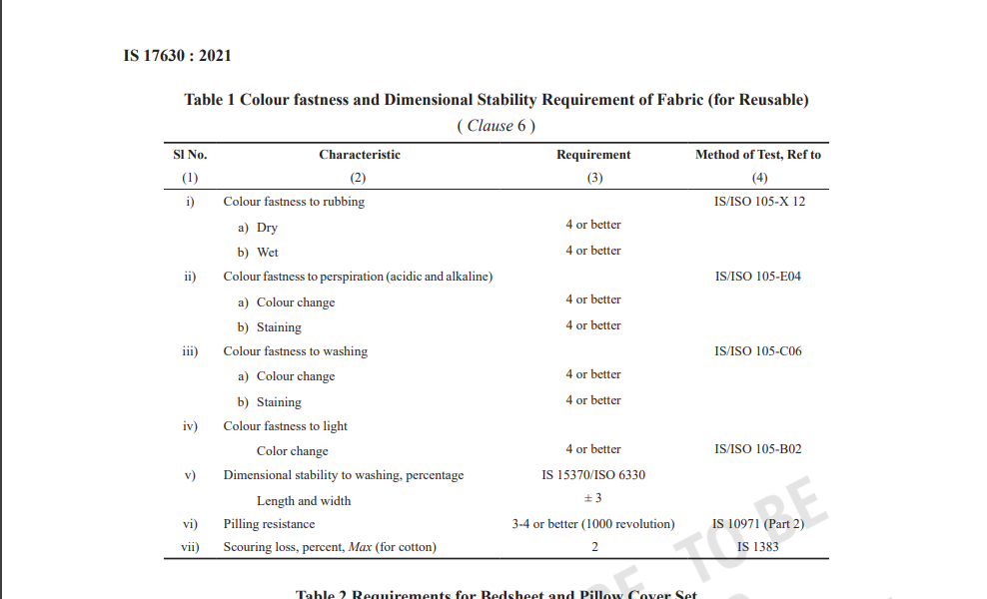

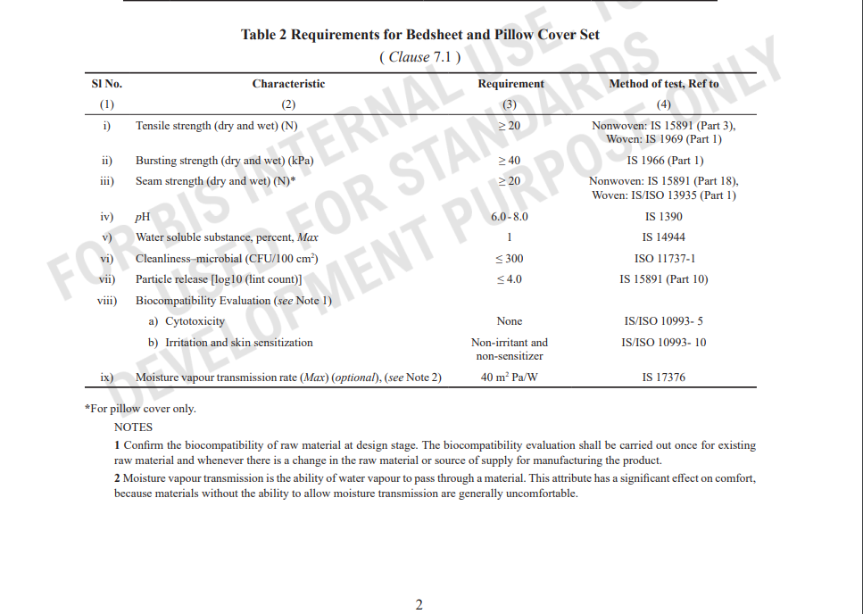

IMPORTANCE AND SIGNIFICANCE BANDAGE IN SUPPORT AND RECOVERY OF INJURY

Managing pain and injury is essential for maintaining overall health, preventing complications, and improving quality of life. Effective pain and injury management helps individuals recover faster, stay functional, and avoid long-term damage.
1. Prevents Further Complications
- Untreated injuries can worsen over time, leading to chronic pain or permanent damage.
- Pain can cause compensatory movements, increasing the risk of additional injuries.
2. Enhances Healing and Recovery
- Proper pain management allows tissues to heal correctly without unnecessary strain.
- Reducing inflammation and discomfort speeds up the recovery process.
3. Improves Mobility and Functionality
- Pain can limit movement, leading to stiffness and muscle weakness.
- Managing pain ensures that individuals can continue their daily activities with ease.
4. Boosts Mental and Emotional Well-being
- Chronic pain can lead to stress, anxiety, and depression.
- Effective pain management improves mood, sleep, and overall mental health.
5. Supports Long-Term Health and Quality of Life
- Addressing pain early prevents long-term disabilities and complications.
- A pain-free life enhances productivity, independence, and overall well-being.

Bandages play a crucial role in the support and recovery of injuries by serving several important functions:
- Stabilization: Bandages help stabilize injured areas, such as sprains or strains, by holding joints or muscles in place and preventing excessive movement that could lead to further damage.
- Compression: Many bandages, especially elastic ones, provide gentle compression that helps reduce swelling by limiting fluid buildup around the injury site. This can also help in managing conditions like sprains or soft tissue injuries.
- Protection: Bandages provide a protective barrier for wounds, preventing dirt, bacteria, or foreign particles from entering the injury and causing infections. They also help shield the wound from further trauma.
- Pain Relief: By providing compression and support, bandages can reduce pain associated with injuries by limiting movement and reducing swelling, making the injured area less sensitive.
- Enhanced Healing: A properly applied bandage can promote faster recovery by encouraging the correct alignment of tissues and minimizing unnecessary strain on the injured part. It can also improve circulation, which aids in the healing process.
- Prevention of Re-injury: Bandages help prevent further strain or re-injury by restricting movements that could aggravate the injury. They offer stability and support, which is essential during the recovery phase.
- Improved Functionality: In some cases, bandages can allow individuals to maintain some degree of mobility during the recovery process, making it possible to perform necessary tasks while minimizing the risk of worsening the injury.

IS 4605 : 2020, CREPE BANDAGE — SPECIFICATION
(SECOND REVISION)

CREPE BANDAGE

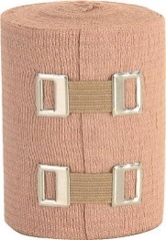

Crepe bandage consists of characteristic fabric of plain weave or needle loom weave, in which the warp threads are crepe-twisted for ensuring maximum elasticity. Crepe bandage is used for dressing of varicose veins, weak ankles, legs, knees and wrists in case of sprains and other conditions in which light support is required.

They work by applying gentle, even pressure to the affected area, which helps in reducing swelling and inflammation, alleviating pain, and stabilizing joints. This compression encourages blood flow, which is crucial for faster recovery, and reduces the chance of further injury by limiting unnecessary movement.

Consumers expect several important quality parameters in crepe bandages to ensure effectiveness, comfort, and durability. These parameters can vary depending on the intended use, but generally, they include:

Material Composition:

The crepe bandage shall be made from cotton or mixture of rayon and cotton that provide the required stretchability, durability and comfort.

Dimensions: The crepe bandage should be manufactured in standard widths, generally ranging from 6 cm to 15 cm or as agreed to between purchaser and supplier. The length of the bandage must be specified, generally ranging from 4 m to 6 m for standard medical use.

Performance Requirements

• Elasticity: After stretching, the bandage should return to its original shape and size without losing its elasticity and structural integrity over time.
• High Stretch: A good quality crepe bandage should offer reasonable degree of stretch, providing firm yet comfortable support.
• Tensile Strength: The bandage must have sufficient tensile strength to withstand the forces applied during use, without tearing or losing its functionality.

Water-soluble and ether-soluble substances – water-soluble substances helps identify potential contaminants, prevent skin irritation, and verify the bandage's ability to absorb moisture and manage moisture effectively. ether-soluble substances ensures the bandage is free from oils or waxes that could impact its breathability, flexibility, and overall stability.

Packaging and Marking

• The bandages should be properly packaged to avoid contamination or damage during transport and storage.

• The packaging should contain necessary markings, including the manufacturer’s name, width and stretched length, batch number to facilitate identification and traceability. IS 4605: 2020 lays out the comprehensive requirements for the manufacturing, testing, and quality of crepe bandages used in medical applications. It ensures that the product is safe, effective, and reliable for providing compression and support in healthcare system.

IS 16111: 2013 Elastic Bandage

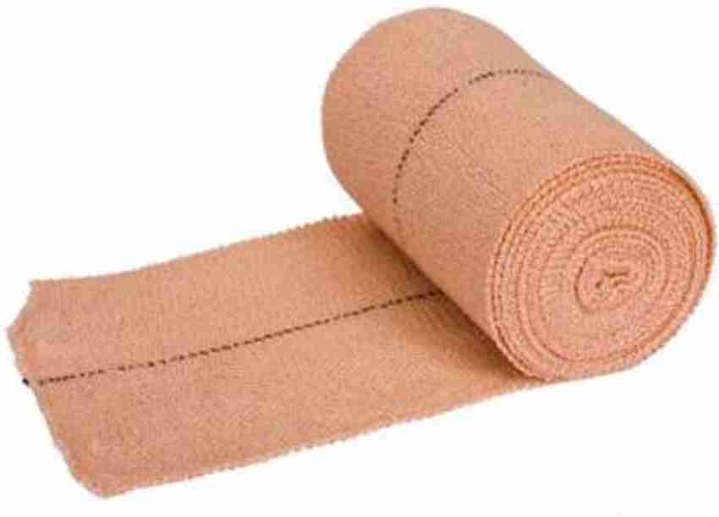

An elastic bandage is a continuous strip without joints, of woven/knitted material to provide support and immobilize dressings covering the wounds besides the function of compression and support for orthopaedic purposes.

Elastic bandages are crucial for injury recovery as they provide controlled compression to reduce swelling, stabilize injured areas, and offer pain relief. Their flexibility ensures comfort and proper fit, while preventing further injury during the healing process. These bandages are versatile, supporting various body parts and allowing for functional movement, making them an essential tool in managing soft tissue injuries, sprains, and strains.

Six types of Elastic Bandages are specified in the Indian Standard based on type of yarn along with their method of manufacture. These are
a) Type A – Woven cellulosic yarn bandage
b) Type B – Knitted cellulosic yarn bandage
c) Type C – Woven non-cellulosic yarn bandage
d) Type D – Knitted non-cellulosic yarn bandage
e) Type E – Combination of both cellulosic yarn/noncellulosic yarns woven knitted
f) Type F – Combination of both cellulosic yarn/noncellulosic yarns woven knitted.

The standard prescribes requirements relating to dimensions and tolerances, weight, stretch length and extensibility, and regain that an Elastic Bandage must conform in order to ensure a quality product which would provide the desired function of compression and support for the wound dressings.

The standard lays down that cellulose-based Elastic Bandage shall have a minimum 35 percent of Hydrophilic/cellulosic fibre content. In case of Filament yarns, these shall be made from partially oriented yarn (POY) of polyester, polyamide, polypropylene or equivalent material and consist of a core made of high stretch spandex, lycra, polyurethane, rubber or similar material and covered/wrapped with synthetic filament yarn or grey/ bleached/dyed cotton and/or viscose/rayon.

Another important requirement to check the quality of elastic bandage is to measure its extensibility which shall be 65 to 220 percent and its regain which shall be not less than 70 percent when tested as per the test methods described in the standard

IS 4738 : 2020, Medical Textiles - Bandage, Plaster of Paris - Specification ( Third Revision )

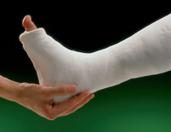

Plaster of Paris bandages are used primarily in the medical field for immobilizing fractures and providing support during the healing process. When mixed with water, the bandage becomes moldable and can be applied directly to the injured area, where it hardens into a rigid cast, stabilizing broken bones and preventing movement. The significance of Plaster of Paris bandages lies in their ability to ensure proper bone alignment, reduce the risk of further injury, and promote faster healing by providing strong, durable support to the affected area until recovery is complete.

Plaster of Paris bandage comprises of a cotton gauze impregnated uniformly with plaster of Paris containing some adhesive. This bandage is used for immobilization and splinting of fractures and for the construction of rest splints and body supports. It is also used for support and connection splinting.

Raw Material for Plaster of Paris Bandage

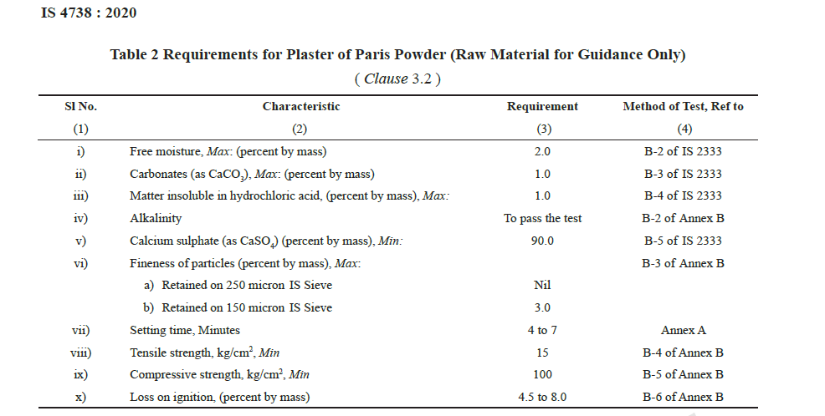

The important performance parameters used in plaster of Paris bandages include:

Setting Time : The plaster mass which remains workable for not less than 1 minute after removal of the bandage from water, shall set within 8 min.
The time of setting in plaster of Paris bandages is crucial for ensuring ease of application, patient comfort, and the stability of the cast. A suitable setting time allows for accurate molding, proper bone alignment, and prevents the plaster from hardening too quickly or too slowly. If the setting time is too short, the bandage may not be applied correctly, while a long setting time could delay the process and cause discomfort. Additionally, the right setting time ensures the plaster hardens properly, offering the necessary strength and preventing skin irritation from excessive heat.

Cast Breaking Strength - The cast breaking strength of plaster of Paris bandage
shall not be less than 175 N (17.5 kgf approx)

Cast breaking strength is a critical parameter for plaster of Paris bandages because it determines the durability and effectiveness of the cast in immobilizing the injured area. A high breaking strength ensures that the cast can withstand external forces, such as impact, pressure, and movement, without cracking or breaking, which is essential for maintaining proper bone alignment during healing. Insufficient strength could lead to cast failure, compromising support and prolonging recovery. Stronger casts also reduce the risk of further injury to the fractured bone, as they provide more reliable protection.

Calcium Sulphate Content
Calcium sulphate content of plaster of Paris bandage shall not be less than 88 percent,

Calcium sulfate is a key component in plaster of Paris bandages because it plays a vital role in the setting and hardening process. When calcium sulfate is mixed with water, it forms a paste that gradually hardens into a rigid structure, providing the necessary support and immobilization for injured bones. The chemical reaction that occurs between calcium sulfate and water produces heat and transforms the material into a solid, which is crucial for the formation of a durable cast.

IMPORTANCE AND SIGNIFICANCE OF MEDICAL TEXTILES LIKE DRESSING FOR WOUND MANAGEMENT

Managing wounds properly is crucial for several reasons :-
Prevention of Infection: An untreated wound can become a breeding ground for bacteria, which can lead to infections. Managing a wound by cleaning and dressing it properly reduces the risk of bacterial contamination.
Promotes Faster Healing: Proper wound care helps to maintain a moist environment, which promotes quicker and more effective healing. This also helps minimize scarring and other long-term complications.
Pain Relief: By managing wounds with appropriate treatments, you can alleviate pain and discomfort. For example, keeping the wound clean and covered can reduce exposure to irritants and minimize pain.
Prevents Complications: Poor wound care can lead to complications like chronic wounds, delayed healing, or systemic infections that could be life-threatening, such as sepsis.
Minimizes Scarring: Proper wound management helps the tissue heal in a more organized and functional way, reducing the formation of excessive scar tissue.
Reduces Inflammation: Managing wounds helps control inflammation, which can further damage tissues and slow down the healing process.
Improves Quality of Life: Effective wound management can reduce the impact on daily activities by preventing discomfort, infection, or long-term complications, allowing the individual to return to regular activities sooner

Medical textiles, such as dressings for wound management, play a crucial role in promoting healing, preventing infection, and improving patient comfort. These textiles are designed to provide optimal conditions for wound healing by maintaining a clean, moist environment that accelerates tissue regeneration while preventing the entry of harmful pathogens. The significance of medical textile dressings includes:

- Infection Control: Medical dressings act as a barrier to bacteria, dirt, and other contaminants, reducing the risk of wound infection. They are often made from sterile materials that protect the wound from external pollutants.
- Moisture Balance: Many modern dressings, including hydrocolloid, hydrogel, or alginate-based materials, help maintain an ideal moisture level at the wound site. This prevents the wound from drying out, which can slow down healing, and also prevents excessive moisture buildup, which can lead to maceration of the surrounding skin.
- Absorption: These dressings are designed to absorb exudate (fluid produced by wounds), reducing the risk of wound maceration, and preventing the surrounding skin from becoming damaged due to prolonged exposure to moisture.
- Pain Relief: Certain medical textiles used for wound dressings are designed to reduce pain during the healing process. Materials that prevent direct contact with the wound, or those that contain soothing agents, help alleviate discomfort.
- Enhanced Healing: By maintaining optimal moisture levels, controlling infection, and providing a stable environment, medical textile dressings can significantly speed up the healing process, minimize scarring, and improve overall recovery outcomes.
- Versatility and Customization: Medical textiles are available in various types and forms, allowing them to be tailored to the specific needs of the wound, such as for burn wounds, chronic ulcers, or surgical incisions. This adaptability enhances their effectiveness in diverse clinical situations.

In summary, medical textile dressings are indispensable for wound management due to their ability to provide infection control, maintain optimal moisture balance, absorb exudates, and support pain management, ultimately promoting faster healing and better patient outcomes.

IS 16468:2016 Medical Textiles – Absorbent Cotton (sterile and non-sterile) – Specification

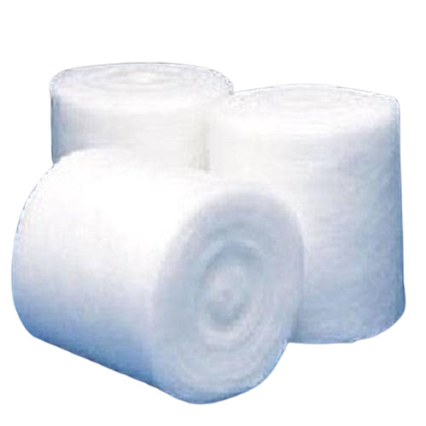

Absorbent cotton is widely used in wound management due to its high absorbency, softness, and sterility. It serves various purposes, including as a primary or secondary dressing to absorb exudate and promote healing, cleansing wounds with cotton swabs or pads, and absorbing blood or fluids to maintain a dry environment. Additionally, it is used as padding to reduce pressure on wounds, prevent infection by creating a barrier, and aid in burn and surgical wound care by protecting the area and absorbing drainage. Its versatility and moisture-absorbing properties make it essential in wound care.

This standard outlines the requirements for both sterile and non-sterile absorbent cotton, ensuring they meet specific standards for medical use.

The standard covers key performance criteria such as the presence of foreign fibers, neps, fluorescence loss on drying, absorbency, pH of aqueous extract, extractable coloring matter, water-soluble substances, and surface-active substances. For sterile cotton, sterility is also specified. Additionally, the standard includes clauses on marking, sampling, conformity criteria, and packing requirements to ensure consistent quality and safety in medical settings.

The presence of foreign fibers, neps, fluorescence loss on drying, absorbency, pH of aqueous extract, extractable coloring matter, water-soluble substances, and surface-active substances are important for absorbent cotton in medical applications because they directly affect the cotton's quality, safety, and effectiveness in wound care. Here's why each parameter matters:

- Foreign Fibers: Foreign fibers can introduce contaminants into the wound area, increasing the risk of infection or allergic reactions. Ensuring the cotton is free from foreign fibers maintains its purity and safety.
- Neps: Neps are tangled or matted fibers that can cause roughness and irritation when used on delicate skin or wounds. Their absence ensures that the cotton is smooth and gentle for patient use.
- Fluorescence Loss on Drying: Excessive fluorescence can indicate the presence of chemical residues, which may cause irritation or allergic reactions. Fluorescence loss ensures the cotton is free from harmful chemicals or dyes.
- Absorbency: The primary function of absorbent cotton is to absorb bodily fluids from wounds. High absorbency ensures it can manage exudate efficiently, promoting a clean and dry environment conducive to healing.
- pH of Aqueous Extract: The pH of the cotton's aqueous extract must be neutral or close to the body's natural pH. A significantly acidic or alkaline pH could irritate the wound or surrounding skin, impairing healing.
- Extractable Coloring Matter: Cotton with excessive coloring agents may cause allergic reactions or stains on skin and wounds. Ensuring minimal extractable coloring matter ensures the cotton's safety and non-reactivity.
- Water-Soluble Substances: Water-soluble substances, such as salts or chemicals, can leach into the wound, causing irritation or interfering with healing. This parameter ensures the cotton does not release harmful substances when it comes into contact with moisture.
- Surface-Active Substances: Surface-active substances or detergents can irritate the skin or impede proper healing. These substances can alter the cotton's absorbency or introduce harmful chemicals, so their absence is crucial for medical cotton.

IS 758 : 2023 Medical Textiles – Cotton Absorbent Gauze – Specification

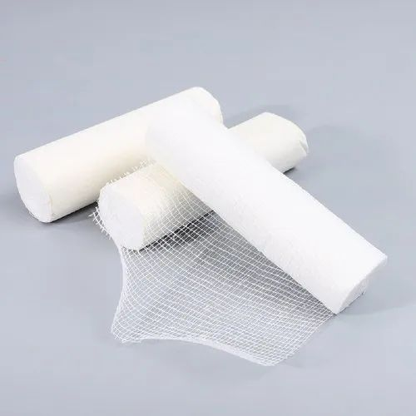

Dressing and gauze are essential components of wound care, providing protection and support to facilitate healing. Dressings are used to heal wounds, preventing infection and absorbing exudate while maintaining a moist environment conducive to recovery. Gauze, typically made from woven cotton, is often employed in conjunction with dressings for its high absorbency and breathability, making it ideal for dressing wounds, cleaning, and applying medications.

Indian Standard IS 758 : 2023 Medical Textiles – Cotton Absorbent Gauze – Specification outlines the constructional particulars and other requirements of bleached and unmedicated absorbent cotton gauze used for medical purposes.

Performance parameters such as pH, absorbency, cleanliness (microbial/bioburden test), scouring loss, and freedom from optical whiteners are critical for absorbent cotton gauze to ensure its quality, safety, and effectiveness in medical applications.
1. pH:
- The pH of absorbent cotton gauze is crucial because it should be neutral or slightly acidic to ensure it is compatible with human skin and wounds. A pH that is too high (alkaline) or too low (acidic) can cause skin irritation, discomfort, or interfere with the healing process of wounds. A balanced pH ensures the gauze is gentle and safe for prolonged contact with sensitive tissues.
2. Absorbency:
- Absorbency is one of the most essential properties of absorbent cotton gauze. The gauze must be able to effectively absorb and hold exudate from wounds, helping to keep the wound area dry, promote healing, and prevent infections. Gauze with inadequate absorbency may lead to wound maceration or infection due to the buildup of moisture.
3. Cleanliness (Microbial/Bioburden Test):
- Cleanliness is crucial for medical products like absorbent cotton gauze, as they must be free from harmful microorganisms, including bacteria, fungi, and viruses. A microbial or bioburden test ensures that the gauze is sterile or sufficiently free from contaminants before it comes into contact with open wounds. This reduces the risk of infection and ensures safe healing.
4. Scouring Loss:
- Scouring loss refers to the loss of weight or material after the cotton has been treated to remove impurities, such as natural waxes and oils. A low scouring loss indicates that the cotton has been properly cleaned without excessive damage to its fibers, ensuring it is soft, absorbent, and free from residues that could irritate the skin or interfere with the healing process.
5. Freedom from Optical Whitener:
- Optical whiteners are chemicals used to make fabrics appear brighter and whiter but can be irritating to the skin and may interfere with the healing of wounds. Absorbent cotton gauze must be free from these substances to ensure it does not cause allergic reactions, skin irritation, or other adverse effects when applied to wounds.

IS 863: 2023 COTTON BANDAGE CLOTH

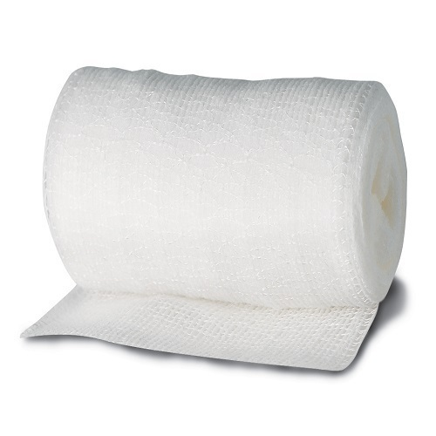

Cotton bandage cloth is a versatile and commonly used material in medical applications, particularly for wound care and injury support. It is soft, breathable, and gentle on the skin, making it ideal for wrapping injured areas without causing irritation. Cotton bandage cloth is highly absorbent, allowing it to effectively manage moisture from wounds or exudates, and is often used for securing dressings, providing support for sprains or strains, and immobilizing body parts after injuries.

The Indian Standard IS 863:2023 specifies the requirements for Cotton Bandage Cloth used for medical and surgical applications. cotton bandage cloth is used for binding, bandaging, and dressing purposes in healthcare. This standard outlines the materials, construction, and performance characteristics of the bandage cloth to ensure that it meets the necessary quality and safety standards for use in healthcare settings. Below are the key quality parameters expected by consumers in this product:

Material Composition
• The cotton bandage cloth must be made from cotton yarn.
• The material of bandage cloth shall be cotton fibre.
Constructional and other requirements
Length and Width of Bandage Cloth: Shall conform to the specified dimensions, typically ensuring that the cloth can be used comfortably for medical applications and to ensure adequate coverage during use.
Mass in GSM: The bandage cloth should meet the prescribed mass specifications as per the standard. This ensures that the cloth is durable enough for use but not overly thick or heavy, which would compromise comfort.
Thread Count: The bandage cloth should have a specified number of threads ensuring proper strength and durability. This thread count will affect the cloth's ability to withstand tension during use.
Sterilization: The bandage cloth must be capable of being sterilized effectively, as it is often used in medical settings. This includes ensuring the material remains safe and effective after sterilization procedures.
Packing and Marking: The bandages must be properly packaged for normal handling and transport without tearing and exposing the contents.
The packaging of the bandage cloth must carry clear marking including product details like the manufacturer's name, batch number, dimensions of the bandage cloth, typically provided in rolls of a fixed width and length.
The finished product should undergo testing for dimensional stability, count of Yarn, Threads, Scouring loss, color fastness.
IS 863 : 2023 sets the benchmark for the quality, safety, and performance of cotton bandage cloth, ensuring that medical professionals have access to reliable and effective bandages for patient care. By meeting these standards, manufacturers can help ensure the material is suitable for medical use while maintaining hygiene, durability, and patient safety.

• Fibre Content: The fibre content is crucial for ensuring the fabric's softness, comfort, and absorbency. Cotton is the preferred material for bandage cloth due to its hypoallergenic properties and ability to wick moisture away from the skin. Verifying the correct fibre content ensures the product meets the required specifications for medical use.
• Construction: The construction refers to the weave, thickness, and strength of the fabric. For a bandage cloth, a strong and durable construction is necessary to withstand the physical stresses of use, such as stretching and tearing, while providing effective support and compression.
• Dimension: Proper dimensional measurements ensure that the cloth fits standard medical sizes for bandages. It’s important that the bandage cloth conforms to the intended use in medical settings and provides the correct coverage or support.
• pH: The pH level is important to ensure that the bandage cloth is not too acidic or alkaline, which could irritate the skin or affect wound healing. A neutral pH is ideal for medical textiles to avoid allergic reactions or skin burns, especially on sensitive skin.
• Scouring Loss: Scouring loss refers to the loss of weight after the cotton fabric is cleaned. Excessive scouring loss indicates poor fabric preparation or the presence of impurities that could affect the quality and safety of the bandage cloth. Low scouring loss is desirable to ensure that the fabric remains stable and does not lose its properties after washing.
• Freedom from Defects: This is important for maintaining the functional integrity of the bandage cloth. Any defects in the fabric, such as holes, tears, or uneven textures, could compromise the effectiveness of the bandage, leading to potential issues with patient care, such as lack of proper wound coverage.
• Optical Whitener: Optical whiteners are often used to give fabric a brighter appearance. However, they can cause skin irritation in some cases, so it’s essential to ensure the cotton bandage cloth is free from optical brighteners, making it safe for prolonged contact with the skin.
• Colorfastness: The ability of the fabric to retain its color when exposed to washing, friction, or moisture is critical for medical textiles. If the dye bleeds or fades, it may affect the cloth’s functionality, hygiene, and appearance. Additionally, colorfastness ensures that no harmful substances are released during use.
• Sterility: Since cotton bandage cloth is often used in wound care, it is vital that the fabric is sterile or can be easily sterilized. Ensuring sterility prevents infections and contamination when used in medical settings.

IS 17351 : 2020, Medical Textiles — Dressing Shell Compressed — Specification

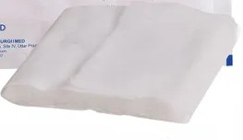
Dressing Shell Compressed is an essential medical product used for wound protection and care. It is compact for easy storage and handling but expands to cover wounds when applied, providing cushioning, absorption of exudates, and a sterile barrier. Its primary uses include protecting surgical sites, managing wound fluids, and offering comfort to patients by preventing contamination and infection. The significance lies in its ability to promote faster healing by maintaining a clean and dry environment, while also being cost-effective, versatile, and suitable for a wide range of wounds.

This standard specifies the requirements for dressing, shell compressed intended to be used mainly as emergency life saver to stop blood flow in case of open injuries.

The performance requirements for water-soluble substances, ether-soluble substances, sulphated ash, sinking time, absorbency, and biocompatibility are crucial for compressed dressing shells to ensure their safety, effectiveness, and compatibility with the human body in medical applications. Here's why each of these factors is important:

1. Water-Soluble Substances:
- Water-soluble substances, like salts or other chemicals, can leach into the wound when exposed to moisture. This could irritate the wound, disrupt the healing process, or introduce harmful substances into the body. Ensuring minimal or no water-soluble substances is essential to maintain the integrity of the dressing and avoid complications like infection or delayed healing.

2. Ether-Soluble Substances:
- Ether-soluble substances, often related to oils or resins, could interfere with the absorbency and the performance of the dressing shell. These substances may cause skin irritation or interfere with the body's natural healing process. Their presence can also impact the ability of the dressing to absorb exudates properly.

3. Sulphated Ash:
- Sulphated ash refers to the inorganic residue left after burning a material. A high level of sulphated ash indicates the presence of inorganic substances or impurities in the dressing shell, which could lead to contamination. For medical products, especially those in direct contact with wounds, the ash content must be minimal to avoid introducing foreign materials into the wound.

4. Sinking Time:
- Sinking time is a measure of the time it takes for the dressing shell to become fully saturated and sink in water. This is an important indicator of the dressing’s absorbency and how quickly it can manage exudates from a wound. A longer sinking time could suggest that the dressing shell might not absorb fluids efficiently, affecting wound care.

5. Absorbency:
- Absorbency is the most critical performance requirement for a dressing shell, as it ensures that the product can effectively absorb wound exudates and body fluids. Proper absorbency helps maintain a dry environment, which is vital for promoting healing, preventing infection, and protecting the wound from external contaminants.

6. Biocompatibility:
Biocompatibility ensures that the dressing shell does not cause any adverse reactions when in contact with body tissues. It prevents allergic reactions, irritation, or toxicity. Since the dressing shell is in direct contact with the skin or open wounds, it is vital that it is compatible with human tissue to ensure safe and effective healing without causing harm.

IS 17528 : 2021, Medical Textiles - Chlorhexidine Gauze Dressing – Specification

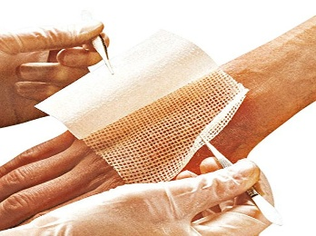

Chlorhexidine gauze dressings are essential in treating burn wounds and major injuries with skin damage. They provide effective infection prevention due to chlorhexidine's broad-spectrum antimicrobial properties, reduce pain with its mild numbing effect, and promote faster healing by maintaining a clean environment. These dressings act as a protective barrier against contaminants, support prolonged healing, and reduce the frequency of dressing changes, making them an important tool in managing severe wounds and promoting recovery.

It consists of fabric of leno weave with two picks in each shed in which the warp and weft threads consists of cotton or viscose or combined cotton and viscose yarn. The fabric has been evenly impregnated with a suitable ointment containing a dispersion of chlorhexidine acetate. The dressing is supplied sterile in single pieces.

The performance requirements such as fibre identification, threads per dm, weight per square meter, content of chlorhexidine acetate, sterility, and ether soluble substances are important for Chlorhexidine Gauze Dressings to ensure their safety, effectiveness, and quality in medical applications.

1. Fibre Identification:

Identifying the type of fibres used in the gauze ensures that the material is appropriate for wound care. Natural or synthetic fibres may have different properties, such as absorbency, strength, and biocompatibility. This ensures that the dressing is suitable for prolonged contact with the skin and wound tissue without causing irritation or allergic reactions.

2. Threads per dm (density of threads):

The number of threads per decimeter (dm) affects the strength and durability of the dressing. A higher thread density typically results in a stronger, more durable product that can withstand handling during application and dressing changes without tearing. It also impacts the absorbency and comfort, ensuring that the dressing stays intact during use.

3. Weight per Square Meter:

The weight of the gauze impacts its absorbency, comfort, and ease of application. A heavier gauze may absorb more exudate but could feel bulkier on the wound. A well-balanced weight ensures that the dressing is effective at absorbing fluids while remaining lightweight and comfortable for the patient. The right weight also helps in the dressing's ability to cover the wound adequately without excess material.

- Content of Chlorhexidine Acetate:

The chlorhexidine acetate content is critical to ensure the dressing provides the intended antiseptic and antimicrobial action. Too little chlorhexidine may reduce its effectiveness in preventing infections, while too much could cause skin irritation. Maintaining the correct concentration ensures that the dressing provides continuous antimicrobial protection without harming the wound area or surrounding skin.

5. Sterility:

Sterility is vital for any dressing that comes into contact with open wounds. Non-sterile dressings can introduce harmful microorganisms into the wound, increasing the risk of infection. Ensuring that the dressing is sterile at the time of use guarantees safety and reduces the potential for wound contamination.

6. Ether Soluble Substances:

Ether-soluble substances can be indicators of the presence of oils, resins, or other chemical contaminants. These substances may interfere with the dressing's ability to absorb exudate, cause irritation, or affect the overall comfort of the patient. Ensuring that ether-soluble substances are kept to a minimum helps maintain the purity of the dressing and ensures it is safe for use on sensitive skin or open wounds.

LIST OF IMPORTANT STANDARDS ON TEXTILES PRODUCTS FOR FOR INFECTION CONTROL, SUPPORT FOR RECOVERY OF INJURY AND WOUND MANAGEMENT PRODUCTS

Sl No | IS No | Title
 | IS 10829 : 1993 | X-Ray Detectable Gauze Swabs and Laparotomy Sponges - Specification (First Revision)
 | IS 11046 : 1984 | Specification for Towel, Operating
 | IS 11163 : 2021 | Medical Textiles - First Aid Dressings - Specification (First Revision)
 | IS 12839 : 1989 | Wool/Polyamide Blended Flannel, Hospital, Grey - Specification
 | IS 14274 : 1995 | Bandage, T - Shaped, Calico - Specification
 | IS 14306 : 1995 | Bandage, Triangular, Calico - Specification
 | IS 14316 : 1995 | Swabs, Small, in Bag of 50 - Specification
 | IS 16111 : 2013 | Elastic Bandage
 | IS 16289 : 2014 | Medical Textiles - Surgical Face Masks - Specification
 | IS 16290 : 2014 | Medical Textiles - Knitted Viscose Primary Dressings - Specification
 | IS 16291 : 2014 | Medical Textiles - Paraffin Gauze Dressings - Specification
 | IS 16302 : 2020 | Medical Textiles - Orthopedic Stockinet - Specification (First Revision )
 | IS 16303 : 2014 | Medical Textiles - Cast Padding for Orthopaedic Plaster - Specification
 | IS 16466 : 2020 | Medical Textiles - Povidone Iodine Ointment Based Knitted Dressing - Specification ( First Revision )
 | IS 16467 : 2016 | Medical Textiles - Graduated Medical Compression Stockings - Specification
 | IS 16468 : 2016 | Medical Textiles - Absorbent Cotton (Sterile and Non-Sterile) - Specification
 | IS 16469 : 2016 | Medical Textiles - Open Weave Bandages - Specification
 | IS 16470 : 2016 | Medical Textiles - Elastic Surgical Adhesive Tapes - Specification
 | IS 16660 : 2017 | Medical textiles - Nonwoven bandage rolls - Specification
 | IS 16668 : 2017 | Medical textiles - Salicylic acid adhesive plaster - Specification
 | IS 16669 : 2017 | Medical textiles - Elastic adhesive dressing - Specification
 | IS 16670 : 2017 | Medical textiles - Absorbent cotton ribbon gauze - Specification
 | IS 16671 : 2020 | Medical Textiles — Belladonna Adhesive Plaster — Specification ( First Revision )
 | IS 1681 : 1998 | Textiles – Hospital blankets, woollen, dyed – Specification (Third Revision)
 | IS 16946 : 2018 | Medical textiles – Elasticated tubular bandages – Specification
 | IS 16948 : 2018 | Medical textile – Permeable nonwoven surgical adhesive tape – Specification
 | IS 16949 : 2018 | Medical textiles - Adhesive extension plaster - Specification
 | IS 16950 : 2018 | Medical textiles - X - Ray detectable absorbent cotton gauze - Specification
 | IS 17334 : 2019 | Medical textiles – Surgical gowns and surgical drapes – Specification
 | IS 17348 : 2020 | Medical textiles – Adhesive incise drape – Specification
 | IS 17349 : 2020 | Medical textiles – Shoe covers – Specification
 | IS 17350 : 2020 | Medical textiles – Abdominal binder – Specification
 | IS 17351 : 2020 | Medical textiles – Dressing, shell compressed – Specification
 | IS 17352 : 2020 | Medical textiles – Foam dressing – Specification
 | IS 17353 : 2020 | Medical textiles – Pressure garment – Specification
 | IS 17354 : 2020 | Medical textiles – Dental bib/Napkins – Specification
 | IS 17359 : 2020 | Medical textiles – Anti-embolic stocking for Post op use upto thigh medium – Specification
 | IS 17423 : 2021 | Medical Textiles — Bio-Protective Coveralls — Specification (First Revision)
 | IS 17506 : 2020 | Medical Textiles - Hydrocolloid Dressing - Specification
 | IS 17507 : 2020 | Medical Textiles - Cellulose Wading - Specification
 | IS 17508 : 2020 | Disposable Adult Incontinence Diaper - Specification
 | IS 17509 : 2021 | Disposable Baby Diaper — Specification
 | IS 17514 : 2021 | Reusable Sanitary PadSanitary Napkin Period panties Specification
 | IS 17528 : 2021 | Medical Textiles Chlorhexidine Gauze Dressing Specification
 | IS 17628 : 2021 | Medical Textiles — Eye Pad — Specification
 | IS 17629 : 2021 | Medical Textiles — Caps — Specification
 | IS 17630 : 2021 | Medical Textiles — Bedsheet and Pillow Cover — Specification
 | IS 17786 : 2022 | Medical Textiles Underpad Specification
 | IS 17787 : 2021 | Medical Textiles Nonwoven Wipes Specification
 | IS 17788 : 2021 | Medical Textiles — Nonwoven Fabric for Wipes — Specification
 | IS 18266 : 2023 | Textiles - Medical Respirator - Specification
 | IS 19022 : 2023 | Medical Textiles - Barrier Face Covering - Specification
 | IS 4605 : 2020 | Crepe Bandage - Specification ( Second Revision )
 | IS 4717 : 2020 | Medical Textiles - Zinc Oxide Self-Adhesive Plaster - Specification ( Second Revision )
 | IS 4738 : 2020 | Medical Textiles - Bandage, Plaster of Paris - Specification (Third Revision )
 | IS 4739 : 2023 | Medical Textiles Zinc oxide elastic adhesive bandage Specification (Second Revision)
 | IS 5405 : 2019 | Sanitary napkins – Specification (Second Revision)
 | IS 6237 : 1971 | Specification for handloom cotton cloth for plaster of Paris bandages and cut bandages
 | IS 674 : 2023 | Medical Textiles Flannel hospital grey Specification (Fourth Revision)
 | IS 757 : 1971 | Specification for handloom cotton lint, absorbent, bleached, non-sterilized (First Revision)
 | IS 758 : 2023 | Medical Textiles — Absorbent Cotton Gauze — Specification ( Fifth Revision )
 | IS 863 : 2023 | Medical Textiles - Cotton bandage cloth - Specification (Third Revision)
 | IS 9751 : 2023 | Medical Textiles Bandage suspensory - Specification (First Revision)
 | IS 18552 : 2024 | Guidelines for Processing of Multiple-use Healthcare Textiles

